Small-scale LNG in East Med: unlocking the permitting puzzle through robust safety assessment methodologies and expertise
Anna APOSTOLOPOULOU^{a,}, Thanos KOLIOPULOS ^{b}, Theodoros KOURBELIS ª, Anastasia KOUVERTARI ª, Panagiota MENTZI ª, Panayiotis MITROU ª
ª Lloyd’s Register, Piraeus, Greece
^{b} Lloyd’s Register, EMEA
Abstract. One of the key challenges to switch to LNG as fuel era is to create “a safe passage” for LNG bunkering, by designing safe, reliable and operable LNG port facilities and operations. Eastern Mediterranean region brings step changes towards small-scale use of LNG fuel for marine transportation through the extensive groundwork developed within European co-funded Poseidon Med II project. Lloyd’s Register, as one of the leading project partners, gauges the risks, by applying efficient tools and advanced methodologies that can accurately model risks and assess potential consequences for LNG bunkering operations in each participating port. This paper features experience gathered from the strategic mapping and approach taken and implemented for all project ports, focusing on the Port of Patras in Western Greece, a port with the plan to combine LNG infrastructure and LNG bunkering operations. There, LR and project experts have undertaken onsite inspections suggesting alternative solutions for infrastructure and operations; have gained experience from the design from scratch of the Shore-to-ship LNG bunkering infrastructure; have set safety and exclusion zones as layers of defense in potential hazards; have safely navigated vessels to/from port installation running real-time simulation scenarios under various environmental conditions; have identified potential hazards and mitigation strategies addressing critical scenarios (HAZID workshops); have developed preliminary hazard & operability (HAZOP) and Quantitative Risk Assessment (QRA) analysis, to evaluate issues and risks to personnel or equipment, and have worked together with the Ministries to create the relevant national legislation for the new supply chain requirements.
Keywords. Small-scale LNG port facilities, permits, risk assessment, Eastern Mediterranean, LNG bunkering

Introduction
In the current decade, the general increased focus on global and local environmental matters has led to a plethora of additional regulations in both international and national level. Some of them are ready and will be entering into force in the near future, whereas other are still under development and will have an impact in the intermediate term, with the scope to reduce shipping emissions. Regulations can be followed by mitigating emissions through either changing fuel type/considering alternative fuel options or by exhaust gas cleaning. One of the results this has led to is the development of sophisticated dual fuel engines and LNG fuelled ships. The European Commission supports the adoption of alternative fuels solutions, one of them being LNG, as well as their supply chain and availability strengthening [1] [2].
The aim of this paper is to present core elements of the EU Eastern Mediterranean region plan and roadmap towards small-scale use of LNG fuel for marine transportation, through the extensive groundwork developed within European co-funded Poseidon Med II project.

Small-scale LNG supply chain in the Eastern Mediterranean

The framework: Poseidon Med II
Poseidon Med II, the European co-funded project is a practical roadmap which aims to transform Eastern Mediterranean ports into small LNG hubs. The project, involves three countries Greece, Italy and Cyprus, 26 partners, six European ports (Piraeus, Patras, Limassol, Venice, Heraklion and Igoumenitsa) as well as the Revithoussa LNG terminal. Eastern Mediterranean region has already identified large potential in small-scale LNG facilities. The wide number of core and satellite ports in the region and the existence of the LNG Import Terminal at Revithoussa Island in Greece, create a fertile ground for developing a secure and efficient small-scale supply chain in the region, covering the needs for Short-Sea Shipping.

The distribution model & the case of Patras Port
Revithoussa LNG Import Terminal with an existing capacity of 130,000 m³ and an under construction extension of 90,000 m³ plays a leading role as LNG distribution hub, as it is located in the vicinity of Piraeus Port –the largest port of the region- and in the centre of the LNG supply chain in the region (see Figure 1).
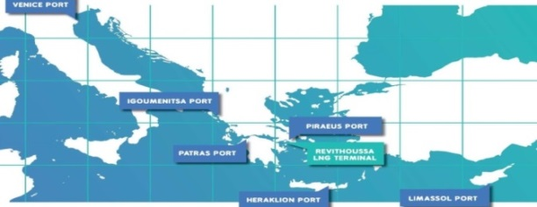
Figure 1. Poseidon Med II map
In order to develop a robust and sustainable LNG bunkering system, Poseidon Med II designs the core LNG bunkering fleet, including a newly-built LNG feeder with 7k m³ capacity to channel LNG cargos to regional ports as well as a smaller LNG bunkering barge with a capacity of 1k m³. Additionally, the project aims to instigate the demand of LNG as fuel, by developing detailed designs for retrofitting various types of vessels to LNG-powered as well as for new-built vessels. Specific emphasis is also given to the Port of Patras in Western Greece, as it represents a high potential growth for LNG bunkering services, both from operations, as well as infrastructure aspects.

The LNG as fuel option
Fundamental for understanding LNG is the examination of its chemical and physical properties both as a gas or vapour and as a liquid. These determine and predict how LNG behaves and influence how safety risks are assessed and managed through the whole supply chain, both for normal operations and for emergency situations. Misunderstanding LNG is not uncommon. Companies in Asia have gone to great lengths to share information about their facilities and to educate locals about LNG.
LNG is natural gas (predominantly methane, CH₄, with some mixture of ethane C₂H₆) which has been converted to liquid form for ease of storage or transport. It is classified as hazardous substance or dangerous good. LNG takes up about 1/600 of the volume of natural gas. Depending upon its exact composition, natural gas becomes a liquid at approximately -162°C (-259°F) at atmospheric pressure, maximum transport pressure is set at around 25kPa (4 psi). LNG’s extremely low temperature makes it a cryogenic liquid. To remain a liquid, LNG must be kept in containers, of specific material, which function like thermos bottles and are of specific material [3] [4].
LNG achieves a high reduction in volume so that the (volumetric) energy density of LNG is 60 percent greater than that of diesel fuel. This makes LNG cost efficient to transport over distances where pipelines do not exist. LNG is odourless, colourless, non-corrosive, non-flammable, and non-toxic. Key liquid and gas properties for LNG are: Chemical Composition, Boiling Point, Density and Specific Gravity, Flammability, and Ignition and Flame Temperatures [5].

LNG Bunkering and infrastructure in a port, relevant operations, navigation, safety, regulatory and monitoring aspects
There is an unquestionable need to create the roadmap, the plan and strategy of ports and EU member states towards adopting means and infrastructure – for vessels and ports - for alternative fuels for the marine industry [6]. This goes together with certain EU Directives, this is in line with the trend, absolute need and culture for less and less emissions and care for the environment and our health. So, the focus is at all levels. This is how EU, Poseidon Med II project and its partners have seen this, starting with setting the plan, then implementing and then adjusting it according to every day developments at all levels.

Risk Assessment – HAZID, HAZOP& QRA Methodologies
For the port of Patras, and as part of the studies [7] for the whole supply chain for vessels bunkering and small scale LNG infrastructure, risk assessment methodologies are being applied during all design phases as appropriate.

Vessel Designs
As part of the Poseidon Med II project, a risk assessment of the vessel designs (both retrofits and new construction ones) for ‘natural gas as fuel’ is required. This is often referred to as the ‘LNG Fuel Risk Assessment’ or simply HAZID and forms part of LR’s formal Risk Based Design (RBD) process [8]. A principal part of the risk assessment is a workshop, and this Terms of Reference (ToR) is a summary of the design information and an overview of the risk assessment approach proposed for that workshop. The workshop is facilitated by LR and consists of a team collectively knowledgeable in the design and operation of natural gas fuelled vessels. The team uses a qualitative/semi-quantitative approach in-line with the risk assessment standard ISO 31010. In simple terms, the team identifies ‘what could go wrong?’, ‘how bad could it be?’, ‘are additional safeguards required?’ and if so, ‘what safeguards are needed?’ [9] [10]
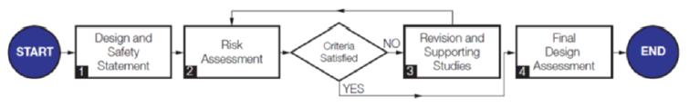

Figure 2. Generic process for the Assessment of Risk Based Designs (RBD)
The objective of the risk assessment, as noted in the IGF Code, is to help ‘eliminate or mitigate any adverse effect to the persons on board, the environment or the ship’. In achieving this objective the risk assessment: helps identify and recommend safeguards that could reduce risk; and, helps determine if the risks have been ‘mitigated as necessary’. The scope of the risk assessment is the use of natural gas, and covers equipment installed on board to: receive, store, prepare and transfer fuel to the engines and other consumers; control the operation; detect, alarm and initiate safety actions; vent, contain or handle operations outside of that intended; protect surfaces from fire, fuel contact and escalation through use of fire-fighting appliances, etc.; and purge and inert fuel lines. The scope also covers consideration of structures and constructions to house equipment, and bunkering equipment installed on board. Following the workshop, LR prepares and distributes a report on the workshop’s findings, deliverables and follow-up actions.
The RBD (Risk Based Design) process consists of four stages as shown in Figure 2. Responsibility for completing this process lies with the organisation requesting full approval or ‘Approval In Principle’ (AIP) from LR. The HAZOP (Hazard & Operability Study) [11] forms part of the Risk Assessment for Stage 4 of RBD. During the HAZOP workshop and study, the system is being looked at in detail, and is separated into discrete process sections accordingly, called ‘Nodes’. The principal objective of the HAZOP is to increase confidence at the final stage that safety related aspects of the design are appropriate [12].

Small scale LNG Infrastructure Designs
The main objectives of the Site Evaluation HAZID study are to: undertake a site survey and discuss feasible types of operations and appropriate sites to make it feasible with minimum impact; Additionally it assesses bunkering fuel capacity requirements under current and future trades, as well as size and numbers of barges, capability for re- loading LNG cargo locally or at remote location, turnaround time service requirements and identify short and long term solutions for storage options; Furthermore it is to assess impact of LNG barge traffic in the Port Authority traffic operations, provide knowledge basis for similar operations in other ports, and address traffic control, jetty operations, port support operations and emergency response; Preliminarily evaluate bunkering systems for service at port including LNG trucks; Also address crew competence standards requirements; and finally issue HAZID Report inclusive of work sheets identifying findings, recommendations and follow up actions.
In order to effectively and qualitatively rank risks at the stages of design an appropriate Risk Assessment Matrix (RAM) has been adopted and shown in Figure 3.
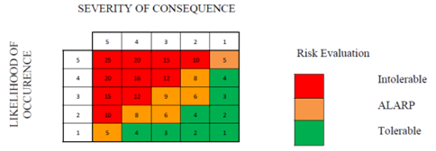

Figure 3. Risk Assessment Matrix
The orange and green areas of Risk Assessment Matrix represent the range where the risks are tolerable if they are ‘As Low As Reasonably Practicable’ (ALARP). This is achieved if the cost of risk reduction would greatly exceed the safety improvements gained. The greater the risk, the greater the disproportion between cost and benefit which is required before an improvement becomes impractical. In the red shaded region the risks are intolerable and would be required to be reduced by design activities. The risks identified during the HAZID study are classified according to their severity to the operations (downtime), impact on personnel on-board ships or at jetty (health/safety), impact to the environment and their likelihood of occurrence.
With the same philosophy as for vessels designs, HAZID is stage 2 of the RDB and HAZOP(s) follow in the next stages. The final stages are also accompanied by a QRA (Quantitative Risk Assessment) study and modelling exercise, which is based on determined scenario releases and which confirms that all generated risks have been identified to be within tolerable and acceptable levels. Also that the terminal generated risk zones do not have any detrimental impact neither would affect future passing ship traffic or cargo fuel loading operations at the nearby buoy, and that the overall societal risks are also within the ‘tolerable ALARP’ region and are dominated only by risks to personnel on-site.
The stronger the risk assessment during the design phase, the higher the confidence given upon the design and the knowledge acquired, and the easier the permitting and construction steps are unlocked. Authorities, interested bodies, key stakeholders and the public should be involved in early stages of the design and decision making, so that the plan receives, constructive input and public acceptance as necessary.

Exclusion Zones
Exclusion zone studies, which constitute a part of the Risk Assessment process, aim at the calculation of minimum distances where activities should be prohibited for a defined set of operational cases, in order to contain hazards from a potential safety incident with LNG (i.e. fire, explosion, exposure to cryogenic temperatures).
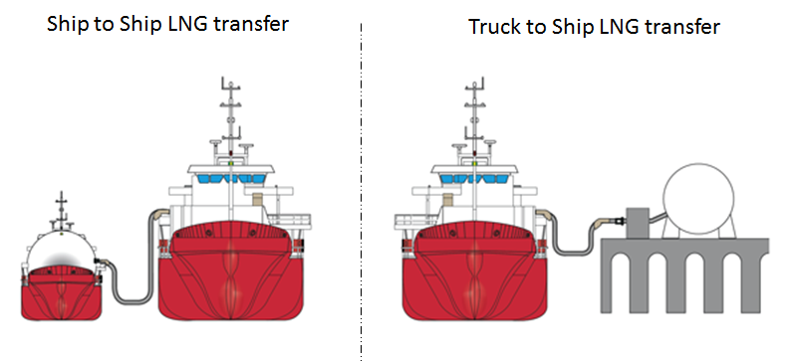
Figure 4. LNG Bunkering Options
Scenarios include bunkering modes from bunker barge to vessel (namely Ship to Ship or STS), while the second is from truck to vessel (Truck to Ship or TTS). Figure 4 depicts these 2 options for bunkering operations. In order to determine the exclusion zones during bunkering operations, indicative gas release locations are used to represent potential points of release from the bunkering system on either the bunkering vessel or truck and the receiving vessel. Examples include three broad categories of release sizes: a hole with diameter 5mm which represents the majority of all leaks, and 2nd and 3rd with 25mm and 35mm holes which represent equipment failure associated with isolation valve and transfer piping failures, all based on a steady state release at the normal operating pressure. Figure 4(a) below shows a representative profile of the LNG release under free field conditions where the gas dispersion is not influenced by any structures or obstruction. As natural gas vapour is denser than air at the initial stages of release, the profile of the flammable gas plume is expected to sink downwards. Figure 5(b) shows the profile on the flammable gas for leaks shown in Figure 5(a).

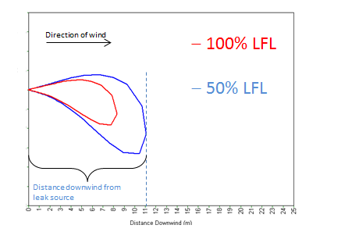 | 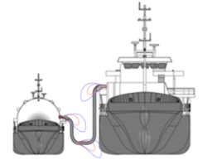
Figure 5(a) and (b): Release Scenarios for STS operations
For the truck to ship operations the same assumptions are employed. Figure 6(a) below shows a representative profile of the LNG release that is close to ground level while figure 6(b) depicts the profile of the flammable gas for leaks at the 3 locations shown in Figure 6(a).
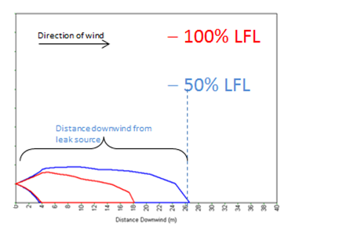 | 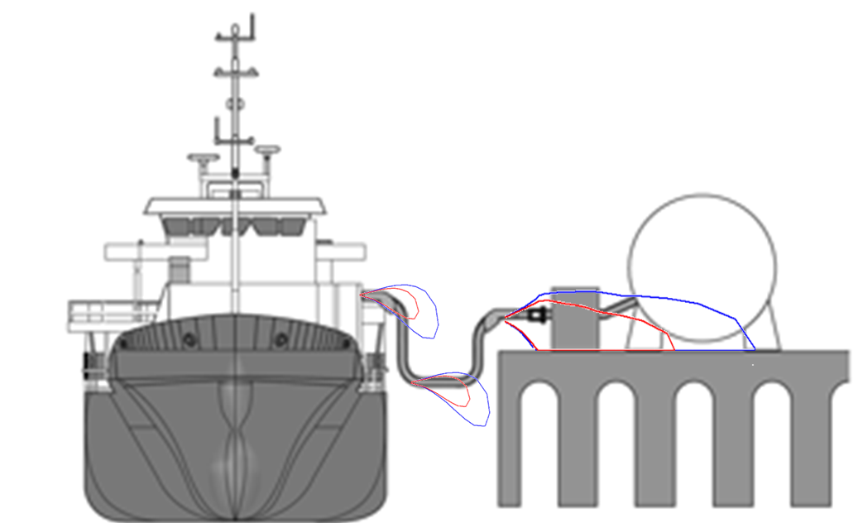
Figure 6(a) and (b): Release Scenarios for TTS operations
The most ‘credible worst case’ event is the release under pressure from a 5mm hole, based on historical data. While atmospheric conditions can be seen to have some effect on the calculated distances it is apparent that the worst case conditions for dispersion are generally those for typical daytime conditions. The recommended safety exclusion zone distances were calculated for operations in the port of Patras and are indicatively presented at the table below.
Table I: Recommended Safety Exclusion Zones Distances
Operations | Location | Minimum Safety Exclusion Distance (m)
Ship to Ship Transfer | LNG barge Bunkering Station, LNG transfer hoses, Receiving ship Bunkering Station | 11.5
Truck to Ship Transfer | LNG transfer hoses & Receiving ship Station | 10
 | LNG Truck Bunkering Station and hose close to ground level | 22
Relief and venting | Vent Mast Tip | 5m

Navigation Simulations
Among the aims of the Navigation Simulation workshop is the verification of the following aspects for the port of Patras: the safe passage of LNG barge and feeder vessels from Revithoussa to Patras small scale LNG infrastructure, the safe manoeuvre of a feeder vessel and a barge for berthing alongside, bunkering at Port of Patras, the number and size of tugs that maybe required and the identification of appropriate emergency procedures. The exercise involves a workshop and participation to it included specialists from LR, BMT who employed the REMBRANDT software, port pilots, as well as key partners and relevant stakeholders. The official Greek Hydrographic Office S-57 electronic chart was used for the simulations whereas wind, wave and current data was based on input from the port’s pilot representatives. Simulations were conducted by a Pilot who controlled the vessel directly and had access to real time information, namely an electronic chart view (ECDIS) showing the position of the vessel, turning circles and exclusion zones, a 3D view from the ship’s bridge, vessel’s speed, heading and course over the ground; depth profile and engine/rudder values and finally the position and % of power usage for each tug.
For the exercise, an LNG Bunker Barge and a slightly larger LNG Feeder Tanker were modelled. In addition to the arrival, departure and berthing alongside, passage scenarios for feeder tanker and bunker barge were assessed. Emergency response scenarios were also simulated, as well as feeder vessel blackout and stuck rudder, also through worst case weather conditions. A total of fourteen run reports were presented with the help of a qualitative grading matrix (shown in Figure 7) that demonstrates the grade of difficulty for each run as a means of comparison for the study.

Figure 7: Qualitative grading matrix for navigation simulation run reports
Drawing from the results of the maneuvering simulations the following conclusions were made: Maneuvering operations of LNG feeder vessel and LNG barge in and around the port did not pose any significant problems. However significant difficulties were experienced in wind speeds above 30 knots where the presence of two tugs was deemed critical; Existing operating tugs have sufficient bollard pull to support feeding vessel maneuvering in the port during simulated emergency procedures and berthing / un-berthing operations under all investigated meteorological conditions and exit from the port for the LNG Feeder and barge and also during bunkering operations.

A light on the regulatory aspects
Looking at the pillars of a regulatory framework, one can consider it from an international, national and local point of view.
At an international level, key role and with a heavy regulatory impact this decade mainly play Sulphur oxides (SOx), Nitrous oxides (NOx), Greenhouse Gases (in particular CO₂) and Ballast Water Management (BWM). Shipping emissions have been internationally regulated by IMO (International Maritime Organisation) and global emission levels are defined and significantly more stringent levels apply to designated sea areas, the Emission Control Areas (ECAs).
At national and local levels, it all goes with the strategy of the Country, following the EU Directives and the Country’s goals and energy plans, as well as the certain port’s culture, organisation and vision. Within the national legislation focus should be given on all matters for both LNG bunkering operations as well as infrastructure; from designing and manuals to operations, permitting process, procedures for normal or emergency situations, mitigation of risks and impact areas, training competences of all involved, monitoring the quantity and quality of LNG [13], navigational matters, providing incentives and tools, identifying areas of overlap with existing legislation, as well as filling the gaps with new drafted one [14].
And concluding, the stronger the preparation of all above, as well as the cooperation of all stakeholders, the easier will be to be transferred to a new era of using alternative means of energy, like LNG and gas, thus lowering the emissions gradually that harm humans and the earth.

Epilogue
Prevailing of Natural Gas over other hydrocarbons will demand among other a further dissemination of its supply chain. LNG will play a major role in this effort as it allows the movement of volumes in density outside the pipelines grid. Going small scale though will not be an easy process especially for an industry which excels in safety performance through the application of rigid controls. Under Poseidon Med II we have combined diverse input from authorities, stakeholders, interested parties, specialists and applied a complete derisking roadmap based on a combination of available tools. The outcomes demonstrate that the current arsenal of LNG available technology can provide ‘fit for purpose’ solutions in almost all layouts and operational envelopes once detailed planning and thorough controls are applied.

References
- DIRECTIVE 2014/94/EU OF THE EUROPEAN PARLIAMENT AND OF THE COUNCIL of 22 October 2014 on the deployment of alternative fuels infrastructure
- DIRECTIVE SEVESO III, EU, 2015
- EN Standards (indicatively): EN 1160 - Installations and equipment for Liquefied Natural Gas – General characteristics of Liquefied Natural Gas, EN 437 - Test Gases – Test Pressures – Appliance Categories, EN 12838 - Installations and equipment for LNG – Suitability testing of LNG sampling systems
- ISO Standards (indicatively): 6141/2/3, 8943, 20519, 28460, 31000, 31010, 69741/2/3/4/5/6
- GIIGNL, ‘Basic Properties of LNG’, Information Paper No.1, 2009, ‘LNG Process Chain’, Information Paper No.2, 2009, ‘LNG CUSTODY TRANSFER HANDBOOK’, Fourth Edition, version 4, 2015
- EMSA, Guidance on LNG Bunkering to Port Authorities and Administrations, 2018
- Poseidon Med II Project Deliverables (up to March 2018)
- International Code for Safety of Ships Using Gases or Other Low-flashpoint Fuels (IGF Code)
- Davies & Fort., LNG as a Marine Fuel - Likelihood of LNG Releases, Journal of Marine Engineering & Technology (12, 3), 2013
- Formal Safety Assessment MSC 85/17/2. Association of Oil & Gas Producers, ‘Risk Assessment Data Directory’, 2010
- IChemE, HAZOP - Guide to Best Practice, 2nd Edition, 2008
- International Association of Classification Societies – IACS, ‘Risk assessment as required by the IGF Code’, No. 146, 2016
- SGMF, ‘Gas as a marine fuel - contractual guidelines – Quantity and Quality’, Version 1.0, Sept 2015
- Websites: http://www.depa.gr; http://www.desfa.gr; https://www.wartsila.com; www.poseidonmedii.eu

Anna Apostolopoulou, EU Projects Management & Coordination Leader, Marine & Offshore, Lloyd’s Register, Hellenic Lloyd’s S.A., 87 Akti Miaouli, 18538, Piraeus Greece; E-mail: anna.apostolopoulou@lr.org

