Shore to ship power supply integrating conventional and distributed generators along with storage
Giordano Torri, Silvio Casini, Andrea Piccin and Denis Mondo
Fincantieri SI spa, Trieste – Milano (Italy)

Abstract. The need for reduction the pollution when ships are in port requires the use of a shore-to-ship power system for supplying energy to the onboard grid. The latter is normally fed at 60 Hz, so a frequency conversion is needed. Power can be taken from the public power grid available on shore. In order to reduce the environmental impact, this power system can be integrated with local, distributed generators that produce energy from renewable sources. Energy storage can also be added in order to smooth power peak demand and production from not programmable generators. The paper shows a system built around an Energy Box that manages the duty of all the power sources in parallel and provides the frequency conversion. A parallel on dc or ac side is considered, according to the power installed in a wide range from few MW up to 20 MW. The Energy Box is controlled by its own Power Management System in order to get a strong reduction of emissions, lower energy cost along with the best efficiency. An example of this technology is also shown.
Keywords. Shore-to-ship power supply, microgrid, frequency conversion, renewable energy, energy efficiency, reduction of pollution.

Introduction
The International Maritime Organization (IMO) released the rules “Marpol annex 6” [1] for the reduction of emissions of SOx and NOx of ships. The European Commission (EC) issued the directive 2016/802 in order to reduce the sulphur of certain fuels. Article 7 of this directive is dedicated to ships in port [2]. The directive 2006/339/EC [3] recommends the use of a shore connection for giving electric power to a ship at berth in ports because the emission reduction is well beyond the use of fuels with low sulphur content. It is evident that new infrastructures must be foreseen for ports, especially where they are close to towns. The IEC has already released the norm IEC80005 dedicated to electric power supply to ships from shore. The norm includes a simplified schematic of such a connection. In order to comply with these directives and norms Fincantieri SI is proposing a system that is capable of providing energy at the required Voltage, Frequency and Power to the onboard grid of the ships. At the same time this system can integrate a plurality of power sources on the shore, either traditional or renewables. The latters can minimize the use of fossil fuels from one side and promote the reduction of pollution and the energy efficiency on the other side. The proposed solution, based on the new concept of “FCSI Energy Box”, is seen as an extension of the idea of the “microgrid” [4] [5] [6]. The fig. 1 shows the generic schematic for such microgrid system, where various types of generators are used along with energy storage. The solution provides a frequency conversion from 50 to 60 Hz too.
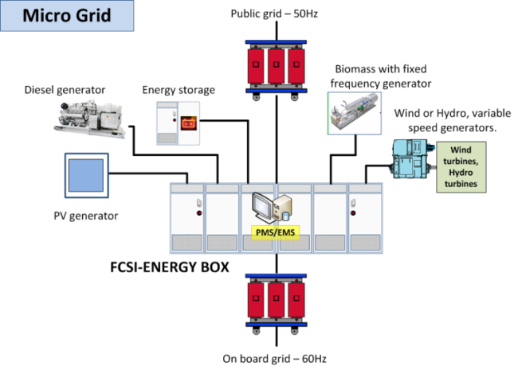
Figure 1. Shore-to-ship connection. General schematic of the microgrid.

FCSI Energy box with DC or AC internal link
The way of putting in parallel various types of power sources requires a connection that can be based on an internal DC or AC link, as shown in fig. 2. The choice depends on the power of the entire equipment as well as on the relative size of each sub-equipment.
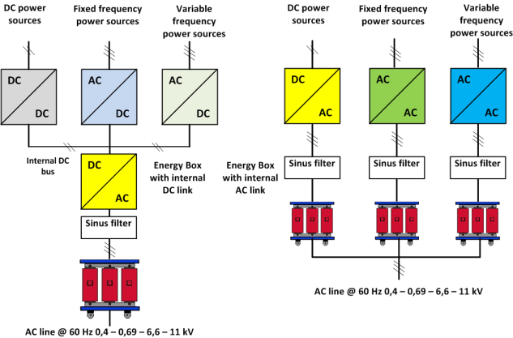
Figure 2. FCSI Energy box with a DC link (left) or with AC link (right).

System performances.
Regardless of the power solution conceived, the system must provide some important features as described hereafter.
- The output voltage should be provided either in LV or in MV, according to the most common standards (0,4 – 0,69 – 6,6 – 11 kV).
- The output frequency must also be provided at 60 Hz in case the on board grid adopts this standard.
- The THD (Total Harmonic Distortion) of the onboard grid should be contained within 5% at all loads.
- The system must be capable of proving energy to an IT grid unearthed or grounded by means of a high impedance. The on board protection system must be preserved.
- The power system must be capable of working in a standalone mode or in parallel to the onboard generators and a seamless transition is required between these two modes.
- Redundancy: the solution must provide the duplication or the interchangeability of critical components with the intention of increasing the reliability of the plant. At the same time redundancy must provide the ability to allow regular maintenance even in case the plant is extensively used.
- Operability: the solution must provide the ability to keep the complete system in a safe and reliable functioning condition, according to pre-defined operational requirements, from local and remote locations. The system must be fitted with an easy-friendly HMI (Human Machine Interface) to allow the operator to conduct the plant and guarantee adequate features for regular maintenance.
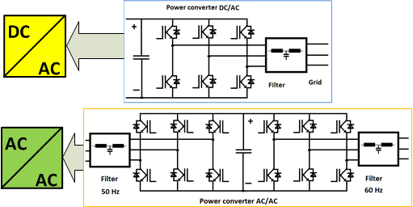
Figure 3. Simplified schematic of the dc/dc and ac/ac power converters.

FCSI Energy Box with DC connection.
The solution for powers limited to few MW or in LV can be designed with an architecture based on an internal DC link as in fig. 2, at the left. Depending on the power sources, two types of converters are used for the generators: dc/dc or ac/dc. The frequency conversion is made again by a dc/ac power converter whose output is equipped with a sinus filter for mitigating the impact of the harmonics.

FCSI Energy box with AC connection.
When the power required is in the range of 5 to 20 MW or when there is a significant difference among the sizes of each power source the best solution is given by fig. 2 at the right. Dc/ac or ac/ac power converters are used for connecting each power source in parallel on the ac side of the 60 Hz line. Again the ac output of each power converter is filtered by a sinus filter for mitigating the impact of the harmonics.

Power converters
The power conversion is based on Voltage Source PWM (Pulse Width Modulation) converters. In order to better understand their features a simplified reference to the 2-level schematic is considered, as in fig. 3. An extension to other and more complex PWM converters is straightforward. In order to comply with the onboard grid the power converters provide an output frequency and voltage at the required values. By default, the frequency can be set at 60 Hz and the voltage adjusted by the transformers or by the inverters themselves. However in case of need and without changing the power configuration, the frequency can also be set at 50 Hz. The output lines are equipped with dedicated sinus filters and EMI (Electromagnetic Interference) filters in order to provide a THD less than 5% from no load to full power and to be in compliance with the limits of the electromagnetic emissions to the loads.
Another important feature is the compliance to the existing onboard protection system. The converters that provide energy to the ship must be capable of feeding the 60 Hz power line with a short circuit current, compatible with the installed protections. Normally the power converters should provide a short circuit current up to 3 times the rated current, without tripping and restoring the normal duty when the faulty line is cleared. Fig. 4 shows the behavior of the converters in normal and in faulty conditions. As soon as a fault is detected the converters limit their output current to the maximum value Icc-max, waiting for the on board protection system clear the fault. After that, the converters provide the restore of the normal voltage and frequency in a seamless way. 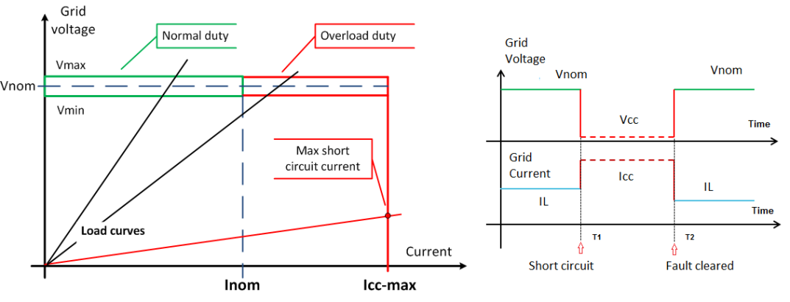
Figure 4. Behavior of the output 60 Hz converter in short circuit condition.
The output converters must also be capable of running in parallel among themselves and to the onboard generators. They must have the capability of primary frequency and voltage regulations [7]. A simple way of getting this feature is the implementation of droop curves, Frequency vs. Active Power and Voltage vs. Reactive Power, as shown in fig. 5. A natural load sharing is obtained. Of course, when the load changes a deviation in voltage and frequency from their nominal values is expected. If so, the Power Management System (PMS) provides a secondary frequency and voltage regulation in order to restore the nominal values of frequency and voltage.
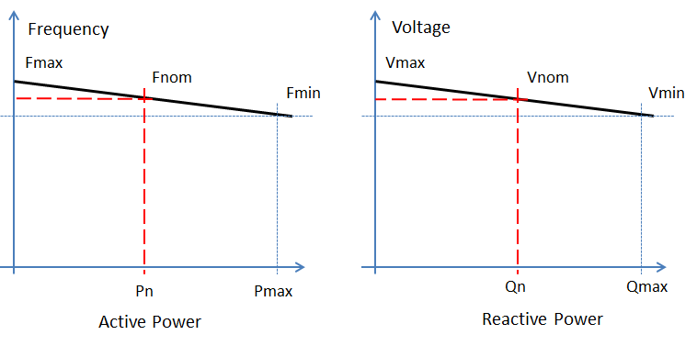
Figure 5. Droop curves for Freq/Active power and Volt/Reactive power.

Supervision and Control System of the FCSI Energy Box
The control core of the system is the Power and Energy Management System (PMS/EMS) along with the control and supervision of the entire plant. Here after the most important features are recalled.
- The management of the logic sequences when connecting and disconnecting the system form the ship in order to get a safe operation and no power loss.
- The management of the power sources in order to provide the best efficiency and the lower energy cost.
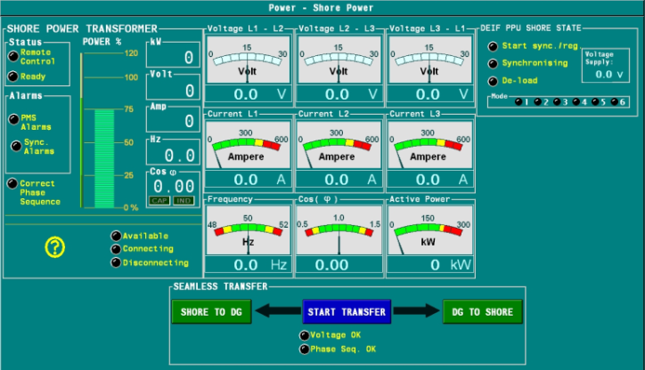
Figure 6. Operator’s station for the management and control of the plant.
- The supervision of the system that includes the monitoring of the relevant parameters, the recording in a data base and the management of any alarm that can lead to undesired situations (like a fault). The operator has a pc-based operating SCADA system that allows to monitor in real time any event and taking any consequent decision. A screen shot is given in fig. 6 as an example.

The proposed solution for a port.
The cruise ships require a large amount of power, typically up to 12,8 MW with a power factor of about 0,8 when in port. This leads to 16 MVA. According to a study of the selectivity of the on board protection system an overcurrent of 150% has been considered on top of 16MVA, leading to 24MVA during the fault.

Solution with a power supply taken from a public grid 50Hz only.
The solution proposed is shown in fig. 7. The following features are met.
- Output voltage. The output transformer has open windings. By means of switchgears its secondary windings can be configured either in a delta or in a star connection (Red dotted box in fig. 7). Two voltage levels are available: 6,6 and 11 kV.
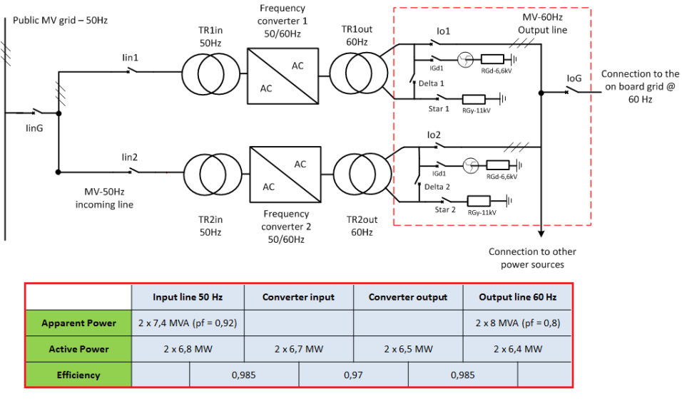
Figure 7. Shore-to-ship connection for cruise vessels. 16MVA/60 Hz.
- Redundancy. Two converters of the same size have been considered in order to provide either redundancy or better efficiency in case of partial or reduced loads.
- System grounding. The output 60Hz line can be grounded using a HRG (High Resistance Grounding) or not. Dedicated switchgears will allow the most suitable connection to the onboard grid.
- Efficiency of the System. The fig. 7 summarizes the performances expected, attaining a global value of about 0,941.
- Power factor and THD on 50 Hz side. The solution is conceived with an input diode bridge configured with 48-pulse to each frequency converter. A power factor better than 0,9 load independent is obtained along with a THD less than 4% at all loads.
- THD 60 Hz side. The frequency converters work at a switching frequency of about 2kHz. A sinus low-pass output filter is provided for each one. High order harmonics are cancelled and a THD less than 5% is obtained.

Solution integrating renewable generators and electric energy storage (EES).
The fig. 8 shows the same system where a photovoltaic (PV) installation is used along with an electric energy storage (EES). The size of the PV has been selected according to the area available in port and a 5MWp plant is considered.
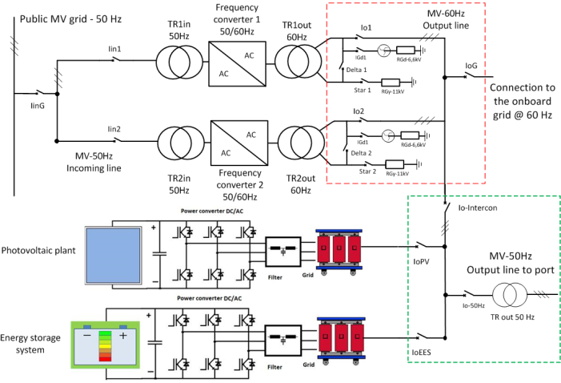
Assuming that a ship stays in berth for 8 hours and its average load is 10MW, the PV can provide from 10% to 30% of the energy demand on a daily basis. The calculus takes into account a zone 40° latitude north and winter/summer sun radiation. Fig. 10 shows the results.
In order to compensate the natural fluctuation of the PV power production and to smooth the changes in the onboard loads an EES is added. The EES is based on Li-ion battery and has a capacity of 1,8 MWh. The EES provides a “load levelling” too. Assuming that the onboard load fluctuates of +/-1 MW around its average, the capacity of the EES is enough for the scope of absorbing a power almost constant from the 50 Hz grid when the shore system is in operation. When the shore system is not used for ships the energy produced by the PV plant can be stored in the battery up to its maximum capacity. When this capacity is exceeded the energy is used for other port infrastructures. Changeover switchgears (marked in the dotted green box of fig. 8) allows the connection of the PV and EES to 50 Hz grid.
Figure 8. Shore-to-ship connection for cruise vessels. 16MVA/60 Hz with PV and energy storage

Extension of the solution to more than one ship in port.
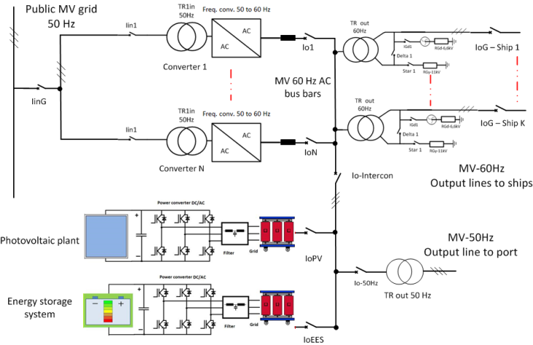
The system is also designed in a modular way that allows an easy extension when more than one ship must be fed in port at the same time. If so, using as a base block the 8MVA frequency converter and a MV switchgear assembly it is possible to combine together all the power units in a number suitable for the total load. Fig. 9 shows the concept for a general case, where “K” independent outputs are provided to different ships. “K” transformers at 60 Hz are used for feeding different ships at the same time. The insulation among the grids of each ship is guaranteed by the transformers. The figure also shows a connection of the PV and energy storage plant to the 60 Hz side of the shore-to-ship plant. The renewable energy can also be used for the loads installed in port when the shore system does not require power. If so, the PV and storage system are connected to the 50 Hz line of the port by means of switchgears and their power converters change the output frequency by SW in a seamless way .
Figure 9. General solution for shore-to-ship connection for small and large ports. The basic unit is 8MVA/60 Hz with PV and energy storage.

Conclusion.
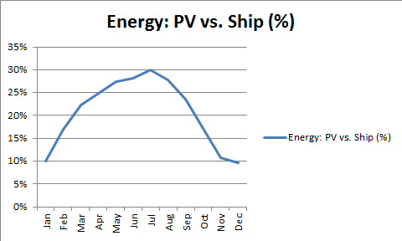
The proposed system for the shore-to-ship power supply based on the “FCSI Energy Box” is an efficient way for reducing to a minimum the pollution in ports, caused by the running engines on board. The solution also gives great flexibility because it can feed ships of different size and in parallel. Using also clean energy sources the overall impact to the environment is reduced even more and it also gives the chance of providing energy to the infrastructure of the port.
Figure 10. Energy produced by the PV plant in % of the energy used onboard, along 12 months.
The solution is modular and suitable for any port installation, from small ones with heavy and continuous traffic of ferries to big ones where cruise ships are moored. Starting from the design of a single power source as in fig. 7, the general solution has been proposed in fig. 9.

References.
[1] http://www.imo.org/en/OurWork/environment/pollutionprevention/airpollution/pages/air-pollution.aspx
[2] https://eur-lex.europa.eu/legal-content/en/TXT/?uri=CELEX:32016L0802
[3] https://eur-lex.europa.eu/legal-content/IT/TXT/?uri=CELEX%3A32006H0339
[4] G. Torri, A. Scaglia, C. Brocca: A model for the design and development of smart micro grids. Proceedings of WEC 2010 – Montreal, 12-16 Sept. 2010. Pages 85-102.
[5] G. Bruni, G. Piscopo, G. Torri: Distributed Power Generation: Integration of Diesel Generators with Renewable Sources and Energy Storage Systems. The Micro Grid Case. PowerGen Europe 2017, Cologne. June 18-2017.
[6] IEC White Paper: Grid integration of large-capacity renewable energy sources and use of large-capacity electrical energy storage. 2012.
[7] G. Marina, E. Gatti: Large Power PWM IGBT Converter for Shaft Alternator Systems. PESC 2004.

