The Bucintoro Preliminary Design: Static and Hydrodynamic Assessment

Giovanni SCARPAa, Luca BRAIDOTTIb,c,[1], Francesco MAURO b,c,   
and Giorgio TRINCASb

a Fondazione Bucintoro, Italy

b Department of Engineering and Architecture, University of Trieste, Italy

c Faculty of Engineering, University of Rijeka, Croatia

**Abstract.** The Bucintoro project has been relaunched after years in stand-by under the name of “Bucintoro of the Third Millennium”. Many contributors from Italy and even from France have accepted the challenge with the purpose of building the modern version of the last Bucintoro burned by Napoleon troops at the end of the Venetian Republic. The previous phase of development brought to a business plan aimed at managing the building and management of the new golden vessel. The hull form of the new Bucintoro will be a perfect copy of the historical one with a special double deck galley inclusive of a lower deck for 168 rowers seated in four at 21 oars each side and an upper deck for authorities, both fitted now with modern systems in order to improve safe navigation. The complete structural scantling drawings with midship section have been already certified by RINA classification society. After a summary on the age-old history of the vessel and a review of technical issues developed and already certifed, this paper addresses the primary static and hydrodynamic issues. To this end, optimal subdivision of internal volumes to comply with intact and damage stability rules as well as theoretical assessment of resistance and powering performance are carried out. Since the Bucintoro will sail in an urban area, in the restricted waters of the Venice Lagoon and in natural parks, manoeuvring and hybrid propulsion are of major concern also to cut emissions. All these issues will be theoretically assessed by means of analytical and numerical codes.

**Keywords.** Bucintoro, Historical ship, Preliminary design, Resistance, Propulsion, Crabbing, Stability.

# Introduction

Venice along her long splendid history was a unique place of commercial economic and cultural exchanges between Asian and European civilizations. Venice Republic anyway remains a referenced sample of long and wise governance mainly during the Medieval and Renaissance periods as recalled by John Ruskin [1]:

The State of Venice existed Thirteen Hundred and Seventy–six years from the first establishment of a Consular Government on the island of the Rialto, to the moment when the General-in-chief of the French army of Italy pronounced the Venetian Republic a thing of the past.

Venice is still to-day promoting herself as a front-running international meeting point in terms of art and knowledge. The Bucintoro Foundation wishes to improve such magnificent scenario with the re-interpretation and the new-building of the last gilded Venetian wooden vessel Bucintoro.

Bucintoro was the legendary vessel used by the Doge of Venice to marry the Adriatic sea with a wedding ring every year on the Ascension day, the so called Venetian “Festa della Sensa”.

References are given since year 1000 to celebrate the victory of Doge Orseolo II against Narentani sea robbers and since year 1177 as first Adriatic sea wedding ceremony to celebrate the peace between Pope Alexander III and Emperor Frederick Barbarossa ruled in Venice by Doge Sebastiano Ziani; as recalled from Frederic C. Lane [2]:

In the Bucintoro, a galley especially designed and gilded for stately occasion, the doge was rowed out through the port of San Nicolò on the day of Ascension, casting a golden ring into the sea as a symbol of dominion.

Bucintoro wooden vessels were built by Venice Senato decree in Venice Arsenale in 1311, 1449, 1526 and 1606. The last one was built in 1729 (Fig. 1) and burnt by Napoleon troops in January 1798 when Venice Republic collapsed.

As referenced also by Frederic C. Lane, Bucintoro may be considered a double-deck large merchant galley where the first lower deck is for the 168 rowers seated in four at 21 oars each side, as per the so called “scaloccio” rowing solution, and the second upper deck for Doge and Authorities totalizing 200 people.

# The Third Millennium Bucintoro Project

Since 2004 the Bucintoro Foundation is operating to the new-building of the last Venetian Republic Bucintoro vessel to be re-named *Bucintoro of the Third Millennium*. This fashionable challenge coming from the new-building of the ancient Venetian golden vessel has many important means that are to be underlined.

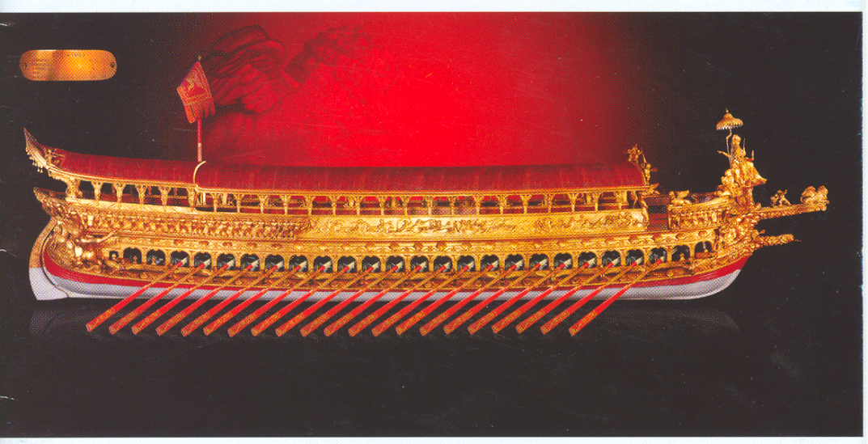

**Figure 1.** Bucintoro mock-up model, 1:10 scale, Venice Naval Historical Museum (1830)

First of all, the traditional workmanship, referred to arts and crafts of Venetianskilled workers, such as shipwrights, carpenters, caulkers, carvers and gilders, will be updated and re-proposed together with application of modern and innovative naval engineering and shipbuilding techniques.

Secondly, but with same relevance, there will be the possibility to improve the cultural museum performances~~,~~ with the opportunity to give a great contribution to the re-use of the spaces of the ancient Venetian Arsenale, by inviting people toward tomorrow on the wings of a fashioning but still solid and valid creative sample symbol, such as the new proposal of this Bucintoro vessel.

Finally, but not without the necessary importance, there could be opportunities to create new working activities with added value inside.

The starting point of this challenge remains within the results of devoted studies, confirming the philological re-building of a new vessel, not only by respecting the latest XVIII century Bucintoro configuration of the Ancient Venetian Republic, but allowing it also to sail in restricted waters such as inside the lagoon of Venice, thanks to devoted navigating, safety and sanitary systems duly placed onboard.

To understand the main characteristics of the vessel in terms of dimensions and general configuration, dedicated philological studies were first of all carried out, mainly referred to the content of the book written in 1729 by Antonio Maria Luchini, and to the mock-up model scaled 1:10 built in 1830 and to-day placed at Venice Naval Historical Museum in order (Fig. 1).

A specific wide engineering design was consequently developed in terms of hull-form, weight list finalization and hydrostatics calculations; relevant scantling drawings, referred to midship section and longitudinal section. Thicknesses of structural wood components such as keel, stem, stern, rib framework, hull and decks planking have been approved by the Italian Register RINA in April 2004 and can be considered the first step to allow the new Bucintoro a safe navigation.

Devoted applications have been also developed to find out the best solution for the rowing apparatus making also reference to the historical study concerning oar mechanics and oar power in Medieval and Later Galleys [3]. In particular, it was confirmed the practically same interval distance between benches, equal to 1.218 m for the Bucintoro solution.

Moreover, it was possible to compare the potential speed to be reached, coming from ergonomic referenced studies for galley vessels with comparable wetted surface in the range of 250 m2; evidencing for a scaloccio type rowing the capability of the rowers to sustain 21 strokes per minute in one hour, each rower developing an average power equal to 183 watt; so that a mean speed equal to 4.5 knots with zero wind and clean hull conditions could be guaranteed on the basis of a power transmission coefficient of 21% to be assumed, taking into consideration the blade-fluid 3D interaction in terms of length of blade into water, angular velocity of the oar, hydrodynamic friction and viscous resistances.

The applied case study to our Bucintoro vessel with the presence of 168 rowers, gives a total potential developed power of 30.744 watts, an effective power equal to 6.456 watts; confirming a referenced guaranteed mean speed of 4.5 knots in one hour period.

## Plant and Services Systems on board New Bucintoro

A green environmental friendly type Energy Generating System with photovoltaic technology and battery accumulation has been conceived in order to feed on board plants and services and consequently to reach approval for safe and comfort passenger transport at sea, namely:

* light and Power distribution;
* fire fighting and bilge water systems;
* station keeping and navigating safety systems;
* air conditioning and ventilating;
* sanitary services;
* safety systems;
* central Control Station.

## New Bucintoro Main Characteristics

The main characteristics of Bucintoro are listed in Table 1. Figure 2 shows the structure and arrangement of the midship section, already approved by RINA.

# Resistance and Propulsion analysis

An estimation of the resistance and propulsion characteristics has been executed on the previously described hull-form at the design draught condition. Because of the initial design stage, a statistical assessment of the total resistance has been considered together with a preliminary estimation of propulsive coefficients. Since the intention is to fit two propulsive pods on the hull bottom, particular attention was paid to the modelling of these non-conventional propulsors. Adopting a B-Series propeller as starting point for powering performance prediction, at each stage of the propeller selection procedure the open-water diagrams are to be corrected to reproduce the effect of the housing on the propeller curve in terms of thrust and torque.

Because the hull geometry did not allow installation of pods in conventional positions and consequently propellers could not act in conventional flow regimes as for traditional vessels; standard statistical values cannot be used for propulsive coefficients estimation. Considering the hull geometry and speeds of interest, it is reasonable to



**Figure 2.** *Scantling Drawings: Midship Section approved by RINA*

**Table 1.** Main particulars of Bucintoro

|  |  |  |  |
| --- | --- | --- | --- |
| Length at water line  (100 Venetian feet) | 34.80 m | Length of authorities saloon | 22.62 m |
| Breadth at “la bocca” 1st deck | 7.32 m | Length of the pergola by stern | 2.09 m |
| Breadth at fully loaded water line | 6.95 m | Length of the “tiemo” by stern | 8.53 m |
| Draught fully loaded from base line | 1.10 m | Length of 9 arcs below the “tiemo” | 2.44 m |
| Midship coeff. *CM* | 0.78 | “Campo corba”- frame space | 0.41 m |
| Block coeff. *CB* | 0.65 | Length of main rostrum | 4.70 m |
| Prismatic coeff. *CP* | 0.84 | Length of each oar (21 each side) | 10.44 m |
| Water line coeff. *CWP* | 0.88 | Rowers | 168 |
| Depth to 1st deck (rowers) | 1.65 m | Other crew members | 40 |
| Depth to 2nd deck (authorities) | 3.90 m | Passengers | 201 |
| Length of “palmetta” by stem | 4.26 m | Total deadweight | 35,72 t |

suppose that propulsors will not operate inside the vessel wake, but in conditions more close to the open-water one. For thrust deduction, the same consideration holds, leading to *t* values more similar to the ones typical for offshore vessels during station-keeping operations, that is, in the range 0.15-0.20. Based on these considerations, even though propellers are installed in an asymmetrical configuration, one on the bow and one on the stern, as first assumption it is reasonable to suppose that the propulsive coefficients can be considered equal for both propellers in order to simplify the calculation procedure. In any case, it is authors’ opinion that the inflow will not change too much for the speeds of interests. As mentioned above, the intention is to install two electric pods with a nominal power of 15 kW each, resulting in a propulsive power around 28.5 kW. Because on this kind of small pods a diameter *D* of no more than 0.40 m can be installed: this parameter was set as a constraint in the propeller selection procedure.

As a result, the 3-bladed propeller ensuring the best efficiency for this kind of configuration is the one having the following characteristics: *AE/A0* = 0.476, *P/D* = 0.686. With two pods mounting the above mentioned propellers, a maximum speed of 4.94 knots is expected in unrestricted waters with the propellers rotating at 1266.4 rpm and absorbing a total propulsive power of 28.5 kW without presence of wind and waves.

With this kind of restrictions, the resulting quasi-propulsive efficiency results really low, with an average value of about 0.30 through the whole speed range of interest. Figure 3 shows the resulting absorbed power and revolution curves, highlighting the rapidly increase of the shaft power *PS* above 6 knots, fact due also to the possible inception of cavitation, especially above 7 knots. In any case, the installed power will not grant to reach such kind of conditions, ensuring some safety to cavitation occurrence. Also by executing bollard pull estimation by applying all the propulsive power available, the propellers would work without any cavitation problem, being able to deliver a nominal thrust of about 5.1 kN at zero speed. All these considerations are essential to evaluate crabbing performances in a more accurate way. It should be noted that the vessel will also operate in shallow water; however, considering the low speed and the mean depth of the ‘Bacino San Marco’ and ‘Canal Grande’, the achievable maximum depth Froude number *Fnh* would be around 0.32, thereby far away from the critical speed flow, leading to a not significant increase of the total resistance.

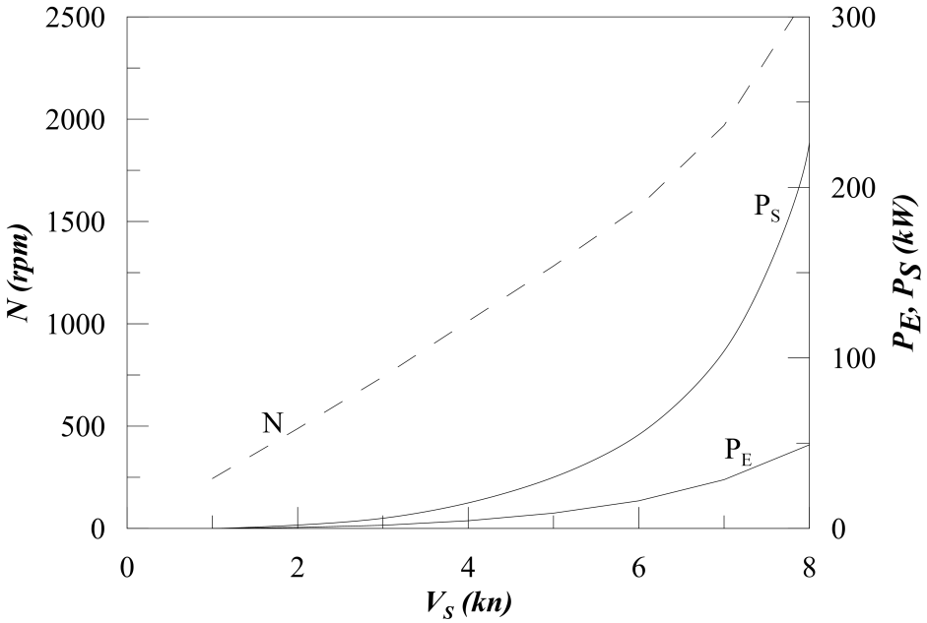

**Figure 3.** Power and propeller revolutions curves of the Bucintoro

# Crabbing Capability

With the propulsive system considered for the propulsion analysis, a crabbing capability study has been performed adopting a quasi-steady approach. Considering to work in a protected environment, no effect of waves has been considered, evaluating only current and wind as main environmental loads acting on the hull.

The algorithm adopted for the allocation strategy has been derived from self-developed dynamic positioning programs, solving the over-dimensioned equation systems needed for the equilibrium equations by means of a non-linear optimisation algorithm [4]. The crabbing motion has been considered as the effect of an extra current acting in transversal direction at each wind encounter angle.

To evaluate the environmental loads, use has been made of non-dimensional coefficients for wind and current. To this end, in absence of more detailed data, use has been made of wind coefficients obtained from statistics [5] of vessels having uniform superstructures and normalized according to the following formulations:

 (1)

 (2)

 (3)

where *AT* and *AL* are the transversal and lateral projection of the wind exposed areas, *ρair* is the density of the air and *α* is the wind encounter angle.

In the specific case of the current, use has been made of conventional sinusoidal and co-sinusoidal loads, evaluating the maximum values according to class indications [6]. The coefficients have been determined in the following way:

 (4)

 (5)

 (6)

where *L* is the length between perpendiculars and *T* is the design draught.

From the analysis executed considering the current acting from starboard (the opposite situation will generate somewhat symmetrical results and for space necessity

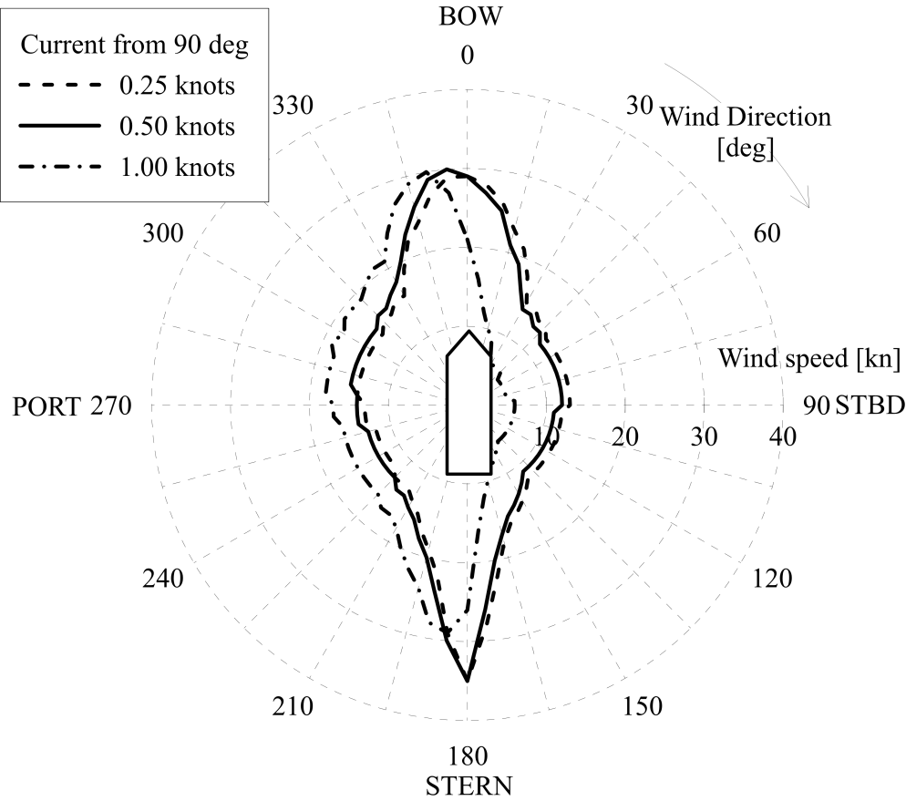

**Figure 4.** Crabbing capabilities at different speeds for the Bucintoro

is not here reported) it results that the vessel will be able to perform crabbing operation up to a relative transversal speed of 1.0 knots in presence of an incoming wind (Fig. 4). Once the relative velocity is higher, then the total forces are too high to perform a pure lateral translation. However, the possibility to perform manoeuvres with a constant wind up to 10-12 knots in the worst encounter condition, can be retained satisfactory for the vessel duties.

# Stability Assessment

The stability of the Bucintoro at the full-load condition has been checked on the basis of RINA rules for Inland Waterway Vessels [7, 8] applying the intact and damage stability criteria for a passenger ship having length greater than 24 m using an in-house built stability code [9]. The effect of oars on stability was neglected (they provide an additional positive effect on stability, thus the assumption is conservative).

The overview of the results obtained for intact stability assessment are provided in Table 2. As was predictable for a 250-years aged ship, the current requirements are not completely satisfied. In particular, the Bucintoro is not compliant with the requirements related to the area under righting arm curve (*GZ*) and its maximum value. The main cause is the low angle to vanish stability *φf*, which has a very low value (20.8 deg) due to the reduced freeboard of the vessel (approximately half a meter). This layout is imposed by the position of oars, which define the position of the rowing deck. Thus, the hull model for stability calculation is limited to such a deck, which is equipped with scuppers.

The area under *GZ* could be increased using one-way scuppers and considering that downflooding occurs at submersion of oarlocks (positioned 0.75 m above the rowing deck). With this arrangement, the downflooding angle is 21.3 deg, which is still insufficient to fulfill GZ area requirements.

Nevertheless, it is worth noticing that the ship fulfills all the requirements connected to the heeling moments associated to crowding, wind, and turning, as well as the requirements for initial stability (the vessel has a *GM* of 0.959 m).

The RINA rules impose for passenger ships a one-compartment deterministic damage stability assessment. The Bucintoro was subdivided into seven compartments under the row deck (assumed as bulkhead deck). Considering that the hull is almost longitudinally and transversally symmetric up to the bulkhead deck, the bulkheads are placed in position longitudinally symmetric. The position of the collision bulkhead is imposed by the rule requirements, whereas the others were placed considering the minimum distance to be considered effective and the compliance for functional requirements of the compartments. The permeabilities were assumed as the maximum allowed by the rules due to the compartment content.

For each damage case, considering lost one compartment, the vessel remains afloat, but again the current rules are not completely fulfilled. Figure 5 shows the *GZ* curves for each damage case at the final stage of flooding compared with intact condition. The criteria concerning maximum equilibrium angle, submersion of unprotected openings and minimum value of *GZMAX* where satisfied for each damage case for all the stages of flooding (25%, 50%, 75%, and 100% of floodwater inside damage compartment).

To evaluate the equilibrium angle at the final stage of flooding, the rules prescribe application of the heeling moment due to passengers crowding; the vessel demonstrates the capability of withstand such a moment, but the bulkhead deck was submerged implying the non-compliance with residual freeboard criterion for final stage of flooding

**Table 2.** Summary of intact stability criteria at full-load condition

|  |  |  |  |
| --- | --- | --- | --- |
| ***Criterion*** | ***Value*** | ***Threshold*** | ***Status*** |
| Area under *GZ* from 0 to 30 deg | 0.034 m rad | 0.055 m rad | FAILED |
| Area under *GZ* from 0 to 40 deg | 0.034 m rad | 0.090 m rad | FAILED |
| Area under *GZ* from 30 to 40 deg | 0.000 m rad | 0.030 m rad | FAILED |
| Minimum *GZ* value at 30 deg | -0.263 m | 0.200 m | FAILED |
| Area under *GZ* from 0 deg to angle at maximum *GZ* | 0.018 m rad | 0.073 m rad | FAILED |
| Angle at maximum *GZ* | 11.6 deg | 15.0 deg | FAILED |
| Minimum *GM* | 0.959 m | 0.150 m | OK |
| Equilibrium angle due to passenger crowding | 4.0 deg | 12 deg | OK |
| Equilibrium angle under wind | 3.2 deg | 12 deg | OK |
| Equilibrium angle due to turning | 1.7 deg | 12 deg | OK |
| Residual freeboard under all heeling moments | -0.137 m | 0.200 m | FAILED |

of compartments 3, 4, 5. In the same scenarios, the area under the *GZ* at the final stage of flooding was non-compliant with rules for the same reason.

Since the Bucintoro is an historical ship and turned out to be non-compliant with current stability criteria, older criteria were applied. The vessel respects the prescriptions of the SOLAS ’60 [10] for all the damage scenarios for both intermediate and final stages. The *GM* was always greater than 0.05 m and the margin line was always emerged. Furthermore,even applying the heeling moment due to crowding, the heel angle was always less than 7 deg. Thus, the safety related to older criteria is satisfactory.

As stated before, the Bucintoro is an historical vessel, designed to reproduce exactly the original 1729 vessel with the same layout and materials. Furthermore, the shape of *GZ* curve is influenced by the non-conventional hull form and arrangements,



**Figure 5.** Righting arm curves in intact condition and at final stage of flooding for all damage cases, compared with passenger crowding heeling lever.

which are substantially different from the current ships for inland navigation. The vessel shape cannot be changed in order to preserve the original appearance, while assuring the functional requirements; e.g. the arrangements for the oars. Therefore, because of these peculiarities a special class taking care of these peculiarities should be applied to this type of historical vessels. Provided that they are able to withstand the heeling moments required to assure safety of passengers, the criteria concerning the shape of *GZ* and deck submersion should be derogated. This lack could be eventually compensated by additional requirements concerning lifesaving appliances and/or special safety training for the crew in order to properly manage any casualty.

# Conclusion

The above mentioned activities prove the excellence of work performed so far to reach the safe engineering analysis and construction performance under the rules of RINA.

Complete cost coverage to match the goal for this special project has also been developed referred to a specific ad–hoc construction plan with contents similar to the industrial planning activities of the Gantt type.

Devoted studies have also been successfully developed in order to support the proposal with finalized project financing references and break-even point, mainly referred to income from museum activities during and after vessel construction and promotion of the relevant trade-mark brand registered under the European Union schemes in 2009. The presence of the Bucintoro of the Third Millennium within the premises of a devoted museum could be a further driver to attract visitors towards the Arsenale in the framework of a new promoting plan vision of returning the whole Arsenale area to the city of Venice.

References

1. Ruskin J. *The Stones of Venice*. Smith, Elder & Co. London, 1851
2. Lane FC. *Venice, a Maritime Republic*. Jhon Hopkins University Press, Baltimore, 1973
3. Bondioli M, Burlet R, Zysberg A. Oar mechanics and Oar power in Medieval and Later Galleys, in: *The age of the galley: Mediterranean oared vessels since pre-classical times*. Conway Maritime Press, London, 1995.
4. Mauro F, Nabergoj R. Advantages and disadvantages of thruster allocation procedures in Preliminary Dynamic Positioning predictions. *Ocean Engineering* 122, pp.96-102, 2016
5. Blendermann W. Wind Loads on Moored and Manoeuvring Vessels. *Proceedings 12th International Conference on O!shore Mechanics and Arctic Engineering (OMAE)*. New York, 1993
6. IMO. *MSC/Circ.645 Guidelines for vessels with dynamic positioning system*. International Maritime Organization, London, 1994.
7. RINA. Pt B, Ch 6, Sec 2, Intact Stability, in: *Rules for the Classification of Inland Waterway Ships and for Conformity to Directive 2006/87/EC*. Registro Navale Italiano, Genova, 2018.
8. RINA. Pt F, Ch 4, Sec 1, Damage Stability for Passenger Ships, in: *Rules for the Classification of Inland Waterway Ships and for Conformity to Directive 2006/87/EC*. Registro Navale Italiano, Genova, 2018.
9. Braidotti L, Trincas G, Bucci V. Analysis of the Influence of Pressure Field on Accuracy for Onboard Stability Codes. *Proceedings of the 19th International Conference on Ships and Maritime Research NAV 2018*; Trieste, 2018.
10. IMO. Ch II, Pt B, Subdivision and Stability, in: *International Convention for the Safety of Life at Sea – SOLAS ’60*. International Maritime Organization, London, 1960.

1. Corresponding Author, Luca Braidotti, Department of Engineering and Architecture, Via Alfonso Valerio 6/1, 34127 Trieste, Italy; E-mail: lbraidotti@units.it.