LESS: a new simulation environment  
for the preliminary design of cruise ship energy systems

Bruno BISELLO[1]a, Dario CANGELOSI b, Michele CAPOBIANCOa,  
Diego MICHELIc , Paolo PINAMONTIc, Giuseppe STRANIERIb,  
Rodolfo TACCANIc and Federico USTOLINc.

a Tempestive s.r.l., via Roveredo 20b, 33170, Pordenone, Italy

bCetena s.p.a., via Ippolito d’Aste 5, 16121, Genova, Italy

*cUniversità degli Studi di Trieste, Dipartimento di Ingegneria e Architettura,  
V. Valerio 8, 34127, Trieste, Italy*

**Abstract.** The number of cruise ships sailing is growing constantly worldwide, driven by a continuously increasing number of passengers. Higher attention to this ship segment runs together with more complex energy systems installed on board due to the needs of improving energy efficiency and reducing operational costs. For these reasons, ship Owners and Shipyards are involved in the design of power plants and energy management systems that ensure lower fuel consumption and compliance with increasingly stringent IMO regulatory requirements on emissions. To respond to these needs, we hereby introduce LESS (Low Energy Ship deSign tool), a simulation environment developed to support the designers to choose among different propulsion/hotel plants solutions since the early stage of the ship design. The software allows analyzing the energy performance of different plant layouts and system components and eases the integration of energy recovery solutions. In particular, the library of components includes heat recovery packages such as Organic Rankine Cycles (ORC) systems to reduce “non propulsive” power demand.

**Keywords.** Energy recovery, Cruise ships, Emissions, Efficiency

# Introduction

The cruise ship industry, in recent years, has begun to worry about the environmental impact. Cruise ships generally use Heavy Fuel Oil (HFO), which is a low-cost fuel with a particularly high viscosity and density [1]. Since 1960s HFO has been by far the most used fuel, and it has been one of the reasons for the robust growth of international maritime trade. But, besides of being a low-cost fuel, HFO is also a low-quality fuel, and it has raised concerns over its environmental impact and its contribution to anthropogenic climate change caused by the greenhouse gases emitted by the burning of HFOs to power shipping. In particular, HFO contains high levels of asphalt, carbon residues, sulfur and metallic compounds. Its high sulfur content (up to 4.5%) leads to particularly high sulfur oxide (SOx) emissions thus contributing in a significant manner to the global emissions of sulfur dioxide (SO2).

In the 1970s the International Maritime Organization (IMO) issued MARPOL 73/78 in order to minimize pollution of the oceans and seas, including dumping, oil and air pollution.

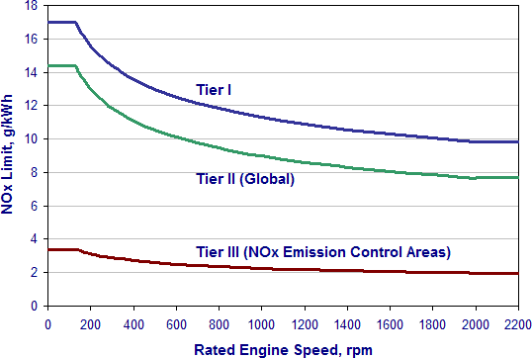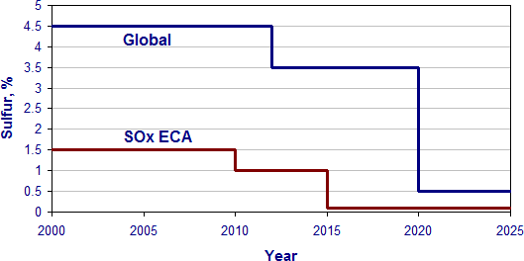

**Figure 1.** MARPOL NOx and SOx’s threshold limits value [2].

In addition to the limits on the NOx and SOx emissions (Figure 1), IMO introduced the Energy Efficiency Design Index (EEDI), which is used to calculate the vessel’s energy efficiency. This is based on a formula, taking the ship’s emissions (CO2), capacity, and speed into account [3]. The lower a ship’s EEDI, the more energy-efficient it is and the lower its negative impact on the environment. IMO regulations stipulate that all new ships, over 400 gross tonnage, must meet a minimum energy efficiency requirement, so their EEDI must not exceed a given threshold, as it is shown in Figure 2. This value, in effect from 2015, is tightened incrementally over a period of 5 years, and it is expected to stimulate continued innovation and technical development of all the components influencing the fuel efficiency of a ship from its design phase. If implemented according to the time schedule, forecasts say that up to 263 million tons of CO2 will be reduced annually by 2030 [4].

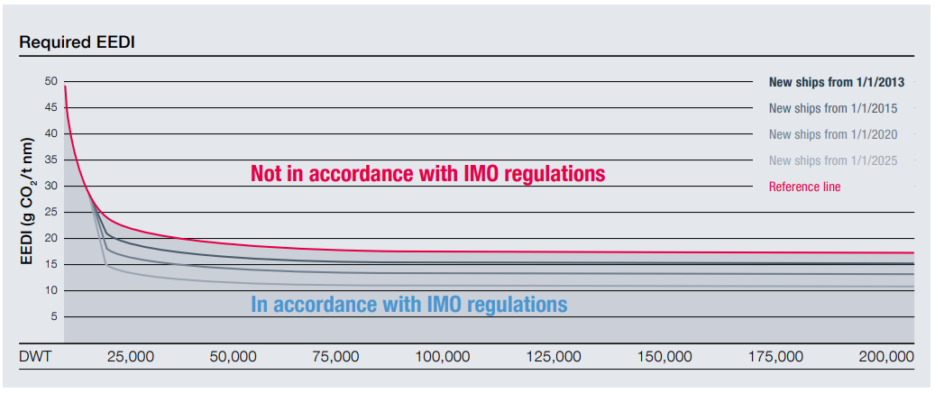

**Figure 2.** Evolution of the EEDI depending on the new vessel’s capacity [5].

The Ship Energy Efficiency Management Plan (SEEMP) establishes a mechanism for operators to improve ship energy by monitoring the performance of a vessel over a certain period. This mandatory mechanism enforces to improve the operational conditions of the ship and it implements more energy efficient technologies for the shipping industry. That includes several necessary steps (i.e. planning, implementation, monitoring, self- evaluation and improvements) and urges the ship owner and operator at each stage of the plan to consider innovative technologies and practices when seeking to optimize the performance of a ship [6].

In order to meet the above-mentioned requirements, ship-owners have to adopt new strategies and solutions.

# Emissions reduction strategies

## SOx abatement systems

There are mainly three ways to satisfy the SOx limits of ECA regulations [7].

The first alternative, currently considered the best medium-term solution [8], is to install exhaust gas cleaning systems called scrubbers. They absorb most of the sulfur content from the exhaust before it is released into the atmosphere, allowing cruise ships to keep using HFO in the ECAs. However, there is to say that the capital costs of the scrubber installation are considerable [9].

The second method, the simplest one, is to improve fuel quality using a low-sulfur fuel, for example MGO (Marine Gas Oil) or LNG (Liquefied Natural Gas) [10], respectively considered the best short-term and long-term solutions [8]. Although it is the easiest method, the fuel-switching approach could be very expensive. Indeed, MGO is much more expensive than HFO, which means that the variable costs of the vessel would increase. As for the scrubber, the LNG option can avoid the consumption of expensive MGO in exchange for a substantial initial capital investment. Furthermore, the LNG approach also suffers from other problems, concerning safety as well as large space requirements and lack of infrastructures [11].

The last option is to use HFO outside ECA zones and a cleaner fuel with lower sulfur content, for example MGO, inside ECAs [12]. This approach requires only minor changes on the ship and therefore very limited initial investments [9].

## NOx abatement systems

Compliance with NOx limits cannot be achieved exclusively controlling fuel composition and combustion phenomena but requires after treatment techniques to be in place. Various NOx after treatment techniques are currently applied on marine and stationary diesel engines and many others are currently being studied [13]. The most frequently used is Selective Catalytic Reactor (SCR) system, which is capable of massive NOx reduction. In the SCR, a gaseous reductant, typically ammonia or urea, is added to the exhaust gases with the aid of a catalyst. The reductant has a strong tendency to absorb oxygen, thus limiting the formation of NOx inside the exhaust gas, forming H2O and N2.

Another method that is increasingly being used is the Exhaust Gas Recirculation (EGR), which works by recirculating a portion of an engine's exhaust gas back to the engine cylinders. Recently, EGR applications for large marine Diesel engines have reached NOx reduction potential up to 90% [14].

## EEDI-SEEMP: methods to increase efficiency

In order to respect EEDI and SEEMP, ship owners must find ways to increase the energy efficiency and reduce the CO2 emission from the ship power plants. Many fuel saving solutions for shipping have been subject of research and development. Among them, operational measures, including improvements in engine monitoring [15] or weather routing [16], in addition to waste heat recovery (WHR) [17], globally considered the most effective one [18].

In Figure 3, two typical heat balances for a low speed 2-stroke engine and a 1.2 MW 4-stroke genset, at full load conditions, are shown.

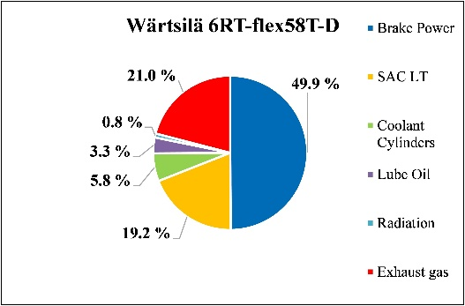 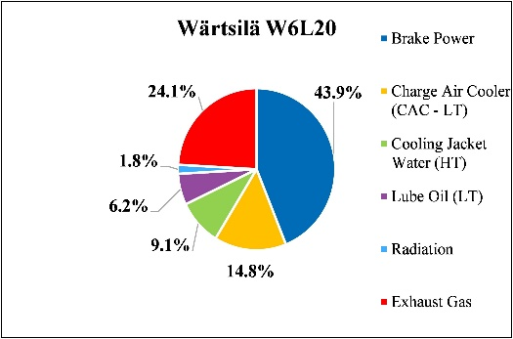

(a) (b)

**Figure 3.** Typical heat balances for a 2-stroke low speed (a) and a 4-stroke medium speed (b) marine diesel engines [19]

As it can be observed, MW size 2-stroke engines for ship propulsion can reach a brake thermal efficiency close to 50%, while 4-stroke units are typically in the range between 40 to 50%. For all these types of engines, due to the high gas flow rates involved in the thermodynamic processes, a high potential for waste heat recovery can be expected, considering heat sources such as exhaust gas, EGR (Exhaust Gas Recirculation), Charge Air Cooling (CAC, 4-stroke), Scavenge Air Cooling (SAC, 2-stroke), cooling jacket water and lubrication oil. In particular, a higher potential regarding exhaust gas heat recovery is expected for 4-stroke units, due to the higher temperature of the exhaust gas after the turbine.

Some data for 2-stroke and 4-stroke engines typical possible heat sources and heat sinks are reported in Table 1.

**Table 1.** Typical heat source and sink data for 4-stroke and 2-stroke marine diesel engines [19]

|  |  |  |
| --- | --- | --- |
| **Heat Source / Sink** | **4-Stroke** | **2-Stroke** |
|  | Temperature, °C | |
| Exhaust Gas Temperature | 300-500 | 250-300 |
| Cooling Water Jacket Temp. | 80-90 | 80-90 |
| Scavenge Air Cooler Cool. Circuir Temp (LT) | / | 25-36 |
| CAC Cooling Circuit Temperature (LT) | 40-65 | / |
| Lube Oil Circuit | 65-80 | 60-75 |
| Sea Water | Up to 30-40 | |
| Engine Room Air | Up to 40-45 | |

However, the large amount of gas mass flows available in 2-stroke engines could also lead to possible advantages when considering heat recovery systems [20].

Usually, part of the energy dissipated by the engines is already recovered onboard for different auxiliary demands, such as, for example, fresh water generation or kitchen and laundry services, but never in the most efficient way and never in its entirety [21]. In particular, energy surplus could be exploited for the conversion of waste heat to electric power using different technologies, which have been widely studied in the scientific community, despite the relative scarcity of industrial applications in shipping [22]. This solution translates into the adoption of an additional thermal cycle, bottoming the main engines, such as Kalina, Stirling, Brayton, Rankine, or Organic Rankine Cycle (ORC), which seems to be the most promising one, because of the lower evaporation temperature of the organic working fluids [7][23].

# Development of a new simulation platform

With such a complex design and operational scenario, the necessity of having a tool capable of helping the ship owners in choosing from different plant layouts, recovery systems and emission abatement systems emerges. In fact, it is not enough to design the single plants separately, but it is necessary to consider the energy system as a whole, thinking from the beginning how the plants would interact with each other in order to optimize the available energy onboard and reduce the emissions. Overall, a holistic approach to manage energy flows in modern ships is becoming an absolute necessity.

Currently, the only commercial product available on the market, able to manage it, seems to be COSSMOS [24]. COSSMOS (COmplex Ship Systems MOdelling and Simulation) is a computer platform, developed by DNV GL that enables the detailed dynamic analysis and optimization of the design, operation and control of a variety of ship machinery systems at the integrated systems’ level.

LESS (Low Energy Ship deSign tool) is a newly developed simulation platform that allow to quickly assess ship energy performances focusing on the ship operational conditions, optimizing energy efficiency and reducing emissions through cogeneration and recovery plants since the early stages of the design process. LESS is organized as a “simulation environment” to determine energy balances and material fluxes between the system components for given operational conditions and gives the user (the designer or a group of designers) the possibility to organize his design activity in a flexible manner.

The simulation environment works around the following fundamental elements:

* **the plant components**, which represent the fundamental objects and, in a simplified manner, the physical components of the energy plant.
* **the plant configurations**, which represent the energy system in both a graphical and functional manner, connecting the system components by mean of “pipes” transferring Low Temperature Water (LTW), High Temperature Water (HTW), Steam, Fuel, Fresh Water (FW) and electric cables.
* **the operational scenarios**, which are a collection of operational conditions for the ship and define the electrical request, divided into propulsive and non-propulsive demands, and thermal requests of the ship;
* **the simulation scenarios**, which are determined by a collection of plant configurations and operational scenarios. Performance are evaluated and assessed for each plant configurations and for each possible operational scenarios.

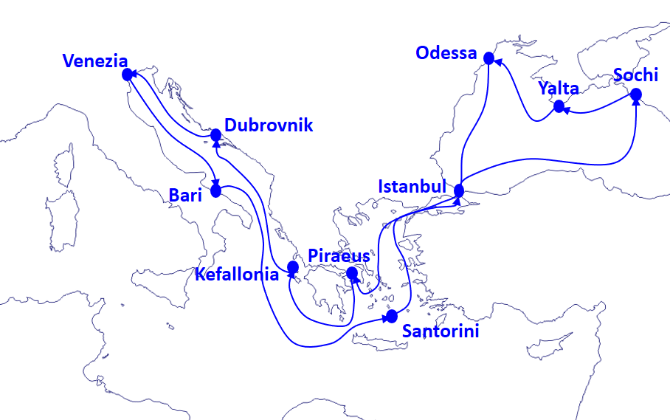

**Figure 4.** A typical cruise plan for Mediterranean and Black Sea.

To describe the cruise plan of Figure 4, an operational scenario composed by at least 11 navigating operational conditions (without considering possible the changes due to intermediate waypoints) and by 10 port operational conditions. A typical operational condition is at minimum describing:

* the cruise speed and the corresponding propulsive power request;
* the non-propulsive power request that might be further detailed according to specific uses where necessary.

The Software allows to set up the plant layout by choosing from different power generators, recovery plants and emission abatement systems, as briefly listed in Table 2.

**Table 2.** “Generic components” implemented in the LESS simulation environment

|  |  |  |
| --- | --- | --- |
| **Power generators** | **Recovery plants** | **Emissions abatement systems** |
| Diesel Engines | Steam Turbines | SCR |
| Gas Turbines | ORC | Scrubber |
| (Engine Rooms) | Exhaust Gas Boilers (EGB) |  |
|  | Absorption chiller units |  |
|  | Fresh Water Generators |  |
|  | Steam and hot water generic users |  |

Each component is characterized by:

* one or more input fluxes and one or more output fluxes;
* a set of “observed variables”, a set of “control inputs”, and a set of “calibration parameters”;
* a description of its behavior.

The flux lines connecting the components typically are the cooling water circuit (LTW and HTW circuits) and the steam circuit. A simplified plant/scheme illustrating the logic of LESS is shown in Figure 5, where one generator is connected to one generic user and, at same time, an ORC system recovers part of the required energy.



**Figure 5.** Simplified scheme of mass and energy flows

The “Engine Rooms”, as a first example of “macro components” or “sub plants”, typically include two or more Diesel Generators and provides at least one steam line and at least one HTW Line. In the initial implementation, the power request is equally distributed between all the Diesel Generators. In a future implementation more complex energy demand distribution logic shall be implemented, taking into account efficiency curves for each generator as well as the exact operational conditions.

The behavior of the components can be characterized in the following manner:

* by a mathematical formulation, describing the relationships between its input, output, and control variables;
* by a set of data, that might be interpolated to define a relationship between variables;
* by a link to an external code or an external model, that can be used to describe the most complex behavior.

The behavior of the plant components can be “tracked” using the “observed variables”, which basically describe the possible introduction of “sensors” in the plant. In addition, by acting on the control inputs it is possible to modify the behavior of the components and, by acting on “constraints” it is possible to fix the values of specific variables (e.g. temperatures, fluxes, power) describing in this way the possible role of control systems acting on the plant. It is worth nothing that no dynamic behavior is considered for such control systems. Power and recovery plants can be simulated by referring to commercial systems, making immediate the layout solution analyzed. Nevertheless, it is also possible to choose custom plants in order to study innovative and optimized layout.

The core of the LESS environment is the “solver” that actually collects all the equations/formulations for all the components and aggregates all the state variables of all the components. The role of the solver is that of identifying the “working conditions” of the plant for each operational conditions in a given operational scenario. In practice a system of non linear equations is solved to identify a set of state variable that satisfies all equations/formulations for all the components.

When components for energy recovery are introduced, the solver identifies the corresponding changes in the working conditions, i.e. a shift in the values of the state variables. In general terms such shift corresponds primarily to a reduction of the “non propulsive” power demand (Figure 5).

The resulting sets of “working conditions” for each simulation scenarios constitute the basic information to implement the “performance indicators” (in terms of energy demand, capital expenditure, operational expenditure, emissions) and support the decisions about the plant configurations.

# Conclusions and future development

To serve the needs of an increasing complex design and operational environment for the energy systems of a cruise ship, a simulation environment able to assess the energy performances of vessels in different operational scenarios has been developed. For given operational scenarios, such tool will help ship owners and shipyards to choose from different plant layouts, recovery systems and emission abatement systems, in order to guarantee lower fuel consumption and operational costs and compliance with increasingly stringent IMO regulatory requirements on emissions.

Future developments will include additional plant components such as, for example, fuel cells, additional functionalities, such as the integration with a geographical information system for route planning, and features, such as fully integrated cost analysis.

Acknowledgements

The work was partly supported by the European Regional Development Fund - Regional Operational Program of Regione Friuli Venezia Giulia, Objective «Investments to support Development and Employment» 2014-2020, Axis 1 – “Strenghten Research, Technological Development and Innovation”, Action 1.3 – “Support collaborative R&D activities to support the development of new sustainable technologies, new products and new services”.

References

1. International Convention for the Prevention of Pollution from Ships, 1973.
2. International Maritime Organization. RESOLUTION MEPC 2008; 176(58)
3. Lokukaluge P., Brage M., Emission control based energy efficiency measures in ship operations, *Applied Ocean Research* 60 (2016) 29–46
4. The International Council of Clean Transportation (icct), The Energy Efficiency Design Index (EEDI) for New Ships, (July 2011).
5. MAN Diesel & Turbo, EEDI - Energy Efficiency Design Index (<https://marine.mandieselturbo.com>, Accessed 14/03/2018)
6. IMO, 2012 Guidelines for the development of a Ship Energy Efficiency Management Plan (SEEMP), resolution MEPC.213 (63);
7. Lion, S., Michos, C. N., Vlaskos, I., Rouaud, C., & Taccani, R., A review of waste heat recovery and Organic Rankine Cycles (ORC) in on-off highway vehicle Heavy Duty Diesel Engine applications. *Renewable and Sustainable Energy Reviews*, *79* (2017), 691–708.
8. Lloyd’s Register. LNG-fuelled deep sea shipping: the outlook for LNG bunker and LNG-fuelled newbuild demand up to 2025, August 2012
9. Gu, Y., & Wallace, S. W. Scrubber: A potentially overestimated compliance method for the Emission Control Areas. The importance of involving a ship’s sailing pattern in the evaluation. *Transportation Research Part D*, *55* (2017), 51–66.
10. Burel, F., Taccani, R., & Zuliani, N., Improving sustainability of maritime transport through utilization of Liquefied Natural Gas (LNG) for propulsion. *Energy*, *57* (2013), 412–420.
11. Armellini, A., Daniotti, S., Pinamonti, P., & Reini, M. Eval. of gas turbines as alternative energy prod. systems for a large cruise ship to meet new maritime regulations. *Applied Energy*, *211* (2017), 306–317.
12. Zhen, L., Li, M. et al., The effects of emission control area regulations on cruise shipping. *Transportation Research Part D*, *62* (2018), 47–63.
13. Raptotasios, S. I., Sakellaridis, N. F., Papagiannakis, R. G., & Hountalas, D. T., Application of a multi-zone combustion model to investigate the NOx reduction potential of two-stroke marine diesel engines using EGR, *Applied Energy*, *157* (2015)., 814–823.
14. Petersen PD. MAN Diesel & Turbo Delivers World’s First IMO-Certified Two-Stroke Engine with Tier III NOx Control. MAN Global Corporate Website: Exhaust Gas Recirculation Systems; 2016.
15. A. Sala, F. de Carlo, G. Buglioni, A. Lucchetti, Energy performance evaluation of fishing vessels by fuel mass flow measuring system, *Ocean Eng.,* 38 (2011), 804-809
16. W. Shao, P. Zhou, S.K. Thong, Development of a novel forward dynamic programming method for weather routing, *J. Mar. Sci. Technol.,* 17 (2011), 239-251
17. DNV. Shipping 2020. Technical Report. Det Norske Veritas, Oslo, Norway, 2012.
18. Yang, M. Payback period investigation of the ORC with mixed working fluids to recover waste heat from the exhaust gas of a large marine diesel eng. *Energy Conversion and Management*, *162*(2018), 189–202.
19. Wärtsilä 20 Product Guide - Wärtsilä. 2013.
20. Lion, S., Vlaskos, I., Taccani, R., Preliminary thermodynamic analysis of waste heat recovery in marine diesel engines using Organic Rankine Cycles. *Proceedings of ECOS 2017, San Diego, California.* (2017).
21. Baldi, F., Larsen, U., & Gabrielii, C., Comparison of different procedures for the optimization of a combined Diesel engine and organic Rankine cycle system based on ship operational profile. *Ocean Engineering*, *110* (2015), 85–93.
22. Larsen, U., Sigthorsson, O., & Haglind, F., A comparison of advanced heat recovery power cycles in a combined cycle for large ships. Energy, 74 (2014), 260–268.
23. Michos, C. N., Lion, S., Vlaskos, I., & Taccani, R., Analysis of the backpressure effect of an Organic Rankine Cycle (ORC) evaporator on the exhaust line of a turbocharged heavy duty diesel power generator for marine applications. *Energy Conversion and Management*, *132* (2017), 347–360.
24. DNV GL – Maritime, COSSMOS. 2016. (<https://www.dnvgl.com/maritime/>, accessed 10/03/2018)

1. Corresponding Author: Bruno Bisello, Tempestive s.r.l., via Roveredo 20b, 33170, Pordenone, Italy; E-mail: bbisello@tempestive.com.