The Strip Planking: an Eco-Friendly Solution for the End-of-Life of Ships
Carlo NASSO^{a,}, Ubaldo la MONACAª, Alberto MARINÒª,
Serena BERTAGNAª and Vittorio BUCCIª
ª Department of Engineering and Architecture, University of Trieste
Abstract. In the last few years, the international and national attention to environmental sustainability has increased, even in shipbuilding. This aim can be achieved through various manners, for example by green propulsion (hybrid propulsion), by containment of spills and by studying the life cycle of vessels. About the last one, the problem of disposal of ships at the end of life is of high importance: due to new regulations about the treatment of hazardous materials, the disposal of plastic materials (as the FRP) is very complicated and expensive. For this reason, the use of wood in shipbuilding, especially for small vessels, is a valid and ecological alternative to FRP. Even though this solution implies higher construction costs, it has the advantage of reducing the risks of disposal of materials at the end-of-life cycle. The strip planking is a relatively modern process for the construction of wooden ships, which provides the vessels with mechanical characteristics comparable to those offered by ships built in FRP.
In this paper, the description of the construction process and the results obtained in a case study of a craft built through the strip planking technique has been analysed.
Keywords: Strip planking, Green shipbuilding, Environmental sustainability, Wooden vessels

Introduction
In recent years, the interest in environmental issues has been exponentially increasing; indeed, global warming and sustainability have become aspects of primary importance for the society. For this reason, companies and industries are called to demonstrate their environmental friendliness and recycle policy. Among the others, also shipbuilding is involved in the process of reducing the environmental impact and developing a “green methodology” for ship construction [1][2][3][4][5][6].
In particular, one of the issues of greatest concern regards the disposal of ships at the end of life. Currently, the most of small vessels is built in Fibre Reinforced Polymers (FRP); the main disadvantage of this type of material is represented by the impossibility of being recycled. Because of its composition [7][8][9], FRP disposal is to be done in accordance with specific procedures based on very complex and expensive methods. Indeed, the entire process is regulated by a specific rule framework dedicated to the treatment of hazardous materials [10][11].
Due to these reasons, the possibility of identifying new construction solutions for small vessels is of great interest. In particular, the use of wood in shipbuilding represents a valid and eco-friendly alternative to FRP. Despite the higher construction costs, wooden boats at the end of life can be easily recycled.
Among all the technologies applied for the construction of wooden vessels, the strip-planking technique represents one of the most advantageous method [12]. The main benefits offered are the great ease of the construction process, along with the possibility of exploiting the mechanical properties of the material at their best [13]. Cold-moulded and strip-planked wood boatbuilding allows to obtain vessels with a remarkable strength-to-weight ratio, high strength to fatigue and resilience.
In this paper, an overview of the current requirements and methodologies regarding the disposal of FRP ships at their end of life is provided, along with a brief survey of the possible hazardous effects that may occur. Besides, as an alternative to FRP boat construction, the strip-planking technology is presented. In order to validate its applicability and the advantages offered, the results obtained from a case study based on a 36-foot vessel built through the strip-planking technique have been analysed.

Fibre Reinforced Polymers disposal
Based on the data provided by MIT (Ministero delle Infrastrutture e dei Trasporti), in 2015 in Italy 102219 vessels have been registered in the maritime offices [10]. However, since the registration requirement only concerns the vessels with length of more than 10 metres, a large number of small boats is not included into such a database. In order to get a clearer estimate about the actual total number of vessels, it is necessary to check the number of berths along the Italian coasts: an evaluation provided in the MIT document has given a value equal to 157567. Of all these berths, 40% concerns boats with length less than 10 metres, 59.7% concerns vessels with length between 10 and 24 metres, whereas only 0.3% concerns ships with length exceeding 24 metres. About 90% of vessels with length less than 24 metres (i.e., about 141000 units) are built using FRP-based technologies for the hull construction. The management of this large amount of FRP will represent a problem when these ships at the end of life will have to be disposed.
The sentence of the Corte di Cassazione n. 807 of 6 July 2007 established that the ship is not a waste: in fact, exclusively the parts deriving from demolition and disposal operations have to be considered as waste. As for wastes, the disposal processes have to be carried out in accordance with the European directive 2008/98/CE [11]. The main innovation introduced by the Article 14 of this Regulation regards the disposal costs that no longer have to be borne by the owner of the vessel as previously, but become the responsability of the shipyard that built the vessel itself: "In accordance with the polluter-pays principle, the costs of waste management shall be borne by the original waste producer or previous waste holders."
The FRP treatment and disposal processes are very dangerous for health: dust of glass due to handling and cutting of FRP panels leads to respiratory problems and eye irritations. Moreover, the Fibre Reinforced Polymers are included among carcinogenic materials.
Currently, the main process to dispose the FRP is the pyrolysis, which consists of a thermal decomposition of the material. Through this method, two products are obtained: synthetic gas (briefly, syngas), generally reused for the production of electricity, and fixed residue (fibreglass), used for the construction of panels. Even if it is possible to recover and reuse these substances, such a process is not particularly advantageous. Indeed, the energy required to reach the temperatures (about 700 °C) for the pyrolysis is very high, and the health risk associated with such a process obliges operators to follow stringent safety procedures. Due to these reasons, the FRP disposal is very expensive: for instance, the process cost inherent a boat 15 metre long is about 16000 €.
Nowadays, the problem of FRP treatment can be solved in three ways:
- for existing units, by extending their end-of-life cycle through a refitting process, rather than a new construction;
- for units that have already reached the end of life, through the FRP disposal process, though such a solution is very expensive and harmful to health;
- for new units, especially for small ones, by the use of innovative building methods based on natural materials. Currently, the eco-friendly materials most used in the shipbuilding are wood, and fibres of linen or bamboo.

Strip planking technology
Due to the disposal difficulties offered by FRP, shipbuilding is in the quest of technologies that may provide better solutions in terms of environmental sustainability. Since there is a lack of convenient disposal or recycling processes capable to comply with the current requirements, often the solution adopted consists in using materials other than FRP.
Wood, despite being the first material to have been used in shipbuilding, represents still nowadays one of the most valid alternative available. Indeed, wood ensures important features such as a valuable strength-to-weight ratio, good fatigue strength and impact resistance, as well as great reparability and adaptability. On the other side, wooden constructions based on conventional methods require highly skilled boat builders, often hard to find, that result in high production costs.
However, among the unconventional techniques, the strip planking technology represents a very easy construction method that can be used also by personnel short of woodworking skills [12]. This method implies the use of glued-laminated wood, that is to say gluing together layers of thin wood planks. Essentially, the hull planking is given by stratifying a number of wood timber with different thickness, whose natural fibres are properly oriented; in some cases, other type of layers can be used too. In order to verify the properties of wood planks and to find a reliable base to allow the rational design of laminated-wood panels with different possible layers, several studies based on tests on various specimens have been carried out [13].
The construction technology implies to make a temporary pattern, consisting of a quite dense series of transversal frames, in order to reproduce the hull forms. These frames, along with the definitive longitudinal stiffeners, serve as support for the strip planks running longitudinally in bow-stern direction. In this manner the entire hull is modelled through the strip planks, which provide also the base for the subsequent layers of veneers. The wood strips are usually kept together by means of epoxy adhesive, but nails and staples can be used in order to force in position the planks, without the use of clamps. Generally, strip planks have a rectangular cross-section, but with the long edges moulded one concave and the other convex (i.e., "bead and cove" edges) in order to fit at the hull curvature. Regarding the length of the strips, ideally they should be long enough to run from stern to bow in a unique piece. Since such a condition hardly occurs, it is necessary to link various strips usually by scarf-joints. In a scarf-joint the ends are cut on a long bevel (slope about 1:7), lapped and glued together. On the external surface of the strip-planked layer, various layers of wood veneers (quite wide and very thin planks) are glued with the grain diagonally oriented at about ±45°, as long as a proper thickness of the hull planking is obtained.
Eventually, it is worth highlighting that the technology above described can be particularly advantageous also for one-off projects.

Case study
The strip planking technology has been applied to a vessel with the main dimensions as in Table 1.
Table 1. Main dimensions of the vessel considered as case study.
 | Length overall | 11.00 | m
 | Breadth | 2.80 | m
 | Draught | 0.65 | m
 | Maximum speed | 6.00 | kn
The case-study vessel is a passenger boat capable of carrying a total of 24 passengers. The unit has been designed to operate into the Grado Lagoon (Italy), in a protected environment where the neighbouring Nature must be respected. Also for this reason, a natural material as wood has been chosen as construction material.
The hull has been built through the strip planking technology. The configuration of the strip planking layers has been verified in according with the indications present in the "Rules for Classification and Construction Ship Technology" by the Germanischer Lloyd [16]. In this case, the stacking sequence is based on four layers: one of strip planks and three of veneers. This configuration respects the checks required; for each layer is verified:
σ_{k} ≤ σ_{zul} (1)
where σ_{k} is the stress in the individual layer, σ_{zul} is the ultimate stress given by:
σ_{zul} = 0.25 σ_{Rm} (2)
with σ_{Rm} the average breaking strength for tension/compression.
The first layer is composed by strips of fir douglas (density 550 kg/m³) with thickness equal to 15 mm, placed in bow-stern direction with the grain oriented at 0° (Figure 1). The strip planks are glued with each other by epoxy resin, and are further fixed to the hull frames with steel staples. The subsequent three layers are veneers of mahogany khaya (density 520 kg/m³) stacked with the grain at ±45° (Figure 2). Each veneer layer is 3 mm thick, so that the total planking thickness turns to be 24 mm.
The strip planks are supported by 25 frames drawn from 25-mm plywood panels of okoumè (density 440 kg/m³⁾, with a spacing equal to 450 mm. In particular, the frames have been obtained from large panels (15303100 mm) that have been cut by a numerical control machine, which ensures a remarkable cutting precision, as well as the possibility to obtain inclined edges according to the hull fairing.

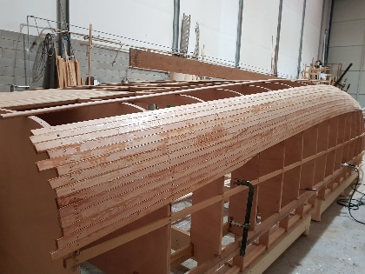
Figure 1. The first layer of strip planks in fir douglas
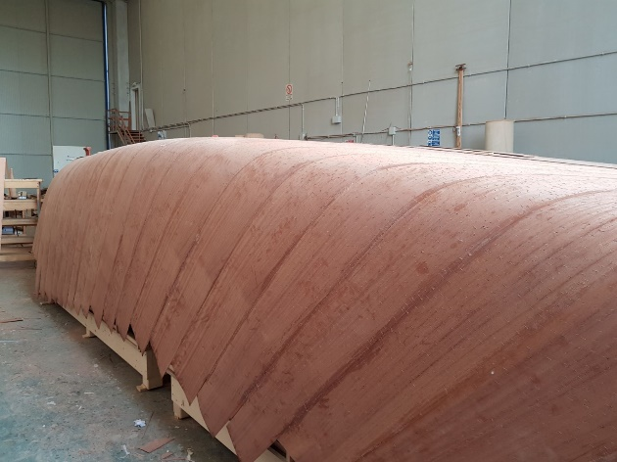
Figure 2. The veneer layers in mahogany khaya
Figure 3. A frame designed in 3D environment
In order to provide the necessary data for the numerical control cutting, it has been necessary to draw all the frames in 3D environment through a CAD software (Rhinoceros): for each frame, by Rhinoceros a solid has been generated, and then exported in a "step"-extension file.
The 3D design tool has offered the possibility to consider, since the first stages of the frame design, the presence of the longitudinal stiffeners of the hull: in fact, each frame has been drawn already considering the specific spaces for the insertion of such structural members. The wood essence used for such elements is iroko (density 650 kg/m³) [14][15]. In the bottom, one central girder along with two side girders made in iroko are present: the central girder has the purpose to guarantee the hooking (through the use of bolts) to the external keel, which has the function of skeg, too. In each side there four longitudinal stiffeners: the first one is located above the bilge, another at half side, and the last two on the top of the frame (inside and outside). The dimensions of these elements are also function of the curvature imposed by the hull shapes.
During the design and drawing phases of the frames, the presence of internal stringers has also been considered. Moreover, the supports for the two POD engines at stern and for the Diesel generator placed near the bow, have been considered. Finally, two longitudinal girders, one on the inner bottom and one on the internal side, have been inserted in order to guarantee a sound support for the seats.
In Figure 3 a generic frame is presented. The inner shape of the panel takes into account the spaces for the central corridor, the four supports for the seats and the two longitudinal stringers at the deck level, whereas on the outer edge, the spaces for the longitudinal stiffeners at sides, lateral and central girders at bottom are present. All the frames have been positioned with the bottom of the vessel upwards to facilitate the fitting up of the strip planks and veneers. In order to vertically align all the 25 frames, two small arms at the end of each frame have been foreseen, in such a way to be properly cut to the right height. In Figure 4 a 3D representation of the vessel with the bottom facing up, whereas in Figure 5 the various frames of the real construction .

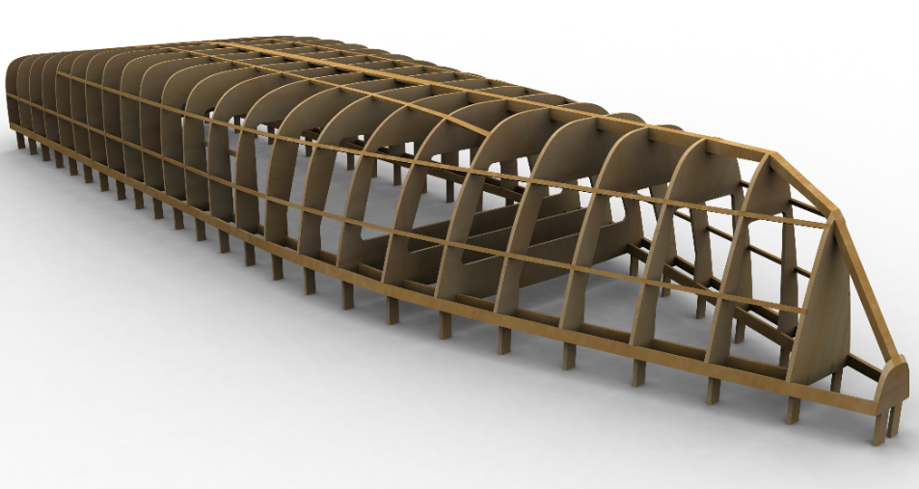
Figure 4. Representation of the frames of the vessel in 3D environment
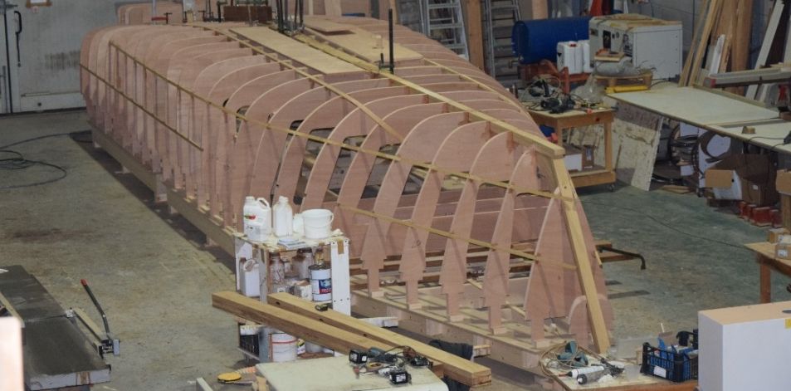
Figure 5. The real construction of the vessel

Conclusion
The project here presented has been aimed to highlight the possibility of using wood, as an alternative material to FRP, in the construction of vessels.
As derived from the analysis of the current rule framework and the disposal methodologies, the treatment of FRP boats at their end of life implies high costs and emissions of substances harmful for environment.
As opposed to FRP, the use of wood offers important advantages such as the greater environmental sustainability and the easier way of disposal of the material. Indeed, wooden vessels can be recycled: the most common recycling process is based on their transformation into chipboard to be used for manufacturing other objects.
The use of wood can be encouraged by the existence of construction technologies that do not necessarily require high skills in working this material. In this paper, the cold-moulding and strip planking techniques are proposed as simple and valuable technologies for the construction of small wooden vessels.

Acknowledgments
This work was supported by “ZELAG – Zero Emission navigation Laguna di Grado” research program, funded by the Regione Autonoma Friuli-Venezia-Giulia with POR-FESR 2014-2020, asse 1.3b.

References
- M. C. J. Caniëls, E. Cleophas and J. Semeijn, Implementing green supply chain practices: an empirical investigation in the shipbuilding industry, Maritime Policy & Management 43:8 (2016), 1005–1020.
- H. Wang and Y. Zhao, Studies of the construction and evaluation of green shipbuilding supply chain system, Energy Education Science and Technology Part A: Energy Science and Research, 32(5) (2014), 4361–4366.
- D. Lu, J. Wang, Y. Liu and X. Wang, The important factors for the implementation of green shipbuilding, RINA, Royal Institution of Naval Architects - International Conference on Computer Applications in Shipbuilding 2 (2009), 999–1022.
- J. Li, H. Yi and Y. Zhang, Research on Green Shipbuilding and Concurrent Green Ship Design, Applied Mechanics and Materials 44-47 (2011), 614–618.
- T. Guo, H. Zang and H. Dai, Analysis of Green Ships Design and Manufacturing Technology, Applied Mechanics and Materials 109 (2012), 489–493.
- A. Rahman and Md. M. Karim, Green Shipbuilding and Recycling: Issues and Challenges, International Journal of Environmental Science and Development, 6:11 (2015), 838–842.
- H. Saechtling, Handbook Plastic Material 7th Edition, Kunstoff-Taschenbuch, München, 1995.
- J. A. Brydson, Plastics Materials 7th Edition, Butterworth-Heinemann, Oxford, 1999.
- C. A. Harper, Handbook of Plastics Technologies: The Complete Guide to Properties and Performance, McGraw-Hill Companies, New York, 2006.
- …, Il Diporto Nautico in Italia anno 2015, Ministero delle Infrastrutture e dei Trasporti, 2015.
- …, Waste Framework Directive, 2008/98/EC, European Parliament and Council, 2008.
- I. Nicolson, Cold-Moulded and Strip-Planked Wood Boatbuilding, Adlard Coles Nautical, London, 1991.
- V. Crupi, E. Guglielmino, M. Maestro and A. Marinò, Indagini Sperimentali sulla Risposta del Fasciame di Imbarcazioni in Legno Formato a Freddo mediante Strip Planking, Atti del IV Convegno SEA-MED 2010 - Structural Engineering Analysis - Marine Development Design (2010).
- P. Corigliano, V. Crupi, G. Epasto, E. Gugliemino, N. Maugeri and A. Marinò, Experimental and theoretical analyses of Iroko wood laminates, Composite Part B: Engineering 112 (2017), 251-264.
- V. Bucci, P. Corigliano, V. Crupi, E. Guglielmino and A. Marinò, Experimental investigation on Iroko wood used in shipbuilding, Proceedings of the Institution of Mechanical Engineers 231 (2017), 128-139.
- …, Rules for Classification and Construction Ship Technology, Germanischer Lloyd, 2003.

Carlo Nasso, Department of Engineering and Architecture, University of Trieste, via A. Valerio, 10, I-34127 Trieste; E-mail: cnasso@units.it

