On the Stability of Undewater Glider at Balancing Motions Modes

Andrey L. SUKHORUKOV and Maksim A. TITOV

JSC Central Design Bureau for Marine Engineering "Rubin", Saint Petersburg

**Abstract.** This study determines hydrodynamic characteristics of underwater glider based on the numerical solution of Reynolds-averaged Navier-Stokes equations. Examined are the methodological aspects for determination of rotary derivatives coefficients for underwater object hydrodynamic forces and moments based on the "sliding computational meshes" mechanism implemented in many software packages of fluid mechanics. Main development stages of the calculation model for solving similar tasks are indicated. The non-stationary calculation of the viscous fluid flow past an underwater object resulted in the determination of velocity and pressure fields in the stream. Obtained are the relations that allow the coefficients of rotary derivatives of hydrodynamic forces and moments to be determined based on the preset values of hydrodynamic impacts.

**Keywords.** Hydrodynamic characteristics, underwater glider, numerical solution of Navier-Stokes equations, balancing mode.

# Introduction

Today, the interest has increased to the design of autonomous underwater vehicles with non-traditional principles of motion. Underwater gliders occupy a special place among such vehicles. Important advantage of this type of vehicles compared to others is considerable spare of energy consumed for motion as well as reduced noise [1-7]. Underwater gliders move due to multiple creation of alternating excessive buoyancy.

This work studies motion of underwater glider (see Fig.1) having a shape close to the vehicle shown in [8]. Experimental data is available for this vehicle. This data refers to wind-tunnel tests in the Science Research Institute for Mathematics and Mechanics, Leningrad State University, which made it possible to compare the hydrodynamic characteristics obtained by experimental and calculation methods [9]. Methodological aspects for numerical determination of rotary derivative coefficients for underwater object hydrodynamic forces and moments are considered. Mathematical model of glider motion is built.

# Determination of mass-inertial and positional hydrodynamic characteristics of glider

The underwater glider is an object implemented according to the aircraft configuration. Object length 1167 mm, hull diameter 178 mm, full submerged displacement V=0,022 m3. Area of wings 0,044 m2; area of aft horizontal control surfaces 0.014 m2. Coordinates of center of buoyancy from the bow хCB=0,55m, уCB=0.001 m.

Added-mass coefficients of glider were determined based on boundary integral equations method for velocity potential. Calculated values of added-mass coefficients amount to:        

Hydrodynamic performance was determined using the ANSYS/Fluent software package, whose computational procedures are based on the numerical solution of Reynolds-averaged Navier-Stokes equations. Detailed description of procedure for numerical determination of positional hydrodynamic performance of the given object is available in [9], where the comparison between the calculated values for coefficients of positional hydrodynamic forces /moments and relevant experimental data is provided.

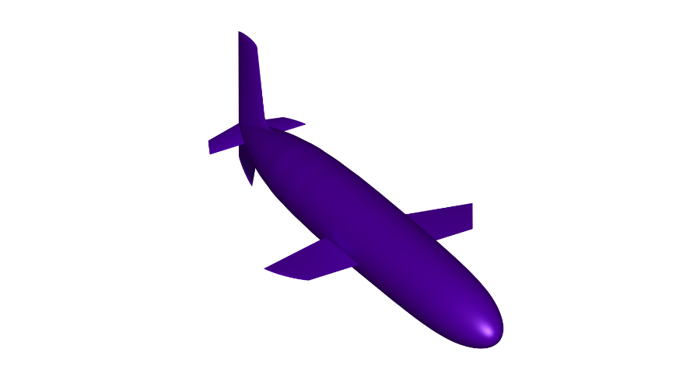

**Figure 1.** 3D model of underwater glider.

# Determination of glider rotary hydrodynamic characteristics in the vertical plane

Until now, determination of coefficients of rotary derivatives of hydrodynamic forces and moments remains a problem issue. Practical necessity to know these characteristics is related to the fact that it is impossible to determine the stability parameters and controllability of underwater object without them. Experimental determination of coefficients of rotary derivatives involves considerable material costs and time but these parameters should already be estimated at earlier design stages. That is why the development of numerical methods for the determination of coefficients of rotary derivatives of hydrodynamic forces and moments is a task of high current importance.

Nowadays, experimental determination of coefficients of rotary derivatives is normally implemented in whirling arm rigs. Earlier, other experimental methods were offered by researchers – method of free or forced oscillations, method of curved models [10-14]. However, these approaches have higher inaccuracy compared to tests in whirling arm rigs and at present time are not used.

Equations of underwater object motion in the vertical plane as projections on the axis of body-fixed system OX1Y1 (see Figure 2) are obtained on the basis of relations given in [10,11]. Values of coefficients 𝑘12 and 𝑘16 compared to other added-mass coefficients are small because the object is practically symmetrical relative to planes OX1Y1 and OX1Z1 and relevant components in equations may be neglected. Besides this, due to smallness of derivative  the member containing a projection of damping force on axis OX1 is not taken into account. As the results of numerical simulation in the specified range of angular velocities have shown, the resistance force practically does not depend on the angular velocity at small angles of attack.

;

; (1)

;

;

Where  Water density,

Displacement of object,

Projection of object’s velocity vector on axis ОХ1,

Projection of object’s velocity vector on axis ОY1,

Absolute value of object’s velocity vector,

Weight of object,

Angular velocity of object’s rotation relative to axis OZ1,

Moment of inertia of object’s hull relative to axis OZ1,

Added-mass coefficients of object,

Coefficients of positional hydrodynamic forces and moments,

 Coefficients of rotary hydrodynamic forces and moments,

Metacentric height,

Excessive buoyancy,

Arms of excessive buoyancy in the body-fixed coordinate system,

Trim angle.



**Figure 2.** Operated coordinate systems.

Assuming that the angle of attack  is small and taking into account that a certain reference counting is selected for (see Figure 2), the following relations may be obtained for velocity vector components in the body-fixed coordinates:

; .

In so doing, equation (1) can be converted into the following form:

;

; (2)

;

.

Then, normal hydrodynamic force and longitudinal moment in case of kinematic excitation of underwater object relative to the trim angle is equal to:

 (3)

. (4)

Let us consider the oscillatory motion of the object near a zero trim angle  and suppose that its angular velocity  is so small that the equal-zero angle of attack can be assumed at zero trim angle . Let the object move at velocity  with simultaneous rotation to positive trim angles . It is obvious that in case of very slow rotary movement of the object  and, as, relevant "quasistatic" derivative is equal to: . Now, let us determine a dynamic angle of attack related to object’s rotation. It has an opposite sign and is equal to: . Then, a relevant "dynamic" derivative is equal to: . Thus, the value of derivative  is determined by contribution of both "quasistatic" and “dynamic" components. Amplitudes of "quasistatic" and "dynamic" derivatives are of the same order for our conditions. However at small angles  and , but. Accordingly, contribution of "quasistatic" derivative is much higher, then . Angular acceleration at oscillatory movement at : . Then, on account of (3), (4) at , we obtain:

 (5)

. (6)

Hence, to determine coefficients of rotary derivatives of hydrodynamic forces and moments based on the numerical solution of viscous fluid dynamic equations it is necessary to determine the law of hydrodynamic force/ moment variation at harmonic kinematic excitation of underwater object and then determine the performance on the ground of relations (5)-(6) at the zero-trim angle. Value of object’s angular velocity at that instant is equal to: , where cyclic frequency of object’s angular oscillation. Then:

 (7)

. (8)

As linearized equations are considered, the obtained calculated relations as well as conclusions are correct within the frames of linear approximation.

Hydrodynamic disturbances at oscillations of underwater object relative to the trim angle were determined in the Ansys/Fluent software package. Underwater object model was developed in the 3D modelling system Catia. Then it was exported to the ICEM CFD mesh generator and relevant computational mesh was formed. The external boundary of computational domain was a parallelepiped with inbuilt computational spherical domain containing the underwater object under consideration (see Figure 3). Sliding interface that was used at the boundary of computational spherical domain provided for the possibility of rotating the underwater object relative to the external computational domain. Оn the basis of recommendations in [17], crowding of computational mesh was set near the object’s surface to have better resolution for the structure of turbulent boundary layer.

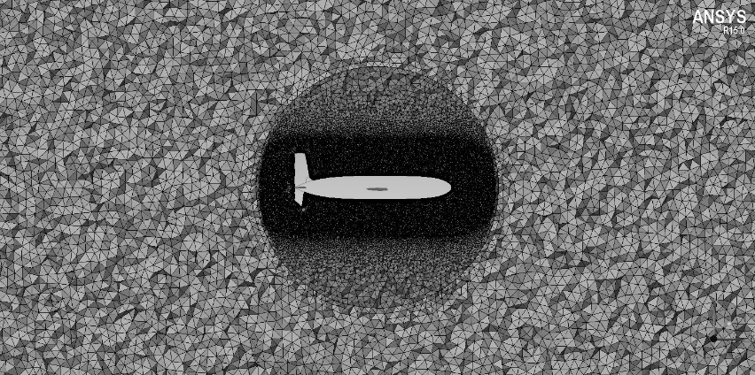

**Figure 3.** Computational mesh near the underwater object.

The turbulent flow past the underwater object was calculated at Reynolds number Re=2•106. At input boundaries of computational domain, velocity of incoming flow was set as 2 m/s. Static pressure in flow at infinity was set at output boundaries. Sticking and non-penetration conditions were specified on the object’s surface. During conduct of calculation, trim angle harmonic oscillations of underwater object with amplitude 4 degrees and dimensionless angular velocities  equal to 0.025 and 0.050 were assigned. In the process of calculation, values of hydrodynamic force and moment reached the stationary mode of harmonic oscillations with frequency corresponding to that of trim angle oscillation .

As an example, Figure 4 shows typical plots of variations of hydrodynamic disturbances under oscillations of underwater object with amplitude 4 degrees and dimensionless angular velocity 0.050. Phase shift between the trim angle oscillation and relevant hydrodynamic disturbances is clearly visible.

Table 1 gives the calculated values of coefficients ,  obtained on the basis of relations (7)-(8). Analysis of Table 1 shows that the coefficients remain practically constant at the specified values of angular velocities. It indicates the weak influence of non-stationary factors on the values of rotary derivatives coefficients of hydrodynamic forces and moments and proves the validity of steadiness hypothesis for such motions.

|  |  |
| --- | --- |
| (a) | (b) |
|  |  |

**Figure 4.** Normal force variation under object’s oscillations – (a), variation of longitudinal moment under object’s oscillations – (b).

**Table 1** – Calculated values of rotary derivatives coefficients.

|  |  |  |  |  |  |
| --- | --- | --- | --- | --- | --- |
| **Dimensionless angular velocity** | **Peak value of angular velocity *ω*,**  **s-1** | **Trim angle amplitude  *ψ*, degrees** | **Cyclic frequency of oscillation**  **, s-1** |  |  |
| 0.025 | 0.178 | 4 | 2.56 | 1.62 | -3.70 |
| 0.050 | 0.357 | 4 | 5.11 | 1.68 | -3.77 |

# Conclusion

This study defines hydrodynamic characteristics of underwater gliders based on the numeric solution of Reynolds-averaged Navier-Stokes equation. Methodological aspects for the determination of coefficients of rotary derivatives of hydrodynamic forces and moments of underwater objects are considered. It is stated that mechanism of "sliding computational meshes" implemented in many software packages of fluid mechanics allows the oscillations of the object in the flow to be set and respective hydrodynamic impacts on the object to be determined.

References

1. Eriksen C.C.,Osse T.J., Light R.D., Wen T., Lehman T.W., Sabin P.L., Ballard J.W., Ghiodi A.M. Seaglider: A long range autonomous underwater vehicle for oceanographic research.// IEEE J. Oceanic Engin., 2001. V.26, Issue 4, pp.424-436.
2. Rudnick D.L., Davis R.E., Eriksen C.C., Fratantoni D.M., Perry M.J. Underwater gliders for ocean research.// Marine Technology Society Journal, Spring 2004. V.38, № 1, pp. 48-59.
3. D’Spain G.L., Zimmerman R., Jenkins S.A., Luby J.C., Brodsky P. Underwater acoustic measurements with a flying wing glider.// J. Acoust. Soc. Am., May 2007. V.121, №5, Pt.2, pp 3107.
4. Wood Stephen L. Autonomous underwater gliders.// Underwater vehicles, Florida Institute of Technology, November 2008, pp. 505-529.
5. Pinegin A. N. On Gliding under Effect of Alternating Excessive Buoyancy as Submarine's and Underwater Vehicle's Manner Of Motion. Anniversary research and development report of CDB МE "Rubin". St. Petersburg, 2011, pp 49-60. (in Russian).
6. Kozhemyakin I.V., Rozhdestvensky K.V., Ryzhov V.A., Smolnikov A.V., Tatarenko E.I., Underwater Gliders: Yesterday, Today, Tomorrow (Part 1). // Morskoy vestnik, St. Petersburg, 2013, No 1(45), pp. 113-117 (in Russian).
7. Kozhemyakin I.V., Rozhdestvensky K.V., Ryzhov V.A., Smolnikov A.V., Tatarenko E. I., Underwater Gliders: Yesterday, Today, Tomorrow (Part 2). // Morskoy vestnik, St. Petersburg, 2013, No 2(46), pp. 98-101 (in Russian).
8. Vinogradov N.I., Kreindel S.A., Lev I.G., Nisnevich M.Z. Tethered Underwater Systems. Aerohydrodynamic Characteristics under Steady-State Mode of Motion. St. Petersburg, St. Petersburg University Publishing. 2005 304 p. (in Russian).
9. Sukhorukov A.L., Titov M.A. Use of Gliding Effect for Motion of Underwater Vehicles//Collection of Scientific Proceedings. Fundamental and Applied Hydrophysics. St. Petersburg, Nauka, 2012. No 7, pp. 88-101. (in Russian).
10. Rozhdestvensky V.V. Submarine Dynamics. Leningrad, Sudostroeyniey, 1970. 352 p. (in Russian).
11. Pantov E.N., Makhin N.N., Sheremetov B.B. Basics of Motion of Underwater Vehicles Theory Leningrad, Sudostroeyniey, 1973. 216 p. (in Russian).
12. Fedyaevsky K.K. Selected Works. Leningrad, Sudostroeyniey, 1975. 440 p. (in Russian).
13. Fedyaevsky K.K., Sobolev G.V. Ship Steerability. Leningrad, Sudpromgiz, 1963. 376 p. (in Russian).
14. Firsov G.A. Ship Steerability. Leningrad, Publishing House of F.Dzerzhinsky Higher Naval Engineering School (VMIU). 1954. 176 p. (in Russian).
15. Guryev Yu.V., Tkachenko I.V. Computer Technologies in Ship Hydrodynamics. Monograph. St.Petersburg Publishing House of Navy Science and Education Centre (VUNTS) "VMA", 2010. 326 p. (in Russian).
16. Sukhorukov A.L., Kaverinsky A.Yu. Experience in the Use of Software Package "Star-CD" when Solving Some Practical Tasks of Submarine Hydrodynamics // Proceedings of 3rd Conference for the Users of Software CAD-FEM, M., CAD-FEM, М.,2002. pp. 119-126. (in Russian).
17. Sukhorukov A.L. Use of Computing Software Packages for Determination of Hydrodynamic Characteristics of Submarines // Interdisciplinary Research and Practice Conference "Naval Construction in XXI Century" VOKOR-2006, The 1st Research Institute of the Russian Defence Ministry, Proceedings of Conference, St.Petersburg, 2006. pp.45-54 (in Russian).
18. Bellevre D., Diaz de Tuesta A., Perdon P. Submarine manoeurability assessment using Computational Fluid Dynamic tools // Twenty-Third Symposium on Naval Hydrodynamics, France, 2001.
19. Ray A., Singh S.N., Seshadri V. Evaluation of linear and nonlinear hydrodynamic coefficients of underwater vehicles using CFD // Proc. 28th ASME Conf. On Ocean, Offshore and Arctic Engineering. Honolulu, Hawaii, USA, 2009.
20. Vaz G., Toxopeus S. Holmes S. Calculation of manoeuvring forces on submarines using two viscous-flow solvers // Proc. 29th ASME Conf. On Ocean, Offshore and Arctic Engineering. Shanghai, China, 2010.
21. Ostoslavsky I.V. Aerodynamics of Plane. Moscow, Oborongiz, 1957. 562 p. (in Russian).
22. Ostoslavsky I.V., Strazheva I.V. Dynamics of Flight. Stability and Steerability of Aircraft. Moscow, Mashinostroeyniey, 1965. 468 p. (in Russian).
23. Sukhorukov A.L. The Theory of Underwater Cables and Engineering Applications. Moscow, Fizmatlit, 2017. 272p. (in Russian).