Analytical formulation of plating ultimate strength with pitting corrosion wastage
Vincenzo PISCOPO^{a,} and Antonio SCAMARDELLAª
ª The University of Naples “Parthenope”, Naples, Italy
Abstract. The assessment of plating ultimate strength with pitting corrosion wastage is a basic issue for the proper scantling and design of ship structures. In the past, several nonlinear FE analyses have been performed to investigate the incidence of pitting degree and corrosion depth on plating ultimate strength, with the main aim of providing some approximate formulations, useful at least in a preliminary project phase. Based on actual state of art, the main aim of current research is to provide an analytical solution for the ultimate strength of platings with random pitting corrosion wastage, by solving the Marguerre nonlinear governing differential equations for large deflection analysis of platings in the post-buckling regime. A comparative study with a series of FE results is performed and a simplified formulation to assess the plating ultimate strength reduction, as a function of pitting degree and corrosion depth to gross thickness ratio, is proposed.
Keywords. Plating ultimate strength, Marguerre equation, Pitting corrosion wastage, FE analysis

Introduction
In the last century, the ultimate strength analysis of steel-plated structures was studied by a variety of researchers throughout the world [1-5], to correctly assess the ultimate strength of large sea-going ships [6-8], even if only recently research activities investigated the incidence of random pitting corrosion wastage on the plating ultimate strength, following the growing interest of Classification Societies on the risk and reliability assessment of ageing structures [9]. In this respect, Khedmati et al. [10], Jiang and Soares [11], Zhang et al. [12] among others provided some practical design formulas to predict the plate strength degradation, based on a series of non-linear finite element analyses.
Based on actual state-of-art, there is still need to investigate the ultimate strength of platings affected by pitting corrosion wastage under uniaxial compression. In this respect, the analytical formulation based on the well-known Marguerre equations is extended to pitted platings and a comparative analysis is performed with the FE results derived by a series of elasto-plastic large-deflection simulations performed by Ansys Mechanical APDL. Current results show a very good agreement between the FE values and the analytical formulation that reveals to be reliable for the practical assessment of the ultimate strength of platings affected by pitting corrosion wastage.

Ultimate strength of uncorroded platings

Solution of Marguerre equations
The post-buckling behavior of platings under uniaxial compression can be assessed by solving the coupled nonlinear governing differential equations of large-deflection plate theory, namely the equilibrium equation and the compatibility condition that, in absence of pressure loads, can be resembled as follows [13]:
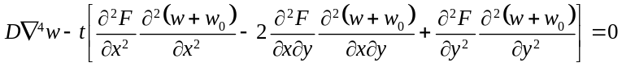 (1)
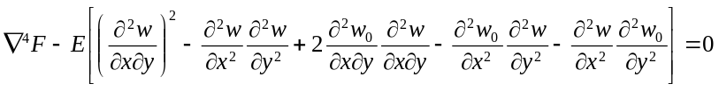 (2)
having denoted by 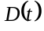 the plating flexural rigidity (thickness), by the Airy stress function, by 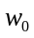 () the initial (added) deflection field and by the material Young modulus. After determining the Airy stress function and the added deflection field, the membrane stresses inside the plating can be easily calculated as follows:
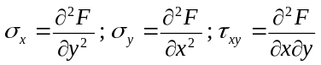 (3)
Equations (1) and (2) can be efficiently solved by the energy-principle or Galerkin method, after expanding the initial deflection field into a suitable double sine trigonometric series, satisfying the simple support boundary conditions at plate edges:
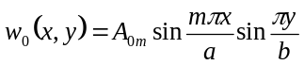 (4)
where 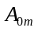 is the initial deflection amplitude, () is the plating length (breadth) and is the half wave number in the longitudinal direction which is equal to the minimum integer satisfying the following inequality, as a function of the plate aspect ratio:
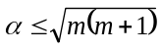 (5)
Similarly, the added deflection field is assumed to include the only buckling mode:
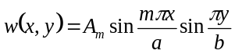 (6)
having denoted by 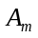 the unknown added deflection amplitude. After replacing eq. (4) and (6) into eq. (2), the Airy stress function is derived:
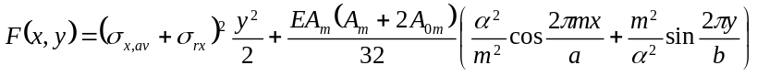 (7)
where 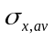is the average compressive stress and 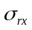is the welding stress that depends on the yield strength 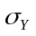, the tensile block width and the welding tension block parameter , as depicted in Figure 1:
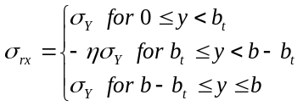 (8)
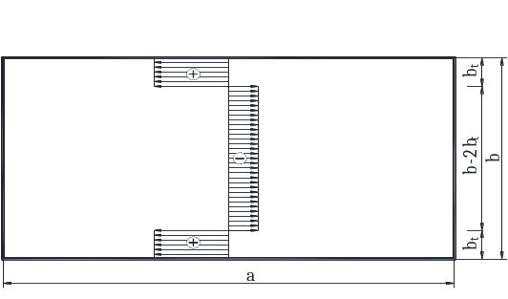
Figure 1. Welding residual stress field.
Hence, the total deflection field 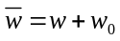is determined by the energy principle:
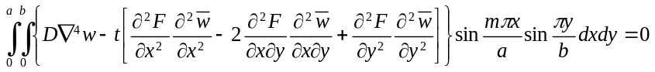(9)
that is resembled by the following equation, with respect to the variable 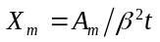, having denoted by 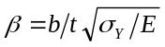 the plating slenderness parameter:
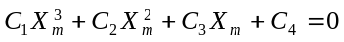 (10)
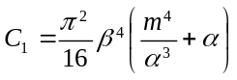 (11.1)
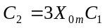 (11.2)
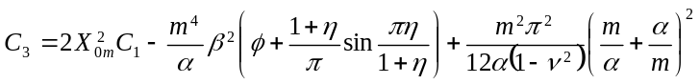 (11.3)
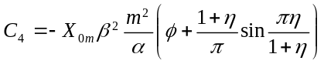 (11.4)
In eq. (11) is the non-dimensional initial deflection amplitude and 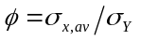 is the edge function, namely the average to yield strength ratio.

Yielding criterion
After determining the unknown variable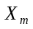, maximum and minimum values of longitudinal and transverses stresses are determined by eq. (3) as follows:
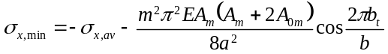 (12.1)
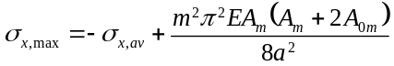 (12.2)
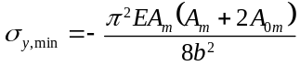 (12.3)
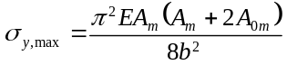 (12.4)
Hence, the plating ultimate strength , namely the ultimate 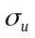 to yield strength ratio, is reached when first occurrence of yielding at plate corners, longitudinal or transverse edges, occurs:
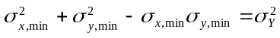 (13.1)
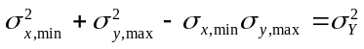 (13.2)
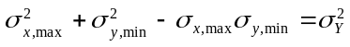 (13.3)

Geometrical imperfections
The panel initial deflection amplitude can be assessed on the basis of onboard deflection measurements or by the empirical formulations proposed in the past by several researchers. In current analysis, the model developed by Smith et al. [14] is embodied to account for different levels of welding-induced distortions:
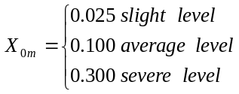 (14)
Similarly, the level of welding residual stresses is determined as follows [14]:
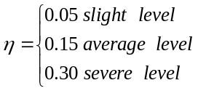 (15)

Ultimate strength of pitted platings
Based on the main outcomes of past research activities, the ultimate strength of pitted platings is influenced by the pitting intensity degree () and the pitting corrosion degree (). The former is the percentage area of the plate panel affected by corrosion wastage and is generally assessed, for practical purposes, by means of the pitting diagrams reported in Figure 2. The latter, instead, refers to the thickness loss in the pitted area and generally ranges from 0 up to 50%.
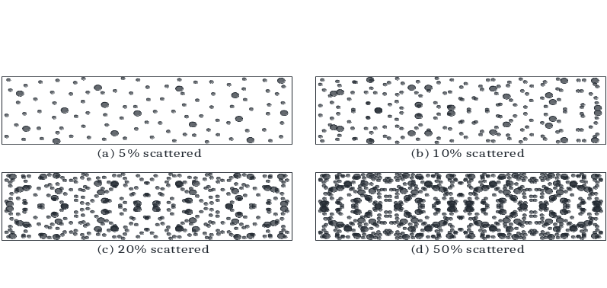
Figure 2. Pitting intensity diagrams.

In current analysis, the ultimate strength of pitted platings 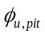 is assessed after determining the ultimate strength 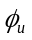 of the plate panel by the procedure detailed in Section 2. In this respect, the slenderness parameter of the uncorroded plating has to be preliminarily replaced by the equivalent slenderness parameter 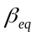that, in turn, refers to the mean thickness of the corroded plating:
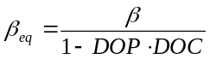 (16)
Subsequently, the ultimate strength of platings affected by pitting corrosion wastage is determined by the following design formula:
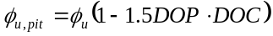 (17)
where a further reduction of the strength occurs, to account for the strength loss at the edges between the uncorroded and pitted areas. This formulation will be verified in Section 4 by a comparative analysis with a series of non-linear large-deflection FE simulations, carried out by Ansys Mechanical APDL, where random distribution of pitted areas was simulated based on different combinations of DOP and DOC degrees. In this respect, the 4-node SHELL181 element was applied to mesh the plate panel, as this element is suitable for both thin and moderately thick shell structures, with a bilinear material model and strain-hardening effects. The code also allows to account for: (i) welding residual stresses, that are superimposed as a pre-stress field, and (ii) initial imperfections, by varying the vertical coordinate of each node on the basis of a given initial displacement function.

Numerical analysis

Platings without pitting corrosion wastage
The availability of the analytical method is preliminarily investigated, by a comparative analysis with the FE results obtained by a series of elasto-plastic large-deflection simulations for platings without pitting corrosion wastage. In this respect, Figure 3 report the comparative analysis between the analytical formulation and the FE results, based on average level of initial imperfections, coupled with no and average welding residual stresses. The plating slenderness parameter is varied from 1 up to 2, with 0.1 step, and then from 2 up to 4 with 0.5 step. Current results show a very good agreement of the proposed analytical formulation with the FE results.

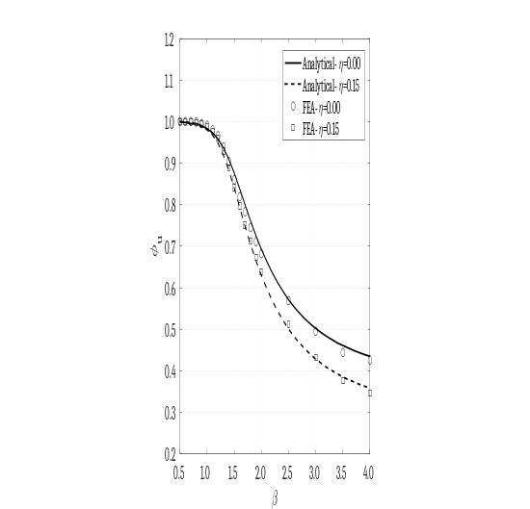
Figure 3. Comparative analysis between analytical formulation and FE results for uncorroded platings.

Platings with pitting corrosion wastage
The availability of the analytical method for the ultimate strength assessment of platings affected by pitting corrosion wastage is investigated by the comparative analysis with the FE results reported in Table 1. Particularly, two β-values are considered, each one coupled with no and average welding residual stresses. Besides, for each case different combinations of and degrees are analysed up to 50%. Based on the graphs reported in Figures 4 and 5, a very good agreement between the analytical formulation and the FE results is achieved, confirming that eq. (17) can be applied with confidence for practical design purposes. Finally, it is also verified that pitting corrosion wastage significantly affects the ultimate strength of platings under uniaxial compression, with a decrease up to 50% as regards the uncorroded platings.

Table 1. Ultimate strength of pitted platings.
DOP | DOC | η=0.00 |  |  |  | η=0.15
DOP | DOC | β=2 |  | β=3 |  | β=2 |  | β=3
% | % | FE | Analytical | FE | Analytical | FE | Analytical | FE | Analytical
5 | 10.0 | 0.674 | 0.684 | 0.492 | 0.496 | 0.631 | 0.623 | 0.428 | 0.424
5 | 25.0 | 0.652 | 0.672 | 0.478 | 0.489 | 0.610 | 0.610 | 0.418 | 0.416
5 | 50.0 | 0.630 | 0.652 | 0.454 | 0.475 | 0.574 | 0.591 | 0.393 | 0.404
10 | 10.0 | 0.669 | 0.676 | 0.486 | 0.492 | 0.625 | 0.615 | 0.421 | 0.419
10 | 25.0 | 0.638 | 0.652 | 0.463 | 0.475 | 0.595 | 0.591 | 0.398 | 0.404
10 | 50.0 | 0.586 | 0.611 | 0.427 | 0.450 | 0.535 | 0.552 | 0.371 | 0.381
25 | 10.0 | 0.650 | 0.652 | 0.469 | 0.475 | 0.601 | 0.591 | 0.408 | 0.404
25 | 25.0 | 0.582 | 0.592 | 0.428 | 0.438 | 0.539 | 0.534 | 0.365 | 0.370
25 | 50.0 | 0.483 | 0.500 | 0.354 | 0.378 | 0.422 | 0.445 | 0.305 | 0.317
50 | 10.0 | 0.617 | 0.611 | 0.451 | 0.450 | 0.571 | 0.552 | 0.387 | 0.381
50 | 25.0 | 0.518 | 0.500 | 0.380 | 0.378 | 0.458 | 0.445 | 0.311 | 0.317
50 | 50.0 | 0.353 | 0.340 | 0.256 | 0.272 | 0.292 | 0.295 | 0.207 | 0.224

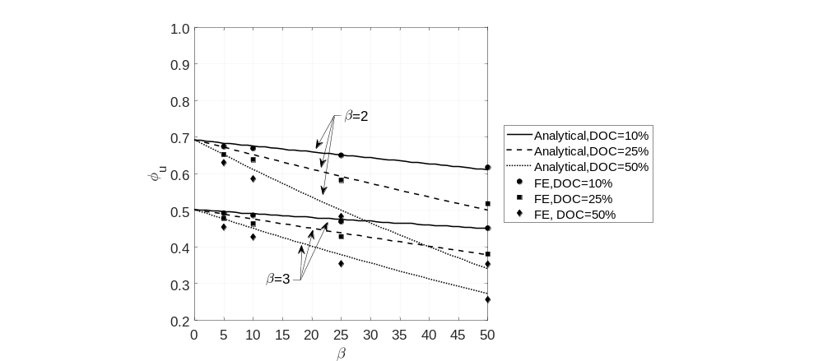
Figure 4. Comparative analysis between analytical formulation and FE results for pitted platings– η=0.00 .

Conclusions
An analytical formulation, based on the solution of the well-known Marguerre equations and devoted to the strength assessment of platings under uniaxial compression, was developed and applied to investigate the incidence of pitting corrosion wastage on plating ultimate strength under uniaxial compression. By the comparative analysis with the FE results obtained by a series of a elasto-plastic large-deflection simulations, carried out by Ansys Mechanical APDL, it was found that the proposed formula allows to efficiently estimate the plate ultimate strength reduction due to pitting corrosion wastage, for any combination of pitting and corrosion degrees up to 50%. Besides, current formula reveals to be very effective also in presence of welding residual stresses, as gathered from the results reported in Table 1 and Figure 2.
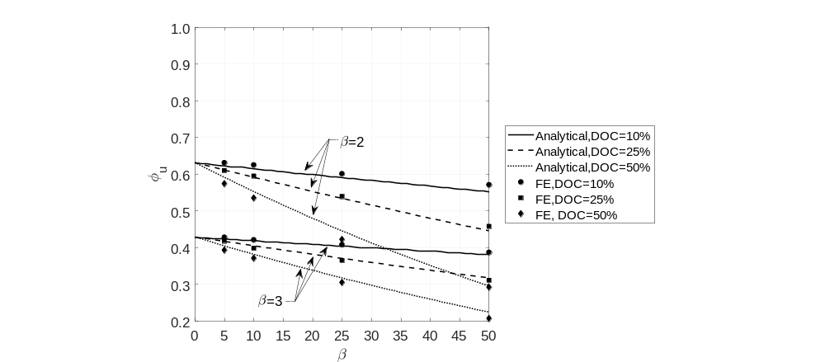
Figure 5. Comparative analysis between analytical formulation and FE results for pitted platings– η=0.15.
References
- Cui, W., Wang, Y., Pedersen, P.T., 2002. Strength of ship plates under combined loading. Marine Structures 15, 75-97.
- Paik, J.K., Thayamballi, A.K., Lee, J.M., 1997. An empirical formulation for predicting the ultimate compressive strength of stiffened panels. Proceedings of the 7th International Offshore and Polar Engineering Conference, Honolulu (USA).
- Paik, J.K., Thayamballi, A.K., Lee, J.M., 2004. Effect of initial deflection shape on the ultimate strength behaviour of welded steel plates under biaxial compressive loads. Journal of Ship Research 48(1), 45-60.
- Piscopo, V., 2010ª. Buckling analysis of rectangular plates under the combined action of shear and uniaxial stresses. World Academy of Science, Engineering and Technology 46, 546-553.
- Piscopo, V., 2010^{b}. Refined buckling analysis of rectangular plates under uniaxial and biaxial compression. World Academy of Science, Engineering and Technology 46, 554-561.
- Campanile, A., Piscopo, V., Scamardella, A., 2014. Statistical properties of bulk carrier longitudinal strength. Marine Structures 39, 438-462.
- Campanile, A., Piscopo, V., Scamardella, A., 2016ª. Incidence of residual stresses and steel property variability on corroded bulk carrier reliability. Ocean Engineering 128, 58-80.
- Campanile, A., Piscopo, V., Scamardella, A., 2016^{b}. Time-variant bulk carrier reliability analysis in pure bending intact and damage conditions. Marine Structures 46, 193-228.
- Paik, J.K., Wang, G., Thayamballi, A.K., Lee, J.M., Park, Y., 2003. Time-dependent risk assessment of ageing ships accounting for general/pit corrosion, fatigue cracking and local dent damage. Proceedings of the Annual SNAME Meeting, San Francisco (USA).
- Khedmati, M.R., Nouri, Z.H.M., Roshanal, M.M., 2012. A comparative computational investigation on the effects of randomly distributed general corrosion on the post-buckling behaviour of uniaxially loaded plates. Journal of Mechanical Science and Technology 26(3), 767-783.
- Jiang, X., Guedes Soares, C., 2012. Ultimate capacity of rectangular plates with partial depth pits under uniaxial loads. Marine Structures 26, 27-41.
- Zhang, Y., Huang, Y., Meng, F., 2017. Ultimate strength of hull structural stiffened plate with pitting corrosion damage under uniaxial compression. Marine Structures 56, 117-136.
- Paik, J.K., Thayamballi, A.K., 2006. Ultimate limit state design of steel-plated structures, John Wiley & Sons Ltd, Chichester (UK).
- Smith, C.S., Davidson, P.C., Chapman, J.C., Dowling, P.J., 1988. Strength and stiffness of ships’ plating under in-plane compression and tension. RINA Transactions 130, 277-296.

The University of Naples “Parthenope”, Department of Science and Technology, Centro Direzionale Isola C4 80143 Naples, Italy; E-mail: vincenzo.piscopo@uniparthenope.it

