Airborne noise prediction of a ro/ro pax ferry in the port of Naples
Tommaso COPPOLA ª, Luigia MOCERINO ª, Enrico RIZZUTO ª, Massimo VISCARDI ª and Daniela SIANO ^{b}
ª Department of Industrial Engineering, Università degli studi di Napoli “Federico II”
^{b} National Research Council (CNR)-Istituto Motori, Naples, Italy

Abstract. Noise emissions from various transportation modes became in recent years a major concern for environmental and governmental agencies due to their impact on the community. As a result, experimental campaigns and studies have been directed towards the analysis and control of the main noise sources. Only a few analyses, however, have regarded noise exposure due to port activities. In this paper, the focus is on airborne noise emissions from a ferry ship. At first, the main onboard noise sources were identified in terms of their nature and location. Secondly, sources data on the main sources were derived, based on onboard measurements of the ferry berthed in the port of Naples. A geometrical 3D model was created, including all bodies present in the acoustic field of the surrounding area. Finally, by post processing, the consistency between actual acoustic field and numerical model results was checked.

Keywords. Ship noise, acoustic field in ports, ship sources, noise emissions from ships

Introduction
Noise emissions from various transportation modes including seaports have become a major concern for environmental and governmental agencies in recent years, due to the impact they have on the community.
Historically, in Europe, many urban areas developed in close vicinity of harbours, particularly in the Mediterranean Sea. This applies both to the case of big ports with large commercial traffic and of small ports mainly devoted to touristic traffic. On the other hand, the European Union is particularly concerned with the negative impact of ambient noise and is a world’s leader in formulating rules and requirements to control noise. As a result of the EU directive 2002/49/EC, noise maps were prepared for major seaports like Hamburg and Copenhagen [18]. This type of noise models are valuable tools for municipalities and port authorities when taking key urbanistic decisions (both on port and urban areas) as they allow the prediction of the noise impact of future development projects.
Despite the fact that, so far, no specific requirements have been issued for ports (at the moment included in the broader class of ‘industrial plants’), the question of their acoustical impact is going to pose technical, juridical and financial challenges to Port Authorities, also in relation to the concerns brought forward by other Authorities from neighboring areas.
In addition to other contributors to the total noise levels (repair shipyards, gears for loading and un-loading goods, transportation means ashore, etc) ships themselves are most significant noise source in ports and possibly those generating the largest impact [1], [2], [3], [4]. The features of ships as noise sources are peculiar and make a proper characterization quite problematic.
Ships, while berthed, run powerful auxiliary engines producing the electric power they need. The noise generated by these engines presents strong components at low frequencies, making it quite annoying. Low-frequency noise propagates with long wavelength: a proper attenuation requires big, space-consuming silencers onboard the ship. Further, standard countermeasures placed in buildings ashore, like noise walls, soundproof windows and similar are insufficient to mitigate it.
In RoPax ships, the ventilation systems of car decks, including fans and compressors, are equally important noise sources [5], [6]. Air conditioning systems for cabins are also contributors, as well as cargo handling equipment (cranes, ramps for vehicles, etc.).
All these noise sources are located in different positions on board, making the ship quite a complex noise source, with, in addition, different emissions while sailing and maneuvering or while berthed [7].
The paper focuses on the acoustic pollution originating from a ferry ship berthed in the port of Naples and potentially affecting the surrounding portion of the town. All noise data have been derived from measurements carried out in a portion of the port of Naples. This investigation is a part of a wider impact analysis being carried out by the University of Naples on the town port, taking into account also the effects of chemical pollution due to ships in the area [8], [9].
The final aim of this part of the study is to obtain a tool able to investigate continuously the acoustic impact of ships operation in any point around the harbor and the effect of possible countermeasures against noise generation and/or propagation in the area. As the Ro/Ro sector features the highest growth potential, the levels of noise generated by activities at the Ro/Ro terminals may affect seriously the port personnel as well as the residential neighbors.

Experimental campaign
On May 11th 2017 an experimental campaign was carried out in the Port of Naples, aiming at recording data for the characterization of a passenger ship as source of noise and for a calibration of a propagation model.

2.1 The port of Naples
The port of Naples is today one of the largest of the Mediterranean in term of quantity and variety of traffic. Strength of the port is certainly the passenger traffic: according to the latest statistics, in 2017, cruise passenger were 927.458 and the total number of passengers (cruise, local and ferry) was as large as 6.684.772.
The port is divided into two main areas, distinct for type of traffic and geographical location. The west end, closer to downtown, is dedicated to passenger traffic and features three sub-areas:
- Molo Beverello, with hydrofoil service connecting the town to the three main islands in the Gulf. Every day hundreds people, (tourists and commuters) embark from this pier.
- Molo Angioino, pier for cruise ships. A large passenger terminal was recently built on it;
- Calata Porta di Massa and Calata Piliero, two more piers used for long range ferry boats.
The eastern area (much wider) is dedicated to cargo vessels, equipped with several basins and facilities for handling and storage of liquid and dry goods and containers. The port area interested by the measurement campaign was the one used for passenger traffic, in particular near the passenger terminal.

2.2 Measurement instruments and characterization of the source
The experimental surveys were carried out by 3 sound level meters (two Larson Davies 824 and one LXT); these instruments are able of measuring five quantities at the same time among: Equivalent Sound Level (L_{eq}), Sound Pressure Level (SPL), Sound Exposure Level (SEL) and maximum and minimum sound pressure level.
Phonometric surveys were carried out following the usual procedure, including calibration, carried out by means of a calibrator device and selection of the instrument settings (range, weighting, etc.). Measurement were carried out by directing the microphone towards the sound source at a height of about 1.5 m from the ground and at least 1m from other interfering surfaces such as walls, barriers or obstacles.

2.3 Analysis of the acquired data
Data records covered the three main situations for a ship in port: navigation, maneuver and ship at berth. As known, the noise emitted from ships varies according to the operation conditions. The investigated source is a ferry boat arriving each day in Naples around 6 am and departing at 20 pm. On the moored ship, the electric power generators run all time to feed hoteling and hull services.
The mooring situation on the day of measurements is shown in Figure 1, where the source ship is highlighted.
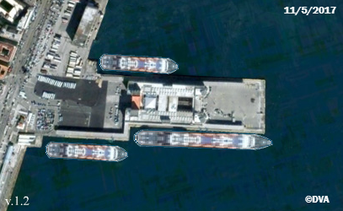

Figure 1. Position of the ship source after mooring.
Surveys were carried out in several points and at different distances from the ship, to cover arrival, maneuver and mooring of the ship. The main positions chosen were around the Passengers Terminal Building (Stazione Marittima), see Figure 2.
In area 1 of these figures, the receivers were placed on the ground (SNAV service area) on their supports; in area 2, the same receivers were located on the balcony of Passenger Terminal.
The ship entering the port and maneuvering was surveyed from area 1. Noise records with time duration of about 60 minutes (steps of 10 sec), were stored in form of third octave band spectra. In figure 3 the equivalent sound pressure level is presented vs. time.

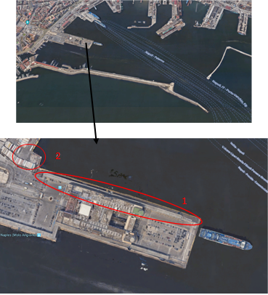
2

Figure 2. Main locations of surveys.

After maneuvering and berthing of the ship, other measurements were carried out on board the ship for a better characterization of the source.
Initial surveys were carried out while garage fans were running; noise levels were then recorded in the areas immediately around the ship's funnel, which is realised with a support structure consisting in the aft side of a perforated sheet. The last measurements were carried out in the Snav Service Area. The L_{eq} of each measurement point are shown in Figure 4 where the dashed and continuous lines represent the two main sound level meters used.

Figure 3. L_{eq} vs time, during the maneuvers.

Figure 4. L_{eq} of each measurement point.

The measurement points on board were grouped by zones and for each of them the average levels were estimated in third octaves. The areas are identified as follows:

Zone A (Level I, [upper level] around the funnel-stern);
Zone B (Level II [medium level] around the funnel-stern);
Zone C (Level III [lower level] around the funnel-stern);
Zone D (Level III around the funnel-starboard);
Zone E Level III around the funnel-port);
Zone F (Level III around the funnel-bow).

An overall comparison is shown in Figure 5 among different measurement locations on board (levels in dB filtered (A) vs frequency). The different shape of the spectra show how in the proximity of the source (funnel) quite a complex transmission is present.

Figure 5. A- filtered spectra measured in the various positions on board

Simulation model

3.1 The “Terrain” software
The adopted software, Terrain by Olive Tree Lab-Suite, is based on a ray-tracing approach implementing International Standard ISO 9613-2 methodology. The model is based on high frequency resolution calculations, but results can also be represented in 1/1 and 1/3 octave, both as sounds spectra and cartographic maps. Figure 9 shows the 3D model developed to represent the ship in the position of the test day and the structures of the port near the mooring point. The source used was a dodecahedral type with a flat spectrum (Figure 10); the receivers were placed in way of the survey points adopted on the test days (Figure 10-11). The software allows also to visualize the incident rays as shown in Figure 11.

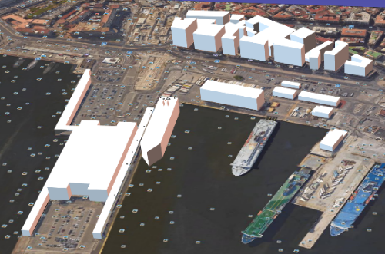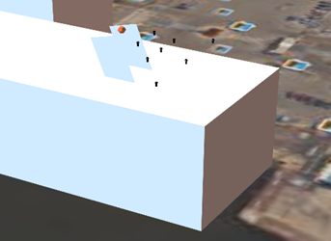
Figure 6. 3D model. Figure 7. Position adopted for the source (in red).

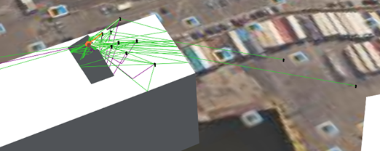
Figure 8. Acoustical rays modelling the propagation.

The simulation model provided transmission losses from the source (placed on the funnel, see Figure 7) to the various receiving positions (in Fig. 7 some of the nearest positions are shown in black). In order to derive the absolute value of noise radiation, the source strength was derived by back-computing it using the experimental value in a given position and the transmission losses computed in the same point. This ‘calibration’ exercise of the source strength was performed in each single survey point available on board, obtaining different characterisations for the source. The various predicted levels (one for each source strength derived as above) were compared with the actual measurements (excluding the point used for calibration) this provided information for optimizing the fitting between predictions and experiments.
Figure 9 below show the results of this exercise in terms of average difference and standard deviations between the predicted values and the experimental ones (a couple of values for each calibration point): the adoption of calibration in points 20 and 21 provided the lower BIAS and lower Standard deviation, respectively.

Figure 9. Average and standard deviations of differences between predicted and measured values
(depending on the calibration point)

Table 1 reports the detailed results for the calibration point n.20. Results show a fairly good agreement in the areas close to the noise source (and calibration point, but are quite disappointing in position 24 and on the points in the SNAV service area, where experimental values are respectively lower and higher than predictions. In those positions, acoustical effects not included in the model seem to affect predictions

Table 1. Expected against experimental values of the equivalent sound pressure.
Position | Results L_{eq} [dB(A)]  (Experimental value/ predicted value)
Receiver 18 (Level III)  Receiver 19 (Level III)  Receiver 20 (Level II)  Receiver 21 (Level II)  Receiver 22 (Level II)  Receiver 23 (Level I)  Receiver 24 (Level II)  Receiver 25 (Level I)  N (SNAV Service Area)  M (SNAV Service Area)) | 80.5/82.6  80.5/82.0  78.4/78.4  77.8/78.5  76.5/79.5  73.2/74.0  71.5/76.2  73.7/74.6  62.6/57.2  63.3/59.6

Conclusions
A numerical/experimental activity was carried out in a specific area of the port of Naples , aiming at calibrating a tool able of predicting the acoustic impact of the moored ship in the neighboring positions in the harbor.
A model based on the Ray Tracing technique was built and calibrated by means of a part of the surveys. A validation carried out with the remaining experimental results suggests that the main part of the transmission losses are captured by the model. The differences between predicted and measured levels are consistent with the approximation of the model developed at this stage. More efforts are needed to improve the model and obtain reliable predicted values far away from the source.

References
- WHO 1999. Guidelines for Community Noise, Berglund B., Lindvall T. & Schwela D. Edts. World Health Organization, Occupational and Environmental Health Team, Copenhagen DK http://www.who.int/docstore/peh/noise/guidelines2.html.
- Badino A., Borelli D., Gaggero T., Rizzuto E., Schenone C. 2011. Acoustic impact of ships: noise-related needs, quantification and justification, IMAM 2011, 14th Congress of the Internat. Maritime Association of the Mediterranean, Sept. 2011, Genoa, IT.
- Badino A., Borelli D., Gaggero T., Rizzuto E. Schenone C. 2012. Noise emitted from ships: impact inside and outside the vessels Procedia: Social & Behavioral Sciences, Elsevier, Vol.48 pp 868-879.
- Badino A., Borelli D., Gaggero T., Rizzuto E., Schenone C., 2012b. Normative framework for Ship Noise: Present Situation and Future Trends Noise Control Engineering Journal, Institute of Noise Control Engineering Vol.60, pp 740-762.
- Viscardi M., Coppola T., Quaranta F., Rizzuto E. 2017. On field experimental characterization of the ship sources of acoustic pollution within a commercial harbor, 24th Intern. Congress on Sound and Vibrations, July 2017, London GB.
- Coppola T. Quaranta F. Rizzuto E., Viscardi M, D. Siano 2017. Development, calibration and validation of a model for the acoustic field generated by a ship at port, International Maritime Association of the Mediteranean, October 2017, Lisbon, Portugal.
- Badino A., Borelli D., Gaggero T., Rizzuto E., Schenone, C. 2016. Airborne noise emissions from ships: experimental characterization of the source and propagation over land, Applied Acoustics, Elsevier, Vol. 104, March 2016, pp 158-171. Acoustics, Elsevier, Vol. 104, March 2016, pp 158-171.
- Battistelli L., Coppola T., Fantauzzi M., Quaranta F. 2011. A case study on the environmental impact of harbour activities: analysis and solutions; INT-NAM Conference, Oct. 2011, Istanbul (Turkey).
- Battistelli, L., Fantauzzi, M., Coppola, T., Quaranta, F. 2012 Evaluation of the environmental impact of harbour activities: Problem analysis and possible solutions, Sustainable Maritime Transportation and Exploitation of Sea Resources - Proceedings of the 14th International Congress of the International Maritime Association of the Mediterranean, IMAM 2011 2, pp. 945-950.
- Di Bella A. & Remigi F., 2013. Prediction of noise of moored ships, Journal of the Acoustical Society of America, vol.133, issue 5, p.3495.
- Di Bella A., 2014. Evaluation methods of external airborne noise emissions of moored cruise ships: an overview, Proc. of the 21st International Congress on Sound and Vibration, Beijing, China.
- Di Bella A., Remigi F., Fausti P., Tombolato A., 2016. Measurement methods for the assessment of noise impact of large vessels, ICSV 2016, 23rd Intern. Congress on Sound and Vibration,Athens, GR, July 2016.
- Borelli D., Gaggero T., Rizzuto E., Schenone C., 2015. Analysis of noise on board a ship during navigation and manoeuvres, Ocean Engineering, Elsevier, Sept. 2015, Vol. 105, pp 256-269.
- Borelli D., Gaggero T., Rizzuto E. and Schenone C., 2015b. Measurements of airborne noise emitted by a ship at quay, ICSV 2015, 22nd Intern. Congress on Sound and Vibration, July 2015, Firenze, IT.
- ISO 1993. Attenuation of sound during propagation outdoors Part 1: Calculation of the absorption of sound by atmosphere Standard ISO 9613-1 International Organization for Standardization, Geneva, CH
- ISO 1996. Attenuation of sound during propagation outdoors Part 2: General method of calculation, Standard ISO 9613-2 International Organization for Standardization, Geneva, CH.
- PEMARD 2017. Olive Tree Lab Suite: An integrated acoustics software for indoors and outdoors. Mediterranean Acoustic Research Development Ltd., Limassol CY http://www.mediterraneanacoustics.com/olive-tree-lab-suite.html.
- NoMEPorts partners 2008 Good Practice Guide on Port Area Noise Mapping and Management;

Prof. Tommaso Coppola, Department of Industrial Engineering, Università degli Studi di Napoli “Federico II”, Via Claudio 21, 80125 Napoli, Italy; E-mail: tommaso.coppola@unina.it

