On the deck structural layout of megayacht

Gianmarco VERGASSOLAa,[1], Dario BOOTEa, Tatiana PAISa and Lisa RICCI b

a DITEN, University of Genoa (IT)

b Naval Architect (IT)

**Abstract.** The growing increase in length of super and megayachts has driven structural designer to adopt longitudinal layouts as a main point in the structural scantlings. By the way, the optimization of weights, strength, deformations and dynamic behaviour has to be assessed one off for each new units because of peculiar and unique characteristics of each vessel.

For this assessment, in particular considering the dynamic behaviour of ribbed plates, the use of numerical software based on the Finite Element (FE) Methods is largely used up to the early design stages in order to highlights benefit and weakness of a particular structural design.

In this paper, two different structural layout for a superyacht deck have been studied and tested by using a FE software: the first one has been created with longitudinal and transversal stiffeners with the same cross section. In the second layout, transversal stiffeners are smaller in dimension but with lower span. The comparison has been made in terms of maximum strength, deformation and dynamic behaviour.

**Keywords.** Megayacht, deck structural scantling, FEM, vibration analysis.

# Introduction

In the last few years, after the drop due to the international financial crisis, the demand of super and megayacht has increased both in term of number of unities and average length. The design of such vessels required one off design and production because of the high customization required by the owner.

For these reasons, the structural scantling has to be carried out case by case [1] and the use of numerical tools, such the Finite Element Method [2] [3], is universally adopted by structural naval architect in order to validate different structural layouts in terms of strength, weight’s optimizations [4] and vibrations [5].

The aim of the work is to compare, qualitatively and quantitatively, different structural solutions for steel megayacht decks. For this porpoise, two scantling philosophies have been taken into account: in the first one, transversal and longitudinal reinforced beams are equal in terms of sectional modulus (Configuration 1) and, in the Configuration 2, transversal girders are significantly smaller and closer to each other than the longitudinal reinforced ones. From these two main layouts, six different schemes have been created by varying spacing and stiffeners’ dimensions.

# Definition of study cases

For this research, a main deck portion of a 95 meter superyacht has been analysed; the characteristics of the yacht has been reported in Table 1 and the original structural scantling in Fig. 1; the structural scantling has been carried out according to the Lloyd’s Register [6] regulations.

**Table 1.** Dimension of the superyacht assumed as study case

|  |  |
| --- | --- |
| **Dimension** | **Value** |
| **LOA** | 95,10 m |
| **LWL** | 85,86 m |
| **LPP** | 81,70 m |
| **LR** | 82,43 m |
| **B** | 20,50 m |
| **BWL** | 16,22 m |
| **D** | 8,35 m |
| **TN** | 4,40 m |
| **T** | 4,60 m |



**Figure 1.** Original deck structural layout.

The six different structural layouts (Fig. 2) proposed in this paper has been selected and created with a constant longitudinal spacing of 600 mm both for Configuration 1 and 2; the frame distance has been varied from 1300 mm (structural layout 2.1) to 2600 mm (structural layout 1.1). Two intermediate transversal spacing (1730mm and 2080 mm) have been also studied in order to have a more accurate investigation on the different of the two Configurations. The thickness of the deck plating has been fixed to 6 mm of Fe520 steel.

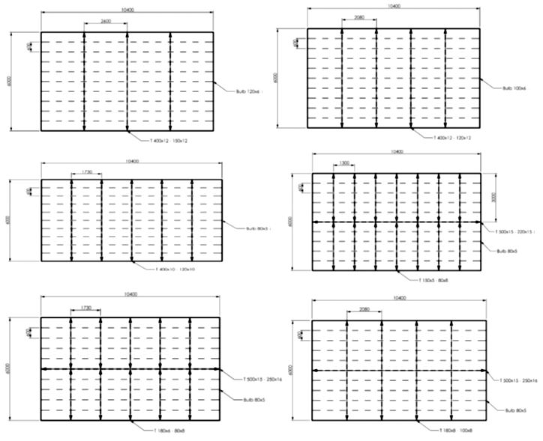

**Figure 2.** Structural layout assumed as study cases: from top left to bottom right, layout 1.1, 1.2, 1.3, 2.1, 2.2, 2.3.

# Finite Element analysis on the different structural layout

The proposed layouts have been tested by using the commercial FE code ANSYS [7] by static structural analysis and eigenvalue analysis for the assessment of natural modes. These analyses are necessary because the structural scantling according to [6] take into account neither the holes on the primary beams (necessary for auxiliary plants and weight reduction) nor the interactions among the different structural stiffeners. The FEM analysis is the most reliable way to check these behaviours, apart from specific laboratory tests with higher times and costs.

In each layout, reinforced girders and plates have been both modelled as linear 2D shell elements, while linear 1D beam elements have been used for secondary stiffeners. A fine mesh (Fig. 3) has been used in order to improve the reliability of results especially for the natural mode analysis.



**Figure 3.** Mesh density.

In order to create a load case as much close as possible to a real case, a distributed weight of 50 kg/m2 has been applied to the entire deck portion. The FE model has been constrained by symmetry boundaries on the longer longitudinal edges and with fixities, that should represent the bulkheads’ rigidity in correspondence of transversal edges.

The first eigenmode of layout 1.1 and 2.1 has been reported in Fig. 4 and in Table 2 the results of structural analysis have been presented.

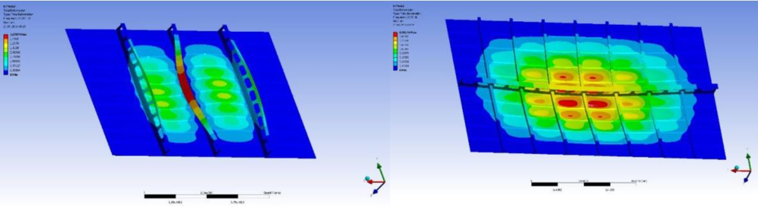

**Figure 10**. Results of modal analysis in terms of eigenmode: left layout 1.1 and right layout 2.1.

**Table 2.** Results of structural and natural eigenvalue analysis on different structural layout

|  |  |  |  |  |
| --- | --- | --- | --- | --- |
| **Layout** | **Weight [kg]** | **Max Stress [N/mm2]** | **Max deformation [mm]** | **1° natural frequency [Hz]** |
| **1.1** | 4724 | 174 | 4,42 | 29,9 |
| **1.2** | 4723 | 167 | 4,1 | 29,9 |
| **1.3** | 4917 | 147 | 3,74 | 30 |
| **2.1** | 4864 | 160 | 5,16 | 27,5 |
| **2.2** | 4872 | 142 | 5,09 | 27,5 |
| **2.3** | 4976 | 140 | 5,07 | 27,5 |

Since the first eigenmode of layout 2.1 is fully reliable, in layout 1.1, the big difference in dimensions among transversal and longitudinal stiffeners leads to misleading results. This behaviour is due to the fact that, during the first scantling, no considerations have been carried out regarding the difference in dimensions between reinforced and secondary elements and regarding the dimension of holes.

# Redesign due to construction requirements

Since the non-realistic behaviour of the results reported in Fig. 10, the 6 different deck layouts have been redesigned in order to verify a structures closer to real cases. In particular, the dimensions of beams and holes have been modified:

* Standard web’s holes of 480x240 mm (Fig. 11);
* web’s hole area not greater than 40% of the total web sectional area, so beams in configuration 1 not smaller than 450mm;
* configuration 1 beams’ web not thicker than 12mm;
* configuration 2 beams’ web not higher than 200mm;
* configuration 2 beams’ web not thicker than 10mm.



**Figure 11**. Connection holes

The first modification is due to the standard dimension of pipes used on board: referring to the same standard for each yacht built allow the shipyard to simplify the production of beams and girders making it faster and cheaper. The other specifications came from the designers’ experience and consider the needs of the structure in terms of stress resistance, durability and simplicity of construction (in relation with quality, time and cost of production).

The layouts have been then remodelled and analysed, both with static and modal FE analyses; while the structural capability to static loads has not been modified by the aforementioned construction requirement (Table 3), the first eigenmode (Fig. 12) is more realistic then the one reported in Fig. 10.

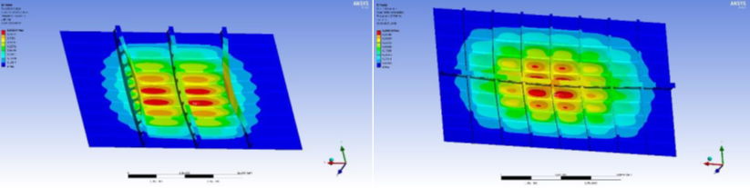

**Figure 12**. Results of modal analysis in terms of eigenmode after the redesign according to construction requirements: left layout 1.1 and right layout 2.1.

**Table 3.** Results of structural and natural eigenvalue analysis on different structural layout after redesign due to construction requirements

|  |  |  |  |  |
| --- | --- | --- | --- | --- |
| **Layout** | **Weight [kg]** | **Max Stress [MPa]** | **Max deformation [mm]** | **1° natural frequency [Hz]** |
| **1.1** | 5011 | 173 | 4,2 | 29,3 |
| **1.2** | 4841 | 175 | 4,36 | 30,5 |
| **1.3** | 4921 | 162 | 4,31 | 27,4 |
| **2.1** | 4864 | 160 | 5,16 | 47,4 |
| **2.2** | 4973 | 143 | 5,11 | 43,1 |
| **2.3** | 5144 | 144 | 5,03 | 41,7 |

As it can be seen from Table 2 and 3, the total weight is intentionally proportional to the spacing between transversal frames, but, by the way, the variation range is quite negligible (up to 6%). From the stress point of view, Configuration 1 has to withstand higher loads, but is less deformable then Configuration 2; this aspect is led to the fact that the scantling of structural element between the two Configuration is very different. In fact, following the LR rules [6], the direct calculations implies a sort of interruption (fixity) when a secondary stiffener encounters a reinforced beam. The analyses on Configuration 1 show results closer to this condition, while for Configuration 2 it has to be considered a non-realistic approximation. The main parameter that lead to this different behaviour is the ratio between the dimensions (mainly the height) of stiffeners and beam;: in Configuration 1 the reinforced beams are much higher than the stiffeners (the web’s height is more than twice the height of the stiffener) and they provide a perfect support for them. The more similar dimensions of beams and stiffeners in Configuration 2 make them bear part of the beams load, instead of been completely supported by them.

# Harmonic responses

As a further parameter in the comparison among the different solutions, a sinusoidal force has been applied to each layout in order to evaluate its harmonic response [8].

These analyses will be mainly a confirmation of the previous modal analyses: if the structure is well modelled and supported, then from the frequency response graph will result an absolute maximum in correspondence of the first mode found in the modal analysis [9]. The peak in the harmonic response, both in terms of velocity and acceleration, could lead to comfort and fatigue problems.

Since the model is only a portion of a deck, it was impossible to represent the behaviour of the real harmonic forces due to mechanical propulsions as affirmed by Pais et ali. [5]; for this reason, a unitary force of 100 N has been applied to the models.

As stated by Vergassola et ali. [9], structural damping must be taken into account in harmonic and dynamic FE analyses A standard damping value assumed for steel is 1%, that complies with the results of the investigation reported in [9].

In Fig. 13, the damped acceleration on the vertical axis for all the layouts is reported.

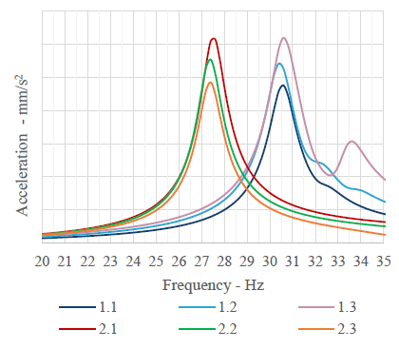

**Figure 15**. Harmonic response of different layout of deck structures

As expected, the curves have a peak in correspondence of the first natural frequency of the panel. The presence of other smaller peaks is due to higher modes with similar modal shape of the first one; for example, in Layout 1.3, the second evident peak around 33,8 Hz corresponds to the eighth mode of the structure, which has a deformation shape similar to the first one.

In each configuration, it can be seen how the acceleration is inversely proportional to the spacing of transversal structures. It is probably due to the fact that greater spacing allows smoother structural displacements.

# Welding length

The last parameter that has been considered in this investigation is the welding length that is necessary in order to construct the study cases. The importance of this comparison is due to the influence of the total welding length on the final construction cost. The reinforced elements’ welding is always the most influent in the overall construction cost of a deck because it cannot be done with an automatic laser procedure (average speed of 1 m/min instead of 0,3 m/min for manual welding), so it is slower and more expensive.

Since each layout is a kind of longitudinal layout, the differences in the welding length depend mainly on the number of transversal primary elements, as it can be seen in Table 4

**Table 4.** Analysis of the welding length

|  |  |  |  |  |
| --- | --- | --- | --- | --- |
| **Layout** | **II order welding [m]** | **I order transversal welding [m]** | **I order longitudinal welding [m]** | **Total welding length [m]** |
| **1.1** | 93,6 | 18,0 | - | 111,6 |
| **1.2** | 93,6 | 24,0 | - | 117,6 |
| **1.3** | 93,6 | 30,0 | - | 123,6 |
| **2.1** | 83,2 | 42,0 | 20,8 | 146,0 |
| **2.2** | 83,2 | 30,0 | 20,8 | 134,0 |
| **2.3** | 83,2 | 24,0 | 20,8 | 128,0 |

As expected, the longest welding is the one of Layout 2.1, which has the greatest number of transversal elements.

Of course, even if the length of welding is greater in Configuration 2, the thickness of the beams involved is smaller. This means that the increment of welding time and cost will not be directly proportioned with the length, but also the different needs in term of welding thickness and penetration should be taken into account.

Considering a welding speed of 0,3m/min, the different required construction time of Layout 1.1 (335 min) and Layout 2.1 (438 min) is equal to 1 hour and 40 minutes.

# Conclusions

Longitudinal structural layout is nowadays the most common for large yacht for many reasons; first it ensure a greater strength of the shell plate with is susceptible to buckling and this effect is more evident with large yachts: bottom structure of yachts of 100m or more are compulsorily longitudinal. They are also generally lighter and have a smaller number of element and, consequently, a reduced welding length. Despite so, anyway, the main disadvantage for a longitudinal structure is the fact that the construction is slightly more complex because of the higher number of joint: smaller boat, for which the general loads are not so demanding, are indeed built using a transversal layout.

In this research, six different deck structural layouts have been tested by the Finite Element Method in order to evaluate them from a static and dynamic point of view.

The principal pro of configuration 1 is the reduced weight, together with smaller panel height and shorter welding length. This configuration is also less deformable, even if the variation range is not very significant. On the other hand, configuration 2 is heavier and more deformable and has longer welding that increases costs, but it reduces the maximum stress value and the first mode shape has lower eigenvectors, which leads to lower level of vibration.

The choice of the layout for the structures of a yacht, of course, is also influenced by the peculiarity of the ship itself that often contrast with what would be the optimal solution for the structural assessment. The starting point of a new structure design, in fact, is usually the interior general arrangements: it defines the vertical space available for structures and connections as well as the longitudinal and transversal subdivision. The bulkheads’ disposition is generally a consequence of the internal subdivision of the ship and it may influence the choice of the spacing. Another important issue is the final purpose of the vessel: for example, a yacht focused on performance will be as light as possible preferring configuration 1. On the other hand, when a quite small difference in weight does not make any significant difference in terms of performance, a more resistant and comfortable structure such as configuration 2 might be a more suitable choice.

References

1. Roy J., Munro B., Walley S., Meredith A., “Longitudinal versus Transversely Framed Structures for Large Displacement Motor Yachts”, 20th International HISWA Symposium on Yacht Design and Yacht Construction, Amsterdam, The Netherlands, 2008.
2. Boote D., Vergassola G., Di Matteo V., “Strength analysis of superyacht superstructures with large openings”, International Review of Mechanical Engineering, Vol. 11(1), 2017.
3. Boote D., Vergassola G., Pais T., Kramer M., “Finite Element Structural Analysis of Superyacht Superstructures”, International Review Of Mechanical Engineering, Vol. 11(4), 2017.
4. Zanic V., Andric J., Prebeg P., “Superstructure deck effectiveness of the generic ship types – a concept design methodology”, Maritime Transportation and Exploration of Ocean and Coast Resources 2005.
5. Pais T., Boote D., Vergassola G., “Vibration analysis for the comfort assessment of a cabin cruiser”, Ocean Engineering, 2018.
6. Lloyd’s Register, “Rules and Regulation for Classification of Special Service Craft”, Part 3, Chapter 1, Section 6, 2012.
7. ANSYS Workbench User’s Guide, ANSYS Inc., Conosburg (USA), 2011.
8. Petyt M., “Introduction to Finite Element Vibration Analysis”, Cambridge University Press; 2nd edition, 2010.
9. Vergassola G., Boote D., Tonelli A., “On the damping loss factor of viscoelastic materials for naval applications”, Ship and Offshore Structures, 2018.

1. Electrical, Electronics and Telecommunication Engineering and Naval Architecture Department (DITEN), University of Genoa, Via Montallegro 1, Genoa, Italy; E-mail: Gianmarco.vergassola@edu.unige.it