Time domain assessment of vertical motions of planing hulls

Silvia PENNINOa[[1]](#footnote-1), Ermina BEGOVICb, Carlo BERTORELLOb, Antonio SCAMARDELLAa

a University of Naples “Parthenope”, Naples, Italy

b University of Naples “Federico”, Naples, Italy

**Abstract.** Planing hull forms seakeeping assessment is a fundamental step for successful design of fast patrol boats, pleasure craft, SAR vessels where these are commonly used. Operating in high speed regime leads to hydrodynamic lift and displaced volume diminution, consequently the boat experiences the changing of trim, rise of centre of gravity and wetted surface decreases. Standard linear model, for planing hulls seakeeping assessment, based on the linear free surface condition and small changes in wetted surface are not applicable at all. This work is focused on the description and validation of a numerical code for the calculation in time domain of planing boats vertical motions. The code has been developed by the authors according to Zarnick’s theory for monohedral hull in full planning regime advancing in regular waves. The obtained numerical results have been compared with experimental data presented in Begovic et al. [1] and in Begovic et al. [2], reporting have, pitch and accelerations at CG and at bow. The comparison of numerical and experimental data is given for one model speed in wide range of tested wave frequencies.

**Keywords.** planing hulls seakeeping, 2D nonlinear time domain code, regular wave tests, bow accelerations, water impact wedge

# Introduction

Since first works on planing craft performances in rough water, experimental and semi-empirical methods took place over complicated mathematical modelling of planing hull seakeeping. Fridsma’s experimental work and regression formulas developed by Fridsma [4], reviewed in Savitsky and Brown [14] and Savitsky and Koelbel [15] are still the milestones for assessment of added resistance and accelerations values at CG and bow, at different speed regimes of monohedral planing hulls. In Begovic et al. [2] effect of deadrise variation along the hull on heave, pitch and acceleration at CG and bow is analysed for a small systematic series of three warped hulls, presented in Begovic et al. [1], in regular waves forming a possible benchmark for software testing. In Begovic et al. [3] the Weibull distribution was found to be the best-fit for statistical analysis of vertical acceleration maxima at CG and bow. As regard numerical predictions for planing hulls seakeeping, a fundamental step in forming the mathematical model of planing hull seakeeping is transformation of complex 3D problem into 2D wedge impacting on the water surface. Several authors developed potential flow methods solving two-dimensional impact of a wedge with varying degrees of complexity. Another approach, following the works of Martin [9] and Zarnick [19], is based on strip theory approach where the normal hydrodynamic force per unit length acting at each section is assumed equal to the rate of change of momentum and cross flow drag components. Martin [9] developed a linear semi-empirical strip theory for constant deadrise prisms in regular waves. In this method no free surface deformations are taken into account except for a correction for pile-up. Later Zarnick [19] extended the method to a non-linear time domain strip theory for planing constant deadrise prisms. The most important works based on this approach are: Keuning [8], Hicks [7], van Deyzen [18]. Keuning [8] further extended the basic Zarnick [19] model to variable deadrise hulls. Hicks [7] presented a non-linear model without simplification of small trim angle, this model leads to second order members in forces equilibrium equations. Van Deyzen [18] extended Keuning’s model to three degrees of freedom: surge, heave and pitch motion. Garme [5] used a combination of the semi-empirical non-linear strip theory of Zarnick and Keuning, combined with precomputed sectional hydrodynamic coefficients based on Tulin for planing craft in waves. Sebastiani et al. [16] presented 2D nonlinear theory based on Zarnick theory using Payne [10] [11] approach for added mass. Ruscelli [13] and Ghadimi et al. [6] developed the final extension of Sebastiani’s methodology to the three coupled degrees of freedom (heave, roll and pitch). The presented validation is for Fridsma’s prismatic hulls and proper roll validation is missing due to the lack of data. Tavakoli et al. [17] presented a mathematical method for time-domain simulation of coupled heave, pitch, and roll motions showing that the amplitudes of the heave and pitch motions exhibit an increase when the boat is free of roll. In the last decades there is an increased interest in CFD simulations of planing hulls but still planing hull behavior modelling for RANSE methods is complicated, requiring advanced users, enormous computational time and obtained results have precision in the order of simplified theories. This work is aimed at validating a non-linear time domain strip theory mathematical model based on the approach by Zarnick, as reviewed by Sebastiani [16], Ruscelli [13] and Ghadimi [6] for vertical motions. Nonlinear time domain simulations were performed using 2D+t theory. At each time step, the total force and moment on the hull is obtained by the sectional forces calculated in those 2D planes relative to real wetted surface. The validation of the developed mathematical model is performed for monohedral hull designed and tested by the authors.

# Mathematical model for planing hull vertical motions calculation

The model describes a boat of weight W advancing at constant speed v with trim angle . The weight is balanced both by the hydrodynamic force vertical component and by the hydrostatic force component. For the definition of the mathematical model is necessary to define three reference systems as shown in Figure 1. G is the local coordinates system, reference system moving with the boat, with origin on the boat centre of gravity G;  axis is parallel to the inclined base line, positive forward;  axis perpendicular to base line, positive downwards;  axis perpendicular to plan , positive rightwards. OXYZ is the mobile reference system, in the case of constant speed it is an inertial reference system. This reference system moves with the same boat speed v, with origin O on the projection of the centre of gravity on the undisturbed free surface of water at the initial instant, it is adopted for the description of the wave elevation. Gxyz with origin located at the boat’s centre of gravity, the x axis is aligned along the calm water free-surface, positive in the direction of boat travel and the z axis positive downward. In this reference system the equilibrium equations are solved.

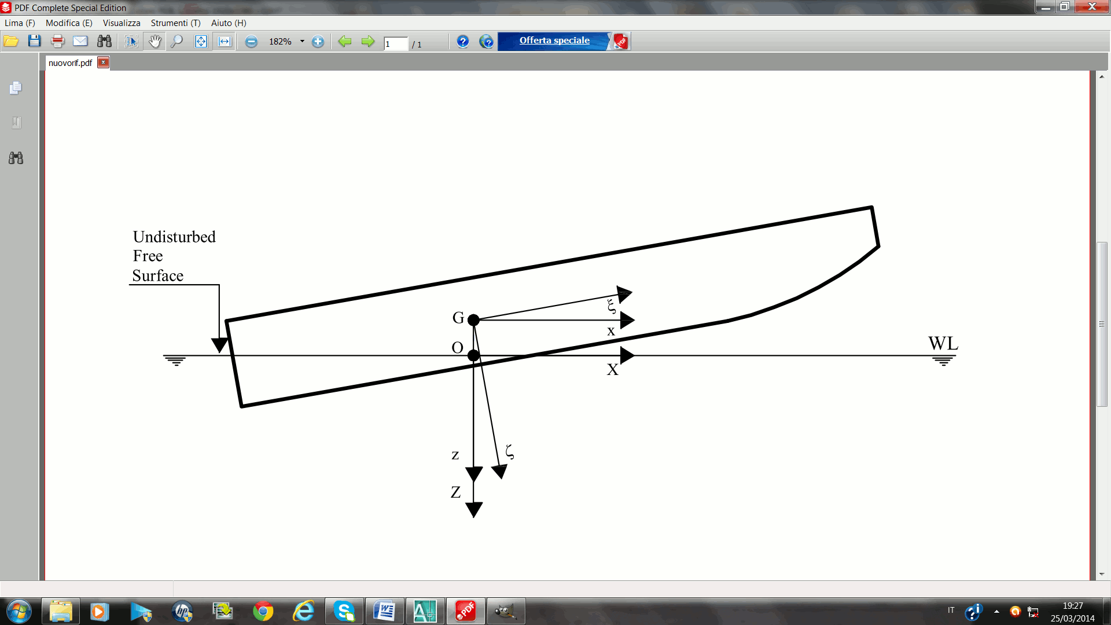

**Figure 1.** Reference systems definition

The forces acting on a planing hull in calm sea conditions are: weight force W, shaft thrust T, drag D, hydrodynamic force FHD and hydrostatic component FHS as schematized in Figure 2. When wave invests the hull a modification of hull volume changes the vertical forces balance. Shaft thrust and drag are neglected, as their horizontal components, which are predominant, are assumed constant over time and thus in stationary equilibrium. Forces acting on a planing hull in waves are defined as: hydrostatic force; hydrodynamic force (lift); Froude-Krylov hydrodynamic force.

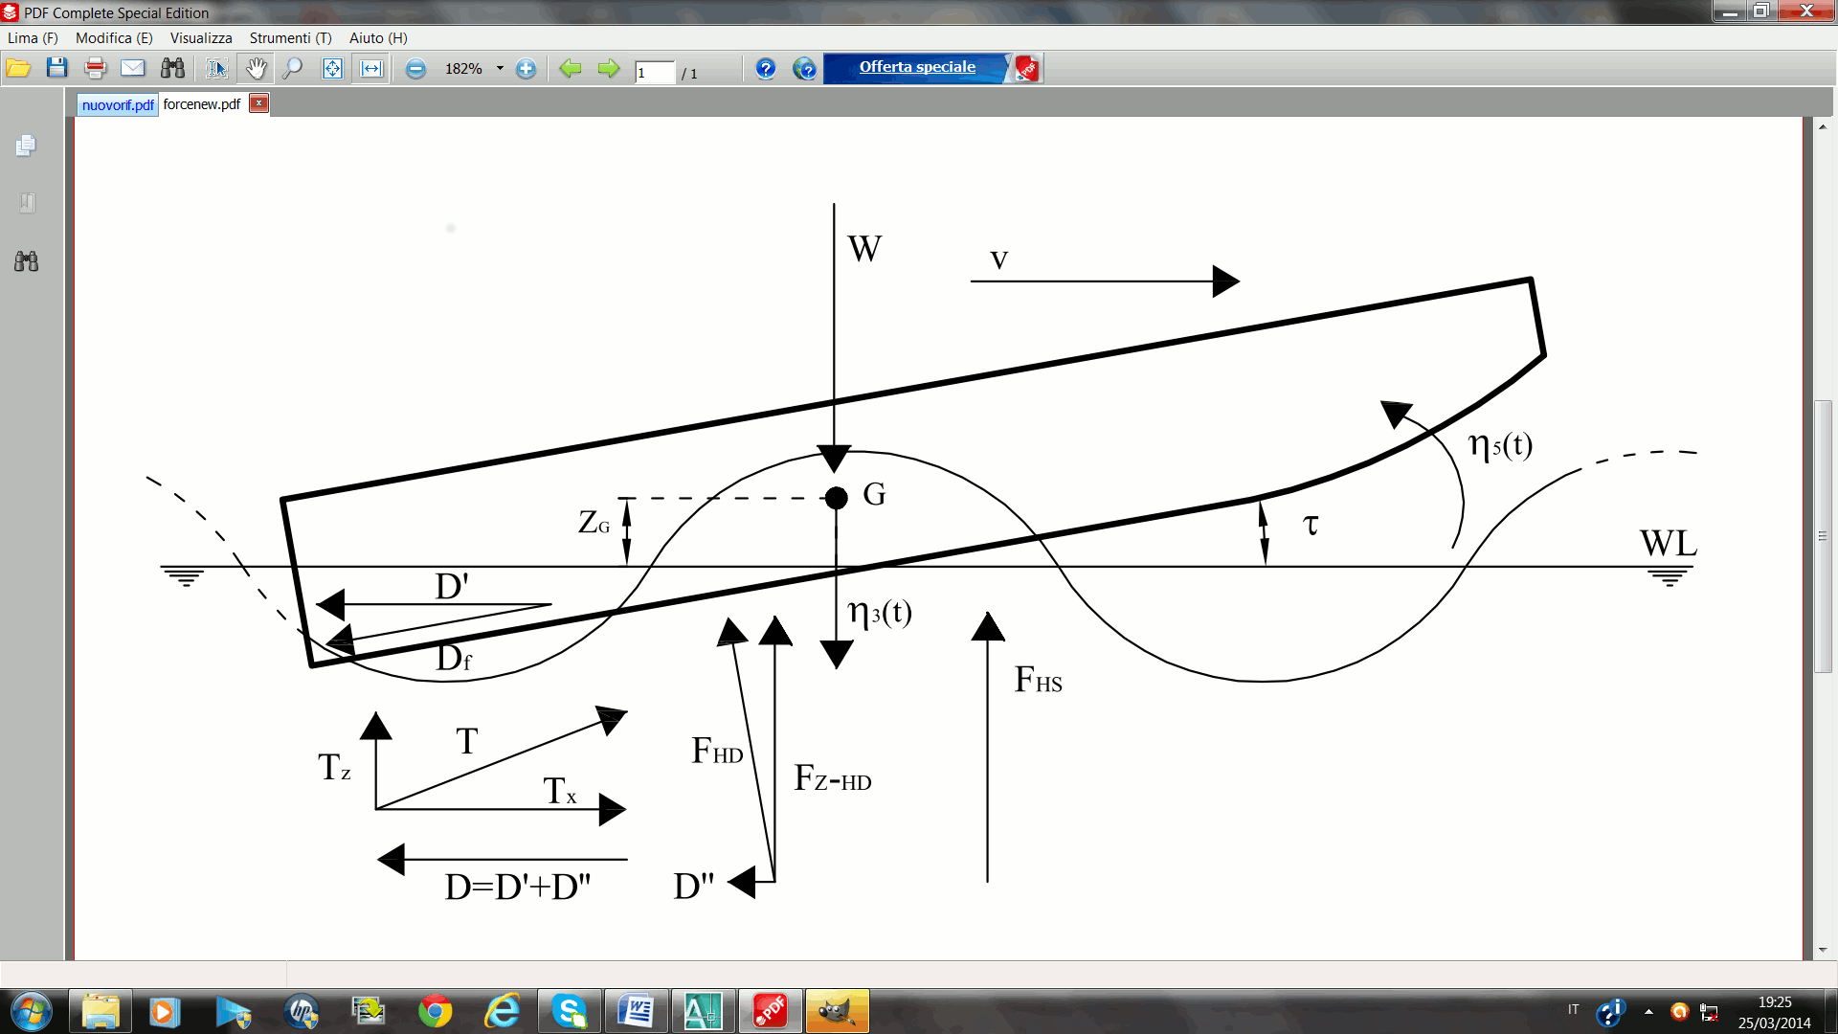

**Figure 2.** Acting forces at planing hull in waves and definition of motions

For planing hull diffraction force is assumed zero. The amplitude of the diffracted waves is proportional to the hull volume, which is, in planing conditions, small and therefore also the damping forces, related to the diffraction of wave, are negligible compared to the other forces. The considered vertical motions of the hull are characterized by heave η3 (positive downward) and pitch η5 (positive bow up). All other motions are neglected. The initial heave is corrected with sinkage, i.e vertical rise of centre of gravity, while the initial pitch is equal to  running trim at considered speed. In the planing mode the hydrostatic force is negligible as it is the hydrodynamic lift that support the weight, but when the hull encounters a wave and passes through it the wetted surface and the hull volume change and the hydrostatic component becomes no longer negligible. The global hydrostatic force acting on hull is obtained by the integration of the sectional static component. This leads to final expression for hydrostatic force and moment:

 ,  (1)

where A(ξ,t) is the cross sectional area,  is the water density and g the gravitational acceleration. Following the Airy theory, applied in a non-linear form which accounts for the effective draught of each section, the sectional Froude Krilov force is calculated as the integral on the wetted perimeter of the dynamic component of pressure. The regular waves are described in the reference system OXYZ by:

 (2)

where A is the wave amplitude; k is the wave number;  is the wave direction;  is the wave frequency; ωe is the encounter frequency;  is the wave phase With this definition at initial time, the regular wave has its crest in correspondence with the boat centre of gravity. The sectional force is given by:

 (3)

where S is the wetted perimeter of each section and pFK is the dynamic component of pressure. The integration along the hull length of the sectional forces gives the total wave forces.

 ,  (4)

The sectional dynamic component fHD(,t) is calculated considering that the force exerted by a fluid on the hull is equal to the variation of the momentum associated to the fluid mass moved by the boat with speed equal to the relative vertical velocity between the boat and the undisturbed fluid:

 (5)

where mA is the sectional added mass, V is the relative velocity in plane of the cross section normal to the baseline. The relative speed of the boat is the sum of two components: a component due to the advanced velocity and to the keel inclination angle with respect to the horizontal (stationary component); a component resulting from the relative movement between the section and the water free surface in the concerned section (dynamic component). Considering that for small angles  and  the relative velocity becomes defined as:

 (6)

where wZ is the vertical component of the wave velocity.

The global lift force is reported in the following equations:

 (7)

The global hydrodynamic component of the pitch moment is obtained by the sum of three contributions.

 (8)

The horizontal velocity U is approximated to the advance velocity v. In the developed numerical code, for the evaluation of the sectional added mass the Payne’s approach has been used. The 2D sectional added mass mA is expressed by (9) where Cm is the non-dimensional sectional added mass coefficient, Payne [10] [11]; deff is the ‘effective penetration’ of generic section inside water including pile-up,  is the deadrise angle. Finally, force and moment equilibrium equations, in coordinate system Gxyz, are written by equations (10) and (11). The complete mathematical model is reported in Pennino [12].

 (9)

 (10)

 (11)

# Validation of developed code

The 2D nonlinear numerical code is developed for hard-chine hulls with variable deadrise angle and beam along boat length. The mathematical model is implemented considering the hull as made of 2D ‘strips’, and evaluating the total 3D forces as the resultants of sectional forces which act separately without interactions. The geometry is imported from a 3D CAD modeller. The developed code consists of two parts. The first part allows the calculation of forces and motions coefficients depending on the effective wetted surface in incident wave. In the second parte the system of equations is solved instant by instant using the numerical integration algorithm of 4th order Runge-Kutta adding the initial conditions relative to the undisturbed steady equilibrium position at the specified speed. The ship velocity, running trim and sinkage are input parameters and heave and pitch motions are computed as a variation in time around this position. To validate the developed code experimental data are used. Model main dimensions and inertial properties are given in Table 1. Seakeeping tests were performed in the Towing Tank of the University of Naples “Federico II” at constant speed with models restrained to sway, roll and yaw. Tested wave frequencies are given in Table 2. The code calculations are performed with a time step 0.002 s, the same as the sampling frequency used in experiments. Simulation time of 50 seconds in model scale was considered, although from model tests maximum time history is about 15 s. It was seen from the flow separtion, from calm water tests, Begovic et al. [1], that at speed 4.6 m/s, corresponding to a volumetric Froude number equal to 2.60, model is in a planing regime and that the numerical assumptions are fairly respected. The numerical results and the comparison with experimental data are given for this velocity. Examples of calculated vs. measured heave and pitch responses are given in Figure 4 and 5 for wave frequency of 0.65 Hz and 7 seconds registration. It has to be noted that pitch curve presents different shape of crest and troughs, indicating nonlinear form. Before any further data analysis, FFT has been performed, and it was shown that very small second order harmonic in heave and small second order harmonic in pitch will results in very pronounced higher order harmonics in accelerations, as can be observed in Figure 6.

**Table 1.** Model principal characteristics

|  |  |  |  |  |  |  |  |  |  |
| --- | --- | --- | --- | --- | --- | --- | --- | --- | --- |
| **LOA** | **LA-B** | **B** | **TAP** | **** | **  ** | **LCG** | **VCG** | **k44** | **k55** |
| **(m)** | **(m)** | **(m)** | **(m)** | **(N)** | **(deg)** | **(m)** | **(m)** | **(m)** | **(m)** |
| 1.9 | 1.5 | 0.424 | 0.096 | 319.7 | 16.7 | 0.697 | 0.143 | 0.1281 | 0.5833 |

**Table 2.** Test matrix

|  |  |  |  |  |  |  |
| --- | --- | --- | --- | --- | --- | --- |
| **f** | **** | **k** | **** | **/LOA** | **A** | **H/** |
| **(Hz)** | **(rad/s)** | **(rad/m)** | **(m)** |  | **(mm)** |  |
| 1.00 | 6.283 | 4.026 | 1.561 | 0.821 | 16 | 0.020 |
| 0.90 | 5.655 | 3.261 | 1.927 | 1.014 | 20 | 0.021 |
| 0.80 | 5.027 | 2.576 | 2.439 | 1.284 | 20 | 0.016 |
| 0.70 | 4.398 | 1.973 | 3.185 | 1.676 | 20 | 0.013 |
| 0.65 | 4.084 | 1.701 | 3.694 | 1.944 | 32 | 0.017 |
| 0.60 | 3.770 | 1.449 | 4.335 | 2.282 | 32 | 0.015 |
| 0.55 | 3.456 | 1.218 | 5.160 | 2.716 | 35 | 0.014 |
| 0.50 | 3.142 | 1.006 | 6.243 | 3.286 | 35 | 0.011 |
| 0.45 | 2.827 | 0.815 | 7.708 | 4.057 | 45 | 0.012 |
| 0.40 | 2.513 | 0.644 | 9.755 | 5.134 | 45 | 0.009 |

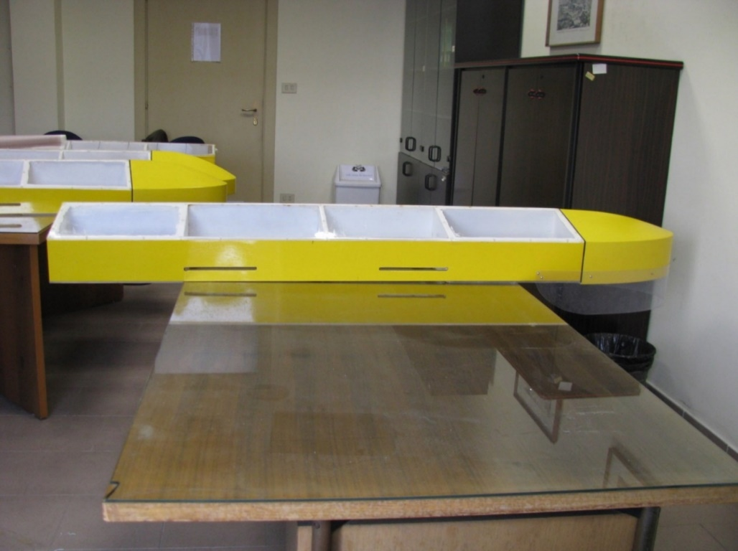

**Figure 3.** Monohedral hull geometry

|  |  |
| --- | --- |
| heave**Figure 4.** Numerical vs. experimental heave | pitch  **Figure 5.** Numerical vs. experimental pitch |

FFT_num

**Figure 6.** FFT of heave, pitch and accelerations at v=4.6m/s, f = 0.65Hz

# Comparison of numerical and experimental data for monohedral hull

Comparison of numerical and experimental results for heave and pitch are summarized in RAO diagrams given in Figures 7 and 8. As can be noted from figures heave and pitch motions are generally well predicted, the biggest differences between numerical and experimental are approximately 20%. To validate accelerations calculations, comparison of experimental and numerical first two harmonics is given as RAO in Figures 9-10. Second order acceleration RAO is defined as amplitude of 2nd order harmonic divided by g. It can be noted that at /L>2.2 the prediction is worse than for shorter waves. What can be noted it is that accelerations at LCG are reasonably well predicted while, as regard bow accelerations are further underestimated. This is mainly due to the pitch underestimation which plays an important role in motion composition.

|  |  |  |
| --- | --- | --- |
| **Figure 7.** Comparison of calculated and experimental heave RAOs | **Figure 8.** Comparison of calculated and experimental pitch RAOs | |
| **Figure 9.** Comparison of calculated and experimental accelerations at CG | | **Figure 10.** Comparison of calculated and experimental accelerations at bow |

# Conclusions

A 2D time domain nonlinear code is developed in Matlab-Simulink for vertical motions and acceleration prediction. Although the method is known, new and original part of the work is focused on the validation of the method for acceleration prediction. High sampling frequency of 500Hz during tests allowed precise acceleration determination. Higher order harmonics found in experimental records, especially for bow accelerations, have been reproduced by applied mathematical model. Both predicted and experimental time series have been analysed, in the same manner, by FFT identifying first and second harmonic RAO for all wave frequencies. The error in pitch prediction is propagated to bow accelerations where the numerical values are significantly underestimated. The reason for these results should be searched in some critical issues of mathematical model. First of all, in the case of wetted chine, superelevation of free surface is considered although this is physically incorrect, because of flow separation. Furthermore, pile up coefficient, used in Payne’s work, is function only of deadrise angle and surely effect of forward speed should be taken into account. Assumptions of small trim angle and horizontal velocity identical to forward speed lead to great simplification of mathematical model. From the comparison of experimental and numerical results of vertical motions, the model can be useful tool in the design stage of high speed small craft as it is fast and reasonably accurate.

References

1. Begovic, E., Bertorello, C., 2012. Resistance Assessment of Warped Hullform, Ocean Engineering, Vol 56 (2012), pp. 28–42, DOI: 10.1013/j.oceanengineering.2012.08.004.
2. Begovic, E., Bertorello, C., Pennino, S., 2014. Experimental seakeeping assessment of warped planing hull. OceanEng. Doi: 10.1016/j.oceaneng.2014.03.012.
3. Begovic, E., Bertorello, C., Pennino, S., Piscopo, V., Scamardella, A., 2016. Statistical analysis of planning hull motions and accelerations in irregular head sea. Ocean Engineering, Vol 112 (2016), pp. 253–264, DOI No: [10.1016/j.oceaneng.2015.12.012](http://dx.doi.org/10.1016%2Fj.oceaneng.2015.12.012).
4. Fridsma, G., 1969. A Systematic Study of the Rough Water Performance of Planing Boats, Report 1275, Stevens Institute of Technology, November 1969, Report 1275.
5. Garme, K., 2005. Improved time domain simulation of planing hulls in waves by correction of the near- transom lift. International Shipbuilding Progress, 52(3):201–230.
6. Ghadimi, P., Dashtimanesh, A., Reza, S., Yaser, D., Maghrebi, F., 2013. Development of a mathematical model for simultaneous heave, pitch and roll motions of planing vessel in regular waves, International Journal of Scientific World, 1(2), Science Publishing Corporation.
7. Hicks, J.D., Troesch, A.W., Jiang, C., 1995. Simulation and Nonlinear Dynamics Analysis of Planing Hulls, Journal of Offshore Mechanics and Arctic Engineering, Vol. 117, Feb. 1995, paged 38-45.
8. Keuning, J.A., 1994. The nonlinear behaviour of fast monohulls in head waves, Ph.D. thesis. Technische Universiteit, The Netherlands.
9. Martin, M., 1976. Theoretical prediction of motions of high speed planing boats in waves. David W. Taylor Naval Ship Research and Development Center Report 76-0069.
10. Payne, P.R., 1994. Recent developments in "added-mass" planing theory. Ocean Engineering 21. No. 3, 257-309.
11. Payne, P.R.,1995 Contribution to planing theory. Ocean Engineering, Vol. 22, No.7, 699-729.
12. Pennino, S., 2014. Vertical motions assessment of planing hulls, Ph.D. thesis. University of Naples “Federico II”, Italy.
13. Ruscelli, D., 2009. Dynamics of High Speed Craft, Ph.D. Thesis, University of Genova.
14. Savitsky, D., Brown, W. P., 1976. Procedures for hydrodynamic evaluation of planing hulls in smooth and rough water. Marine Technology, 13, 381–400, Oct.
15. Savitsky, D., Koebel, J.G., 1993. Seakeeping of Hard Chine Planing Hulls, Technical Research Bulletin No. R-42, SNAME.
16. Sebastiani, L., Ruscelli, D., Rambaldi, G., Viviani, M., 2008. A Momentum Theory Approach to the Seakeeping of Planing Crafts. HSMV2008.
17. Tavakoli, S., Ghadimi, P., Dashtimanesh, A., 2017. A nonlinear mathematical model for coupled heave, pitch, and roll motions of a high-speed planing hull. Journal of Engineering Mathematics.Volume 104, Issue 1, pp 157–194.
18. Van Deyzen, A., 2008. A Nonlinear Mathematical Model of Motions of a Planing Monohull in Head Seas. HIPER08, Naples, Italy.
19. Zarnick, E., 1978. A Nonlinear Mathematical Model of Motions of a Planing Boat in Regular Waves. DTNSRDC/SPD 0867-01.

1. Silvia Pennino, University of Naples “Parthenope”, Department of Sciences and Technology, isola C4 Naples - Italy; silvia.pennino@uniparthenope.it [↑](#footnote-ref-1)