Inclusive Yacht Design

Paolo FERRARI^{a,} and Walter UKOVICH^{a,}
ª University of Trieste, Trieste, Italy
Abstract. The proposal focuses on the definition of a new approach for the design of accessible and inclusive sailing yachts that takes into account the typical problems of users affected by permanent and temporary disabilities, as well as children, the elderly and pregnant women. Starting from the analysis of the current state of the art relating to sailing yachts ranging from 33 to 78 feet, it is possible to determine a series of cases in which the user, depending on his limit, may encounter problems of accessibility or use of external and internal spaces. The research aims to define the most suitable solutions for each of them, in order to create a reference standard in the field of nautical design to promote accessibility and inclusion. The deepening of this theme, which is not easy due to the numerous variables that make up the disability framework and the peculiarities of the "boat" environment, leads to the drafting of a manual that analyzes a series of design solutions applicable to narrow spaces like that of yachts, respecting the rules of ergonomics applied to the dimensions required by the particular conditions of the user, in order to eliminate the architectural barriers present on board.
Keywords. Design, yachts, disability, accessibility, inclusion, ergonomics.

Introduction
Through a predictive analysis, considering the lengthening of life expectancy, experts say that the world population will be getting older and therefore characterized by different types of disability [1]. For this reason it is essential that designers and architects focus their attention on projects that can meet the needs of all, developing, especially in the context of inclusive disciplines, specific design approaches.
The inclusive design today is therefore addressed to every human being: considering that the average individual represents a small part of the population, designing according to a standard means penalizing or excluding a large part of individuals from the use of products, services and environments. In this sense, the most appropriate design methodology is defined by the "Design for Inclusion".
In the last few years some pleasure boats have been created to favor the inclusion, giving life to crews made up of men and women, young and old, able and disabled. This type of experimentation, even if not widespread, gives an idea of ​​the potential inherent in such a design approach, which would allow to create boats able to satisfy different types of users simultaneously, creating inclusion, integration and opening new commercial scenarios. At present, however, there are no precise indications for the design of accessible pleasure craft, so this document focuses on the definition of guidelines for the design of accessible and inclusive sailing vessels that takes into account the typical problems of users with permanent or temporary motor difficulties and of the so-called “weak groups” (children, elderly people, women in an interesting state). It is important to note that, even in large boats, these problems have never been taken into consideration, even if the dimensions make the solutions easy.

Possible solutions to improve the accessibility of sailing yachts

In order for a boat to be accessible, it is advisable to provide a fully open transom. The design of the boats, thanks to the geometry of the lines of modern hulls, has already led to this result, but it is of fundamental importance that it is not hampered by any kind of obstacle to the passage for the person in wheelchair.
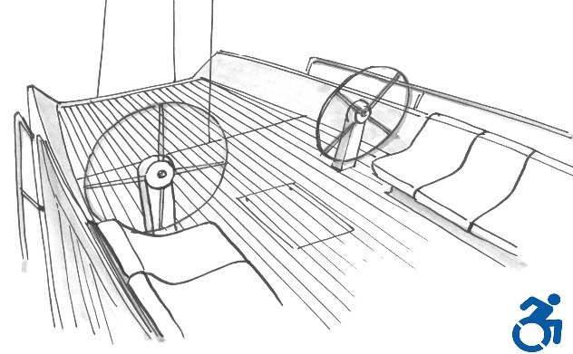

Figure 1. The transom, completely opened, and the insertion of a helm composed of two wheels, sufficiently distant from each other, are the ideal solution for an easy boarding.

A designer must be aware of the problems and difficulties of a disabled person and try as much as possible to meet his needs. This means designing any accessory, aid, environment or even just part of it, in such a way as to satisfy the ergonomic and spatial requirements, safety and autonomy of all those who are not able to overcome certain physical and sometimes psychological obstacles.
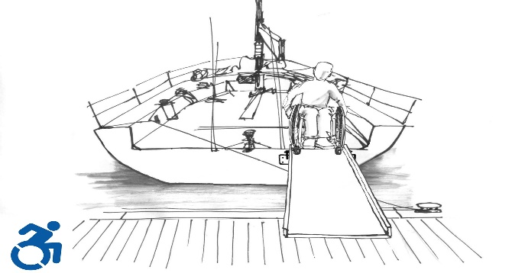

Figure 2. An inclusive design must be able to facilitate the boarding and disembarkation of the person in a wheelchair, in total safety and, as much as possible, independently.

This can also mean having to completely rethink what has been done to date. A solution, for example, that would allow people with disabilities to have an accessible berth in each port or marina, consists of a system already in use in the construction sector for the restoration of facades or for the cleaning of glass in buildings : an electrically operated scaffolding, permanently fixed to concrete piers, can facilitate access to any type of boat equipped with an accessible transom. A tilting platform would also ensure the safety of the individual and save the boat from the risk of damage, due to the wave motion or the ups and downs due to the tide. It would be useful for each marina to offer a small percentage of moorings for boats with disabled passengers on board, equipped with special features to facilitate onboard access and maneuvers. This could be quickly inserted into national (and international) regulations as it alredy happens in public parking lots, in which a certain percentage of stalls are reserved for disabled people.
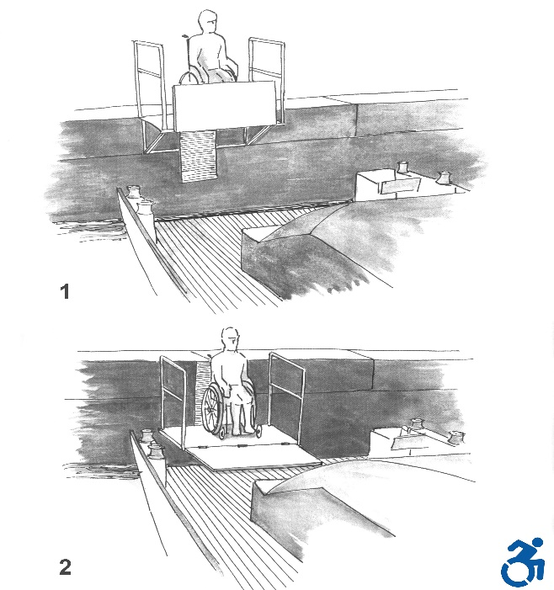
Figure 3. An innovative system of permanent embarkation for accessible berths, suitable both for harbors and for marinas.

An innovative system to solve the problem of ergonomic use of the helm by a disabled person consists of a passing wheel, in which the spokes and the supports are moved below the deck, in order to allow the wheelchair to easily cross the helm to access the cockpit area. In this way it is therefore conceivable a path without obstacles along the longitudinal axis of the boat.

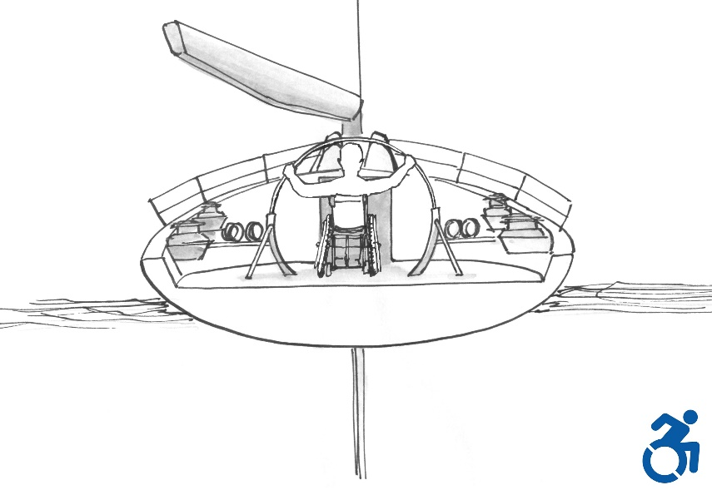
Figure 4. Innovative helm with central passing wheel: the mechanisms are placed below the deck to allow the wheelchair to cross the wheel and access the cockpit area.

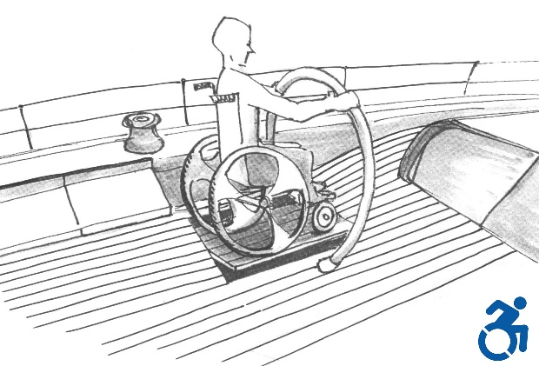
It is therefore necessary to provide the use of assistive systems that fix the wheelchair to the deck of the boat and it is useful to imagine to prepare the boat to accommodate a tilting platform, positioned near the governing bodies or maneuvers, which ensures the straightening of the wheelchair in the event of heeling, also constant, and modify it at any time through an electronic control system based on the principle of the gyroscope.

Figure 5. In order to avoid the overturning of the wheelchair, already secured to the bridge by exsisting blocking systems normally mounted on trains and city buses, it is necessary to place it on a tilting platform, electronically controlled, so as to support the rolling and the heeling of the boat.

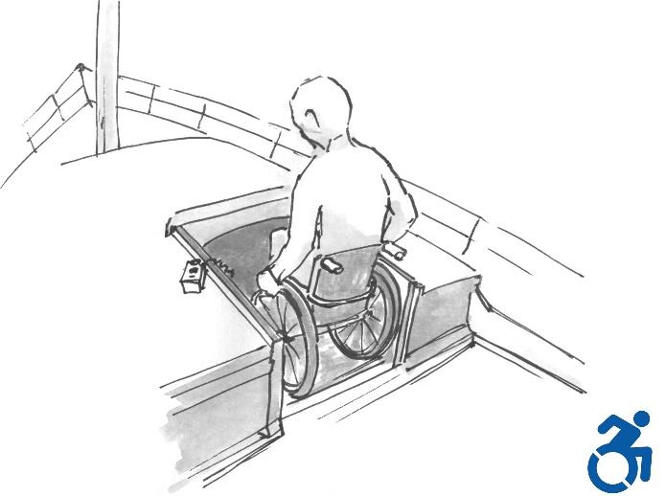
A fully accessible hatch is the first element of the boat on which to set up a design that is attentive to the needs of disabled people. It must have a net light of at least 80 centimeters, have a one-piece hatch, which can slide sideways, and must not show coamings or obstacles higher than 25 millimeters. It is also advisable to insert an internal threshold, with a "wheel lock" system, for greater personal safety.
Figure 6. It is necessary to change the current design approach to allow the best access to the spaces below deck, independently and without risk.

To access the lower deck and to overcome any difference in height it is suggested the adoption of an electric lifting platform that gives the possibility to the disabled person to move between the various levels of the boat in total autonomy.
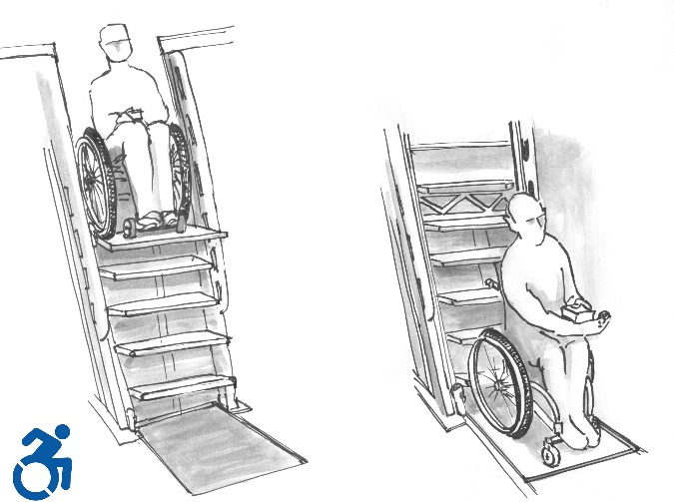
Figure 7. Concept of a possible electric lifting platform, designed to make the interior spaces of any boat accessible in total autonomy.

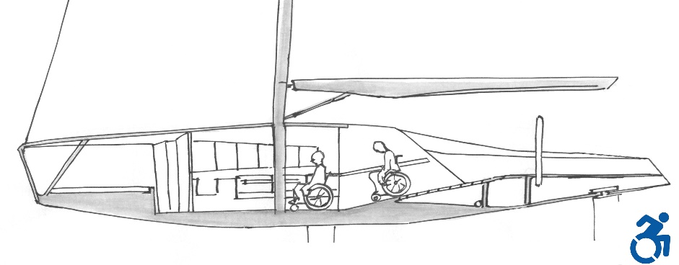
On boats larger than 15 meters, it is conceivable to use controlled slope ramps, to replace the classic access ladder.
Figure 8. Only by reconsidering the project in its entirety, according to the principles of Design for Inclusion, it is possible to create innovation with solutions accessible to everyone.

The dinette table must not have fixed seats along the corridor, either to avoid tightening the passage or to offer the disabled person the possibility to easily occupy a seat at the table. The height of the table must always be adjustable: although it is quite widespread on most existing boats, in order to lower the table top to that of the chairs to turn the dinette into a large bed, it is not always expected. The ability to adjust the height plan, according to the needs of each, is a detail that expresses particular attention towards individuals with different skills and types of disability. Furthermore, it is advisable to plan the interior spaces so as to give the wheelchair the possibility to make a 360° rotation, without having to force the disabled person to carry out complex maneuvers.
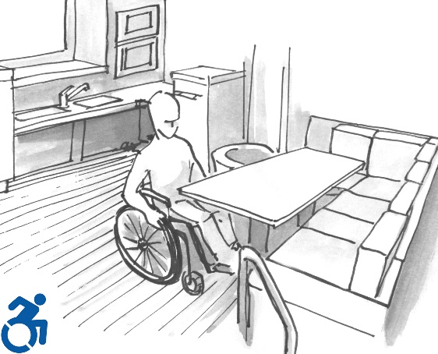
Figure 9. Removing seats placed towards the center of the boat, allows people in wheelchairs to easily take a seat at the table.
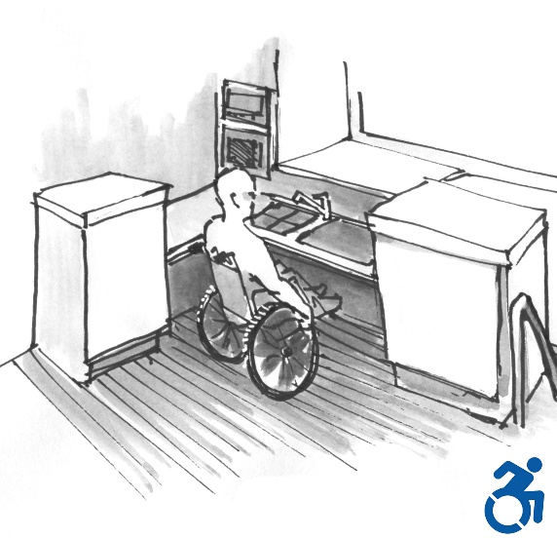
Figure 10. A design for an extended use does not impact the usability of the kitchen by everyone: it is very important to respect the ergonomic needs that a disabled person needs.

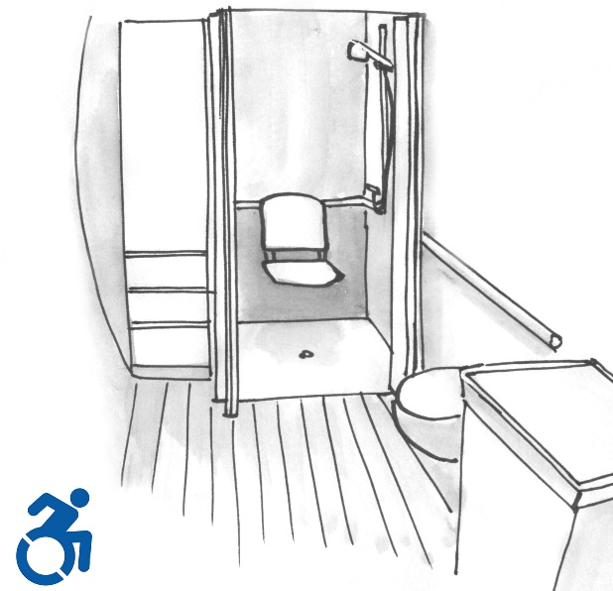
As already mentioned, it is necessary that the design of every environment takes care of the need of everybody. The bathroom, as the kitchen, follows the rules of ergonomics and common sense, so that disabled people can enjoy the inner accessories without any discomfort. Accessible doors, space to maneuver the wheelchair, folding seat in the shower not to wet the wheelchair, mirrors and fixtures at the correct height.
Figure 11. In the case of shower box, it is not necessary to provide the wheelchair rotation, but it is necessary that the disabled person can access it from the front to be able to move on the retractable seat, so as not to wet his wheelchair.

Conclusions
The work aims to provide a series of guidelines for the design of inclusive sailing boats, as well as to give solutions also applicable to motor yachts. In fact, it proposes alternative solutions to the traditional design methodology of a boat: solutions based on dimensioning more attentive to the needs of people with motor disabilities have been adopted. Innovative proposals were also studied to improve the accessibility conditions of a boat, starting from the system of passage between the mainland and the boat's deck, contributing to make yachts inclusive and aggregating, as well as without any discriminating elements.
Accessibility has been examined in relation to the external space (dock-boat access, mobility in the cockpit area and deck) considering the disable person both as a transported host and an active member in the conduction of the vehicle. The interior space has been examined starting from the problems of access to the lower deck by a individual in wheelchair, the route to the fruition of the main functions (toilets, bed) and those related to the preparation of food and the best layout for the table in the dinette area.
The safety of the disabled person was considered for each of the functions mentioned above; subsequent researches will have to reconsider the structure of the wheelchair and deepen, simplify and make easy the ways of use of the safety devices, already considered in this phase, so important in a space continually oscillating on the three Cartesian axes.
The paper also try to make up for the almost total absence of specific publications on the topic addressed, creating a precedent within the scientific literature of the sector.
By adopting integrally or even partially the solutions proposed in the research it is possible to create a new type of sailing boat and allow everyone not only to navigate autonomously and safely, but also to create new business opportunities such as charter for extended users, inclusive sailing schools and the development of further solutions that are increasingly useful for making boats truly "for everyone".

References
- Sergei Scherbov, Daniela Weber – BMJ Journal: “Future trends in the prevalence of severe activity limitations among older adults in Europe: a cross-national population study using EU-SILC”. http://bmjopen.bmj.com/content/7/9/e017654
- Opacmare Transformer website:
http://www.opacmare.com/Catalog/transformer-integrato-nel-portellone-del-garage/

Paolo Ferrari, Department of Engineering and Architecture, via Alfonso Valerio 6/3 - 34127 Trieste, Italy; E-mail: pferrari@units.it.
Walter Ukovich, Department of Engineering and Architecture, via Alfonso Valerio 6/3 - 34127 Trieste, Italy; E-mail: ukovich@units.it.

