Italian Navy future fleet – Analysis on on board electrical system and cold ironing
Michele CATANEOª, Gennaro LIPARDI^{b}
ª Italian General Navy Staff, Rome, Italy
^{b} Italian Naval Directorate, Rome, Italy
Abstract. Shore Connection has become a topic of huge technical interest both for merchant ships and for military ships. The Navy’s fleet renewal program offers the opportunity to reconsider this aspect within the main naval bases of the Italian peninsula. In particular, the presentation analyzes the overhaul project of Stazione Navale Mar Grande’s electrical system in Taranto with the aim to be ready to host the future fleet in 2027. It is proposed a working methodology to optimize the final result for several future scenarios in order to guarantee the maximum flexibility and interchangeability for the mooring and shore connection services that will be provided for different ship sizes and electrical power levels. Finally, further improvements in the electricity grid are considered (potential “spin off”), such as energy efficiency systems, green energy sources and distributed cogeneration integrations to meet the need and to gain the desired load shaving.
Keywords. Cold Ironing, Electrical Power Energy, Bidirectional Shore Connection, Dual –Use Converter

Introduction
Cold Ironing (CI) is a practice in use in the Italian Navy (“Marina Militare Italiana”, MMI) since the 70s for maintenance needs of the hull, the fittings or the combat system. During the stay at berth (for a few days as well for months) the activities on military ships require a huge supply of electricity for on-board services. For MMI ships, therefore, the use of Shore Connection Systems (SCSs) is beneficial for several reasons, such as the reduction of air emissions and noise pollution in the harbour area. Moreover, the reduction of the hours of motion of diesel generators and the number of security personnel. For these reasons, the CI remains a topic of discussion in MMI, as in NATO, where the update of the ANEP 67 [1] standard foresees a session dedicated to the SCSs topic, with the aim of standardize the solutions of the individual members. The CI constitutes an important opportunity also for cruise ships or merchant ships, subject to periods of continuous stay in port shorter than the military ones. Today, there are many countries that aim to reduce polluting emissions and that is why the three IEC, ISO, IEEE bodies are working to harmonize and standardize the CI internationally in the drafting of the IEC/ISO/IEEE 80005 series “Utility connections in port”. The standard, as is known, aims to standardize the myriad of electrical connections found in the merchant market, without imposing too rigid solutions. This article summarizes some considerations on CI in the MMI field with the aim of providing possible solutions of SCSs which are able to meet the energy needs of the “Fleet 2027” scenario, as well as proposing a “logical process” (Figure 1) in order to provide a line of direction towards the future horizon.
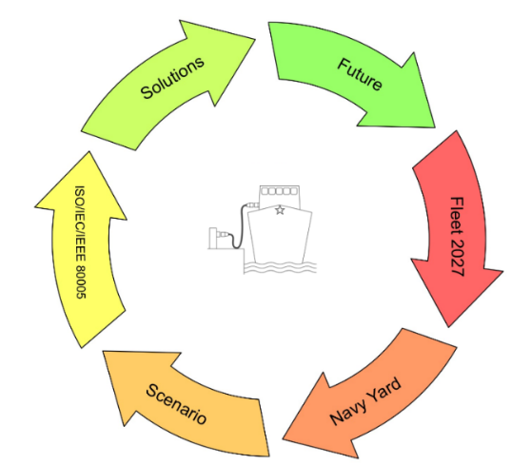
Figure 1. The logical path used for the definition of shore connection systems.

The evolution of cold ironing of military ships and the common denominator: the growth of power
Since the early 70s, all military vessels moored at the main naval bases (“Arsenale MMI” of La Spezia and “Arsenale MMI” of Taranto) were electrically powered from the shore at 440 V @ 60 Hz or 380 V @ 50 Hz, with limited load requirement of up to about 0.5 MVA.
The executive project of the electrical installation of the Mar Grande Naval Station of Taranto (SNMG), today the main Naval Base of the MMI, is dated 1998 and was intended to ensure the power supply to ships that would have been housed in a few years. The SCSs had to operate according to the Voltage/frequency levels mentioned above, but guaranteed a power up to the order of 1.8-2.3 MVA per Unit. These power levels allowed the major units to be fed with an adequate margin, such as ITS Garibaldi (1.6 MVA) or the two DDGs Durand de la Penne Class (0.8 MVA).
A turning point was set in 2002 by the study of the power supply of the new major ship (Cavour Aircraft Carrier). It consisted of the adoption of a distribution frequency of 50 Hz, in order to use COTS (commercial off-the-shelf) and a SCS at the same frequency used in Italy (as well as in the rest of Europe). The choice, initially in contrast to the NATO or International contexts, where the use of 60 Hz was favoured, has not yet highlighted any operational shortcomings of the Unit over the years. Conversion systems, rotating or static are now technologically mature to be installed on board military ships without increasing weight and size. The weapon system has a has a limited power load demand of about 10%, compared to total power installed on-board. This has ensured a 60 Hz sub-network that complies with NATO standards [2].
On the other hand, the voltage level chosen for the distribution (660V) and load demand in the port (about 4 MVA), favoured an innovative solution for the management of the electrical connection operations of the ship to the ground network compared to the traditional methods illustrated in Figure 2.
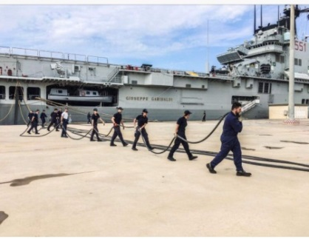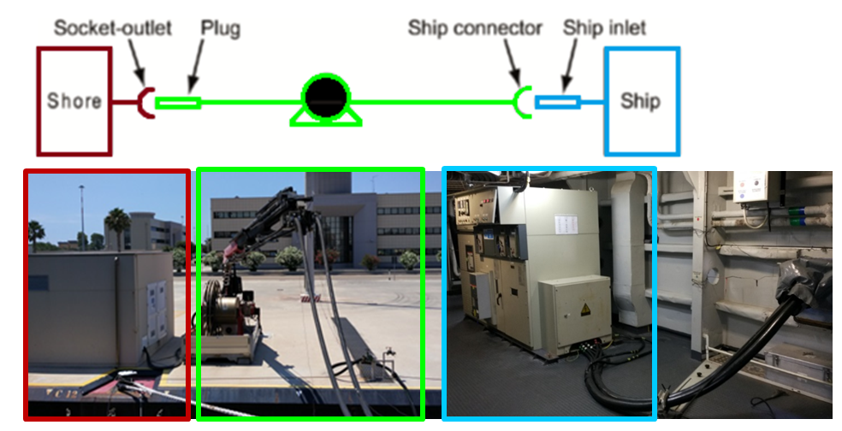
Figure 2. Traditional operations of laying cables for shore connection (ITS Garibaldi, on the left) and HVSC System from shore cabin to ship (ITS Cavour, on the right).
The use of medium voltage, exclusively for cold ironing only, appeared the best solution. Thus, on board were installed two 6000/660 V from 4.4 MVA (each) shore connection transformers. On the other hand, in addition to the shore transformer cabin, it was decided to use a cable management system that would have greatly simplified the connection operations. In this way, the ship was freed space for specific dedicated equipment, such as the shore connection cables (about 3 km estimated) and the respective motorized reels girders (traditionally both on board), whose volumes and weights would have been superior to those of the two shore connection transformers. Although marking a new trend, however, the ITS Cavour experience of the beginning of the millennium represented an isolated case, without becoming a policy/constraint for the naval designer and for the infrastructural designer, as indicated in Sulligoi et al. [3]. The first decade of the new millennium was characterized by the Italian-French Program European Multi-Mission Frigates (FREMM), for the construction of 10 Naval Units in place of those of the Maestrale Class. In this case, it was not convenient to manage 50/60 Hz conversion systems to supply power to the combat system and TLC loads. In fact, these systems were much more energy-consuming than in the past. The electrical distribution on board was thus built on two voltage levels, 6600-440 V @ 60 Hz, each with a dedicated shore panel. Also in this case, there was a significant growth in terms of power demand of the ships for the cold ironing: from the 0.5 MVA required by the Maestrale Frigates, it passed to around 1.8 MVA for each FREMM. The infrastructural adaptation of the bases did not require a transition to medium voltage, as the existing 440V @ 60Hz shore connection systems were used. However, the use of electrical power was higher and the management was more complicated for the ship personnel due to the absence of handling automated.
The “Programma di Rinnovamento” includes the construction of 7 Multipurpose Patrol Ship (PPA), an amphibious Unit (LHD, Landing Helicopter Dock), a logistic Unit (LSS, Logistic Support Ship). The on-board electrical systems are characterized by voltage and frequency levels once again different from each other and with a considerable increase in power required in port compared to previous constructions:
- LHD operating at 6000 V @ 50 Hz, for about 6.5 MVA;
- LSS operating at 690 V @ 50 Hz, for about 1.9 MVA;
- PPA operating at 690 V @ 60 Hz, for about 1.9 MVA.
The fleet scenario in 2027 is therefore composed of Units with high “power load demand”. Figure 3 shows the comparison between the trend lines of the total powers installed on board the main MMI ships of the last forty years and those of cold ironing requirements for the same ships. It’s worth noting that the increase in terms of demand for electric power on board is not a prerogative of the propulsion system alone.

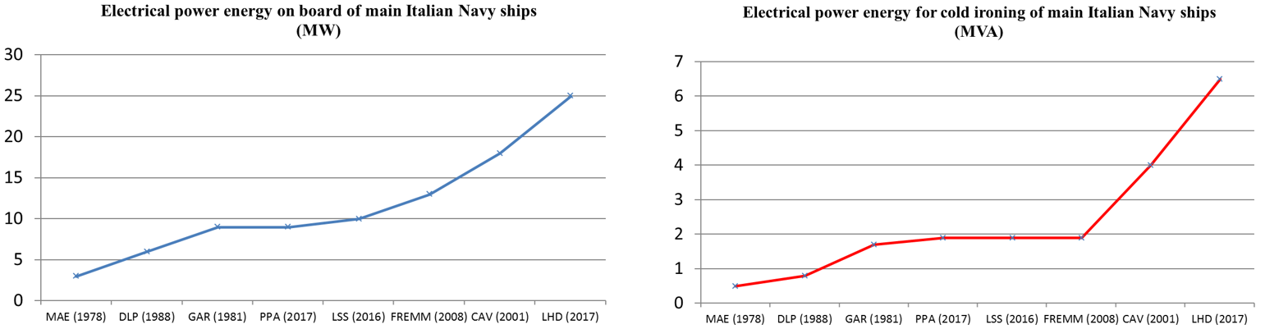
Figure 3. Increase of electrical power on board of Italian Fleet.

The electrical system of the Stazione Navale Mar Grande di Taranto (SNMG)
The SNMG electrical network is of the simple radial distribution type, divided into two double frequency electrical sub-nets, 50 Hz and 60 Hz (Figure 4). As can be seen, a 50 Hz network is used to power ITS Cavour (6000 V @ 50 Hz) and small tonnage vessels (up to 0.2 MVA at 400 V @ 50 Hz). Another 60 Hz sub-network ensures the supply of more naval main Units (440 V @ 60 Hz). The third 50 Hz network is dedicated to ground works (workshops, offices and barracks). At the X0 power plant, the availability of the national distributor is 325 MVA whereas in the primary substation X1 it is dimensioned for the limit power of 32 MVA. The 60 Hz subnet, on the other hand, is capable of delivering a maximum of 24 MVA [4].

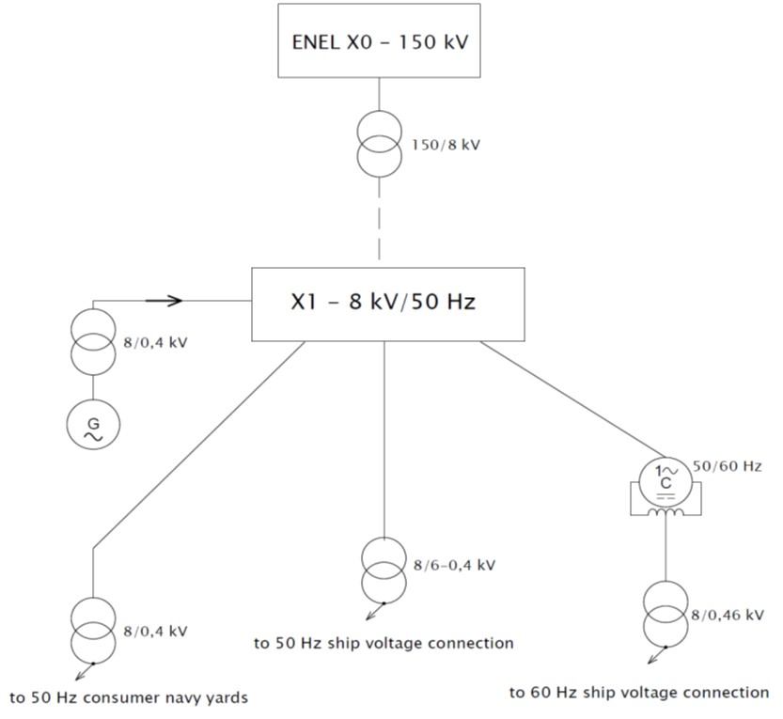
Figure 4. SNMG power plant.

Shore-to-Ship 50/60 Hz and Ship-to-Shore
PPA and LSS have an innovative system to adapt the ship-shore interface to the frequency standards of 50 and 60 Hz used in all countries around the world. The frequency switch is guaranteed by machines already on board: the propulsion converters. Each converter has a power of more than 2 MW and it is of the Active Front-End (AFE) type. On navigation, they are used to control the Electric Propulsion Motor (EPM). During the shore connection period of the ship, they allow to receive 690 V @ 50 Hz electrical power from ground shore panel and convert it to the values of 690 V @ 60 Hz (e.g. in the case of PPA), or receive electricity from the ground shore panel to 690 V @ 60 Hz to convert it to 690 V @ 50 Hz (in the case of LSS). The supplying electrical power to disadvantaged terrestrial sites (disaster relief) or to land base camp is another aspect that characterizes LHD, LSS and PPA. The characteristics and the power of the electric energy vary according to the naval Unit involved and the possible use of integrative container modules. It’s possible supply electricity in the hinterland up to about 2 km (Figure 5) [5] [6] [7].

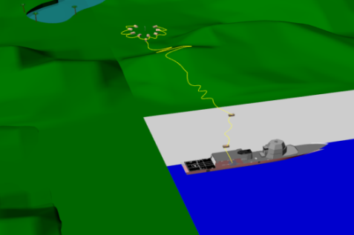
Figure 5. PPA – ship-to-shore mode.

Main differences between mercantile and military reality
As will be noted, due to the ship power requirements and the mission to be carried out, the electrical networks of military vessels has changed by Voltage/frequency levels, imposing reflections on the correspondence of the electrical shore interface. The ISO/IEC/IEEE 80005-1 standard attempts to set the use of SCSs with a value of 6.6 kVac or 11 kVac for ships with power demand greater than 1 MVA [7]. However, this solution is a compromise. That is useful for a ship market essentially spot, with short time spent in port (a few hours) and characterized by different stakeholders (ship-owners, port authorities): a complete standardization remains more theoretical than practical. The use of Navy ships is very different from that of merchant or cruise ships. Figure 6 shows some differences between the Merchant Marine and the Navy. For the Navy only, it emerges the triple role of the “State” as the Ship-owner, owner of the port facilities and decision-maker of the ship’s task profile.
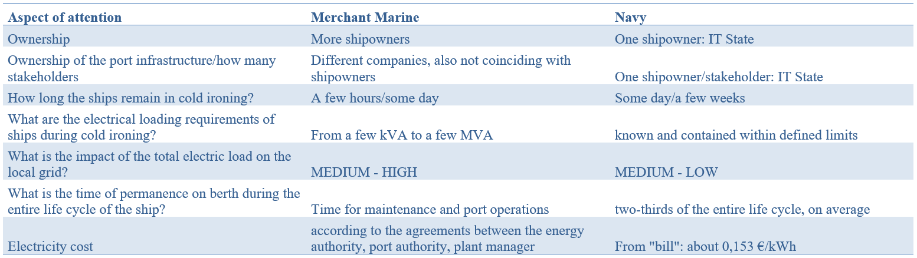
Figure 6. Some differences between the Merchant Marine and the Navy (the reference is to a port infrastructure).

The SNMG Case Study
The input data for the Fleet 2027 shore connection load demand are showed on figure 7. The data are to be understood as “peak” values and non-continuous.
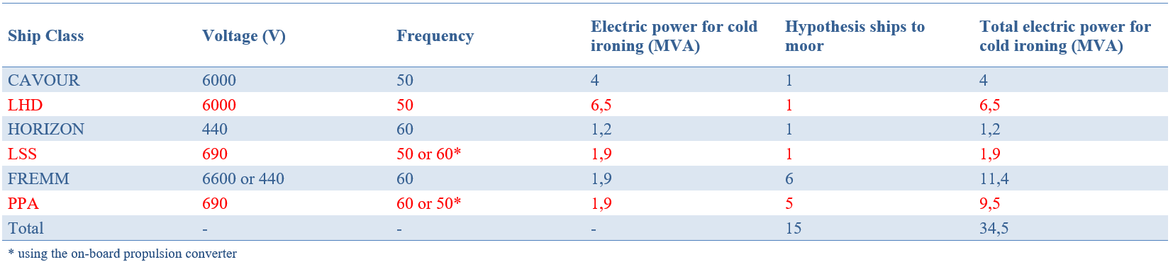
Figure 7. Input data for the Case Study SNMG power grid (in red, the ships for which the new shore connection systems are to be built).
The results highlighted some “grid bottlenecks”:
- “Peak” total power required ships and port buildings is equal to 34.5 MVA. It exceeds the maximum limit of power that can be supplied from the ground system that is 32 MVA. However, the average values absorbed by the Units were also investigated. Figure 8 shows an example the energy performance of ITS Cavour during 6 working days and during a typical working day (standard winter harbour setting).
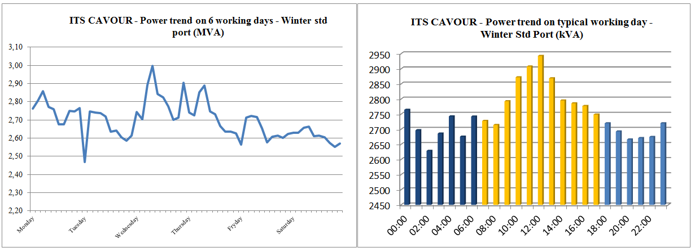
Figure 8. Power trend for cold ironing of ITS Cavour during 6 working days (on left) and during one typical working day (on right).
Although trend data refer only to the winter season, they provide significant considerations:
- The power absorbed by the ship in port is not constant but oscillates both in the 24 hours and in the week;
- The average value of the absorbed power is about 2.7 MVA, that is, less than the 4 MVA estimated in the project and the power values never exceed the peak of the 3 MVA (therefore, below 25 % to the estimate data);
- The time interval in which the power request is higher coincides with the working day, that is, when most of the ship’s crew is present on board;
- The consumption of a standard working day in winter is about 53 MWh;
- The cost of ITS Cavour’s electricity consumption when in winter cold ironing and for a high-intensity working day is about 8 k€ (if the ship’s electric plant was built at 60 Hz, it is estimated an increase in cost around 8%).
- “Peak” total power required by 60 Hz ships equal to 24 MVA, that is, equal to the total nominal power of the 50/60 Hz conversion station. This is an important limitation. With the exception of the aforementioned point a., the solution in the case study under review imposes two possibilities:
- The first requires the use of on-board converters of the PPAs to receive power from the 50 Hz subnet. The remaining 60 Hz ships would thus require a total power of just over 12 MVA;
- The second requires the construction of SCSs equipped with its own static conversion system and capable of providing the dual frequency 50/60 Hz. In reality, such systems would only be a duplication of what the PPA and LSS propulsion converters can already do. Rather, it was thought of the acquisition of some multi-platform SCSs, able to output all voltage levels in use on MMI ships (400 V, 440 V, 690 V) at a frequency of 50 or 60 Hz, to a maximum power of 2.5 MVA each. These systems represent the most versatile solution to the Case Study, even if economically more expensive.

Future trends
The case study highlights, once again, that the use of the 50 Hz frequency on board and for the SCSs is certainly to be preferred for Italian Navy ships. In cases where this cannot be ensured, the on-board conversion systems in switch mode will be used which, as seen for LSS and for PPA, already represent a reality. Certainly, any requests from the international forum in which Italy has chosen to join and for which the current MMI infrastructures already guarantee adequate solutions cannot be ignored.
Beyond the power limit of 1 MVA, High Voltage SCSs (at 6000 V) will be preferred also thanks to the use of on-board 6000/V_{ship} transformers. In such a way, that will permit as to “free” the choices of on-board electrical systems from those on the land shore. Where possible, it will prefer the double use of on-board propulsion transformers even as shore connection transformer (in similarity with what has already been done with the use of propulsion converters for the frequency).
Finally, the on-board shore panels will all be bi-directional, such as to be able to manage the flow of energy in Shore-to-Ship or Ship-to-Shore mode. In addition to the “dual use” advantages, this possibility also opens up to different scenarios, such as the use of ships such as Emergency Source to power all the land uses of the Naval Base.
In addition, looking again the Figure 8, it is not difficult to think about the use of Energy Storage Systems (ESS) to perform time shift function as well as to improve the network flexibility and the quality of the energy supplied. In detail, the energy profile of ITS CAVOUR allows to hypothesize an ESS on an average value of 2750 kVAh that could be able to accumulate in the night arc (from 6 pm to 9 am) about 600 kVAh to be released in the moments with higher energy absorption (from 9 am to 6 pm). The use of accumulation could be integrated into an evolutionary idea of SNMG, transforming its electrical network from passive to active (with the inclusion of new plants, coming from and Renewable Energy Sources and conventional) and the introduction of a large fleet of service/work/transport electric vehicles.
In conclusion, the process of rethinking the SNMG power grid as a micro Smart Grid could be the foundation to laid for the integration of diversified energy sources and to start an energy transformation process. The new SNMG could become prosumer of itself and self-sufficient in the better hypothesis.

Conclusions

The electric power installed on board the MMI ships has increased more and more over the years and so has the cold ironing load demand. Today, it is no longer possible to think of being able to manage shore connection systems only at 440 V @ 60 Hz.
New levels of voltage and frequency characterize the rebuilding of the shore connection systems for the ships of the Fleet 2027. In response, the MMI has started a process to continue to satisfy the so varied requests of the ships, even with multi-socket outlet solutions with high flexibility, able to accept the demand from international agreements, too.
For cold ironing load demands of more than 1 MVA, the IT Navy policy address reflects the example of ITS Cavour. That is based on a 6000 V @ 50 Hz interface standard but also integrated with the latest innovations: the bidirectional capacity of the ships shore panel (i.e. LHD, PPA, LSS) and the dual use of the on board conversion systems, both for propulsion and for the shore connection (i.e. PPA, LSS), able to matching to frequency (eventually, even to voltage) in use on board, if necessary.

References

[1] ANEP 67 “Guidance to Naval Ship Designers on Concepts for the All-Electric Ship”.
[2] Characteristics of Shipboard Electrical Power Systems in Warships of the North Atlantic Treaty Navies, STANAG 1008 Ed. 9
[3] G. Sulligoi, D. Bosich, R. Pelaschiar, G. Lipardi and F. Tosato, ‘‘Shore-to-Ship Power’’ Procedings of the IEEE Vol. 103, No.12, Decembre 2015
[4] Consorzio Arsenale, “Relazione tecnica illustrativa - FASE 3 SLICE 43/3NB4371”, gennaio 1992, e “Progettazione esecutiva impianto elettrico – Nuova Stazione Navale Taranto – Provide Naval Base FASE 3 SLICE 43/3NB4371” (1997-1998).
[5] SEGREDIFESA/NAVARM, C.tto Rep. N. 20340 in data 16 giugno 2015 per la progettazione, costruzione e fornitura di una Unità anfibia multiruolo Landing Helicopter Dock (LHD).
[6] OCCAR, LSS Contract No.LSS.14. PROD.001 e PPA Contract No.PPA.14. PROD.001 For the Design, Development, Production, and In-Service Support of 1 (one) Logistic Support Ship (LSS) e of 6 (six) Multipurpose Patrol Ship (PPA) for the Italian Republic (and Amendments No.1).
[7] Utility Connection in Port Part 1: High Voltage Shore Connection (HVSC) Systems General requirements, IEC/ISO/IEEE Standard 80005-1, 2016, ed. 2.0., and Utility Connection in Port Part 3: Low Voltage Shore Connection (LVSC) Systems General Requirements, IEC/ISO/IEEE Standard 80005-3, 2016, ed. 1.0 – draft edition.

Corresponding author: michele.cataneo@marina.difesa.it
The choice of the 60 Hz frequency, once again, was dictated by reasons of design compromise, linked above all to the power required by on-board users operating at 60 Hz.
It is ITS CAVOUR, LHD, LSS, FREMM and PPA. The year coincides with the delivery date of the last PPA.

