Air quality simulations and forecasting of along-route ship emissions in realistic meteo-marine scenarios
Andrea ORLANDIª, Francesca GUARNIERIª, Caterina BUSILLOª, Francesca CALASTRINI^{a, b} and Andrea Coraddu^{c}
ª Consorzio LaMMA, Florence, Italy
^{b} CNR-IBIMET, Florence, Italy
^{c} University of Strathclyde, Glasgow, UK
Abstract. In the present study, scenario simulations are performed by integrating ship performance prediction models with meteo-marine forecasting and pollutants emissions transport models. By considering the detailed simulation of seakeeping and powering performance of a ship along predefined routes, in different realistic meteo-marine conditions, the concentration of the emitted pollutants and their fate in the atmosphere are analysed. The relationship between the increase of pollutants emissions due to adverse meteo-marine conditions and the corresponding pollutant diffusion characteristics of the ensuing atmospheric dynamics is investigated. In this paper the authors report the results of the first part of the study, finalized to better comprehend the numerical implementation details of an integrated system aimed at forecasting the powering performance and corresponding pollutant emissions impact based on realistic meteo-marine conditions and ship data.
Keywords. Ship emissions, Ship performance modelling, Air quality modelling

Introduction
The awareness of the relevant contribution of marine shipping to air pollution has grown steadily in recent decades both at the global [1] and at European scale [2][3] and gradually more restrictive regulations have been adopted by institutions like IMO, that made them to enter into force in recent years (e.g. see . Chapter 4 of IMO MARPOL Annex VI and [4]). As a consequence, the adoption of energy efficiency and emissions reduction measures, both at the design and at the operational stages, become a relevant forcing for the shipping industry [5][6][7]. In this scenario, the use of environmental modelling resources (e.g. see [8][9][10][11]) may be exploited in order both to increase the knowledge of the real situation and to contribute to the consequent decision making process [12][13]. The more reliable results are expected from studies based on a sound integration of observed data with modelling resources, e.g. see [1][14] for an interesting integration of modelling with AIS data. For the correct implementation of air quality modelling, by the use of pollutant dispersion numerical models [15][16] it is not enough to know vessel positions and routes, but also good estimates of emission factors and reliable emissions inventories are needed [17][18]. Considering the impact of ship emissions on air quality, particularly sensitive land areas are ports, with their surroundings [19][20], and coastal areas [21] characterised by crowded coastal navigation. Considering the problems caused by GHG to the climate system, the whole shipping activities can be impacting. In the Mediterranean Sea, due to its limited extension, most of the routes can have an important impact on the air quality of inhabited land areas.
In this context, the authors have implemented and tested a first simplified version of an integrated modelling system, aimed at the realisation of detailed along-route simulations [22] of emission dynamics and the corresponding pollutant dispersion. The system is capable of exploiting the detailed meteo-marine data produced by mesoscale weather and wave forecasting models for simulating both ship performance and emissions and the fate of the latter in the atmosphere. The first tests have been at the moment focused on NO_{x}, and are mainly finalised to better comprehend the numerical implementation details by considering realistic meteo-marine conditions for two opposite case studies: a fair weather and a heavy weather condition.

Along-route ship emission modelling
The simulation is accomplished by integrating three stages of modelling. The first stage consists in generating detailed data by the use of state-of-the-art meteorological and wave forecast models. In the second stage, the data from such models (in particular wind and seaway conditions) are used to compute the ship performance along each considered route. In the third stage, ship powering performance data are used to compute the ship emission rates of the relevant pollutants and these, together with the same atmospheric forecast data, are used to feed state-of-the-art pollutant dispersion models to evaluate the corresponding evolution in the atmosphere of each modelled pollutant.
A description of each one the modeling stages is given below.

Meteo-marine forecasting models
In this work meteo-marine data are from the Consorzio LaMMA operational forecasting system. The meteorological component is based on the mesoscale [23]meteorological model WRF [24], with initialization and boundary conditions [25] from the American global model (NOAA NCEP GFS). Consorzio LaMMA wave forecasts are generated by running, in cascade with respect to WRF model runs (i.e. by using 10 m wind data from it), the third generation spectral wave model [26][27] Wavewatch III (WW3) [28]. The resulting wind-wave forecasting operational chain is run two times a day (initialisation at 00:00 and at 12:00 UC) over the whole Mediterranean Sea for the next five days at a resolution of about 12 Km [29] [30].

Ship performance computation along the route
The ship performance along each route is computed by the use of SPAR Algo (Seakeeping and Powering Along a Route Algorithm) developed in [31]. It is composed of a main procedure that drives the whole computation process along the way points of a given route (RtWPs), by extracting wind and wave data at the correct space-time positions. These are used to perform seakeeping and powering computations. The output from SPAR Algo, for each RtWP, comprises: significant amplitudes of seakeeping motions, main components of ship resistance and corresponding fuel consumption rate, RPM and power parameters characterising the working point of the engine and propeller. Seakeeping computations are performed by adopting the strip theory approximation, [32], in particular a modified version of the PDSTRIP program, [33] is used (PDSTRIP-SPC [31]) allowing the computation of significant responses by the use of directional wave spectra from WW3 model. For powering, engine load and fuel consumption are evaluated through the dynamic balance between propeller(s) thrust and total ship resistance by applying standard algorithms [34]. The total ship resistance is evaluated in terms of a decomposition in the three main components [32]:
R_{tot} = R_{hull} + R_{wind} + R_{aw} (1)
where R_{hull} is the calm-water resistance, to be furnished to SPAR Algo as an input array of values in a range of ship speeds. R_{aw} is the added resistance in waves and is numerically computed in terms of the integral of the product of the Response Amplitude Operator and the directional wave spectrum from WW3 model [35][36]. The wind resistance R_{wind} is computed in terms of the longitudinal wind resistance coefficient C_{x} [35]. SPAR Algo has already been applied to evaluate the fuel saving potential of weather routing systems in the Mediterranean Sea [36] [37].
In this work generic data of a typical Ro-Ro ship of about 170 meters have been adopted, supposing her to be equipped with four 4-strokes diesel engines of about 12000 kW power each one. With the installed propulsive power, at 100% load (514 RPM), the ship can reach 28 knots of maximal speed.

Pollutant emissions and dispersion modelling
The adopted pollutant dispersion modelling approach is based on the CALMET-CALPUFF System [38]. CALMET is a diagnostic meteorological model that provides the hourly three-dimensional input fields to the Lagrangian dispersion model CALPUFF. It plays the role of “numerical interface”, needed to process the data from a generic meteorological forecasting model to allow them to be properly utilized by CALPUFF. The tasks performed by CALMET consist not only of mere interpolations, but they also require modelling to guarantee dynamical consistency. CALPUFF simulates the non-steady-state transport, dispersion, removal and chemical transformation of air pollutants and calculates hourly concentrations at specified receptor grids. This approach has been used for the study of ships emissions in [39][40][41].
CALMET and CALPUFF are configured on a common computational domain with the same resolution, and they operate with a terrain-following vertical coordinate system. In the proposed configuration, the horizontal spatial resolution is 9 Km, and in the vertical dimension there are 14 levels from 10 to 4500 meters, more densely spaced at the lower surface.
The input for CALPUFF is completed by pollutants sources data, which are characterized in terms of the respective emission rates. In this application, a point sources approach has been adopted. In the first implementation, only NO_{x}, in inert mode, is considered. In the complete implementation, other pollutants will be included (e.g. SO₂, PM10) activating the needed numerical parametrisations. The ship emission process is here schematized by sequentially activating a point source for each route Way-Point (EmWP, Emission Way-Point). Each EmWP is activated when the ship passes it, in accordance with route kinematics (i.e. ship speed of advance and along-route distances). To fit with the time resolution needed by CALPUFF, emission rate data on EmWPs are obtained by linear interpolation of ship performance data from SPAR on RtWPs. The NO_{x} Emission Rate (ER) of pollutant, in g/h, for each EmWP point source is evaluated accordingly to the formula:
ER = α (RPM)^{-0.2} P (2)
where RPM is the engine speed in revolution per minutes (functional dependence corresponding to Tier I limits for NOx), P is the engine power andα is the emission factor, in this case its value has been set to 42.67, determined to fit with values reported in data sheets from the engines constructor. The values from (2) are in fair accordance with those reported in [11] and with similar estimates based on emission factors reported in [17][18].

Discussion of case studies and analysis of results
Numerical tests of the system have been performed by considering two extremely different case studies. In Figure 1 significant wave height maps are reported illustrating both (the corresponding wind fields are in upper panels of Figures 2, 3). In the left panel the calm condition on 28th August 2015 at 03:00 UTC is shown, through the resulting calm sea state. A high pressure configuration was present over the Mediterranean area, with a main pressure max located at the centre of Tyrrhenian Sea. The resulting circulation was basically anti-cyclonic (clockwise) with a very weak wind pattern, very calm conditions resulted, except for the area of Sardinia Channel and surroundings, where relatively stronger winds are present due to dynamic intensification.
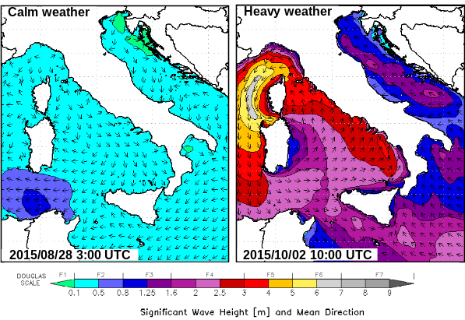
Figure 1. Significant wave height fields for the two case studies. Left: Calm weather condition, on 2015/08/28 at 03:00 UTC. Right: Heavy weather condition, on 2015/10/02 at 07:00 UTC. Data are from wind-wave operational forecasting models of Consorzio LaMMA.

In the right panel of Figure 1 the rough sea-state of 2nd October 2015 at 07:00 UTC is represented. A very deep and concentrated low pressure system was present over the Central Mediterranean Sea. In its quite fast South-to-North motion its centre spanned both Sardinia and Corse Islands, generating strong winds and rough sea conditions. At the time of the figure, the low pressure centre was over Corse Island. Due to the cyclonic circulation, wind and waves direction was from Southern quadrants over the Tyrrhenian Sea, and from Northern quadrants over the Ligurian and Corse Sea.
In this study the modelled ship has been supposed to perform the voyage from Genoa to La Valletta (Malta), with two different speeds of 18 and 24 knots, and along three different routes. Route 00 is the central and shortest one, Routes O1 and E1 are Western and Eastern variants of it, respectively. The times of departure (TOD) are: 2015/08/27 12:00 UTC and 2015/10/01 16:00 UTC for the Calm and Heavy case study, respectively. In the first four columns of Table 1 some voyage data are summarised. The geometry of the routes is shown in Figures 2, 3, 4, 5. In the Calm case, the total ship resistance is essentially given by the calm water term R_{hull} plus a wind added resistance term R_{wind} solely due to the ship speed. In the Heavy case, for the most part of each voyage on all the routes, heavy head wind and sea conditions are present, with a relevant increase of total resistance, due to a greater R_{wind} and a due to very relevant values of the added resistance in waves R_{aw.} Due to heavy weather a significant increase (w.r.t. the Calm voyages) of fuel consumption resulted: about 17% and 18% along Routes 00 and E1 resp., while of about 11% along Route O1, due to a sheltering effect of Corse and Sardinia Islands. Corresponding increase (in the same proportion) due to heavy weather, is present also in the computed NO_{x} emissions.

Table 1. Results of the simulation of all the voyages of the modelled ship, from Genoa to La Valletta, at 18 and 24 knots, over the tree route variants 00, O1, E1. The first four columns report voyage data. The fifth column reports the total fuel consumption, the last two ones report NO_{x} emissions data (total emitted and voyage averaged emission rate).
Calm Weather
Ship  Speed  [kn] | Route  Name | Route Length [NM] | Voyage Duration  [h] | Total Fuel  [t] | Total NOx  [kg] | Average NOx Rate [kg/h]
18 | 00 | 585.2 | 32.5 | 81.78 | 5630.6 | 173.3
18  18 | O1  E1 | 610.6  641.1 | 33.9  35.6 | 86.04  88.32 | 5939.5  6094.7 | 175.2  171.2
24  24 | 00  O1 | 585.2  610.6 | 24.4  25.4 | 108.96  114.38 | 7760.0  8131.7 | 318.1  320.2
24 | E1 | 641.1 | 26.7 | 117.96 | 8355.4 | 313.0
Heavy Weather
Ship  Speed  [kn] | Route Name | Route Length [NM] | Voyage  Duration  [h] | Total Fuel  [t] | Total NOx  [kg] | Average NOx Rate [kg/h]
18 | 00 | 585.2 | 32.5 | 98.16 | 6798.4 | 209.1
18  18 | O1  E1 | 610.6  641.1 | 33.9  35.6 | 98.00  108.42 | 6784.2  7509.3 | 200.2  210.9
24  24 | 00  O1 | 585.2  610.6 | 24.4  25.4 | 131.09  128.10 | 9405.8  9158.4 | 385.4  360.6
24 | E1 | 641.1 | 26.7 | 143.59 | 10283.2 | 385.1

In Figures 2, 3, 4, 5 some of the results of the dispersion models are shown for NOx. In Figures 2, 3 two “snapshots” of the plume shape are shown for the voyages at 24 knots for all the three routes, after 15 hours (upper panels) and after 22 hours (lower panels) from TOD. In particular the hourly averaged NO_{x} concentration on the lowest model layer is shown in the shaded colour palette.

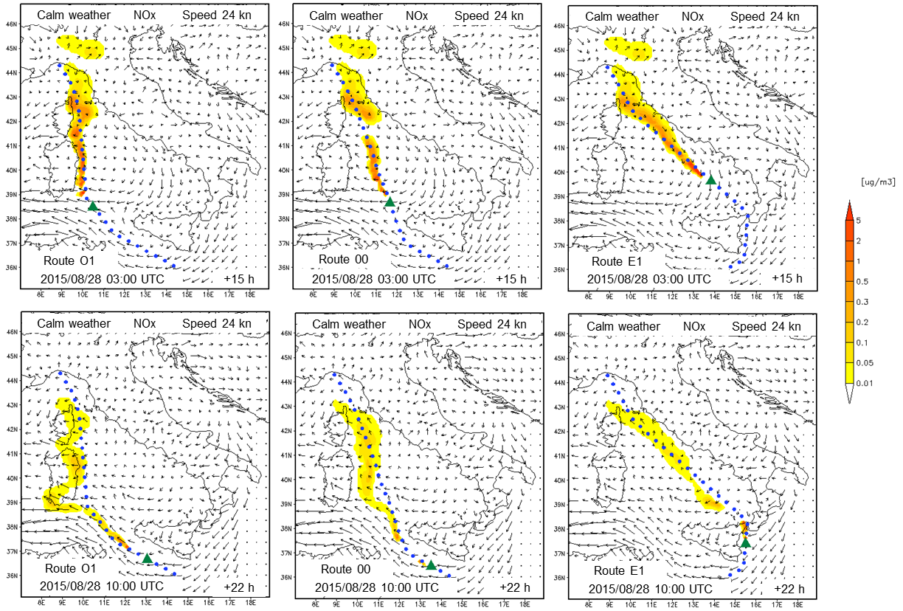
Figure 2. Calm weather: modelled hourly averaged NO_{x} concentration on the lowest model layer and surface wind vectors, for all the three routes O1, 00, E1, resp. from left to right. Upper panels for 2015/08/28 03:00 UTC. Lower panels for 2015/08/28 10:00 UTC.

Figure 3. Heavy weather: modelled hourly averaged NO_{x} concentration on the lowest model layer and surface wind vectors, for all the three routes O1, 00, E1, resp. from left to right. Upper panels for 2015/10/02 07:00 UTC. Lower panels for 2015/10/02 14:00 UTC.
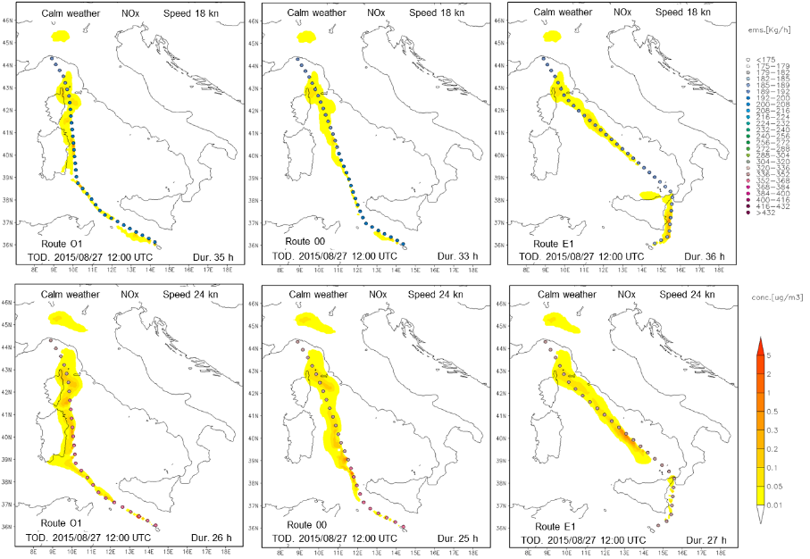
Figure 4. Calm weather: modelled NOx concentration values on the lowest model layer, averaged over the whole voyage duration, for all the three routes O1, 00, E1, resp. from left to right. Upper panels: ships peed 18 kn. Lower panels: ship speed 24 kn.

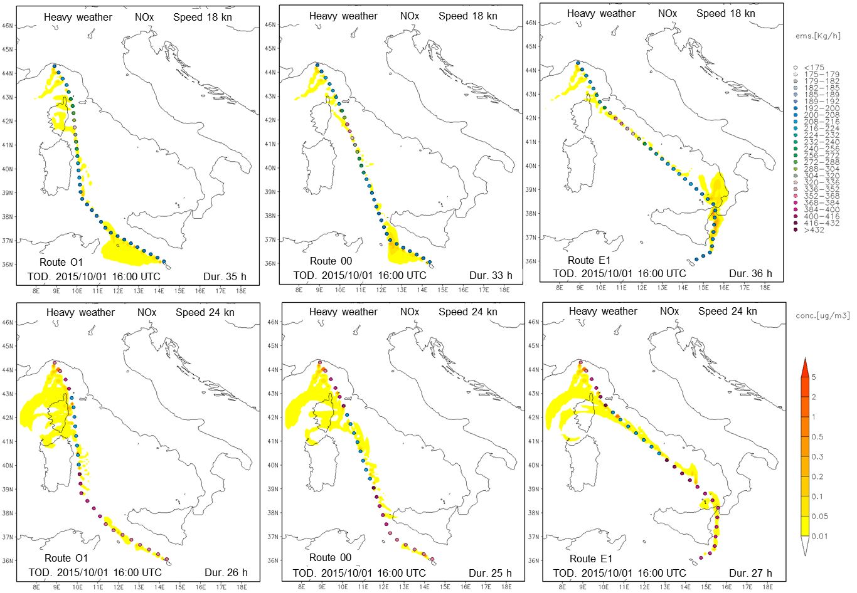
Figure 5. Heavy weather: modelled NO_{x} concentration values on the lowest model layer, averaged over the whole voyage duration, for all the three routes O1, 00, E1, resp. from left to right. Upper panels: ships peed 18 kn. Lower panels: ship speed 24 kn.
In this scheme, the jumps that can be noticed in the shape of the shaded areas correspond to plume portions that lay only at higher levels. At these levels winds are likely to be stronger and can cause faster advection of pollutants, which only subsequently fall to the lowest level, farther apart.
Also surface wind vectors are plotted and give an idea of the dynamic evolution. The comparison between Figure 2 (Calm) and Figure 3 (Heavy) shows how different the pollutants fate can be in calm and heavy weather situations. In calm weather ship emissions are lower, but under high pressure and low wind conditions pollutants have a stronger tendency to stagnate along the route. Only in the Southern part of the voyage, relatively stronger winds tend to advect more effectivley and dilute the pollutants. In heavy weather conditions, though we have an increase of about 12-18% of emissions, these are more rapidly advected and diluted, also reaching further areas.
In Figures 4, 5 the NO_{x} concentration values on the lowest model layer, averaged over the whole voyage duration, are shown in shaded colour palette (upper panel 18 knots, lower panel 24 knots), for all the routes, for the Calm (Figure 4) and Heavy (Figure 5) case, respectively. The dots for the EmWPs that delineate each route are coloured in relation to the intensity of computed (meteo-dependent) emission rate. The analysis of these patterns confirms most of the elements emerged from Figures 2, 3. The difference in speed from 18 to 24 knots causes higher emissions (about 25% more fuel and more emissions), and gradually different encountered meteo-marine conditions, due to a different voyage timing. Moreover it must be noticed that, depending on the meteo-marine conditions, different polluting impact patterns emerge from the different routes.
It must be pointed out that NO_{x} concentration values from a single ship, as in Figures 2, 3, 4, 5, are vey low, if compared with public safety regulation thresholds. Obviously, the overall impact of shipping activities comes out from the superposition of the many contributions of all the ships in a given area. In a general scenario, such a superposition must be modelled accounting for the many non-linearities coming out from the combined complexity of meteo-marine dynamics and chemical behaviour of the many involved compounds. As a consequence, the operational implementation of reliable modelling approaches, requires sound preliminary scientific investigations, and rigorous comparisons with reliable observed data. The work here described represents only a first step along this way.

Conclusions
The results of the first implementation tests of an integrated system for ship emitted pollutants dispersion modelling along Mediterranean routes have been summarised. The described system has been first applied to NOx emissions with the numerical model of a generic ro-ro ship, by considering two relevantly differing case studies. A calm weather scenario has been compared with a heavy weather one.
Interesting results show the capabilties of such a system to describe the detailed dynamics related to the fate of pollutant emissions along routes. Relevant differences emerge thanks to the detailed treatment of realistic meteo-marine conditions. Heavy weather causes higher fuel consumption and pollutant emissions, but the ensuing strong winds allow a more efficient pollutant dispersion, with respect to the calm weather condition, where the minor emissions tend to stagnate in the lower atmospheric layers. The impact of pollutants on surrounding coastal areas resulted to have a relevant dependence on the interplay of meteo-marine conditions and route shape and timing.
The system still needs to be completed by extension to all the relevant pollutants (and adding all the required non-linear and chemical modelling details) and a careful tuning through comparison with reliable measurements could improve its reliability.
The main elements emerged from this first analysis suggest that, in its complete version, the system could find relevant applications in studies for the evaluation of the pollution impacts of marine navigation, in fleet management and in the context of single ship operational optimisation and weather routing.
References
- L. Johansson, J-P. Jalkanen, J. Kukkonen, Global assessment of shipping emissions in 2015 on a high spatial and temporal resolution, Atmospheric Environment 167 (2017), 403e415.
- EEA, The impact of international shipping on European air quality and climate forcing, European Environment Agency (EEA), Technical report No 4/2013.
- A. Aulinger, V. Matthias, M. Zeretzke, J. Bieser, M. Quante and A. Backes, The impact of shipping emissions on air pollution in the greater North Sea region – Part 1: Current emissions and concentrations, Atmos. Chem. Phys., 16, (2016), 739-758.
- IMO, Training course on the Energy Efficient Operation of Ships. Trainer’s Manual. World Maritime University (WMU) and International Maritime Organization (IMO), May 2013.
- E. A. Bouman, E. Lindstad, A. I. Rialland, A.H.Strømmana, State-of-the-art technologies, measures, and potential for reducing GHG emissions from shipping – A review, Transportation Research Part D: Transport and Environment, Volume 52, Part A, (2017), Pages 408-421.
- ABS, Ship energy efficiency measures advisory. Status and guidance, American Bureau of Shipping , 2014.
- J. F. Helfre, P.A. Couto Boot, Emission Reduction in the shipping industry: Regulations, Exposure and solution. Sustainalytics, (2013).
- D. Segersson, A dynamic model for shipping emissions. Adaptation of Airviro and application in the Baltic Sea, SMHI Meteorology 153 (2014).
- P. Huszar, D. Cariolle, R. Paoli, T. Halenka, M. Belda, H. Schlager, J. Miksovsky and P. Pisoft, Modeling the regional impact of ship emissions on NOx and ozone levels over the Eastern Atlantic and Western Europe using ship plume parameterization, Atmos. Chem. Phys., 10, (2010), 6645–6660.
- V. Matthias, A. Aulinger, A. Backes, J. Bieser, B. Geyer, M. Quante, and M. Zeretzke, The impact of shipping emissions on air pollution in the greater North Sea region – Part 2: Scenarios for 2030, Atmos. Chem. Phys., 16, (2016), 759-776.
- C. Wang, J.J. Corbett, J. Firestone, Modeling energy use and emissions from North American shipping: application of the ship traffic, energy, and environment model, Environ Sci Technol. 1;41(9) (2007), 3226-32.
- C. A. Kontovas, The Green Ship Routing and Scheduling Problem (GSRSP): A conceptual approach, Transportation Research Part D: Transport and Environment, Volume 31, (2014), Pages 61-69.
- L. Chen, T. L. Yip, J. Moud, Provision of Emission Control Area and the impact on shipping route choice and ship emissions, Transportation Research Part D 58 (2018), 280–291.
- D. Chen, N. Zhaoa, J. Lang, Y. Zhou, X. Wang, Y. Li, Y. Zhao, X. Guo, Contribution of ship emissions to the concentration of PM2.5: A comprehensive study using AIS data andWRF/Chemmodel in Bohai Rim, Science of the Total Environment (2018) 610–611, 1476–1486.
- R. Paoli, D. Cariolle, and R. Sausen, Review of effective emissions modeling and computation, Geosci. Model Dev., 4, (2011), 643–667.
- Á. Leelőssy, T. Mona, R.Mészáros, I. Lagzi, Á. Havasi, Eulerian and Lagrangian Approaches for Modelling of Air Quality. In: Bátkai A., Csomós P., Faragó I., Horányi A., Szépszó G. (eds) Mathematical Problems in Meteorological Modelling. Mathematics in Industry, vol 24. (2016) Springer.
- C. Trozzi, Emission estimate methodology for maritime navigation, 9th International Emission Inventory Conference, San Antonio, Texas September 27 - 30, 2010.
- J. Beecken, J. Mellqvist, K. Salo, J. Ekholm, J.-P. Jalkanen, L. Johansson, V. Litvinenko, K. Volodin, and D. A. Frank-Kamenetsky, Emission factors of SO2, NOx and particles from ships in Neva Bay from ground-based and helicopter-borne measurements and AIS-based modeling, Atmos. Chem. Phys.15 (2015), 5229–5241.
- H. Winnes, L. Styhre, E. Fridell, Reducing GHG emissions from ships in port areas, Research in Transportation Business & Management 17 (2015), 73–82.
- T. Coppola, F. Quaranta, Il caso del Porto di Napoli: valutazione dell'impatto sull'ambiente cittadino generato dal traffico marittimo, The Future Boat & Yacht 2010 Venice Convection.
- M. Viana, P. Hammingh, A. Colette, X. Querol, B. Degraeuwe, I. de Vlieger, J. van Aardenne, Impact of maritime transport emissions on coastal air quality in Europe, Atmospheric Environment 90 (2014), 96-105.
- E.J. Claessens, H.J.M. Pinkster, R.P. Dallinga, On the use of a wind-wave model in the prediction of operational performance of marine structures. Int. Shipbuild. Progr., 52 (2005), 297-323.
- S. R. Pielke, Mesoscale meteorological modelling, Academic Press, Second edition, 2002.
- J. J. Michalakes, D. Dudhia, T. Gill, J. Henderson, W. Klemp, W. Skamarock, W. Wang, The Weather Reseach and Forecast Model: Software Architecture and Performance, in George Mozdzynski (ed.) Proceedings of the 11th ECMWF Workshop on the Use of High Performance Computing In Meteorology, 25–29 October 2004, Reading.U.K., 2004.
- E. Kalnay, Atmospheric Modeling, Data Assimilation and Predictability, Cambridge University Press, 2003.
- G.J. Komen, L. Cavaleri, M. Donelan, K. Hasselman, S. Hasselman, P.A.E.M Janssen, Dynamics and modelling of ocean waves, Cambridge University Press, Cambridge, United Kingdom, 1994.
- WISE Group, L. Cavaleri et al., Wave modelling. The state of the art, Progress in Oceanography, 75 (2007), 603-674.
- H. L. Tolman, User manual and system documentation of WAVEWATCH III version 3.14. NOAA NWS NCEP MMAB Tech. Note 276 (2009).
- A. Orlandi, C. Brandini, F. Pasi, S. Taddei, B. Doronzo, G. Brugnoni, G. Rossini, R. Benedetti, B. Gozzini, A. Ortolani, F. P. Vaccari, Implementation of a meteo marine forecasting chain and comparison between modelled and observed data in the Ligurian and Tyrrhenian seas. Volume sulle attività di ricerca scientifica e tecnologica del CNR nell'ambito del mare e delle sue risorse, CNR, Italy, Rome, 2009.
- LaMMA meteo-marine models web pages: www.lamma.rete.toscana.it/mare/modelli/vento-emare.
- Orlandi, A., Integration of meteo-marine forecast data with ship seakeeping and powering computational techniques, PhD Thesis in Naval Architecture and Marine Engineering, Supervisor: Dario Bruzzone, University of Genoa, 2012.
- Lewis, E. V., Principles of naval architecture: volume III. SNAME Editions, 1990.
- Bertram V., Veelo B., Soding H., Program PDSTRIP: public domain strip method. software documentation, 2006.
- Carlton, J. S., (2007), Marine propellers and propulsion, Elsevier, ISBN: 978-0-7506-8150-6, 2007.
- T. Fujiwara, M. Ueno, Y. Ikeda, Cruising Performance of a Large Passenger Ship in Heavy Sea, Proceedings of the Sixteenth (2006) International Offshore and Polar Engineering Conference San Francisco, California, USA, May 28-June 2, 2006.
- A. Orlandi, F. Pasi, V. Capecchi, A. Coraddu, D. Villa, Powering and seakeeping forecasting for energy efficiency: assessment of the fuel savings potential for weather routing by in-service data and ensemble prediction, IMAM 2015 Conference Proceedings, Towards Green Marine Technology and Transport – Guedes Soares, Dejhalla & Pavleti (Eds) © 2015 Taylor & Francis Group, London, ISBN 978-1-138-02887-6, 2015.
- A. Orlandi, R. Benedetti, V. Capecchi, F. Pasi, L. Rovai, A. Coraddu, Evaluation of the fuel saving potential at the Mediterranean scale by the use of high resolution metocean forecasts and detailed ship performance numerical models, HullPIC 2016, Conference: Hull Performance and Insight Conference, (2016).
- Scire J.S., D.G. Strimaitis, R.J. Yamartino. A User's Guide for the CALPUFF Dispersion Model. Earth Tech, Concord, MA, January, 2000.http://www.epa.gov/scram001/dispersion_prefrec.htm#calpuff
- Report – J. Aherne et al. Kitimat Airshed Emissions Effects Assessment. ESSA Technologies Ltd. Suite 600, 2695 Granville Street, Vancouver, (2013) www.essa.com.
- G. Lonati, S. Cernuschi, S. Sidi. Air quality impact assessment of at-berth ship emissions: Case-study for the project of a new freight port., Science of The Total Environment, Vol. 409, Issue 1 (2010), 192-200, ISSN 0048-9697.
- K. Poplawski, E. Setton, B. McEwen, D. Hrebenyk, M. Graham, P. Keller, Impact of cruise ship emissions in Victoria, BC, Canada, Atmospheric Environment, Vol. 45, Issue 4, (2011), 824-833, ISSN 1352-2310.

