Interaction between Industry and Class Societies in Cruise Ships Structural Design: a Positive Fincantieri Experience.
Mauro SICCHIERO ^{a,}, Matteo SIDARI ª, Vincenzo LIGUORI ª, Mario CROCE ^{b}, Andrea TARELLO ^{b}, Enrico GOMBI ^{c}, Alessandro GRASSO ^{c}
ª Fincantieri S.p.A., Trieste, Italy
^{b} Lloyd’s Register, Trieste, Italy
^{c} RINA, Genova, Italy
Abstract. The paper illustrates the developments in rules and design lifecycle of modern cruise ship, resulting from the cooperation between industries and classification societies. Fincantieri S.p.A. experience together with Lloyd’s Register and RINA technical background, worked side by side in order to overcome not harmonized rules and regulation not specific for this type of ships. Latest IACS example in Common Structural Rules for Bulk Carrier and Oil Tankers development combined with understanding of cruise ship peculiarities have been the basis of the present work. Results of cooperation have been the development of two direct analysis procedure (LR Structural Design Assessment, Procedure for Primary Structure of Passenger Ships, 2017; RINA Guide on Complete Ship Model Calculation of Passenger Ships, 2017), a guideline (LR Ship Rules applicable to Modern Passenger Ships, 2017), and the monitoring of the effects of their application on new buildings. The obtained proposal of harmonized rules and specific regulation highlights the importance of an active role of industries in the rules development that nowadays must be oriented to modern ship business.
Keywords. passenger ships, classification societies, rules and regulations, finite element analysis

Introduction
Modern cruise ship business is nowadays characterized by continuous innovation of arrangements and architectural designs. Proposed structural solutions may be not always within the range of applicability of existing rules and regulations. In order to maintain the adequate reliability and safety of structural design, but also optimized weight distribution and efficiency, the cooperation between classification societies and industry in rules development and design assessment is fundamental.
The aim of the paper is to present recent years work done in this direction by Fincantieri S.p.A. (FC), RINA and Lloyd’s Register (LR) concerning prescriptive rules requirements together with direct calculation procedure and approval process flow.

Rules prescriptive requirements
Prescriptive requirements are typical of all classification societies rules and regulations. Based on combination of statistical analysis, experience and good practice, they are representative of classification societies knowledge, useful to guide the designers in the first definition of scantlings but also important to ensure the correct safety level of the structures against the unavoidable uncertainties in theoretical analyses due to construction, maintenance and operational aspects. Obviously this kind of requirement is to be tuned considering the specific ship type verifying the limits of applicability, and has to be periodically reviewed in conjunction with other regulatory developments.
It is expected that developments in mandatory structural analysis and controls during construction have to play an important role in the reduction of the uncertainties implicitly covered by above mentioned requirements. In case of passenger ships the LR additional notation ShipRight Structural Design Assessment (SDA) and Construction Monitoring (CM) is generally mandatory, with the consequent increase of reliability on structural design assessment and improvement of quality during construction. In spite of the possibility of optimization offered by the latest strength analysis procedures, the actual minimum requirements of LR Rules and regulations for the classification of ships [1] for some structural member, appeared to be more onerous compared with other classification societies. This have been the main motivation for starting a joint project between LR and FC in order to identify a set of new interpretation applicable to modern passenger ships in the direction of optimisation of weight distribution.

Scope of work
FC has carried out, in conjunction with Naval Architecture Department of Trieste University, a study on a 55,000 GT cruise vessel comparing the minimum thickness requirement among Bureau Veritas (BV) [2] and LR [3]. The investigation shows that LR minimum requirements get up to a potential 2-3% steel weight increase compared to BV. According to that study and to recent FC experiences the following areas and structural members have been highlighted as the most affected by differences in the requirements:
- double bottom construction and arrangement;
- decks and topside;
- forward slamming area and stern impact area;
- pillar bulkheads.
The four areas have been analysed by LR and FC looking for solutions through revised formulas, minimum thickness requirements and rules interpretations. The assessment of all main structural member according to LR Structural Design Assessment, Procedure for Primary Structure of Passenger Ships [4] through a complete Finite Element model, has been considered a prerequisite ensuring analysis able to identify real critical aspects and relevant verified solutions. This was the basis of the acceptance of alternative arrangement and scantlings as permitted by existing rules.
Object of the new set of interpretation has been not only the minimum thicknesses but also the requirements about loads, structural arrangements and details that FC reported as important for production, such as:
- minimum spacing and extensions requirements for engine room floors and girders;
- distributed loads for workshop, machinery, stores and refrigerated spaces;
- extension definition of weather exposed lifeboat deck;
- end connection of secondary member to primary members.

Example from the new set of interpretations: non watertight floors
Traditionally the Rules for passenger ships refer to a formula applicable to general cargo ships to determine scantlings of double bottom. In particular the formula for non watertight double bottom floors plating given in Part 4, Chapter 1, §8.5.1 [1]:
$t=\left(0.009 d_{DB}+1\right)\sqrt{k}$ or 15mm, whichever is the lesser (1)
is an empirical formula which comes back from the LR Rules in the 1970. For large cruise ships (e.g. 300 metres Rule Length), the thickness required is 15 mm.
The above traditional formula has been reviewed and considered too conservative in conjunction with the modern cruise standard design arrangement (floors spacing less than 3000 mm with pillar lines or equivalent structures every two primary spaces) considered a suitable additional support to the floors. For instance Part 4, Chapter 8, §7.5 [1] applicable to container ships provide a different formula for the scantlings of floors as follows:
$t=6+0.03L$ or 12mm, whichever is the lesser (2)
Applying this formula the new max thickness for floors is reduced by 3mm.
It has been considered that both container ships and cruise have a continuous support from internal vertical structure, therefore it has been agreed that the above formula for container ships can be applied to cruise ships having the arrangement described above.
The reduced scantlings must be supported by a thorough verification of the double bottom strength which is now a compulsory requirements of LR Shipright Procedure for Primary Structure of Passenger Ships [4]. The double bottom, including floors and bottom girders structure have to be analysed by FE methodology with loading conditions assuming local loads in addition to global loads. Acceptance criteria for floors are then about allowable stresses and buckling, considering also a thickness deduction of 1 mm in way of tanks.

Achieved advantages
From the final analysis carried out by comparing the revised minimum thickness of defined elements, it has been noted that the gaps between LR and BV reduced even if some differences still remain. Anyway the evaluation of steel weight reduction in future LR class ships made by FC have been estimated noteworthy.
The benefits for structural design has been not only the possibility to start from a minimum thickness baseline and then make further design review in conjunction with other strength analyses, but also to take a significant step toward a scenario of requirements harmonized between various classification societies.

Continuous development in direct strength analysis procedure
In contemporary passenger ship designs, superstructure extends over most of the ship length and internal structure comprises of a large number of decks connected together with pillars, longitudinal and transverse bulkheads. The structure, in general, presents a lot of discontinuities such as knuckle points, non-continuous primary structures and openings in deck and bulkheads as well as many side shell doors and windows. To evaluate ship global stiffness, establish the load carrying ratio between different structures and to assess the global and local strength of the design, the use of direct analysis methods is nowadays deemed necessary.
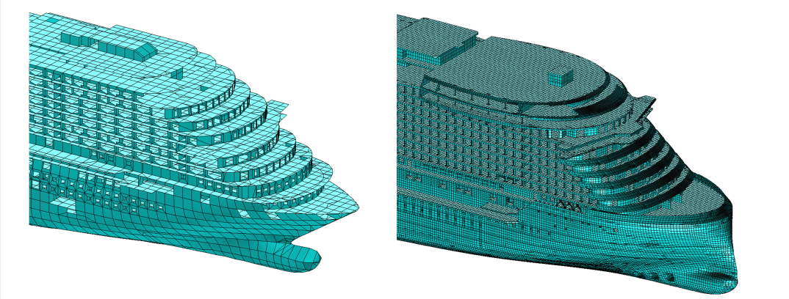
Figure 1. Comparison between previous and new mesh size in global finite element model.
During 2016 FC’s finite element analysts together with classification society specialists, of RINA and LR, cooperated in order to develop a set of new procedure with the aim of replace the previous ones, considered obsolete for the novel design of cruise ships. The result of this collaboration has put into effect, during the early 2017, with the publication of two design guidelines:
- RINA Guide on Complete Ship Model Calculation of Passenger Ships (2017) [5], hereafter referred to as RINA-CSM (2017);
- LR Structural Design Assessment, Procedure for Primary Structure of Passenger Ships (2017) [4], hereafter referred to as LR-SDA (2017).

Global strength analysis
The finite element global model for passenger ships is commonly used to perform the yielding and buckling check of stiffened plates and pillars and also to provide the boundary conditions for the fine mesh models. In this field the most important advancements presented in the new procedures are related to mesh size, bottom strength and stress adjustment.

Structural modelling
The existing outdated procedures such as LR-SDA (2004) [6] required a global coarse mesh with one element between primary transverses, as can be seen in Figure 1. The resulting mesh size for element length was about 2800 mm. The analysis of structural behaviour in modern concept of cruise ships made by FC engineers together with the analysis of requirements of actual procedures such as IACS Common Structural Rules for bulk carrier and oil tankers [7] made by LR and RINA specialists, highlight the need of a more accurate representation of stiffness especially in bulkheads fitted with openings. The result of these studies can be found in the actual procedures proposed by LR and RINA where the request for global coarse mesh is one element between every stiffener resulting in an element length about 700 mm.
In design process, global finite element modelling is a very time consuming task. Therefore in order to develop such a fine global mesh a tool for automatic mesh generation is fundamental to keep design time within required targets. However this kind of modelling lead to a lot of benefits from the design point of view, in particular providing a better analysis of the response, removing the use of orthotropic and higher order elements, and giving a better support for locate fine mesh models.

Bottom strength
Proposed LR-SDA (2017) [4] procedure presents a new load combination case for the assessment of double bottom. In particular, it requires the application of rule local wave crest pressure over the full length of the finite element model in combination with maximum hogging condition, and local wave trough in combination with maximum sagging condition. The proposed method to remove the local wave vertical imbalance without adding longitudinal bending moment to the hull girder consist in:
- Application of vertical constraint at each web frame;
- Addition of counteracting vertical forces distributed to side shell nodes at every web frame, in order to avoid vicious stress response.
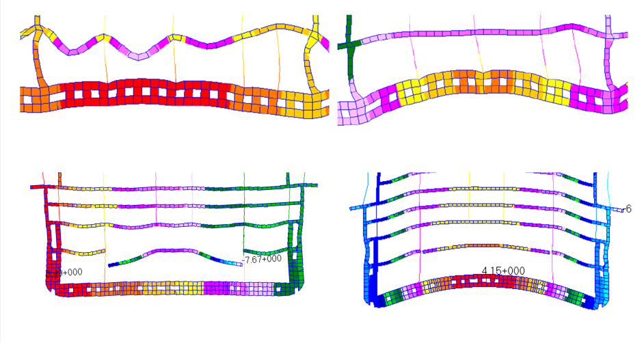
- (b)
Figure 2. Longitudinal (above) and transversal (below) bottom structure displacement under local wave crest pressure balanced with vertical loads distributed on decks (a) and side shell vertical forces (b).

In the physical phenomenon the overpressure caused by wave is balanced by inertial forces applied to the mass of the entire ship. Therefore subsequent study made by FC and shared with LR demonstrated that, in order to have a better representation of bottom structure behaviour, the vertical balance counteracting local wave loads have to be achieved by applying a field of forces distributed on decks and generating null longitudinal bending moment. The difference in structural behaviour of bottom structure deriving from the implementation of the two methods described above can be seen in Figure 2. This study is been the basis for the reliable application of the new prescriptive Rules requirements for double bottom primary structures presented in 2.2.

Global stress adjustment for longitudinal strength
One of the problem in the global longitudinal strength analysis is the harmonization between rules requirements and numerical approach. Wave shear force and bending moment provided by Classification Societies aren’t linked by a differential equations and loading conditions actually proposed in direct analysis guidelines always require adjustments of calculated stress to be compared with admissible values. The support of an explicit results correction methodology, not included in previous guidelines, was highlighted by FC as an important precondition for a not debatable analysis.
At first, FC attempted to apply a numerical method to perform this adjustment, taking as a reference LR-SDA (2012) for the assessment of primary supporting member of Ro-Ro ships [8]. This approach has the big advantage of facilitating the automatization of the results post processing, but involved the use of boundary conditions (i.e. rigid links the extremities) introducing not negligible alteration in global model stiffness. On the basis of FC reporting, LR tried to overcome the obstacles of the previous approach in the LR-SDA (2017) [4] by substituting the concentrated loads applied at the extremities with a distributed loads applied on the bottom.
It is easy to demonstrate that bending moment and shear force influence factor calculation is equivalent to the research of a linear combination of the basic and auxiliary load cases act to achieve the rules values. Due to three dimensional effects, the superposition of effects of loads is not applicable to integral values. Since local correspondences of bending moment and shear force generated by different overall distribution presents differences in stress response, the above mentioned approach may be considered applicable only if the global distribution does not differ to much from the target ones. Moreover the solution of the mathematical equations is ensured only if the two auxiliary loading conditions are linearly independent over the domain.
LR proposal in LR-SDA (2017) [4] can be surely considered an improvement but still partially satisfies all the constraints of the problem and implicitly requires a carefulness by the structural analysts for its application.
Actual RINA procedure for passenger ship [5] propose a stress adjustment equivalent to LR-SDA (2012) for the assessment of primary supporting member of Ro-Ro ships [8].

Local strength analysis
Analysis of structural details with very fine mesh models are common practise on passenger ships due to the amount of structural discontinuities, such as large deck and side shell openings, doors on longitudinal bulkheads and the presence of novel architectural solutions. The aim of these analyses is to control plastic deformation, through peak stress, and fatigue life in opening corners.
Unfortunately in these kind of analyses there is still some spread between different classification society procedure. Sometimes these differences lead the design of details towards different structural solutions. In this type of assessment the advancements presented in the two new guidelines are focused on methods to assess the peak stress values and dynamic stress range formulation and dependences.

Peak stress
In the assessment of peak stress for local details, LR-SDA (2004) procedure [6] defined the limit of yield stress for one element with dimensions comparable with the thickness of plate under analysis. Through the examination of existing and more contemporary direct calculation procedures such as IACS CSR (2015) [7], RINA and LR specialists together with FC introduced the concept of an averaging area for stress together with a permissible direct stress higher than the yield stress for the material. This development allow a detailed structural design with the control of plastic deformation in a small area.
The comparison of peak stress assessment, calculated at the same probability level of 10⁻⁸ for dynamic loads induced by wave, highlight that at this level of analysis actual procedures by different classification societies are not completely in accordance, as can be seen in Table 1. A future joint study in order to bring the procedures into alignment is mandatory.

Table 1. Comparison of local stress allowable values for mild steel and edge free from welding [N/mm²].
 | LR (2017)  [4] | RINA (2017)  [6] | DNV-GL (2018)  [9]
Average stress calculated on equivalent area 50 mm x 50 mm | 235 | 396 | 400

Fatigue life
In fatigue life assessment LR-SDA (2004) [8] established the dynamic stress range as function only of the type of detail, specifically discerning between welded and free from weld details.
Taking into account fatigue formulation reported into IACS CSR (2015) [7], both LR and RINA with the support of FC introduce in their new procedures the dependences of dynamic stress range allowable values by ship length, plate thickness, edge machining method and material grade. The effect is that a structural detail with thinnest plate, material with higher grade and edge machining treatment presents a more suitable behaviour against fatigue life. The main dimensions of the ship, in particular length, play also an important role in allowable stress range definition, but its contribution is more related to loads history.

Interaction with classification societies during design phase
When the time available for the design is very short, not only industries internal processes have to be optimized but also the flow of information with third parties. Classification societies play an important role during the design phases and an efficient way to reduce time and consequent costs cannot neglect the importance of this interaction.
For this purpose LR offers an instrument called “mapping” that, as understandable from the name, has the goal of map the activities needed for a correct approval process, considering both the completeness of the contents and time schedule of their submission. All these information have to be shared between yard design office and classification society technical appraisal department in order to find the correct compromise between relevant needs. Dynamically updated during design development, the mapping allows designers and surveyors to monitor the activities in terms of time and quality, in order to launch corrective actions promptly avoiding impacts in the production phase.
On the other hand, not only the information flows but also human interaction are important in particular in the first phase of the design when the most significant decisions are taken. Recent experience of in-site approval of drawings offered by RINA to FC on prototype ships such as MSC-SEASIDE, configured as successful co-design. Experience and knowledge of industry and classification society has been shared since the beginning reducing time needed for the typical design-approval process, due to interaction between the professionals.

Conclusions
Cruise ships represent a small share of the total world fleet. This is a market niche involving few yards and not continuously all IACS classification societies. However features and frequent innovations foreseen in the design of passenger ships have to be carefully considered, ensuring the correct safety level but without affect the competitiveness of all stakeholders.
Considering the limited number of actors interested, the development of common structural rules for cruise ships in short time cannot be expected but would be beneficial in terms of simplification, improvement and safety. In this scenario, the role of the yards in giving evidence to classification societies of specific needs is fundamental. Recent FC’s cooperation with RINA and with LR surely represent a positive experience, intended to be preserved, strengthened and extended in the near future.

References
- Lloyd’s Register, Rules and regulations for the classification of ships, Lloyd’s Register Group Limited, London, United Kingdom, 2017.
- Bureau Veritas, Rules for the Classification of Steel Ships, Bureau Veritas, Courbevoie, France, 2007.
- Lloyd’s Register, Rules and regulations for the classification of ships, Lloyd’s Register Group Limited, London, United Kingdom, 2007.
- Lloyd’s Register, Structural Design Assessment Procedure for Primary Structure of Passenger Ships, Lloyd’s Register Group Limited, London, United Kingdom, 2017.
- RINA, Guide on Complete Ship Model Calculation of Passenger Ships, RINA, Genova, Italy, 2017.
- Lloyd’s Register, Structural Design Assessment Primary Structure of Passenger Ships Guidance on direct Calculations, Lloyd’s Register Marine Business Stream, London, United Kingdom, 2004.
- IACS, Common Structure Rules for Bulk Carriers and Oil Tankers, IACS - the International Association of Classification Societies and International Association of Classification Societies, London, United Kingdom, 2017.
- Lloyd’s Register, Structural Design Assessment Primary Structure of Ro-Ro Ships Guidance, Lloyd’s Register Marine Product Development, London, United Kingdom, 2012.
- DNV GL, Rules for classification: Ships , DNV GL AS, Høvik, Norway, 2018.

Mauro Sicchiero, Merchant Ship Business Unit - Hull Structure Design Department, FINCANTIERI S.p.A., Passeggio S.Andrea, 6/b, 34123 Trieste, Italy; E-mail: mauro.sicchiero@fincantieri.it.

