Launch and Recovery for Ship-Deployed Autonomous Underwater Vehicles

A.M. YAZDANIa, K. SAMMUT a,[1], O.A. YAKIMENKOb, and A. LAMMASa

a Centre for Maritime Engineering, Control and Imaging, College of Science and Engineering, Flinders University, Adelaide, Australia, SA 5042

b Department of Systems Engineering / Department of Mechanical and Aerospace Engineering, Naval Postgraduate School, Monterey, California, 93943-5194

**Abstract.** Autonomous underwater vehicles (AUVs) are increasingly being used for underwater survey and exploration missions. The expanding mission scope for AUVs highlights the need for a long-endurance operational capability, which mainly depends on propulsion efficiency and battery capacity. For most deployments, AUVs are launched and recovered from a mother ship. While the launch process is relatively straightforward and automated, the recovery process is more risky and conventionally involves man-in-the-loop intervention to ensure that the AUV can be recovered safely. The use of submerged docking stations (DS) permitting battery recharge, data transfer and vehicle recovery offer a means of enabling persistence while also reducing associated deployment/recovery costs and risks. Autonomous docking with a submerged dock towed behind a ship is however complicated by the presence of currents, propeller wash and by the tow behaviour, all of which combine to cause disturbances that create misalignments in pose between the dock and the incoming vehicle. A robust docking guidance system is identified as a core and crucial component for ensuring successful AUV docking. This paper proposes an efficient and universal docking guidance framework that can help to address the limitations of existing docking guidance solutions.

**Keywords.** AUV, docking operations, robust guidance system

# Introduction

To date, several studies relating to underwater homing and docking of AUVs have been reported in the literature, the majority of these have focused on docking with fixed docking stations [1-3] with very few studies on docking with non-stationary stations [4][5]. In [6], the Lyapunov stability theory is utilized for designing a guidance controller that generates the reference heading and crabbing angle to compensate for horizontal and vertical deviation during pool testing of docking operations. The experimental results showed that the system achieved 80% successful docking rate. Other classic guidance laws such as, pure pursuit guidance [7] and linear terminal guidance [8] are also considered for guiding an AUV towards a DS. Relying on a set of assumptions and simplifications, these laws try to minimize the drift and miss distance during the terminal phase. Even though these latter approaches are relatively simple to implement, they are limited to controlled operating environments and operate based only on the geometric relationship and the AUV’s kinematics. Neither of these approaches can provide a closed-form solution assuring a collision-free unsaturated-control motion.

The overall goal of this paper is to describe the development of a universal and robust guidance system for recovering an AUV from a DS towed behind a mothership/boat. The guidance system proposing in this paper, first transcribes the docking problem into an optimal control problem (OCP) and then offers an appropriate direct method (considering the underlying docking scenario conditions) to solve it numerically. As such, the proposed guidance system can address a set of requirements which are necessary and sufficient for developing a universal and robust guidance system. For example, the guidance system allows real-time generation of feasible free- and fixed-time 3D collision-free trajectories, assuring compliance with vehicle kinematic/dynamic limitations, and high-order state derivative limitations required for smooth and safe arrival into a DS. The proposed guidance system can offer closed-loop solutions that will result in online generation of trajectories which accommodate variability of a DS pose and complexity of operating environment, current disturbances and wake turbulences.

This paper is organized as follows. Section II presents the AUV docking problem and its transcription in the form of an OCP. In Section III, functionality and mathematical details of the proposed universal docking guidance system are described. Section IV considers the results of implementation for a representative docking scenario with a mothership. Finally, the conclusions are presented in Section V.

# Underwater docking problem

In a docking scenario, the ultimate goal of an AUV is to arrive smoothly and with minimal collision risk into the DS cone. In this regard, the DS (funnel-shaped station) utilizes an ultra-short baseline (USBL) and an inertial navigation system, to estimate the DS position and orientation and broadcast these to the AUV. The AUV docking guidance system will attempt to minimize critical performance indices such as battery consumption and operation time, while obeying all vehicular and environmental constraints. For example, the AUV planned trajectory to the DS must accommodate the impact of current disturbances, wake-turbulence, and unforeseen obstacles. Additionally, the AUV’s trajectory should take into account the physical limitations of the vehicle’s thrusters, vehicle’s field of view, and vehicle states in conjunction with the geometrical constraints of the DS such as the cone entrance angle. These make the docking scenario challenging and highlight the need for a robust and universal guidance system.

To transcribe the docking problem in the context of optimal control theory, the AUV actuator arrangement must first be considered. The AUV selected for this study is a conceptual torpedo-shaped AUV [3] that the motion in the surge direction is provided by a single bi-directional rear thruster that can provide a maximum speed of 5 knots. Horizontal and vertical steering motions are produced by two pairs of additional bi-directional thrusters located, in crossed configurations, at the vehicle bow and stern. The traditional submarine control surfaces, rudder and stern planes, that serve as the primary controls at the high speeds, are still used in low-speed operations assuring roll and pitch stabilization. As a result, the yaw and heave motions are decoupled from roll and pitch motion. The following hydrodynamic 4-DoF AUV model is used:

 (1)

 (2)

 (3)

where *x, y, z* are the coordinates of the AUV’s centre of gravity in a local tangent frame {*n*}; *u, w* are surge and heave velocity components respectively, in the body coordinate frame {*b*} relative to the water, *ψ* is the yaw angle and *r* is the yaw rate, *cx* and *cy* are the northerly and easterly components of the current velocity, *Tu*, *Tw*, *Tr* are the control inputs in surge, heave and yaw directions. The AUV is characterized by the vehicle mass *m* and its inertia around the z-axis *Iz*, components of the linear terms drag *Xu, Zw, Nr*, and components of the quadratic terms drag, *Xu|u|, Zw|w|, Nr|r|*. The parameters are given in [9].

The utilized state and control vectors, considering the vehicle’s hydrodynamic model, are introduced by *X*=[*x y z ψ u w r*]*T* and *U*=[*Tu* *Tw* *Tr*]*T*, respectively. The docking problem, in the context of optimal control theory, for driving AUV into the DS, is defined as follows; starting from *X*0=[*x*0 *y*0 *z*0 *ψ*0 *u*0 *w*0 *r*0]*T* with *U*0=[*Tu;*0 *Tw;*0 *Tr;*0]*T*, it is desired to bring the AUV to some equilibrium state *Xf* =[*xf yf zf ψf uf wf rf*]*T* with corresponding control *Uf* =[*Tu;f* *Tw;f* *Tr;f*]*T* while obeying constraints and minimizing a performance index. The constraints include physical limitations on the AUV’s states and controls

       (4)

along with multiple path constraints of the form

      (5)

where the vector [*xnf ynf znf*]*T* denotes the centre of a no-fly-zone (such as wake-turbulence areas and obstacles) and *rnf* is its radius. The performance index is represented by

       (6)

where *tf* represents finish time. The proposed cost function (6) allows the AUV to perform docking operations with a smooth trajectory which minimizes the control forces.

# Universal docking guidance system

This section establishes the guidance framework for the trajectory generator engine based on the context of optimal control theory. The steps in brief, comprise transcription of the docking problem into a high-fidelity two-point boundary value problem (TPBVP) and employs suitable direct methods to numerically solve the TPBVP. Depending on the docking scenario, for instance static, floating or towed dock, the universal guidance system first determines whether the mission is an offline or online docking mission. Next, it selects one of the appropriate direct methods such as Legendre/ hp-Adaptive pseudo-spectral or inverse dynamic in the virtual domain (IDVD) methods as the trajectory generator engine. The consequence of this approach is to form a trajectory generator engine capable of generating a set of trajectories for a range of operating conditions. Given the capability of the IDVD method [10] to generate near-optimal trajectories in real-time and its closed-loop configuration, the IDVD method is selected as the on-line trajectory generator engine for dynamic docking applications. In essence, the IDVD method works along the lines of the following steps:

* ***Step 1*** Generate a reference function in the virtual domain (*τ* domain) that is independent of time derivative constraints.
* ***Step 2*** Convert the reference trajectory back into the time domain using the speed factor (*λ*).
* ***Step 3*** Employ inverse dynamics to calculate states and controls.
* ***Step 4*** Execute optimization routine considering boundary condition, constraints and performance index.

For the proposed underwater docking problem, the reference functions are defined for the three spatial coordinates *x*, *y*, *z* using some analytically-defined basis functions of some abstract scaled argument 

(7)

These spatial reference functions provide substantial flexibility for varying the curvature of the trajectory using higher-order derivatives at the terminal points. Differentiating (7) three times with respect to and taking into account the initial and final boundary conditions on the states and their derivatives, the unknown coefficients in (7) are determined.

       (8)

It is important to note that the spatial trajectory formulated in the virtual domain does not define the speed profile. It is the mapping between the virtual and physical domains that creates the speed profile. This mapping is done using the so-called speed factor (9).

       (9)

The discrete representation of (9) relating time and virtual space is:

     (10)

where and *N* determines the number of computational nodes along the arc *τf*. Regarding the subscript of time in (10), it is also necessary to compute the time step as it is not constant. This time step is calculated based on the division of distance between two computational nodes along the arc for a particular speed

     (11)

Now, the rest of the states and controls can be computed

     (12)

    (13)

When all parameters (states and controls) are computed in each of the *N* points, the performance index (14) is computed:

    (14)

where *kt* and *ku* are the weighting coefficients that allow individual terms to be balanced.

For docking with a moving DS, the universal guidance system implements the IDVD method in a closed-loop configuration to generate online trajectories. To this end, the explicit receding horizon control (RHC) configuration is employed [3], [11].

# Results and discussion

To examine the performance of the guidance system, a representative scenario of an AUV docking with a DS towed behind a mothership is defined. It is assumed that the AUV receives a USBL update from the DS every $t_{update}$. The simulated relative DS pose and position information is corrupted by representative sensor and environmental noise. As the AUV approaches the DS, the pose and position uncertainty reduces. To make the scenario more challenging, a cluttered environment with six NFZs modelled as in (5), is simulated. A 2D current disturbance $c_{x}$ =0.25 m/s, $c_{y}$ =0.25 m/swith respect to the North and East respectively in the {$n$} frame, is added. The initial and final conditions together with the constraints over the AUV’s states and controls are set as follows:

 (15)  (16)

In (15), the first three elements of the final state vector are dependent on the range from the true DS position, *Dr*, and modelled as

 (17)

where represents the DS position with a normally distributed uncertainty. The *uf* is set free to provide more flexibility for the vehicle to use its total range of manoeuvring. As a result, at each DS position update, every *tupdate* the AUV reference trajectory needs to be recomputed to account for an updated X*f* (*Dr*(t)). When doing so, the trigger corresponding to new trajectory generation is activated; whereupon the current AUV states and control values are used as new initial states X0=X(*t*) and controls U0=U(*t*). In this scenario, the concept of RHC is explicitly used in such a way that it is suitable for the slow dynamic nature of the AUV docking operation. In this regard, we set *thorizon*= *tupdate*and *tsample*to termination time of one optimization run. Meanwhile, in this representative scenario, the docking performance is required to be performed with a minimum control effort within a fixed operation time *tf* =120 s. Therefore, the normalized cost function (6) is utilized. In this scenario, *N* = 50 computational nodes is used for the IDVD initialization. The optimization routine is performed on a desktop PC with an Intel i7 3.40 GHz quad-core CPU equipped with MATLAB®R2015a and *fmincon* solver as an optimization solver.

Figures 1–3 demonstrate the results of the guidance system performance where a reference trajectory was updated twice based on two sequential USBL updates on the DS position. Fig. 1, illustrates the generated path in 3D, revealing no-fly-zones and current fields. The three solid circles in Fig. 1 (including the start point) indicate the position along the trajectory at which the DS position is updated while the three triangles show the corresponding perception of the DS position at the same time update. Thus for example, the guidance system generates the first reference trajectory based on the DS position information available at the first solid circle, denoted as Start. At this point, the DS position is thought to be at the location denoted as 1st Destination .With this reference trajectory, the AUV continues its motion to this destination. At the first update corresponding to the AUV position depicted by the second solid circle (1st update), the vehicle receives a new ping from the USBL and based on the new information, the guidance system refines the reference trajectory and generates a new one leading to the 2nd destination point. The AUV keeps tracking the second reference trajectory until the next USBL ping from is received, and the 2nd update occurs. Another reference trajectory is then generated with respect to the updated estimate of the DS position denoted as the Actual DS in Fig. 1 (at this point, being about 40m away from the DS, its horizontal and vertical position is known to within 1 m and 0.1 m, respectively). As seen in Fig. 1, each of the three reference trajectories forces the AUV to manoeuvre around NFZ and that is where IDVD-approach capability to generate spatial non-singular arc solutions in real-time (total execution time of about 12 sec for all three updates) pays off.

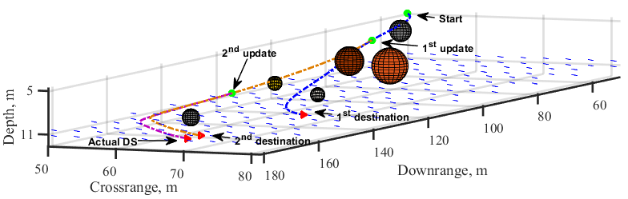

**Figure 1.** 3D collision-free path re-optimized based on a better knowledge of the DS location.

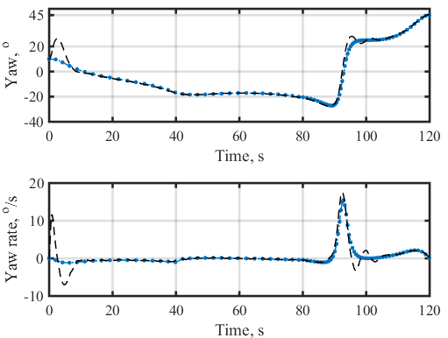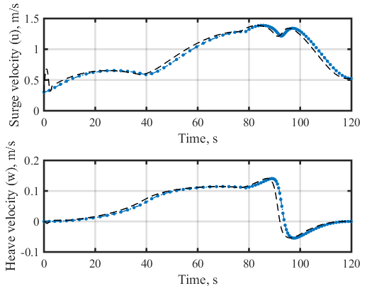

(a) (b)

**Figure 2.** FSILP-based evolution of yaw and yaw rate (a); surge and heave velocities (b).

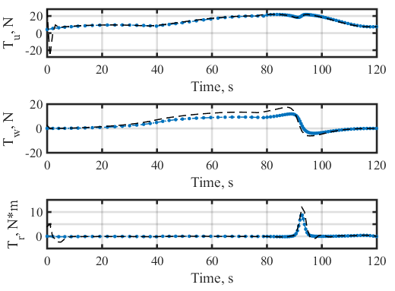

**Figure 3.** FSILP-based evolution of controls.

Figures 2-3 compare the corresponding time histories of surge and heave velocities, yaw angle and yaw rate, and controls obtained by the guidance system (indicated by the blue-dotted lines) and their equivalent trajectories (indicated by the black-dashed lines) obtained by the Flinders Software-In-the Loop Platform (FSILP) [3]. Fig. 2 (a) shows the capacity of the guidance system to adjust the surge and heave velocities (as opposed to the fixed speed profile in the classic docking guidance systems) while assuring smooth arrival at the DS. Fig. 2 (b) clearly shows a correct final zero-yaw-rate aligning the AUV with the DS centre-line. The control time histories shown in Fig. 3 demonstrate that all controls are within their limits (within pre-set tolerances). These control profiles result in a normalized performance index *J* = 0.6 or equivalently 22.54% energy saving () as compared with the guidance system in which the docking manoeuvre is performed at the control bounds ().

# Conclusion

The goal of this paper was to investigate the performance effectiveness of a universal docking guidance system for recovering an AUV using a towed DS behind a mother ship/boat. The developed system was thoroughly tested within a software in the loop environment and proved its practicality and suitability for on-board implementation. The computational efficiency of the guidance system allows the reference trajectory to be updated in real time as needed for online trajectory generation (closed-loop configuration), and therefore makes it a good candidate for embedding within a typical AUV x86 back seat driver.

The next stage of this work which is currently underway is to implement the docking guidance system on an actual AUV and test it with a towed docking station.

References

1. B. Allen, T. Austin, N. Forrester, R. Goldsborough, A. Kukulya, G. Packard, M. Purcell, and R.Stokey, Autonomous docking demonstrations with enhanced REMUS technology, *in OCEANS 2006 MTS/IEEE Conference*,2006, pp. 1-6.
2. A. Yazdani, K. Sammut, O. Yakimenko, A. Lammas, S. MahmoudZadeh, and Y. Tang, "Time and energy efficient trajectory generator for autonomous underwater vehicle docking operations," *in OCEANS 2016 MTS/IEEE Monterey*, 2016, pp. 1-7.
3. A. M. Yazdani, K. Sammut, O. A. Yakimenko, A. Lammas, Y. Tang, and S. M. Zadeh, "IDVD-based trajectory generator for autonomous underwater docking operations," *Robotics and Autonomous Systems*, vol. 92, pp. 12-29, 2017.
4. G. D. Watt et al., "A concept for docking a UUV with a slowly moving submarine under waves," *IEEE Journal of Oceanic Engineering*, vol. 41, no. 2, pp. 471-498, 2016.
5. F. Raspante, "Underwater mobile docking of autonomous underwater vehicles," *in OCEANS 2012 Conference*, 2012, pp. 1-15.
6. Y. Li, Y. Jiang, J. Cao, B. Wang, and Y. Li, AUV docking experiments based on vision positioning using two cameras, *Ocean Engineering*, 110(A), 2015, pp. 163-173.
7. W. Naeem, R. Sutton, and S. M. Ahmad, Pure pursuit guidance and model predictive control of an autonomous underwater vehicle for cable/pipeline tracking, *Journal of Marine Science and Environment C*(1), 2003, pp. 25-35.
8. J.-Y. Park, B.-H. Jun, P.-M. Lee, Y.-K. Lim, and J.-H. Oh, Modified linear terminal guidance for docking and a time-varying ocean current observer, *IEEE Symposium on Underwater Technology and Workshop on Scientific Use of Submarine Cables and Related Technologies*, 2011, pp. 1-6.
9. T. T. J. Prestero, Verification of a six-degree of freedom simulation model for the REMUS autonomous underwater vehicle, *Master of Science thesis*, Massachusetts institute of technology, 2001.
10. O. A. Yakimenko, Direct method for rapid prototyping of near-optimal aircraft trajectories, *Journal of Guidance, Control, and Dynamics*, 23(5), pp. 865-875, 2000.
11. R. Jamilnia and A. Naghash, Optimal guidance based on receding horizon control and online trajectory optimization, *Journal of Aerospace Engineering*, 26(4), 2011, pp. 786-793.

1. Assoc. Prof. Karl Sammut, Centre for Maritime Engineering, Control & Imaging, Flinders University, Adelaide, South Australia, Australia; E-mail: karl.sammut@flinders.edu.au