Hybrid energy and propulsion system for vessels in timetable operation

Martin EINSIEDLER[1]

Head of Naval Architecture and Engineering, Shiptec AG, Switzerland

**Abstract.** The energy consumption of propulsion and all on board systems is becoming more and more into the focus of attention in shipbuilding and operation. After some ample and intensive analysis and measurements of multiple operational profiles of ships, it was determined that a new, hybrid propulsion system, will be the optimal solution to reduce fuel consumption in timetable operation. This parallel hybrid system, which incorporates propulsion as well as the general energy management of all energy consuming parts on board as a holistic system, so that the distinct, transient processes can be smoothed out as much as possible. This allows the multiple diesel engines, which are the main energy producers, to work at their most efficient operating point (or they shut off entirely due to battery buffers). The focus of the project is set on considering the integration of the different systems, their optimal cooperation with each other and the required system dynamics. First measurements at the pilot vessel show that fuel consumption can be reduced by up to 25%. In addition, they show that, with the additional help of downsizing relevant components, the costs of operation can be reduced up to 40% (excl. crew costs).

**Keywords.** reduction of operating costs, based on measured, holistic, cross-linked approach, fuel and CO2 savings, verified by monitoring

# Introduction

When inland vessels are either overhauled or designed from scratch, the close evaluation and specific optimization of their energy consumption from onboard systems as well as propulsion is increasingly important. By reducing fuel consumption, operating expenses may be lowered and emissions reduced. Conventional propulsion and energy generation systems on passenger vessels have a high degree of average energy consumption. On diesel-powered passenger vessels that run according to a fixed timetable, fuel consumption typically equates to 35-40% of ship operating expenses. Achieving significant savings in such energy use therefore is not only environmentally friendly, but also economically worthwhile.

In order to achieve these goals, Shiptec AG has completed several studies and detailed measurements, in order to record the differences between conventional diesel systems and a new (at this time potential) hybrid system that makes use of energy storage (batteries) in order to break peak demand, more evenly distribute energy generation requirements and therefore save fuel.

## The new vessel

The customer’s specification called for a vessel that “sets a new standard with regards to comfort, operational flexibility and energy consumption”.

The intended operational duties of the new ship are regularly scheduled, timetabled lake cruises (75%) as well as specially themed events (15%) and private charters (10%) [1]. In order to meet these varied operational requirements, a new and highly efficient energy and propulsion system was needed. High availability and reliability of the propulsion system and the onboard power supply are also essential, as are high efficiency, low TOC and safe crash-stop behavior (<3.5 x -DWL).

Technical data:

LOA: 63.2 m, BOA: 13.2 m

Displacement: ca. 400 t

Passenger capacity: 1100

Shaft power: 2 x 585 kW

# Analysis of the operation profile and chosen system architecture

Already during the conceptual design stage for the new energy and propulsion system, an emphasis was placed on risk reduction. Benchmarks such as ship type, ship deployment and mode of operation always depend greatly on the individual owner and the crew. Other external factors and the environment of the operating area also have to be factored in. These parameters make it difficult to compare current with previous projects. Often ship owners are not willing to tread new ground and trust emerging technologies, due to a lack of previous experience or uncertainties about future cost or reliability. In some operating environments, the close integration of water with land transport also has significant influence on the design parameters, as do weather conditions in extreme environments. In these cases, “tried and tested” technologies usually win out.

When analyzing all of the potential risks, it quickly becomes clear that a complex and fully integrated energy and propulsion system can only be designed according to accurate measurements of similar operating profiles combined with detailed simulation and prognosis about the expected deployment of the ship. Typically, this kind of due diligence is not practiced during the design and production of inland vessels. Instead, new ships are often built around a spec that includes generous power reserves. These reserves, however, come at the cost of operating efficiency and operating expense. Only by completing this detailed analysis and simulation process, will one obtain the necessary data to specify the degree of downsizing that is necessary to yield financial savings while limiting technical risk.

## Operating profile

At the start of the campaign, exact measurement systems and data recording processes first had to be developed, in order to reliably measure actual power requirements for the propulsion as well as the hotel load. The measurement system had to be dynamic and adaptable to the different operating conditions.

An existing ship was chosen as a substitute for the future vessel and as the testbed case, the regular timetable route from Lucerne to Flüelen was selected on Lake Lucerne in Switzerland. This regularly scheduled, timetabled service is about 93 km/51 miles.

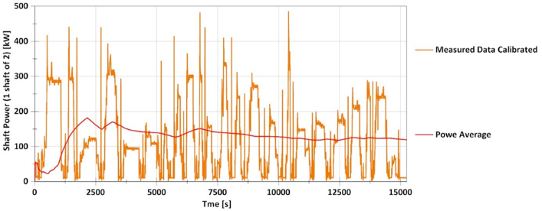Using this measurement system and corresponding methodology, it is possible to establish an operating cycle that should be similar to that of the future ship and therefore can be calibrated with predictions from CFD calculations and towing tank (with future hull design and weight) [2]. Therefore, this overall picture provides a reliable forecast of the dynamic power requirements for the new ship.

**Figure 1**. Measured load case calibrated with towing tank test results

As can be seen in figure 1, the calculated average power requirement (red line) will be quite small in relation to projected peak power. This illustrates the direct potential of a hybrid solution, since conventional propulsion systems must always be designed for maximum peak power during maneuvers, and the motorization is always oversized when in normal operating mode.

Based on these considerations, the basic concept for the prototype was developed as a parallel hybrid. In this system, a relatively small electric motor is used as a booster to assist the engine during dynamic processes or in continuous operation at constant speed as a shaft generator, while still also generating energy to charge the buffer batteries and the onboard electrical system.

## Integration of onboard energy consumers

As a next step, the system is supplemented by the integration of predicted, partially dynamic onboard energy consumption.

Observing conventional energy systems, one notices that the gensets often have a very poor efficiency because they must be designed for a theoretical peak load, while the average load is much lower. The advantage of a parallel hybrid system is that surplus power from the above mentioned shaft generators can be used to feed the hotel load, as long as the extra power is not needed to recharge the batteries. As part of this project, it has become apparent that as long as the energy management system and the battery capacity are correctly aligned, any shortfall in the provision of onboard energy can be compensated by the batteries. This also works if the shaft generator can only deliver energy sporadically, which is typical for ships running regular timetabled services.

In order to achieve proper system design, all of these considerations, including actual measurements as well as future consumption predictions, must be bundled together, so that the theoretical as well as dynamic behavior of the future batteries can be depicted through a Shiptec specific simulation. The simulation results then form the basis for the actual systems design process and for selecting the right components and closed loop processes.

## Architecture for the 2 propeller prototype ship

**Figure 2.** System architecture of the prototype vessel

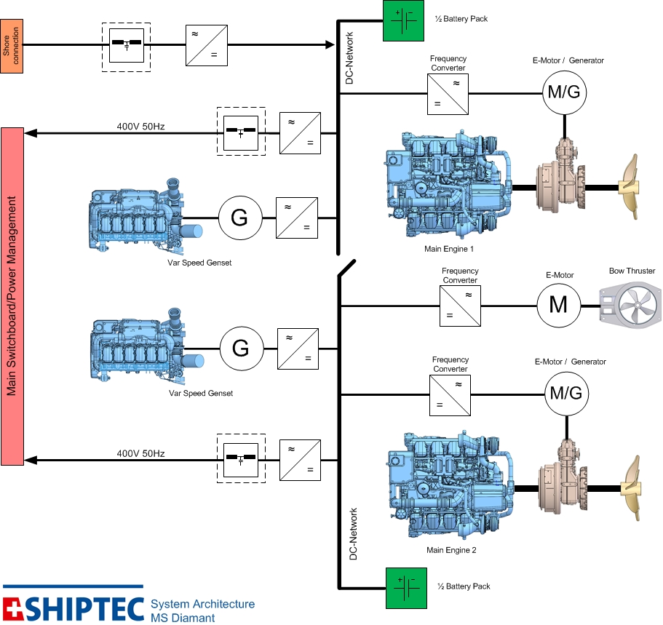

Based on the power requirements of the propulsion, the hotel load and the batteries, the energy system is able to recognize the current load of the different engines and can alternately load, engage or disengage them. Based on the dynamic power requirements, the energy system also recognizes whether the electric motor/generator on the propeller shaft should automatically be switched into boost mode or vice versa. Additionally, the fully integrated power management system also regulates energy supply between batteries, shaft generator and in the worst case the peak load generator, to achieve optimal and reliable power supply for all energy consumers.

# Practical functionality

## Dynamic situation: Pier maneuvers

Pier maneuvers are the departure and arrival of the ship from different piers. In regular timetabled operations, this process usually repeats itself every 5 to 10 min.

In addition to constant speed trials, which were designed to test the boundaries of the system, much emphasis was placed on the dynamic evaluation of typical operational situations. This was intended to parameterize the basic design concept as well as verifying the dynamic and potentials of the propulsion system, while verifying and refining energy distribution to the hotel grid. Figure 3 below depicts the typical sequence of a pier maneuver (sampling rate 0.02s):

a Cruising speed

b Speed reduction

c Propulsion disengagement, speed release

d Astern propulsion burst

e Stop (time required to reach standstill)

f Gradual acceleration

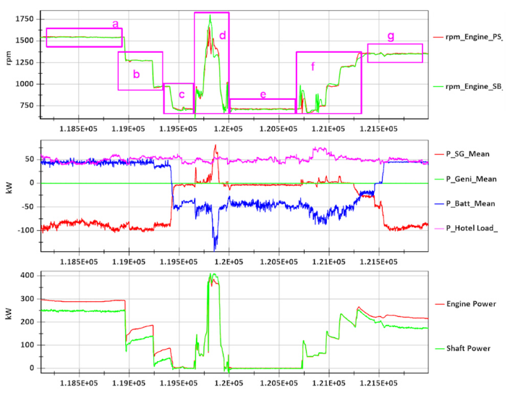g Resumption of cruising speed

**Figure 3.** Pier maneuver

The upper part of the figure shows the effective engine speed during the maneuver.

The third part of the graphic illustrates the situation on the propeller shaft as well as on the main engine. As such, the green curve represents the effective power on the propeller shaft and the red curve displays the power of the engine. Two effects become apparent:

In a, b and g it can be seen how the shaft generator is powered and supplies the vessel with electric current plus battery charging. The graph in the middle highlights this with the red line recording shaft generator power and the blue line indicating battery charging power. In areas c, d, e and f, the shaft generator is not active, instead the board network (as shown in the magenta curve) is being supplied by the batteries. The corresponding negative battery charge is shown by the blue curve. In area d and somewhat also f, the booster comes into play and has been supplied by the batteries, as seen with the red lines marking peak periods. Once this value becomes positive, actual mechanical power is released. As the chart further illustrates, there is no need for the genset to kick in during the pier maneuver and the batteries taking care of all energy supply to the hotel load instead.

## Dynamic situation: Crash stop maneuver

As already mentioned, every vessel in Switzerland must satisfy specific crash stop benchmarks in order to receive certification. The necessary test does place big demands on the system in terms of fast and precise reaction time and requires very high torque on the propeller shaft at very low rpms.

In these instances, the system implements a pre-defined process, which is characterized by a max. permissible time and distance until the vessel has reached a complete stop. Figure 4 below shows this process, with a sampling rate of 0.02 second.

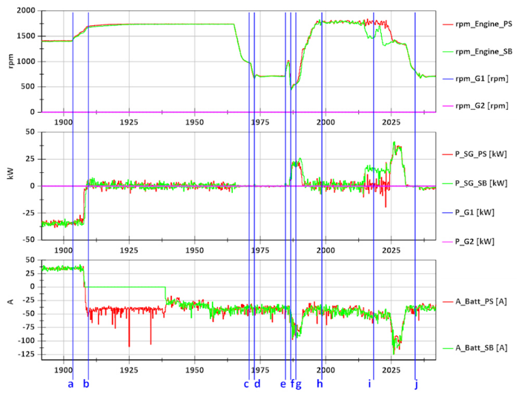a Acceleration to maximum speed

**Figure 4.** Crah stop meneuver

b Achievement of max. speed

c Reduction of propeller speed after the retraction of the control lever (equivalent to idle speed of the engine)

d Disengaging the propeller shaft and braking the shaft with the shaft brake

e Acceleration of the engine prior to engagement of the propulsion

f Engage propulsion

g Acceleration of the engine with the propeller rotating backwards under full load

h Propeller slippage (air)

i Propeller grip with full torque

j Ship has come to a complete stop

The upper part of the diagram shows the speed of the main engines as well as at the gensets. It is noticeable that the gensets do not start during the entire process. The energy for the hotel load as well as the booster is only drawn from the batteries.

Shown also at the lowest chart from figure 4. The negative battery charge current, which is displayed in red and green, represents discharge. The chart in the middle illustrates the power of the shaft generators. It shows a-b the acceleration to maximum cruising speed, as well as shaft generator power goes to 0 kW, in order to provide the propeller with the entire power output from the main engines. Position f shows how the shaft generator becomes a booster during this process, thereby supporting the main engine with maximum boost torque. Position i records propeller grip at full torque.

# Initial results from deployment on revenue services

In addition to the sea trials, initial results from regular operations in actual service have become available for review and comparison with the originally projected energy savings.

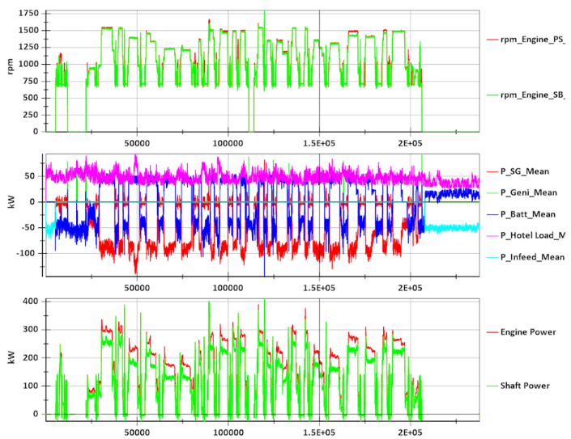The diagrams below show the operating conditions during a timetabled cruise from Lucerne to Flüelen and back, with his 24 pier maneuvers according the one described in section 4.1. This data can be compared to the measurements and simulation records that were originally collected at the beginning of the project. For the sake of this general overview, the individual maneuvers are less important, but rather the entire power distribution cycle and energy flow should be analyzed as a whole. The second curve of figure 5 shows that the system has the required variability to switch between different power sources to cover varying degrees of energy requirements. This so called “load sharing” is easy to follow visually. While the entire power on the hotel load is illustrated in magenta color and remains quite consistent for the full duration of the timetabled cruise, the energy sources respond differently, mainly depending on the rpms of the main engine. At one point, the batteries are being recharged and the hotel load completely supplied by the shaft generators (typically during cruise speed between different stations), while at a different point e.g. during pier maneuvers the electric motors kick in as boosters (red line in the positive area). Later, the hotel load draws its energy from the batteries (blue line in the negative area). The third curve of figure 10 shows the effective power at the main engine (red) as well as the propeller shaft (green). The noticeable difference between these two curves is due to the shaft generator power (red higher than green) or the corresponding boost effect (green higher than red, though hardly apparent in the chart).

**Figure 5.** Operation 11-20 Lucerne-Flüelen-Lucerne

# Conclusion

## Fuel consumption analysis

Because it is impossible to compare the operational parameters of different event cruises with each other, the measured fuel consumption is limited to data from timetabled cruises. These account for roughly 75% of the new ship’s completed mileage.

To establish a calculation basis for the fuel consumption levels based on the energy needs of the hotel load, the electrical power requirements for a full-length timetable cruise was integrated and multiplied by an average fuel consumption value of 193 g/kWh. This value is basically lower than that of a genset running in his optimum. Therefore, optimal consumption values should be classified based on electric output, while energy usage for the propulsion system should be seen as worst case.

In order to evaluate the overall success of the system, the differentiation between energy consumption from the hotel load on one side and propulsion energy on the other, is indispensable because comparable data is only available for these two categories.

In addition to this differentiation between hotel load and propulsion, one needs to factor in different ship sizes when evaluating energy consumption of propulsion. In that regard, ship weight is a helpful benchmark. Based on experience with timetable operating inland waterway vessels, when ship type, build size, speed capability and driving style are all rather similar, fuel consumption will mainly depend linear on vessel weight. The following consumption values are therefore divided by 100 t of ship weight, so as to have comparable benchmarks per propelled ton.

**Figure 6.** Consumption values

By glancing at the different fuel consumption values listed in table 1, the following conclusion becomes relevant:

* The new vessel has higher energy consumption for its hotel load. This circumstance is due to the electrically operated kitchen, a powerful air-conditioning system and more “energy hungry” devices installed on the ship.
* The absolute consumption per kilometer is actually in the same range as for comparable vessels, even though the new ship has 100 t more weight and capacity for 400 extra passengers.
* If fuel consumption per kilometer is divided through 100 t weight of ships, the new ship suddenly has average fuel consumption of 18-25% less than the ships with conventional diesel propulsion (≈ 18-20% CO2 reduction) Furthermore, operational costs can be reduced by up to 40% (excluding crew costs), by downsizing relevant components.

More precise statements and technical data will become available after joint research project with the Lucerne University of Applied Sciences has concluded in late 2019.

References

1. KLUSER, T., ‘MS 2017 Anforderungsprofil’, SGV AG, 2013.
2. VAN HEERD, J., ‘Passenger vessel for Lake Lucerne (60m); calm water model tests’, Marin Report No. 27202-2-DT, 2014.
3. STROHHAMMER, G., ‘Treibstoffverbrauch Flotte SGV ab 2013’, SGV AG, 2017.

1. Martin Einsiedler, Head of Naval Architecture and Engineering, Shiptec AG, Werftestrasse 5, 6002 Luzern, Switzerland; E-mail: m.einsiedler@shiptec.ch