Comparative Study of Hydrodynamic Performance for Optimal Designs of Catamaran and SWATH for Site-Specific Operations
Sing-Kwan LEE ^{a,}, Jiahuan LIU ª, Haidong LU ª, Lixin XU ª, and Jiancheng LIU ª
ª China Merchants Offshore Technology Research Center, China
Abstract. Two typical ship types commonly used in offshore service activities, namely Catamaran and SWATH (Small Waterplane Area Twin Hull), are selected to compare their hydrodynamic performances in a specific site of China Sea. Optimizations of the hulls to minimize their resistances in clam water are performed in this study. According to the optimal hulls obtained, the sea-keeping performance of the hulls are evaluated based on the available wave scatter diagram of a specific site. Through the comparisons of the designs, this study attempts to provide a procedure used in concept design for ship type selection of the offshore vessels operating in site-specific conditions.
Keywords. catamaran, SWATH, hydrodynamic performance, site-specific wave environment

Introduction
Due to the request of energy source diversity, in addition to traditional oil/gas exploitation offshore industry has started to outspread to different energy areas such as gas hydrate and renewable wind energy in open sea. Foreseeably, as the demands of clean energy become more and more ardent under the pressure of environment protection, the offshore activities will extend more to renewable energy development. The recent years’ rapid increases of offshore wind farms in North Sea and East China Sea are two representative examples.
Offshore energy development involves various constructions. For instance, in offshore wind farm development it includes cable laying, foundation installation, wind turbine installation, and subsequent maintenance & operation service, to name some of them. For performing these construction activities special vessels are required. In the designs of these special vessels, hydrodynamic performances in terms of propulsion and sea-keeping are critically concerned as for transportation to remote offshore areas endurance and energy-saving propulsion are two important design indexes and for efficient and safe offshore installation good motion characteristic in open sea wave environment is also essential.
In this paper, two typical ship types commonly used for offshore services, namely Catamaran and SWATH (Small Waterplane Area Twin Hull), are focused to compare their hydrodynamic performances. As known, due to the small waterplane area character, SWATH has excellent sea-keeping advantage but the increase of hull surface underneath water surface causes higher friction resistance thereby disadvantaging energy-saving propulsion. On the other hands, because of its smaller wet surface compared to SWATH, Catamaran has relative lower friction resistance benefit but the larger waterplane area induces motion behavior becoming unfavorable in waves. In principle, comparison of the hydrodynamic performance should not be conducted in a genetic manner by assuming certain wave condition as the actual sea condition is a key factor swaying the actual performance. Instead, site specific metocean data should be applied in performance evaluations for a more meaningful comparison. In this study, optimizations of the hulls for both Catamaran and SWATH to minimize their resistances in clam water are performed. According to the optimal hulls obtained, the sea-keeping performance of the hulls are evaluated based on the available wave scatter diagram of a specific site in China Sea. Through the comparisons of the optimal designs, this paper attempts to provide a procedure to guide the concept design for the ship type selections of offshore vessels operating in specific sea environment.

Overall design/evaluation approach
During concept design phase, it is important to obtain preliminary assessments for different design options rapidly rather than pursuing fine solutions by performing time-consuming sophisticated analysis. In this study, design optimizations and evaluations are performed using computational efficient potential flow based method. The overall design/evaluation procedure consists of hull optimized for minimizing resistance by thin ship theory, RAO (Response Amplitude Operators) calculations by 3D potential flow panel method and site-specific seakeeping performance evaluation using wave scatter diagram along with short term response spectrum analysis.
In hull optimized for minimizing resistance, research codes MICHLET [1] and GODZILLA [2] are used. In MICHLET, thin ship theory and ITTC method are used for wave making and friction resistances evaluations respectively. Validations of the accuracy of MICHLET for thin ship hulls and SWATH are available in [3]. For GODZILLA, it is the evolutionary optimization module for MICHLET. Evolutionary algorithms use principles gleaned from natural genetics and evolution to guide the search for global optimization for hulls with minimum resistance. Applications of GODZILLA for mono-hulls and multi-hulls optimizations can be referred to [4]. In RAO calculations and site-specific seakeeping performance evaluation, WADAM and POSTRESP modules of DNV-GL’s SESAM HYDROD [5] are used first for the short-term statistics of extreme motion analysis. Then the probabilities of year-round operability are calculated based on the site-specific wave scatter diagram and the motion criteria for catamaran and SWATH offshore operations.

Hull optimized for minimizing resistance

Geometries of SWATH and Catamaran
SWATH hull includes submerged pontoon and surface piercing strut parts. For the pontoon part, it consists of ellipsoidal nose, parabolic tail and elliptical cross section parallel midbody. For the strut part, it contains parabolic nose, parallel midbody and parabolic tail. Detailed dimension definitions of the geometries are illustrated in figure 1.
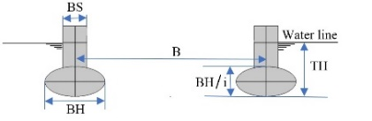
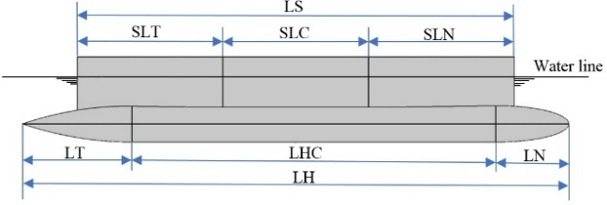
LH pontoon length  LN pontoon nose length  LT pontoon tail length  LHC length of pontoon parallel midbody  BH width of pontoon elliptical cross section  BH/I height of pontoon elliptical cross section  I ratio between pontoon height and width | LS strut length  BS strut beam  SLN strut nose length  SLT strut tail length  SLC length of strut parallel midbody | TH SWATH draft  B distance between pontoons
Figure 1. Dimension definitions of SWATH geometry

Wigley hull (parabolic geometry hull) is used for Catamaran in this study. Similar to nose, tail and parallel midbody parts in SWATH hull, the catamaran hulls are defined with bow, stern and parallel midbody parts as shown in figure 2.
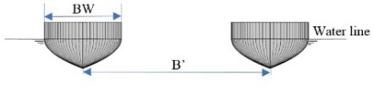
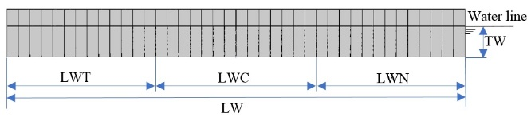
LW hull length  LWT stern part length  LWN bow part length  LWC parallel midbody length | BW hull breath  TW hull draft  B’ distance between Wigley hulls
Figure 2. Dimension definitions of Catamaran geometry

SWATH resistance minimization
In SWATH hull design for resistance minimization, parametric study of the critical parameters with large influence on resistance is performed systemically. As known, wet surface area is the main parameter controlling the friction resistance and for minimizing the friction it should be reduced as much as possible. Although circular shape cross section (i=1) of parallel midbody is well known with minimum wet surface, under the constrains of displacement (38,000 ton), draft (16m) and length (134.4m), the use of circular shape cross section will reduce submerged depth of the pontoons and the widen strut beam causing increase of wave making resistance. To investigate the impact of different cross section shapes on total resistance (sum of wave making and friction resistances) of the original design with the geometry dimensions of Table 1, five different axial ratios i (1, 1.25, 1.5, 1.75 and 2.) of the elliptical shapes for parallel midbody are selected as shown in figure 3 to evaluate their resistances. As seen in the figure, larger i tends to increase pontoon submerged depth and decrease strut beam width which will benefit the wave making resistance reduction although the wet surface areas are increasing from 5350m² for i = 1 to 6636m² for i = 2 causing the friction resistance increase. The calculated resistances for the five geometries are plotted in figure 4 for wave making R_{w} and friction R_{v} resistances and figure 5 for total resistance R_{t}. As expected, when i increases, friction resistance increases but wave making resistance decreases. For the total resistances at the design speed 14 kts (7.2 m/s), due to the greater decreases of wave making resistance compared to friction resistance for larger i value geometry, i = 2 geometry has the lowest resistances as seen in figure 5.

Table 1. Geometry dimensions of original SWATH
i | displacement | LH | TH | (SLN,SLT)/SLC | LS/LH | LHC/LH | LT/LHC | LN/LHC | BS/BH | B
1 | 3800t | 134.4m | 16m | 0.2 | 0.8 | 2/3 | 0.3 | 0.2 | 0.4 | 72m

i=1 | i=1.25 | i=1.5 | i=1.75 | i=2
5350m² | 5662m² | 6014m² | 6330m² | 6636m²
Figure 3. Elliptical shapes for 5 axial ratios i and corresponding wet surface areas

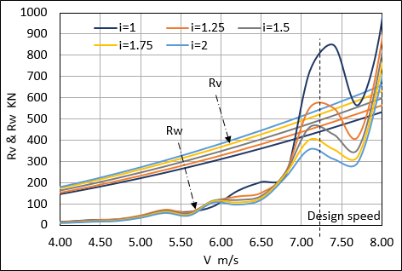 | 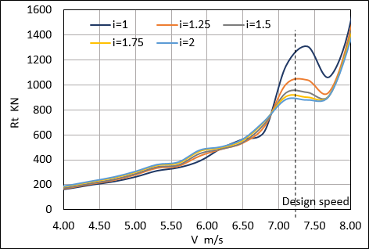
Figure 4. Friction and wave making resistances for different i geometries at different speeds | Figure 5. Total resistances for different i geometries at different speeds
To investigate the sensitivity of distance between pontoons, parameter B indicated in figure 1, to resistance decrease, the parameter B is changed from 36m to 80m for the i =2 geometry previously obtained to evaluate the wave making resistances R_{w} at the design speed 14 kts. It is found although there is a minimum R_{w} = 354kN occurring at B = 50m (figure 6), the decrease of R_{w} compared to the original B = 72m is very small, only 9.3kN. Compared to the total resistance R_{t} = 885 kN for the original B = 72m configuration, the decrease of resistance caused by R_{w} decrease is just about ~1% indicating that the B parameter is not sensitive to the resistance decrease. To consider the better stability of the SWATH, the original B = 72m is maintained instead of using the smaller B = 50m geometry with minimum R_{w}.
For SWATH with deep submergence pontoon configuration (i=2), wave making resistance is more influenced by surface piercing strut geometry. To further optimize the SWATH hull, strut width and strut nose/tail lengths (parameters BS, SLN and SLT) are investigated. Figure 7 presents the total resistances R_{t} for varied BS/BH and (SLN, SLT)/SLC in the ranges of 0.2 – 0.4 and 0.2 – 1.0, respectively. It is found the optimal hull for minimum resistance is the geometry with strut width ratio BS/BH =0.4 with equal strut tail (SLT), nose (SLN) and parallel midbody length configuration (SLN, SLT)/SLC =1.0. The detailed dimensions of the optimal SWATH are summarized in Table 2 and the hull geometry is plotted in figure 8.
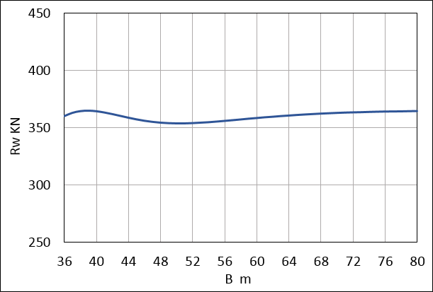 | 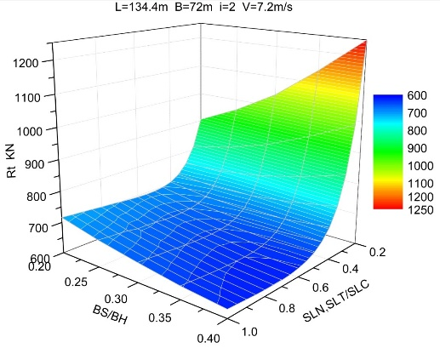
Figure 6. Wave making resistance R_{w} for different distances between pontoons B at design speed 14 kts | Figure 7. Total resistance R_{t} for varied strut widths and strut nose/tail lengths

Table 2. Geometry dimensions of optimal SWATH hull
displacement | LH | B | LHC | LN | LT | LS | SLN, SLT, SLC | BS | BH | BH/i
3800t | 134.4m | 72m | 89.6m | 17.92m | 26.88m | 107.52m | 35.84m | 7.09m | 17.73m | 8.865m

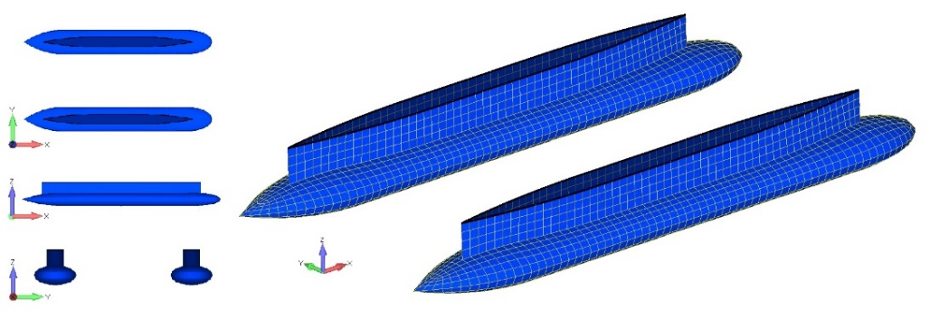
Figure 8. Optimized SWATH hull with minimum resistance

Catamaran resistance minimization
Unlike the parametric study method used in SWATH hull optimization, hull optimization for catamaran is carried by GODZILLA using evolutionary algorithms based on principles gleaned from natural genetics and evolution to guide the search for optimal hull form. Similar to SWATH, ship length and displacement are constrained during the optimization for resistance minimizing of the hull. Here, the same ship length 134.4m of the SWATH is set for catamaran hull optimization and for the design ship speed, it maintains 14 kts same as the SWATH. Different from the SWATH, as catamaran does not have to be ballasted to fulfill the deep draft 16m as the SWATH does, the displacement can be reduced to 25,824t, instead of 38,000t used in the SWATH. In hull optimization, the breath BW, draft TW, bow part length LWN, stern part length LWT, parallel midbody length LWC and distance between the Wigley hulls of the catamaran B’ can be varied in the ranges as listed in table 3. In performing the optimization, the object function is to minimize the total resistance, the size of the population of vessels is set as 60. During the search for optimal hull form more than one hundred thousand times fitness evaluations have been performed. Table 4 provides the dimensions of the final optimal hull. The geometries of the optimal Wigley hulls are plotted in figure 9.

Table 3. Dimensions varied ranges of catamaran for hull optimization
BW | TW | LWN | LWT | LWC | B’
3m ~ 30m | 5m ~ 9m | 26.88m ~ 67.2m | 26.88m ~ 67.2m | 0m ~ 80.64m | 30m ~ 80m

Table 4. Dimensions of optimal hull
BW | TW | LWN | LWT | LWC | B’
23.43m | 9m | 67.2m | 67.2m | 0m | 56.84m

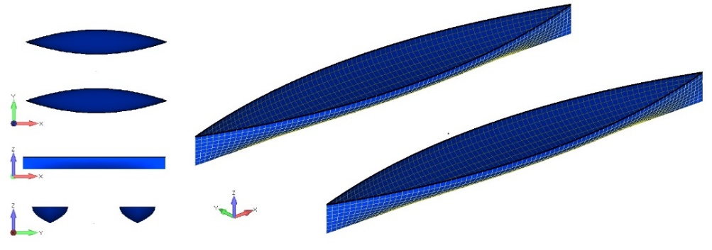
Figure 9. Optimal Wigley hull form of catamaran

Resistance comparison between SWATH and catamaran
For the optimal hulls of the SWATH and the catamaran obtained, the wave making resistances R_{W}, friction resistances R_{v} and total resistances R_{t} are summarized in table 5 for comparison. As seen in the table, due to the wet surface increase of the SWATH (45%), the friction resistance R_{v} of the SWATH is increased about 33% compared to the catamaran. However, for wave making resistance as the SWATH can apply the configuration of optimal strut and deeply submerged pontoon, it results in large reduction of wave making resistance. Compared to the catamaran, the SWATH can reduce 167.8 kN in wave making resistance (about 141% reduction compared to the catamaran) and eventually leads to the total resistance of the SWATH almost same as the catamaran.

Table 5. Resistances comparison of SWATH and catamaran
 |  | SWATH |  |  |  |  | Catamaran |  |  |  |  | Difference  $$\frac{SWATH-Catamaran}{SWATH}\%$$
Wet surface area |  |  |  | 12520.2 m² |  |  |  | 6890.2 m² |  |  | +45.0%
Resistances | R_{w} |  | R_{v} |  | R_{t} | R_{w} |  | R_{v} | R_{t} | R_{w} |  |  | R_{v} | R_{t}
[kN] | 119.1 |  | 507.8 |  | 626.9 | 286.9 |  | 340.2 | 627.1 | -140.9% |  |  | +33.0% | -0.03%

Motion RAO analysis
In addition to resistance and propulsion performance, seakeeping characteristic is another critical element to evaluate the vessels for offshore services. Based on the optimal hull forms obtained for the SWATH and catamaran, motion analyses are performed. As known, in open sea operation, among different wave directions head sea direction is usually chosen for minimum motion operation. Figure 10, 11 and 12 plot the heave, surge and pitch RAOs of the same reference point at midship centerline on free surface under head sea condition for the optimal hulls of the SWATH and catamaran. As seen, compared to the catamaran, the surge and pitch RAOs of the SWATH always have lower values and for the heave RAO the SWATH also shows smaller motion than the catamaran except when the wave periods are larger than 15s. According to the RAOs features, it can preliminarily conclude the SWATH can have better seakeeping performance compared to the catamaran if the waves with periods larger than 15s are not dominant in wave environment.

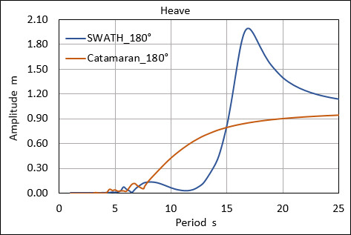 | 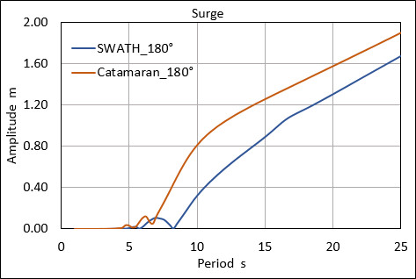 | 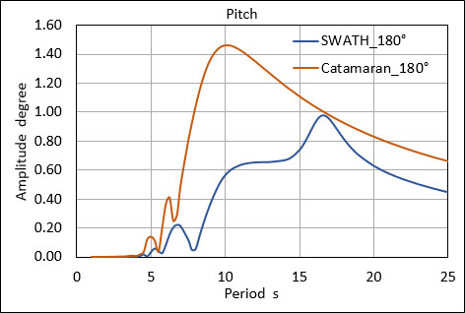
Figure 10. Heave RAO at head sea | Figure 11. Surge RAO at head sea | Figure 12. Pitch RAO at head sea

Site-specific seakeeping performance evaluation
To further evaluate the seakeeping performance at site-specific condition, a wave scatter diagram of an offshore site in China Sea is selected (table 6) for site operation evaluation of the SWATH and catamaran. The extreme value of vertical and horizontal motion combination corresponding to maximum response in 3-hours duration at two representative points located at central plane (A and B) as shown in figure 13 are calculated based on short-term statistics using PM wave spectrum. The results are summarized in table 7 and 8 for the SWATH and catamaran respectively. By setting the operation limit at the two representative points as 1m, the allowable operation sea states can be determined which are the sea states highlighted with blue color in table 7 and 8. According to the wave scatter diagram and the allowable operation sea states, the probabilities of year-round operability for the SWATH and catamaran are calculated which are 95.7% for the SWATH and 62.4% for the catamaran.
Table 6. Wave scatter diagram of an offshore site in China Sea  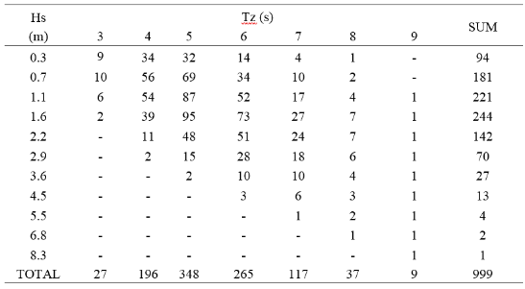 | 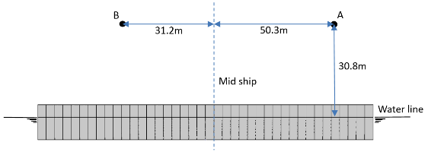  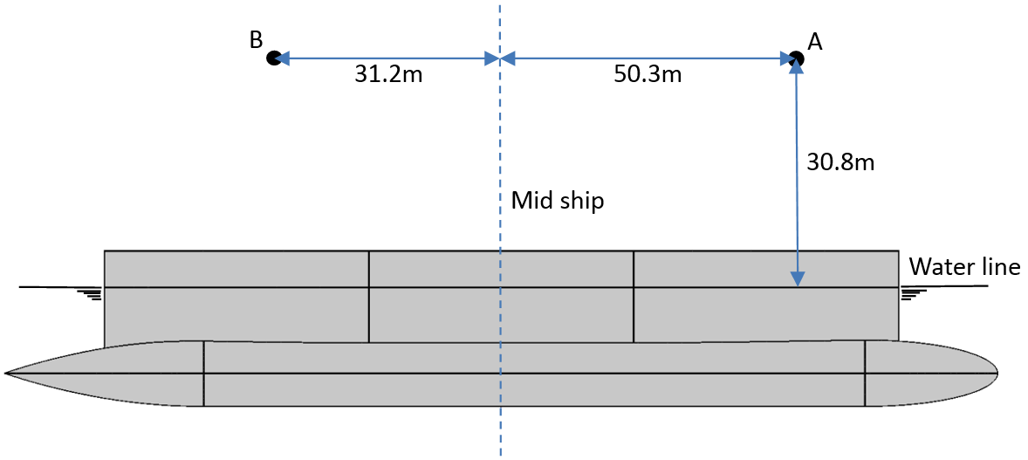  Figure 13. Rrepresentative points A and B for allowable operation check

Table 7. Maximum translation motion at reference points (A and B) of SWATH | Table 8. Maximum translation motion at  reference points (A and B) of catamaran

Concluding remarks
Two typical ship types commonly used in offshore service activities, namely Catamaran and SWATH, are studied for their hydrodynamic performance in site-specific operations. The hull geometries of SWATH and Catamaran are optimized for minimizing their resistances. Although the SWATH has larger wet surface than the catamaran causing higher friction resistance, due to the use of optimal strut and deeply submerged pontoon the SWATH can be optimized to largely reduce the wave making resistance. By comparing the total resistances between the SWATH and the Catamaran after optimization, it is found unlike the general expectation that the SWATH will has higher resistance than the catamaran, the total resistance of the SWATH can achieve the same level of the catamaran.
To evaluate the seakeeping performance, motion RAOs for heave, pitch and surge at head sea operation are calculated for the vessels. The results show the SWATH accomplishes better seakeeping performance in general sea states except for the very long wave dominated sea with periods larger than 15s. To further estimate the performance of SWATH and catamaran for specific site operations in China Sea, the operation limit criteria for two representative points are defined as 1m and the allowable operation sea states are obtained based on short-term statistics using PM wave spectrum. According to the wave scatter diagram and the allowable operation sea state results, it is found the probabilities of year-round operability are 95.7% for the SWATH and 62.4% for the catamaran. The SWATH has 1.53 times larger operability than the catamaran.
Through the comparative study, a practical as well as efficient procedure for hull optimization and sea-keeping performance evaluation for site specific operations of different vessel types has been demonstrated, which is applicable to decision making of hull type screening at concept design stage.

References
- MICHLET 9.33 User’s Manual, 2015
- GODZILLA 9.33 User’s Manual, 2015
- Tuck, E.O., “Wave resistance of thin ships and catamarans”, Internal report T8701, Applied Mathematics Department, University of Adelaide, 1997.
- GODZILLA 9.33 Examples and Templates, 2015
- DNV GL “User Course SESAM HYDROD – Hydrodynamic analysis of offshore floaters” 2018.

Corresponding Author, China Merchants Offshore Technology Research Center, 1 Xin An Jiang Road, Floor 7, Bin Jiang Street, Haimen, Jiangsu Province, China; E-mail: leesk@cmhk.com.

