Engineering progress measured on CAD 3D model data rather than drawings
Igor JURICIC ª and Luciano MARESCA ^{b}
ªIntergraph Italia LLC
^{b} Intergraph Engineering Environment Services S.p.A.

Abstract. Current CAD/PLM technology is finally allowing to perform engineering progress evaluation based on the model data rather than on traditional drawings and human subjective estimation. The paper illustrates the applied method, the requirements posed on the CAD/PLM solution to guarantee the applicability and a solution already available on the market. The real case study shows an example of the design progress and costs evaluation based on “bulk items by weight” that well fits the case of Work Packages dealing with the hull structure in the shipbuilding industry.
Keywords. CAD, Project Control, Engineering Progress, Cost Assessment.

Introduction
The purpose of this paper is to illustrate a solution that allows to quickly control the progress in the design of any kind of process, power or marine plants, including ships prototype, sister-ships or semi-repeated ships. The evaluation of the executed job, based on objective and standardized criteria can be extended to the cost assessments in terms of engineering hours spent in design and in the creation of deliverables e.g. drawings and reports which content is generally described in the standard procurement specifications.
Thanks to the unique CAD model database and the centralized Project Control tool the described evaluation method is applicable to internal as well as to external (subcontracted) design engineering activities [1].
The evaluation of the executed job compared to the expected final results is called progress. The progress is expressing, in numbers/percentage, the evolution of the 3D model i.e. it’s reached maturity level at pre-defined check-points. At the check-points (Milestones) the requirement is not only the creation of a number of specific business objects (components) but also obtaining an approval status while reaching certain characteristics e.g. different representation levels and a growing number of non-graphical attributes showing the achievement of pre-defined stages.
In order to express the engineering progress of all the outfitting components the following formula is applied:

Progress = EarnedValue / PlannedValue = Σ (Ev * Wt) / Σ (Pv * Wt) (1)

where:
Ev is the earned value of each measured object
Wt is the object type “figurative”weight
Pv is the planned number of objects for each type of object
Assuming that the evolution of the CAD 3D model from scratch to the “ready-for-production” might be framed by the following 4 typical milestones and sample maturity percentage: Issue for Approval (25%), for Design (60%), for Procurement (80%) and finally Issue for Construction (100%).

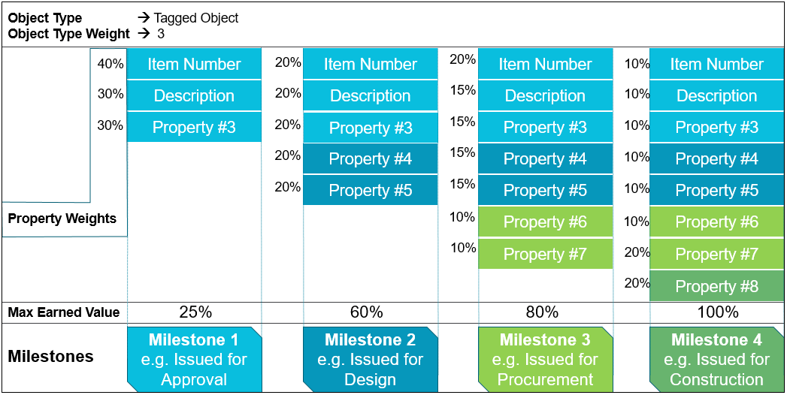
Figure 1. Template milestones and values applied for tagged outfitting components

The engineering progress calculation is based on the sum of the maturity of each of the considered objects in the 3D model e.g. assuming that the maximum contribution in the Earned Value for the milestone 2 is 60%; if one of the 2 properties additionally requested for this milestone has not been populated and each of them “weights” by 20% the resulting Earned Value will be 80% out of the maximum reachable 60% i.e. 0.48 of the target.
The structural components are treated as “bulk” in spite of the fact that each of them, individually, is evolving through clearly defined stages: structural components are typically created during the basic design stage, these are modified during the detailing phase and finalized during the manufacturing/construction phase. The progress for an Engineering Work Package that contains “bulk items by weight” as in the hull structure or “bulk items by volume” as in the building concrete, can be calculated using the same formula where instead of the number of components (business objects) the quantities are expressed in [Kg] or [m³].
The case-study considers only hull design activities; typical outfitting/plant activities like equipment layout, pipe and duct routing or electrical cable routing have been left out for future analyses.
In the configuration of the proposed solution the 3D CAD tool can easily extract and share with the Project Control tool the data relevant to all the objects that are composing an area of the plant or a section/block of a ship and evaluate the progress and the engineering costs following the formulas that fit the nature of the objects as well as the specificity of the business case.

The CAD and the Project Control integration
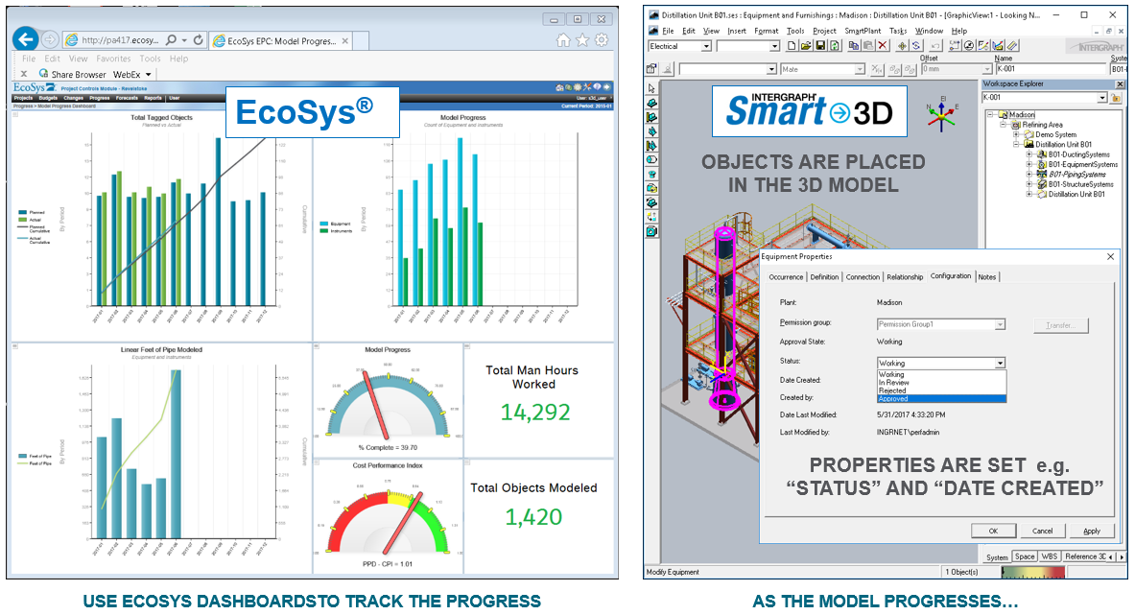
Figure 2. The Project Control and the CAD 3D tool

The current level of integration between the 3D CAD and the Project Control tool is the result of incremental development steps that are including also other applications of the comprehensive SmartYard® solution (see the updates of the 3D model (n.9) and the corresponding evaluation of the progress (n.22) in Figure. 3.
beside Smart®3D and EcoSys® integration there is also the material management (Smart Materials), the construction (Smart Construction) and the third party planning tool (Primavera®).

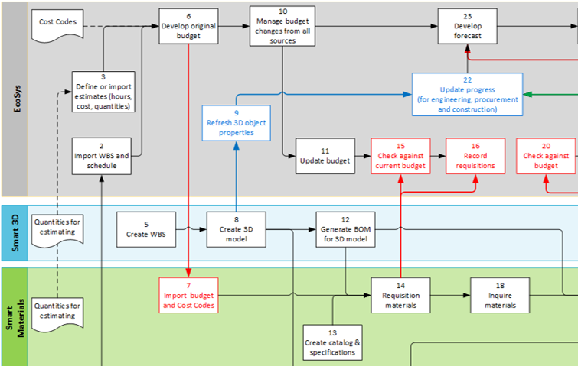
Figure 3. Portion of data flow diagram including the CAD and Project Control streams.

The integration between Smart®3D and EcoSys® allows to share relevant CAD data in a structured way [5] so that the system (PBS) or the assembly hierarchy (WBS) used for the design process maps the CBS in EcoSys® that is built on Cost Control Levels.
The latest steps in the development of the integrated solution have introduced dedicated Web APIs that enable Project Control customized applications and reports to run in traditional as well as in the Cloud system architecture.
The most important consequence of such a tight integration between the CAD and the Project Control tool is the possibility to perform Project Control activities by the interested management profiles with the necessary discretion and the desired frequency without requesting any overhead labour to the designers or other CAD system operators.

The case-study
The purpose of the case-study was to validate on-site the proposed method and define the formulas to express numerically the engineering progress.
Together with the Customer it has been decided to focus on a discipline that is considered critical and to keep the analysis as simple as possible, therefore the scope of the case-study was limited to:
- Hull structure of already modelled blocks of a cruise ship
- Consider all the hull structure as of the same object type i.e. no differentiation between primary and secondary structure as suggested in other cases (plants)
- The use of MS Excel sheets for the data transfer between the 2 tools in use i.e. an interface to prove the concept rather than an integration as it should be put in place in production.
Smart®3D has been the only CAD 3D tool used to create all the structural objects and to modify them during the engineering process adding data (properties) important for the manufacturing and the construction. Regardless of the approval status and the maturity level with Smart®3D it is always possible to extract the Weight and the CoG of an aggregation of components (assembly) then, to the need, Smart®3D can discriminate (filter) the report generation of structural objects by type, by time stamp, by author and by any other associated attributes. The generated outputs are MS Excel sheets.
For the case-study a report including a subset of the considered areas of the hull, has been used to transfer the data (weight/lotto) from the CAD to the Project Control tool.
In EcoSys®, to express the engineering progress of the hull structure the used formula is equivalent to (1) where:
Ev is the earned value of each weighted structural object
Wt is the physical weight of each structural object
Pv is the planned weight of the completed “lotto”
The progress might be roughly expressed by the ratio between the weight of all the structural components belonging to a “lotto” and the expected (total) weight of the completed “lotto”.
The project gets by default a progressive number e.g. PRJ-000032; this was good enough for the case-study although the displayed name in the table should be substituted with an Alternative ID fully matching the analyzed ship/build.

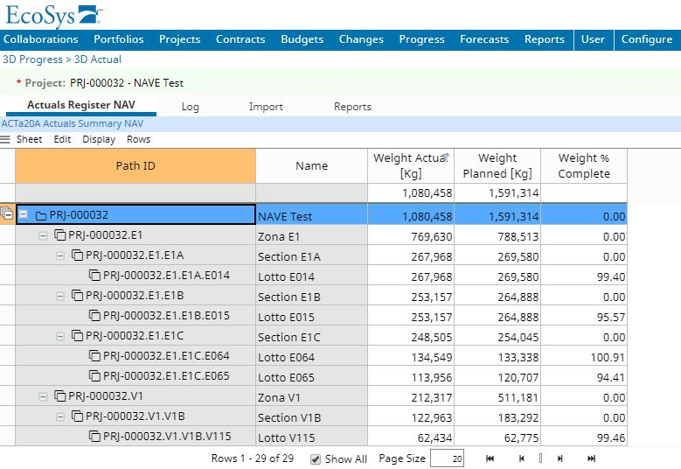
Figure 4. Progress evaluation based on Weight Complete.

In addition to the progress linked directly to the weight of the “lotto”, thanks to an existing internal Fincantieri document/tool [2] aiming to estimate the number of engineering hours necessary to develop the production documentation for every structural block, the case-study entered also the area of the labour/cost assessment.
The internal document contains a series of parameters and coefficients that allow to correlate the engineering hours to the weight of the involved structure corrected according to the size and type of vessel or area with a homogeneous technical content. The data refer to cruise ships or passenger ferries. The document illustrates the metrics and drivers, made on a historical basis, to be used for the evaluation in hours of the coordination and executive design activities related to the hull structure. The coefficient K1 reflects the size of the ship i.e. the complexity/density of its structure. The coefficient K2 has been introduced in order to define the areas with homogeneous content in structural terms and therefore cost per unit of weight, said parameter has been diversified by ship area. The coefficient K3 (optional) might be used in order to apply a corrective factor to a specific “lotto” within a homogenous structural area; default value is 1. The above parameters and coefficients (Kn) are continuously refined following their application to real cases.
In the case-study both the expected weight of each “lotto” and the corrective coefficients used for the cost/labor assessment are passed together to EcoSys® with a spreadsheet like in Figure 5.
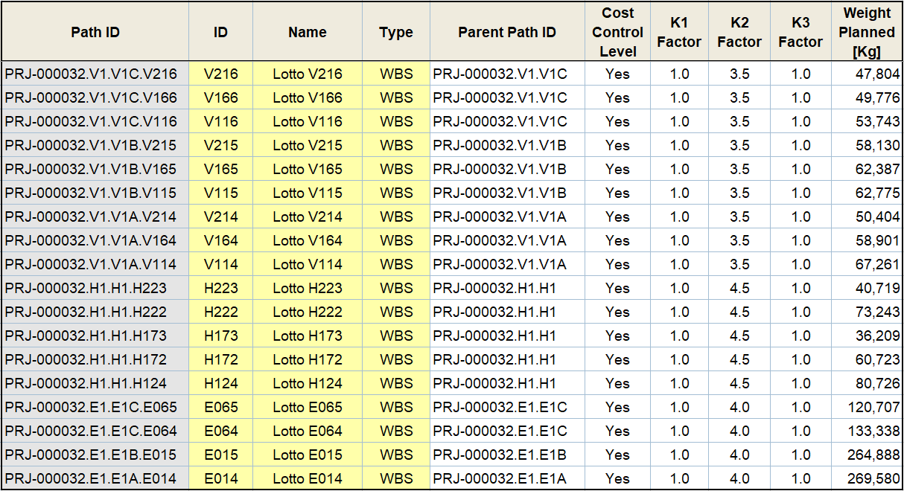
Figure 5. Planned Weight and related Kn coefficients by ‘lotto’

Figure 6. to illustrate the planned and the actual weight and the correlated engineering hours for the selected lotto V114:

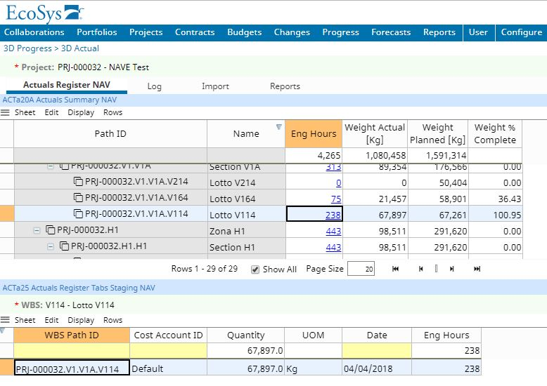Figure 6. Engineering hours spent on the lotto V114

Conclusions
The weight of the modelled structure has been identified as the most satisfactory parameter to evaluate the progress in the engineering of the hull structure, nonetheless, even without differentiating the structure by type (e.g. primary and secondary) the physical weight of the components should be corrected by a factor that is expressing the maturity level of the components/objects in a way analogous to the “property weights” used for the outfitting components described in Figure 1.
The possibility to express numerically the maturity level of the components and the implied effort necessary to generate the deliverables at certain engineering stage is probably representing the biggest difference compared to the traditional evaluation of the progress when dealing with the hull structure. In the traditional design an object is considered as defined when it is detailed on a drawing; then its weight it is also calculated and reported. In Smart®3D the weight is there (in the database) since the earliest definition of the object in Molded Forms [3]. The weight is subsequently refined introducing cuts and holes during the Structural Detailing stage and, after that, in the Manufacturing stage, additional effort (hours) is required to add production and construction information to objects that are not changing in terms of physical weight any more [4].
Considering the target to evaluate “in hours the coordination and executive design activities” [2] necessary for certain hull zone or block, Figure 7. illustrates the effort along the engineering process and should be used in the evaluation of the progress.

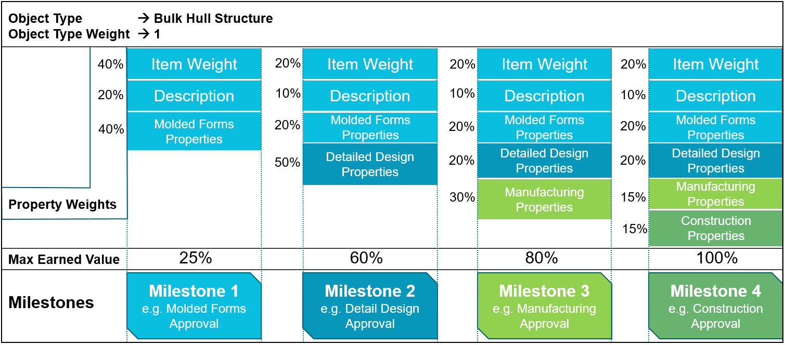
Figure 7. Template milestones and values applied for hull structure

The Max Earned Value per stage/milestone has been aligned with the outfitting disciplines (the 25, 60, 80 and 100%). These values can be easily refined taking into account the actual spent hours per stage/milestone. Milestone 2 is supposed to carry 1/3 of the overall effort in spite of the automation in detailing and drawing generation; this because the stage should be inclusive of some “manual” Struct Detailing and all the Molded Forms re-modelling due to the co-ordination with the outfitting disciplines.
The analysis of the available data (purely indicative) shows that more than 2/3 of the weight of the hull structure for a zone/block can be defined during the first week of the design work and that 4/5 of the estimated weight can be reached in the subsequent week.
Applying the suggested ‘weighted’ formula (1) for the progress we should obtain the following after the 2nd week of design work:
(ActualHull / PlannedHull) * (MaxEarnedValue) e.g. 45[t]/55[t] * 0.25 ~ 20%
A couple of weeks of modelling hull structure in Molded Forms [3] seems enough for the validation of the co-ordination and also for the fine tuning of the estimated weights of zones/blocks in case of prototypes ships. To be confirmed by the practice, of course.
Anyhow the case-study validated the idea of integrated 3D CAD and Project Control tools each performing within respective domain while providing a transparent unique solution where the CAD is giving real-time information about the content and the status of the 3D model (business object quantities with related maturity levels) while the Project Control tool is providing continuous visibility to power business users on project earned values with respect to budgeted and/or planned values just through its configuration that includes the use of custom formulas to evaluate the engineering progress.

Acknowledgements
The authors are grateful to Fincantieri DMC - Marineria (Process Owner and his team) for sharing valuable data and time for the case-study. The proposed solution, suggestions and conclusions expressed herein reflect those of the authors and not necessarily those of Fincantieri or Hexagon; any reference to new features or functions, work flows, business processes and schedules are for illustration purposes and should not be interpreted as commitments by either party.

References
[1] A. Mouyal, Intergraph Smart3D and EcoSys Integration, Hexagon PPM Internal, 2017.
[2] Fincantieri DMC, Ingegneria sviluppo scafo – ore standard per zona, (extract) VAI, 2015.
[3] M.Polini, Y.L.Duparcmeur, P.Lemoine, Adapting and adopting 3D design technology to cruise ships, ICCAS, 2013.
[4] S.Yamauchi, A. Zuurhout, Y.Kosaka Reducing workload in production design stage by rule-based automation of CAD, ICCAS, 2013.
[5] M.M.J.M.Veldhuizen, Capital Project Lifecycle Management vs. Product Lifecycle Management for Shipbuilding, Marine and Offshore industries, ICCAS, 2011.

