A mixed AC/DC low voltage electrical distribution architecture for increasing the payload on ships
Maria Carmela DI PIAZZA^{a,}, Massimiliano LUNA ª, Giuseppe LA TONAª,
Angelo ACCETTAª, Marcello PUCCI ª, and Andrea PIETRA ^{b}
ª CNR- ISSIA, Palermo, ITALY
^{b} FINCANTIERI S.p.A., Trieste, ITALY
Abstract. This paper presents the development of a novel architecture for the low voltage (LV) electrical distribution on board using a mixed AC/DC approach. The design of the proposed solution is based on a real-world case study, i.e., an electrical distribution grid within a main vertical zone (MVZ) of a large cruise ship. The new electrical architecture is designed with the aim of obtaining a gradual transition toward a totally DC electrical distribution grid on-board. Furthermore, according to the selected technical criteria, the proposed scheme can be implemented on a real ship by using devices either available in the market or easily adaptable from commercial items. The impact of the proposed electrical design on technical volumes and weights of the electrical equipment is evaluated in comparison with the existing solution. Such a comparison shows that the proposed scheme allows a reduction of electrical plant components’ weight and volume of about 30%.
Keywords. DC microgrids, all-electric ship, marine electric power systems, payload increase

Introduction
Maritime transportation is responsible for the emission of 1000 million tons of CO₂ per year, and furthermore it causes about 2.5% of greenhouse gas (GHG) emissions, according to the 3rd IMO GHG study [1].
Shipping is continuously engaged in efforts to minimize fuel consumption, and despite ships are universally recognized as one of the most fuel-efficient systems for transportation, IMO studies have identified a significant potential for further improvements in energy efficiency [2]. In order to exploit such a potential, IMO “International Convention for the Prevention of Pollution from Ships” (MARPOL), Annex VI, Chapter 4, imposes the adoption of the energy efficiency design index (EEDI) for new ships and the ship energy efficiency management plan (SEEMP) for any ship larger than 400 GT [3], [4].
Nowadays, the totality of new-built large passenger ships, such as cruise liners, are electrically propelled, and most of older ships have been already retrofitted to implement electric propulsion. According to this technical choice, the all-electric ships (AESs) concept has established, i.e., a new paradigm where all the onboard thermal engines are used exclusively as prime movers of the electrical generators. AESs are equipped with a main power station on board, which generates the needed electrical power for supplying all shipboard loads (propulsion, hotel, and auxiliaries), according to a concept known as integrated power system (IPS) [5]. Although technical progress in power electronics has increased operational flexibility of ship power systems, the current solutions for electrical power generation, distribution and use in large passenger ships rarely optimize the available space and the fuel consumption with related pollutant emissions. Therefore, to achieve the maximum ship payload capability and energy efficiency, new technologies and technical paradigms have to be introduced and applied on board.
As far as the electric power distribution is concerned, in the last years there has been a revival of the historical “war of current” started between Thomas Edison and Nicholas Tesla during the II industrial revolution, with a reaffirmation of DC power distribution concept. The renewed interest in DC distribution on board today is supported by scientific papers, technical standards, technological roadmaps, research programmes, and examples of commercial solutions [6], [7], [8], [9], [10]. The technical solutions that have been proposed so far for electrical power distribution in ships are: 1. the variable frequency AC distribution (considered as an intermediate step toward the DC grid on board) [11], 2. the medium voltage DC (MVDC) [12], and 3. the mixed solution consisting of a MVAC and low voltage DC (LVDC) grids [13].
In this paper, a variant of the latter solution is explored; in particular a mixed AC/DC electrical architecture to be applied for the low LV electrical power distribution in ships is proposed. In detail, a LV distribution system within a main vertical zone (MVZ) of a large passenger ship is chosen as case study.
In order to define the new electrical architecture, the current topology has been firstly analyzed, and then suitable modifications have been introduced to minimize the size of the electrical plant equipment. A comparative analysis highlighting the obtained advantage in terms of volume and weight saving is finally presented.

DC microgrids on board
In the last decade, the advantages of DC distribution of electrical power have been widely discussed and assessed in terms of both energy efficiency and simplification of the electrical architecture [14]. Nowadays, DC distribution is considered a very promising grid infrastructure for the setup of new reliable and efficient smart microgrids/nanogrids in both terrestrial and marine applications [6], [15].
One of the most interesting examples of LV DC electrical power distribution on board has been recently proposed by ABB, i.e., the Onboard DC GridTM, which is applicable to any ship with an installed power up to 20 MW. The introduction of such an approach represents a further significant step toward the optimization of ship efficiency and payload capability. In fact, according to the manufacturer, it can reduce the fuel consumption and emissions by up to 20% and the electric equipment volume/weight by up to 30%, contributing to an improved flexibility in the equipment positioning as well [10].
The recognized advantages of DC power distribution are numerous, for example:
- Simplification of electrical equipment connection to the power grid;
- Elimination of power transformers;
- Possibility to optimize the generation system by using high speed generators;
- Reduction of fuel consumption by optimizing the operating points of the gensets’ prime movers;
- Elimination of voltage drop due reactive power;
- Elimination of the need for power factor correction.
As an example, the possibility to obtain a fuel reduction by DC distribution systems, is illustrated in Figure 1, which shows that the operation of a diesel engine with a variable rotational speed (compatible with the DC distribution solution) implies a lower specific fuel oil consumption (SFOC) with respect to the case of a diesel engine with a fixed rotational speed (corresponding to conventional AC distribution) [10] .

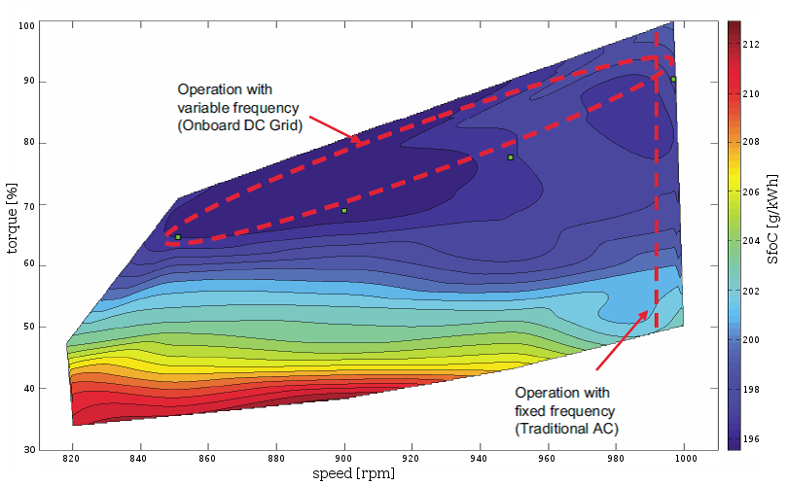

Figure 1. Engine fuel tests at variable speed (color scheme indicates SFOC in g/kWh) [10].

One of the most important enabling technologies for implementing DC distribution on board is power electronics. Nowadays, power electronics is a mature technology, that has anyway further room for improvements thanks to recent achievements on new static device materials and on new converter topologies [5], [16]. On the other hand, the main technical issues hindering a wide diffusion of DC grids on ships are the absence of specific commercial off-the-shelf (COTS) marine equipment (since they are still designed and built to be compatible with a fixed frequency AC input), and the absence of industrial partners able to supply validated and safe DC components. These factors lead designers to ignore DC distribution, and consequently discourage suppliers to make related investments [5]. Nonetheless, investigation on DC grids on board is worth being further explored since their advantages and their future potential are also strictly related to the possibility of integrating, more easily and adopting a lower number of converters, new power sources (e.g., fuel cells), and energy storage systems (ESSs) in both merchant and military ships. Moreover, DC grids on board are well compatible with the distributed generation, which is currently considered an emerging paradigm for the highly-efficient and environmentally sustainable ships of the future.

Analysis of the proposed mixed AC/DC architecture

The case study
In this paper, the perspective increase of ships’ payload due to the adoption of an innovative electrical power distribution system is investigated. The study has been focused on the LV distribution system downstream of a substation transformer placed in a MVZ of a large passenger ship. Specifically, one of the sections highlighted in Figure 2 (representing a typical scheme of electric plant implementing the IPS concept) has been studied. The considered electric distribution system supplies prevalently ship’s hotel services (such as passengers’ cabins, air conditioning, common areas, etc.) within the MVZ and involves an installed power of about 1 MW.
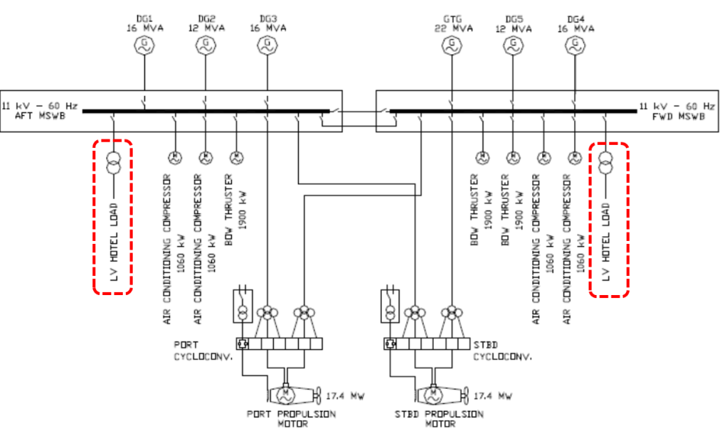
Figure 2. Integrated Power System (IPS).

Since the considered electrical plant is very extensive, a preliminary classification and aggregation of electrical loads has been performed. In this way, a new representation of the electrical plant is obtained, which is suited to for comparing the existing solution with the new proposed one.
Starting from the above mentioned classification, the single-wire equivalent scheme of the electrical plant illustrated in Figure 3 has been deduced. In this scheme, feeders for aggregated loads can be found. Furthermore, for each aggregated load, (Air conditioning, Engine room - E.R., lighting and loads supplied by transformers), starting from the relative active and reactive power consumption, the formation and equivalent length of the feeding cables have been defined. It was first examined whether the cables used in the original plant were compatible with the new proposed architecture; then the following procedure was applied to characterize the equivalent feeders. A set of N electrical loads, each of power P_{i} (i=1...N), supplied by N groups of cables, has been considered. The i-th group of cables is formed of p_{i} cables in parallel, each with a length l_{i}, a cross section S_{i}, a radius r_{i}, and a weight for unitary length w_{i}. Such a system can be represented as an equivalent system where electricity is supplied by a unique group of cables to a unique lumped load with a power P equal to the sum of powers of the N loads.

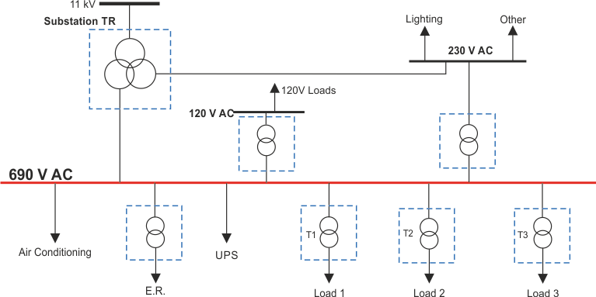

Figure 3. Current AC solution for LV distribution of electrical power.

The equivalent section (S_{eq}) of such group of cables and the number of paralleled cables in it (p_{eq}) are obtained using the conventional thermal sizing method.
The equivalent length, instead, can be determined by imposing the condition that the equivalent system maintains the same total weight or the same total volume of the original system. In the first case, the total power is expressed by:

(1)

where w_{eq} is weight for unitary length of the equivalent group of cables and is the length of the equivalent group of cables. Then, the equivalent length is computed as follows:
(2)

Alternatively, the equivalent length can be computed imposing the total volume, whose expression is the following:

(3)

where r_{eq} is the external radius of the equivalent group of cables. In this case, the equivalent length is computed according to (4):

(4)

In this study, the equivalent length is computed as the average of the equivalent lengths obtained by (2) and (4), thus averaging the weight and volume effects:

(5)

The proposed mixed AC/DC architecture
To define the new electrical architecture, suitable modifications to the current topology (Figure 3) have been proposed in order to minimize the volume and weight of the electrical plant equipment. The main modifications can be summarized as follows: 1. a 1000 V DC power distribution bus has replaced the conventional 690 V AC counterpart; 2. the three-winding substation power transformer has been replaced with a two-winding power transformer; 3. all the other bulky power transformers have been replaced with appropriate power electronic converters.
The obtained electrical architecture is described by the single-wire equivalent scheme shown in Figure 4. It should be observed that, for the perspective setup of the new electrical architecture, commercially available equipment have been considered. On such a basis, the possibility of a real-world implementation of the proposed scheme in the near future is assessed. Moreover, a quantitative evaluation of volume and weight of the involved equipment is feasible and makes possible the comparative analysis between the conventional and the proposed electrical architectures, as presented in the following section.

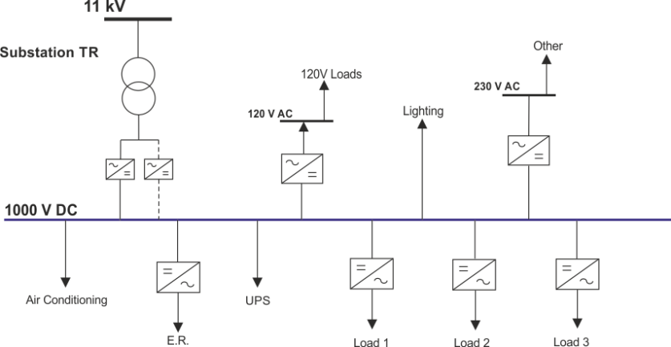

Figure 4. New mixed AC/DC solution for LV distribution of electrical power.

Comparative analysis
The volume and weight of electrical cables, transformers and power electronic converters have been evaluated and compared. The obtained results are summarized in Figure 5 and in Tables 1, 2 and 3. Figure 5 shows the comparison between the original and the new proposed electrical distribution architectures in terms of both volume and weight of the different electrical plant equipment.
It is possible to observe that the prevalent impact on volume is given by power transformers, whereas the major contribution to weight is due to power cables. It is also noticeable that the transition to the new mixed AC/DC system implies an appreciable reduction of cables’ volume and weight and a relevant reduction of power transformer volume and weight.
In Table 1 the volume and weight variations for electrical cables, passing from the currently used solution to the proposed one, are quantified. Table 2 summarizes the volume/weight variations determined by replacement of power transformers adopted in the AC architecture with power electronic converters and by replacement of the three-winding substation power transformer with a two-winding one.
The overall results of the comparative analysis are shown in Table 3 which shows that the weight and volume reductions obtainable with the mixed AC / DC solution are over 30%. It should also be noted that this metric is underestimated since the comparison was made considering the power electronic devices currently available on the market and not specifically designed to be connected to a DC bus. The space and weight saving due to the proposed redesign of the LV distribution system under study is exploitable in terms of increase of the ship’s payload. It should be observed that, if the ship’s payload remains unchanged, the pursued reduction of size and particularly of weight, indirectly implies an increase of the ships efficiency in terms of fuel consumption reduction. In conclusion, it is worth noting that the presence of several power electronic converters in the new proposed electrical architecture increases the level of flexibility and controllability of electrical power flows on board, thus promoting the transition toward the paradigm of smart electrical distribution in ships.

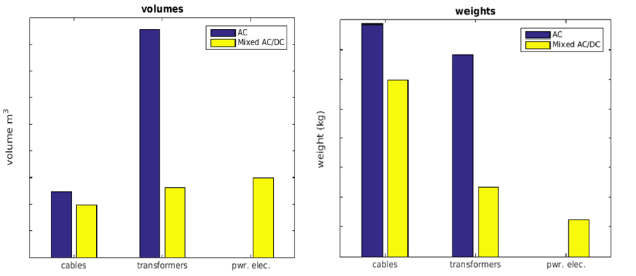
Figure 5. Comparison of volumes and weights.

Table 1. Volume and weight variation for electrical cables
 | Volume variation | Weight variation
AC solution | - | -
Mixed AC/DC solution | -19.83% | -24.13%

Table 2. Volume and weight variation due to replacement of power transformers and introduction of power electronic converters
 | Volume variation | Weight variation
AC solution | - | -
Mixed AC/DC solution | -34.1% | -46%

Table 3 Overall comparative analysis results
 | Volume variation | Weight variation
AC solution | - | -
Mixed AC/DC solution | -34.9% | -31.4%

Conclusions
A new mixed AC/DC architecture for LV electrical power distribution on ships is proposed. The impact of the new electrical design on volumes and weights of the electrical equipment is evaluated in comparison with the currently adopted solution.
The comparison shows a reduction of about 30% in electrical plant components’ weight and volume. Therefore, the new electrical architecture has proved suitable for contributing to the increase of ship’s payload or, alternatively, of ship’s efficiency.

Acknowledgements
This study is part of Project “Leadership Tecnologica”, a Research and Innovation project coordinated by Fincantieri S.p.A. with the participation of the National Research Council (CNR); the project receives grants from the Italian Ministry of Infrastructures and Transport (MIT).

References
[1] International Maritime Organization (IMO), “Safe, Secure and efficient shipping on Clean oceans,” Third IMO Greenh. Gas Study, 2014.
[2] E. Hughes, “A new chapter for MARPOL Annex VI – requirements for technical and operational measures to improve the energy efficiency of international shipping,” 2013.
[3] IMO, “Guidelines for voluntary use of the ship EEOI”,MEPC.1/Circ.684. .
[4] IMO, “2012 Guidelines for the development of a ship energy efficiency management plan (SEEMP)” IMO MEPC, Resolution MEPC.213(63). .
[5] G. Sulligoi, A. Vicenzutti, and R. Menis, “All-Electric Ship Design: From Electrical Propulsion to Integrated Electrical and Electronic Power Systems,” IEEE Trans. Transp. Electrif., vol. 2, no. 4, pp. 507–521, Dec. 2016.
[6] E. Skjong, R. Volden, E. Rodskar, M. Molinas, T. A. Johansen, and J. Cunningham, “Past, Present, and Future Challenges of the Marine Vessel’s Electrical Power System,” IEEE Trans. Transp. Electrif., vol. 2, no. 4, pp. 522–537, Dec. 2016.
[7] Institute of Electrical and Electronics Engineers. and IEEE-SA Standards Board., IEEE recommended practice for 1 kV to 35 kV medium-voltage DC power systems on ships. Institute of Electrical and Electronics Engineers, 2010.
[8] A. Vicenzutti, D. Bosich, and G. Sulligoi, “MVDC power system voltage control through feedback linearization technique: Application to different shipboard power conversion architectures,” in 2013 IEEE Electric Ship Technologies Symposium (ESTS), 2013, pp. 303–307.
[9] D. Bosich, M. Gibescu, I. Fazlagic, N. Remijn, and J. de Regt, “Modeling and simulation of an LVDC shipboard power system: Voltage transients comparison with a standard LVAC solution,” in 2015 International Conference on Electrical Systems for Aircraft, Railway, Ship Propulsion and Road Vehicles (ESARS), 2015, pp. 1–7.
[10] “Onboard DC Grid The step forward in Power Generation and Propulsion.”
[11] M. K. Sami Kanerva, Pasi Pohjanheimo, “Dynamic AC concept For variable speed power generation,” 2016.
[12] “MVDC Large Ship – ‘Sistema elettrico integrato con distribuzione in media tensione a corrente continua per grandi navi a propulsione elettrica.’” [Online]. Available: http://www.mvdc.it/. [Accessed: 25-Sep-2017].
[13] A. Vicenzutti, “Innovative Integrated Power Systems for All electric Ships,” Trieste Univ., 2016.
[14] S. Anand and B. G. Fernandes, “Optimal voltage level for DC microgrids,” in IECON 2010 - 36th Annual Conference on IEEE Industrial Electronics Society, 2010, pp. 3034–3039.
[15] M. H. Wang, S. C. Tan, C. K. Lee, and S. Y. R. Hui, “A Configuration of Storage System for DC Microgrids,” IEEE Trans. Power Electron., vol. 33, no. 5, pp. 3722–3733, 2017.
[16] Fraunhofer IISB, “High Power SiC DC/DC Converter.” [Online]. Available: https://www.iisb.fraunhofer.de/content/dam/iisb2014/en/Documents/Research-Areas/vehicle_electronics/Publications/DCDC_Converters/PDB_HighPowerSiC.pdf. [Accessed: 25-Sep-2017].

Corresponding Author, Consiglio Nazionale delle Ricerche (CNR) Istituto di Studi sui Sistemi Intelligenti per l’Automazione (ISSIA), via Ugo La Malfa, 153 - 90146 Palermo, Italy; E-mail: mariacarmela.dipiazza@cnr.it.

