Recent Advances on Propeller Shaftlines for the Marine Industry
Elias BOLETIS ^{a,} and Matthias KELLER ^{b}
ª Wärtsilä Propulsion, Drunen, The Netherlands, elias.boletis@wartsila.com
^{b} Flender GmbH, Voerde, Germany, kellermatthias@flender.com

Abstract. A vital component on the CP propeller shaft line is the gear box. The gear box is nowadays developed as a high- technology product being integral part of the shaft line system allowing: a) optimal rotational speeds for the propeller and the engine; b) configurational arrangements (e.g. twin- in, single- out layouts); c) propeller two- speed operation; d) integration of propeller hydraulic systems and d) integration of machinery room power systems (power take- in/ power take- off). The added functionalities require advanced product development tools and robust manufacturing technologies. On product development, the design party needs to possess significant product knowledge through applications in lengthy periods of time. The design party must also have significant knowledge of all relevant machinery room equipment – from the propeller to the power supply unit - allowing the best integrated solution. The manufacturing party needs to have adequate tools and experienced personnel on gear technologies. In our recent working arrangement, Wartsila selected Flender GmbH for contract manufacturing, which is now responsible for the manufacturing and assembly of the product. The paper presents the technical advances for a number of marine market applications showing the added value of the gearbox technologies to the customer.
Keywords. Propeller Shaft Lines, Gear Boxes, Two speed, hybrid, fuel consumption

Introduction
The marine world is in front of an important step to continuous integration and the implementation of the smart marine philosophy. Still, on a daily base we are confronted with the identification of the needs of the owners and the ship yards. Their analysis remains a difficult task due to the various market segments and the uniqueness of each planned operation.
From this point of view, we as propulsion solution providers need to remain open to changes. The propulsion products require adaptability in order to properly cover the wide range of the market requirements. The standardization of some products is possible and can be recognized in the output, sizes, interfaces and built-on equipment which can be largely pre-defined. The transmission system components need still to fulfill the needs of expected customization from the ship designer’s and owner’s side. This is a reality, being a component ‘in- between’.
The target of the propulsion system integrator is to achieve the best combination of the following requirements:
- Highest system performance
- Lowest operational cost
- Lowest capital expense
The system performance can be translated to propulsion requirements for:
- High efficiency at critical conditions
- High propelling (thrust) capability
- High Reliability, time to overhaul, lifetime of parts
- Reduced propeller cavitation risk
- Exterior and interior noise levels
- Space integration, small footprint
The present paper attempts to put the transmission mechanism (the gear box) into the picture. The gear box is an essential part of the propeller shaft line. It has as primary function the reduction of the rotational speed of the reciprocating engine to the level required for optimal propeller efficiency. However, it is more and more a functionality enabler:
- It allows ‘power take- off and take- in concepts’ by connecting electrical machinery to the shaft lines
- It allows various layouts (relative position of engine and propeller shafting)
- It is tailored to the available space envelope and the engine layout
- It can allow integrated systems with the adjacent products like the CP propeller
Figure 1 shows a modern shaft line with a high technology medium speed engine, an advanced propeller with energy saving devices and electrical machinery having the need to be connected and operate together. The gear box fulfils this need. We attempt to present in this paper that the gear box is the enabler for functionality and high performance. 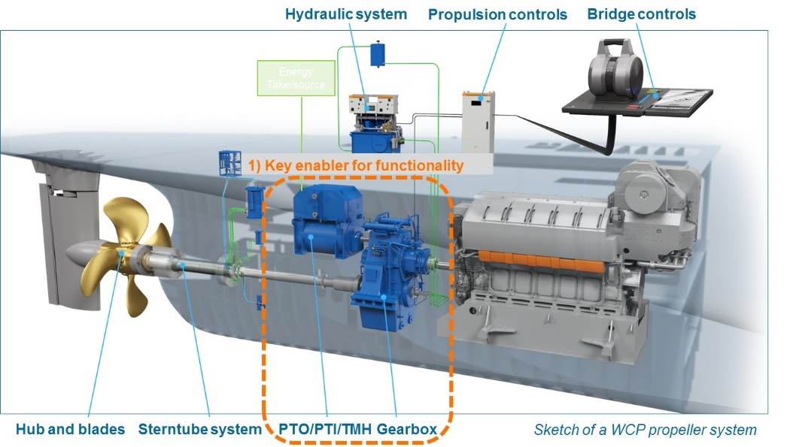
Figure 1. Propeller Shaft Line with integrated systems
The proper selection and integration of machinery room solutions is the first part of the long journey to smart marine solutions that we are aiming at.

(Machine Room) Configurational Arrangements
Gear boxes are designed for single engine to propeller power transmission or as alternative layouts with e.g. two main engines powering a single propeller. In parallel, they enable power supply and delivery to the auxiliary system through the connected PTO/ PTI machinery.
A reference configuration of a twin CP propeller system is presented at the upper machinery layout of Figure 2. Each gear box – for this specific vessel application- is connected to two reciprocating engines of 3MW each and a power take- off generator of 2.6MW (reference configuration).
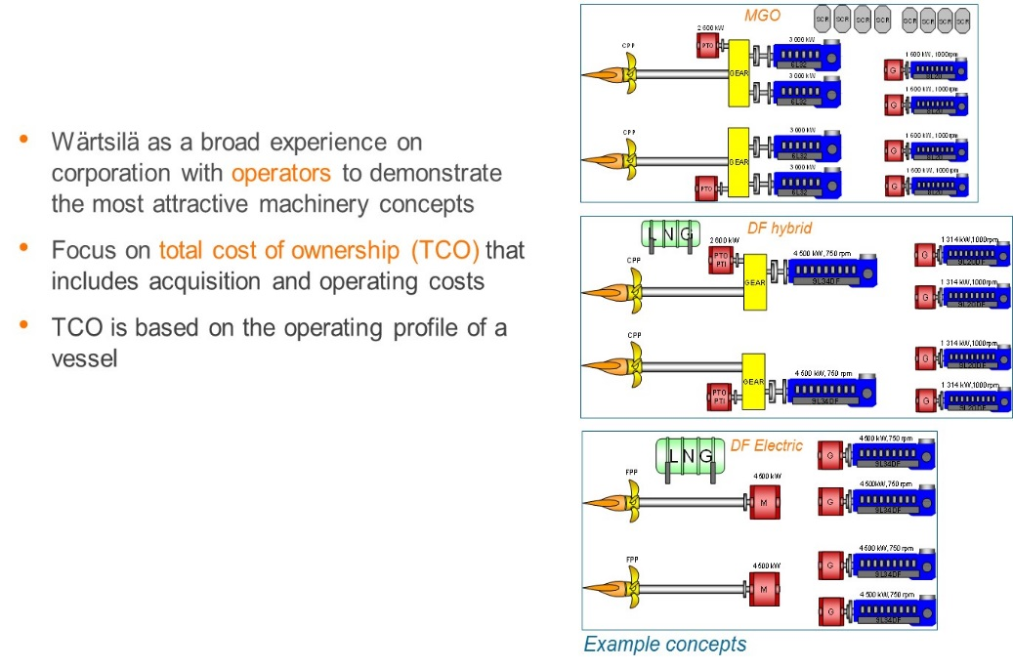
Figure 2. Alternative Machinery Layouts
The second machinery layout corresponds to a hybrid solution with an electric motor/ generator of 2.6 MW allowing the power supply from the main engines to be downsized by 1/3 and the auxiliary gensets by approx. 20%.
The third (lower) machinery layout is a pure diesel electric configuration with installed power increasing and the fixed- pitch propeller in this case directly driven by electrical motors of 4.5 MW each. This configuration does not require a gear transmission.
Figure 3 shows the impact of the machinery layouts on the annual fuel consumption and the payback time of the equipment. The ‘conventional’ diesel mechanical layouts with DF (hybrid and diesel mechanical) show very good fuel consumption level with payback times of 1 to 2 years relative to the reference configuration. The DF electrical alternative shows also good fuel consumption but longer payback times.
This type of studies are made for all new vessel types and the final decision on the machinery selection depends on the operator/ owner. Our product knowledge and system integration enables a successful evaluation of the advantages and disadvantages of the concepts. We are ready to deliver all variants.
Still, our partial conclusion is that the diesel mechanic machinery layout, esp. as hybrid, provides an important alternative with very good fuel consumption and good payback times which is not easy to be beaten.
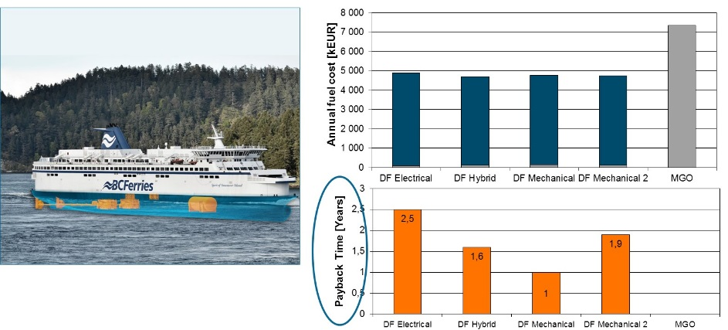
Figure 3. Fuel cost and payback times of alternative layouts

Optimal Selection of Propeller Rotational Speed
In this paragraph we concentrate on single engine to propeller transmission. Different offsets between the main engine centerline and the propeller shaft line allow for larger gears and therefore higher gear ratios. The offset can be vertical, horizontal or diagonal. The Wartsila designs cover a large range of power levels from approximately 1MW to 25 MW (see Figure 4).
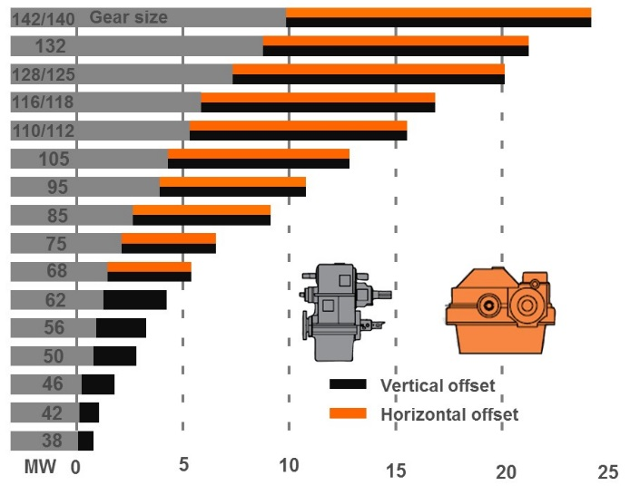
Figure 4. Sizes of Gear Boxes with horizontal and vertical offset (standard family)
A significant characteristic of the transmission mechanism is the torque of the unit relative to the required gear transmission ratio. Figure 5 presents a typical engine/gear box interfacing chart. Three engine sizes are considered (8V31, 10V31 and 12V31) being connected to four gear box sizes of different vertical offset (SCV75/ 85/ 95 and 105). Each gear box size can be coupled with different engine sizes with a selection potential available.
This is further explained in Figure 6 in combination with the propeller performance curves at different propeller diameters. As the propeller diameter increases, the requirement for engine power is reduced at the sizing conditions. The optimum propeller speed is indicated for each propeller diameter. With the 10V31 selected in this case, there are four gear box sizes available which are leading at four different gear ratio’s If we select the smallest gear box, it means that the gear ratio is too low, the propeller efficiency is low and the power required is the highest but the propeller diameter is the smallest. If we select the largest gear box, it means that the gear ratio is high, the power required is the smallest and the propeller diameter is the largest. Obviously vessel geometrical constrains and the availability of engine power need to be examined.
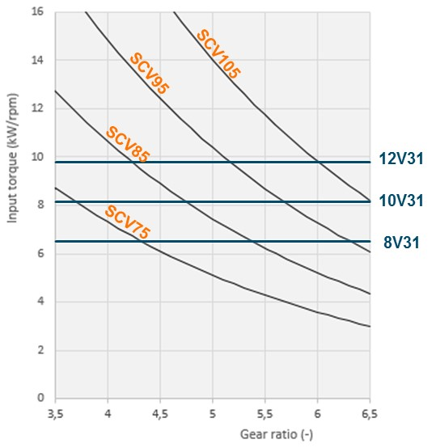
Figure 5. Engine and Gear Box mapping

The above means that the selection of the equipment (engine/ gear box and propeller) can not be made independently of each other. The project and systems engineer need to make a judicious decision, taking into account the operational cost (impacted by fuel consumption) and the capital expense (initial equipment cost) of each alternative.
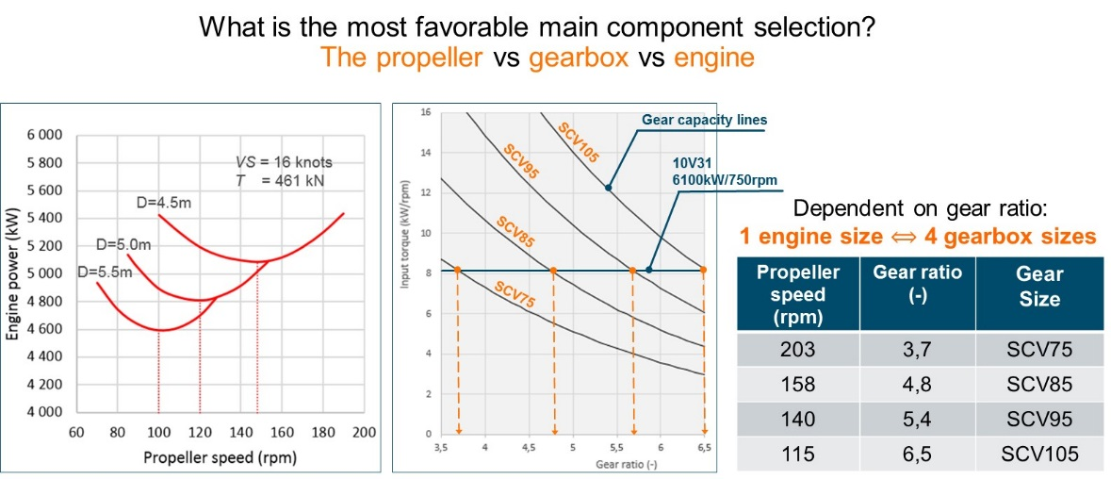
Figure 6. Propeller, engine and gear box selection

Manufacturing Process on Marine Gear Boxes
Starting from 2017, Wartsila designed gear boxes are manufactured and assembled at Flender GmbH in Germany. This allows us to combine the Wartsila knowledge of the market requirements and design capability with the strong Flender manufacturing background on gear boxes.
Flender produces since 1998, beside different types of industrial gearboxes, marine gearboxes for a variety of applications and for customers worldwide.
The manufacturing of complete marine gearboxes under the Flender brand hereby includes the design, the parts manufacturing and the assembly and testing. The whole process includes also the survey activities with the respective classification societies and procurement activities as well. For the logistics and manufacturing planning the mix between industrial and marine products means a special challenge as a series production needs a different production set up compared to a single parts production. A special data matrix code stamped on each single part ensures traceability along the entire production line. The accompanying documentation allows supervising of each step of the machining process within the internal quality system.

The machining process for geared parts
Production of the geared parts includes the soft machining, the hardening, the hard machining and the testing. Depending on the single part, either cut bar material or forged material is used. The product portfolio covers spur gear, helical gear pinions, bevel gears, shafts, hollow shafts, casted and welded housings and planet carriers. Core technologies for geared parts are hobbing and form cutter milling for the soft machining and mainly grinding for the hard machining.

The Assembly and testing (FAT)
The assembly follows the process written down in the internal work instructions. A special, adapted, work instruction plan has been generated for the Wärtsilä designed gearboxes. Within these instructions, each assembly step is described with its associated test and measuring activities. The experience from many years of gearbox manufacturing for different kind of applications is poured into these work instruction plans.
During the FAT, the testing of the gearboxes is carried out under partial load. It includes functional tests of integrated clutches, turning device and locking device, the monitoring and documentation of temperatures and pressures, measuring of the backlash and the measuring of air borne and structure borne noise. The check of the contact pattern and the filters are done once all previous tests are carried out.

Two Speed Propeller and Hybrid Operations
Two speed gearboxes are used in different applications. For shipping vessels with single engine operation, they allow the CPP the run close to the optimum for different speeds. With multiple engine gearboxes in two speed configuration research vessels can operate with full load in normal mode and in silent mode with the propeller running with reduced speed.
An effort to explain the operational capability of the single and two speed transmission units can be made based on Figure 7. A single speed transmission unit results in a sub- optimal propeller rotational speed. A 2- speed transmission unit allows that the propeller rotational speed is further reduced/optimized for cruising conditions. This means a reduction of the power required for cruising when the vessel spends significant amount of operational time. Moreover the engine can be separately tuned for the lowest specific fuel consumption at the desired conditions. On this way, the combination engine/ transmission and propeller is configured to the exact needs of the vessel.
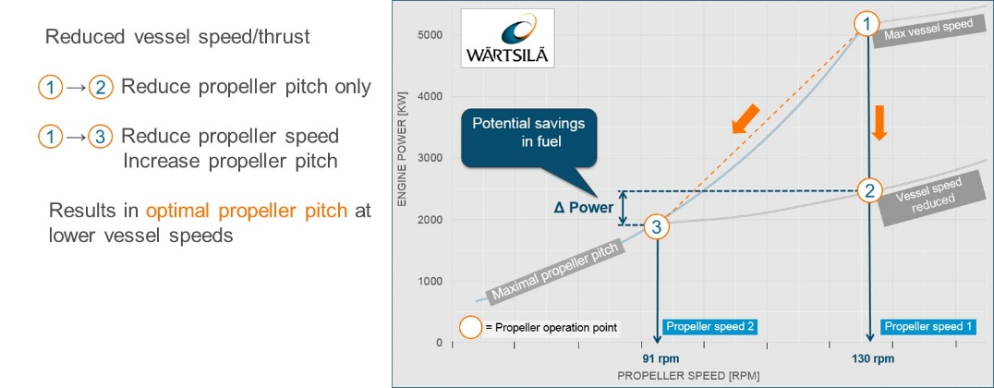
Figure 7. Two speed operational benefits
In parallel, allowing the connection to an electric motor/ generator (through PTO/ PTI shaft), creating on this way a ‘hybrid CP system solution’ (see Figure 1). The system can be further extended with the use of a battery system at the motor/ generator shaft side. The operation modes of the complete Hybrid CP System are as follows:
- High Propeller Speed (Speed 1)/ Diesel Mechanic
- High Propeller Speed (Speed 1) / Power Boosting
- Lower Propeller Speed (Speed 2)/ Diesel Mechanic
- Lower Propeller Speed (Speed 2) / Diesel Electric
- Generator Mode

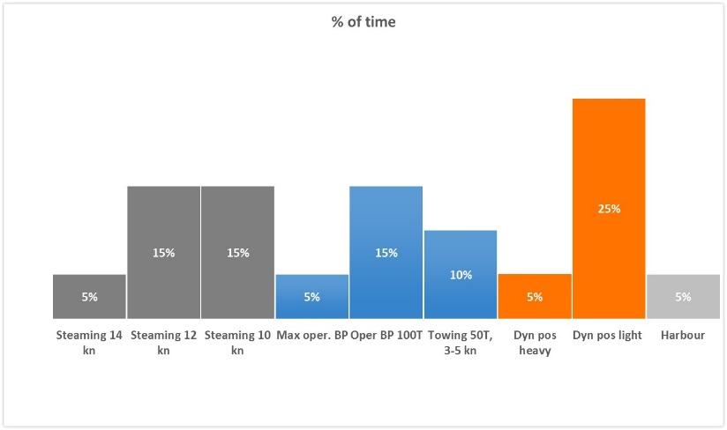
Figure 8.Operational mission for a typical two- speed GB application
The advantages in fuel consumption of the two speed hybrid operation depend on the vessel operational profile. For typical operations of anchor handling tug supply (AHTS) and fishing vessel (see Figure 8) the improvement can be significant. As indicated in Figure 9, the fuel consumption reduction is the biggest at slow steaming and dynamic positioning reaching the level of 30%. Such studies need to be executed for each vessel type separately and quantify the potential benefits.
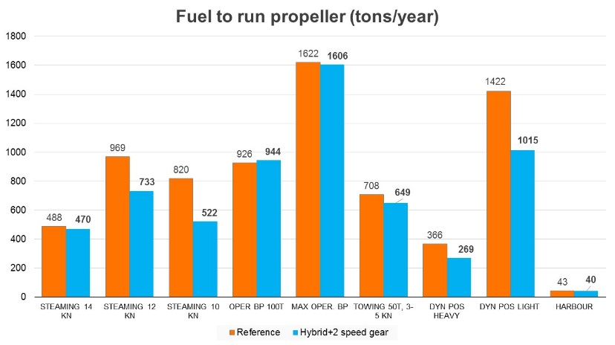
Figure 9. Fuel consumption for each part of the operational mission

7. Concluding Remarks

It is attempted to demonstrate that the gear box in a modern propeller shaft line is not only a single power transmission component but a functionality and performance enabler. Our main conclusions are:
- The ship machinery layout needs to be selected through a business feasibility study. The evaluation must be based on the vessel type, size, operational mission, availability of solutions and technical preferences of the operator;
- The diesel mechanic layouts especially as DF hybrid concepts provide a very good solution at many cases;
- The sizing of the components (gear box, engine and propeller) needs to be examined together as part of an integrated system;
- The integration of functional systems (e.g. hydraulics) can save space on the vessel and reduce the capital expense of the machinery;
- Hybrid solutions are enabled by the gear box on propeller shaft lines. We could be able to create various power take- out, take- in alternatives. Hybrid solutions can also provide additional operational equipment redundancy;
- Two speed gear boxes help greatly improving the performance of vessels with variable operational mission;
- The evolving manufacturing technology enables high performance, reliability and lifetime of the key components. The manufacturing quality of the end product is critical for customer satisfaction and is fully achieved.
As technologies are further advancing and the needs of the shipping industry are evolving, further integration of propulsion systems and components is expected. This is part of our roadmap toward the smart marine technologies of the future.

Corresponding Author, Book Department, IOS Press, Nieuwe Hemweg 6B, 1013 BG Amsterdam, The Netherlands; E-mail: bookproduction@iospress.nl.

