A Numerical Way for a Stepped Planing Hull Design and Optimization
Flavio DI CATERINOª, Rasul NIAZMAND BILANDI^{b,d}, Simone MANCINI^{c,d,}, Abbas DASHTIMANESH^{b}, Maria DE CARLINI^{d}

ª Cantieri Navali del Mediterraneo
^{b} Persian Gulf University
^{c} University of Naples “Federico II”
^{d} Eurisco Consulting S.r.l.s

Abstract. Stepped planing hulls enable the feasibility of running at a relatively low drag-lift ratio by means of achieving more optimal trim angle at high speeds than a similar non-stepped hull. Furthermore, stepped planing hulls ensure good dynamic stability and seakeeping qualities at high speeds. However, there is no precise method to analyze these hulls over the full range of operating speeds. For the above-mentioned reason, in this study, a CFD-based design was presented, starting from a non-stepped hull configuration, a multiple step solution was developed and an optimization of the unwetted aft body area behind the steps was performed. The goal of the optimization is the drag reduction and a dynamic stability. The CFD results were compared with the well-known empirical approach and a novel 2D+T analytical method.

Keywords. Stepped hull, CFD simulation, CFD-based design, Planing hull, Stepped hull design, U-RANSE simulation

1. Introduction
In recent years, the design of planing hulls with maximum speed has been one of the important issues among researchers and designers. Accordingly, researchers and designers have modified hull geometry in order to increase the speed. They, by adding the step, tunnel and hydrofoil on the hull geometry, somewhat increased the speed of planing hull. Among these changes, the step has had the slightest change in hull geometry, so it has attracted the attention of researchers.
For a stepped hull, ﬂow separation occurs at step location and then reattach at aft body. In experiments, calculations and theoretical studies it has been shown that these steps can reduce resistance in certain conditions, as indicated in Clement and Pope [1], Clement [2], Garland [3], Garland and Maki [4], and White et al. [5]). Until a few years ago, the most famous study that could predict the effectiveness of stepped hull with a non-negligible level of approximation was the approach proposed by Savitsky in 1964. However, in order to improve the accuracy of the Savitsky method [6] in predicting the efficiency of the stepped hull, some stepped hull hydrodynamic properties were extracted. Hence, Savitsky and Morabito [7] conducted a thorough study on stepped hull hydrodynamics. Svahn [8] used Savitsky and Morabito [7] relationships and founded a mathematical model on this basis. The Svahn method was developed only for one step planing hull, with numerous limitations and ambiguities. In addition, Svahn [8] did not compare his method with experimental data. Danielson and Stromquist [9] claim that the Savitsky and Morabito [7] relationships are true only for one step planing hull and cannot predict the flow separation in two-step planing hull. Dashtimanesh et al. [10,11] presented a mathematical model based on the Savitsky [6], Svahn [8], Jonas and Stromquist [12] methods and the linear wake theory. They established a new mathematical model, with the assumption of a linear flow separation from the steps for the two-stepped hull case.
After this research, researchers were trying to find a way to model in still water condition stepped hull more accurately. Niazmand Bilandi et al. [13] after many studies paid attention to 2D+T method. The main reason for this choice is the high potential of 2D+T method, in more realistic hull design and geometry modelling. They, using Wagner [14], Algarin, and Tascon [15], Ghadimi et al. [16] and Dashtimanesh et al. [10,11], developed a mathematical model based on 2D+T method and linear wake theory for stepped hull.
In recent years, researchers have studied the hydrodynamic properties of stepped hull in still water, using numerical methods. The most important simulation carried out in the field of stepped hull was done by Garland and Maki [4]. Garland and Maki [4] performed a series of numerical simulations on the effect of step geometry on the lift and drag forces of a stepped planing surface. They performed simulations by changing the step height and position, in the draft and at the fixed trim angle. They found that the step height relative to the step longitudinal position was more effective in order to reduce the drag-to-lift ratio. In 2017, Dashtimanesh et al. [17], using a morphing mesh approach, conducted a 3D simulation for the two stepped hull model C2 from the series of Taunton et al. [18]. In another study, De Marco et al. [19] performed a verification and validation analysis of a stepped hull, comparing numerical with experimental way. For a numerical method, they used morphing mesh and overset mesh methods and the obtained results were compared with experimental results. They concluded that the overset mesh method gave less error than the morphing mesh method.
About this work, a CFD/analytical-based design approach is presented and a first stage optimization of a stepped hull process is shown, starting from a non-stepped hull configuration. The main reason to change hull shape configuration is to increase significantly speed performance maintaining the same horsepower on board, and avoid dynamic stability problem, such as porpoising phenomena. This design stage has been performed using a hybrid approach, i.e. a combined CFD/analytical method.

2. Hull Geometry Definition
In Figure 1 the non-stepped hull shape is shown (initial hull configuration) and in Table 1 are summarized the main non-dimensional data of the hull.

Figure 1. CNM44 Hull - side and front view.

The initial speed range for the non-stepped hull is Fr∇ = 2.25, 3.37, 4.50, 5.62. The challenge of enhancing performance is to reach a speed equal to Fr∇ = 6.74 (a speed increase equal to 20.0%).

Table 1. Main non-dimensional data of the CNM44 hull
C_{B} | 0.398
L/B | 3.400
B/T | 5.289
L/∇^{1/3} | 5.293

3. Analytical approach
3.1 Problem Definition
In this section, some information about the analytical approach utilized is reported.
For this problem, considered that boat is moving forward with a constant speed V and dynamic trim angle τ. In the steady motion of planing hull, planing hull is stable after reaching a dynamic trim angle and sinkage, and then no motion will take place. For a non-stepped hull, the hydrodynamic force distribution is referred to one planing surface, but for stepped hull, it depends on the number of steps. For a planing hull with n steps, there will be n+1 planing surface. The geometry of the non-stepped hull is illustrated in Figure 2.
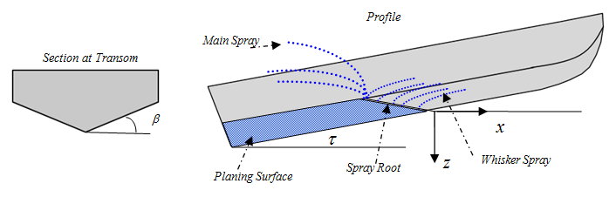
Figure 2. Non-stepped hull geometry.
3.2 The 2D+T theory
To compute the forces acting on non-step or two stepped planing hull, the 2D+T theory is utilized. Figure 3 shows a representation of the typical 2D+T theory of stepped and non-stepped hulls. for non-step planing hull, it is assumed that the boat passes through a fixed observation plane. Within that plane, the motion of the hull appears to be similar to the constant velocity water entry of a wedge. for stepped planing hulls, the observation plane depends on a number of steps.
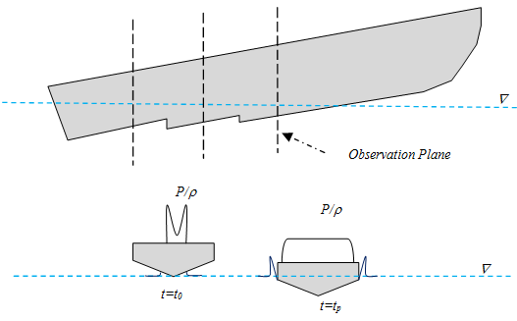
Figure 3. 2D+T Steady stepped hull at constant trim angle as it passes through a ﬁxed two-dimensional observation plane for each planing surface. Pressure distributions given at two different time solution.
For each section, two forces containing hydrodynamic and hydrostatic forces act on the wedge. To determine the forces, the pressure acting on the wedge should be determined. This pressure can be calculated using the following equation, which depends on the solving time.
(1)
In this equation, w, c, y, , and i are respectively: the impact velocity, the half beam of spray root, horizontal distance from the keel, derivative c with respect to time, and the number of planing surface.
For stepped hull, the flow separation from the steps is considered linear. Before, researchers, as Danielsson and Stromquist [10], Dashtimanesh et al. [10,11] and Niazmand Bilandi et al. [13], observed that linear wake profile may be a good assumption for flow separation from steps.

4. CFD Approach
4.1 Numerical setup
In this section, some details of the numerical setup used in all the simulations are reported. The Unsteady Reynolds Averaged Navier Stokes (U-RANS) simulations have been performed using the commercial code CD Adapco Star-CCM+ and taking into account the hull-body motion with the Inverse Distance Weighting (IDW) approach for the mesh deformation.
An implicit solver has been used to find the field of all hydrodynamic unknown quantities, in conjunction with an iterative solver to solve each time step. A Semi- Implicit Method for Pressure-Linked Equations (SIMPLE) to conjugate pressure and velocity field, and an Algebraic Multi-Grid (AMG) solver was used to accelerate the convergence of the solution. A segregated flow solver approach has been used for all simulations. The free surface has been modeled with the two phase VOF approach with a High-Resolution Interface Capturing (HRIC) scheme based on the Compressive Interface Capturing Scheme for Arbitrary Meshes. The streaking problem (or numerical ventilation problem) has been limited to modifying the HRIC standard schemes by removing the local Courant Number (CFL) dependency scheme. More details are available in De Luca et al. [25], [26]. The wall function approach was used for the near wall treatment, in particular, the All wall y+ model. It is a hybrid approach, that attempts to emulate the high y+ wall treatment for coarse meshes, and the low y+ wall treatment for fine meshes. For turbulent flows, y+ values in the range of 30 - 300 are generally acceptable. The values of wall y+ on the hull surface are shown in Figure 4. The Reynolds stress is solved by means of the k-ω SST turbulence model.

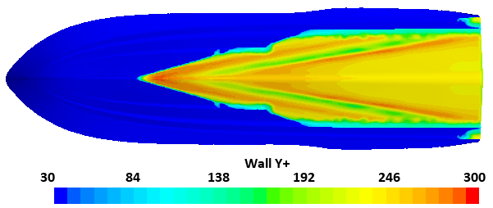
Figure 4. Wall y+ visualization on the non-stepped hull at maximum speed (Fr∇ = 5.62)
The dimensions of the computational domain and the boundary conditions applied are illustrated in Figure 5. All the domain dimensions in compliance with the ITTC prescriptions [20]. The origin of the reference frame is located at x-position equal to the Longitudinal Centre of Gravity (LCG) position of the hull model, y-position equal to 0, and z-position equal to a draft of interest.

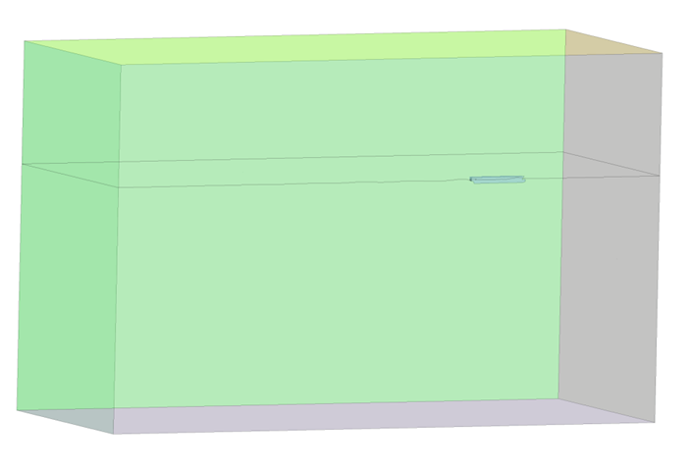
Inlet (Velocity Inlet)
2.0 L_{PP}
1.5 L_{PP}
3.5 L_{PP}
5.5 L_{PP}
3.0 L_{PP}
Symmetry (Symmetry condition)
Outlet (Pressure Outlet)

Bottom (Velocity Inlet)
Top (Velocity Inlet)

Side (Velocity Inlet)
Figure 5. Computational domain dimensions and boundary conditions applied

5. Results and Discussions
5.1 Non-stepped hull analysis
The following graphs show the performance obtained for the non-stepped hull by different evaluation methods. In particular, the previous exposed analytical approach was compared with CFD full scale simulation and Savitsky method. The CFD results are generally lower than the other approaches. Comparing with the CFD full scale simulation, the Savitsky method overestimates the results with an average error of 14.5%. Instead the analytical method overestimates the results with an average error of 10.0%. In particular, as shown in Figure 6 – left side, the analytical method has a good agreement for the very high speed.
About the dynamic trim angle, the analytical method gives results closer to the CFD values than Savitsky evaluation, for the lower speed conditions. For the higher speed the trend is different and the Savitsky approach is more effective (Figure 6 – right side).
Figure 6. Non-stepped hull performances: non-dimensional resistance and dynamic trim with porpoising analysis using the Milton Martin approach, Martin [21].
5.1.1 Porpoising analysis
As above mentioned, for a planing hull the enhance of performance is strictly related to the dynamic instability problem. One of the main dynamic instability is the porpoising phenomenon. It is a function of hull loading and the LCG position as well as the curvature of the buttock lines; as exposed in the general guideline of Blount and Codega [22]. However, two main methods exist to investigate the porpoising phenomenon, with different level of accuracy, i.e. Day and Haag [23] and Milton Martin method [21]. For the non-stepped hull, using the Day and Haag approach no porpoising problem has been detected. However, the Milton Martin method, developed for the instability analysis of the Systematic Series 62 hulls, requires the evaluation of a load coefficient (C_{Δ}). For the non-stepped hull, the C_{Δ} is equal to 0.31. This value is close to the less value analysed by Martin (C_{Δ} = 0.36). Observing the graph in Figure 6, the extended line of the theoretical result with load coefficient of 0.36 shows that for the trim angle of Fr∇ = 5.5 the hull is in the "non-safety zone". Indeed, the CFD analysis for the non-stepped hull pointed out that the inception of porpoising has been observed at Fr∇ equal to 5.5, with a small periodic change of trim angle, and, at Fr∇ equal to 6.74, a large porpoising has been detected with a huge variation of trim angle and observing also the hull-fly-over phenomenon.

5.2 Stepped hull analysis
In this stage, the stepped hull has been defined starting from the non-stepped hull geometry considering the first step position located at the LCG position and a forward angle step equal to 8.0°. As mentioned in Nourghassemi et al. [24], exists a strict relation between forwarding angle value and hull speed. However, at this stage have not been analysed. As mentioned above, the increase of the lift-to-drag ratio and the reduction of the dynamic trim were the main two reasons why investigate the stepped hull configuration. The first hypothesis of stepped hull geometry is shown in Figure 7 (a) and compared with a literature-available-benchmark, the C2 stepped hull of the Taunton Systematic Series (Taunton et al. [18]), shown in Figure 7 (b).
The variable parameters in the stepped hull design were the second step position and the height of the two steps.
(a)
(b)
Figure 7. First hypothesis of stepped hull (a), C2 Hull from Taunton et al. [18] (b)
Figure 8. Stepped hull performance results: non-dimensional resistance and dynamic trim angle
The results of the performance evaluation of the first hypothesis of the stepped hull are shown in Figure 8. It is possible to observe that no reduction of non-dimensional resistance has been obtained. However, comparing the first stepped hull design to the C2 hull (Taunton et al. [18]), a performance improvement has been carried out. The dynamic trim angle has been reduced to 0.5 – 0.6 degree for high speeds and more than 1.0 degree for the lowest speed.
In order to reduce the resistance, several concurrent configurations of the stepped hull have been tested, changing the above exposed variables. The details of each concurrent hull configuration are shown in the following tables (Table 2). The concurrent hull geometries have been evaluated using the previous exposed analytical approach, which represents a very fast tool for the designers in order to perform a fast comparison among several configurations.
Table 2. Different stepped hull configurations tested.
 | Hull 1 (First Hypothesis hull) | Hull 2 | Hull 3 | Hull 4 | Hull 5 | Hull 6 | Hull 7 | Hull 8 | Hull 9
L_{WL} / B_{WL} | 3.5 | 3.5 | 3.5 | 3.5 | 3.5 | 3.5 | 3.5 | 3.5 | 3.5
∇ / 0,001 L_{WL}³ | 5.732 | 5.732 | 5.732 | 5.732 | 5.732 | 5.732 | 5.732 | 5.732 | 5.732
LCG/ L_{WL} | 0.345 | 0.345 | 0.345 | 0.345 | 0.345 | 0.345 | 0.345 | 0.345 | 0.345
1ST Step position / L_{WL} | 0.36 | 0.36 | 0.36 | 0.36 | 0.36 | 0.36 | 0.36 | 0.36 | 0.36
2ND Step position / L_{WL} | 0.144 | 0.144 | 0.144 | 0.134 | 0.134 | 0.134 | 0.168 | 0.168 | 0.168
1ST step height / B_{WL} | 0.021 | 0.015 | 0.027 | 0.015 | 0.021 | 0.027 | 0.015 | 0.021 | 0.027
2ND step height / B_{WL} | 0.021 | 0.015 | 0.027 | 0.015 | 0.021 | 0.027 | 0.015 | 0.021 | 0.027

The comparison, shown in Figure 9, confirms that the improvement of performance can be obtained starting from the first hypothesis stepped hull configuration. The Hull 9, with the forwarded second step position and the higher step height, has given the best performance, reducing the resistance up to 9.0%.
At the moment, the stepped hull optimization is on-going and others concurrent stepped hull configurations are under analysis, changing also other variable parameters, such as the longitudinal first step position and the forward angle step.
At the end of this stage, a fine optimization will be performed by CFD code.

Figure 9. Resistance comparison among the different stepped hull geometries tested

6. Conclusions
In this paper, a stepped hull solution has been investigated by the authors in order to enhance the performance of a non-stepped hull geometry and in order to avoid the dynamic instabilities phenomena, such as the porpoising phenomenon at the highest speeds.
A design and optimization stage of the stepped hull has been performed by an analytical/CFD based method, obtaining interesting results. However, the optimization stage is still on-going.
This combined solution represents a very fast way for the designers in order to analyze and compare a high number of concurrent hulls. The analytical method has been validated against Savitsky method and CFD full scale analysis for the non-stepped hull geometry. Furthermore, a porpoising analysis has been performed for the non-stepped hull.

Acknowledgments
The authors would thank Cantieri Navali del Mediterraneo (CNM) Shipyard for the support in the project development and for allowing the hull data and surfaces of the new M/Y. Furthermore, the authors would thank Eurisco Consulting S.r.l.s, a Startup Consultancy Company in R&D field, for the support to develop this project.

References
[1] Clement, E.P. and Pope, J.D., "Stepless and Stepped Planing Hulls-Graphs for Performance Prediction and Design." (No. DTMB-1490). David Taylor Model Basin Washington DC, 1961.
[2] Clement, E.P., "A configuration for a stepped planing boat having minimum drag (Dynaplane Boat)." This publication is available on the web site of the International Hydrofoil Society: www. foils. org Jan, 2006.
[3] Garland, W.R., "Stepped planing hull investigation." SNAME Trans., p.p. 1-11, 2010.
[4] Garland, W.R. and Maki, K.J. "A numerical study of a two-dimensional stepped planing surface." Journal of Ship Production and Design, 28(2), pp. 60-72, 2012.
[5] White, G., Beaver, W., and Vann., D., "An experimental analysis of the effects of steps on high speed planing boats." In 3rd Chesapeake Power Boat Symposium. 2012.
[6] Savitsky, D., "Hydrodynamic design of planing hulls." Marine Technology, 1, pp. 71-95, 1964.
[7] Savitsky, D., and Morabito, M., "Surface wave contours associated with the forebody wake of stepped planing hulls," Marine Technology, 47, pp. 1-16, January 2010.
[8] Svahn, D, "Performance prediction of hulls with transverse steps (M.Sc. thesis)," KTH Centre for Naval Architecture, Stockolm, Sweden, 2009.
[9] Danielson, J., Stromquist, J., "Conceptual Design of Super Yacht Tender". Marine System Center for Naval Architecture, KTH University, 2012.
[10] Dashtimanesh, A., Tavakoli, S., Sahoo, P., "Development of a simple mathematical model for calculation of trim and resistance of two stepped planing hulls with transverse steps." In Proceedings of 1st International Conference on Ships and Offshore Structures, Hamburg, Germany, 2016.
[11] Dashtimanesh A, Tavakoli S, Sahoo P., "A simplified method to calculate trim and resistance of a two-stepped planing hull." Ships and Offshore Structures, 12(sup1), S317-S329, 2017.
[12] Jonas, D., and Strømquist, J., "Conceptual Design of a High-Speed Superyacht Tender: Hull Form Analysis and Structural Optimization." 2012.
[13] Niazmand Bilandi, R, Dashtimanesh, A, Tavakoli, S, "Development of a 2D+T Theory for Performance Prediction of Double-Stepped Planing Hulls in Calm Water", Proceedings of the Institution of Mechanical Engineers, Part M: Journal of Engineering for the Maritime Environment, Revised, Oct, 2017.
[14] Wagner, H., "Phenomena associated with impacts and sliding on liquid surfaces", Washington, DC, NACA Translation, 1932.
[15] Algarin, R., Tascon, O., "Hydrodynamic modeling of planing boats with asymmetry and steady condition." Proceedings of the 9th International Conference on High Performance Marine Vehicles (HIPER 11), Naples, Italy, 2011.
[16] Ghadimi, P., Tavakoli, S., Dashtimanesh, A. and Zamanian, R., "Steady performance prediction of a heeled planing boat in calm water using asymmetric 2D+ T model." Proceedings of the Institution of Mechanical Engineers, Part M: Journal of Engineering for the Maritime Environment, 231(1), pp. 234-257, 2017.
[17] Dashtimanesh, A, Esfandiari, A, Mancini, S., "Performance Prediction of Two-Stepped Planing Hulls Using Morphing Mesh Approach." Journal of Ship Production and Design, 10.5957/JSPD.160046, 2017.
[18] Tauton, D., Hudson, D., and Shenoi, R., “Characteristics of series of high speed hard chine planing hulls-part 1: performanc in calm water,” International Small Craft Technology, vol. 152, pp. 55-75, 2010.
[19] De Marco, A., Mancini, S., Miranda, S., et al., "Experimental and numerical hydrodynamic analysis of a stepped planing hull", Applied Ocean Research, 64, 135-154.
[20] ITTC, "Recommended Procedures and Guidelines 7.5-02-02-01," 2011.
[21] Martin, M., “Theoretical Determination of Porpoising Instability of High-speed Planing Boats”, Report 7S-0068, DTMB Research Center, 1976.
[22] Blount, D., L., and Codega, L., "Dynamic Stability of Planing Boats" Marine Technology, 29 (1), 1992.
[23] Day, J., P., and Haag, R., J., “Planing Boat Porpoising”. Webb Institute of Naval.
[24] Nourghasemi, H., Bakhtiari, M., Ghassemi, H., “Numerical study of step forward swept angle effects on the hydrodynamic performance of a planing hull” Journals of the Maritime University of Szczecin, 2017, 51 (123), 35–42.
[25] De Luca, F., Mancini, S., Miranda, S., Pensa, C., “An Extended Verification and Validation Study of CFD Simulations for Planing Hulls”, Journal of Ship Research, Vol. 60, No. 2, June 2016, pp. 101–118.
[26] De Luca, F., Mancini, S., Ramolini, A., “Towards CFD Guidelines for Planing Hull Simulations Based on the Naples Systematic Series” , VII International Conference on Computational Methods in Marine Engineering (MARINE 2017), Nantes, France, 2017.

Corresponding Author, simone.mancini@euriscoconsulting.com

