The irradiated noise limits of the Rules are very different: how it is possible for cruise shipbuilders to deal with very different technical approach?

Francesco DE LORENZOa, Adrià OLIVA TOMASa

aFincantieri S.p.A.

**Abstract.** Noise pollution under the sea has been far away from all the existing rules up to a few years ago, but with the emergence of links between noise and environmental diseases, this problem is having an increasing attention. In this paper the authors outline the evolution of the international regulation framework, with references to the class notation issued from Registers: but the interest in this field has produced a lot of different noise criteria, practically one for every single Rule. This situation can have, as consequence, many problems for the cruise ships shipbuilders because the limits to be reached are very different from one Rule to the other.

**Keywords**. Underwater noise, measurements, URN limits, Class Notations.

# Introduction

Reduction of vessel emissions into the marine environment, including energy like the sound radiated underwater, has in recent years received growing attention. Underwater noise from shipping is generally considered as a major contributor to overall sea noise levels. Surface vessels radiate underwater noise mainly due to propeller cavitation; machinery on board and water flow around the ship hull and appendages also contribute to the overall radiated noise (see for inst. Urick, 1975 and De Jong, 2009). High sound levels are a potential threat for marine fauna as they can mask acoustic signals used to communicate, navigate and hunt, or even induce temporary or permanent damage to sensory organs (see for inst. Dolman et al., 2004).

Even if a general consensus on mechanisms and effects of underwater noise on marine life hasn’t yet been fully reached (see Ona et al., 2007 and Sand et al., 2008), nevertheless lack of this knowledge will not avoid the precautionary introduction of specific rules. The EU has established the Marine Strategy Framework Directive (MSFD) to investigate and implement programs of measures to achieve or maintain ‘Good Environmental Status’ in the marine environment (see Van der Graaf et al., 2012).

To date, the measurement of radiated noise from ships has been carried out mainly at fixed noise ranges. Only recently, a quite large set of different mobile deployable systems to measure shipping noise have been used in the civilian ambit. Even if these measurements have provided a valuable contribution to the understanding of the phenomena, the lack of a standardized methodology in terms of measurement procedure and data analyses has not allowed accurate comparisons among datasets of different origins. Moreover, non-standardized data from far field measurements of underwater radiated noise of ships have resulted of limited utility in feeding numerical models able to generate affordable and comparable sound maps of specific sea areas.

# URN noise emission from ships

Ship traffic is contributing, and more and more increasing, to the URN noise in the oceans:

* Increased commercial activity over the last 40 years has led to an increase in the number of ships and their gross tonnage (figure 1).
* A 3 dB per decade increase has been observed.

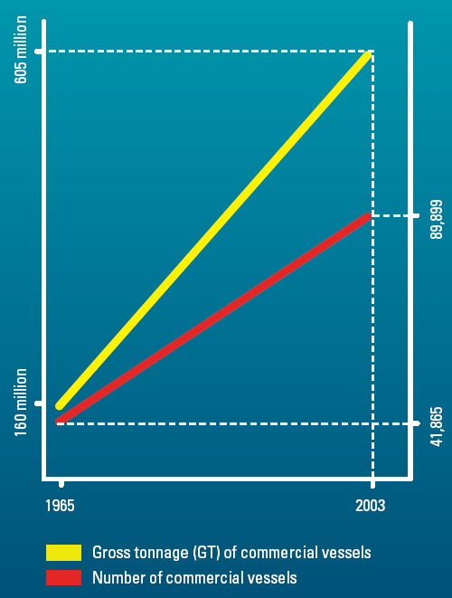

**Figure 1.** Increase of ships and their gross tonnage during the years.

The cruise interest for remote areas and the extension of the commercial transport have enlarged the number of the geographical areas in danger. The environmental noise compatibility of cruise ships has also a relevant economic impact, the nicest areas are the more quiet ones. In order not to make any mistake, it is important to keep in consideration 3 different aspects: presence of fauna, noise limits and ship noise.

The main ship noise sources are: diesel engines and diesel generators, propellers (cavitation) and waves generated by the hull. URN can propagate up to very long distances before it comes under environment level. Masking is considered the most important consequence for the relationship between mammals, mainly in the range below 1 kHz. Furthermore, it is proved that some whales have changed their behaviour, their feeding habits and their reproductive activity.

Anyway in general there is not a complete knowledge on the way ship traffic can affect the marine fauna behaviour. Furthermore, it is important to notice that noise emission is not always the main risk: for instance if the ship is not noisy the fish cannot hear it and can collide with the ship.

In case of new rules on URN, the main changing should involve propulsion, resilient mountings under the main machineries and high efficiency insulations. Most of these devices are in normal practice on navy ships. All these devices are more efficient if installed in the design phase of the ship, even if with higher cost, they can be installed also in retrofitting the vessel. For this reason it is important that calculation methodologies enter the ship design phase, in order to plan the best solution to lower down noise emission.

It has been estimated that in order to lower URN of 20-30 dB, ship construction costs will increase of abt. 30%. These costs can be gained thanks so an higher efficiency of the ship due to the higher design and construction quality; furthermore there would be also a positive effect on comfort on board for passenger and crew members.

# URN noise emission from ships

The evolution of URN limits has encountered the absence of a scientists agreement on the impact of noise level on fish and mammals. Here below some of these rules are mentioned:

1. UNCLOS: united nation convention on the low of the sea (1994), where ‘pollution’ is used to indicate any form of energy caused by human beings.
2. IMO resolution A 927(22) (2001) using for underwater noise both ‘substance’ and ‘pollutant’.
3. ICES: international council for the exploration of the sea (1995), which indicates as limit 30 dB more than the hearing threshold of cods and herring
4. ACCOBAMS: agreement for the conservation of cetaceans of the black sea, Mediterranean sea and contiguous Atlantic areas (1996) where the scientific committee indicates noise as relevant for some kinds of whales.
5. ASCOBANS: agreement on the conservation of small cetaceans of the Baltic and north seas (1992) – resolution n.5 on effects of noise and of Vessels (2003) which gives some recommendation for the future ships.
6. Ligurian sea cetacean sanctuary agreement (1999) where a request of the impact of ship traffic on mammals is required.
7. BESST 2011
8. DNV 2010
9. SOUTHALL 2007

Recently ISO/TC 8, ships and marine technology, is evaluating the impact of URN on marine fauna with a consequent definition of measurement methods and criteria. In October 2008, researchers, class societies and yards met in Sorrento to start a discussion concerning underwater noise pollution and the effect on marine environment of ship traffic. An important meeting has been recently done in Portopiccolo, close to Trieste, in order to approach the ISO URN measurement standards and silent classes limits issued by Class Societies.

In June 2009, ISO/TC8/SC2 organized in London a meeting on this subject.

Underwater radiated noise measurement methods, for the application to civil ships, have been issued by technical committees of different international bodies, especially during the last half a decade. These methods, each of which implies specific precision levels and exhibits strong points and limitations in terms of actual application, cover all the aspects of ship radiated noise trials in full scale, i.e. the measurement system specification, the location requirements for the tests, the prescribed vessel course, the analysis and the reporting of the data. Moreover, all include a rule to assess the noise levels at a reference distance, even if often according to different criteria, in general clearly specified. So they can be considered as measurement standards for the underwater radiated noise assessment of commercial vessels, which augment the capability of comparing measurements, in principle even when the relating datasets are obtained according to different methods.

Among Classification Societies, Det Norske Veritas was the first one to publish their additional DNV Silent Class Notation (see DET NORSKE VERITAS, 2010). After that Bureau Veritase published their BV URN Rule Note NR 614 (see BUREAU VERITAS, 2014). In 2018, RINA and Lloyd’s Register have been publish their additional class notations regarding URN (Dolphin Notation and Additional Design and Construction Procedure for the Determination of a Vessel’s Underwater Radiated Noise , respectively).

In the ISO (International Organization for Standardization) ambit, the Draft International Standard ISO/TC8 DIS 16554.3 (see ISO, 2014) and the ISO/TC43 WD 17208-1 (see ISO, 2013) are close to be released, while an ISO Publicly Available Specification (PAS) is available (see ISO, 2012), which is based on the popular ANSI/ASA (American National Standards Institute/Acoustical Society of America) S12.64-2009/Part 1 (see ANSI/ASA, 2009).

Of course the additional class notation documents, in addition to methodologies, also include radiated noise limits against which vessels must be compliant in relation to the proposed methods and the different operational conditions of the ship. Noise limits were also included into the ICES Cooperative Research Report No.209 (ICES, 1995), which addresses (fishing) research vessels, and was published many years ago. Noise limits, when reported in the standards, are expressed in terms of spectra, in the frequency range specified within each standard.

The interest for environmental implications of underwater noise grew at the beginning of the two-thousand years, and rapidly the need of effective measurement systems suitable for civilian application emerged.

According to this trend, a first system was jointly developed, implemented and first applied by Fincantieri and CETENA (see Pescetto et al., 2006). An effort was made to align layout and procedures of a cost effective system with the emerging measurement standards. In particular the system was composed by two separate units: an in-water unit (a cylindrical ‘buoy’ of 1,900 mm height 220 mm diameter) and a receiving station on the target ship. A single omni-directional hydrophone was suspended to the underwater cable which could be arranged for measurements at 30 / 50 / 80 or 100 meters of depth. The surface buoy was provided with an audio board that digitalized the acoustic data recorded from the hydrophone with a sampling frequency of 44,100 Hz and 16 bit quantization. The adopted course configuration was similar to that visible in figure 1.

In figure 2 (left) the emerging part of the buoy-based system is visible during its first application on a 290 meters length and 110,000 tons cruise ship. In figure 2 (right), an example of measured third octave band radiated noise levels is reported. After that first trial, several other ships have been tested through the same system, including leisure ships as mega-yachts.

During the first period of application of the single hydrophone system, it resulted more and more clear that a more sophisticated method could also be necessary to fulfill emerging standards. So a second measurement system, fulfilling the ANSI/ASA approach and the other similar methods, has been developed (see Figoli et al., 2013 and Gaggero et al., 2014), based on a vertical array of three digital hydrophones. The layout of the system is visible in figure 3 (left).

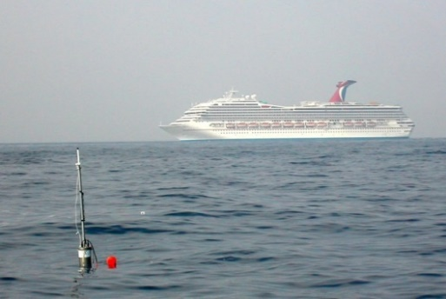

**Figure 2.** Right: application of the single hydrophone system – Left: third octave band noise levels.

The array has variable total length and variable spacing between hydrophones, to conduct measurements on ships of different size, according to standard requirements. Each hydrophone includes a depth sensor and an electronic calibrator. Depth data are included in the digital acoustic data flow for providing real-time monitoring of hydrophone’s depth. The hydrophones are hosted by a single underwater cable of 335 m of length. The data are addressed to a multi-channel data receiver able to get a continuous flow of digital data at very high rate simultaneously from all the hydrophones. The receiver allows the user to set the array parameters, in particular the sampling frequency (96 or 192 kHz). In September 2013 the system was firstly applied (see Dambra et al., 2015) to measure the underwater radiated noise of a research vessel (the Princess Royal) managed by the University of Newcastle, in the ambit of the collaborative EU ‘SONIC’ (Suppression of Underwater Noise Induced by Cavitation) project (http://www.sonic-project.eu/). The project, funded under the FP7 and involving thirteen organizations from five countries, has started in October 2012 and it’s aimed at delivering the technical knowledge required for mapping, measuring and mitigating noise from shipping, contributing to quieting the oceans and improving the well-being of marine life. After the SONIC trials, the system has successfully been applied in subsequent measurements on Fincantieri vessels. A typical narrow band spectrum of underwater noise from the three hydrophones of the system is shown in figure 3 (right).

|  |  |
| --- | --- |
| Fig2b1 | Immagine |

**Figure 3.** Right : variable length/spacing array – Left : typical narrow band spectrum.

# URN limits

## ICES

First limits that it is possible to find are due to ICES. Underwater Noise Limit specified by the International Council for the Exploration of the Sea (ICES) in Report 209 dated May 1995. Applies to Research Vessels in order to avoid alerting marine life. Recommended Speed: 11 knots

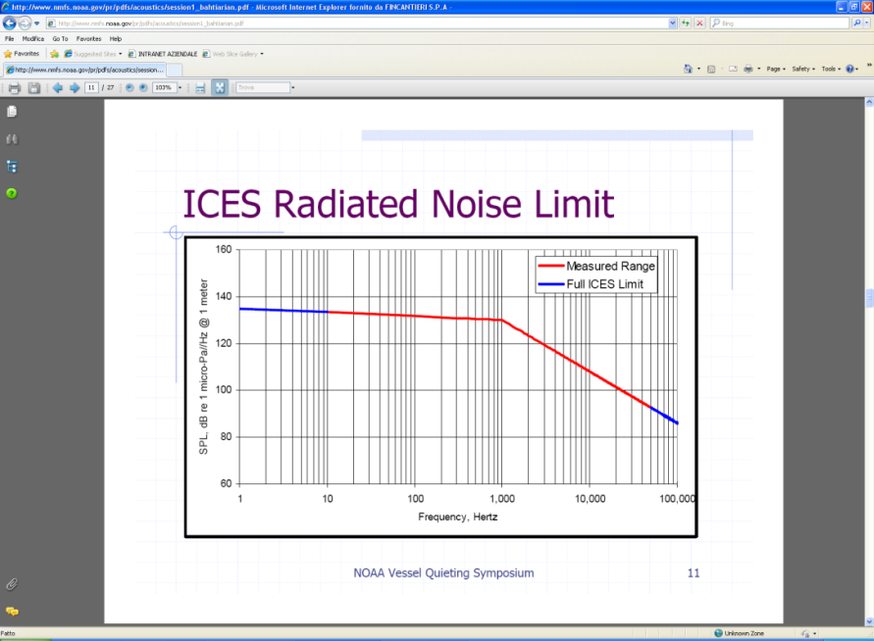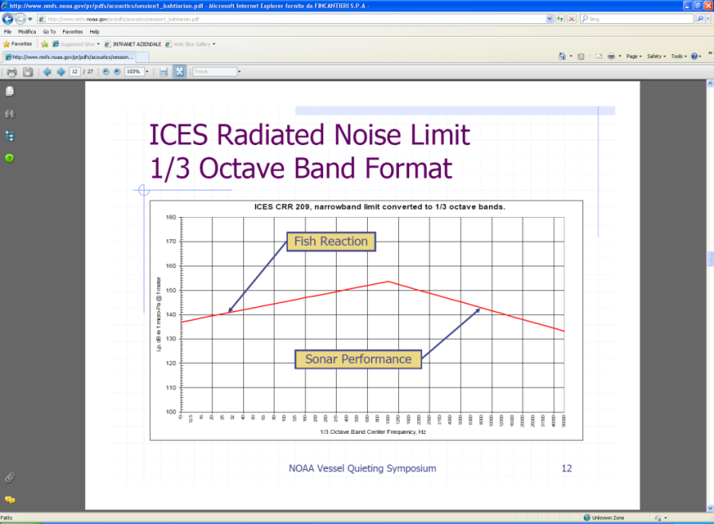

**Figure 4.** ICES URN limits.

## Class Societies Rules

The URN Rules from Class Societies specify requirements for maximum underwater noise emission for a given set of operation conditions. The rules specify different requirements for specific vessel groups as shown in the figure 5. Limits for quite condition are intended for cruise ships and other vessels operating, e.g. in environmentally sensitive areas, typically with a maximum speed of 10 knots, while transit condition is assigned to ships complying with the limits reported in figure 5 at contractual normal sea going conditions.

Compliance with the rules shall be demonstrated by measurements following the procedures specified by the class society, which are different between them (n° of hydrophones, n° of runs, measurements only on deep/shallow water, etc.).

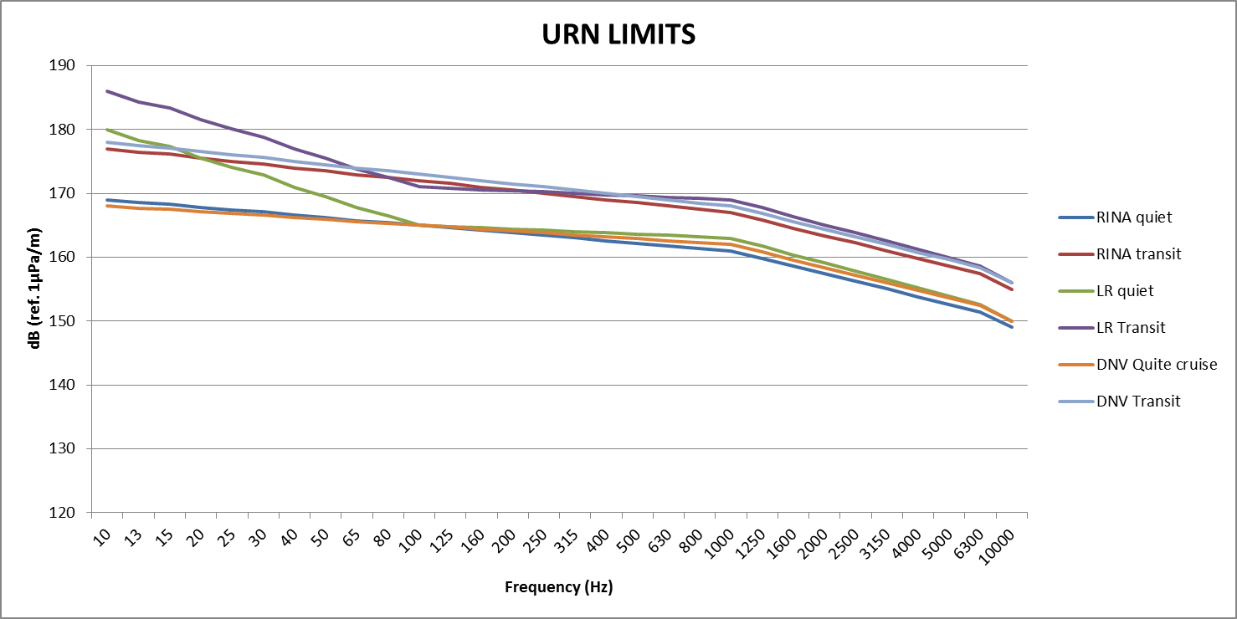

**Figure 5.** Class Societies URN limits.

BV limits are reported in figure 6, since the limits are given in a different scale (dB ref. 1µPa@1m/Hz) compared to the other Class Societies (dB ref. 1µPa@1m).

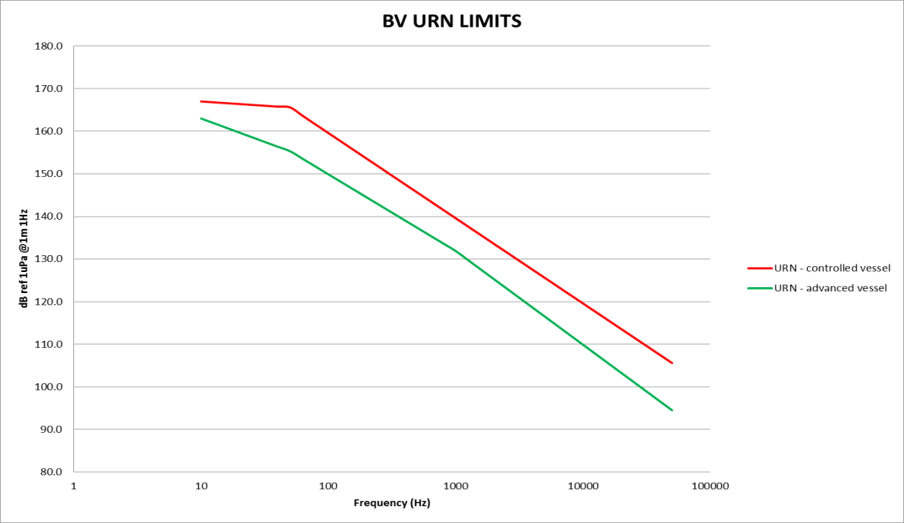

**Figure 6.** BV URN limits for controlled and advanced vessels.

# Conclusions

All the Classification Societies have presented different URN procedures and limits, also if in many cases the difference is about few dB. Furthermore, limits have been imposed on the basis of surveys carried out on different vessels rather than taking into account the real effect of the URN levels on the marine fauna.

It would be useful that all the Classification Societies work together in order to obtain only one curve and one measurement method, which would be really helpful during the design phase and during sea trials for the Shipyards. In fact, it is unreasonable to expect shipbuilders to conduct different measurement methodologies during sea trials in function of the Certification Society in order to achieve the additional required classification.

The authors suggest to various agencies to participate to ISO meetings in order to achieve one solution in order to achieve a simplified method for measurements, which will be adopted by the Shipbuilder, and only one limit curve to be respected.

References

1. Ainslie, M., Principles of Sonar Performance Modelling, Springer, 2010.
2. ANSI/ASA, S12.64-2009/Part 1 Quantities and procedures for description and measurement of underwater sound from ships – Part 1: General Requirements, 2009.
3. Bureau Veritas, Underwater Radiated Noise – Rule Note NR 614 DT R00 E, 2014.
4. Dambra R., Firenze, E., Underwater radiated noise of a small vessel, accepted for ICSV22, Florence, Italy, 12-16 July, 2015.
5. De Jong, C.A.F., Characterization of ships as sources of underwater noise, in Procs. NAG/DAGA, 2009.
6. De Lorenzo F., Oliva Tomàs A. and White P. Underwater noise limits and measurement of underwater radiated noise from merchant vessels, accepted for 24th International Congress of Sound and Vibration, London, UK, 23-27 July, 2017.
7. Det Norske Veritas - Rules For Classification Of Ships Newbuildings - Special Equipment And Systems Additional Class - Part 6 Chapter 24 - Silent Class Notation, 2010.
8. Dekeling, René, et al. "The European Marine Strategy: Noise Monitoring in European Marine Waters from 2014." The Effects of Noise on Aquatic Life II. Springer New York. 205-215, 2016.
9. Dolman, S., Owen, D., Parsons, E.C.M., Simmonds, M.P., Swift, R., Weilgart, L., Oceans of Noise 2004 – A WDCS Science Report, Editors: Mark Simmonds, Sarah Dolman and Lindy Weilgart, 2004.
10. Figoli, A., Tesei, A., Dambra, R., Bassetti, M., A digital vertical array with variable geometry for accurate measurement of underwater ship-radiated noise, 1st Int. Conf. and Exhibition on Underwater Acoustics (UA2013), Korfu, Greece, 23-28 June, 2013.
11. Gaggero, T., Bassetti, M., Firenze, E., Tesei, A., Trucco, A., Processing strategies for evaluating the ship radiated noise using an underwater vertical array, 2nd Int. Conf. and Exhibition on Underwater Acoustics (UA2014), Rhodes (Greece), 22-27 June, 2014.
12. ICES (International Council for the Exploration of the Sea), Cooperative Research Report No. 209 Underwater Noise Of Research Vessels - Review and Recommendations, Ed. R.B. Mitson, 1995.
13. ISO (International Organization for Standardization) DIS/16554.3 Ships and marine technology — Measurement and reporting of underwater sound radiated from merchant ships — Survey measurement in deep-water, 2014.
14. ISO (International Organization for Standardization), WD/17208-1 Underwater acoustics — Quantities and procedures for description and measurement of under-water sound from ships — General requirements for deep water measurements used for comparison purposes, 2013.
15. ISO (International Organization for Standardization), "Acoustics - Quantities and procedures for description and measurement of underwater sound from ships. General requirements for measurements in deep water," ed: International Organization for Standardization, 2012.
16. Lloyd’s Register – Additional Design and Constructin Procedure for the Determination of a Vessel’s Underwater Radiated Noise – February 2018.
17. Ona, E., Godø, O.R., Handegard, N.O., Hjellvik, V., Patel R., Pedersen, G., Silent research vessels are not quiet, J. Acoust. Soc. Am. 121 4, 2007.
18. Pescetto, A., Dambra, R., De Lorenzo, F., Grossi, S., A light system to assess acoustic signature of surface vessels, Procs. NAV2006, Genova, Italy, 21-23 June, 2006.
19. RINA – Amendemnts to Part A and Part F of “Rules for the Classification of Ships” – Additional Class Notation: “Dolphin quite ship” and “Dolphin transit Ship” - Part F Chapter 13, Section 25.
20. Rolland, Rosalind M., et al. "Evidence that ship noise increases stress in right whales." Proceedings of the Royal Society of London B: Biological Sciences 279.1737, 2363-2368, 2012.
21. Sand, O., Karlsen, H.E., Knudsen, F.R., Comment on “Silent research vessels are not quiet” J. Acoust. Soc. Am. 121, ELI145-EL150] (L), J. Acoust. Soc. Am. 123 (4), 2008.
22. Solan, Martin, et al. "Anthropogenic sources of underwater sound can modify how sediment-dwelling invertebrates mediate ecosystem properties." Scientific reports 6, 2016.
23. Urick, R.J., Principles of Underwater Sound, New York, McGraw-Hill, 1975.
24. Van der Graaf, A.J., Ainslie, M.A., André, M., Brensing, K., Dalen, J., Dekeling, R.P.A., Robinson, S., Tasker, M.L., Thomsen, F., Werner, S., European Marine Strategy Framework Directive-Good Environmental Status (MSFD GES).