Definition and Development of the Modularity Features for the Italian Navy Multirole Patrol Vessel Mission Bays

Francesco GRECOa[1], Simone SERPAGLIb

*a Italian General Navy Staff, Rome, Italy*

*b Fincantieri SpA, Genova, Italy*

**Abstract.** All NATO navies are facing the challenge of meeting current and future operational requirements while reducing procurement and life cycle cost of naval platform. To this regard, the Italian Navy (IT Navy) has adopted, over the last years, new design concepts in order to maximize operational flexibility for future needs by an extensive use of modularity features on its platforms. During 2016 through 2017, the activities performed in the NATO Mission Modularity Specialist Team, NATO Total Ship System Engineering Specialist Team and in the procurement activities for the Italian Navy Multirole Patrol Vessel project, allowed to define a collaborative multi-disciplinary team between Italian Navy and Italian companies (Fincantieri) in order to identity and develop an exploratory approach for assessing the capabilities and functionality features of newly designed mission bays. This paper aims at underlining the IT Navy innovative approach to procure more effective and affordable naval units, through a deep insight on the whole-warship design impact of Mission Bays and standardized modular areas, aiming at the maximum versatility of operational use of its military ships.

**Keywords.** Italian Navy, Marina Militare Italiana, Fincantieri, Multirole Patrol Vessel, PPA, Mission Modularity (MM), Mission Bays.

# Introduction

Over the last years Italian Navy has put additional effort during the early design stage of the development of its new warship in order to wisely balance the need for increased operational capabilities with systems affordability, as reported in Grimaldi [1]. One of the central ideas for achieving the aforementioned goal has been the extensive use of maritime Mission Modularity (MM) that, according to the NATO-wise common meaning, is the process of delivering capability in a vessel through the use of standardised modules (containers, skids or other standard arrangements). Mission Modularity allows a naval operator to share and embark a capability on several vessels, to re-role vessels in a short period of time and even to share capabilities across navies. Since the full development of a Mission Modularity capable ships requires the ship designer to take into account transversal impact on overall ship size, displacement on so on, Italian Navy, leveraging the knowledge developed in the NATO Mission Modularity Specialist Team and in the NATO Total Ship System Engineering Specialist Team, decided to establish a standing working group (with both Governmental and Industry representatives) for the full development of this concept. One of the main goal was to practically determine how to better fit all the requirements, related to Mission Modularity, in the procurement activities of the new Multipurpose Offshore Patrol Vessel (PPA) (Figure 1), now under construction by Fincantieri for the Italian Navy. A similar approach was developed by the US navy starting from 2010 for the LCS (Littoral Combat Ship) project, which had a constrained budget with fulfilling its missions in an environment of evolving threats and a corresponding rapidly evolving mission system technology base. This is the main reason to Modular Adaptable Ship (MAS) technologies in order to enabling the affordable transformation of a ship over its service life and to maintain military relevance. The LCS is designed to augment its core self defense capability with modular mission packages (MPs) that provide focused warfighting capabilities, as indicated in Volkert et al. [2] and in Doerry [3].

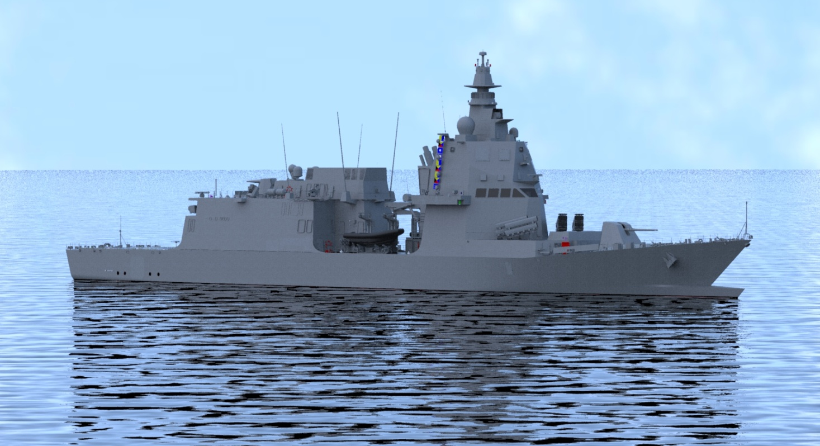

**Figure 1.** PPA external view in a Virtual Reality (VR) environment.

# Time constraint in developing mission modularity for PPA

Italian Navy firstly expressed the need for a Mission Modularity Capable Vessel in 2013 during the early concept design phase of the new warship that make up the Naval Law. Fincantieri received formally the PPA’s operative requirement from Italian Navy in later 2013. Usually, this milestone represents the activity kick-off for Industry in the project, starting to breakdown functions into low-level requirements, with the scope of defining systems and solutions to be implemented in the ship. At that time, Mission Bays were implemented in the Ship configuration only as volume requirement, not having defined functions and goals associated. Therefore, PPA definition started without the knowledge of Mission bay contents. In the first quarter of 2014, Italian Navy elaborated an initial draft of PPA modularity operative requirements, sharing with Fincantieri first ideas of Bays configuration that were later on included into the 2015 contract. However, since both Government’s and Industry’s feeling was that innovative Mission Modularity requirements would have asked for more time to be fully developed, a decision was taken: only paramount requirements of Mission Bays would have been put into the Ship’s contract, agreeing each part to develop systems and solutions in contractual phase, carrying on working groups also after the contract signing. Follow on, in the 2016 through 2017 timeframe, it was commonly decided to go deeper into requirements definitions with the help of a standing working group, composed by Navy and Industry subject matter experts (SMEs). A detailed and up to date 3D view of the PPA is shown in Figure 2.

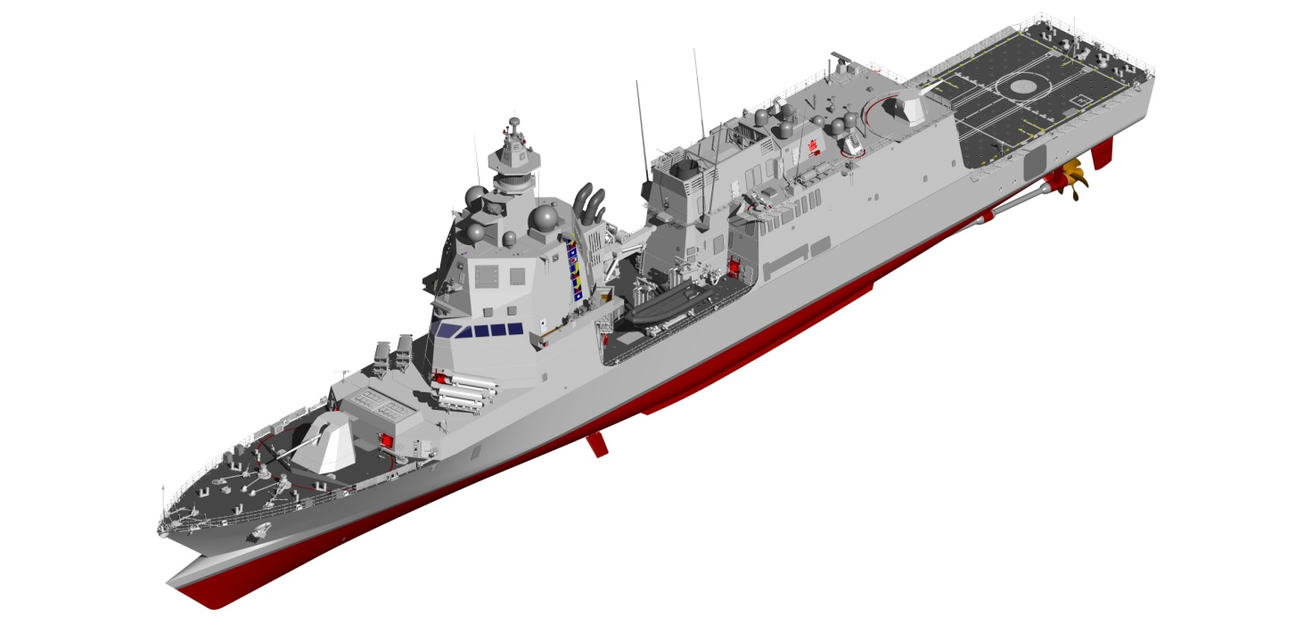

**Figure 2.** PPA full 3D model.

So far, more than twenty meetings have been held, with a total amount of more than 100 Action Items managed, to define detailed solutions. This process has led, among other results, to the submittal and following approval by the Italian Navy, of the Procurement Technical Specifications for the architecture and the inherent systems of the Mission Bays.

# Mission bay requirements management

Mainly, two different Mission Bays are foreseen in PPA: a ship internal one, located in the last two aft compartment under the Fly Deck, and an external one, located amidships on the Weather Deck. Main drivers of both are: reconfiguration of ship’s capability depending on the assigned mission, cargo capability optimization, independence of operation from the quay. The integration of Mission Bays has implied several technical constraints for ship project:

1. Volume allocation. Space designated for Mission Bays can’t be easily shared for other Ship functions. This had to be addressed for PPA considering modular zones like impenetrable areas.
2. Structure definition. Especially for the Aft Modular Area, hull definition must respect rigid drivers (no pillars under the Fly Deck, large openings in the hull, watertight bulkhead penetration for ship’s systems).
3. Topside layout. Mainly for the Central Modular Area, the topside definition has led to innovative solutions compared to past design choices taken by It Navy and Fincantieri (*i.e.* SSM missiles moved to forecastle).
4. Weight balance. Mission Bay integration had also impact on the distribution of masses that had to be considered particularly from an hydrostatic point of view. In fact, most of the weights are to be computed on the extreme aft (critical for floatability) and above weather deck (critical for stability).

The inclusion of such constraints in the PPA Project led to huge impact in the basic design principles, driving choices regarding watertight subdivision, overall performance and hull definition. Moreover, the presence of Mission Bays introduced the need for additional design validation: as an example, dedicated tank tests were performed to measure ship motions in the modular zones, water pulse at operational speeds and verification of interference wake/transom when aft boat operations occurs.

In addition to what defined in standard platform development, some trade-off in the classic whole warship transversal requirements had to be accepted. From a susceptibility point of view, impact on both the RCS and Infra-red signature had to be considered by the integration of Mission Bays. As a practical example the fore engine room exhaust gas ducts design had to be extended outside the funnel, although not recommended in literature as an optimal solution form an Infra-red signature point of view, with the aim to lower the risk of high temperature and particulate drop in the Central modular area, with beneficial effect on the Mission Bay operability. To these respect, Mission Bays features are not only to be considered as design constraints but mostly as drivers in the project development.

# Mission bay systems overview

### Boat Launching and Recovery System

As shown in Figure 3, in the aft compartment of the ship, a Launch and Recovery System (LARS) useful for PPA organic Rigid Hull Inflatable Boats (Rhibs) will be implemented. This new system will have completely different features respect to what has been requested by the Navy and installed by Fincantieri in recent class Frigate. In the PPA configuration astern LARS is basically based on an aft ship structural slipway, with no moving saddles on the bottom, but provided with a single transversal rope connected to two side trolleys; these latter moving synchronously along the lateral structure of the slip. System results simpler respect to the previous ones although it is paramount to conceive in a proper way the integration with the ship, with some requirements to be integrated also in the Rhib project (mainly the fore capture hook).

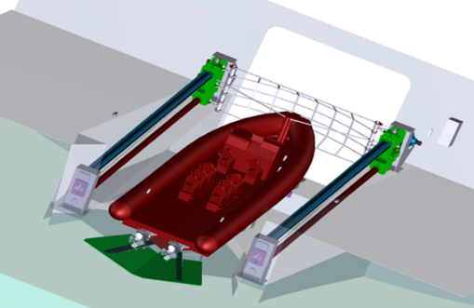

**Figure 3**. LARS concept for astern Rhibs.

### Aft handling systems

To achieve maximum operational flexibility across the two aft watertight compartments of PPA, a complex handling system has been integrated, made of three main sub-systems (as shown in the following Figure 4). These being: An Overhead Transversal Crane (OTC), located in the fore compartment, capable of moving, within the space, alternatively either 20,0 feet containers or Rhibs up to a length of 9,39 m or general cargo up to a weight of 10,0 tons; A Longitudinal Handling System (LHS), capable of moving, between the two aft compartments, abovementioned Rhibs or cargo across a sliding watertight door about 4 meters wide; A Transversal Handling System (THS), located in the aft compartment, composed by two synchronous winches running on transversal beams, sweeping the compartment side to side for various purposes. The capabilities of aft handling system are mainly the shifting of complex cargo like Rhibs and containers in and between the Aft modular zones, reconfiguring the ship asset depending on the assigned mission.

|  |
| --- |
| **Figure 4.** Aft Mission Bays Handling Systems concept. |

Moreover the combined action of LHD and THS gives the additional capability of embarking and disembarking a tailored modularised version of either ATAS[2] or TDS[3], according to the ship’s version[4] that can be launched and recovered via one dedicated stern opening for said towed underwater systems, as shown in Figure 5.

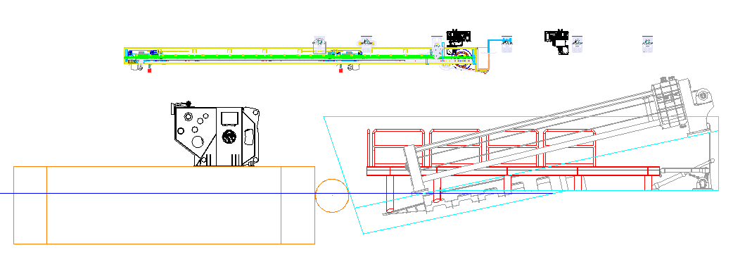

**Figure 5.** Aft Mission Bays Handling Systems concept.

### Aft Removable Platform

Another feature integrated in the Aft Mission Bay is the possibility to install, temporarily onto the slipway, a steel platform (Figure 6, right-side and left-side). This gives the possibility to restore a flush horizontal deck in the central area in ZMPP2, useful for the following functions:

1. Loading/unloading operations. Through the LHS previously described, the Ship will have the possibility to pick up systems/cargo from the aft, laying them on the platform for following movement. In detail, this could be used, in addition to the embark/disembark of sonar systems located on the right side of the aft part of the Mission Bay (also called ZMPP2), for handling cargo from outside to either the left part of ZMPP2 or to the fore part of the Mission Bays (also called ZMPP1).
2. Employment of a Mission Module from the ZMPP2. The removable platform gives the possibility, when underway, to launch and recovery with the Astern Door open, Italian Navy owned assets, deployable throughout a 20 feet container.

The ship to Mission Module interfaces in both compartments of the aft Mission Bays (*i.e.* ZMPP 1 and 2) are being designing taking into account the work done within NATO working groups and partially published into the relevant ANEP [4].

|  |  |
| --- | --- |
|  |  |

**Figure 6.** Aft Removable Platform (left) with ISO 1C Mission Module (right).

### Aft shell doors

To further extend the flexibility of the fore compartment of Aft Mission bay (*i.e.* ZMPP 1), two side shell doors have been integrated (Figure 7). The main scope is the capability to use the aft modular area also for load/unload cargo at sea, through the employment of OTC. The main feature of such items is the possibility to open the door in two positions, folding the panels at rotating of 180° or 105°, depending by the operational situation (either launch and recovery operation with Rhibs or flight operations with Aircrafts/Helos). A similar shell door is located aft in the ship transom, designed to be opened for Rhibs launch and recovery operations.

|  |  |
| --- | --- |
|  |  |

**Figure 7.** Side shell doors concept.

### Central Mission Bay systems

In the Central Mission Bay amidships, with a basement insisting on the weather deck, it has been located the Ship main cargo crane (Figure 8, left), knuckle boom type, with a cargo capability of 20,0 tons at 14,0 meter. The crane gives the ship the load/unload capability of various cargo (mainly either 20 or 40 feet ISO containers) independently of the facilities available in port/harbour. This requirement is considered of high importance for ship missions abroad, either when the ship is moored in a not equipped quay or, most importantly, in a Mission Relief type of mission.

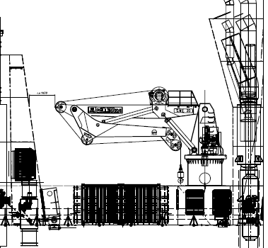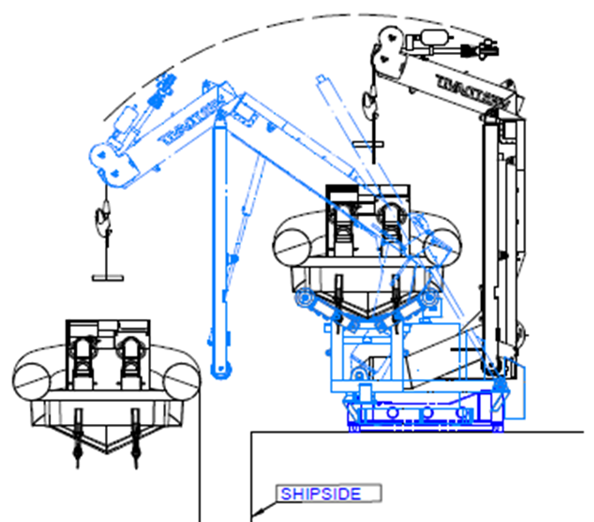

**Figure 8.** Main cargo crane (left) and davits cranes for RHIBs launch (right), in central modular area.

Also, on both sides of the area, two davits are located (Figure 8 right), useful for the launch and recover of Rhibs amidships. The systems are designed based on the possibility to move, for interoperability needs, boats already in use by Italian Navy up to a Maximum size of 14,0 meters in length. The most important features of such item is its deployability, hence the capability to be removed, restoring the flush deck for other cargo purpose, and to be installed on other PPA.

# Current and future activities

The effort is being focused on the qualification of Mission Bay equipments that have already successfully overcome the design review process. To this regard, major care is being directed towards the management of specific technical details, like the following:

1. Laws and Regulation applicability. A deep analysis has been performed at the beginning of the project, detecting and agreeing between Industry and the Navy the references, being sometimes Military and other times Statutory Rules, to be adopted in the design process.
2. Requirements traceability. The integration of Mission Bays in the Ship is so strong that, for this innovative project, is not possible to separate specific requirements allocation from the Ship’s one. Consequently, Mission Bays requirement management is being considered, by all stakeholders[5], at the same level of whole warship requirements.
3. Functions definition. The capabilities of systems adopted in Mission Bays are so wide, that is necessary to develop dedicated functionality studies to enlist all the functional possibilities of modular areas. Most of all, it is necessary to set operational mode to the PPA limits (Ship motions, loading capacity, safety, etc..).

Among that, detailed procurement specifications have been defined and sent to sub-suppliers including standard interfaces and detailed layouts as a result of virtual 3-D simulation undertaken during the development phase. Also, for all systems described in previous chapter, Factory Qualification and Acceptance Test are foreseen in order to verify their compliance with the required design features. The first system that needed to be developed quickly was the LARS for astern Rhibs; since its integration onboard implies the definition of the Ship’s hull aft structural details. To validate the engineering design solution, a full-scale mock-up of the ship slipway has been reproduced on a barge in Fincantieri Shipyard, as reported in Figure 9, and the prototype of LARS has been here on installed. Testing, scheduled for a week long duration, has started as early as December 2017 in order to verify all possible loading conditions of barge (simulating PPA operational drafts) and Rhibs approaching maneuvering. Need for some minor modifications arose during the first week of the trials so that a further test in January 2018 has been performed in order to close all pending remarks.

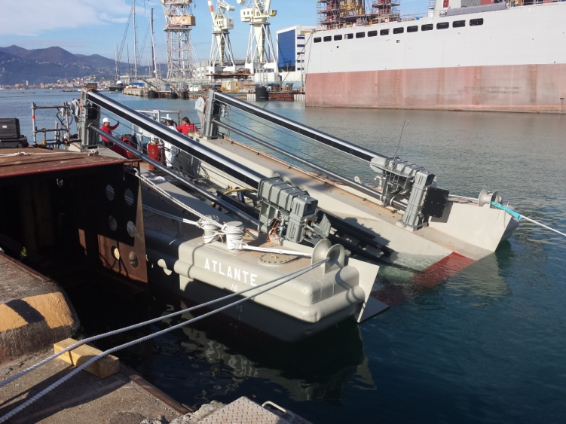

**Figure 9.** Astern LARS test bed located in Muggiano Shipyard.

For all other items FAT are scheduled in Supplier’s premises in the few next months, since their integration could occur with the ship in an advanced state of construction.

**6. Conclusions**

To wrap up the main results the IT Navy and Industry has attained so far, from all design phases of Mission Bays and related systems of the PPA development process, we can consider: Firstly, that MM and Mission Bays offer an efficient way to balance flexibility in operational capabilities with affordability in ship procurement; Secondly, that Modularity and flexibility are a robust ship design approach that leverages, and is allowed by, knowledge developments and technical advances (such as design of compact and reliable systems of autonomous handling of modular assets), developed, from the initial Ship’s general operational requirements, within ad-hoc transversal working group; Eventually, that the design approach followed gives program managers wider visibility and controllability of the procurement process of the new systems related to MM. Also, Modularity provides opportunities for sharing the know-how achieved within the international community and for leveraging, within the Alliance, the existence of Mission Bays capable of hosting interoperable Mission Modules.

**References**

[1] Grimaldi, A., “Designing of a Modular Mission Bay for a Multirole Patrol Vessel”, 18th International Conference on Ships and Shipping Research NAV 2015, 24-26 June, Lecco, Italy.

[2] Volkert, R., Jackson, C. and Whitfield, C., “Development of Modular Mission Packages Providing Focused Warfighting Capability for the Littoral Combat Ship”, 2010, Naval Engineers Journal, 122: 75-92. <doi:10.1111/j.1559-3584.2010.00281.x>.

[3] Doerry, N., H., “Institutionalizing Modular Adaptable Ship Technologies”, 2012, Journal of Ship Production and Design, Vol 30, Issue 3, [DOI: 10.5957/JSPD.30.3.130038](DOI:%2010.5957/JSPD.30.3.130038).

[4] NATO STANDARD – ANEP 91 – Standard Interfaces for Mission Modules – Edition A Version 1.

[5] OCCAR, PPA Contract No.PPA.14. PROD.001 For the Design, Development, Production, and In-Service Support of 6 Multipurpose Patrol Ship (PPA) for the Italian Republic (and Amendment No.1).

1. Corresponding author: [francesco.greco@marina.difesa.it](mailto:francesco.greco@marina.difesa.it)
2. Active Towed Array Sonar (ATAS), with tailored modularized feature, is being developed by Leonardo Company within the PPA program scope of supply.
3. Torpedo Detection System (TDS), with tailored modularized feature, is being developed by Leonardo Company within the PPA program scope of supply.
4. As PPA is going to respond to different capability profiles, the Navy has chosen a single platform able to accommodate at least 3 levels of weapon systems with increasing capabilities.
5. Including Industry, Italian Navy, OCCAR as Contract Authority and NAVARM as National Point of Contact [5]