Comparative test in design of hydrofoils for a new generation of ships
Ing. Ph.D. Ferdinando MORACEª – Ing. Ph.D. Valerio RUGGIERO^{b}
ªLiberty Lines, Trapani
^{b}Dipartimento di Ingegneria, University of Messina
Abstract.
Compared to the traditional fast ferries, Hydrofoil represents the best solution for the fuel economy and reduction of any ship motions. These advantages are still undisputed primates of the wing supported means.
It is then wondering why hydrofoils are not so used in modern commercial fleets even considering the high management costs from the maintenance point of view, the initial acquisition cost higher than other similar solutions.
The article shows the results of a tank tests campaign performed by Liberty Lines on new class of hydrofoils called "Admiral-250", designed and built by Liberty Lines, where fundamental points have been touched upon, such as: the wing hydrodynamic optimization by means of model testing; the structural study of new wing systems and the update of the production processes with new construction techniques, and the improuvement in comfort for passengers in terms of accelerations and vibrations.
The tests for the hydrofoil projects outlined above have been carried out in main towing tanks in Europe, showing a significative gain for new projects.
The know-how achieved, following the definition of the "Admiral-250" project, has made it possible to develop a challenge: the "Admiral-350" hydrofoil class, the largest passenger cargo hydrofoil ever produced, equipped with POD propulsion.

Keywords. Hydrofoils, self propulsion test, wing design
- Introduction
Since 2011 Liberty Lines (formerly Ustica Lines) for its fleet has started to develop series of hydrofoils with new generation of semi submerged wings that faced the typical defects characterizing this type of naval unit.
The seakeeping qualities of the hydrofoil, compared to other types of units with the same displacement, remain undisputed and have already been extensively dealt with in the literature of the sector [1].
The technological advancement in the field of materials, production processes and the appearance of applications for the design aid has allowed us to review, update and improve this type of unit, limiting or even completely solving the defects and limitations typical of this ship.
The carried out work focuses on all those aspects related to the design and construction of the supporting wings. The present work will focus on comparison between traditional RHS-160 and innovative project named the HF01 project.

  - Conventional hydrofoil
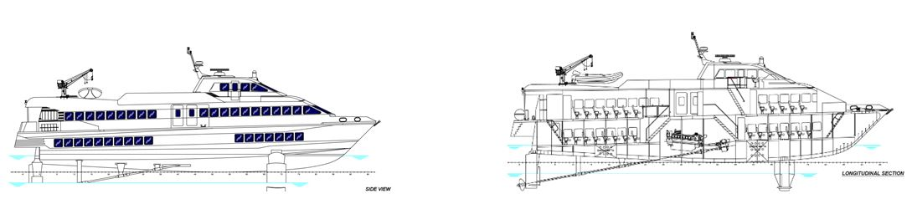
Figure 1: RHS 160
For conventional hydrofoil (fig1) we mean the fastest ship most used in the transport of passengers among the smallest islands, that is represented by the RHS 160F hydrofoil where the main characteristics are shown below:
• Overall length: 31.20 m
• Width outside the frame: 6.70 m
• Maximum immersion: 4.20 m
• Distance between the wings: 20.98 m
• Passenger capacity: 212
• Maximum speed 35 knots
The propulsion and power transmission apparatus is realized by two 4 strokes diesel engines MTU 16V 396 TE 74L of 2000 kW each, and by two shaft lines with fixed pitch propellers.
The wing configuration is of the "Avion" type, i.e. about 70% of the weight of the unit, during the flight phase, is substained by the lift of the forward wing. The shaft line, more than 15 meters long, starts from the engine positioned at about half length of the ship up to the aft wing where the central flow plate acts as a support. The long axis line, where for most of its length operates outside the frame, is supported by three orders of "V" arms.
Figure 2: Fore and aft wing
The wings of this type of unit are secant (semi submerged) of polygonal shape, characterized by wing profiles of the NACA family with thickness distribution "16" and median line "65".
In order to increase lift at taking off and as an aid to electronic stabilization, the flaps are moved by integrated feedback hydraulic actuators.
The constructive system is traditional fairing type, and is characterized by a structure composed of frames, longitudinal stiffeners and shell plates, welded in every part.
The material used is a semi-structural structural steel designated with the abbreviation S460 with yield strength of 460 Mpa.
The limits of this construction are related to the construction of the wing profiles, in fact the technique used does not allow to obtain profiles with complex shapes and therefore has got a range of decidedly limited solutions.
The used steel, suitable to be hand-crafted, and the thermal stress that the structure undergoes due to the intense welding cycle causes the wing assembly not to be suitable to work under an intense load of fatigue, generating periodically and repeatedly structural failure in areas of greatest concentration of stresses.
The following figures show the typical breakages for this type of wing system:
Figure 3: Break forward wing , break aftwing
Summarizing, the weaknesses of this type of unit are the following:
1. Breaking fatigues of the wings
2. Expensive constructive process of the wings
3. Simple wing profiles with low performances
4. Technology of construction of the obsolete hull
As regards point 4, the old generation hydrofoils were built according to the old concept of the bolted hydrofoils.
The problems of this type of realization are reported in the following points:
1. High production costs
2. High maintenance costs
3. Detachment of the shell plates over time
4. Constant infiltration of water in the bilges
5. Structural vibration
All these points produce high operating costs and continuous service interruptions.

- Project HF01
The HF01 is an optimization of the RHS 160, with a completely different wing profile, a different technology for construction of wings and realization of structure.
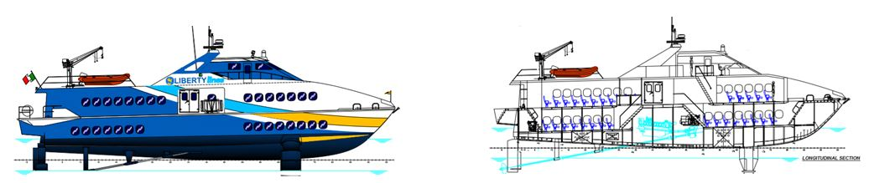
Figure 4: HF01
The main data are shown below
- Overall length: 31.70 m
- Width outside the frame: 6.80 m
- Maximum immersion: 4.20 m
- Distance between the wings:20.95 m
- Passenger capacity: 235
- Maximum speed: 35 kn
The main engines used are two Caterpillar 3516 C HD from 2000 kW at 1800 RPM.
The HF01 project comes from the need to cope with most of the problems inherent in the traditional hydropower.
The hydrodynamic project has been carried out with the aid of the MARIN naval tank as regards the self-propulsion testing campaign and the optimization of the wing profiles. Several studies and computer hours, using the most modern finite element techniques, have allowed to create a ship that would reduce to the minimum, if not cancel, the above mentioned problems, trying to exploit the advantages of the hydrofoil compared to other types of units.

  - Choice of the wing profile

The study and optimization of the wing profile is based on reaching the maximum possible value of the lift/resistance ratio remaining within the cavitation limits.
Several thickness distributions and different median lines were tested in order to determine the best combination of the characteristics highlighted above.
The incidence of the wing profile, the “t/c=thickness-rope ratio” and the “f/c=buckle-rope” vary along the wingspan. The best values of the ratios f/c, t/c, α=incidence angle, and Cl2 (Cl2= coefficient of lift capacity 2D in unlimited flow) have been obtained from the optimization process.
Figure 5: Wing disposition
Considering the average chord length and the surface roughness, the boundary layer is in turbulent regime for most of the length of the wing profile. The viscous resistance of the profile is for the most part governed by the thickness ratio and its distribution. The higher the thickness, the higher the form factor, consequently the frictional resistance increases.
The reduction in the t/c ratio reduces the resistance, but increases the negative pressure peak caused by the variation of incidence during the take-off phase, making the profile and consequently the whole wing more vulnerable to cavitation, a phenomenon that must be limited as much as possible and in some areas of the wings totally absent. The second consequence, just as important as cavitation, is the one related to strength, because of the high Cl a thinner profile would lead to problems of structural collapse.
The following images show a comparison among the traditional wing profiles historically used in the field of secant wing hydrofoils and the wing profile selected by the optimization process.

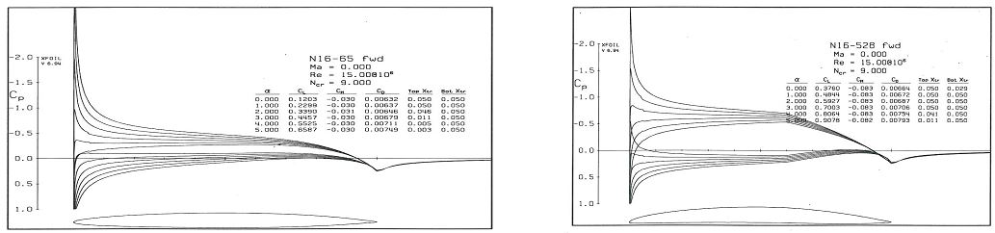
Figure 6: Traditional vs new internal wing profile
The graph compares the hydrodynamic coefficients of the wing profiles between the hydrofoil RHS-160 and HF01.
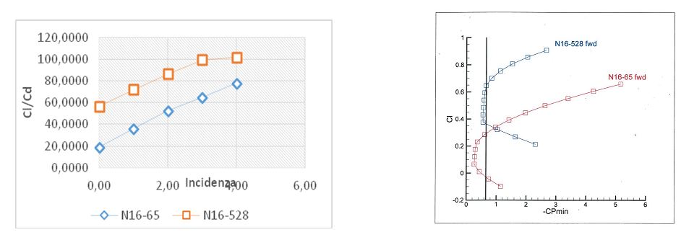
Figure 7: Hydrodynamic coefficients: Cl = lift coeff., Cd = drag coeff.
Cavitation buckets show how the new profile is able to work in the absence of cavitation for the values of Cl, -CPmin (pressure coefficient) of interest.
The cavitation number, for a speed of 36 knots is equal to 0.65.
From the above analysis it was found that the new profile (N16-528) is more suitable for the purpose than N16-65 profile. N16-528 profile allows to have a higher Cl/Cd ratio at the same incidence and to work in the absence of cavitation.
The advantages of this solution can be summarized in the following points:
• Greater hydrodynamic efficiency.
• No cavitation.
The weaknesses of this type of wing profiles relate exclusively to their geometric complexity, which is directly reflected in the real wing construction process.
  - Self Propulsion Tests attended at MARIN Institute
The model of was built on a scale of 6,591: 1; turbulence stimulators were installed at the forward area of the hull and at the leading edge of the two wings.
The model has the possibility to modify the overall incidence of the wing and the position of the ailerons. The tests were conducted in still water.
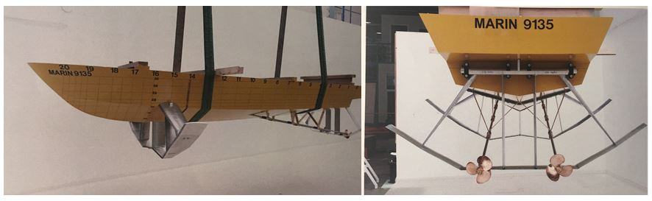
Figure 8: MARIN Model
In a preliminary way, with the aid of an empirical analytical software for the study of the resistance behavior and the ability to fly on the hydrofoil, an evaluation was made of the optimal distance between the hull and the wing.
From the tests in the tank the total trends of the absorbed power have been obtained, as the overall incidence of the wing and the flaps varies.
The tests show that the optimization of the wing profile and the consequent optimization in use of flaps can lead to a reduction of resistance of more than 10%.
The power required at 35 knots shows very interesting values compared to similar vehicles of the same displacement and payload, the final chosen solution is justified by the fact that the hydrofoil in those conditions develops significantly higher lift at the lowest power condition, this guarantees greater comfort in rough seas.
  - Seakeeping and resistance between HF01-RHS160 attended at SVA
In order to compare the two solutions, it was decided to involve a third party to complete the comparative campaign between the two classes of hydrofoils, so Resistance test and Seakeeping test have been carried out at Vienna Model Basin (Schiffbautechnische Versuchsanstalt - SVA) to investigate not only the differences in power but also the vertical accelerations for the hull navigating in rough sea, with waves[2]. The tests have been carried out at tank test to guarantee the scientific approach [3] [4] [5], ensuring the exact reproduction of the same wave spectrum, for both the models. Considering the operational area of the Liberty Lines the wave spectrum has been selected as follows and applied to a speed of 30 kn.
Wave spectrum: JONSWAPP γ= 3.3 , H_{W1/3} = 1.25 m, T_{P} = 4.0s, where T_{P} = period of wave, H_{W1/3} = height of 1/3 of waves, γ= constant according JONSWAP spectrum.
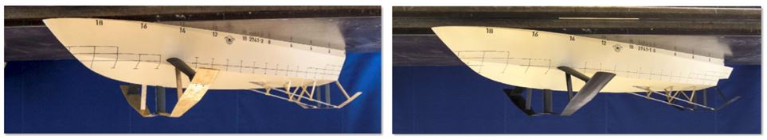
Figure 9: 2741-2 RHS 160 – 2741-1 HF01
The test comparison showed a significant advantage of HF01.
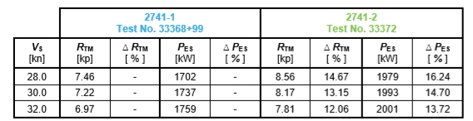
Figure 10: Comparison of resistance
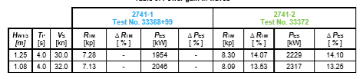
Figure 11: Comparison of resistance HF01 14% less
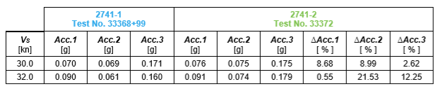
Figure 12: Comparison of significant vertical accelerations HF01= 8% less
In summary it can be confirmed that compared to the design solution of the RHS-160F, the new wing system offers advantageous solutions in terms of performance in calm seas than in rough seas [6].
The following pictures, taken in the SVA during the tests shows the behaviour of the two projects and the better efficiency of wing design of HF01:

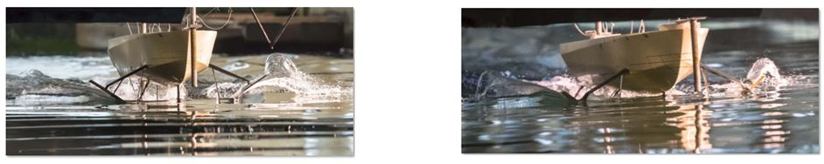
Figure 13: HF01 and RHS-160F
Conclusions
The results obtained from the tests in the tank for the HF01 are the result of the careful optimization of the wing profile and of the variation of incidence along the wingspan [7][8]. The production process of the wing profile changes drastically, the most complex form required by the new completely modifies all the classic construction phases.
Two images of the profile of the project HF01 and RHS 160-F are reported.
Figure 14: External Profile wing HF01 and RHS-160
The results of the works shows the progress made in the design of hydrofoils, the test at model basin have been validated also through a set of measurements during navigation in sea [9], and the result obtained with a combination of the state of art technologies in welding and carpentry processes and the adoption of new wing profiles shows a gain of 8% in vertical accelerations and 14% in resistance. So, finally, it is possible to achieve important increases in performance for resistance and seakeeping, and simultaneously solve some of the typical problems of stress resistance for materials and structures.
References
- T.M. BUERMANN SNAME – GIBBS AND COX, LT. CMDR P. LEEHEY, CMDR J.J. STILWELL U.S.N. (1953) An appraisal of Hydrofoil Supported Craft
- B.V. KORVIN-KROUKOVSKY, The theory of seakeeping (1961,) SNAME Society of Naval Architects and Marine Engineers
- C. TOMASZ CEPOWSKI, (2012), The prediction of the motion sickness incidence index at the initial design stage Maritime University of Szczecin Faculty of navigation. (2012)
- S. ESTEBAN, J.M. GIRON SIERRA, J. RECAS, J. M. DE LA CRUZ, (2005) Frequency-domain analysis for prediction of seasickness on ships, Departemento de Arquitectura de computadores y automatic, Universitad complutense de Madrid, Ciudad Universitaria, Madrid Spain
- M. REICHEL, A. BEDNAREK ,The experimental studies on hydrofoil resistance at Ship design and research centre, Ship Design and Research centre S.A. Ship Hydromechanics Division, Szczecinska 65, Gdansk, Poland
- A.R.J.M. LLOYD, SEAKEEPING: Ship behavior in rough water (1989), Senior principal scientifica Officer Admiralty research Establishment Haslar, Gosport, Hampshire.
- V. RUGGIERO, S. RICCA, F. CUCINOTTA, A. RUSSO “Optimization of stabilization wing for an high speed craft multihull” (2007) ICMRT 07 - Ischia. pp 11-18, ISBN 8890117435.
- V.RUGGIERO, F.CUCINOTTA, E.GUGLIELMINO,A.CRISTELLI, V.RUSSO, (2011). “A preliminary study for the numerical prediction of the behavior of air bubbles in the design of ACS” - Proceedings of the 14th International Congress of the International Maritime Association of the Mediterranean” , IMAM 2011, ISBN: 978-041562082-6,Volume 1, 2012, Pages 27-33
- R. NABERGOJ, Fondamenti di tenuta della nave al mare (2007), Università di Trieste.

