Integrated Ship Design and CSI Modeling: a New Methodology for Comparing Onboard Electrical Distributions in the Early-Stage Design
Vittorio BUCCIª, Ubaldo LA MONACAª,
Daniele BOSICH^{a,}, Giorgio SULLIGOI ª and Andrea PIETRA^{b}
ª Dept. of Engineering and Architecture,
University of Trieste, Trieste, Italy
^{b} Fincantieri S.p.A - Merchant Ships Business Unit -
Electrical Power Systems Department
Abstract. In recent years, the MVDC distribution has been proposed as a viable solution for the redesign of the shipboard Integrated Power System (IPS). Indeed, there are relevant advantages promised by the innovative DC concept, among others a desirable reduction in the electric power system size. For providing a virtual proof-of-concept of this technology, parametric and interactive 3D models can be developed by a new Computer System Integrator (CSI) software. The latter may give the possibility to quantify the expected onboard benefits (i.e. increase of pay load) already during the early-stage design, thus opening interesting evaluation since the very first stage of ship design. By exploiting the capabilities offered by the integrated design methodology, a comparative analysis between a conventional MVAC electrical distribution and innovative MVAC/MVDC hybrid systems is performed in this paper. In particular, a significant Main Vertical Zone of a large cruise ship is modeled by the CSI software for providing a detailed comparison (volumes/weights) among the power distribution architectures (MVAC vs hybrid MVAC/MVDC).
Keywords. integrated design, computer system integrator, MVDC, hybrid system.

Introduction
As well known, the decision taken by the design team in the earliest stages of ship design can have the greatest effect on the whole vessel life. In such a context, innovative ship design projects often require an extensive concept design phase to allow a wide range of potential solutions. The latter are to be investigated in order to identify the one capable of complying with the requirements imposed by Rules in force [1] or ship-owner specifications. The capabilities offered by the new technologies available on the market are so significant to justify huge design efforts in performing the proof-of-concept of their use onboard. As a matter of fact, it is convenient to assess the impact of such technologies on the main design drivers (weights, volumes, reliability) since the very initial design phases. In this regard, different studies [2]-[4] have been developed for evaluating a new design methodology: the so-called Integrated Ship Design (ISD), which not only may compare different components/subsystems, but also can evaluate their impact on the ship since the early-stage.
The benefits in the design process due to the integrated methodology are even more important when the onboard electrification powers the ship propellers. Indeed, for the so-called All Electric Ships (AESs), the innovative integrated ship design results crucial for easily comparing different electrical distribution systems, whose impact is notable in the overall weight/volume performance. By applying the ISD, the onboard power system distribution may be selected basing on objective and impartial comparison data, thus optimizing the design choice towards the fulfilment of the main driver (i.e. pay load increase). Not only topology (e.g. Medium Voltage AC power system, Medium Voltage DC power system, MVAC/MVDC hybrid system), also the main bus voltage value (e.g. 6.6 kV, 11 kV) can be used as an integrated design parameter for properly comparing the consequent variation in weights/volumes of distribution cabinets/electrical cables. In case of a pervasive electrification, almost all of the traditional ship design tools do not provide the best solution, limiting quick reconfiguration by focusing on detailed definition only. Instead, the parametric capabilities offered by the new Computer Software Integrator (CSI) software (e.g. automatic regeneration of the hull surface) can model topology as well as systems in a 3D environment offering notable advantages.
In this paper, with reference to a Main Vertical Zone (MVZ) of a large passenger ship, a comparative analysis between a conventional MVAC electrical distribution and innovative MVAC/MVDC hybrid systems is performed. The used CSI software provides a 3D representation of such solutions and also a detailed comparison in terms of weights and volumes between the power distribution architectures.

Ship Design Methodology

Integrated Design Process
In the past, the ship design process was conventionally pictured by means a spiral [5], where the design progressive development passed through several iterative steps until a feasible synthesis. On one hand, the final synthesis was capable of complying with the requirements, on the other one it provided an acceptable balance among all the design drivers. The application of the traditional ship design method is based on the use of many different computer tools, which need several re-modeling activities in order to allow the necessary data exchange. Surely, re-modeling activities are very important for translating information among different software environments: conversely, they are time-consuming and possibly subjected to data consistency loss.
In this context, the new Integrated Ship Design (ISD) methodology is proposed for saving time, assuring quicker responses to ship-owner changing needs, while guaranteeing design deliverables’ accuracy. Nowadays, the system integration is already used in many engineering fields, where it combines processes and procedures from systems engineering, systems management and product development. Successful system integration requires the good cooperation among the different disciplines involved in the ship design/construction process (i.e., naval architecture, marine engineering, structural engineering, electrical engineering, etc.). It is important to notice that the new integrated design methodology is in accordance with the principles of concurrent engineering, machinery hierarchy and reserved space approach. Therefore, such an approach may offer quick, multiple and deeper design investigations, thus making possible the proof-of-concept of innovative technologies since the early-stage.

Computer System Integrator Software
Since the 90s, the ship design process has been performed by using several types of software, either individual for addressing single design aspects (CAD, CAE and CAM) or integrated packages for considering a range of ship design characteristics (CIM and Product model programs). Instead, the new integrated design methodology involves the use of new Computer System Integrator software (CSI). Thanks to CSI, the ship design process is enhanced, thanks to the exploitation of individual modules sharing their results from a common database. Actually, since the early stage, all the design information is collected in a coherent unique database, which can be used for conveniently setting the output, i.e. the 3D parametric model. In other words, CSI software allows a seamless process through basic design, detailed design and construction phases, without the need of any re-modeling activity.
Modern CSI software not only improve the efficiency of ship design, but also it enhances the efficiency of ship production, providing numerical cutting, workshop drawings and production information. Moreover, CSI software is able to digitalize the traditional ship design 2D drawings, bills of materials and schedules, while performing complex design calculations. Most importantly, CSI software advances the ship design process into a multi-user environment, whilst providing a full-ship 3D-based database. Consequently, there are several advantages given by CSI software: among others decreased design hours, reduced lead time, increased productivity, early detection of interferences, ease design changes and availability of production-oriented data. Finally, all the reliable and consistent information collected in the common database can be shared at any time among the various actors involved in the design/construction activity (e.g. designers, shipyard, ship-owner, suppliers, classification society and regulatory bodies). Furthermore, CSI software dynamically faces design changes: for instance, a hull-form change can trigger an automatic update of the involved structures/systems, upon the requested permission from the project manager. Nowadays, different CSI software packages are available on the market: for example, AVEVA, Dassault Systemes, Foran v.80 and Intergraph Smart 3D are representative of the current state-of-the-art.

Case study
In this paper, a comparative analysis between a conventional MVAC electrical distribution system and several innovative MVAC/MVDC hybrid systems has been performed for appreciating the new integrated design methodology and the related CSI tools. In particular, a significant Main Vertical Zone of a large cruise ship has been modeled by the CSI software for providing a detailed comparison (volumes/weights) between the different power distribution architectures. First of all, it has been necessary to depict the ship environment, where the comparison among the electrical distribution system architectures have been carried out. Since the considered ship was already built, all the traditional design documentation was available (in particular the general arrangements plan, the hull-form plan, the structural plans and the plans for the arrangement of the electrical distribution panels). Thus, the definition of the ship environment in common 3D CAD software has started from modeling the portion of hull/superstructure related to the considered MVZ. Subsequently, these surfaces have been imported into Intergraph Smart3D and detailed with all the structures and fire/flooding subdivision bulkhead (Fig. 1). Then, a catalog containing all the main characteristics (position, volume, weight, etc.) of the existing MVAC electrical distribution cabinet in the MVZ has been created. Finally, the 3D parametric model has been completed with all these cabinets and all the relevant cableways. A similar procedure has been followed for modeling the cabinets related to the innovative MVAC/MVDC hybrid systems. Catalogs and datasheets have been finally consulted in order to carry out the comparative analysis of the following paragraphs. Figures 2-3 present a detailed render with structures, cableways and furniture of a cabin group.
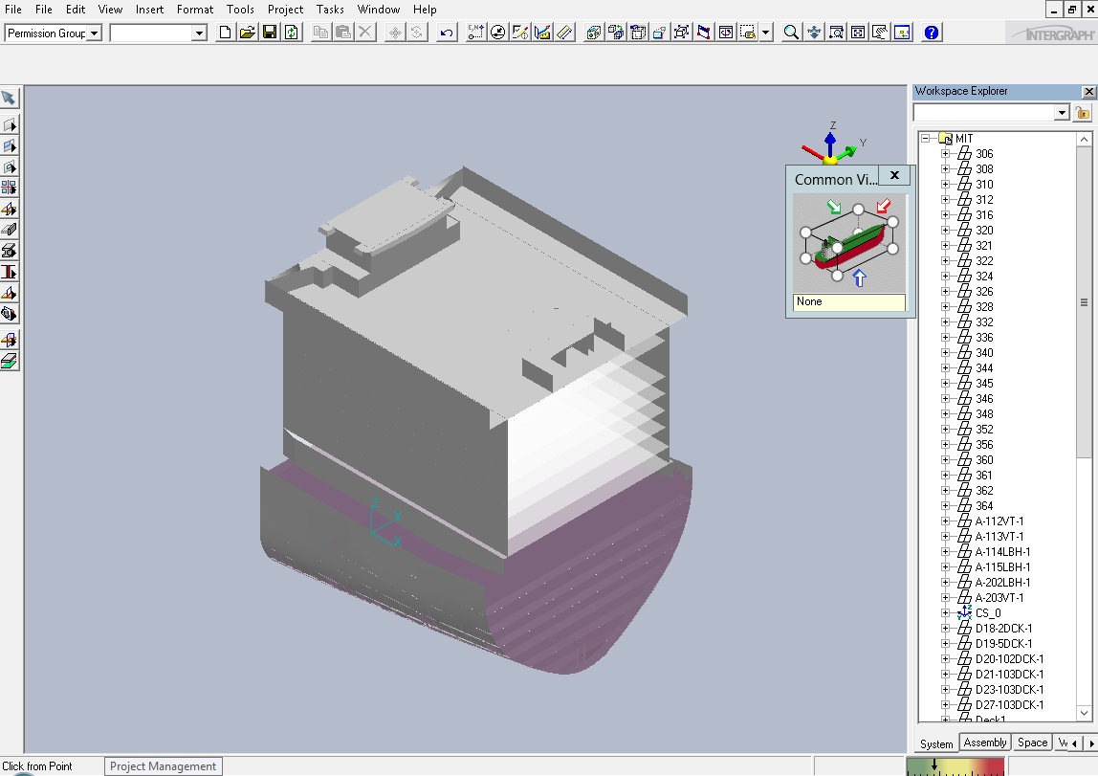
Figure 1. Import of the reference 3D model within Intergraph Smart3D.
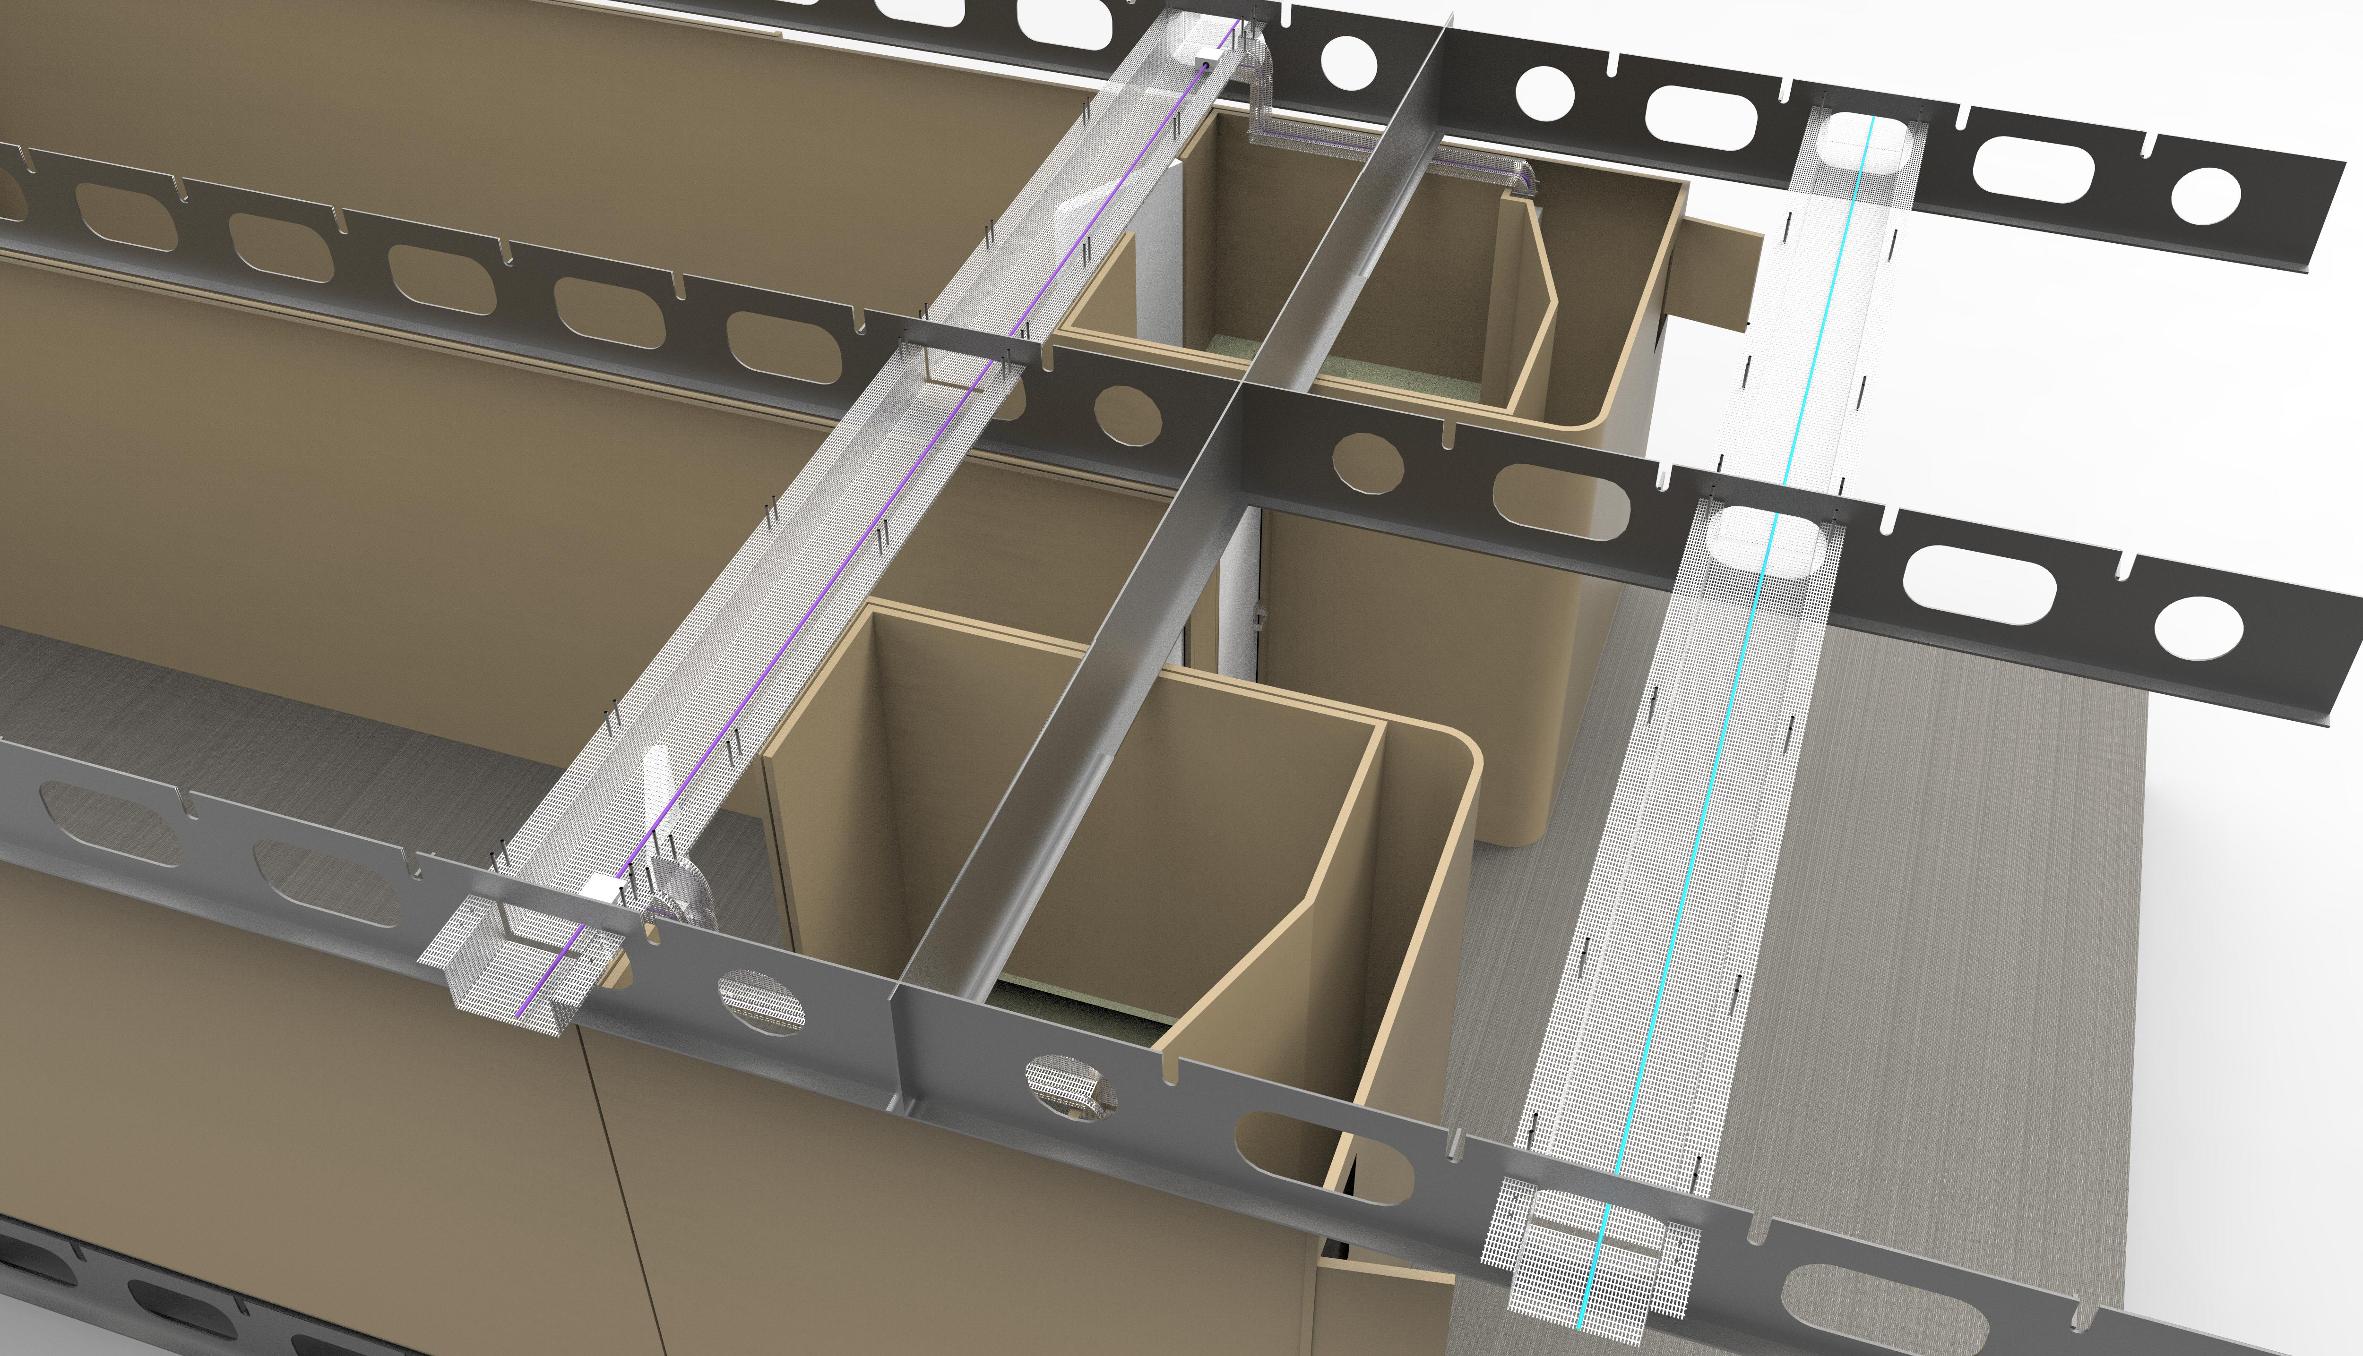  Figure 2. Detailed render of structures and cableways. | 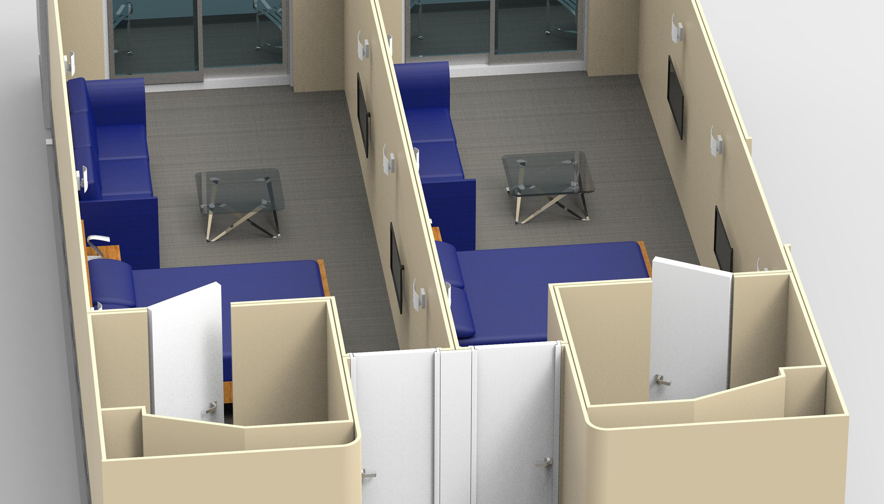  Figure 3. Detailed render of furniture of a cabin.

The Electrical Distribution Redesign
The present Section is aimed at discussing a possible redesign for the electrical distribution system installed on large All Electric Ships (AESs). By starting from the conventional solution that is nowadays employed on cruise vessels (i.e. Medium Voltage AC distribution), different alternatives based on DC technology will be presented in the next Subsections. Particularly, such a redesign process will be focused on the main substation whose present functionality (step-down voltage transformation) will evolve thanks to the MVAC/MVDC hybrid concept. In this regard, several solutions based on power electronics will be conveniently adopted for interfacing the main MVAC switchboard (generators side) and the MVDC electrical distribution (loads side). By starting from the case A, which represents the conventional onboard distribution, in this Section seven possibilities (from case B to case H) will be designed for optimizing the volume/weight of the main substation. By taking into account these two paramount indices, first comparisons about the different redesign options will be discussed in Section 4, whereas the pros offered by the innovative distribution systems will be quantified in Section 5.

MVAC conventional distribution
The conventional distribution of a large AES is depicted in Fig. 4 and marked by letter A. Particularly, the main substation of each MVZ is based on a three winding transformer (690 V and 230 V are the line-line voltages at the secondary) and two standard transformers (690/120 V and 690/230 V are the transformation ratios). The latter is installed for redundancy matter. Each transformer is characterized by a tag (e.g. FZ/003TFB), which is useful for recovering the datasheets from Fincantieri shipyard, then important information like size, volume and weight (Subsection 4.4) can be retrieved. These parameters act as references in the distributions comparison (Sec. 5).
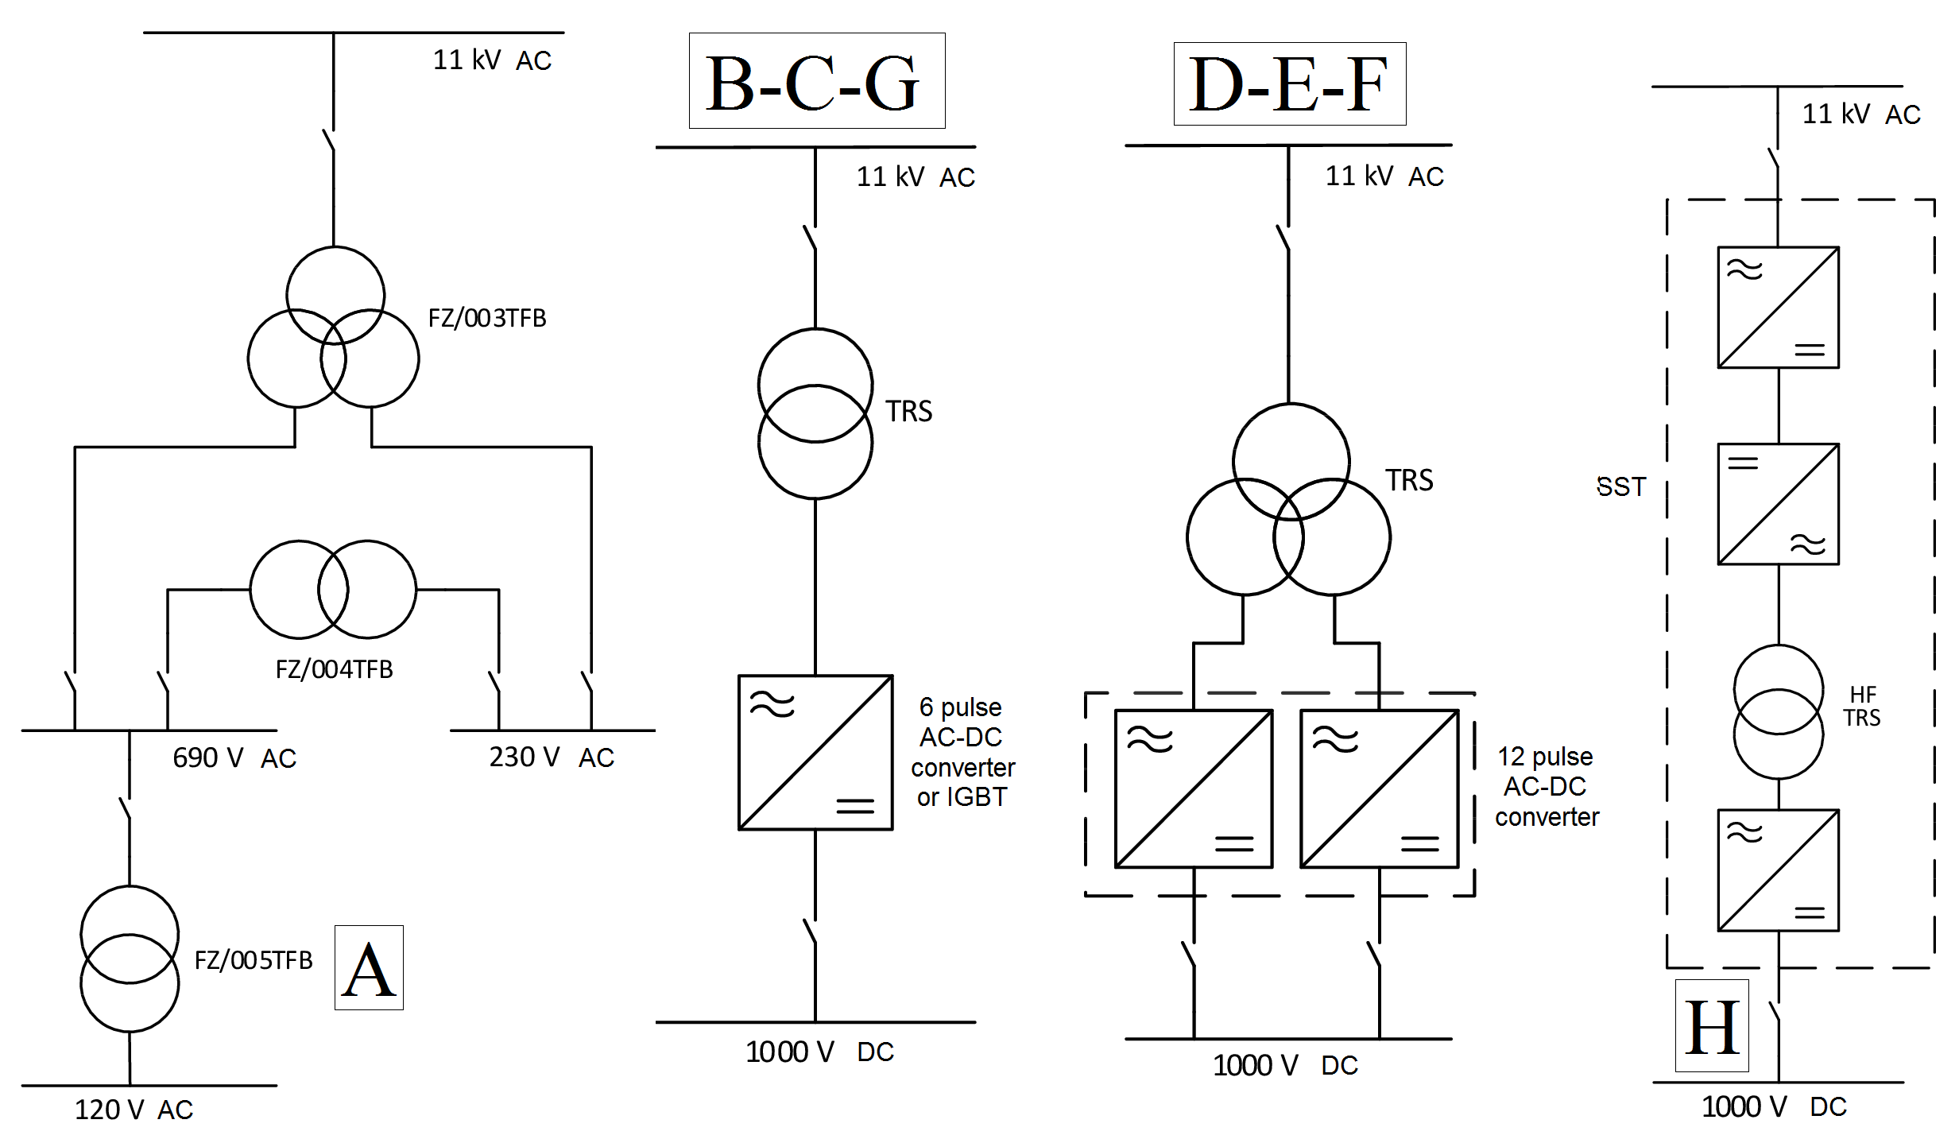
Figure 4. Shipboard electrical distribution: MVZ substation (deck 4).

MVAC/MVDC hybrid distributions
The hybrid distribution (middle of Fig. 4) interfaces the MVAC voltage input from generators switchboard (11 kV) and the MVDC supply of loads (1000 V). Particularly, B and C are standard solutions available on the market for providing the AC-DC conversion stage (i.e. step-down AC transformer + 6 pulse AC-DC converter). Instead, D, E and F are three commercial options for solving the power quality issues of B and C arrangements. Actually, star-delta secondary on the three winding transformers allow to implement the 12 pulse AC-DC conversion for limiting the harmonic distortion on currents, thus avoiding the use of large filtering stages. Also the solution G is capable of enhancing the power quality, being the AC-DC converter endowed with controllable IGBT switches. The six alternatives of Subs. 4.2 are completely based on commercial devices, whose datasheets may be analyzed for determining the main dimensional data.

SST-based distribution
The final arrangement (letter H) is the one given by the Solid State Transformer (SST), obtained by cascading four components for making available the 1000 V DC distribution: AC-DC converter, DC-AC inverter, High Frequency transformer, and final rectifier. At present, the SST is not yet commercialized therefore its sizing will be determined by rearranging some recent scientific results published on [6]. Although such sizing is therefore approximated, it may constitute a valuable benchmark for valuing the overall bulkiness.
Table 1. Main components for the electrical distribution: sizing of the 8 solutions.
S | Component | P [MW] | N_{C} [·] | N_{FC} [·] | N_{F} [·] | L_{F} [m] | W_{F} [m] | H_{F} [m] | V_{F} [m³] | WE_{F} [ton]
A | Tr. 11/0.69/0.23 kV | 2.35 | 1 | 1 | 1 | 2.90 | 1.36 | 1.83 | 7.22 | 5.24
 | Tr. 690/230 V | 0.60 | 1 | 1 | 1 | 1.80 | 0.91 | 1.48 | 2.42 | 1.97
 | Tr. 690/120 V | 0.16 | 1 | 1 | 1 | 1.11 | 0.65 | 1.12 | 0.81 | 0.62
B | Tr. 12/1.1 kV | 2.50 | 1 | 1 | 1 | 1.79 | 1.30 | 2.25 | 5.24 | 4.70
 | 6 p. AC-DC conv. | 2.50 | 1 | 1 | 1 | 0.56 | 0.56 | 1.23 | 0.39 | 0.15
C | Tr. 12/1.1 kV | 2.50 | 1 | 1 | 1 | 1.79 | 1.30 | 2.25 | 5.24 | 4.70
 | 6 p. AC-DC conv. | 0.80 | 3 | 1 | 3 | 0.28 | 0.49 | 0.78 | 0.11 | 0.07
D | Tr. 11/0.69/0.40 kV | 2.35 | 1 | 1 | 1 | 2.90 | 1.36 | 1.83 | 7.22 | 5.24
 | 12 p. AC-DC conv. | 1.50 | 2 | 1 | 2 | 0.49 | 0.42 | 1.31 | 0.27 | 0.1
E | Tr. 11/0.69/0.40 kV | 2.35 | 1 | 1 | 1 | 2.90 | 1.36 | 1.83 | 7.22 | 5.24
 | 12 p. AC-DC conv. | 2.52 | 1 | 4 | 4 | 0.24 | 0.58 | 1.40 | 0.20 | 0.18
F | Tr. 11/0.69/0.40 kV | 2.35 | 1 | 1 | 1 | 2.90 | 1.36 | 1.83 | 7.22 | 5.24
 | AC-DC conv. 12 p. | 0.90 | 3 | 2 | 6 | 0.17 | 0.42 | 1.17 | 0.08 | 0.08
G | Tr. 12/1.1 kV | 2.50 | 1 | 1 | 1 | 1.79 | 1.30 | 2.25 | 5.24 | 4.70
 | AC-DC conv.IGBT | 2.50 | 1 | 4 | 4 | 0.24 | 0.58 | 1.40 | 0.20 | 0.12
H | SST | 2.20 | 1 | 3 | 3 | 0.95 | 0.64 | 2.22 | 1.35 | 1.03

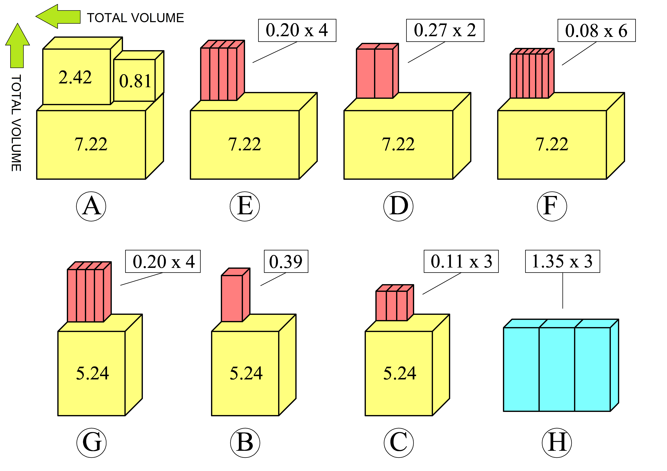
Figure 5. Main components for the electrical distribution: 3D representation of the 8 solutions (yellow: AC transformers, purple: AC-DC power electronics, cyan: SST, number: frame volume).

Sizing
By observing Table 1, the electrical power distribution for the 8 solutions S is achieved thanks to the employment of several components, i.e. AC transformers and AC-DC/SST power electronics devices. For the different options, such components are to be combined and sized for guaranteeing the power distribution of approximately 2.5 MW to the load side. In this regard, the column P represents the power of each single frame constituting the distribution option, while the system composition is explained from col. 4 to col. 6 (i.e. N_{C} components number, N_{FC} number of frame per component, N_{F} frames number). The physical dimensions of each frame is shown in cols. 7-9, where L_{F}, W_{F} and H_{F} are respectively frame length/width/height. Finally, the total frame volume V_{F} is given as L_{F} x W_{F} x H_{F}, whereas the datasheets can be consulted for the total frame weight WE_{F}. In this regard, H solution is the only one highlighted in Table 1 by green color for showing that its data are not commercially available but defined by interpolation of scientific results [6]. Once defined the size of each frame constituting the 8 solutions, the 3D representation of Fig. 5 can provide a first visual evaluation about the different distribution alternatives. As a matter of fact, the standard AC distribution (A) is the bulkiest while the SST (H) the smallest: the market-based hybrid solutions (from B to G) are clearly in the middle.

The Electrical Distribution Solutions: Volume/Weight Comparison
By summing the volume/weight of each frame forming the singular solution, the 8 electrical distribution systems are compared in Table 2 taking into account total volume V_{T} and total weight WE_{T}. This comparison is achieved by neglecting cables/switchboards/filters, thus focusing the target on the only interfacing components. The results of Table 2 can be depicted in two graphs (Figs. 6-7), where the contrast among the solutions is made evident. Particularly, the bulkiest/heavier arrangement (A) is taken as a yardstick for appreciating the reduction achievable with hybrid solutions (from B to G) and SST (H). Albeit the advantages of SST are outstanding (about -60% both in volume and in weight), also more feasible solutions (e.g. solution C) are capable of providing important volume/weight saving (-46% in V_{T} and -38% in WE_{T}).

Table 2. Comparison among the 8 solutions for the electrical distribution: total volume/weight.
 | A | B | C | D | E | F | G | H
V_{T} [m³] | 10.45 | 5.63 | 5.57 | 7.76 | 8.02 | 7.70 | 6.04 | 4.05
WE_{T} [ton] | 7.83 | 4.85 | 4.91 | 5.44 | 5.96 | 5.72 | 5.18 | 3.09

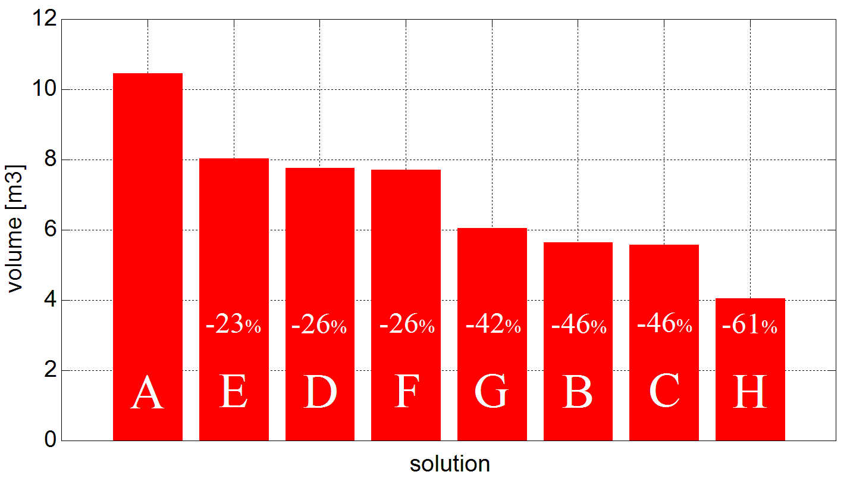
Figure 6. Volume of the 8 electrical distributions.

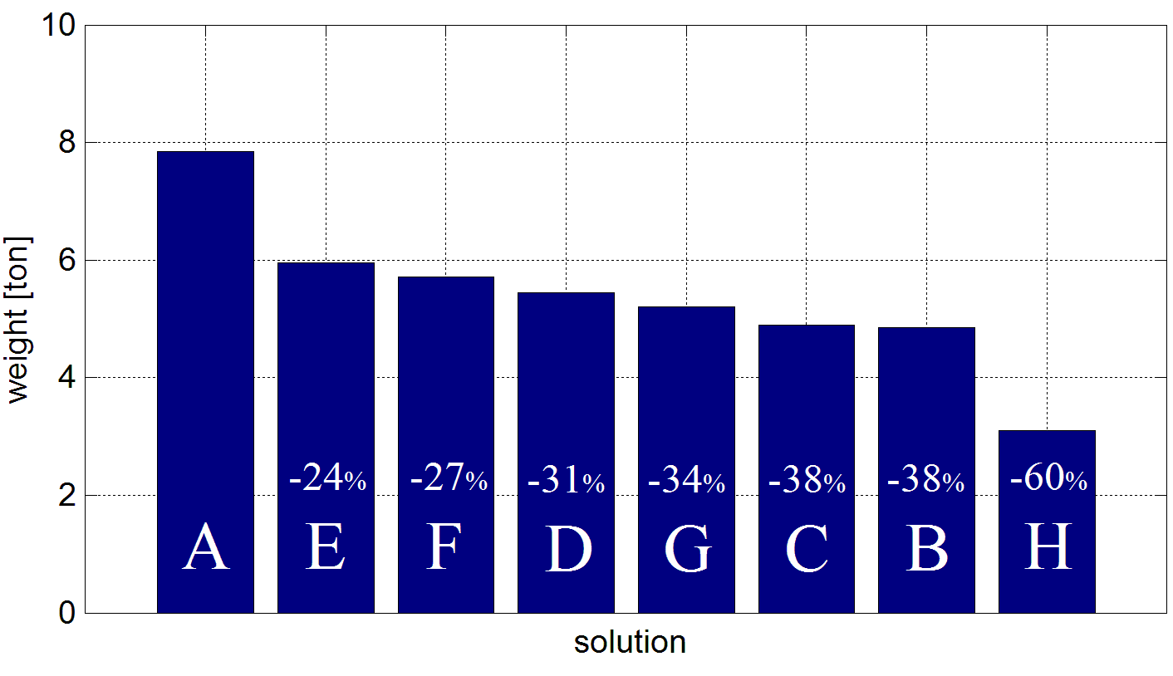
Figure 7. Weight of the 8 electrical distributions.

Conclusions
The advantages offered by applying the Integrated Ship Design methodology to the study of the electrical distribution system installed on large All Electric Ships have been highlighted in this paper. In particular, through the usage of CSI software, it has been possible to compare different solutions in terms of volume/weight since the early-stage design, in order to identify the best configuration for the purpose.
Acknowledgments
This study is part of Project “Leadership Tecnologica”, a Research and Innovation project coordinated by Fincantieri S.p.A. with the participation of the National Research Council (CNR) and the University of Trieste; the project receives grants from the Italian Ministry of Infrastructures and Transport (MIT).

References
- A. Vicenzutti, V. Bucci, G. Sulligoi and R. Pelaschiar, "Impact of Safe Return to Port rules on passenger ships power systems design," 2016 AEIT International Annual Conference (AEIT), Capri, 2016, pp. 1-7.
- V. Bucci, A. Marinò, D. Bosich and G. Sulligoi, "Inland Waterway Gas-Fueled Vessels: CASM-Based Electrification of a Pushboat for the European Network," in IEEE Transactions on Transportation Electrification, vol. 2, no. 4, pp. 607-617, Dec. 2016.
- D. Bosich, V. Bucci, U. la Monaca, A. Marinò, G. Sulligoi, A. Vicenzutti and G. Lipardi, "Early-stage design of integrated power and energy systems for naval vessels electrification: Advanced modeling using CSI," 2017 IEEE Transportation Electrification Conference and Expo (ITEC), Chicago, IL, 2017, pp. 387-392.
- A. Vicenzutti, U. la Monaca, D. Bosich, V. Bucci, A. Marinò, G. Sulligoi and R. Pelaschiar, "Early-stage design of shipboard integrated power systems: CSI-based multiple solutions comparison", 2017 IEEE Electric Ship Technologies Symposium (ESTS), Arlington, VA, 2017, pp. 478-485.
- J. Evans, "Basic Design Concepts", Naval Engineers Journal, vol. 71 issue 4, pp. 671.678, Nov. 1959.
- J. E. Huber and J. W. Kolar, "Volume/weight/cost comparison of a 1MVA 10 kV/400 V solid-state against a conventional low-frequency distribution transformer", 2014 IEEE Energy Conversion Congress and Exposition (ECCE), Pittsburgh, PA, 2014, pp. 4545-4552.

Daniele Bosich, Dept. of Engineering and Architecture, University of Trieste, Trieste, Italy; E-mail: dbosich@units.it.

