Fuel cells and shipping emissions mitigation
Rodolfo TACCANI ^{a,}, Federico USTOLIN ª, Nicola ZULIANI ª,
Paolo PINAMONTI ª, Andrea PIETRA^{b}
ª University of Trieste, Engineering and Architecture Department, Via Valerio, 10 - 34127, Trieste, Italy
^{b}Fincantieri S.p.a.

taccani@units.it
Abstract. Data analysis of vessels routes show that shipping is responsible of about 2,6% of world CO₂e (carbon dioxide equivalent) emissions. The effect on environment is increased as most of the emissions are concentrated in coastal areas. IMO and other bodies are making growing efforts to impose severe limits on shipping pollutions. Different technical and operational improvements have been made but hydrogen and fuel cells remain one of the best candidates to substantially reduce emissions and fuel consumption. This paper gives an updated review of the fuel cells applications in the marine sector and analyses the potential of different fuel cells technology for the on board installation. The analysis shows the advantages that fuel cells can give in terms of emissions reductions and fuel saving. The benefits are dependent on the type of ship and the operating profiles. Nevertheless, even if some fuel cells types are today ready for marine application, costs, hydrogen availability and certifications issues still hamper the full exploitation of the technology. Keywords. LNG, Fuel Cells

Introduction
Protecting the ocean environment and encouraging the development of the maritime trafﬁc is an important challenge for the maritime industry. Currently, most of the world maritime traffic consists of vessels whose engines are fed by Heavy Fuel Oil (HFO). HFO is cost effective but contain high levels of asphalt, carbon residues, sulphur and metallic compounds, as well as having properties of high viscosity and low volatility. Due to these characteristics, during the burning process in marine diesel engines, these fuels can produce signiﬁcant amounts of air pollutants such as nitrogen oxides (NO_{X}), sulphur oxides (SO_{X}), carbon monoxide (CO) and carbon dioxide (CO₂). For ships, emissions rules are imposed by the International Maritime Organization (IMO) that, in particular through the MARPOL Annex VI, sets limits on NO_{X} and SO_{X} emissions from ship exhausts, and prohibits deliberate emissions of ozone depleting substances. Both IMO and the European Union (EU) recognise protected areas called Emission Control Areas (ECA) where emission limits are more stringent. To meet these emission requirements it is necessary to use more refined fuels or, if HFO is utilized, introduce expensive emissions reductions systems. A fuel that today is relatively cheap is Natural Gas (NG). While NG is widely used in gaseous form for industrial and domestic applications, in the maritime field the most promising solution is to use it as Liquified Natural Gas (LNG). In the last decade, LNG has been widely adopted as fuel in LNG carrier ships [1], where the boil off gas (BOG) produced inside the LNG tank is used in dual fuel diesel engine. In past years, attention to LNG for ships propulsion other than LNG carrier has been growing [2]: several related studies can be found in literature and some real applications have been implemented. For example in [3], [4] fundamentals, benefits and operational issues of adopting LNG as fuel for ship propulsion are discussed. Bunkering and infrastructure related issues are presented in [6], while ship and propulsion system design are discussed in [7], [8]. These papers highlight as the use of LNG stands out from other emission reduction solutions because it appears to be the most economically advantageous, and because emissions levels are still lower than those obtained with others emission reduction systems.
In addition to environmental and economic aspects, it is also interesting to observe that, if LNG is used as fuel for ships, new propulsion technologies could be considered. Among them, attention is growing for marine applications of fuel cells and several demonstration studies have been carried out. At the Engineering and Architecture Department of the University of Trieste, a research activity has been started with the aim of studying novel ship energy systems. This paper describes the environmental and economic benefits of using LNG respect to conventional heavy oil fuelled ships and discuss marine applications of fuel cells. In the first part of the paper, advantages and disadvantages of using LNG as fuel for ships are described and marine applications of fuel cells are reviewed. In the second part of the paper an LNG fuelled cruise ship, where BOG is exploited by means of a fuel cell system, is considered. System performance, in terms of emission and efficiency variation, are discussed.

LNG as fuel for shipping
Due to its chemical and combustion properties, the use of LNG allows a significant reduction of NO_{X}, SO_{X}, and also CO₂. In particular, compared to HFO, the use of LNG leads to the following emission advantages [2]:

- NO_{X} emissions are reduced by approximately 85%, thanks to the lean burn combustion process implemented in dual fuel internal combustion engines;
- SO_{X} emissions are almost completely eliminated as NG does not contain sulphur;
- particle matter production is very low;
- CO₂ emissions are reduced by 20-30%, due to the higher hydrogen content in the molecule respect to HFO/MDO.

An interesting comparison between emission reduction results obtained operating using heavy oil fuels and the use of LNG is described in [9] - [11]. A switch from HFO to LNG will solve simultaneously the SO_{X}, NO_{X} and PM problems and produce an important reduction of CO₂ at the same time. This means that expensive emission reduction systems, that must be used when operating with oil fuels, can be avoided. LNG is also cheaper than oil fuels therefore, ship operating costs can be lower. For these reasons, the use of natural gas can be considered as a way to bridge the gap between the use of current fuels and sustainable and renewable fuels such as hydrogen. From another point of view, some technical issues when using LNG have to be taken into account. In particular the Boill Off Gas (BOG) management has to be considered: indeed, the LNG can be stored in insulated tanks, however, heat flux from the surroundings will increase the temperature inside the tanks causing the liquid to evaporate and increase the tank pressure. To handle BOG production, different solution can be employed [12], amongst them, the use of fuel cell systems can be attractive as they do not require a high feed pressure and they can be less sensitive to fuel composition variation if compared to Internal Combustion Engine [ICE]. Moreover, the fuel efficiency can be higher than ICE.

Overview on LNG fuelled ships
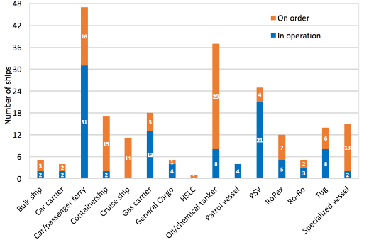  a) | 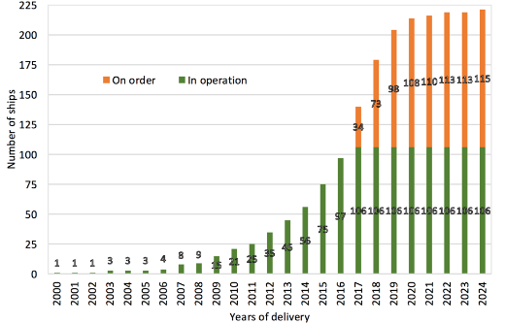  b)

Figure 1. a) LNG uptake by vessel segment as of May 2017 [16], b) trend of the LNG ships fuel from the 2000 to the 2024 [16].

LNG as fuel is used for different kind of vessels, for example car/passenger ferry, Power Supply Vessel (PSV), Patrol vessel, oil/chemical tanker, General Cargo, RoPax, RoRo, Tug, Gas carrier, Container ship and Bulk ship. As of May 2017 there were 106 LNG fuelled ships in operation worldwide and 115 confirmed LNG fuelled ships new builds [16]. Figure 1 a) shows the number of ships in operation and in order by different vessel segment as reported in [16]. LNG fuel is expected to be used especially by car/passenger ferry (47 total vessels), oil/chemical tanker (37 total vessels) segments and specialized vessels such as Icebreaker, High Speed RoPax, Dredger, Hopper Barge, Cable Layer, Heavy lift vessel, Reefer, Offshore installation ship, Emergency Response ship, Research ship. The cruise ships are a segment where there today there are not LNG ships in operation but 11 ships are in order. Figure 1 b) shows the trend of the LNG fuel ships growth, from 2000 to 2024 [16].

Fuel cells in marine applications: state of the art
Fuel cell is an electrochemical device that uses hydrogen and oxygen to produce electricity, with only water, and heat as its by-products. Fuel cells have some common characteristics with batteries even if they are intrinsically different, as the latter are storage devices and fuel cells are power producers which can operate, in theory, with no limits until fuel is supplied. Fuel cells can be categorized according to the type of electrolyte used. Changing electrolyte, the chemical reaction inside the fuel cells will be different.
Table 1. Main characteristic of fuel cells according to electrolyte used [17]
FC type | Relative cost | Sensitivity to fuel impurities | Operative temperature
AFC | Low | High | 80 – 100°C
PAFC | Medium | Medium | 80 – 200°C
MCFC | High | Low | 650 – 700°C
SOFC | High | Low | 500 – 1000°C
PEMFC | Low | High | 65 – 85°C
HTPEMFC | Medium | Medium | 140 – 200°C
DMFC | Medium | Medium | 50 – 120°C

Hence, the composition of the fuel and the products of the reaction will be not the same for each fuel cell type. The characteristics of each fuel cells type are listed in the Table 1. Alkaline Fuel Cell (AFC) has an electrolyte made of potassium hydroxide (KOH) and usually the catalysts are nickel and silver. Phosphoric Acid Fuel Cell (PAFC) has the electrolyte layer formed by phosphoric acid spread over a porous substrate, which works as a support, and catalysts are usually formed by platinum or platinum alloys dispersed on carbon. The Molten Carbonate Fuel Cell (MCFC) electrolyte is made of molten carbonate salt and a nickel catalyst. Solid Oxide Fuel Cell (SOFC) electrolyte is made of porous ceramic material (zirconia) and the catalysts are nickel, lanthanum, strontium and manganite. The Polymer Electrolyte Membrane Fuel Cell (PEMFC) electrolyte is made of polymer (often Nafion®) and the catalyst is platinum-based. In the case of High Temperature PEM Fuel Cell (HTPEMFC), the electrolyte can be phosphoric acid-doped polybenzimidazole (PBI-based) and the catalyst is always platinum-based. The Direct Methanol Fuel Cell (DMFC) electrolyte is made of polymer and the catalyst is platinum ruthenium [17]. Currently, the most widespread types of fuel cells are PEMFC and SOFC as they have demonstrate an appropriate operating life, although under certain operating condition, and high conversion efficiency. Nowadays, fuel cell market is considered a niche market however, fuel cell diffusion trend is positive. Figure 2 shows the global fuel cell shipments’ trend by MW by sector [23]. Regarding the marine sector, first fuel cells’ studies and applications started during the cold war period in the military field. The fuel cell’s diffusion involved also the civil marine sector, which now counts various installations in different types of ships, as reported in [17]. Fuel cells on board ships can be used for the following purposes:
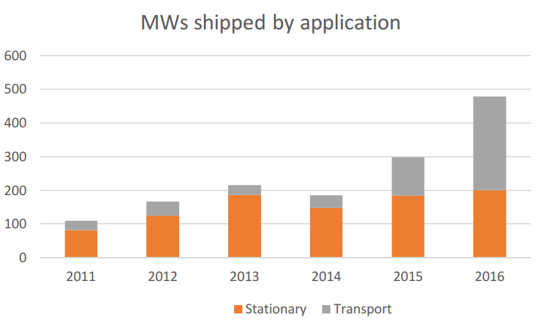
Figure 2. Fuel cell power shipped by application [23]
- as APU - Auxiliary Power Unit - as a generation system for on-board auxiliary systems. To be used especially in certain operating conditions, such as, for example, when the ship is at berth or in port or the when the ship sail through emission controlled areas;
- as main power plant for the propulsion system.

To date, a number of demonstration and theoretical projects have been implemented also in the civil maritime field. Most of them are small recreational or fluvial ship applications where FC partially or completely replace the main generator. Regarding the application of fuel cells on large ships, the number of applications and projects is lower, although in the last few years several activities have been planned, in particular for the use of fuel cells as APU systems. Table 2 shows the most important projects, already implemented or currently underway, which include a fuel cell on board of a ship. Regarding cruise ships, it is important to observe that Royal Caribbean has recently announced that it will put into service, for the year 2022 and the year 2024, two new "Icon" class cruise ships with a fuel cell-based generation system on board fed by LNG. Royal Caribbean plans to preliminary test the use of the cells on board of "Oasis" class ship since this year. Currently, information on which fuel cell type will be used aboard is limited.

Table 2. Selection of marine FC projects, already implemented or currently underway.
Project | FC type | FC size | Fuel | Ship type
U212 submarines | PEMFC | 9x30-40kW  2x 120kW | Hydrogen | Navy submarine
U214 submarines | PEMFC | 2x 120kW | Hydrogen | Navy submarine
FellowSHIP  Viking Lady | MCFC | 320 kW | LNG | SV
METHAPU  Undine | SOFC | 20 kW | Methanol | Car Carrier
Ships –Pa-X-ell,  MS MARIELLA | HT-PEMFC | 2x 30 kW | Methanol | Cruise-ferry
Ships – SchIBZ,  MS Forester | SOFC | 100 kW | Diesel | General Cargo
ZemShip  Alsterwasser | PEMFC | 96 kW | Hydrogen | Small passenger boat
Nemo H2 | PEMFC | 60 kW | Hydrogen | Small passenger boat
MC-WAP | MCFC | 150 kW | Diesel | Passenger ship
Hornnblower Hybrid | PEMFC | 32 kW | Hydrogen | Ferry
Hydrogenesis | PEMFC | 12 kW | Hydrogen | Small passenger boat
MF Vågen | HT-PEMFC | 12 kW | Hydrogen | Small passenger boat
Sandia’s Maritime  Cell Generator  Project | PEMFC | 100 kW | Hydrogen | Barge
UV Urashima | PEMFC | 4 kW | Hydrogen | AUV
HUGIN 3000 | alkaline Al/HP  battery-fuel cell | 1.2 kW | HP hydrogen - peroxide | AUV

BOG exploitation by means of a fuel cell on a LNG fuelled cruise ship
In this paragraph, the installation of a fuel cell on a cruise ship is considered. A simulation model is used to evaluate the effect, in terms of efficiency and pollutant emission variation, of the fuel cell implementation into a conventional ICE (Internal Combustion Engine) plant layout. It has been assumed that the fuel cell is fed only by the BOG produced in the LNG tanks. The considered ship is a cruise ship with a gross tonnage of 140,000 tsl (about 3600 passengers and 1300 crew members). The operating profile considered, that is the level of the power required in the different operating phases, is described in Figure 3. According to [4], for the considered operating profile a BOG production of 1,6 MW (considering C-type LNG tank) has been taken into account.

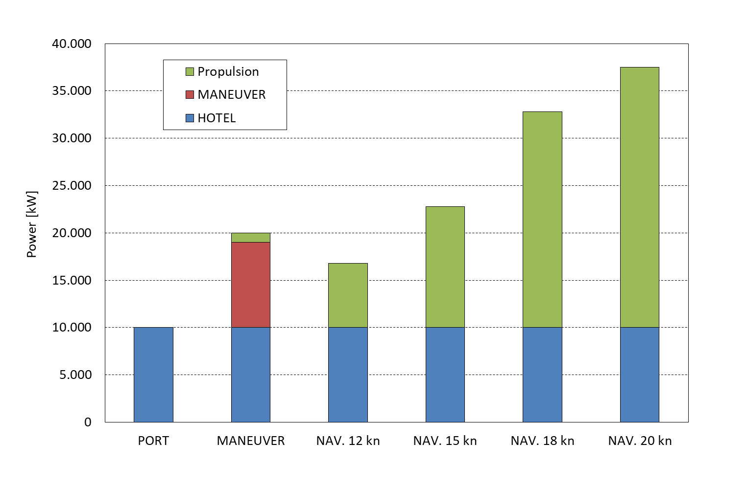
Figure 3. Ship operative profile considered

Fuel cell system assumption
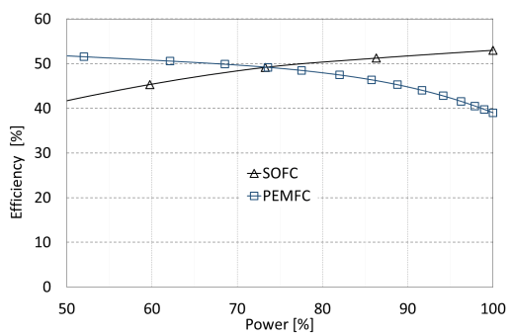  a) | 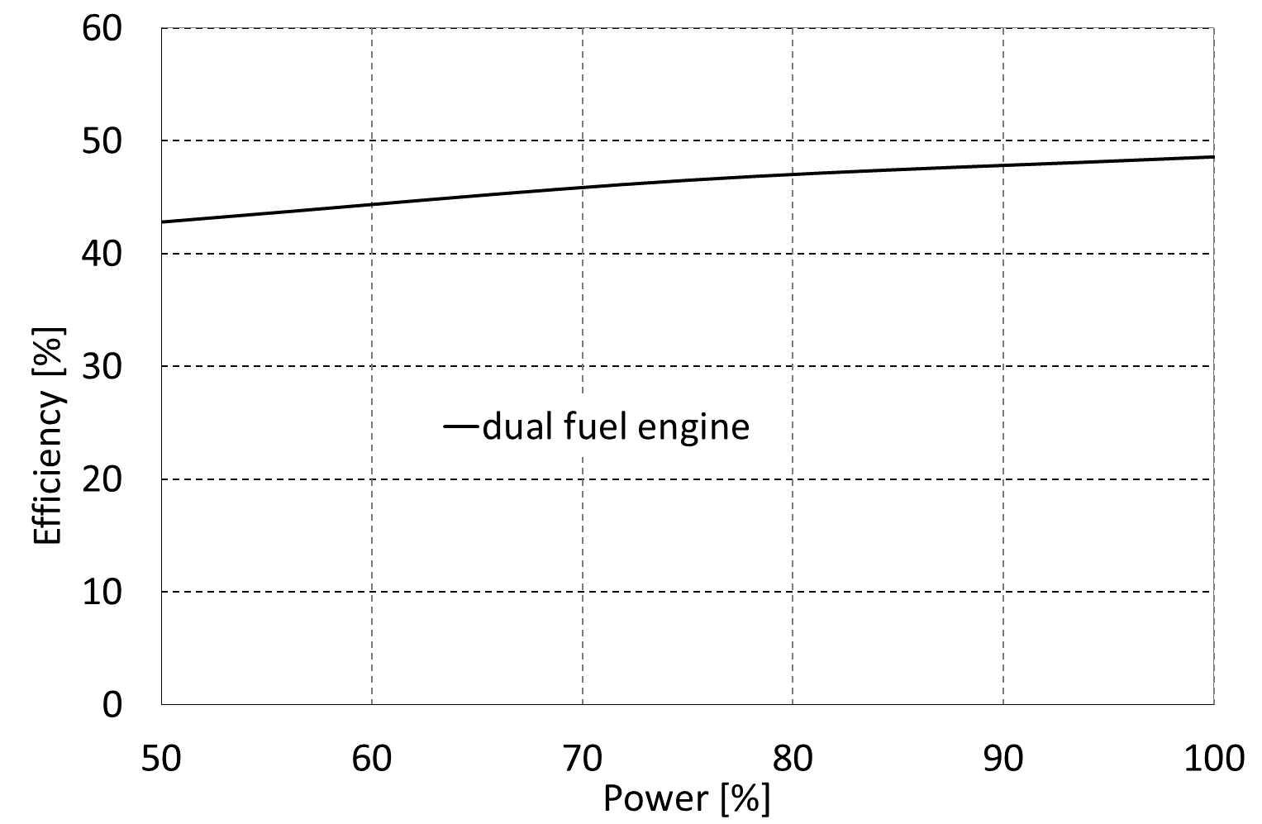  b)
Figure 4. Effect of load on efficiency for the considered power plants: a) PEMFC and SOFC and b) duel fuel ICE engine.

The model can calculate the performance of two fuel cell types based systems: PEMFC and SOFC. In both cases the fuel cells are used for exploiting the BOG and reduce the main ICE load. Results from the simulation are compared with a reference plant that consist of a LNG fed ICE. Figure 4 shows a) PEMFC [18], SOFC and b) dual fuel ICE [22] efficiency variation with load considered in the model. For the SOFC, fuel cell efficiency variation has been elaborated from data in [19] and [20]. For the PEMFC system, a fuel processor is also taken into account in order to convert the BOG into a hydrogen rich gas. The fuel processor is considered to have a constant conversion efficiency of 78% [21].

Results
Table 3. Efficiency and CO₂ emission variation for the considered cases
 | Reference case (ICE) | PEMFC | SOFC
Efficiency | 46,22% | 45,88% | 46,69%
CO₂ emissions | 100% | 101% | 99%

Table 3 shows the overall plant efficiencies for the LNG ICE (reference case), PEMFC and SOFC system case. The implementation of a PEM fuel cell system decreases the overall efficiency of about 0,5%. This is mainly due to the PEMFC fuel processor used for converting the BOG in hydrogen that affects the overall system efficiency. A possible method to mitigate the effect of the fuel processor on efficiency is changing the system design by increasing the PEMFC size, thus operating the fuel cell at higher efficiencies.
The implementation of the SOFC increase the overall efficiency to 46,69%. This is due to the high SOFC system conversion efficiency (53% at 100% load).
Regarding pollutant emissions, CO₂ emissions are associated to the carbon content in the fuel and, therefore, to the fuel consumption. For this reason, referring to Table 3, for the PEMFC based plant, CO₂ emission is higher, while is lower for SOFC.

Conclusions
In past years, attention to LNG for ships propulsion other than LNG carrier has been growing. The utilization of natural gas paves the road to the utilization of fuel cells aboard, high efficiency power plants where combustion is not necessary and, therefore, lower emissions are expected. In particular, the implementation of fuel cells on LNG fueled ships can allow for exploiting the BOG produced in the LNG tanks while reducing fuel consumption and pollutant emissions. However, it has been observed that, when PEMFC are considered, the fuel processor is responsible for significant efficiency loss and that the overall plant efficiency is lower if compared to a conventional ICE based plant. From this point of view, the utilization of the heat that can be recovered from the PEMFC is essential for decrease fuel consumption. In contrast, SOFC based systems show higher conversion efficiencies and allows to reduce pollutant emissions.

References
- B. Curt, “Marine Transportation of LNG”, presentation at the Intertanko Conference, March 29, 2004.
- Web journal article: “LNG-Powered Cruise Ships Lead the Way”, visited on 15.02.2018, available at: https://www.maritime-executive.com/article/lng-powered-cruise-ships-lead-the-way#gs.ZjracN4
- A. B. Smith, “Gas Fuelled Ships: Fundamentals, Benefits Classification & Operational Issues, proceedings of the first gas fuelled ships conference, Hamburg, Germany, 2010.
- F. Burel, R. Taccani, N. Zuliani . Improving sustainability of maritime transport through utilization of Liquefied Natural Gas (LNG) for propulsion. In: Proceedings of the 25th ECOS 2012 Conference. PERUGIA, ITALY, JUNE 26-29, 2012.
- F. Burel, R. Taccani, N. Zuliani, “ Improving sustainability of maritime transport through utilization of Liquefied Natural Gas (LNG) for propulsion”, Energy, issue 57(2013), p. 412-420.
- B. Scholz, G. Würsig, “Bunkering of LNG Fuelled Vessel Technical Challenges and Perspectives”, proceedings of the first gas fuelled ships conference, Hamburg, Germany, 2010.
- I. B. Flusund, I. Hildebrand, “Vessels Propelled by Gas Engines Driving Controllable Pitch Propellers Through Mechanical Transmission”, proceedings of the first gas fuelled ships conference, Hamburg, Germany, 2010.
- O. Levander, “Turning the Page in Ship Propulsion by Switching to LNG”, technical presentation at the Gas as Fuel for Propulsion of Ships: Status and Perspectives Conference, March 2008, Copenhagen, Denmark.
- J. Cofala, M. Amann, C. Heyes, et all. “Analysis of Policy Measures to Reduce Ship Emissions in the Context of the Revision of the National Emissions Ceilings Directive”, report submitted to the European Commission, DG Environment, Unit ENV/C1, 2007.
- IMO, “Amendments to the Annex of the Protocol of 1997 to Amend the International Convention for the Prevention of Pollution from Ships, 1973, as Modified by the Protocol of 1978 Relating thereto (Revised MARPOL Annex VI)”, Resolution MEPC.176(58), 10 October 2008.
- A.H. de Ruiter, “Sailing for Cleaner Skies. Study of LNG Fuel for Sea Vessels in Rotterdam”, master thesis in transport infrastructure and logistics, Delft University of Technology, 2008.
- American Bureau of Shipping (ABS) echnical guide: “Guide for propulsion and auxiliary systems for gas fueled ships.” Accessed in data 07/01/2018, available online from: https://preview.eagle.org/eagleExternalPortalWEB/ShowProperty/BEA%20Repository/Rules&Guides/Current/181_GasFueledShips/Guide
- G. G. Dimopoulos, C. A. Frangopoulos “A Dynamic Model for Liquified Natural Gas Evaporation During Marine Transportation”, International Journal of Thermodynamics, Vol. 3, pp.123-131, 2008.
- Y. Calogeras, “Gaseous Fuels for Propulsion, Rules, Key Safety Considerations & Main Challenges”, proceedings of the first gas fuelled ships conference, Hamburg, Germany, 2010.
- DNV GL, “Highlights Projects in the LNG as Fuel History”, Report, 2015.
- DNV GL, “LNGi status update”, Report, 2017.
- DNV GL, “Study on the use of Fuel Cells in Shipping”, European Maritime Safety Agency (EMSA), Report, 2017.
- Hydrogenics HY-PM 180 power module technical data, accessed in data 02/02/2018, available online from: http://s2e9ea1389dbb387e.jimcontent.com/download/version/1358833091/module/6482047058/name/HyPM_HD180_one-pager_EN_A4_rev00.pdf
- Each Convion C50 power module technical data. Accessed in data 05/02/2018, available online from http://convion.fi/products/
- K. Sommer, E. Mesenhöller, REHVA Journal, “Practical experience with a fuel cell unit for Combined Heat and Power (CHP) generation on the building level”, October 2013. Available online from: http://www.rehva.eu/fileadmin/REHVA_Journal/REHVA_Journal_2013/RJ_issue_5/P.12/Sommer.pdf
- N. Zuliani, Ph.D thesis, Analisi teorica e sperimentale di sistemi di generazione elettrica basati su celle a combustibile polimeriche ad alta temperature, University of Udine, 2012.
- Wartsila 18V50DF dual fuel engine technical data. Accessed in data 05/02/2018, available online from: http://www.uspowerco.com/generator_attachments/8718-product_guide_o_e_w50df_2.pdf
- E4tech. (2016). The Fuel Cell Industry Review. E4tech.

Corresponding Author, Rodolfo Taccani, University of Trieste, Engineering and Architecture Department, Via Valerio, 10 – 34127, Trieste, Italy; E-mail: taccani@units.it.

