GASVESSEL - CNG sea transportation project
Loris COK^{a,}, Pierluigi BUSETTOª, Luca DE ZOTTIª, Silvia DORIGOª, Spartaco ANGELINI ª
ª Navalprogetti Srl
Abstract. The GASVESSEL project aims to prove the techno-economic feasibility of a new CNG transport concept enabled by a novel patented Pressure cylinder manufacturing technology and a new conceptual ship design including safe cargo handling. It introduces an innovative solution for manufacturing Pressure cylinder that are 70% lighter than state-of-the-art alternatives. These superlight Pressure cylinders enable new ship designs with much higher payloads and dramatically lower transportation costs per volume of gas. Where the exploitation of stranded gas is currently economically not viable, GASVESSEL brings a solution, as a cost-efficient and flexible CNG transport system that can unlock energy resources and decrease Europe's dependence on a single supplier by serving as a flexible interconnector, which enables energy to flow freely across the EU. The project supports the EU’s Maritime Transport Strategy in which maritime transport is considered key to securing Europe’s energy supply. The validation and proof of concept of the GASVESSEL project is performed by a cost-benefit analyses (financial viability), safety assessment, environmental impact analyses and value chain business cases development in relation to real-life geo-logistic scenarios. The project is carried on by 12 European Partners and coordinated by Navalprogetti.
Keywords. Gasvessel, Europe

INTRODUCTION
GASVESSEL project is fully supported and funded by EU H2020 program. Its scope is to proceed with all the necessary research actions intended to obtain the expected technological results, validation and approvals, as required, for safe and technologically advanced novel method for waterborne/land transportation and distribution of natural gas.
The successful results of the research will allow granting and integrating the energy supply chain to the European Union.
Removing barriers to cost-effective transport of stranded, associated and flared gas, as targeted by GASVESSEL, can unlock up to 5 times the amount of gas currently used in Europe from European sources. GASVESSEL will therefore rebalance European global energy security equations, reducing the dependency from external sources and contribute solving the important environmental issues in the global Oil & Gas exploitation.
The main ambition of the project is to develop and validate the suitable method for gas export to consumers, from stranded gas fields and for recovery of associated and flared gas, using economically viable solutions where traditional methods (LNG and pipeline) are less attractive in terms of return of investments, proper remuneration of gas supply chain and timewise. Gasvessel potential is to unlock and grant EU Energy re-balance up to at least 119 TCF of stranded gas from Europe only.
GASVESSEL project gathers independent well-known existing industrial technologies, which, for the first time, are put together and patented accordingly.
The containment system allows safe transportation of compressed natural gas at an operational pressure of 300 bar in gaseous state. The system avoids the necessity of liquefaction and regasification plants. The transported gas is directly injected into the existing onshore gas distribution net to users, after pressure reduction to 70-120 bar, according to the pressure standards of served Country.
The novel technology is based on very large dimensions cylinders made in composite materials, with thin internal liner in stainless steel wrapped externally with fiberglass and carbon fibers, as necessary to grant the required strength and fatigue resistance. Cylinders are arranged on board of specially designed new or converted ships. Ships will be fitted with appropriate loading/unloading facilities for offshore operations in order not to impair the safety of coastal population, ports activities or nearby shore infrastructures.
In addition GASVESSEL can ensure energy supply at a cost-effective level to the small consumers (i.e.: Mediterranean and Aegean Sea Islands) where other natural gas supply means will result economically impracticable.
Gasvessel research study is based on a deeply investigated background that shows that among a selected range of distances and gas quantities the waterborne transportation of CNG could be made at a competitive rate. See Figure 1 and Figure 2.
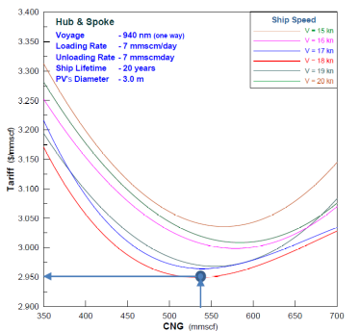
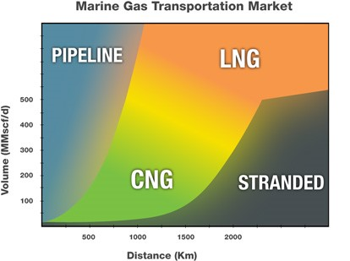
Figure 1. Additional CNG opportunities Figure 2. Transport cost CNG

STATE OF ART OF THE CONTAINMENT SYSTEMS
Today, pressure cylinders construction with a diameter of 2-3 m, 20-30 m in length and working pressure of 300 bars, are impracticable to be made out of steel or metal alloys because of heavy weight. This will make ship transportation uneconomic for low allowable gas payload.
The only solution is to build these cylinders with a composite technology.
Currently, no composite cylinders of this size in combination with high working pressure exist.
CYLINDER TYPE | Ratio Weight/ Capacity | Note
TYPE I Full metal | 1,1-0,9 | Excessive weight
TYPE II Only circumferentially reinforced | 0,9-0,75 | Excessive weight
TYPE III Inside metal liner and composite overwrapped | 0,75-0,55 | Existing technology
TYPE IV Full composite | 0,55-0,3 | Not Applicable for the required dimensions
TYPE III very thin metal liner (new technology) | 0,45-0,27 | GasVessel Project
Table 1. Cylinder types
According to the above Table 1, the type I and Type II technologies are not suitable because of an excessive weight compared to the transported gas. Type IV is not suitable for the required dimensions due to a lack of construction technology and for the limits of the operative temperature. The target of the Gasvessel project is to produce a Type III cylinder with a reduction of weight and costs compared to the existing technology.

THE INNOVATION
To date there is no metal liner produced in a single piece with an incomparable thin thickness. The only technology, which allows producing thin thickness, is the welded construction.
A process called “autofrettage” will treat the type III cylinder (Figure 3). This is a radial expansion, where a pressure application procedure strains the metal liner past its yield point sufficiently to cause permanent plastic deformation, and results in the liner having compressive stresses and the fibers having tensile stresses when at zero internal pressure.
If a safety factor of about 3 is adopted to the working pressure, the deformation reached at this pressure will be inevitably around 1%. This deformation level of the steel liner occurs already in the plastic phase with significant permanent deformation.
Clearly, this permanent deformation depends on the thickness of the external composite and thickness of the liner. It can be intuitively understood and mathematically proven, that, for the same thickness of the composite without using a safety coefficient the greater the deformation of the liner, the smaller the thickness of the liner is.
This means that after the autofrettage treatment of the tank, the compression of the liner is inversely proportional to its thickness. If compression becomes sufficiently high, it can work against the phenomenon of elastic instability (EULER phenomenon).
To prevent this (with the same geometry and material of the liner), the only solution is to extend the elastic range of the liner material before autofrettage. This procedure involves the hardening of the material and the increase of the field of elastic deformation of the liner before entering the plastic range, consequently reducing the degree of permanent plastic deformation and the compression amount of the composite.
In fact, it is known that for some types of metal materials the point of yield stress can be increased through cold working by stretching or deforming.
However, not all steel types are suitable for this treatment, because they become brittle and their fatigue behavior is drastically reduced. The only suitable steel types are the austenitic stainless steels and in particular the AISI 3xx group.
To obtain the degree of cold working necessary to the liner the hydroforming technology is used.
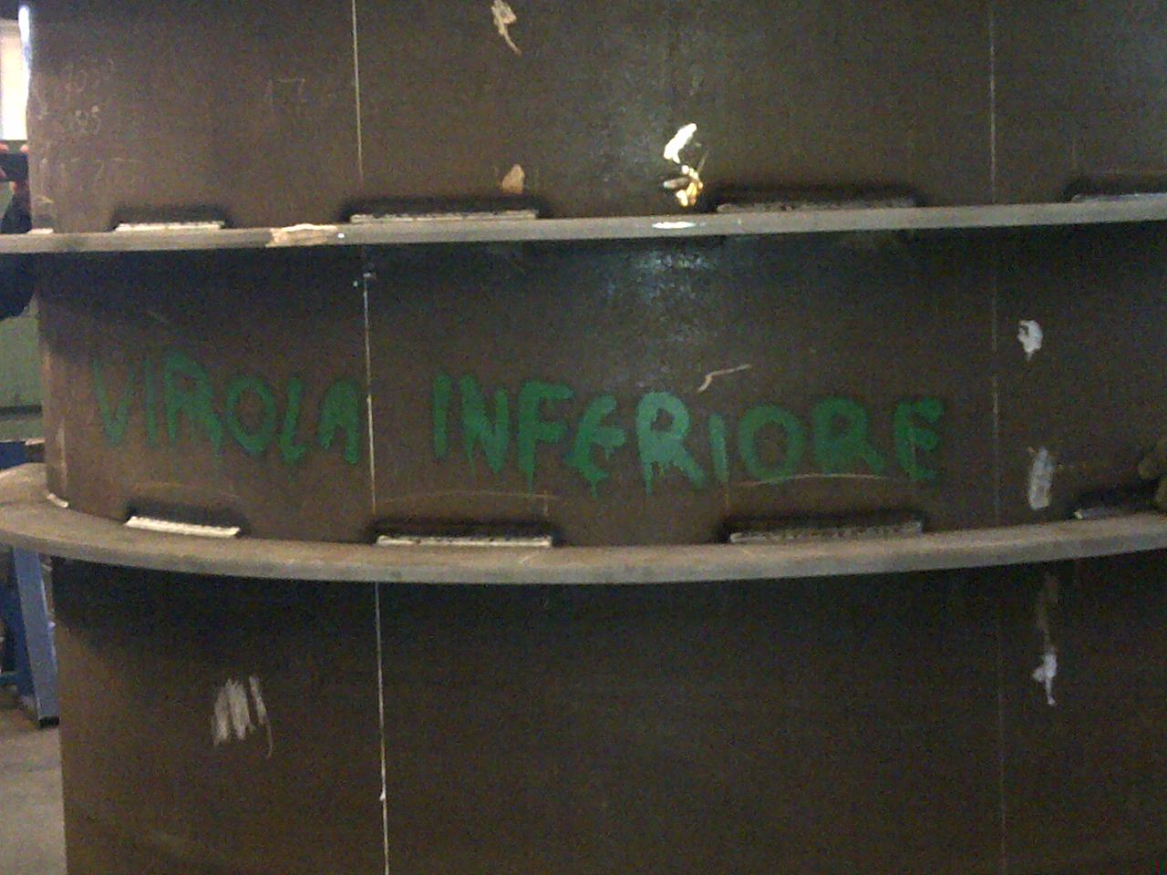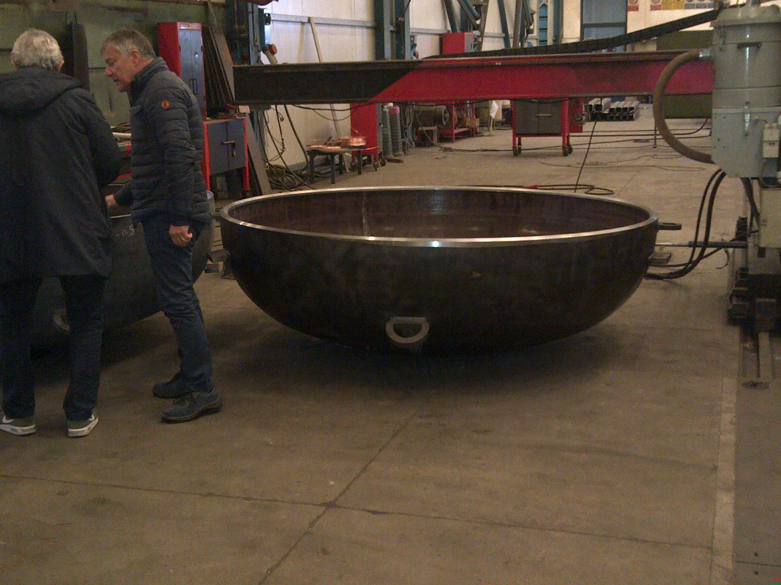
Figure 3. Hydroforming mold cylinder drawing on the background and the hydroforming mold cap on the right during the building phase.

A first liner with a smaller size than the final liner is inserted into an appropriate mold and afterwards, water with high pressure is pumped inside the molded liner, up to a pressure adequate to reach the yield stress and go beyond.
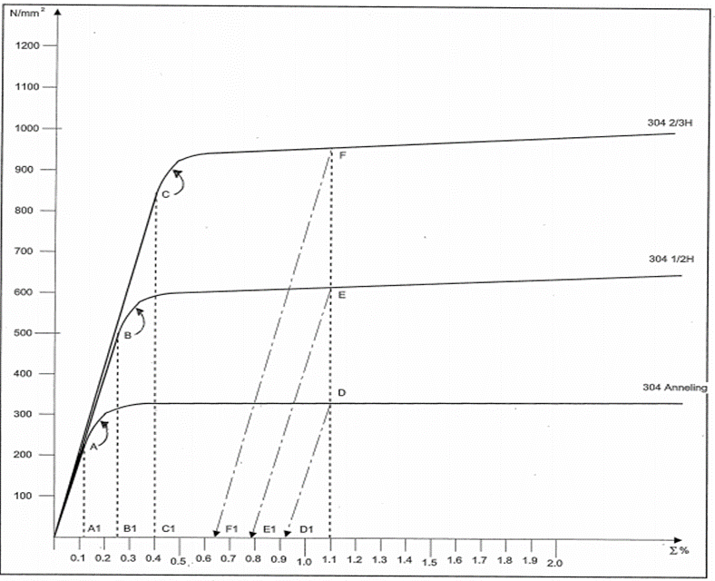
Figure 4. Graph σ-ε for different degrees of hardening of a steel AISI 304

The liner will deform, while stretching cold until it reaches the inner walls of the mold. This procedure allows increasing the elastic range of the material and decreasing the plastic range. We are always referring to the total deformation that the liner will reach further to the autofrettage pressure, after being wrapped with the composite material. This pressure must be higher than the hydrostatic test pressure.
As shown in Figure 4, the increase of the hardening stage of the material at same strain (result of autofrettage process) leads to a lower residual deformation.
The steel AISI 3xx group (in particular AISI 304) are very suitable to withstand large deformations without becoming brittle and increasing their mechanical properties massively, in particular the yield strength. Even after cold working with a thickness reduction of 20-30%, the elongation at break exceeds 15%. Even the performances to fatigue remain good or even better. Also during the hydroforming, all deformations induced by shrinkage from the welds are removed and flattened. This is very important because in the next phase of the winding it is essential that the geometry of the liner is as perfect as possible, to avoid buckling.
Summarizing the described technique for the construction of large liner combined with the use of a particular type of steel allows to optimize the thickness and weight of the liner with reduced costs, without compromising mechanical performance and reliability like fatigue strength, elastic stability and corrosion resistance.

CARGO CYLINDER
The cargo cylinders are of Type 3, made of an internal stainless steel AISI 304/304L liner (or other suitable type of austenitic stainless steel) warped with carbon/glass fibers in an epoxy resin matrix. In Figure 5, the first built liner is shown.
The average thickness of the liner is about 5mm in the cylindrical area and in the junction zone between the cylindrical zone and the domes. These cylinders have two necks, one for each dome.
The area of the neck is tapered gradually in a flange that is welded to the dome internally and externally as shown Figure 5. The cargo cylinders are arranged vertically on steel supports on double bottom deck. The supports are about 2.0 m high, and allow easy inspection and maintenance of the pipes and connections arranged below the pressure vessels. Each cargo cylinder is equipped with pressure and temperature sensors arranged at the top.
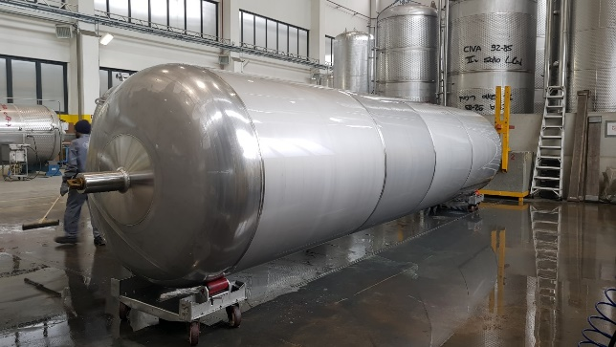
Figure 5. First liner built for hydroforming and testing (April 2018)

USED MATERIAL CHARACTERISTICS
The cargo cylinders are made of a metal core, in this specific case austenitic stainless steel AISI 304/304L (or other suitable steels of the austenitic family) reinforced externally by an appropriately arranged carbon fiber and/or glass composite, both in a circumferential and axial direction, impregnated with epoxy resin.
On cylinder completion, the thermal conductivity of the cylinder walls will be calculated and checked. The cycle tests will confirm the good adhesion between steel, liner and composite materials.

CARGO CYLINDER FABRICATION AND TESTING
Here below are concisely described the various stages of the manufacturing process to obtain the finished cylinder.
- Liner hydroformed in the mold.
- Winding of the liner with carbon / glass fiber impregnated with epoxy resin. The liner is inserted and suspended between a motor spindle and a tailstock. The liner gripping is made on both the necks. The wrapping machine has at least one winding head and 4 degrees of freedom. All motion axes are simultaneously interpolated via a programmable control unit (CND) that is controlled by a specially developed software. The winding machine allows wrapping the liner according to the angles required by the winding pattern.
- Curing: during the winding phase hot air is injected from one of the two necks and extracted from the other. The air is heated by means of electric heating elements and the temperature is controlled by an automatic system. In this way, we anticipate the gel time of the epoxy resin. After completely wrapped, the liner is brought to the curing and post curing station where it remains in slow rotation during all the first phase of curing, to prevent the resin drips along the walls of the cylinder.
- Autofrettage and Hydraulic test A pump with pressure booster is connected to the neck of the cylinder. An appropriate bleed circuit allows to extract any air trapped inside the cylinder. The pressure booster allows to reach pressures of autofrettage.
- Test &Certifications by batch: Cycling and Burst test will be performed.

SHIP’S DESIGN
According to the innovative cylinders, the marine transportation of gas in compressed form becomes economically competitive. The gas will be transported by a cargo containment system arranged in the cylindrical ship’s body (Figure 6).
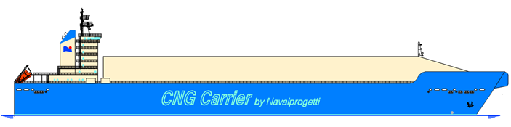
Figure 6. CNG Ship longitudinal view
Containment system is made of a number of Type 3 composite cylinders suitably grouped in the cargo holds. The remaining ship’s marine facilities (accommodation, marine systems, power generation, propulsion, etc.) will be superior with the traditional LNG ships design. The present concept is for the ship to load and unload at dedicated locations. Special care will be dedicated to collision and grounding studies (Figure 7). according to Class requirements. HAZID and HAZOP session will be performed in agreement with the Class and Risks individuated together to appropriate mitigation actions.
Preliminary cargo capacity of the ship is abt. 12M of Nm³ of gas.
The cargo tanks are arranged in segregated leak tight cargo holds. (Figure 8). The dimensions and number of cylinders included in a cargo hold shall be in accordance to the required ship size. The hold spaces will be segregated from the sea by a double bottom and longitudinal bulkheads forming side tanks. Suitable cofferdams will segregate the cargo holds from machinery spaces, accommodation spaces, service spaces and control stations.
There is no segregation between cargo tanks within each cargo hold. The cargo holds are nitrogen inerted to overpressure in order to avoid air access. All the necessary controls such as relief valves, burst discs hatches, etc. are provided to control the pressure in the cargo holds.
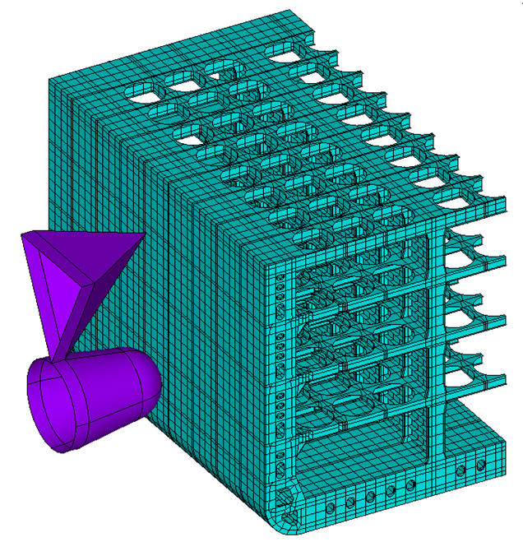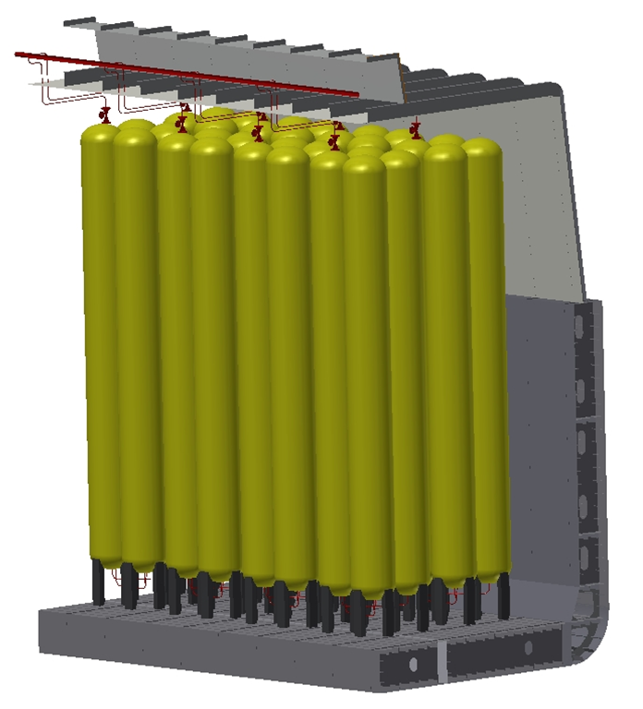
Figure 7. Ship’s Collision model Figure 8. Cargo hold 3D layout

PARTNERS
A Consortium of 13 European Partners from Italy, Slovenia, Germany, Cyprus, Greece and Belgium is engaged in GASVESSEL research project. All Partners have their tasks assigned as detailed in the Grant Agreement documentation, and are interconnected and coordinated by Navalprogetti in order to ensure the quality and the prompt issue of all deliverables.

CONCLUSIONS
The research activities outlined in this paper are intended to prove the techno-economic feasibility of the CNG transport concept, enabled by a novel patented pressure cylinder manufacturing technology and a new conceptual ship’s design. The project supports the European Commission’s Maritime Transport Strategy in which maritime transport is considered key to securing Europe’s energy supply. For additional information, please visit the website www.gasvessel.eu.

