Comparison of Marine Technologies for Mediterranean Offshore Gas Export

Giorgio TRINCAS
Department of Engineering and Naval Architecture, University of Trieste, Italy

Abstract. This paper aims at identifying the most viable marine technology to transport natural gas in a Mediterranean Sea scenario. Pipeline, LNG, SSLNG, and CNG solutions are put in competition. Techno-economic modelling of each technology is performed to evaluate corresponding capex and opex. To highlight which of the competitive transportation modes offers the minimum supply chain cost through a discounted cash flow model, estimations of the total cost of investment, shipping, and operation tariff were taken as primary attribute in the ranking process. Number of LNG, SSLNG and CNG ships are developed at conceptual design level and stored in databases which feed the optimal composition of fleets, also to compete with subsea pipeline projects whose main technical and cost parameters are available from different sources. Pipeline and LNG cost reductions are considered to make uniform comparison of these technologies with ready advances in CNG technology. The comparative results on the Zöhr-Brindisi route show that the CNG marine solution is economically the most advantageous transport mode provided lighter pressure vessels are fitted on CNG ships.
Keywords. Compressed natural gas, Fleet composition, Shipping tariff, Marine gas transportation, Concept design

Introduction
Natural gas has played and will play an increasing role in the supply of energy demand worldwide as a result of the increased consumptions and environmental requirements. Among the available hydrocarbons, natural gas is by far the most clean and environmentally friendly energy source that is believed to increase continuously in the next 30 years, with an estimated annual growth rate of 2.2% from 2015 to 2050. The total natural gas production in 2025 is projected to a total of 151 trillion cubic feet (tcf), nearly 70% higher than the 2001 total of 90 tcf [1].
Italian demand for energy is expected to consistently grow over the next decade, mainly driven by the services sector forecast at 118-124 Twh with respect to 110-115 TWh for the industrial sector. At the same time the energy offer shall be reshaped also because higher feed-in from renewables has to be postponed due to both technological and economic reasons.
According to the new national energy strategy (SEN) [2], Italy should increase the share of natural gas in the supply mix even though the natural gas market is experiencing “temporary oversupply” that could be reabsorbed by the mid-2020’s. There could be a gradual reduction of imports from the Netherlands, Norway and Algeria in spite of possible renegotiations of long-term contracts with Eni and Enel.
In the oncoming decades of the envisaged Italian energy transition, natural gas would help to tackle the poor flexibility, high industrial power costs and slowing down in decarbonisation, while accelerating fuel switching to gas from coal in power generation. At the same time, SEN aims at warranting Italy’s security of gas supply in case of many long-term contracts not being renewed. Governmental decisions should aim to develop alternative supply sources by increasing the level of energy independence most of all from pipeline gas suppliers even though Russia will continue to be the primary supplier to the Italian grid. In this context, the potential of natural gas exports to Italy from the giant field of Zöhr (Egypt) could be a ready alternative source.
The main focus of this paper is in the midstream, e.g. the gas shipping. The technical and economic viability of the marine CNG chain is investigated against the pipeline, LNG, and SSLNG chains using the overall value chain tariff as primary attribute for comparison. The presented case study envisages to shuttle gas from a possible offshore loading terminal near the Zöhr field to a terminal near Brindisi (Adriatic Sea).

Marine Transportation of Compressed Natural Gas
So far the traditional transport modes for delivering natural gas have been pipelines and LNG. Nevertheless, with natural gas set to play an increasingly role in meeting the world energy demand, these transportation modes should be reviewed and/or complemented by other technologies because a considerable portion ($\sim$50%) of the world’s natural gas reserves fall into categories termed as ‘stranded gas’ and ‘associated gas’, that cannot be monetized via pipeline or LNG. That is why in the last decade the interest for development of new technologies such as Compressed Natural Gas (CNG) and Small Scale Liquefied Natural Gas (SSLNG) has grown. It is not the objective of this study to present a state-of-the-art overview of the technologies and chemistry behind these systems, as they are comprehensively discussed in the scientific literature [3, 4, 5].
Pipelines are the most efficient way to supply gas to the ultimate consumer onshore, but their offshore potential is limited by high costs in durable investments - offshore pipelines can cost up to ten times more than onshore lines - compounded by the distance between the gas source and the market, water depth and seabed orography. On the contrary, import of natural gas through marine transportation presents an undeniable advantage because it does not imply an indissoluble physical tie between producer and buyer and can be a flexible solution in the spot market [6]. But the LNG supply chain is complicated and costly mostly because the infrastructure (liquefaction and regasification plants, LNG tanks) can be extensive and expensive to build.
CNG is the emerging technology with potential to economically fit between pipeline and LNG. It has grown to a level of maturity suitable to consider it a viable solution for natural gas transportation. This option seems especially tempting as it allows for cost savings since it does not require costly infrastructures. Moreover, the CNG transport mode might enable more flexibility in use of the ships as they would not be as dependent on a well-developed infrastructure being in place as is the case for the LNG supply chain. It can also be used in the start-up phase of an LNG train or a pipeline project development and will enable an early gas start-up. This will facilitate a gradual build-up of the export volume without waiting for the large investment necessary for a fully developed export train.
To mention some possibilities, the marine CNG might be the ideal solution in trades as diverse as from South China Sea to Korea and Japan, from Sakhalin to Korea, Japan and China, from the Middle East to India, from Indonesia to India, from Eastern Indonesia to Japan and Korea, from North Africa to Europe, from North Sea and Barents Sea to North Europe, from Eastern Canada to the Eastern US and Canadian seaboards, from Trinidad & Tobago to Caribbean islands, and in West Africa close to Nigeria and Equatorial Guinea’s gas reserves. All these possibilities are within a transport range of up to about 2500 nm, which for fleets with large CNG ships may be within the economic competitive range.

The CNG chain
A typical offshore-based CNG value chain consists of the following sequential elements: gas supply, gas drying, compression for loading and metering, STL loading system or jetty-based facility, transportation by sea, SPM discharging system including offloading or jetty-based facility, compression and metering
After metering, the gas is routed via a short pipeline system connecting the onshore or offshore facility with the offshore loading buoy. Then, the CNG ship disconnects the loading buoy, and starts the sea voyage. In the receiving terminal, the discharging buoy is connected to a pipeline system, which brings the gas to the onshore or offshore receiving terminal which consists of a discharging compressor and gas metering. The CNG ship is discharged by way of pressure/flow control without any compression until the containment system pressure reaches the receiving system pressure (typically around 70 bar in Italy). The pressure is then let down by the discharging compressor to approximately 30 bar, leaving 10-12% of heel gas inside the pressure vessels.
For continuous gas deliveries, a system of two loading and discharging buoys are used. It is advisable to equip the CNG ships with gas drying and compression facilities.

The CNG Projects
In a CNG project, at least 85% of the investment is in ships since terminals, buoys and infrastructures are absolutely smaller and cheaper than for LNG transport mode. Attempts to ship gas by sea without high costs associated to liquefaction and regasification plants have been done by many parties over the past 40 years but all the proposed solutions have so far encountered most of all because of high weight and cost of pressure vessels [7, 8, 9, 10].
In the past, the large weight of the steel-based systems (Type I) combined with the high capital cost of heavy and too large ships compelled to drop any marine CNG project. Recently, the Gresik/Lombok Project [11] has been just a pilot case where a 2,200-m³ capacity ship with steel pipes onboard “demonstrated that CNG utilization can provide cleaner and cheaper alternative solution for peak shaving purposes”, at least theoretically.
The new generation of gas containment systems is light, has higher specific properties, and can weigh as much as 40-50% less than metal-based containment systems for the same external diameter of pressure vessels, thereby increasing transportation capacity and energy density, and lowering the unit cost of transported gas. Lighter material combinations like steel liner wrapped with fibres (Type III) and full composites (Type IV) allow production of pressure vessels with diameter up to 2.50 m and length up to 35.0 m.
Several important advantages of economic and financial nature can be envisaged for marine CNG projects which can be summarized as follows:
- CNG projects can begin at modest volumes with few ships in the fleet and match growing demand by adding ships. It can be assumed that an additional ship would have about a one-year lead time.
- For CNG ships, loading and unloading from offshore terminals is possible, thereby mooring them away from populated or industrial areas, and to inject into existing pipeline systems reducing needed costs of compression stations.
- CNG ships operate at ambient temperature so it is not required any complicated loading scheme or refrigerated hold. Emergency depressurization will not result in unsafe low temperature conditions in the ships.
- CNG is a green technology since the energy consumed in a CNG project is about 2.5 less than that in an LNG project.
- Marine CNG allows accelerated monetization of natural gas during the interim period of construction of large LNG facilities or long-distance gas transmission pipeline systems.

The CNG Ship Concept and Optimal Fleet Composition
Since at least 85% of the overall investment in a CNG project is in ships, it is mandatory to optimise ship design and fleet composition. Determination of the ship overall voyage time is integral in determining the number of sister ships composing the optimal fleet, their capacity and size, and the economical service speed on the basis of the logistics equations reported in [12]. To assess the economic cost of a marine CNG fleet, the built-in code for selection of the optimal fleet composition allows to tailor the fleet for any specific CNG service. The search for the optimum CNG ship requires identification of the fleet that offers the lowest shipping and overall tariff for a given expected rate of return from a set of feasible fleets.
Since CNG ship design is a new research field for naval architects, the concept design phase assumes an even higher importance compared to projects of well-known ship types, not only as regards the main parameters determination and performances assessment, but also for multiobjective optimisation of the main ship subsystems such as midship section structure, gas containment system, and propulsion system. In particular, effects of different concepts for the afterbody hull form and propulsion system, e.g. twin-skeg versus azipod solution, on ship size and shipping tariff are fully described in [13].
A CNG ship does not require sophisticated processing to maintain the gas in the containment system as it is stored under ambient temperature (no insulation is needed) at a pressure up to 250 bar in vertical high pressure vessels (PV). The PVs, which are based on several patents, have been designed according to the principles and requirements laid down in the ABS and DNV-GL rules for CNG carriers and certified by ASME. High pressure (250 bars) in the pressure vessels are far beyond the scope for pressure vessel type-C tanks as defined in the International Gas Carrier Code (IGC). This drawback has been filled by the DNV-GL Class Rules at least partially for Compressed Natural Gas Carriers [14], following an equivalent Formal Safety Assessment (FSA) approach [15]. Similar to large LNG and SSLNG carriers, CNG ships are designed to be fuelled with natural gas for purposes which may include propulsion, electrical power generation or steam generation, thereby reducing the emissions of nitrogen oxides, carbon dioxide, sulphur and particles to the environment.
Contrary to other designs which have seen the CNG ships as a combination of consolidated ship concepts (for example, merge of an oil tanker with a container ship), the CNG ship concept is conceived as a “hydrodynamic and functional dress” around the PVs stored in modular hold spaces [13].
For a given transport scenario established in terms of annual gas throughput, distance from wells to receiving terminal, gas loading/offloading rates, stand-by time, connection/disconnection time on/from buoys, the selection process for the optimal fleet determines the “best possible” CNG ship yielding the number of ships in the fleet, gas capacity (deadweight) and optimal service speed simultaneously by means of a multiattribute decision-making approach.
A decision-based design (DBD) scheme was developed by the author to improve the efficiency and competitiveness of CNG shipping, aimed at reducing the overall capital investment and operating expenditure. A number of databases of CNG ships of different capacity (from 50 to 950 mmscf) and speed (from 15 to 24 kn) were built off-line at conceptual design level, which provide technical and economic information sufficient to optimize the fleet composition. Each combination of any type of pressure vessels with a different propulsion system [16] compels to build a dedicated database of CNG ships. Selection of the optimal fleet is performed through generation of a finite number of fleets feasible from the logistics viewpoint and application of a ranking procedure where higher priority is given to the CNG shipping tariff. To this end, the DBD scheme integrates the logistics strategy with the menu of CNG ships to solve the decision-making model [17] for both hub-and-spoke and milk-run distribution patterns as well as for continuous-continuous, continuous-interrupted, and interrupted-interrupted services.
Among several studies carried out on the subject, only some results concerning the simulation of the Zöhr-Ravenna CNG shipping for a continuous-continuous service required to achieve a 12% IRR, are illustrated in Figure 1 as energy unit tariff versus ship capacity for different terms of contract (15 versus 20 years). Each curve is related to a specific gas volume to deliver on an annual basis, where the related minimum (the lowest tariff) corresponds to the optimal combination of ship capacity and service speed. Points on each curve denote service speeds, here ranging from 15 to 22 knots. It is clear that when the gas volume increases also the number of ships in the fleet increases with a nonlinear reduction of the tariff.
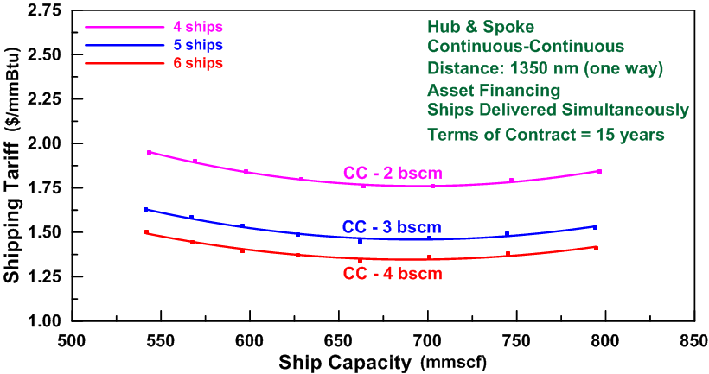
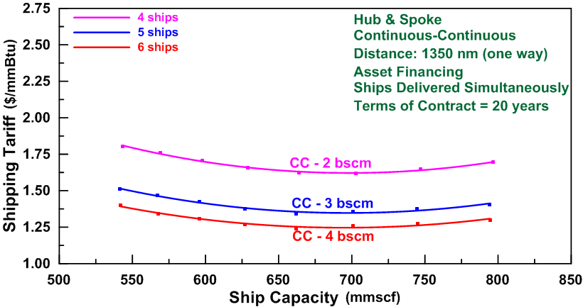
Figure 1. Sensitivity analysis on terms of project (15 vs. 20 years)
As expected, tariffs decrease if the terms of contract increase: for instance, in case of 4 billion cubic meters per year (bscm/y) of gas production the shipping tariff totals1.340 $/mmBtu for 15-years contract vs. 1.241 $/mmBtu for 20-years contract, which generates savings around 11.2 million dollars per year.

LNG
The liquefied natural gas chain is a cost effective transportation mode only in case of large volumes, huge delivery distances, and long terms of contract (not less than 20 years), provided the ship utilization factor is as high as possible in terms of LNG transport pressure [18]. The pricing mechanism for LNG is based historically on long-term commitment by the supplier and consumer and is linked in some extent to crude oil price. These pricing mechanisms for LNG should be in the long-term result in a flatter and less volatile price regime.
The LNG chain is characterized by a relatively inflexible system, high transportation costs and economies of scale in transportation and distribution. LNG liquefaction unit cost can be stated as $4/mmBtu. Onshore LNG terminals can cost more than $1 billion and require five years for construction. They offer economic advantage over a 10-15 year horizon with significant utilisation [19]. LNG projects consistently cost about $1,200 - $1800/tonne depending on gas volume production and delivery distance. LNG ships are built in line with the IMO’s IGC Code [20] and Class Society rules.
In the LNG value chain evaluation particular attention has been devoted to implementation of the design mathematical model based on enhancement of the techno-economic model developed in [21].

Offshore Pipelines
Building an offshore pipeline system to link an offshore gas field to the mainland implies a huge capital investment and poses many challenges, such as stability of pipeline structures because of strong currents, shifting seabed and steep seabed slopes. Today, the cost of current offshore pipeline projects in deep waters (the Ionian Sea, for instance) is estimated to exceed $8.5 million per nautical mile.
Although it is impossible to find two identical gas subsea pipelines in the gas industry because technical factors as well as natural and climatic conditions are always different, capital charges typically make up at least 90% of the construction cost of offshore pipelines. This cost depends on many factors such as geographic location and terrain, pipe diameter, operating pressure, distance, different labour and tax laws, etc., which are highly variable. The share of material and labour costs dominates the pipeline construction cost, which is more than 70% of the total cost, as can be seen in Table 1 where absolute values are obtained as average for different water depths along the Zöhr-Brindisi route.
Table 1. Estimated pipeline building costs per nautical mile and percentage of total
Material | Labour | Miscellaneous | ROW | Total
$1,280,000  (19%) | $3,650,000  (54%) | $1,620,000  (24%) | $200,000  (3%) | $6,750,000
Miscellaneous cover surveying, engineering, supervision, administration and overheads, telecommunication equipment, freight, taxes, regulatory filing fees, interest, and contingencies. ROW include rights-of-way and damages, and are normally negligible, but can be assumed as 3% of the total construction cost.
Pipeline operating costs mainly vary according to the number of compression stations, which require significant amounts of fuel and labour costs. Compressor stations usually account for 20% of the total capital costs.
Improved pipeline techniques and use of much higher pressure have made deep water lines technically feasible as demonstrated by the Blue Stream project. However, long-distance pipelines tend to be more sensitive to economies of scale than do LNG projects.

Small Scale LNG
What is small scale LNG (SSLNG)? The International Gas Union (IGU) defines small scale liquefaction and regasification facilities as plants with an installed capacity under 1 million metric tons per annum (mtpa). In turn, SSLNG carriers are defined as ships with an LNG storage capacity set to a maximum of 30,000 m³. The key challenge of the SSLNG technology relates to the capital costs due to the lack of economies of scale and expensive cryogenic material.
In recent years a relevant diffusion of SSLNG projects has emerged even though this technology can be relatively expensive. New liquefaction and distribution facilities are being built and operated worldwide, often supported by national governments in order to become more independent of pipeline gas suppliers. As to Italy, a national decree was approved in Italy setting a 0.01% sulphur limit for navigation in the Italian waters of the Adriatic and Ionian seas (including EEZ), starting from 2018, although the enforcement is conditional on the approval of Croatia and Slovenia of equal or higher limits.
In the upstream, liquefaction construction requires an investment of around 850 million dollars for a plant capable of handling 1 mtpa according to comparative analysis of similar projects in Europe. As to opex for the liquefaction activities expenses, it figures up at 17.5 million dollars per year. The expected repayment period is between 8 and 10 years [22]. In the midstream, each 30,000 m³ LNG ship ((Type C tank) in the fleet would cost $85 million to $100 million. Regasification and storage plants (ship berthing, storage tanks, etc.) would cost $0.6-$0.8/mscf, being investment cost for a tank of 28,000 m³ as $60 million [23]. The weighted average unit cost of onshore regasification is set to $285/tonne in 2018 [24]. Smaller terminals involve higher unit regasification costs.
Table 2 gives the energy unit total cost of SSLNG value chain together with the single components.
SSLNG technology has higher energy unit costs than for large scale LNG because it costs more to transport a cubic metre of gas in a small carrier compared with a large carrier and much more to store a cubic metre of LNG in a small bullet than a full size terminal tank. However, the total cost increase can be reduced if SSLNG concept is properly chosen through a cost optimisation scheme, considering simultaneously logistics, technologies and, if possible, existing available infrastructure.
Table 2. SSLNG value chain
Liquefaction | Shipping | Regasification &Storage | Total
$1.4-$2.1/mmBtu | $1.0-$1.2/mmBtu | $0.6-$0.8/mmBtu | $3.0-$4.1/mmBtu

Case Study: Export of Natural Gas from Zöhr to Brindisi
Typically, CNG will compete with other means for exporting natural gas, i.e. pipelines, LNG, and SSLNG. LNG and different technologies of pressure vessels fitted on CNG ships are compared first over the proposed Zöhr-Brindisi project with 1,000 nm distance between supplier and customer that will receive around 1 mtpa. Then the CNG solutions are also compared to subsea pipeline and SSLNG. It is assumed that the ship owners own the LNG, SSLNG and CNG ships. As there is no difference in costs for the exploration & production phases between the competitive technologies, they are not considered in the chain total costs. The scenario assumes that the downstream supplier and upstream producer have signed a long-term contract with “take-or-pay” obligations.
Specific cost estimating models have been developed in-house as a basis of calculated results. LNG and SSLNG receiving terminals have many machinery items in common and their costs are kept constant throughout the comparison, being independent the on the ship size. The financial model for each technological option comprises corporate tax rate of 30%, no depreciation value, 60% debt capital at 6.5 interest rate, payback period of 8 years (principal and interest), and 12% IRR as reasonable project return.

Comparison between CNG and LNG
Figure 2 illustrates the comparative assessment between LNG and CNG technologies for two different expected rate of return. As gas volumes increase, tariffs logically decline. It is clear how the tariff dramatically increases for low gas volumes, e.g. for less than 2 bscm/y, for all the marine transportation modes. It goes without saying that LNG chain cannot be considered at all a solution for short distances as it is the case in the internal Mediterranean gas market.
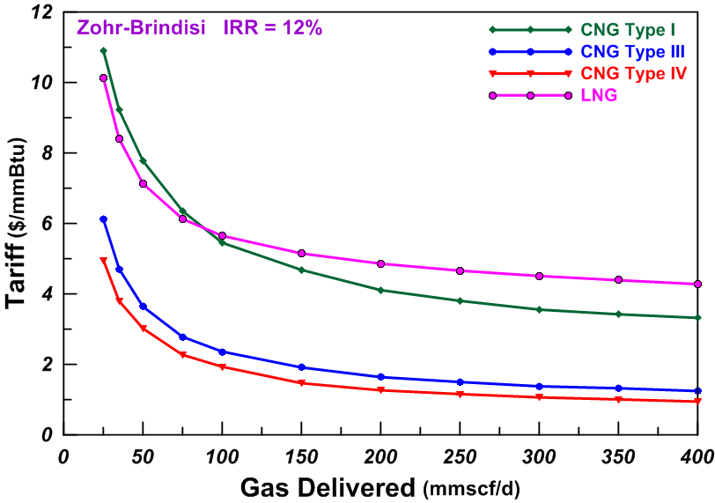
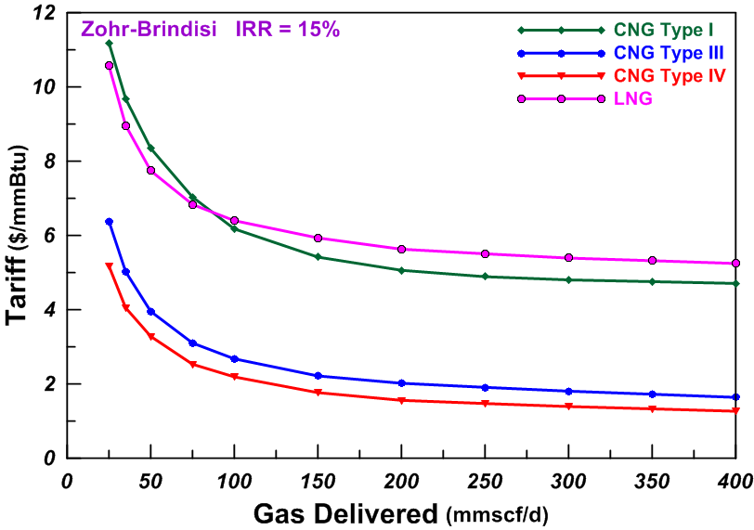
Figure 2. Comparison of total tariff among CNG and LNG marine transport

Comparative Assessment of Natural Gas Transport Technologies
The following summarizes the comparative assessment of all the technologies considered in this paper. For the pipeline solution, assumption is made that the quantity of imported gas is such that the pipeline is working at full capacity to meet both the domestic and industrial demand. For the LNG ships, the typical service speed was assumed as 19 knots.
In the case of the SSLNG chain the process starts at a large scale liquefaction facility with break bulk, loads LNG into small scale carriers (30,000m³), transports LNG to a receiving terminal and stores LNG in small scale tanks to be regasified.
Results are expressed through value chain tariffs unitized on an mmBtu basis. The quantitative analysis for the available technologies lends itself to a ranking easily readable in the bar diagram given in Figure 3.
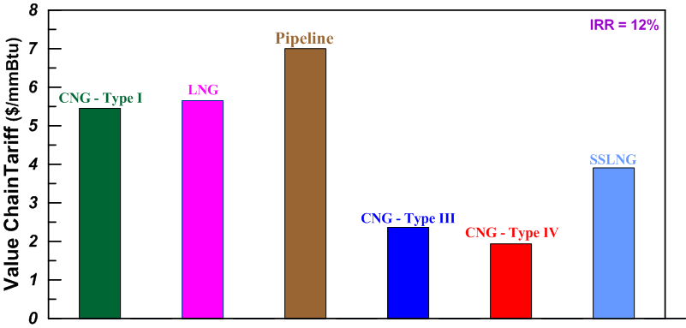
Figure 3. Comparison of gas delivering tariffs for different technologies

Conclusions
The uncertainties and complexity of the LNG and pipeline marketplace due to the geopolitically risky areas of the Middle East should encourage gas companies to diversify the planned exports to South Europe regional markets in order to achieve an early monetisation of the natural gas finds in Zöhr giant field. Such markets, situated within a range of up to 2,000 nautical miles, include Italy, Croatia, Spain, France, and even islands in the Aegean and Ionian Seas. Some of these markets do not have a large enough profile to sustain the commercial viability of LNG supply chain or to justify the long-term and huge investment for offshore pipelines. These markets could easily be accessed using marine CNG which is a flexible and versatile technology. Indeed, even though no one had the courage to implement a marine CNG project so far, this technology undoubtedly presents many advantages: lower costs for the total supply chain, fat, and low footprint.
That is why the primary objective of this paper was to analyse different technological solutions for transporting natural gas and to find whether CNG marine transportation is a viable solution within the Mediterranean Basin. The overall tariff for delivering an energy unit of gas in a possible Mediterranean crossing (from Zöhr to Brindisi) was assessed putting in competition four technologies, namely LNG, SSLNG, CNG, and pipelines. It has been highlighted that in what might be termed “actual transport competition”, the CNG chain is absolutely the most economical one.
Marine CNG should find good applications in complementing offshore gas gathering and floating production systems adding value, to FNLG and onshore LNG plants without high terminal capital expenditure, but can stand on its own too. Delivery system commercial convenience is estimated up to 2,000-2,500 nm. Marine CNG is particularly advantageous at short distances: when supplying 500 MW of power generation capacity, savings of about $50 million per year can be achieved with respect to whichever alternative technology.
Nevertheless, it must be pointed out that also adoption of a CNG chain strategy would depend on securing long-term contracts (not less than 10 years). Only national states could be able to secure such contracts in the framework of solid energy plans. In this respect, Italian and European politicians and decision makers must evaluate not only the economic viability and risks of whichever solution, but also take into account the negative implications of political turn points, trade embargos and terrorist threats.

References
- Energy Information Administration (IEA), International Energy Annual 2016, DOE/EIA-0219 (2016).
- Ministry of Economic Development: Italy’s National Energy Strategy, Rome (2017).
- A. Aspelund, T. Gundersen: The Liquefied Energy Chain, 1st Annual Gas Processing Symposium (2009), Doha, Qatar, Elsevier B.V.
- J.H. Cho, H. Kotzot, F. DelaVega, C. Durr: Large LNG Carrier Poses Economic Advantages and Technical Challenges, Oil and Gas Journal, 2 (2005).
- E.D. Garcia-Cuerva, F. Sanz Sobrino: A New Business Approach to Conventional Small Scale LNG, IGU 24th World Gas Conference (2009).
- L. Chernyavs’ka, S. Dorigoni: Transportation Modes of Natural Gas and Liberalization of Markets in Europe: Pipeline or LNG? (in Italian), Economia delle Fonti di Energia e dell’Ambiente, 2 (2003).
- P. Lothe, N.K. Str$ø$m: Pressurized Natural Gas – Next Generation Marine Gas Transport Solution, Offshore Technology Conference, Houston (2007).
- D. Stenning: The Coselle CNG Carrier: A New Way to Ship Natural Gas by Sea, NOIA Conference, Newfoundland (1999).
- D. Stenning, A. Cran: The Coselle CNG Carrier – The Shipment of Natural Gas by Sea in a Compressed Form (2001), 305-311.
- S. Välsgard, K.J. M$ø$rk, P. Lothe, N.K. Str$ø$m: Compressed Natural Gas Carrier Development – The Knutsen PNG Concept (2009).
- R. Longo, M. Suryadi Mardjoeki, A. Sidanta: CNG Storage & Transportation by Sea for Energy Demand Peak Shaving: The Gresik/Lombok Pilot Project (2014).
- G. Trincas: Optimal Fleet Composition for Marine Transport of Compressed Natural Gas from Stranded Fields, 2nd International Symposium on Naval Architecture and Maritime, INT-NAM 2014, Alkan Ed., Istanbul (2014), 25-38.
- F. Mauro, G. Trincas, L. Braidotti: Effect of Different Propulsion Systems on CNG Ships Fleet Composition and Economic Effectiveness, 19th International Conference on Ship & Marine Research, NAV 2018, Trieste (2018).
- Det Norske Veritas: Rules for Classification of Ships Pt 5 Ch 15 – Compressed Natural Gas Carriers (2003).
- International Maritime Organisation (IMO): Guidelines for Formal Safety Assessment (FSA) for Use in the Rule-Making Process, MSC/Circ.1023, MEPC/Circ.392 (2002).
- G. Trincas: Feasibility Project for Shipping CNG from Cyprus to North Adriatic Arc, 16th International Maritime Association of the Mediterranean, IMAM 2015, Pula (2015).
- G. Trincas, F. Mauro, L. Braidotti, V. Bucci: Handling the Path from Concept to Preliminary Ship Design, 13th International Marine Design Conference, IMDC 2018, Helsinki (2018).
- R. Heede: LNG Shipping via Fleet of LNG Carriers, Climate Mitigation Services, Snowmass (2012).
- A. Bourgeois.: Small Scale LNG Economics, LNG Fuel Forum, Stockholm, 2011.
- International Maritime Organisation (IMO: IGC Code, MSC.5(48), (1986).
- L. Aldous, T. Smith: Speed Optimisation for Liquefied Natural Gas Carriers: A Techno-Economic Model, Low Carbon Shipping Conference (2012).
- International Gas Union (IGU): Small Scale LNG, 2012-2015 Triennium Work Report, Program Committee D3, WGC Paris 2015 World Conference (2015).
- International Gas Union (IGU): World LNG Report, sponsored by Chevron (2017).
- M. Baker: LNG Storage Tank Cost Analysis, Interior Gas Utility Fairbanks Gas Distribution Advancement Project, Anchorage (2013).

Giorgio Trincas, Department of Engineering and Architecture, Institute of Naval Architecture, University of Trieste; E-mail: trincas@units.it

