The Green Fleet Project:  
Energy Saving Measures

Cdr. Massimiliano LEONARDIa[1]

a *Marina Militare Italiana*

**Abstract.** The Italian Navy has always had, among its mission, the safeguard of the marine environment, and it is strongly oriented in giving its contribution to the targets fixed form the European Parliament with the “2020 Climate and Energy package”. In 2012 ITN has launched the “Flotta Verde” initiative, with the purposes of reducing gas emissions and improving, at the same time, the national energy security. The paper presents an overview about the Flotta Verde initiative and a case study aimed to optimize the power consumption of Engine-room ventilation Plant for ITN ships. In particular, the study analyzes the energy needed to ensure the proper air flow in the engine-room as a function of the ship operating conditions. Aboard a navy ship, the aim of an engine room ventilation plant is to provide comfortable working conditions, and to ensure the necessary air flow to prevent heat-sensitive apparatus from overheating. The case study compares traditional solutions with new technologies in the field of energy saving and calculates the time for ROI (Return of investment).

**Keywords.** Italian Navy, Green Fleet, Energy savings, Green Diesel, biofuel, FAME, EcofiningTM, Marine Strategy, eco-design technology, energy saving measures.

# Introduction

Starting from an overall strategic vision in which our country is included, the main dynamics, including economic ones, that influence the maritime dimension follow the national guidelines in relation to the current legislative evolution.

The legitimate use of the maritime environment has a very high price for traffics, trade, the free use of sea communications, which can be affected, even from an economic point of view, by the presence of illegal activities.

Thus there is a need for a maritime strategy to address the opportunities offered by the new scenarios able to contribute to security, stabilization, peaceful and sustainable development in areas of our interest.

# EU Energy Strategy

By 2020, the EU aims [1] to reduce its greenhouse gas emissions by at least 20%, increase the share of renewable energy to at least 20% of consumption, and achieve energy savings of 20% or more. Recently EU countries have agreed on a new 2030 Framework for climate and energy [2], including EU-wide targets and policy objectives for the period between 2020 and 2030. Through the attainment of these targets, the EU achieve a more competitive, secure and sustainable energy system, and decrease its dependence on foreign fossil fuels, while keep energy affordable for consumers and businesses.

## Energy policies

Energy efficiency contributes to the achievement of all the above mentioned energy policy objectives: reducing our energy costs thanks to savings in fuel consumption, reducing environmental impact (energy efficiency is the most economical way for emissions reductions, with a return on investment that is often positive for the country, and that should be preferred to achieve the environmental objectives), the improvement of our security of supply and reducing our dependence on imported energy; economic development generated by a sector with a strong positive impact on the national value chain, in which Italy has numerous leadership positions which can also be projected in the rapidly expanding market abroad.

The strong impulse to energy efficiency will absorb a substantial portion of expected increases in energy demand by 2020, both in terms of primary supply and final consumption. In this context, the sector will have to deal with a scenario in which overall demand will likely remain steady, at levels comparable to those of recent years.

# Marine Strategy

The European Community, as per the regulation 2008/56/CE, entrusted the EU countries with creating national strategies involving all the main naval institutions, aimed at marine conservation. Italy applied this regulation with the Legislative Decree 13 October 2010, nr. 190 which gives the Ministry of the Environment and Protection of Land and Sea of Italy (MATTM) [3] the role of coordinator of the strategy through the Technical Committee for the Environmental Marine Strategy (the so called Marine Strategy).

To this national committee belong the representatives of the ministries active in the marine conservation, including a representative of the Italian Navy, as a permanent delegate of the Ministry of Defense.

The Marine Strategy Program provides a tangible contribution to the protection of marine environment. Through the *Green Fleet Project* [4] the Navy is giving specific attention to environmental issues and its work benefits the Country, the European Union and the scientific community involved in oceans habitat and environment conservation.

# Green Fleet Project

The Italian Navy's Green Fleet ("Flotta Verde") Project was initially launched in 2012 to aimed at demonstrating that oil dependence can be halved by 2020 and that the EU's climate and environmental objectives can be reached and surpassed. The project was initially oriented to find an alternative marine fuel derived from resources other than petroleum, with a view to enhancing national energy security while reducing pollutant emissions.

Afterwards, the Italian Navy's commitment to addressing environmental and energy challenges also included the adoption of several innovative technologies within the all-encompassing strategic "Green Fleet" concept, envisaged in the framework of the recently-launched fleet renewal programme.

The following strategies may be actually associated to the "Green Fleet" Project:

* adoption of a renewable synthetic fuel, in line with the targets established by the EU Directive 2009/29/EC (Horizon 2020) [5];
* development and use of innovative eco-design technologies, enabling the reduction of the environmental impact of ships (LED lighting, SCR, silicone paints);
* global reduction in ships' energy consumption, through the adoption of energy saving operating procedures (electric propulsion, energy dashboard).

The Italian Navy received the *Green Global Banking Award*, during a one-day conference on the green economy, on account of its commitment to protect and preserve the Mediterranean Sea through the implementation of the Green Fleet Project and its endorsement of the EU Marine Strategy.

## Alternative fuels

Biofuels are produced from biomass that is organic matter of vegetal or animal origin, and may be used as alternative to conventional fuels derived from petroleum.

The use of biofuels – namely those produced from vegetable oils – allows significant reduction in carbon dioxide emissions, by as much as 52% compared to fossil fuels, thanks to the good CO2 uptake rate in the life-cycle of oleaginous plants. Moreover, the diversification of supply sources enhances the so-called national energy security.

Nevertheless, biofuels for current civilian uses (the so-called FAME[2] biofuels) present compatibility issues in the marine sector owing to their physical and chemical properties that make them hard to mix with fossil fuel, and difficult for long-term onboard storage[3].

The Italian Navy signed a cooperation agreement with ENI for the development and testing of an alternative fuel produced from renewable sources [6], in accordance with NATO naval fuel standards [7]. ENI - in partnership with the US Honeywell-UOP - developed the Ecofining™ technology (**Figure 1Figure 1)**, through a series of laboratory and engine bench tests conducted at ENI's Research Centre. The final product of this technology is the Green Diesel™[4] fuel, which can be blended up to 50% with conventional fossil fuel, in accordance with NATO specifications [8], with no need for engine or equipment modifications.

The Italian Navy is leader in the biofuels sector in Europe, being the first (and only so far) to launch a test programme on the use of Green Diesel in the naval sector, and to use a blend of up to 50% green renewable diesel, even before the mandatory 10% target set by the EU [9] to be achieved by 2020.

Another alternative fuel is represented by Liquefied natural gas. LNG is of growing importance, being a highly efficient, environmentally friendly and competitive energy source.

The Italian Navy is interested in the use of LNG as a marine fuel, for cost-reduction purposes and with a view to reducing environmental impact both in port areas and high-value and marine protected areas, such as the Arctic and Antarctic Zones, and natural reserves.

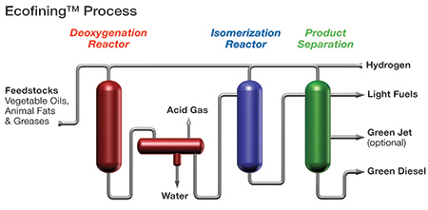

**Figure 1** EcofiningTM process diagram.

## Ecodesign Technologies

Cutting-edge technologies and eco-friendly design methods have been used for the new ships of the Italian Navy in order to ensure their environmental sustainability thanks to the reduction of energy consumption.

Such methods include:

* use of LED-based lighting, allowing nearly 40% energy saving as against fluorescent lamps, along with additional 10% reduction due to the reduced heat generation;
* use of silicone-based paints (**Figure 2**), not harmful to the marine environment, for hull coating, allowing propulsion fuel saving of over 25%, thanks to improved antifouling treatments;
* use of Exhaust after-treatment with Selective Catalytic Reduction (SCR) system for reducing nitrogen oxide (NOx) emissions causing the so-called acid rains, below the Tier III limits as defined in Marpol-Annex VI, in force since January 2016 for Emission Control Areas.

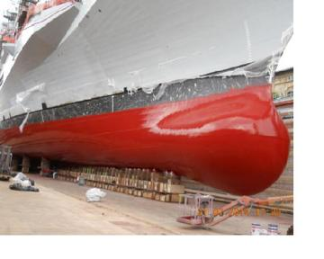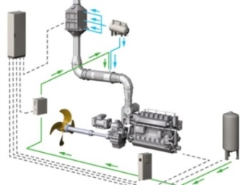

**Figure 2** Silicon-based paints and SCR Technology.

## Energy saving measures

Energy efficiency measures adopted onboard modern ships are developed since the early design stage through fixed procedures and feasibility criteria.

Some of these procedures were commonly used onboard the Italian Navy vessels, but newly-built and future ships have been designed to apply more advanced technologies in line with the degree of flexibility required for the new dual-use naval platforms.

Such measures mainly include:

* underwater propeller cleaning, periodically performed by the ship's divers;
* one shaft trailing mode with the propeller pitch set for low speed patrolling;
* use of electric propulsion;
* automated control of electric loads.

# Energy Efficiency

Energy efficiency will play a part in achieving all of the energy policy objectives mentioned in the previous paragraph.

The national energy demand required by the industrial sector amounts to about 50% of the total demand. Most of this energy used in the industrial sector (around 74%) is used for machinery with electric motors. It’s easy to understand how, by making these components efficient, the advantage in terms of energy is significant.

## Asynchronous electric motor

Asynchronous motors are used in pumps, fans, elevators and cranes, from air compressors to refrigeration units, from mixers to conveyors, but the list is endless because in most technological applications, both industrial and service sectors, to derive mechanical energy from electrical energy these motors are used.

Using an inverter to control the motor, it is possible to adjust the flow rate of the fluid by acting directly on the motor speed through the variation of the frequency. If we consider a production cycle that requires the pump or fan to cut the flow in half, the inverter will automatically reduce the motor speed by half and, remembering that the power required by the load varies with the speed cube, the energy absorption would drop from 100 % to only one eighth of the nominal one.

To better understand the energy saving mechanism that is obtained through the use of inverters, we take into consideration the characteristic graphs of a pump relative to head, efficiency and power. The characteristic curve of the pump results to be that at 2900 rpm. In case of operation at nominal flow we are at the operating point A of the graph below (**Figure 4**). If there is the need to halve the flow rate with just the use of a damper, the head H increases and the operating point moves to B on the characteristic curve of the pump. In this case, the efficiency decreases by about 15 % and the power consumption decreases by about 6 kW. In case of use of a pump with inverter control, the reduction of the flow rate is done by speed adjusting. In this case the characteristic curve of the pump varies with the decrease of the rotation speed. If I need to halve the flow, I will be able to reduce the pump speed from 2900 rpm to 2000 rpm, thus lowering the characteristic curve to work from point A to point C (**Figure 3**). In this case the efficiency decreases by a few percentage points (about 4%), due to the inverter losses, while the absorbed power decreases by about 45 kW.

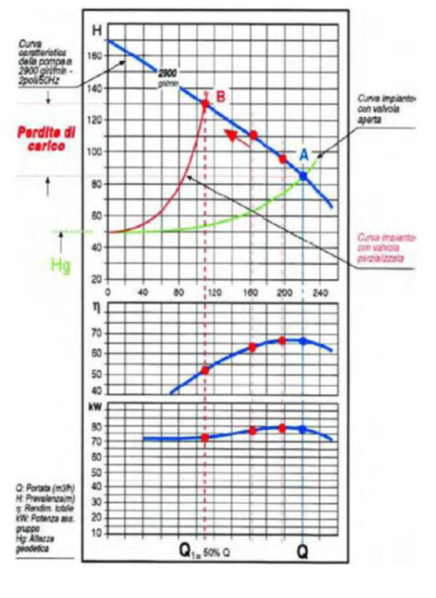

**Figure 3** Pump with inverter control system.

Q: flow (m3/h)

H: head (m)

η : efficiency

kW : power

Hg : geodesic height

Q: flow (m3/h)

H: head (m)

η : efficiency

kW : power

Hg : geodesic height

pump characteristic curve @ 2000 rpm

bent valve system curve

open valve system curve

open valve system curve

Pump characteristic curve @2900 rpm

Head  
H (m)

Pump characteristic curve @2900 rpm

**Figure 4** Pump without inverter.

## Case study: implementation on military ships

To evaluate the possible military applications and carry out a comparative study on energy savings deriving from the use of inverter technology, one starts by identifying a military unit, its operating profile, and the related electrical budget.

Energy saving is evident when a percentage of its potential is requested from the machinery designed to develop a specific performance at 100% of its capacity, so in all situations where a variable flow rate is required (fans, pumps, variable speed systems).

Through the analysis of the operational profile and the electric budget of a military ship in service, it is possible to make an assessment of cost effectiveness in terms of energy saving. In this case study, efficiency improvement is focused on the engine room ventilation system. The aim of an engine room ventilation plant is to provide comfortable working conditions, and to ensure the necessary air flow to prevent heat-sensitive apparatus from overheating. Starting from these considerations, we calculated the air flow rates required in the different operating conditions of the ship, both during navigation and harbor (**Figure 5**).

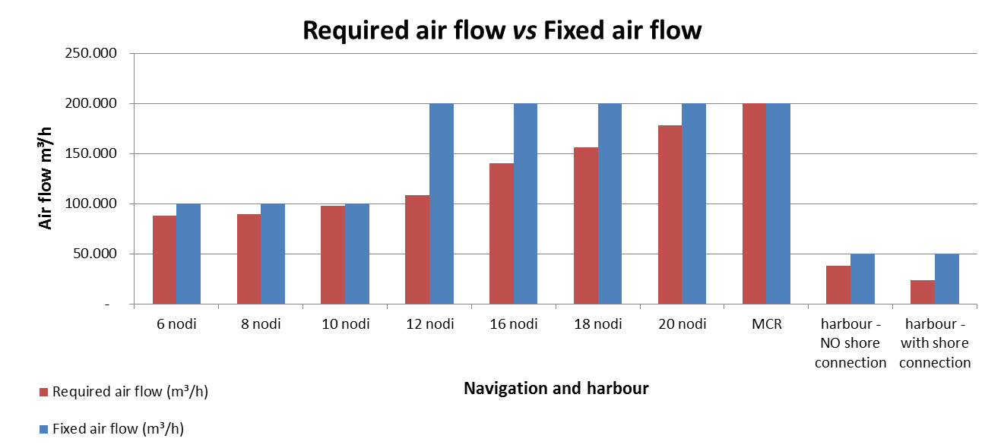

**Figure 5** Flow rate needed vs fixed flow rate.

In inverter ventilation systems, the variable air flow is controlled by the fan rotation speed by modifying the voltage / frequency ratio. In fixed-flow ventilation systems, the airflow varies by changing the number of fans in operation (or double-speed fan).

Knowing the air flow required to ensure the right operation of the machinery room at the different operative conditions and during the port visit, and knowing the operative profile of the ship, and therefore the hours of operation under the various conditions mentioned, the total energy consumption of the two ventilation systems is obtained.

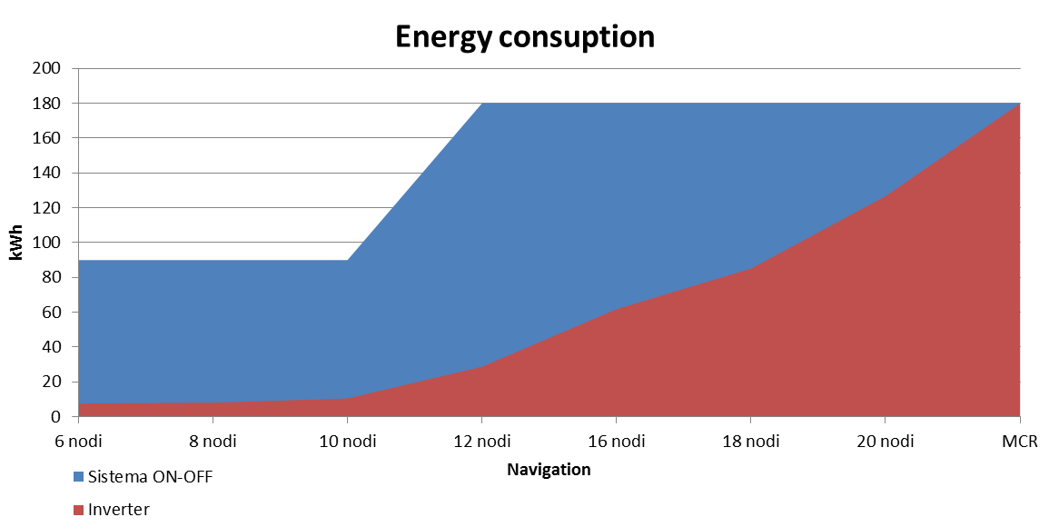

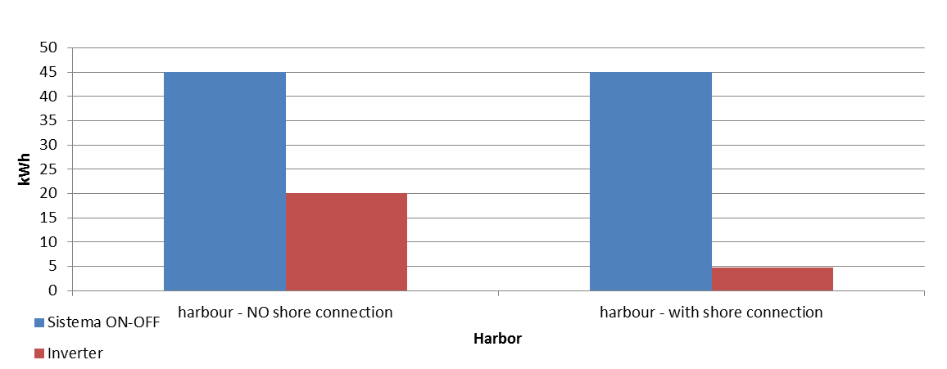

**Figure 6** Evaluation of energy costs

For the evaluation of the energy cost per kWh (**Figure 6**) we consider an average cost for naval fuel (F76) of 500 €/t. The specific consumption of a diesel-generator used on board is 220g/kWh. While the average cost of energy through the shore connection is 0,14€/kWh.



**Table 1** Comparison of energy costs.

# Conclusion

The results show how the adoption of an inverter system for the ventilation of the machine room allows an effective energy saving, estimated to 500 MWh/year, corresponding about 62k€/year.

The summary **Table 1** shows that compared to an annual energy expenditure of about 74k€, through a management system of inverter ventilation machines, an average saving of 82% can be predicted, corresponding to an annual energy expenditure equal to about 13k€.

The budget cost indicated for the implementation of the hypothesized inverter system for the machine room ventilation has been estimated at around 150 k€. The savings resulting from the comparative analysis shown in the previous table is about 62 k€/year; therefore, in addition to the environmental benefits, the system analyzed would theoretically allow a return on the initial investment in a period of less than 3 years.

# References

[1] Europe 2020: Commission proposes new economic strategy", European Commission COM (2010) 2020

[2] Energy Efficiency and its contribution to energy security and the 2030 Framework for

climate and energy policy. COM (2014) 520 Final.

[3] Legislative Decree 13 ottobre 2010, nr 190 - Ministry of the Environment and Protection of Land and Sea of Italy (MATTM).

[4] Stato Maggiore Marina – Prospettive e orientamenti di massima della Marina Militare per il periodo 2015-2025 (2014).

[5] Horizon 2020 - The Framework Programme for Research and Innovation - Communication from the Commission •COM/2011/0808 (2011).

[6] Performance Standard MM-PRF-1000A - Naval Gasoil Technical and Operational Requirement (2015).

[7] STANAG 1135 – Interchangeability of fuels, lubricants and associated products used by the armed forces of the NATO.

[8] STANAG 1385 – Guide Specification (minimum quality standard) for naval distillate fuels (F-76).

[9] RED - Renewable Energy Directive (2009/28/EC).

1. Commander, Italian Navy General Staff - 7th Dept. Ship Design & Combat Systems - Propulsion Plants Office; E-mail: massimiliano.leonardi@marina.difesa.it.
2. FAME (Fatty Acid Methyl Ester) is the generic chemical term for biodiesel derived from renewable sources. FAME is created during the transesterification of vegetable oils and animal fats to make biodiesel.
3. The methyl esters in biodiesel are hygroscopic. This means that they can absorb considerably more moisture than petroleum derived diesel and hold this in suspension in the fuel.
4. Green Diesel is an high-quality sustainable green bio‐fuel from vegetable oil and biomass produced by Eni’s innovative Ecofining™ technology.