Technical and Economic and Environmental Feasibility of an Innovative Integrated System of Management and Treatment of Waste On Board
Alessandro IANNELLO^{a,}, Serena BERTAGNAª, Dario POZZETTOª, Luca TONEATTIª, Riccardo ZAMARINIª and Vittorio BUCCIª
ª Department of Engineering and Architecture, University of Trieste
Abstract. The cruise passenger ship market is one of the most developing sectors globally. In order to satisfy the ever increasing demand from tourism, the number of ships and their size have been exponentially growing. As a result, the impact on environment caused by the increased marine traffic represents one of the most current problem worldwide. The necessity of developing new eco-friendly and sustainable technologies has led to study the technical, economic and environmental feasibility of an innovative integrated waste management and treatment system on modern cruise passenger ships. The benefits of the new configuration compared to the traditional one have been identified by analysing the entire waste chain, from on board production to final disposal, through the various energy recovery and treatment phases. Consideration has been given to the potentiality of waste addressed to treatment, flows, mass and energy balances, and operation of the system, defining technologically advanced and innovative systems and their application scenarios, with particular attention to safety and hygiene in rooms on board involved in the process. Finally, the environmental sustainability, referring to the existing regulations both in IMO and in existing mooring ports involved in the disposal of residual waste, and the economic outcomes of the innovative configuration have been analysed and evaluated.
Keywords. Cruise ship, Environmental sustainability, Waste disposal, Energy recovery, Green shipbuilding

Introduction
In the last decades, the cruise market demand has growth in such an exponential way that large amounts of money have been invested, in order to achieve the planning and implementation of new and numerous offer proposals [1].
The increasing production of vessels for the cruise sector unavoidably led to the raise of marine traffic, which is considered one of the global most relevant pollution causes, affecting in particular areas such as ports and the principal marine routes [2][3][4]. Therefore, the attention of several studies is focused on the environmental protection. New technologies have been developed, in order to introduce the idea of “green economy”, i.e., a theoretical model of economic progress in which, besides the benefits of a peculiar production system, also the environmental impact is considered. In this model, the notion of sustainability represents one of the main decisional factors; in fact, the power of the “Green” trend is presented not only as a simple transient trend of consuming and marketing, but also as a driver able to influence and vary the success of a project [5].
In particular, one of the most interesting field that offers great possibilities for development regards the ship waste treatment. Nowadays, waste is disposed by means of incinerators installed on board. Through this methodology, it is possible to obtain a solid residue of sterile and harmless nature, free from pathogens. In addition, a further step that can be made is based on the recovery of energy from the waste combustion, through the use of specific technologies, in order to improve the efficiency of ships and reduce their environmental impact [6][7][8]. The internal spaces of ships dedicated to the incinerator system will have to be re-organized; through an integrated ship design approach, by means of Computer Software Integrator (CSI) software, the various systems could be modelled in a 3D environment and their integration evaluated [9][10].
In this paper, an analysis of the current waste treatment cycle is presented, along with a brief survey of the most common types of system aimed to the disposal processes and the Regulations they have to comply with in order to be installed on ships [11][12][13]. Furthermore, innovative solutions for waste energy recovery are described; in order to validate their usage, they have been applied on an existing cruise ship. Eventually, the results obtained from the different systems have been reported with the aim to identify the best solution analysed.

Waste cycle
Since the number of cruise ships has been exponentially increasing in recent years, implementing a “green policy” for their management is of great importance [5]. In particular, one of the most interesting theme regards treatment and disposal of waste.
Cruise ships generate a large amount of different types of waste: the most common are solid waste, hazardous waste, oily bilge water and ballast water. These refuses, if not treated and disposed in a proper way, may represent a source of toxic substances that can threaten the marine ecosystem and the environment. Furthermore, it has to be considered that also their treatment emits air pollutants in the air and in the water.
On the other hand, given the importance of cruise ships within the international maritime industry, the treatment process adopted for this large amount of waste, taking into account the cost deriving from their various management options, must represent not only an eco-friendly solution, but also an economic advantage for the ship-owners.

Waste disposal
For almost every type of waste, a specific on board treatment methodology is applied. The waste management procedure follows the subdivision described below (Figure 1) [6][7][8]:

- waste collection, it represents the operations of collecting, selecting and grouping similar refuses through a separate collection, in order to facilitate reuse, recycling and recovery of raw materials;
- waste treatment, in which a set of techniques aimed at ensuring a smaller encumbrance on board, facilitating the discharge in ports and improving the assimilation of waste unloaded into the marine environment is carried out;
- waste storage, it is the procedure of temporary arrangement and conservation, into the garbage room, of the waste that, by now treated, have to be disposed of;
- waste disposal, it is the last phase of the cycle, in which the residual fraction of waste collection undergoes particular procedures that allow it to be eliminated, in port or at sea, or re-use on board, in a definitive and safe way.
All procedures that involve the removal of waste are regulated by the International Convention for the Prevention of Pollution from Ships (MARPOL), but deletion in port is the only one that must take into account the laws in force at each port of call, implemented by the port authorities.
The treatment and management of the various types of waste have been analysed, on the basis of the standard and general procedure applied in most of the world cruise fleet, in order to describe the entire supply chain, from production to disposal (Figure 2).

Incineration system
In this framework, it is clear that the incineration phase is extremely important, since it represents the best technological approach to develop a single compact on-board system able to deal with relative simplicity the wide variety of waste produced by a cruise ship.
The incineration process operates through a thermal degradation treatment under oxidative conditions. By means of such a technique it is possible to obtain a solid residue (ash) of a purely inorganic nature (various metal oxides, silica, carbonates, various salts), sterile and harmless; moreover, it allows to convert the combustible material of waste into gas, reducing weight and volume of waste (7-30% of the initial weight and even 6-10% of the initial volume).
The incinerator is divided in three main chambers: in the first one, a preliminary pyrolytic decomposition is carried out (with a temperature between 825°C and 1200°C, as required by the Regulations), in absence of oxygen and in low turbulence atmosphere to contain dust entrainment; in the secondary post-combustion chamber, complete oxidation of the gaseous unburnt occurs; eventually, in the tertiary chamber, sedimentation and fume cleaning are carried out.
In order to provide a high redundancy, the necessary daily treatment potential is distributed on two separate incineration lines sized for a daily operating time slightly less than 12 hours. The operation of this plant is limited by the Regulations that bind the incineration phase only at distances that exceed 12 miles from the coast.
Cruise ship incinerators must comply with the International Maritime Organization (IMO) Resolution MEPC.76(40) - Standard Specification for Shipboard Incinerators, adopted on 25 September 1997, and subsequent amendments [11]. This specification covers the design, manufacture, performance, operation and testing of incinerators intended to incinerate garbage and other shipboard wastes generated during the ship's normal service. It applies to those incinerator plants with capacities up to 1,500 kW per unit and does not apply to systems on special incinerator ships, e.g., for burning industrial wastes such as chemicals, manufacturing residues, etc. The Regulation provides, among the others, i) emission requirements; ii) fire protection requirements; iii) provisions for incinerators integrated with heat recovery units; and iv) provisions for flue gas temperature.
Cruise ship incinerators have to be designed and operate also in accordance with the Annex VI of MARPOL Convention [12], concerning the prevention of air pollution from ships. In particular, Annex VI requires that on-board incinerators installed after 10 January 2000 are approved by type and meet specific air pollution criteria; they should only be used to incinerate materials that are specified by the incinerator manufacturer. The incineration of cargo residues (MARPOL Annex I, II and III), contaminated packaging materials, polychlorinated biphenyls (PCBs), contaminated waste with more traces of heavy metals, refined petroleum products containing halogen compounds and exhaust gas cleaning systems is strictly prohibited. Due to the potential environmental and health effects of its combustion, also polyvinylchloride (PVC) incineration is not allowed on board, with the exception of on-board incinerators for which IMO homologation certificates have been issued (MEPC.76(40) or MEPC.59(33) [13] specifications). Moreover, the incineration of any type of waste, generated during the normal operation of the ship, is forbidden near ports and estuaries.
Special rules for incineration may be established by the authorities of some ports and may exist in some special areas. In any case, before using an incinerator in port, it is necessary to request an authorization to the port authority concerned. However, the use of waste incinerators on board in ports in urban areas is usually discouraged due to the increase of air pollution they may cause.
Figure 1. Waste management procedure flowchart.
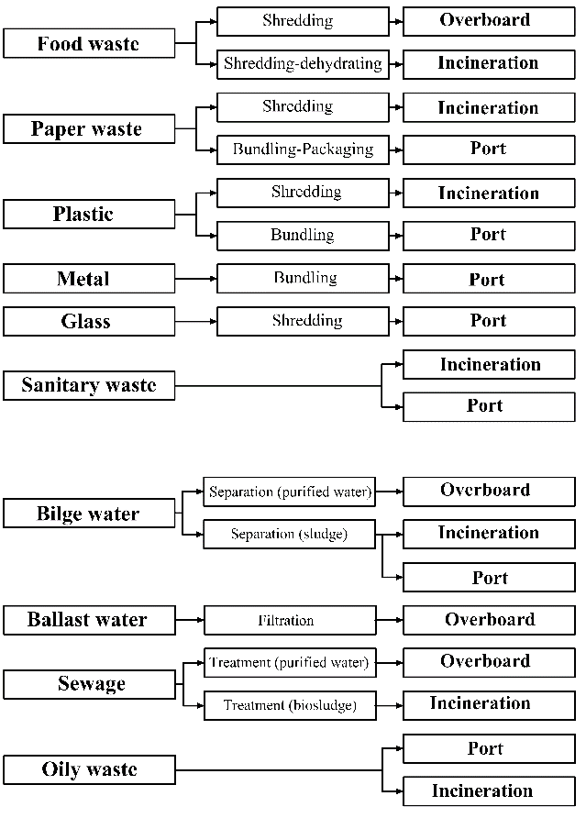
Figure 2. Solid and liquid waste treatment and management procedure flowchart.

Innovative solutions
Due to the high interest in developing innovative technologies able to improve the environmental sustainability of ships, different systems aimed to recover energy from waste disposal have been studied. In particular, two of the most interesting solutions currently available are represented by the syngas production system and by recovering heat of incinerator fumes to feed an absorption system.

Syngas production system
The system for the production of syngas provides the possibility of recovering energy through the waste gasification; in fact, since the gasification products may be transformed into fuels similar to those deriving from fossil sources, they can represent a valid alternative for the on board electro-generation.
Gasification is a thermochemical conversion process of a solid or liquid stuff rich in carbon into a synthetic gas useful as fuel. The production process takes place through a waste degradation reaction, in which both a dehydration and a decomposition occurs with a consequent release of volatile substances. These substances are made of high molecular weight hydrocarbon compounds, which are in the gas phase only by virtue of the high temperature (TAR), and by low molecular weight compounds (methane, ethane, etc.). The TAR and the gas then undergo a gasification process that leads to the breakdown of the most complex organic molecules in volatile compounds and to the formation of CO, CO₂, CH₄ and H₂O, through a thermo-conversion treatment that implies air or oxygen injection, in order to allow the oxidation of volatile and unburnt products. The temperatures in this process vary between 300 and 1000°C. Overall, a synthesis gas (Syngas) consisting of CO, CO₂, H₂, CH₄ and other heavy hydrocarbons is obtained, with values of lower calorific value (PCI) above 5 MJ/Nm³.
The Syngas has a calorific value such as to allow its use as a fuel in internal combustion engines. Moreover, if additional cleaning processes are carried out during the gasification, the Syngas turns out to be a very clean fuel, able not to give rise to ashes and free from substances that may cause problems during the combustion phase, such as chlorine and potassium.

Heat recovery of incinerator fumes to feed absorption system
The absorption system provides the possibility of recovering energy from the heat of incinerator fumes deriving from waste combustion; in fact, the aim of this technology consists of exploiting the thermal energy deriving from the losses of the on board incinerator chimney. The waste heat, instead of being dispersed in the environment, could be managed, recovered and converted into other forms of energy, in order to bring advantages in both the environmental and the economical field. Thanks to the recovery of excess heat extractable from the incinerator, it is possible to exploit the efficiency of new technologies for the construction of cooling systems by absorption cycle.
Currently, the conversion of the incinerator thermal energy in electric energy represents a solution particularly difficult to implement, due to the numerous complications linked to the necessity of a system dedicated to the conversion process and its interface with the existing generation system. Moreover, since the system would be operative only for a few hours per day, in particular during navigation and never near shore or at the quayside, recouping the estimated costs of the system installation would be very difficult.
On the other hand, exploiting the energy contained in the fumes produced by the incinerator for thermal purposes seems to be a more interesting solution. Actually, according to the estimated data, the energy demand for the heating system is almost always satisfied by the primary engine, but the possibility of recovering energy from the waste combustion is noteworthy, above all because it does not require changes from the point of view of the incinerator management.

Case study
An existing cruise ship has been considered as the case study, aimed at analysing the possibility to install on board the innovative solutions described above.
In order to study in detail the waste production and management, it has been necessary to collect the specific data about the ship considered (Table 1).

Syngas production system
Currently, the only Syngas production systems are terrestrial; the study must therefore be based on these to outline the main characteristics of the technology.
First of all, it has been necessary to identify the waste typologies suitable for the gasification process, analysing the following features: i) macroscopic and physical characteristics, they allow to estimate a priori the amount of fuel, the specific heat and the amount of waste obtained; and ii) energy characteristics, the amount of heat produced per unit of weight of fuel.
The process potential is strongly dependent on the reactivity and composition of the fuel used and on the operating conditions of the plant. In theory, by pyrolysis, from 1 kg of mixed waste, 0.15-0.3 kg of Syngas, 0.5-0.6 kg of tar and 0.2-0.3 kg of char are obtained.
Within a cruise ship the spaces that can be dedicated to the entire Syngas production system are very small, as each space is optimized for a specific function. The new system would find space thanks to the elimination of the entire incineration system. Even though terrestrial systems are not capable of sustaining the load needed by a cruise ship, they have represented the basis for defining the features of a ship plant. From the study, it has been evaluated that an appropriate output power could be equal to 600 kWe; such a system would provide a work equal to 2.3% of that generated by the traditional electricity generation system, with consequent economic recovery from fuel savings.

Heat recovery of incinerator fumes to feed absorption system
The most practicable solution consists of exploiting absorption refrigeration cycles, in place of or in addition to those already present, dedicated to environmental air conditioning and "cold generation" for food storage, both in cold and freezing storage. From the comparison of the values of a representative system some critical issues have been immediately highlighted (Table 2): i) the installed power for the environmental conditioning is of an order of magnitude higher than that of the single incinerator; and ii) the total power ("CHILL" and "FREEZE" services) installed for food storage is comparable to that of the incinerator.
Since the operating temperatures of the cold room and the freezing are not equal, the use of two different solutions is required. The main differences are due to the different refrigerator fluid treated (Figure 3).
For the sizing, the thermodynamic references are represented by the properties of the ammonia in the phases of liquid, vapour and mixture of the two, and by the characteristics of the water-ammonia solution at different operating temperatures and pressures, obtained through algorithms calculation that allow to evaluate the link between enthalpy, pressure, temperature and molar fractions of the solution [14]. The overall dimensions for the system main components will hardly allow the installation of both solutions. Therefore, it has been chosen to analyse the technology that offers the greatest economic impact, i.e., the cooling of the cold room operating at temperatures between 0 and 4° C.
Since the system can operate only in conjunction with the incinerator, the savings achievable have to be evaluated on the basis of the navigation hours spent outside the 12-mile limit from the coast. It is also necessary to evaluate the utilization factor of the cooling system, influenced by the degree of insulation of the cooled environment, the mode of use (number and frequency of access openings) and the external temperature. Assuming for this factor three values, the results have been evaluated (Table 3), assuming a fuel consumption equal to 178.7 g per kWh of electricity generated and a fuel cost equal to € 0.316 / kg.
Table 1. Daily waste output from cruise ship.
Waste output | (kg=Pers=day) | (kg =day) | (m³=Pers=day) | (m³=day)
Plastic | 0.22 | 1232 | 2e-04 | 1.12
Paper | 0.98 | 5488 | 1e-03 | 5.65
Food | 2.00 | 11200 | 2e-03 | 11.37
Glass | 0.68 | 3808 | 2.72e-04 | 1.52
Aluminum | 0.02 | 112 | 7.41e-06 | 0.04
Total | 3.90 | 21840 | 3.48e-03 | 19.70
Table 2. Main features examined.
LSA | Eng power [kW] | HVAC power [kW] | HVAC redundancy | Refrigeration power [kW] | Incinerator power [kW]
Total | 62400 | 18400 | 112.50% | 509 | 1800
Table 3. Results obtained.
Utilization factor | Fuel saving [kg/h] | Cost saving [€/h] | Return period [h]
25% | 10.25 | 3.239 | 7333
50% | 20.50 | 6.478 | 3666
75% | 30.75 | 9.717 | 2444
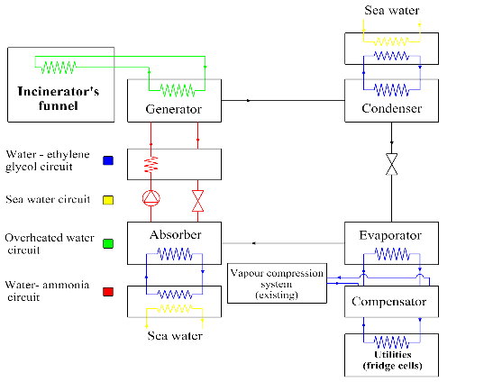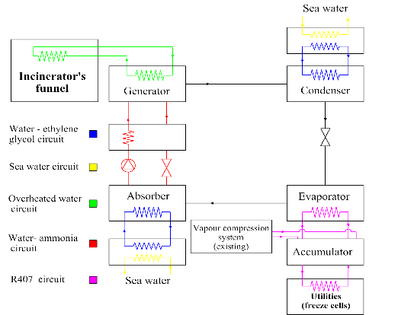
Figure 3. CHILL system (left) and FREEZE system (right).

Conclusion
In comparison with the technologies traditionally installed, the possibility of recover energy from refuses represents one of the most valuable advantages; in fact, by means of the new systems, it is possible to exploit materials that were previously unused, saving a certain amount of fuel and, therefore, achieving a long-term cost reduction.
About the Syngas solution, the installation of a waste gasification system on a cruise ship is not feasible since the system is of considerable size and certainly does not meet the demand for space reduction. Furthermore, the gasification process requires a total time that is far superior to the incineration processes; since one of the main objective of the study is to make the treatment process faster and easier, it is not worth yet to consider the Syngas system as a valuable solution.
Regarding the absorption system, the possibility of making a connection between this technology and the incinerator chimney has put the basis for the identification of the most problematic issues, from the point of view of both the thermodynamic cycle and the construction. The strength of this technology is represented by not requiring any changes in the incinerator management. However, the solutions currently available are not suitable for partial load operation, nor do they give good results during transient phases, since they produce a notable deterioration in machine performance. In addition, also the problems of space have to be considered.
This study represents the basis for future developments, which will allow the improving of important aspects, such as compactness, safety, durability and reliability.

References
- J.G.C. Kester, Cruise Tourism, Tourism Economics 9(3) (2003), 337–350.
- N. Butt, The Impact of Cruise Ship Generated Waste on Home Ports and Ports of Call: A Study of Southampton, Marine Policy 31(5) (2007), 591–598.
- R.A. Klein, The Cruise Sector and its Environmental Impact, Bridging Tourism Theory and Practice 3 (2010), 113–130.
- J. Commoy, C.A. Polytika, R. Nadel, J.W. Bulkley, The Environmental Impact of Cruise Ships, Proceedings of the World Water and Environmental Resources Congress 2005, Anchorage AK, USA.
- M.C.J. Caniëls, E. Cleophas, J. Semeijn, Implementing green supply chain practices: an empirical investigation in the shipbuilding industry, Maritime Policy & Management 43(8) (2016), 1005–1020.
- M. Boscolo, S. Tommasi, Impianti di Smaltimento Rifiuti sulle Navi da Crociera, Impiantistica Italiana 3 (2004), 61–74.
- X.J. Wang, Q.H. Shen, Y.Z. Ji, Research Progress of Ships Waste Treatment Technology, Applied Mechanics and Materials 587-589 (2014), 674–679.
- A. Smookler, C. Alig, The Navy’s Shipboard Waste Management Research & Development Program, Naval Engineers Journal 104(3) (1992), 89–97.
- D. Bosich, V. Bucci, U. la Monaca, G. Sulligoi, A. Vicenzutti, G. Lipardi, Early-Stage Design of Integrated Power and Energy Systems for Naval Vessels Electrification: Advanced Modeling Using CSI, Proceedings of the iTEC Conference 2017, Chicago IL, USA.
- A. Vicenzutti, U. la Monaca, D. Bosich, V. Bucci, A. Marinò, G. Sulligoi, R. Pelaschiar, Early-stage design of shipboard integrated power systems: CSI-based multiple solutions comparison, Proceedings of the ESTS Symposium 2017, Arlington VA, USA.
- …, Standard Specifications for Shipboard Incinerators, MEPC.76(40), Marine Environment Protection Committee, 1997.
- …, MARPOL Consolidated Edition 2011, CPI Group (UK) Ltd, Croydon, 2011.
- …, Revised Guidelines for the Implementation of Annex V of MARPOL 73/78, MEPC.59(33), Marine Environment Protection Committee, 1992.
- J. Patek, J. Klomfar, Simple Function for Fast Calculations of Selected Thermodynamic Properties of the Ammonia-water System, International Journal of Refrigeration 8(4) (1995), 228–234.

Alessandro Iannello, Department of Engineering and Architecture, University of Trieste, via A. Valerio, 10, I-34127 Trieste; E-mail: alesssandro.iannello@dia.units.it

