Past, Present and Future in Ship Design
Rodrigo PEREZ FERNANDEZ^{a,}
ª SENER, Ingeniería y Sistemas
Abstract. The shipbuilding industry has varied widely throughout history. This paper traces the history of ship design since Roman times, when ship designers began to use curves for drawing frames, through the Venetian techniques (XIII-XVI centuries) reusing templates, to the most modern methods for ship design with CAD/CAM Systems. Throughout the first half of the XX century, ships were getting bigger; so it was necessary to work on larger scales. The templates allowed working on different scales, such as widely used 1:10 scale. But with growing ship size, the moment came it was no longer practical to use templates. This happened at a time when the first computers came to our industry, promoting the development of ship design CAD tools. The new CAD Systems offer a comprehensive process for the design and construction of ships, offshore platforms and submarines, with the help of computers. There are many advantages of using CAD in shipbuilding: ease of design, speed of construction, use and reuse of information, etc. It is expected that in the future CAD tools will advance further and allow greater information management and virtual access through smart devices. In general, CAD Systems provide tangible benefits while the process is optimized, reducing design time and production, and therefore costs.
Keywords. Shipbuilding CAD System, Product Lifecycle Managements, Virtual Reality

A brief introduction about Shipbuilding history
The ship design has varied extensively throughout history. One could claim that the first shipbuilders were the Egyptians, due to evidence of the Khufu Ship around 2500 BC. It was built largely of cedrus libani planking in the shell-first construction method, using unpegged tenons of a type of Paliurus. The ship was built with a flat bottom composed of several planks, but no actual keel, with the planks and frames lashed together with esparto [1].
All Mediterranean civilizations (Cypriots, Greeks, Carthaginians and Romans) were successively improving their fleets, as they were becoming naval and military powers. Undoubtedly, the growing domination of Rome over the Mediterranean domain, beating Greece and Carthage at the end of the first millennium BC, influenced in the size and quality of the fleet built at this time. In those days, hull forms and sizes of ships changed, but also the construction processes. Just to mention that the oldest assembly system known, the mortises-and-tenon edge-joining, was used in Greco-Roman vessels [2].
During the first century BC, the increasing demand for cargo space required more strength to the hull structure and integrity, requiring thicker planking or hull structures with inner and outer planking with wool or other fabrics saturated in wax in between. These Romans techniques were perfected by the Venetians from the XIII to the XVI century. The Venetian Arsenal became one of the earliest large-scale industrial enterprises in history using the concept of production chain.
The Venetians began to define the form of the frames in terms of tangent continuous circular arcs, biarcs in modern dialect. A biarc is a model commonly used in geometric modelling and computer graphics; it is composed of two consecutive circular arcs with an identical tangent at the connecting point. The ship hull was obtained by varying the frames’ shapes along the keel, an early manifestation of today’s tensor product surface definitions.
Drawings to define a ship hull became popular only in the XVII century in England [3]. The earliest existing mention of a spline, a wooden beam used to draw smooth curves, seems to be from the XVIII century. The birth of classical splines is believed to come from shipbuilding [4] and [5]. So probably, shipbuilding was the earliest industry to use constructive geometry to define free-form shapes. In the late XIX and early XX centuries the frames of a steel ship were stood up on the keel like those of a wooden ship, and the plates attached later. Frames had to be shaped to match the curves of the hull design. Each one was heated in a forge and then hammered or jacked to match the shape of its template. In late XIX century, it was not easy fairing the hull. Flexible sticks called battens, were used for fairing the lines, i.e. checking the measurements against the lofting and making sure they looked fair with no kinks or irregularities [6].
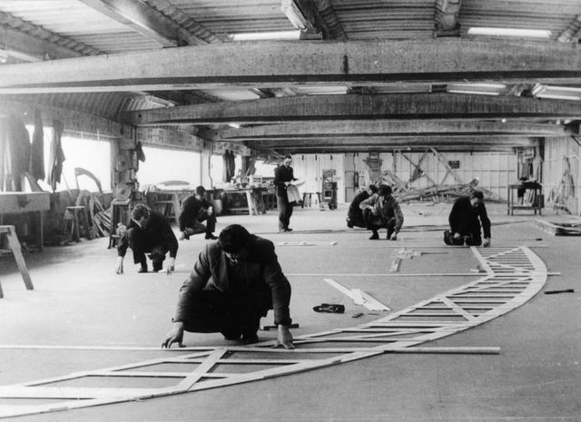
Figure 1. Old mould loft floor [7]

Finally, the lines were transferred onto full-sized moulds (patters) sawn from thin wood. These were traced to shape the timbers for the ships, much as a dressmaker uses paper patterns to cut cloth for a garment. Loftsmen cut the mould stock (thin pine boards) to shape using a band-saw. Each pattern was marked to indicate which piece of the frame it was. The patterns could be stencilled with the hull number to keep track of the sets. Often two or three sets of moulds were made: one to mark and cut the timbers, and one or two up in case the originals were damaged. Ship designers in the design office, as shown in figure 1, drew up construction details and compiled tables of offsets, or measurements, for the full-scale hulls. At some shipyards, drawn plans were used instead of, or in addition to, a half-model. In some shipyards, carving a half-hull model was the first step in designing a new boat. Drawing on both tradition and experience, shipbuilders carved hull forms that had been proven seaworthy and economical. Half-models were carved from layers (or lifts) of wood. Sometimes contrasting wood types indicated design features like the waterline. Old shipyards used models with the lifts glued together, taking measurements from the outside of the model [7].
Throughout the first half of the XX century, ships were getting bigger; so it was necessary to work on larger scales. The templates allowed working on different scales, such as widely used 1:10 scale. But with growing ship size, the moment came it was no longer practical to use templates. This happened at a time when the first computers came to our industry, promoting the development of ship design Computer-Aided Design (CAD) Systems.

Origin and evolution of shipbuilding CAD Systems
CAD Systems help engineers and designers in various industries, designing and building 3D models of airplanes, cars, bridges, digital cameras ... and of course, ships, submarines and floating structures. There are other acronyms that are usually accompanying the acronym CAD, such as Computer-Aided Manufacturing (CAM), Computer-Aided Engineering (CAE), and Computer Integrated Manufacturing (CIM), including instructions to Computer Numerical Control (CNC) machines. One could claim that these CAD/CAM/CAE Systems had their origin around the year 350 BC, with the mathematician Euclid of Alexandria. Many of the postulates and axioms used by today’s CAD tools are based on Euclidean geometry. More than 2000 years later, many see the birth of 3D CAD with the work of Pierre Bezier, a French engineer working at the Arts et Métiers ParisTech. After his mathematical work concerning surfaces, he developed UNISURF, between 1966 and 1968, to ease the design of parts and tools for the automotive industry [8]. Then, UNISURF became the working base for the following generations of CAD software. Only one decade later, CAD Systems were introduced in academic courses. The real breakthrough in CAD tools came, logically, with the development of computers; and during the 1980s the application of CAD Systems matured to a similar stage as known today.
CAD tools are usually divided into 2D drawing and 3D modelling programs. The drawing tools are based on 2D vector geometric entities such as points, lines, arcs and polygons. In 3D modellers, solids and surfaces are created. In the early stages of the development of CAD Systems, the software was running on mainframes, which limited use of CAD tools for manufacturing. With the arrival of workstations and Personal Computers (PCs) came then widespread use of CAD Systems in engineering on a daily base.
The use of CAD Systems for outfitting: piping, machinery, Heat Ventilation and Air Conditioning (HVAC)...; is much more recent than hull form design or structural design. Outfitters used plastic models until the late XX century as it appears in the figure 2. It was only then that CAD tools expanded the application range, covering all project stages, thanks to the evolution of graphics environments.
Traditionally, most shipbuilding CAD Systems focused on hull form definition, naval architecture calculations and structural design. This changed when new challenges in shipbuilding, demanding closer coordination between hull structure and outfitting, obliged marine suppliers to devote special attention to this matter. Some marine CAD tools started the development of particular outfitting tools, others limited tried to find a closer integration with existing plant design oriented systems. The development of the particular outfitting design tool was based on the fact that the actual requirements for outfitting design are not limited to a close integration with the structural design. Problems to be solved, regulations, working procedures, nomenclature, production information, etc. are so particular to ship design that it is convenient to have a dedicated tool rather than try to adapt an existing one. As time went by, outfitting tools have been increasing the scope of support.
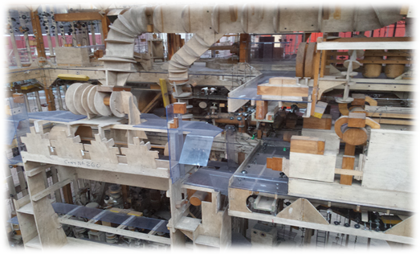
Figure 2. A scale ship model for manufacturing purposes. Image taken by the author in the Irvine Maritime Museum

Today, tools usually include particular environments for equipment modelling and layout, piping and HVAC ducts routing, definition of auxiliary structures (foundations, gratings, ladders ...), and definition of distributor supports and hangers. In some cases also electrical and accommodation aspects are considered. Particularities of outfitting design require to work in a pure 3D environment and with a friendly and suitable user interface, but new developments in outfitting tools have been always handicapped by the available technology (hardware, graphic possibilities...). Nowadays it is commonly assumed that outfitting tools should be able to work in a solid visualization method, with huge amounts of information on the scene being dynamically handled.
It was the 1960s, when some ship design offices, could not find computing tools to boost the efficiency of its projects. Small research teams was formed with naval architects and students with special interest in computer science. This combination of experience and skills within the team proved to be extremely fertile and was subsequently maintained as a desirable requirement for successful development.
Soon it was realized that mathematical descriptions of ship hull forms could be used not only to represent or fair existing hull forms, but also to generate new hull forms starting from a set of main ship dimensions and coefficients as it is shown in an old advertisement exposed on the figure 3.
The generation of intrinsically faired ship hull forms starting from the main ship design basic data was achieved in the beginning of the 1960´s [9]. The objective of this type of software/module was to obtain an approximate hull form sufficient for qualitative appearance and hydrostatics. Another module defined as earlier as the generation of hull forms, were the fairing one, used to fit (and optionally fair) an existing hull form defined by a table of offsets or by lines drawing, by means of bi-arc and splines techniques [10]. This type of module can be used to modify locally fair forms already created, in which case only the local modification, defined by point coordinates, needs fairing after fitting. For non-fair forms designed by alternative methods, both fitting and fairing are required for the whole hull form for production purposes.
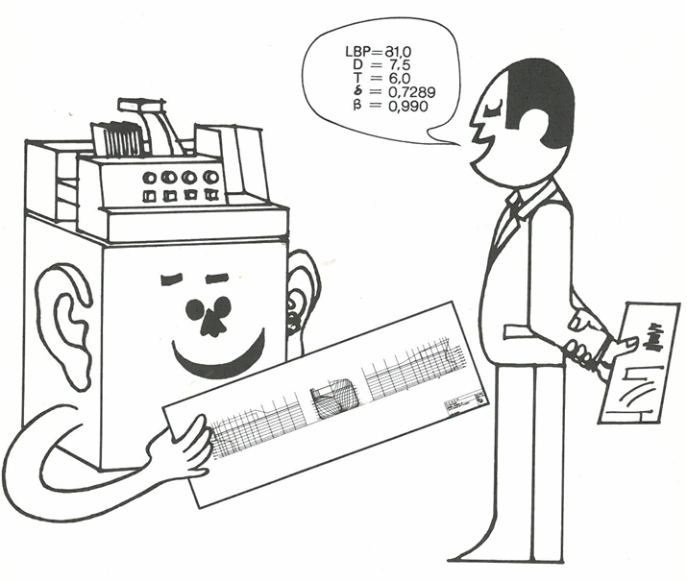
Figure 3. Old CAD System advertisement from late1960s [7]

The former CAD Systems were conceived with all ship design disciplines (hull form generation, hull fairing, naval architecture calculations, design and production of structure) coordinated, with ultimate goal obtaining ship production in the shortest and cheapest way.
The Marine CAD tools were continuously improved and used as an internal tool at different ship design offices and shipyards, supporting high-quality projects within unusual response time. In 1969, the Spanish company, Bazan (now known as Navantia) was one of the first shipyards to use shipbuilding CAD Systems. Since then, it is not understandable the ship production and design without the use of a CAD [11].
From 1970s, CAD’s functionalities were expanded (structure, machinery, piping, electrical and beyond). This evolution ran parallel to the course of computers, from large computers operated with punching cards, modules running on mainframes only available for the largest shipyards, through the mini-computers like PRIME or VAX with monochrome graphical screens, then the UNIX Operating System, moving forward for working on PCs, with amazing graphics and great computing capabilities.

Ship design using CAD Systems
Over the past forty years, CAD tools have progressed from mainframe computers to PCs, from independent programs to fully-integrated programs, and from large shipyards to all sizes of shipyards. More to the point, key advances during the past several years have made 3D product modelling a tool that can significantly improve small yard efficiency, quality, and profit. However, 3D product modelling can do these things only if implemented in a planned and well thought-out manner, tailored to the specific yard. Importantly, 3D product modelling is but one of several innovations (some others are CNC and the workstation approach to production) that, when combined, can make a shipyard remarkably more competitive than when using traditional methods (such as stick building and full-size lofting).
A 3D product model may be defined as a computer program that supports the analysis and informational needs for engineering, design, construction, and maintenance of a ship. The product model database contains geometric information such as hull form definition, and non-geometric information such as equipment weights. The information is contained in a central database and is available as graphical displays, hardcopy printouts, and as electronic files for use by CNC production equipment. The database provides a single source for complete, updated and consistent information to all involved in the design and production processes [12].
The 3D capability of 3D product modelling is important in ship design and construction. Traditional ship design is carried out in 2D in the preliminary stages and extended to 3D in the detailed stages. The extension from 2D to 3D results in a large expenditure in time and labour [13]. Product models enable the designer to either begin in 3D or to easily progress from 2D to 3D, realizing savings over the traditional approach.
3D product modelling makes possible an integrated approach to ship design and construction within a multi-user environment and implies elements such as the following [14]:
- The designer works in a fully interactive 3D graphic environment.
- Structure and outfitting may be designed in parallel.
- Information about hull form, decks and bulkheads is always available to all designers who are using the product model.
- A designer working in a zone or block of the ship has available the information of other zones or blocks (contiguous or not).
- Outfitting designers in a zone use the last updated information of the hull structure, available in the product model.
- Automatic references to the hull, decks, bulkheads, frame system, or to any ship part can be obtained when generating drawings for production (e.g., plan drawings, pipe isometrics, and perspective drawings).
- Designers’ choices are limited for steel plate, steel shapes, and outfit items through the use of shipyard-defined design catalogues (these catalogues may be carried over to follow-on designs).
- Data may be exchanged with other users and multiple users at remote sites can simultaneously work on a single ship design.

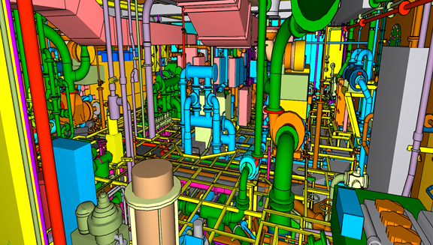
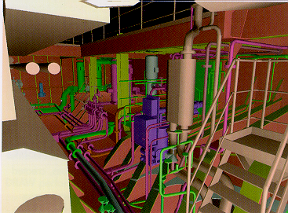
Figure 4. Two screens from different CAD chronological periods. Left view a machinery space from late 1990´s. On the right, a machinery space with a CAD Systems nowadays

3D product modelling enables designers to use the same model of a ship, from the earliest states of design all the way to production, helping to maximize consistency of data throughout the design process. Advantages of product models include: decreased design hours, reduced lead time, increased productivity, early detection of interferences, ease in making changes, a drastic reduction of information errors, a primary source of design information, and the availability of production-oriented data. This technology may include expert systems and artificial intelligence. As an example, in the figure 4 it is shown different representations of a machinery space from different periods on time.

The Internet of Things applied in a CAD Shipbuilding environment
Shipbuilding process, generates a lot of information and data, which a priori makes impossible to have all this data in real time, but the new processors, simpler and smaller, with a good connection to the Internet, make it possible.
The different machinery equipment to be installed in the ship will have to be prepared for connections between them in order to provide the necessary information that the components must to share for the normal operation [15].
There should be two different networks of connections. An internal network where the systems and components of the ship work together to get the best operation possible. Different smart devices, components and systems will share their state, or their needs for a better operation. But, another connection must be done to the external world. This external connection will provide the interconnection of the whole ship as a smart ship with the centralized intelligence of the ship-owner. This connection will share information necessary for the better operation of the ship, or will allow to receive the orders for a better operate according with the information received from other hips.
Also the information necessary to get the replacement or revisions of the components will be transmitted from the components itself.
To make possible this approach it is necessary that the CAD tools are able to manage the amount of data generated and the relationship between the components and target of the information they share.
Adapting shipbuilding to the concept of Internet of Things (IoT) can be done from different approaches [16].
The future ship design tools must be opened to take advantage of the information that smart devices and smart ships already adapted to IoT will supply. Information such as the performance of its operations, consumption, trips, etc. They will allow for an early evaluation of naval projects and better designs.
The information shared in the scope of the IoT must be managed along the whole lifecycle of the ship, starting from the beginning of the initial design. This need requires the CAD tools to be prepared with specific characteristics to handle that information.
Many of those characteristics are not yet available and the software developers must to prepare them. It is necessary to design CAD software able to receive information of ships in operation to evaluate the performance of the designs with real data. And of course, the product data model must have the ability of incorporating relations between internal and external components.

Shipbuilding & CAD facing the Future together avoiding mistakes in the design
CAD vendors have taken their time preparing oriented solutions including those that allow to minimize designer errors. In recent projects, there has been the need, for ship designers, to use CAD tools to work better, avoiding to introduce mistakes into the 3D model, with all parts information and classification and construction drawings as much accurate and precise as possible. A CAD tool with design rules embedded would allow to reduce time and cost, and produce detailed 3D models and accurate classification drawings, in addition to others.
During the first stages of the ship design, it is where there are more implications downstream, so more mistakes could imply more losses of productivity. At top of this some of future improvements regarding General Arrangement and Naval Architecture Calculation are:
- The CAD tools should not allow to place compartments in incorrect locations, as they are stated on the Rules of the Classification Societies, and they should also request the inclusion of a cofferdam. As an example, the CAD should avoid locating a fuel tank next to the external hull.
- This CAD Systems should avoid the wrong positioning of an equipment inside the wrong compartment.
- According to power estimation, the software should apply the most convenient method in order to calculate the Effective Horse Power, because the program already has the necessary information about hull forms, as for example Froude Number, Block and Prismatic Coefficients.

Also in the hull structure discipline there is plenty of room for improvement. Some of the ideas for the future:
- The Systems should avoid the location of macro-holes closer than a minimum distance from a watertight bulkhead.
- The CAD tools should avoid piping, HVAC and cable trays penetrations if in the structure there is a hole closer than a minimum distance according to the Classification Society’s rules.
- Improvements in the welding management. There are so many areas where the designer could make an error applying welding procedures or tasks.

As mentioned before, there are many areas where the CAD Systems could improve the design rules, and the electrical discipline is not an exception:
- The Systems should control the minimum and maximum distance between the cable tray and the surface where the supports lay.
- There is no control of the cable tray material to be used based on the zone of the ship, i.e. steel, aluminium, etc. The CAD tools should control the cable characteristics, as it is isolated against fire, oil, corrosive, low emission in the case of fire.
- There is not control regarding connectors/equipment linked with specifications.

Sensors, Big Data and the cloud are some of the most interesting changes in the way the technology collect and manage data in recent years. These changes have not significantly influenced the common practices in condition monitoring and validating CAD Data. In part this is due to the reduced trust in data security, data ownership issues, lack of technological integration and obscurity of direct benefit. It is necessary to design and prepare a method for incorporating smart sensor techniques and distributed processing in data acquisition for condition monitoring to assist during the design process.
New technologies are appearing in the world that in a very short term shall be linked with the design systems in order to facilitate the design in self. The technologies of treatment of Big Data and fast searches, shall allow to engage the design of a part or any concept with the applying rules. The integration of the validation of the structural models by the Classification Societies shall be done by using the cloud computing or with direct connection with cloud applications. This will result in a faster and more reliable design.
Monitored full-scale performance data should be analysed in the future in order to improve the performance conducted at the design and manufacturing stages. Performance evaluations should be made, employing developed monitoring and performance analysis methods, so full-scale performance can be evaluated with a high degree of confidence, and its results can be effectively utilized in the ship design stage. CAD simulation tools and Artificial Intelligence for user guidance, Big Data using Artificial Intelligence to help ship designer for optimizing the 3D model, so it is easy to predict that this is the future.
There are many advantages of using CAD in shipbuilding: ease of design with the design rules embedded, speed of design, use and reuse of information, etc. It is expected that in the future CAD tools will advance further and allow greater information management through these new improvements. In general, CAD Systems provide tangible benefits while the process is optimized, reducing design time and production, and therefore costs. As a summary, there are several scenarios of improvements, as the design rules explained in this paper, for the next years. Some of these improvements may seem unrealistic in the short term, but reality often exceeds expectations in any field, and probably more in technology.

References
- CLARK, L. AND TYSON, P.: “Explore Ancient Egypt”, Nova. PBS. Retrieved December 2012.
- LEON, C. AND DOMINGO, B.: “La construcción naval en el Mediterráneo greco-romano, Centro Nacional de Investigaciones Arqueológicas Submarinas”, CuPAUAM, pp.199-218, 1992.
- DUHAMEL, H.L.: “Elements de l'Architecture Navale ou Traite Pratique de la Construction des Vaissaux”, Paris, 1752.
- MUNCHMEYER, F.C., SCHUBERT, C. AND NOWACKI, H.: “Computer Applications in the Automation of Shipyard Operations and Ship Design IV”, pp.183-188, 1984.
- NOWACKI, H.: “Splines in shipbuilding”, 21st Duisburg Coll. on Marine Technology, 2000, Duisburg.
- BERGER, S.; WEBSTER, A.; TAPIA, R. AND ATKINS, D.: “Mathematical ship lofting”, J Ship Research, vol. 10, pp. 203-222, 1966.
- PEREZ, R. AND GONZALEZ, C.: “History and Evolution of Shipbuilding Oriented CAD Tools,” COMPIT, Germany, vol. 1, pp 8-21, May, 2015.
- MEHLUM, E. AND SORENSON, P.: “Example of an existing system in the shipbuilding industry: the AUTOKON system”, Proc. Roy. Soc. London, Series A, vol. 321, pp. 219-233, 1971.
- THEILHEIMER, F. AND STARKWEATHER, W.: “The fairing of ship lines on a high speed computer”, Numerical Tables Aids Computation, vol. 15, pp. 338-355, 1961.
- ROGERS, D. AND SATTERFIELD, S.: “B-spline surfaces for ship hull design”, Computer Graphics (Proc. Siggraph 80), vol. 14, no. 3, pp. 211-217, 1980.
- PAPANIKOLAOU, A.: “Holistic ship design optimization”, Computer-Aided Design (JCAD), vol. 42, pp. 1028-1044, 2010.
- BAUM, S., AND RAMAKRISHNAN, R. “Applying 3D Product Model Technology to Shipbuilding,” Marine Technology, January, 1997.
- PEREZ, R. AND DOO-JIN L.: “An innovative approach for Korean CADres”, The Naval Architect, July-August, pp.58-61, 2014.
- NSRP: “Evaluate the Shipbuilding CAD/CAM/CIM Systems,” Phase II Report 0479, CAD/CAM/CIM Requirements, Project 4-94-1, National Shipbuilding Research Project, February 1997.
- MUÑOZ, J.A. AND PEREZ, R.: “CAD tools for designing smart ships in the world of the Internet of Things (IoT)”, Smart Ship, London, United Kingdom, vol. 1, pp 29-35, January, 2017a.
- MUÑOZ, J.A. AND PEREZ, R.: “The Internet of Ships: a new design for Smart Ship”, The Naval Architect magazine. pp. 26-30, 2017b.

Corresponding Author, Rodrigo, Perez Fernandez, C/ Severo Ochoa, 4 - 28760 Tres Cantos - Madrid (Spain); E-mail: rodrigo.perez@sener.es.

