A Ballast Allocation Technique to Minimize Fuel Consumption
Luca BRAIDOTTI^{a,b,}, Francesco MAURO^{a,b}, Luca SEBASTIANI^{c}, Sergio BISIANI^{d} and Vittorio BUCCIª
ªDepartment of Engineering and Architecture, University of Trieste, Italy
^{b} Faculty of Engineering, University of Rijeka, Croatia
^{c}Seastema S.p.a., Genova, Italy
^{d}MarineLab d.o.o., Izola, Slovenia
Abstract. Nowadays, fuel consumption reduction is a primary concern in order to minimize operative costs and emissions during navigation. On this purpose, ballast management play an important role, in order to find the best configuration for ship navigation. An optimal ballast water distribution ensures to find a floating position having the minimum fuel consumption while assuring the fulfillment of rules requirements related to strength and stability. Since ships are operating also in adverse sea state condition, optimal ballast conditions should be found also for service conditions, considering the impact of added resistance due to waves on the propeller and consequently to fuel consumption. Within an emergency decision support system, an optimum ballast system has been developed satisfying the above mentioned requirements. In order to assess the optimal ballast allocation in a fast and accurate way, the equations are linearized and solved by means of pseudo inverse matrix. The target of this process is to find for a defined set of ballast tanks the level, or rather the volume, of water to reach the optimum floating position. The procedure has been tested on a reference ship and the results are here reported and described.
Keywords. Ballast water, Optimization, Fuel consumption reduction.

Introduction
Shipping companies are always concerned in cost reduction to increase their competitiveness on the market. The fuel cost is one of the most important components of operative expenditure (opex) connected to the maritime transport of passengers and goods. In the last two years, the fuel prices are constantly increasing, even though they remain far from the maxima reached before the fall of 2008 and 2015. These circumstances, together with the growing attention to the environmental issues and the increasingly restrictive rules on emissions give new importance on fuel consumption reduction in shipping industry.
The most effective way to obtain this goal is indeed considering the most important attributes connected to resistance, propulsion and seakeeping since the early stages of concept design in order to consequently define best possible solutions [1]. Even if the design of the ship has the utmost influence on opex, for a built ship, fuel consumption shall be minimized combining properly ballast allocation and weather routing, especially for hull shapes where trim has a strong influence on the calm water resistance.
Many works concerning weather routing [2] present techniques to reduce fuel consumption by avoiding heavy seas on the base of weather forecast. On the contrary, a limited literature exists about ballast allocation. The problem is usually connected to the ballast control systems of crane vessels, floating docks [3] or underwater vehicles [4] where only a reduced number of ballast tanks (usually four) are considered. Other heuristic methods provide a ballast allocation to support stowage planning on containerships [5].
The aim of this paper is to develop a fast and reliable technique to perform ballast allocation in order to reduce fuel consumption. For each ship speed, an optimal floating position is defined taking in consideration all the most important aspects of propulsion system. Then, on an arbitrary set of ballast tanks, the volumes of water to obtain such a floating position (or the closest) are assessed by means of a pseudo-inverse matrix [6] based approach, already used to approximate complex optimisation problems [7] related to naval field. This procedure is designed to be part of an onboard Decision Support System (DSS) devoted to assess the overall safety of the ship in emergencies as well as in navigation. The low computational load of the ballast allocation technique allows a fast and wide application on onboard system provide a viable solution to monitor and contain fuel consumption and consequently the emissions.
The proposed technique is applied as case study on a crude-oil carrier sailing in ballast condition.

Ballast DSS
For certain type of vessels, the ballast distribution has a strong impact on ship resistance and, consequently, on fuel consumption. A navigation in a non-optimal floating position decreases the ship efficiency resulting in higher emissions of pollutants and fuel costs. This is why, an onboard DSS concerning ballast should be recommended.
Such a DSS has to be make the crew aware of the possibility to reduce fuel consumption during navigation by acting on ballast allocation. Crew shall perform the allocation of ballast in compliance with the stability and longitudinal strength requirements, avoiding to reduce ship’s safety while optimizing the floating position of the vessel. Thus, ballast DSS should be integrated within a risk based framework devoted to assess the overall safety state of the ship [8, 9]. In this contest, for a generic operative loading condition, it is possible to define a so-called “environmental risk”, measuring how the actual emissions exceed the emissions corresponding to the optimal floating position, i.e. the one which minimize fuel consumption. The environmental risk index i can be defined as:
(1)
Where FC is the actual fuel consumption and FC_{O} is the fuel consumption corresponding to optimal ballast distribution; both are evaluated at the actual speed and actual weather condition. The index i varies in the range 0-1. It assumes unitary value if the environmental risk is null, namely when the actual loading condition is the optimal for fuel consumption.
In addition, an on-board DSS has to provide a ballast allocation tool which allows the crew to reproduce the floating position with minimum fuel consumption. The ballast allocation tool can be used to support ballast and de-ballast operations in port or during navigation, providing rapidly the distribution of ballast water corresponding to a required floating position and, in the corresponding loading condition, the overall safety state of the ship.

Definition of Optimal Floating Position
The optimal floating position of a ship is the one able to guarantee the minimum fuel consumptions in compliance with rule requirements. Therefore, it is necessary to express the fuel consumption as a function of all the parameters characterizing the problem.
A generic floating position is defined univocally by three parameters: the mean draught T_{M}, the trim angle θ and the heel angle φ. The heel angle corresponding to the minimum fuel consumption for a symmetric hull is null; therefore, in any case the ballast shall be allocated in a way to limit the heel of the ship. Regarding the trim, it is well known that it can strongly influence the total resistance R_{T} of a vessel. For such a reason, trim is of primary importance for the fuel consumption minimisation in calm water.
Besides, in an operative condition, the added resistance due to waves R_{AW} can have a non-negligible impact in case of heavy seas, increasing the total demand of propulsive power. When sailing in heavy sea, the increase of ship motions can be such important to cause also an involuntary speed reduction. The added resistance can be assessed using methods based on the strip theory [10] in regular waves or in an irregular sea modelled with a wave spectrum as well as by statistical methods [11]. From resistance the effective power in a seaway is determined as in Equation (2)
(2)
It is possible to perform an optimization based on the effective power, neglecting the hull-propeller interaction, the effect of propeller itself, and the load of the main engine(s). Nevertheless, all these aspects have an important influence in the determination of the fuel consumption of the engine. The minimization of this parameter assures certainly better results than the minimization of effective power. For a standard diesel-mechanic arrangement, the engine power P_{B} can be evaluated as in Equation (3).
(3)
Where η_{m} is the efficiency of the shaft line and eventual reduction gear, η_{H} is the hull efficiency, η_{R} is the relative rotative efficiency, η₀ is the open-water propeller efficiency.
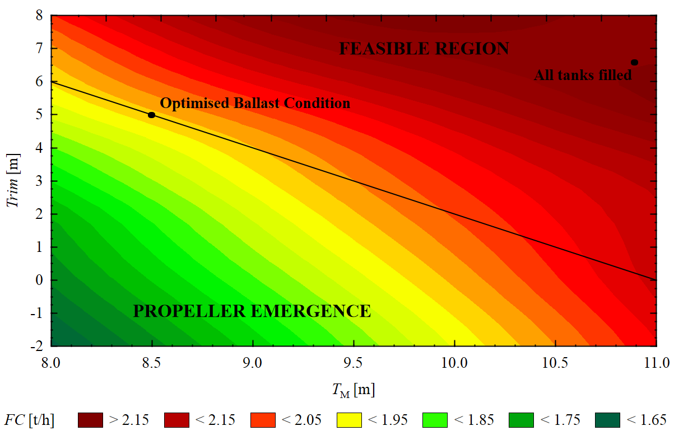
Fig. 1. Fuel consumption of a crude-oil carrier in calm water
The propeller efficiency has an utmost influence on this efficiency chain and varies substantially with propeller load, especially for a fixed pitch propeller.
The break specific fuel consumption BSFC is provided by the engine manufacturer as a function of the engine load (P_{B}/MCR). Using this value is possible to determine the fuel consumption FC, the quantity that shall be minimized.
Applying this process, the fuel consumption can be assessed for each floating position taking into account all the most important parameters connected to propulsion, weather condition and their interaction. Figure 1 shows the influence of trim and mean draught on the fuel consumption for a crude-oil carrier at the constant speed of 13 kn.

Ballast Allocation
In an optimum ballast system, the allocation of ballast water is a primary concern. When an optimal floating position (target) is selected in order to minimise fuel consumption, the ballast allocation process has to spread the ballast water inside a set of selected tanks in order to reach the required target. The process (Fig. 2) can be faced with a linearised approach, where the equilibrium equations, dependent on the volume of water inside each tank, are linearised in order to apply simple optimisation methods.
When the optimal solution is found, it is necessary to evaluate its feasibility, checking if the needed volumes comply with the tank capacities. If the water volumes are not feasible, a new solution has to be searched removing properly unnecessary variables. The process is repeated until a feasible solution is found or all the variables are removed (in the latter case the target is unreachable, but the system will provide the closest solution). Then the loading condition including final ballast water distribution should be processed to verify the compliance with stability and structural strength requirements.
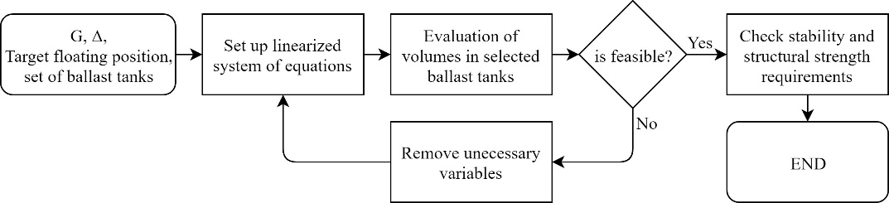
Fig. 2. Ballast allocation process

Linearised Problem
In the earth-fixed reference system referred to the target floating position, the following equilibrium conditions have to be satisfied.
(4)
(5)
(6)
Where G_{i}, ρ_{i} and v_{i} are the mass centre, the density and the volume of fluid inside i-th ballast tank respectively; W and G are the ship’s weight and mass centre respectively considering empty all the n selected ballast tanks, whereas B and Δ are the centre of buoyancy and the displacement associated to the target floating position, respectively.
Equation (6) is already linear and does not require further attention. On the contrary, Equations (4) and (5) are non-linear since the position of the mass centre of the tanks depends upon the volume of liquid. In such a case, the system can be linearised assuming a constant position of the tanks’ mass centre that, for standard tank shapes, varies significantly only in vertical direction (having a lower grade of influence on the system of equations). Then, it can be assumed as the geometric centre of the tank. Based on the above considerations, the equilibrium equations can be easily rewritten in matrix form as:
(7)
Where A is a 3×n matrix, v=(v₁,…,v_{n}) is the n×1 vector of ballast tanks volumes and k is a 3×1 constant vector.

Pseudo-Inverse Solution
The solution of the system (4) can be easily found evaluating A⁺, the pseudo-inverse of the matrix A, as described in Moore [6]. Singular value decomposition (SVD) should be applied to evaluate pseudo-inverse in a computationally efficient way [12]. In order to avoid the divergence of the inverse of singular values, they are assumed null if the related singular value is less than the Froebius norm of the matrix A multiplied by a small quantity, in the present work assumed as 1E-10. Therefore, the solution of the system in equation (7) is then evaluated as in equation (8).
(8)
Where v* represents the volumes of ballast water that satisfy the systems in Equation (4) while minimizing the Euclidean norm.
This least square solution is equal to the system solution when it is determined, namely when the level of three non-aligned ballast tanks has to be found. When a larger number of variables are used, the system results undetermined; in this case the least square solution provides intrinsically an optimal distribution of ballast water, minimizing its total amount. Finally, if the system is over-determined and no solution can be found, the technique anyway provides a least square approximation, allowing to define the ballast distribution resulting in the closest floating position compared to the target. Nevertheless, it could happen that the volumes provided by Equation (5) are not physically feasible: the amount of water contained inside tanks could result negative or exceed tank capacity. This is way the feasibility of the solution has to be checked and, if it necessary, the number of variables reduced conveniently.

Feasibility Check
The volumes provided by Equation (7) are submitted to feasibility check. An×1 vector r is initialized with all elements to null value. For each tank, the feasibility check is performed as follow: if the volume is negative, the tank is assumed void; otherwise, if the volume exceeds tank’s capacity, the tank is assumed full of ballast water. In both cases a value 1 is assigned to r_{j}. If at least one tank do not pass the feasibility condition ‖r‖₁>0, a new iteration is required and all the variables related to unfeasible ballast tanks are removed. The constants’ vector is updated as in Equation (9).
(9)
A new system without the removed variables and including the new constants is defined as in Equation (6); then a new iteration is started.

Worked Example
The ballast allocation technique was tested on a crude-oil carrier having a deadweight of 179,500 t and sailing in ballast condition at the service speed of 13kn. The main particulars of the ship and of its propulsion system are provided in Table 1.
Table 1. Crude-oil carrier main particulars and propulsion system
L_{BP} | 284,000 m | L_{OA} | 291.750 m | B | 44.980 m
T | 18.150 m | D | 25.000 m | C_{B} | 0.85
Main Engine | 1 x 2-stroke | MCR | 25,270 kW | Engine Speed | 90.8 rpm
Prop. diameter | 8.35 m | Pitch ratio | 0.735 | Area ratio | 0.525
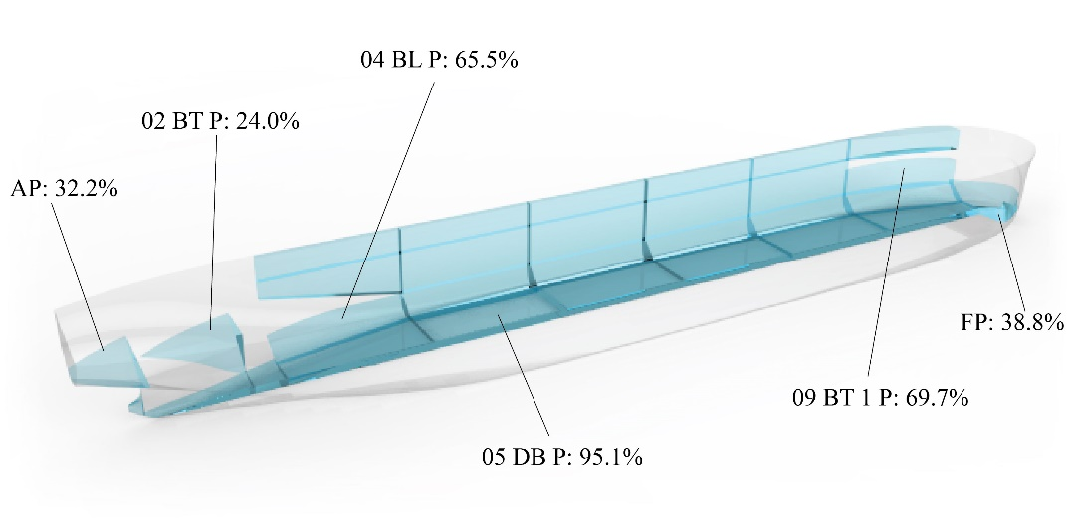
Fig. 3. Ballast allocation at optimal floating position for a crude-oil carrier
(except for compartments 1 and 10), two bilge tanks in compartments 4-9, four double side tanks for compartments 4-9, and two side tanks in compartment 2 (besides engine room). All tanks’ volumes are assumed as variables of ballast allocation problem.
The optimal ballast floating position is characterized by a mean draught of 8.5 m and a trim of 6 m (Fig. 1). It was assumed as target for the ballast allocation process. The process provided the results presented in Figure 3. Most of the ballast tanks were completely filled demonstrating the effectiveness of feasibility check.
The resulting volumes were used to determine the new weight and mass centre of the ship. Those parameters were assumed as input of an equilibrium evaluation in order to determine the associated floating position and compare it with the target. The comparison is provided in Table 2 and shows that the linearised technique has a very good accuracy, within the limits required for on-board loading computer systems [13].
The fuel consumption of the optimal floating position was compared with the consumption at the draught of 10.80 m and trim of 6.6 m, corresponding to a condition characterized by all ballast tanks completely filled. The results (Tab. 2) highlights a reduction of 0.26 t/h in fuel consumption and a reduction of environmental risk of 0.12.

Conclusions
This paper shows the viability of ballast allocation to increase the energy efficiency of the ship. It provides a simple and accurate technique to perform ballast allocation in the contest of an onboard DSS.
A limit is represented by the non-direct inclusion of rule requirements in the allocation process.
Table 2. Ballast allocation at optimal floating position
 | After Draught | Mean Draught | Forward Draught | Heel Angle | Ballast Water
Target | 11.000 m | 9.500 m | 6.000 m | 0.00 deg | 50568 t
Evaluated | 10.967 m | 9.499 m | 8.030 m | 0.00 deg | 50568 t
Error | 0.30% | 0.01% | 0.37% | 0.00% | 0.00%

Table 3. Comparison between optimal ballast condition and all ballast tanks filled
 | P_{B}[kW] | n [rpm] | FC [t/h] | i
Optimised | 11660 | 80.5 | 1.98 | 1.00
All tanks filled | 13196 | 83.9 | 2.24 | 0.88
Diff. | 1536 | 3.4 | 0.26 | 0.12

Anyway, the problem is easily overcome by considering the environmental risk connected to ballast distribution as an element of a risk-based framework, already taking into account the compliance with rules. Further studies should be carried out to include inside the procedure a more flexible and non-linear allocation strategy.

Acknowledgements
This work has been developed under the EDSS (Emergency Decision Support System) project of the POR FESR 2014-2020 Friuli Venezia Giulia.
Thanks to Ubaldo la Monaca for the ship rendering.

References
- Trincas G, Mauro F, Braidotti L, Bucci V. Handling the Path from Concept to Preliminary Ship Design. Proceedings of 13thInternational Marine Design Conference, IMDC 2018. Helsinki, 2018.
- Veneti A, Makrygiorgos A, Konstantopoulos C, Pantziou G, Vetsikas IA. Minimizing the fuel consumption and the risk in maritime transportation: A bi-objective weather routing approach. Computers and Operations Research, 2017; 88:220-236.
- Ohkawa T, Itoh M, Matsunaga H,Horiguchi K, Sato K. Automatic Ballast Control for Floating Dock. Proceedings of the 9th Triennial World Congress of IFAC. Budapest,1985.
- Li JQ, Wan L.The heel and trim adjustment of manned underwater vehicle based on variable universe fuzzy S surface control. Proceedings of 2011 International Conference on Electronics, Communications and Control, ICECC 2011; Ningbo, 2011.
- Zeng M,Low MYH, Hsu WJ, Huang SY, Liu F, Win CA.Automated stowage planning for large containerships with improved safety and stability. Proceedings of Winter Simulation Conference; Baltimore, 2010.
- Moore EH. On the reciprocal of the general algebraic matrix. Bulletin of the American Mathematical Society, 1920; 26(9):394-395.
- Mauro F., Nabergoj R. Smart thrust allocation procedures in early design stage dynamic positioning predictions, in: Proceedings of 18th International Conference on Ships and Shipping Research, NAV 2015, Lecco (Italy), 2015
- Trincas G, Braidotti L, De Francesco L. Risk-Based System to Control Safety Level of Flooded Passenger Ships. Brodogradnia. 2017; 68(1):31-60.
- Braidotti L, Prpic-Orsic J, Valcic M, Trincas G Bucci V. Fuzzy Analytical Hierarchical Process to Assess Weights of Importance in Ship Operation Risk Assessment. Proceedings of the 19thInternational Conference on Ships and Maritime Research NAV 2018; Trieste, 2018.
- Gerritsma J, Beukelman W. Analysis of the resistance increase in waves of a fast cargo ship. International Shipbuilding Progress, 1972;19(217):285-293.
- Gerritsma J, van den Bosch JJ, Beukelman, W. Propulsion in regular and irregular waves. International Shipbuilding Progress,1961; 8(82):235–247.
- Golub G, Kahan W. Calculating the Singular Values and Pseudo-Inverse of a Matrix.Journal of the Society for Industrial and Applied Mathematics Series B Numerical Analysis,1965; 2(2):205-224.
- IACS. UR L5 Rev.2 On Board Computers for Stability Calculations. International Association of Classification Societies, London, 2006.

Corresponding Author,Luca Braidotti, ISD Lab, Department of Engineering and Architecture, Via Alfonso Valerio 6/1, 34127 Trieste, Italy; E-mail: vbucci@units.it.

