Non-Linear and Modular Planning
Vedran SLAPNIČAR^{a,} and Ivan ADUM ^{b}
ª University of Zagreb, Faculty of Mechanical Engineering and Naval Architecture, Ivana Lučića 5, 10000 Zagreb
^{b} Torbarova 14, 10000 Zagreb
Abstract. Shipbuilding is a nonlinear and modular process. Activities in production, design, management, and finance are interlinked and interdependent. That has been, but only partially, already tackled by PERT [1] and net diagrams depicting interdependence of activities, but in the production process mainly. We deem it desirable and indispensable to introduce all activities not only during the production process but in the preparatory stage as well, i.e. design, development of drawings, class and government bodies’ approvals, purchase of materials, finance i.e. cash flow. The shipbuilding process in a broader sense includes also after delivery activities which should also be part of planning and prediction process. Our response time i.e. countermeasures could and should be instantaneous. Shortening of the reaction time is the key to the success. Novum that we suggest is the definition of the whole, total, shipbuilding process as a number of interlinked and interdependent activities, activity modules.
Keywords. Shipbuilding process modular planning, Total algorithm, permanent, control, effective management

Introduction
One vivid example from past and real-life 3.MAJ shipyard from Rijeka has faced insolvency and possible bankruptcy in 1971. Bottleneck has been the steel prefabrication, joining sections and assembly on the slip. Although the vessels then under construction have been rather simple general cargo and Lake size bulk carriers, the practically total absence of planning has created an almost insurmountable problem. By introducing a net planning, but alas in steel preassembly and assembly plant only, the total steel fabrication in one year rose from modest, to say the least, 30.000 tons to well over 80.000 tons, final result instead of 4 vessels 3.MAJ delivered 11 vessels in 12 month span. One should attribute to every event, stage in production process, an inter-dependability factor, number 1 being the factor stable independent event that is neither influenced by other events nor affects other vessels, and 1/10 event in correlation with other ten events. By introducing such, or other similar factors, coefficients, net planning becomes more realistic and reflects real physical and commercial relations. Mathematics is just a servant of reality of physics in broader sense.
Felix qui potuit rerum cognoscere causas TLC should inspire us to think, and not just to apply ready-made gadgets, algorithms and subroutine packages. TLC would have undoubtedly been a good naval architect. Importance of planning and prediction rises with the complexity of the project that is self-evident. One might say, how shall we plan and predict something we do not know well enough before we start the project? Just because! Even the biggest and the strongest naval architecture today, i.e. US naval yards, have made significant improvements by introducing early planning and prediction. Planning is inter alia a cost control. First submarine of Virginia class, the most advanced and deadly attack submarine in US fleet, that took 10 years to plan, design and build, and took abt. 15.000.000 man-hours to build only, while the ninth in a series needed, still staggering, 10.000.000 man-hours. The reduction is significant, abt. 33 %. Similar data available for much smaller and less complex naval vessels built in Shipyard Kraljevica (Croatia), show the conformity of percentage of learning, saving in a series, it seems that relative figures are the same irrespective of the complexity. Kraljevica building a series of nine fast attack vessels in batches of three. The third series had a reduction in man-hours of abt. 35 %.
Relatively simple vessels are easy to build. Scottish engineer, which has emigrated to Sweeden to start serious shipbuilding there, has transferred all then available and useful knowledge in a single book, a portfolio of drawings [2]. When American naval architects came to Great Britain during the WW II to collect the drawings and specifications for a cruiser, a team of 12 engineers, they presumed that one planeload would suffice to carry all. How naive. How to process so much data? In order to do it in the past, humans, Homo Sapiens that is, has developed letters and numbers. That enabled all the data to be stored and processed. According to Yuval Noah Harari from Hebrew university in Jerusalem, first writing in Mesopotamia, cuneiform, has been used exclusively for bookkeeping. Writing is a safekeeping of information. Simple letters and numbers are possibly also able to record swollen number of information needed to design and produce today’s vessels but are not suited to process so much data in an acceptable period of time to make it commercially and technically viable. We need algorithms, and we need advanced mathematics but as a servant only. Master is the thinking, cognitive process, design, we should never be led to think that by applying fancy gadgets we can replace creative process.

Subdivision of Total Algorithm
We have divided the whole process into logical parts, modules that are interlinked and inter-dependent but they could be also reviewed separately, the overall cognitive process should be integral (Fig .1).

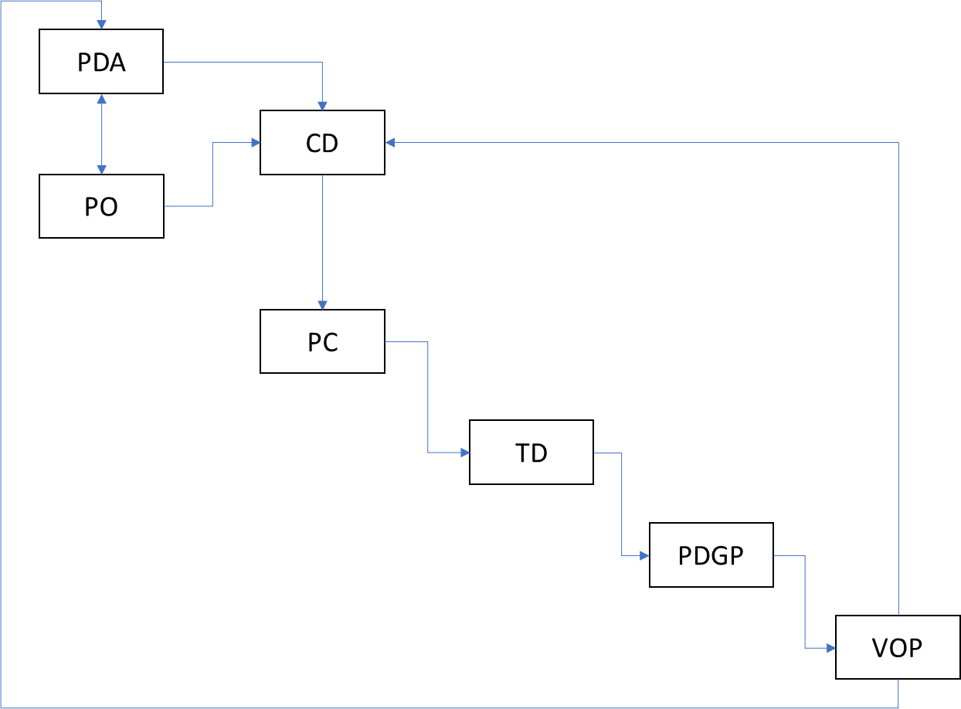
Figure 1. Subdivision of total algorithm.

PO - Project organization
How to tackle the problem? By vertically integrated organization or by modules which could be subcontracted, outsourced. Besides purely commercial reasoning one should take into consideration overall control and the management of the project. Numbers only should not govern our decisions, it is very important to check the reliability of all subcontractors and reasonable guarantees should be an integral and indispensable part of outsourcing. One can plan a shipbuilding project either in established shipyard with vertical integrated functions, such as say, purchase of steel plates and or profiles and tubes, shot-blasting, cutting, welding of panels, preassembly of sections, assembly of sections, hull, on slip or in dry-dock and launching, and finally outfitting and tests. One can skip some of the work and functions named above and buy it as a subcontract and or outsourcing. It is today very often the case in order to streamline the costs and fight against ever-increasing competition. One can buy primed panels, even cut to dimensions, an entrepreneur in such a case supplies the data for cutting in electronic form. This eliminates the need to have a shot-blasting and priming plant for the comparatively small quantity of steel. This adds cost element but eliminates some of the fixed amortization costs for heavy equipment in a yard. It is relatively simple to make equations which should give us the answer and choice. Such plates, profiles, and tubes can then be sent over to local subcontractors to make block sections, later on, to be painted in a paint shop either by the subcontractor or in the yard itself, one can eventually order the whole hull, mostly in lower labor cost areas and or countries. In such extreme case of outsourcing one reserves the position of designer, decision maker, all the remaining process is relatively low-cost operation but has to be meticulously planned in order make the project economically feasible. Sloppy planning as a result of lack of knowledge inevitably leads to loss of control, the commercial loss is a logical consequence. One has to conceive, understand the project, its logic, shipbuilding process and its intricacies, and finally translate it into a planning. The decision to subcontract is not an easy one and should not be taken lightly, an irresponsible and substandard subcontractor can produce more damage and cause irretrievable losses, all the guarantees notwithstanding. Non-performance, plain and simple, is the definite loss.
Vertically integrated shipyard has all the functions and shops once regarded as essential, not so long ago yards used to make boilers and steam engines, later to be substituted by in the yard motor shop, factory, limiting the choice of the designer but also having some sort of a control over a very significant cost component of the ship, vessel, plant to be built. In a long run, one has to weigh one argument against the other, rather large amortization cost element plus limited choice versus no amortization and a risk of uncontrolled or better to say the market controlled price of the power plant. There is only one viable argument, what if the competition controls the engine market and denies us the access? Then again we are faced with total loss, we are out of business. But is it at all logical to have all the machinery, parts, devices and apparatuses made within the premises, probably not. It is much more sensible to make a network, strategic alliances with all the producers, fixing the prices and quality standard, and concentrate on design and final assembly of the vessel, ship, plant, and product. Then the shipbuilding could, possibly, but only possibly, have a chance to exist in a relatively high labor cost environment. Jointly we stand a chance, separately we fall. Safety should prevail.

PDA - Project Decision Algorithm
Algorithm module, Project Decision Algorithm, PDA, i.e. checking whether the project, building of a certain type and size of the vessel is commercially viable, feasible. PDA is closely linked with the PO and should be reviewed simultaneously. First loop, very short basic design based on data available from the customer, market and previous yard experience (VOP), second loop cost estimate, comparison with market, assessment of possible price bonus if any, if differential is more than say 10 % or any other arbitrary chosen percentage we deem to be able to bridge by superior design, project rejected, aborted.

CD - Contract design
Algorithm module, contract design, CD, loops: dimensions, hydrodynamics, structure, weight, power etc.. Makers list, fine-tuning of the cost estimate, spending curves, i.e. money over time. Finance, payments, banking, interest rate and finance costs estimate. Contract and pertaining documents such as, but not exclusively, refund bank guarantees, insurance policies, warranties etc. Continuous planning and control should be defined by the development of IT techniques. To monitor the business process, in essence, the prediction of the interaction of multi-dependent factors requires not only a very complex and intricate matrix, it is defined, and indeed limited in a sense, by a number of data we can process in a real-time, making the process viable and operational.
Although some elements have been reviewed before, but separately only, the intention of this paper is to present a novel approach stressing the importance of overall integrating process. We need results on time in order to intervene in the production and or design, we have to have solutions on time, otherwise, the whole exercise of planning becomes learning the lessons for future projects but not for the one underway.
Timeframe, space, attributed to each activity, and or step in design and production process, is not an independent and easily defined factor, it can and will be changed by introducing higher education and/or experience factor i.e. personnel. Today generally referred to as Human resources. The human factor is essential, automation and/or design techniques are but a consequence of understanding the nature, the physical and commercial laws and phenomena. Mathematics we use in explaining them is an approximation of our knowledge, the results we obtain must be corrected in a shortest possible intervals, but adapted to our response capabilities, i.e. if we need x time of days, or hours, or any other time unit to react, it is the precisely that time frame we should seek, otherwise we risk to be inundated with data we cannot process on time. The timely and competent reaction, intervention, is the essence of successful management.

PC - Production and Control
Algorithm module, production and control, PC. Planning i.e. material, money, workforce, and protocols. This includes internal and external quality control which should not impede but enhance production flow. All documents to be electronically recorded.
New paradigm contract [3], instead of only usual and traditional questions and answers that contract contains such as Subject, Price and When, answers and defines very important and significant question, How, it contributes to quality and safety. Although the detailed ship description, specification, and drawings are od paramount importance it is vital to add to this list the detailed description of the procedures that will be utilized in the shipbuilding process (for e.g., but not limited to corrosion protection, steel processing, etc.). Also, accurate maker’s list together with a detailed building plan monitored via computer should be included. De facto, there is no reason whatsoever why the client should not control the shipbuilding process by using cameras installed in a shipyard instead of employing a large number of representatives. Instead of hardcopy records, such camera recordings can be used more effectively and everything can be controlled in the real time. Quality control will be achieved continuously and more efficiently.
At delivery, the shipbuilding process recordings would be submitted as an integral part of the delivery documentation. Significant cost savings of the shipbuilding supervision can be achieved or even eliminated. Shipyards would thus be put on equal footing. For well-developed and experienced shipyards it would not be any problem and for less developed, this could be the impetus to catch up with the first class shipbuilding practice. The client would have fewer supervision costs while the shipyards would have continuous own supervision. And last but not the least the banks would have reduced risks and consequently could lower interest rates. This is a classic "win, win" solution. The plan, in essence, is a list of activities necessary to build the vessel liked with logical interdependencies and time sequence. The ultimate goal is the efficient fulfilment of the contract.
In the past, we used mainly Gantt charts but today with developed IT techniques, we can do much better. Algorithms such as PERT [1] can be corrected on a daily basis and should be an integral part of any serious contract. In the basic document stored on a "cloud service" both contracted parties can make changes based on conducted activities and compare it. Many sources of potential disputes, in such a way a coordinated and daily revised document will be eliminated. It should be pointed out that the PERT planning could be used not only for shipbuilding supervision, but it would be desirable and logical to monitor all financial transactions and financial activities. In the same time, this enables control of builder’s cost and control of customer payments.
Although there is a global harmonization of rules (IACS-Bulk and Tanker, 2012) perhaps it is a sort of an illusion, since classification societies are not on equal footing. Despite the actual global power of their home states, some classification societies are globally not accepted as benchmarks. It should be stressed that adoption of Common Structural Rules [4][5]is for sure something that must be commended, but there is a hidden and widespread practice of tolerance that includes reduced stringency in the strict application of the rules [6]. National authorities, such e.g. Board of trade and similar will be undoubtedly the most powerful obstacle for harmonization of quality and international practice. Governments will retain their right to apply their own rules which are considered, “per se” as the very essence, prerogative of sovereignty. There are no real conceptual obstacles to fulfil common interest, harmonizing maritime safety legislation where possibly IMO should have a key role.

TD - Tests and delivery
Algorithm modules, tests and delivery, TD, in order to make the process of shipbuilding manageable we have identified specific activities, modules, being at all times fully aware that the whole, i.e. ship/vessel is the only product, the final product. Modules are a part of the whole, the vessel is an envelope that includes all, but parts, modules, should not be ignored. The essence of the newly acquired IT techniques, is, understanding them, to apply them. Detailed protocols for each segment, all documents from PC to be included as an integral part of delivery and acceptance protocols, and to be recognized by both parties as a good and valuable testimony of building quality control. Owner’s manual to be made including all pertaining data for each subcontractor and/or maker of the vessels equipment. Cut through clauses so that the owner could have direct access, builder to be duly advised and overall guarantee will not be encroached.
Tests and delivery, previously, or better known, mostly as Acceptance and delivery protocols, stating basics only, such as vessel tests, speed, power, consumption, turning tests, crash stop, list of loose objects on board, fuel and lube-oil in tanks, payments executed, and that was pretty much that. We deem that such a procedure leaves much to be desired. What should be the gist of this action? The vessel is built according to specifications, drawings, and legislation prevailing during the whole building period, it is also tested in parts during the whole building period, all protocols including internal and external control should be a constituting part of this document. What was once cumbersome due to the fact that documents were presented as hard copies only, is now compressed in electronic format and there is no real reason why not to include all the tests done during the building, such as for instance ultrasound records of welding seems, painting protocols and control, photos taken during the building etc. Owner’s manual including all machinery, its makers, drawings and operating instructions are essential. In essence, owner certifies that the vessel he accepts is built according to contract and laws and regulations prevailing and he has no further claims and reservations, the contract is consumed safely for the clauses related to warranty, which should be covered by bank guarantee with cut through clauses. All outstanding money is paid and or covered by instruments of payment such as agreed in the contract. All relation builder – the owner is consumed in that respect safe for warranties, that it remains as the only link to the original contractual obligation and should be defined, limited as such. The vessel is delivered and accepted, all test noted.

PDGP - Post-delivery guarantee period
Algorithm module, Post-delivery guarantee period, PDGP, electronically monitored and controlled, such procedures to be detailed and agreed in advance. Owners should follow the instructions as per in Owner’s Manual. Mirror-type reflection of procedures adopted during the building time i.e. PC, the roles Owner-builder is reversed.

VOP - Vessels operation
Vessels operation, all data from TD and PDGP to be monitored and compared with actual recorded data per vessels log. Feedback should be the basis for the future design improvement. Building tome is just a segment of the vessels life. With today’s life expectancies of 25+ years, it is logical to shift focus on quality and longevity of the vessel. It is logical that the parent, i.e. yard, continues to monitor the vessels during the whole lifespan, its failures, and suggest remedies in order to ensure successful commercial operation. In order to do it, the yard needs a feedback. It is as simple as that. Some owners have extensive and elaborate technical departments to take care of it, some do not, and would only welcome such assistance from the parent yard. If so agreed, it could be one new segment, ship maintenance and/or supervision. Feedback should be welcomed by the yard in order to make better new designs and welcomed by the owner as a sort of free service and diagnosis for repairs. It could and possibly should be covered in the contract in that respect.
That is something that we did not have, so far, in our shipbuilding practice. Why do we think that is an essential part of the whole process, the total algorithm? Vessels are built for the purpose and this can be tested in real life conditions only. Each vessel, even each unit in a series of vessels, is tested in real conditions and in scale 1/1. Most valuable data such as speed power and consumption in adverse sea conditions are of great importance. Cargo should be delivered even at adverse sea conditions, with certain limitations of course, but the voyage should continue albeit slower to a degree, but not to be impeded. Days lost are not days of hire but a loss nevertheless. Vessels form, such as extra-large and shallow forms, adapted by requirements to enter certain ports at full cargo, optimizing the intake of cargo, could be a severe setback sailing head on gale. There are many other occurrences, such as, but not exclusively, non-parametric rolling which should and could be recorded and be made available to the builder and not to owners only. One very important factor is the reliability of vessels machinery and systems, even an, at first glance, insignificant failure could stop the vessel or its operation and cause much consequential damage. One example, the small electromotor i.e. insulation of coils could stop the vessel, one overlook, choice of non-reliable producer, and there we are, stuck in a port waiting for the replacement to be flown in.
One should have a statistical data for replacement of gaskets on cargo pumps, just to mention one, there are many other relatively small items but of great importance, every single item however small is as important as the whole vessel. One nut or bolt could stop the vessel.

Conclusion
The synoptic view of shipbuilding process in all stages and the life-span for that matter, could and should be reviewed as an integral process. By introducing the detailed reviewed techniques for each module, stage of the vessel production and lifespan, however, advanced an innovative, are insufficient to define such a complex product as the vessel. The total parallel approach is possibly the only tool enabling us to sustain commercially viable shipbuilding. Subdivision of the total of algorithm in modules, is just a step in concluding logical process, all modules should be logically integrated and viewed as a whole. Physical modules, either defined by space or by function, have been used for quite some time and have greatly improved production. Novum that we suggest is the definition of the whole, total, shipbuilding process as a number of interlinked and interdependent activities, activity modules. Using all now available tools, IT techniques, to link up all activity modules and permanently control and effectively manage the system, process.

References
- Lawrence, C. D., Program Evaluation and Review Technique, University Press of America, 1966
- Henrik af Chapman, F., Architectura navalis mercatoria, 1768.
- Slapničar, V., Adum, I., The New Paradigm ff Maritime Contract, International Maritme Science Conference, Book of Proceedings, 20-21.4.2017., pp. 424-429
- IACS, Common Structural Rules for Double Hull Oil Tanker, 2012
- IACS, Common Structural Rules for Bulk Carriers, 2012
- Adum, I., Slapničar, V., Management and risk control, 2017, University of Zagreb, manuscript in Croatian, pp. 1-98

vedran.slapnicar@fsb.hr
TLC - Titus Lucretius Carus, De Rerum Natura
A Brief History of Humankind, Copyright 2012 by Yuval Noah Harari

