Interior design of motor yacht, evolution of style and typology
Enrico Tommaso CARASSALEª
ª University of Genoa, Polytecnic School,
Department of Archiecture and Design, Genoa, Italy

Abstract. The analysis of the furnishing system in relation to the evolution of the motor yacht can propose several insights. Firstly, on the aesthetic evolution of furnishings, in relation to the construction systems and materials used, secondly, the evolution of the organization of living spaces in relation to the general proportions of the boat. Ultimately, the study of the evolution of the concept of life on board. If we consider the purpose of modern pleasure crafts -and their evolution over the last decades- the nautical space could be considered as a derivation of residential architecture, from which it takes living and functional standards. Every form and functional solution of yacht interiors appear nowadays a derivation of "home typology" configuration. In general terms, the aesthetic outcome of living spaces is influenced, in turn, by the change of vogue, sociological implications, technological evolution of building processes and materials.
The evolution of inhabited spaces also influence the general aesthetics of the modern yacht, so the interior design nowadays is a increasingly determinant part within the general planning, whereby the geometrically regular shapes of hull and superstructures are the outcome of a common projectual vision that charecterizes the entire project through a unified style concept.
Keyword. Yacht, pleasure craft design and inland vessels design

1. Introduction
The nautical fitting, as an element of completion of habitable volumes, changes over time its aesthetic and formal characteristics, as well as the related construction processes, in the constant adaptation of functional parts to modern quality standards of life on board, increasingly conformed to the trends of modern living. Originally it was a highly crafted work aimed at adapting the disjointed spaces that resulted from the technical compartments; nowadays it appears to be the fruit of a rational planning that favors the organic and unitary conception of habitable space, as a whole, with particular attention to the theme of aesthetic and functional continuity between the adjoining areas, between the inside and the outside, between the different decks, between interior decor and exterior style; the new vision of the interior design seems to assimilate, even through the operating procedures, the typical characteristics of the residential architecture, due to a process of metamorphosis started decades ago, which affects the concept of the pleasure craft itself.
The regularity of the spaces is a typical feature of modern nautical interior, therefore the furnishings have formal characteristics that are more and more similar to the domestic furniture: regularized, modular and standardized, in a construction logic that is less and less traditional and increasingly serialized.
The modern concept of life on board, derived from home design, influences the general shapes of the modern boat: both of the superstructure – more and more squared and regular - and of the hull, increasingly characterized by round shapes, suitable for semi-displacement gait. It is a series of transformations that are delineated in the sign of the compositional coherence between interior decor and exterior design, between use and general planning. In this way the interior design changes its attitudes: from a complementary element to a fundamental component in the overall design definition, able to influence the typological characteristics of the boat.
Unlike the architectural field, in which the characteristics of the interior decor can be separated from the distribution apparatus, the organization of the nautical fittings is closely connected to it, and therefore to the general compositional setting of the boat. This is why, in order to better understand the trends of interior design, it’s necessary to analyze, through an evolutionary excursus, the typological characteristics of the boats. The reference category is the motor yacht, as this type significantly represents the change in the concept of cruising in relation to the standards of liveability and general comfort on board, in the evolution of modern living space.
2. Current trends of the Cruiser Yacht
The aesthetic and operational characteristics of the motor yacht have changed over the years in a more evident and radical way compared to other design categories. To better understand the orientation and the measure of the changes, it is necessary to premise that the factors determining the typological evolution are correlated to other contingent factors, such as the general aesthetic trends, related to industrial design, fashion, car design, home design, interior decor. These sectors represent the reference features that influence and direct the choices of both the designer and the client in the nautical field.
There are also economic and social factors, unrelated to the nautical sector, which however influence the way of life and daily habits, therefore the concept of comfort and luxury varies according to the standard of living and the cultural level of the user, thus influencing the propensity to certain formal and functional aspects rather than others. Furthermore, the interior decor as well as an element of aesthetic characterization is an important means of perceiving the “character” of the boat and the construction philosophy of the shipyard. In the modern yacht the furniture thus carries out a particular communicative task: it must, besides intercepting the client's aesthetic tastes and following his lifestyle, convey the sense of perceived quality.
The interior fittings system is -in its essence- less and less an expression of accessory opulence, but rather the result of a new, more complex aesthetic code, which contemplates the perceptual, sensory, tactile, functional and, last but not least, ethical aspects. In this case, interior design acquires a new order: it is no longer aimed at ostentation of scenographic effects, but rather at application to the nautical context of equipments, utilities, design solutions, already widely tested and appreciated in other areas of use.
According to the latest trends, the aesthetics of the motor yacht is increasingly based on functionality, both indoors and outdoors: it loses the typical characteristics of the aerodynamic style to develop the most concrete themes, such as: safety, comfort and habitability; the latter increasingly characterizes, together with the transformability, both the internal and external areas. The modern cruise boat seems to orient itself, even stylistically, on the modalities of a quiet, smooth sailing wide-ranging, Long Range indeed!
3. Technical characteristics of the furniture
The analysis of the furnishing system in relation to the evolution of the motor yacht, proposes first of all an excursus on the aesthetics of the components and on the organization of the living space on board, then the study about the stylistic relationship between the external shapes and the internal decorative system (according to the compositional continuity principle); but, above all, it imposes considerations about the changes of the notion of nautical stay that, in the conception of spaces, cannot be considered extraneous to the general rules of everyday domestic life.
We will see, then, how this affinity between the different housing models varies over time, in a progressive identification of the nautical model with the residential architectural one [4]. But in the type of motor cruiser the housing system is interconnected to the shape of the superstructure and its general volumes; since the two aspects are interconnected, it is therefore worth analyzing the evolution of the distribution system according to the general typological conformation.
If we consider the model of the fitting out of a classic boat, we will note that the furniture consists of a more or less rectified perimeter lining, which transforms the curved surface of the hull into an enclosure with regular, usable volumes, such as containers or shelves: a cladding apparatus, formally inspired by the architectural boiserie, which follows, in an articulated sequence of rectified surfaces, the shapes of the hull and the superstructure.
The logic of this layout scheme, typical formal and stylistic expression of the historical constructions, is therefore purely artisanal: both in the design approach and in the realization; especially if we refer to the examples of the first half of the twentieth century, for which the design of the interior spaces was not yet developed according to a comprehensive organic vision. By virtue of a design hierarchy that relegated the furnishing system to the merely ancillary role of the accessory and decorative part, the set-up was -in consideration of the technical constraints of the whole building- the result of an action mediated through "in course of work " solutions. The furniture was a work subordinated to the general concept of the boat body, the result of a still partial and fragmentary practice, through the adaptation of the functional parts to the single volumes deriving from the technical partitioning and the insertion of the furnishing components in the available spaces, and their aesthetic integration with the shell plating covers.
In this perspective, the decorative system acquires a decisive importance, in recreating a unifying aesthetic motif on a jagged and articulated (sometimes disjointed) distribution system: the paneling, the frames, the joined surfaces of the furniture and coverings, become the characterizing element capable of reproducing the domestic scenery within narrow and restricted spaces [14].
The nautical decor was therefore a sartorial work, rather than a planning; it was the result of the skill and experience of the artisan and, among other things, his ability to reconcile the different souls of his creation: the efficient “sailing machine” and the reassuring shelter.
Over time, as the nautical building process has been transformed from an hand-crafted work to a serial process, the boat furniture system loses its decorativism: at the same time, the construction skill of the specialized workforce becomes increasingly rare, so that the interior decor is simplified in the forms, with the progressive use of ennobled plywood in place of solid wood essences. The classical formal patrimony is thus gradually abandoned in favor of the streamlined and regular forms of modern furniture.
That new modular logic, based on the principle of standardization, has been widely used since the mid-twentieth century in the civil architectural field, and we see that relating trends will be applied soon to the nautical field, in an attempt to link -in a rationalist approach- the space with the furnishing system. In post-war yachting, therefore, an epochal change was generated, determined by a plurality of competing and correlated factors: society, production and design.
The market, in following the new trends, generated new types of boats: less faithful to the classic patterns, but more functional, and therefore able to interpret a new concept of nautical boating: that’s congenial to a new category of neophytes, aimed at comfort and less sensitive to the themes of nautical traditionalism [11].
The new aesthetic characters are clearly visible in the different volumes of the superstructure, in the distribution concept -now characterized by standardized modular spaces- and in the configuration of the furnishing components. Onboard furniture, increasingly influenced by modernism, presents ever more new functional solutions aimed at rationalizing available spaces. The arrangement and the dimensioning of the furnishing elements becomes an important tool to define the quality standards of life on board in relation to the current comfort parameters.
The design style is progressively oriented towards an aesthetic which is increasingly characterized by taut lines and rectified surfaces. These trends also influence the development of external shapes, with regularized superstructures and ever-larger and less tapered sections of the hull.
With regard to the relationship between the furniture and the habitable space, the perimeter surfaces are characterized by the increasing width of the windows that guarantee, in addition to a high level of panoramic view, a direct connection between the internal and external liveable areas [6].
These last considerations are therefore indicative if related to the overall typological evolutionary process, functional and formal, which closely links the aesthetics of the furniture, the distributional features of the interiors and the morphological and proportional characteristics of the boat.
So to better explain these concepts and to contextualize them within a typological approach, here is the historical excursus of the motor cruiser, of its morphological variation over time, specifically: the general organization of the spaces, the proportions of the boat body as a whole; from which, in fact, depends the overall conformation of the on-board spaces and the articulation of the single parts.
4. Evolution and trends: the system of onboard furnishings in the different stages of the motor cruiser
4.1. Origins of the typology
The Bridge Deck Cruiser is in fact the prototype of the motor cabin cruiser. Closely related to the Fast Commuter; both models are derived -in general forms- from professional craft: defined by a composite superstructure, in which the habitable parts are subordinated to the "seagoing machine”. Their origins date back to the 20s of the last century, in the United States, with the birth of the first individual maritime transport, used by the New York magnates for the connections between Manhattan and their Long Island coastal residences.
The Bridge Deck Cruiser differs from the Fast Commuter for the presence of the raised helm station and the panoramic cockpit forward; in both specimens the hull is characterized by round sections and very narrow in relation to the length, for a better hydrodynamic yield. The living area is splitted on two levels: the lower deck -forward an backward- and the main deck. This composition, given by the addition of the individual habitable cells, determined a disorganized and disjointed habitable area: the main deck at amidship includes the protected wheelhouse, connected to the "wardroom" on the lower deck forward; while aft there is a second habitable area, used as a cabin with two berths, accessible from the cockpit.
The realization of the furnishings was obviously marked by a craft methodology, as evidenced by the stylistic system, still defined on the classic prototype: solid wood is used in profusion for the realization of all the furniture components, according to the rules of a centenary construction practice (Figure 1A).
In the fitting of the perimeter surfaces, the ceiling is formed by a series of beaded wooden slats inserted in the spans of the structural visible beams, in turn connected in continuity with the transversal structures, also in sight. The stylistic language of interiors was characterized by a precise compositional hierarchy that differently highlighted, in order of importance: the structural parts, the infill panels, the “supporting furniture” [7], the support surfaces (shelves, tables and writing desks) and the storage units.
As regards the surface finish, the polishing in cupped wood is very widespread with, or alternatively, the use of opaque white lacquering: in a variety of configurations that goes from the totality of surfaces in "exposed wood" to mediate solutions in which the structural parts and the perimetral aesthetic finishes (frames, furniture doors, doors, edges of the porthole) emerge from the neutral field of the lacquered surfaces. The reference style terms are those of classic furniture: framed doors, with simple or bevelled panels, applied to the front support structure [3].
This constructive system determined the aesthetic imprint of the motor cruiser until almost the middle of the 20th century, becoming a typological pattern, in the nautical production of North America.
In the following decades of "Great Depression", when the American boat industry experienced the first major phase of industrial development, the Fast Commuter became the most popular model in the category of medium and large cabin boats, and so that it was produced, for the first time, in large series. After this years -despite the general planivolumetric configuration had remained almost unchanged compared to the original- the furnishing system was simplified, both in terms of aesthetics and in the construction system.
The solid wood was gradually replaced by the most versatile marine plywood, coherently with a gradual simplification of the shape of the furniture pieces: the traditional nautical decorative elements disappeared and the furniture began to acquire the simple lines of the modern functional furnishings.
The shapes of the storage units became more squared, the classical decorative system disappeared, favoring more sober and poor forms. Between the 40s and 50s, nautical furniture tends to become an aesthetically anonymous product: it has lost the expressiveness of the classic style, but has not yet met the revolutionary spirit of new architectural trends, sometimes resulting in a disharmonic and disordered fusion between traditional and utilitarian spirit (Figure 1B). The typological distribution contents of the fast commuter were assimilated by the Italian shipbuilding industry. Which also assimilated the innovative principles of the US serial production, through a new style that emphasized the modern building system in general forms. This concept materialized in 1959 when the Baglietto shipyard started the production of a medium-sized cab, 16mt lft: the Baglietto Ischia (Figure 1C), a wooden boat produced serially, until 1967, in 96 units. This boat resumed in general approach the model of overseas, with considerable regard to economies of scale, also through a conceptually simplified layout. In the style of the furnishings, the construction system and the finishes were extremely sober.
In line with the logic of the boat, the furniture used the new building technique of plywood with a wood ennobled finish; every reference to the old style disappeared, while the contemporary style was evident, for example in the use of polished metal edging, according to a stylistic uniformity between exteriors and interiors.
The stylistic and functional references change favoring the typical aspects of industrial design, focused on "customer categories" rather than on a single ship owner: this trend will connote the interior of the boat through a series of design solutions familiars to the new category of boaters, often unrelated to the nautical tradition. The yacht design goes well into the modern era since it uses, for the first time, a contemporary communicative and captivating language, shared with the other fields of design.
4.2. Towards a new distribution concept
At the end of the 60s the motor yacht knows its first metamorphosis -in distributive plant- aimed at redefining the general configuration of the board space [1].
As a result of a design revolution, the nautical interior design was deeply influenced by the adoption of proper architectural parameters, in which the residential parts are no longer secondary to the boat's technical-propulsive system, but rather the outcome of a compositional synthesis aimed at the balanced integration of these two components. This new conceptual vision was possible thanks to the synergy that took place between the most innovative shipyards and the creative contribution of a professional figure that, until then, was extraneous to the compositional process of the boat: the architect [13].
Engineering pre-eminence became less influential in the hierarchies of the design process, and therefore, the motor yacht was redesigned “ex-novo” according to an organically functionalist vision and, in comparison with pre-existing models, not as result of partial mutations [10].
The new design focus was thus aimed at redefining the character traits of the cruiser yacht, through the organization of habitable spaces -also in relation to technical areas- under the sign of the compositional order: in the organization of decks according to a functional subdivision, with the layout of the living area on the main deck and the sleeping area on the lower deck; in the continuity between the various areas of the living room, with the direct continuity between the saloon and the cockpit, that becomes a veranda on the sea (Figure 1D); finally, in the superficial expansion of the upper deck, which turns into a large solarium.
The furnishings are now inspired by the shapes of the modern, squared style, definitely devoid of decorative tinsel, designed only by virtue of its functionality: in an aesthetic system that followed, more and more closely, the latest trends in home decor, reducing the contrast conceptual between nautical interior and domestic space (Figure 1E).
These changes constituted the basis of the new typology that continues, even with stylistic updates, up to current times.
For all the years '70 and '80 this experimentation further evolved in the attribution of properly architectural characters to the boat: more and more evident, in the regularity of the spaces (sized according to standards close to the residential ones), in the direct correlation between external form and functionality of interiors: a new aesthetic code was applied to nautical design, permuted by rationalist architecture.
This experimental phase led, however, to redesign the parameters of onboard comfort, through the rational hierarchy of spaces: on the lower deck the cabins, generally equipped with private bathrooms, are the respective transpositions, in nautical terms, of the "master bedroom", of the "guest room" and of the "children’s room", as do the home sleeping area. Similarly, on the main deck the living space is organized, with ordered continuity, through the functional relationships: from the lounge to the dining area, and the adjoining modular kitchen; in a design vision that will lead, later, to reduce the dividing partitions between the individual areas, until reaching the radical solution of the open space [2].
The external areas, which have overcome the original compositional disorder, are now configured as extensions and complements of the living room: spaces to fully appreciate the surrounding environment; astern, the shaded veranda is the privileged place to dine in the cool sea breeze; forward, the sunbathing platform -according to the latest trends- has become an articulated multitasking convivial area; finally, the upper deck is increasingly thought as a place for "outdoor living", comparable to the terrace of a modern metropolitan penthouse.
The physiognomy of the cabin motorboat is now outlined through a series of design solutions that guarantee, together with the technical nautical qualities, the characteristics of a living space increasingly free from technical constraints, in favor of "total livability" (Figure 1H).
5. Conclusions
The formal and distributive outcome of the modern cabin cruiser is only partially a design phenomenon: on the other hand it is, more in general, the result of a constructive evolution that has radically changed the characteristics of the shipbuilding production chain [8]. The inexorable passage from a versatile craftsmanship to a sectorial specialization, in the context of a serialized building process, determined a fragmentation of the production process, where many activities of the construction work are delegated to external service providers.
The shipyard -once the cradle of the entire construction of the boat- now becomes a place of assembly of heterogeneous artifacts: by virtue of this trend, even the furniture is no longer an internal product of the yard but the work of specialized supplier; it is, rather an object applied to the pre-fitted boat, a stylistic personalization tool in addition to the standard boat setting.
Following a logic already experimented in setting up of Maxiyachts [9], the use of furniture brands constitutes a qualifying complement for the stylistic characterization of onboard spaces even for medium-sized motor yachts: according to the dictates of modern interior design, the nautical decor is no longer a tailored work, but rather a mix of custom
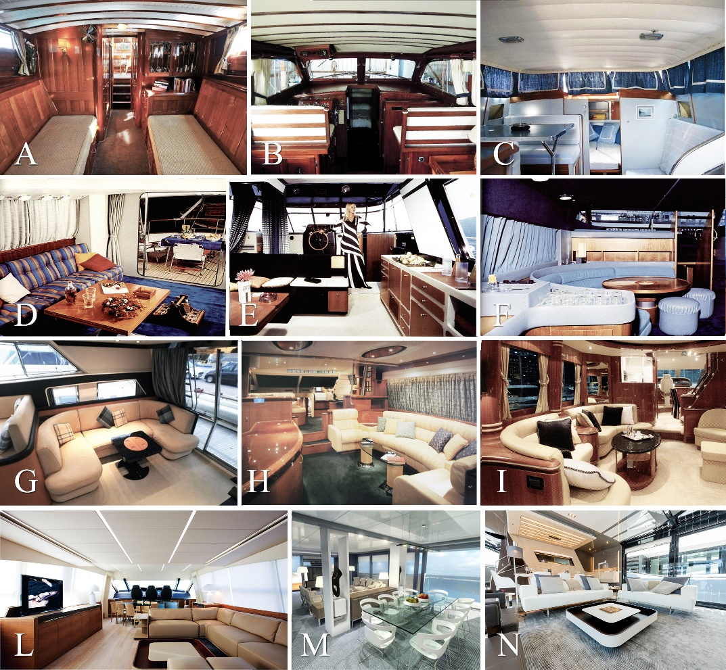
Figure 1. Evolution of onboard furnishings from the era of the first American Fast Commuters to the current years. A: Consolidate Inc. Mohican (1929), B: Chris Craft Sedan (1950), C: Baglietto Ischia (1959), D: Baglietto 16M5 (1967), E: Riva Corsaro (1970s), F: Italcraft Blue Marlin (1980s), G: Riva Aquastar(1990s), H: Riva Opera 24 (1998), I: Elegance 76 (2003), L: Pershing 92 (2014), M, N: Arcadia 100 (2016).

and standard furniture [16]: which combines, therefore, heterogeneous methodologies, techniques and professionalism, once incompatible.
By now the main brands of the furniture industry dedicate to the nautical sector an increasing attention, through the production of models that, properly modified, can be a valuable supplement of the fixed installations on board.
The furnishing of the nautical space is thus comparable to the domestic one, starting from the customization methods: the boat, like the house, must satisfy the particular and fickle preferences, both aesthetic and functional, of a wide variety of clients.
The “inflexible” artisanal fitting out based on a unitary and continuous complex, is therefore supplanted by a variable “multifaceted” space, depending on the aesthetic characterization of individual components (Figures 1M, 1N).
This new approach, which has determined the experimentation of new commercial synergies between the shipyard and the furniture industry, can identify -as well as a connotation of modern shipbuilding- a new compositional practice, aimed at integrating the craft work with the industrial design product, transforming the nautical interior decor in a sort of stylistic compendium.
References
[1] Bassani E., Baglietto 16,50, Yacth’n Italy Export Museum. Il Mediterranean Style ‘59_’79, Vol.I, by Caliari P.F., Musio Sale M., Ucina, Milan 2013.
[2] Bassani E., Technema 82, Yacth’n Italy Export Museum. Il Mediterranean Style ‘59_’79, Vol.II, by Caliari P.F., Musio Sale M., Ucina, Milan 2014.
[3] Bobrow J. Jinkins D., Classic yacht interiors, ShowBoats International, 1993.
[4] Campos C., Living in small spaces, FKG, Barcelona, 2008.
[5] Carassale E., Montecarlo 76, Yacth’n Italy Export Museum. Il Mediterranean Style ‘99_’15, Vol. III, by Caliari P.F., Musio Sale M., Ucina, Milan, 2015.
[6] Dardi D. Paperini M., Interior yacht design. Abitare tra cielo e acqua, Mondadori Electa, Milan, 2009.
[7] De Fusco R., Storia dell’Arredamento, UTET, 1985, ried. F. Angeli, Roma, 2004.
[8] Hix L. C., Interior Design Methods for Yacht Design and the Boat Building Industry, W.I.M.T, Annapolis, 2009.
[9] Kramer S., Super Yachts, Braun, Salenstein, 2011.
[10] Llorella A., Yacht Interior, Daab, Cologne, 2005.
[11] Musio Sale M., Mediterranean yacht design 1959-1979, Yacth’n Italy Export Museum. Il Mediterranean Style ‘59_’79, Vol.I by Caliari P.F., Musio Sale M., Ucina, Milan, 2013.
[12] Musio-Sale M., Yacht Design, dal concept alla rappresentazione, Tecniche Nuove, Milan, 2009.
[13] Soccol A., Nautica italiana: l’epopea storica, Architetture del mare, la progettazione della nautica da diporto in Italia, by Canfailla M., Lee A., Martera E., Perra P., Alinea, Firenze, 1994.
[14] Spurr D., Yacht style: Design and Decor Ideas from the World's Finest Yachts, NewYork, 1997.
[15] Tumminelli P., Boat Design, TeNeues, NewYork, 2005.
[16] Vidari P., Tra design e industria: strutture pannelli e meccanismi, Un’industria per il Design, by Mastropietro M., Milani, Milan, 1986.

Especially if we consider the effects of the production process on the environment.
In the compositional evolution of the on-board fittings many contingent factors converge, for example those of a constructive nature, linked to the technological evolution of the constructive logic of the boat. The progressive transition from individual construction to a serial and industrialized logic entails the abandonment of those artisan peculiarities that, together with the use of precious materials, produced formal and constructive solutions that were extremely sophisticated and complex. This phenomenon has affected the nautical work as a whole, both in the envelope and in the fittings and, not least, in the furnishings.
The main North American shipyard that first specialized in mass production was the Chris Craft, which already in the 40s, with several years ahead of Europe, boasted the offer of a wide variety of models from 5 to 20 mt of length.
The model of overseas assimilated into Italian stylistic canons thus gave rise to a new synthesis in the sixties. The nautical industry contributed in the attribution of a new stylistic characterization to the original typological plant, in a complete constructive formal coherence, according to an interpretive operation very widespread in the 60s also in other sectors of design: the distribution-space system and the furnishings finally acquire a declaredly functionalist language, which becomes an aesthetic expression, in the clear disregard of the questionable classicist revivals that characterize the American models.
Cf. Vitale G, (2010) “Pietro Baglietto. Trentacinque anni di diporto nella nautica italiana” www.altromareblu.com/nautica.
The prototype that defined the typology known as "Mediterranean Motoryacht" is Baglietto 16.50 (1967): the innovative project of architect Paolo Caliari attributes, for the first time, to the boat the characteristics of architectural rationalism, thus becoming the paradigm for future models belonging to this category.

