Systematic analysis of geometrical characteristics of hulls for displacement yachts
Ph.D. Ing. Valerio RUGGIERO^{a,}
ª Dipartimento di Ingegneria – Università di Messina

Abstract. Italy is one of the leaders in construction of large yachts, this market became bigger in the last decades not only in terms of number of constructions but also in terms of ship sizes.
In ‘80s most Yachts were 30-40 m long, megayachts over 60 m were unusual, then the sizes of yachts increased to the actual 100 m and over. Same way the cruising speed raised from 12 to 20 knots and over.
This made necessary developing new types of hulls, able to operate at a Froude number (Fr) relatively high for a displacement hull, around 0.34-0.38, but with ratios L/B quite low for stability purposes.
The purpose of the research was to examine ten hulls of yachts, from 32 to 80 m, all tested at model basin and following built and make a statistical examination of the main geometrical data, and geometrical coefficients:
Position of LCB (longitudinal center of buoyancy) respect to the Length, Ratios Am/T*B (Midship section coefficient), C_{B} (block coefficient) etc, in order to define a guidelines for the design of this type of hulls and to find, if possible, common aspects to consider.
Keywords. hull, yacht, tank test

Introduction
The research has been developed considering 10 hulls, with their tank test, developed and tested in Europe from 1988 to 2017, the hulls span from 26.80 to 77 metres of length overall, and a range of speed from 12 to 18 knots. The tests have been performed in facilities of the ITTC (SVA-Schiffbautechnishe Versuchsantsalt in Wien, MARIN Maritime Research Institute Netherlands in Wageningen), for different shipyards and on input of different customers.
The data have been obtained by the courtesy of MARIN, SVA and the Naval Architects, (Data from SVA , especially, has been used thanks to “Cohoperation agreement” signed between University of Messina Dipartimento di Ingegneria and SVA the 15th February 2018, project referent : Valerio Ruggiero)
All the hulls are of Displacement type, and the ships have been built in steel, (A grade or AH grade).
The Propulsion system is homogeneous with 2 propellers and 2 rudders for all the hulls.
The class for final ship and consequentially the shape of hull was finalized to intact and damaged stability for Yachts and with different register RINA or Lloyd EMEA or ABS ) with some type of LY2-LY3 for some hulls, and those differences influenced the results because they required different ratios L/B to achieve the stability criteria.
The aim of this study is to summarize several data, in order to give a guideline for the geometrical characteristics of the hull, and to make an organized report of the main characteristics.
It is also important to remark that 8 hulls out of 10 are for yachts of more than 41 m of length overall and 6 are over 60 m ; all over the world the yachts longer than 60 m and with this type of hulls, are around 180-200, so even if the total number of hulls is not extremely high, the ratio sample/total number is around 3% .

State of art of this kind of research
It is important to describe the evolution of yacht market: as described in previous works (V.Ruggiero “Changes in design approach for large yachts”)[1] the market of large yachts grow fast in last years[2]: in 1988 the considered yacht N. 7 was, at the time of the tank test, ranked at 50th place in the list of larger yachts in the world, but now is below the 150th position[3] [4].
This extremely fast grew of dimensions, related also the fact that usually a shipyard is required to deliver a yacht in 2-3 years from the contract signature, caused a disorder in collecting data on scientific way, there is no a series of hull for yacht, as for instance NPL series or similar.
In general the hulls used for the yachts were basically hulls of military vessels transformed and adapted in some way. In some cases the whole yacht was a former military vessel adapted or an oceanographic vessel such as Christina C.
So starting from those basis the hulls adopted by Naval Architects were mainly based on military vessels or similar modified with the choice of the geometrical characteristics based on the experience of the shipyard or the naval architect, but without a scientific approach[5].
The aim of the work is consequentially to define a “class” of hulls adoptable for displacement yachts[6].

3. Methodology of research
The first step of research was to focus on a range of hulls, similar for characteristics, with tank test results presented in similar manner, and done in similar conditions: no self propulsion test, trim measurement and so on; and verify the availability of the body plan in order to be able to obtain all the data necessaries .
All the hulls were operating and tested in a range of Froude numbers spanning from 0.30 to 0.39, meaning a speed range, in knots, varying from 9 to 18 knots.
All the hulls were all new constructions, no use of previous hulls transformed and refitted.
A preliminary analysis has been performed to verify that the hulls were operating, at test conditions, in similarity of trim, without a meaningful difference.
It’s interesting to consider that all the hulls tested were operating with basically no trim or an aft difference of Draught of minus than 1% of the Lwl (length water line). This is made to consider the usually weight distribution in this type of ships, with a large superstructure, that, even if built in light materials like alluminium alloy, is extended beyond the Lpp/2 up to 80% of Lpp (length between perpendiculars).
The data of trim have been verified also, where available, with the Stability booklet, to be sure that the position of LCB, value that has been considered for the resistance, is related properly to the weight distribution, as above described.
All the main dimensions and value of resistance have been recorded in a database, to be able to make comparisons and graph, to evaluate the tendencies and average values, with the target to isolate and define, if possible, common characteristics for this type of hulls.
On purpose, the investigation has been extended from a relatively small hull of 26.80 m, LOA to a large hull of 77 m, from 105 t. of Displacement to 1410 t.

Main geometrical data collected
As explained, all the data of the hulls have been collected, and the body plans have been recreated with modern softwares, and analyzed all using the same software, (GHS Marine Hydrostatics) to be sure that all the data were homogenous, without any differences caused by the different technologies used from 1988, year of the first tank test considered (MARIN mod. 6922) , to 2017, year of the last one (SVA mod. 2731).
The main geometrical data of the hulls are:

Table 1
Hull N. | Year | Loa(m) | Lpp(m) | B(m) | Disl.(t) | T(m)
1 | 2000 | 26.8 | 23.94 | 6 | 105 | 1.79
2 | 2004 | 42.85 | 37.1 | 8.2 | 328 | 2.5
3 | 1989 | 49 | 40 | 8.7 | 450 | 2.74
4 | 2008 | 60 | 54 | 11 | 907 | 3.18
5 | 2007 | 55 | 48 | 10.21 | 680 | 2.9
6 | 2008 | 69.5 | 61.5 | 11.3 | 1100 | 3.07
7 | 1988 | 63.5 | 55 | 11 | 721 | 2.8
8 | 2011 | 71.5 | 63.6 | 11.5 | 1340 | 4.05
9 | 2017 | 72 | 68.3 | 11.7 | 1235 | 3.01
10 | 2013 | 77 | 64.5 | 12 | 1410 | 4.16

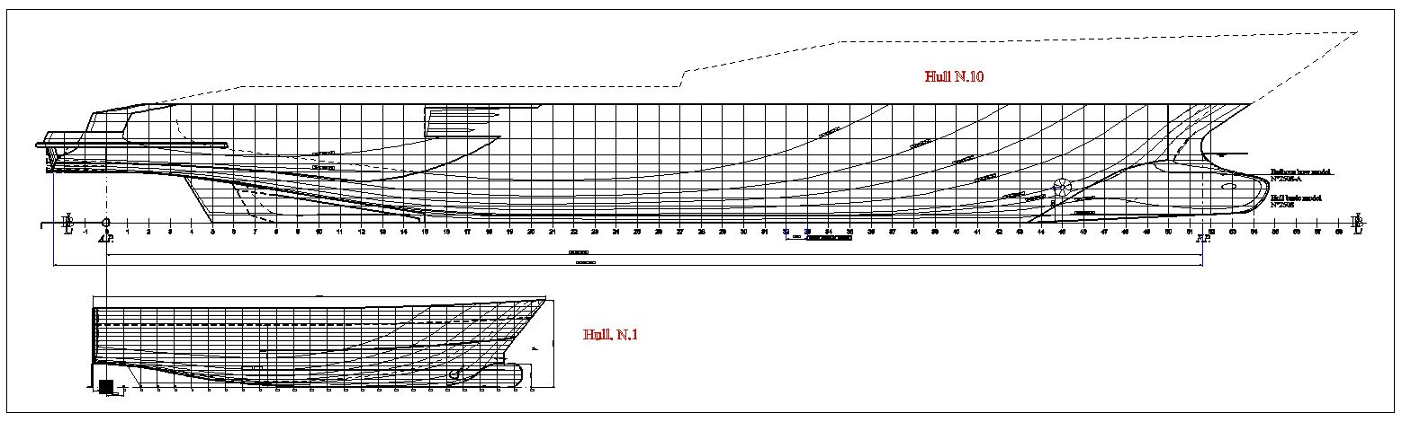
Figure 1: Profile of Hulls N.1 and N.10

Test report analysis of geometrical data
For each hull the tank test results have been considered, correlating all the results to the same procedure, the ITTC 57 and following at the same water temperature (15 °C), all the test and data referring to the same situation of hull without appendages, in order to have results more comparable as possible.

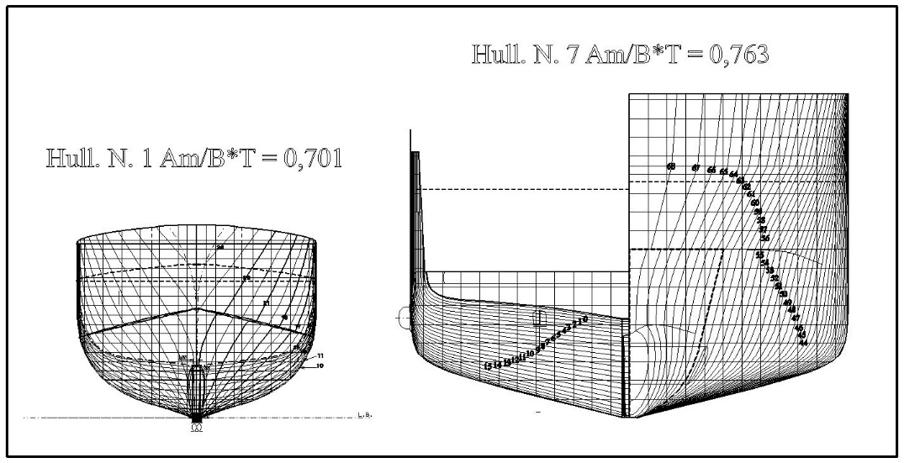
Figure 2: Midship section of Hulls N.1 and N.7

The results of tank test span among various values of speed, from 9 to 18 knots, according to the different requests for each yacht, so it has been considered the values of speed related to Froude Numbers of 0.33 and 0.35, again, the results obviously differs from one other, some 0.331 some 0.329 , and so on. So all the results have been corrected to be reported to 2 values of reference: 0.33 and 0.35.
In this situation, it has been examined the C_{B} coefficient of all the hulls tested, at Displacement considered, and reported the position of LCB compared to the Lwl. and the ratio Am/B*T (Midship section area coefficient).
The following table gives a report of the exact values of speed reported by the Tank test, the Fr corresponding, B and T.
As already explained, all the Fr have been normalized in order to compare the resistance results.

Table 2 – Exact values of speed and corresponding Fr.
Hull N. | Loa (m) | Speed tested (knots) | Fr | B(m) | T(m)
1 | 26.8 | 9.5 | 0.319 | 6 | 1.79
2 | 42.85 | 12.5 | 0.329 | 8.2 | 2.5
3 | 49 | 13 | 0.33 | 8.7 | 2.74
4 | 55 | 14.5 | 0.331 | 11 | 3.18
5 | 60 | 15.5 | 0.336 | 10.21 | 2.9
6 | 63.5 | 15 | 0.337 | 11.3 | 3.07
7 | 69 | 16.5 | 0.33 | 11 | 2.8
8 | 71.5 | 16.5 | 0.322 | 11.5 | 4.05
9 | 72 | 17 | 0.333 | 11.7 | 3.01
10 | 77 | 16.5 | 0.325 | 12 | 4.16

The following Figure shows the relationship between Area of midship section and B*T

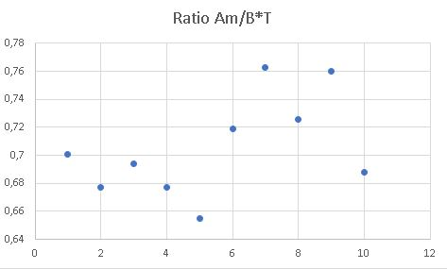
Figure 3: Ratio Am/B*T
The results of this graph shows that the ratio Am/B*T for all the hulls tested is around 0.7 with extremes at 0.65 and 0.75.

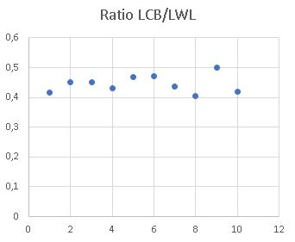
Figure 4: Ratio LCB/LWL
The results of this graph show the ratio LCB/LWL for all the hulls tested and again, we can note that the results are grouped with a limited dispersion around a value of 0.444 , and a minimum of 0.40 and a maximum of 0.47.

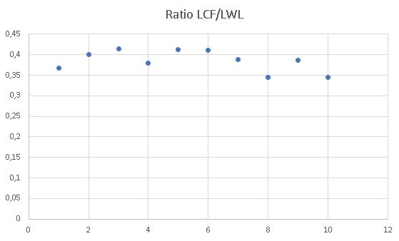
Figure 5: Ratio LCF/LWL
The Figure 5 shows the relationship between the position of LCF (longitudinal center of floatation), at the waterplane corresponding at test condition, and the Lwl, in this case it is showed as the ratio is floating from a minimum value of 0.34 to a maximum value of 0.41.

Test report analysis of resistance data
Finally, after that the analysis of the main geometrical data, the resistance data, for bare hull has been considered, the research focused on the analysis of the coefficient of residual resistance, for the ship, obtained from the tank test.

Table 3 – Exact values of Fr and corresponding Crs related to L/B and C_{B}.
Hull N. | Froude number 0.33, values of Cr (10^3) | Froude number 0.35, values of Cr (10^3) | L/B | C_{B}
1 | 3.873 | 4.70 | 4.3 | 0.360
2 | 3.734 | 4.295 | 4.7 | 0.421
3 | 3.829 | 4.04 | 4.72 | 0.462
4 | 4.095 | 4.585 | 5.09 | 0.457
5 | 3.893 | 4.408 | 5.21 | 0.469
6 | 2.242 | 2.702 | 4.83 | 0.414
7 | 3.173 | 3.57 | 5.87 | 0.50
8 | 4.156 | 4.317 | 6.24 | 0.437
9 | 2.859 | 2.841 | 6.08 | 0.499
10 | 2.985 | 2.8175 | 5.95 | 0.427
It is possible to note that we can find differences in the values, among the various hulls, for the Crs.
The Hull N. 6, which has the lower values, has also a very small leading angle of waterlines at test displacement, but this aspects deserves a further investigation. A further table (Table 4) has been created comparing the results in terms of wetted surface of the hull, speed of hull and Cfs, the speed considered in Table 4, only as reference, is the speed of the hull corresponding to a Fr = 0.33.

Table 4 – Cf , speed and wet S.
Hull N. | Speed (kn) | Wet S (m^2) | Cfs (10^3) | Diff. min/max
1 | 9.5 | 157 | 2.36 | 4%
2 | 12.5 | 353 | 2.15 | 3.5%
3 | 14 | 407.5 | 1.83 | 5%
4 | 14.5 | 557 | 2.02 | 3.3%
5 | 15.5 | 691 | 1.97 | 4.5%
6 | 15 | 559 | 1.98 | 3.5%
7 | 16.5 | 898 | 1.91 | 4.5%
8 | 16.5 | 860 | 1.90 | 3.3%
9 | 17 | 948 | 1.98 | 2.3%
10 | 16.5 | 949 | 1.88 | 3.9%

The above table is introduced to summarize the results of the tank test. All the results have been examined, considering the range of speed tested, varying from 9.5 to 15 kn for the Hull N.1 (26.8 m L.o.a.) and from 10 to 18 kn for the Hull N.10 (77.7 m L.o.a.) and the analysis of the Cfs (Coefficient of frictional resistance), showed an average difference from the reported values of around 2%.

Conclusions and further developments of research
The aim of the work was to make a scientific analysis of the main geometrical data for this type of ships.
Obviously these data must be examined considering that yachts have different requests due to their operational profile: ports and marinas are very different, so the requests in terms of Beam, Draft, Length, can be also subject to the space of berthing owned by the Owner and at the same time to the possibility to be loaded on a transport ships to be moved, for example, from Mediterranean to Caribbean for chartering in various parts of the world. The draft can be defined according to special criteria considering shallow or deep waters, etc.
As final results we must remember that, due to the ultimate customizations we must always consider that yachts hulls are probably more subject to changes than traditional commercial hulls.
Finally the collected data show values quite homogeneous despite the differences in size, and give an indication for the main parameters that a naval architect can obtain during the design.

In the following table, the average values of the main geometrical coefficient have been collected.
So it possible to conclude that the following values can be considered as “standard” for Yacht displacement hull.

Table 5 – Average data
Geometric coefficient | Average
C_{B} | 0.444
LCB/Lwl | 0.44
LCF/Lwl | 0.38
A_{M}/B*T | 0.385
L/B | 5.299

Further aspects and relations among the various coefficients could be the object of further works, investigating the changes in parameters considering the differences in requirements for the stability, especially considering that from 1988 to 2017 yachts have been subject to the various changes of Rules, from Private Yachts and Charter yachts or even Passenger Yachts, with consequent requests of more strict criteria not only for intact stability, but also for damaged stability and consequent need to change the Beam and the Height of the hulls to meet the new criteria[7].
References
- V. RUGGIERO , Changes in design approach for large yachts, Proceedings of III Multidisciplinary scientific conference on social sciences and arts – SGEM 2016, , Stef92 Technology td, Sofia (Bulgaria), 2016. ISBN 978-619-7105-54, pp. 155-164
- M.E. RUGGIERO, “Note sul evoluzione del disegno nel progetto navale”, Book, Rapallo, 2007, Officine grafiche Canessa.
- The Superyachts, Book, UK, September 2016
- The Superyachts, Book, UK, September 2017
- D. L. BLOUNT & J. A. McGRATH, Resistance characteristics of semi displacement mega yacht hull forms , Trans RINA, Vol 151, Part B2, Intl J Small Craft Tech, 2009 Jul-Dec – DOI No: 10.3940/rinaijsct.2009.b2.95
- P. VAN OOSSANEN, J. HEIMANN, J. HENRICHS, K. HOCHKIRCH, “Motor yacht hull form design for the displacement to semi displacement speed range” 10th International Conference on Fast sea transportation, FAST 2009, Athens Greece, October 2009, pp 629-643
- V.RUGGIERO, “2004-2014 Ten years of changing in the project of passenger ferries on Italian lakes, due to the 2006/87/CE and consequent rules”, 18th International Conference on Ships and Shipping Research, NAV 2015, 2015, ISBN: 978-889405571-9, Pages 1080-1089

