Gain in Fuel Consumption with Frictional Resistance Reduction by Air-Bubbling Technique
Enrico RAVINA^{a,} and Sofia GUIDOMEI ^{b}
ª DITEN, Polytechnic School, University of Genoa (Italy)
^{b} DITEN, Polytechnic School, University of Genoa (Italy)
Abstract. The paper refers on a research activity developed at DREAMS Lab of the University of Genoa (Italy), focused on experimental application of air-bubbling technique on a hull model. With this method the injection of compressed air on the bottom of the model generates air bubbles modifying the boundary layer; measurements are implemented in towing tank. The hull model has got a large flat bottom that is particularly suitable to this application and a customized pneumatic circuit assembled to allow the injection of compressed air. The design of the pneumatic unit is made to perform tests in different operating conditions with a flexible distribution of air in different areas of the hull. Seven different operating conditions at three different levels of speed was measured at the towing tank with the goal to estimate the changes in local frictional drag at different levels of flow rate and pressure of injected air in different areas of the bottom. In particular the most favourable combination can reach a frictional resistance reduction about of 13%.This hull equipped with pneumatic circuit can be used in future to arrange new systematic experiments oriented to optimize the gain related to air bubbling technology.
Keywords. Resistance reduction, air-bubbling, hull model, towing tank, pneumatic circuit.

Introduction
As well known, one the most strategical problems is the air pollution and a lot of researches are oriented to propose solutions to reduce it. About 30% of the total use of energy, mainly given by oil, is spent in the transports areas and 80% of the global trade is represented by the maritime one. Consequently there is a wise interest to improve ship energy efficiencies to control the emissions.
Ships efficiency can be improved reducing the loss of energy or using new kind of alternative energies. One of the most important causes of energy lost is the hull friction drag, representing 60÷70 % of the to-al drag. Different approaches and techniques are proposed and applied to reduce this kind of resistance, in particular modifying the hydrodynamic conditions of the hull-water interface.
One of most promising techniques modifying the boundary layer structure is the air-bubbling, subject of this experimental study, implemented on a hull model. The main goal is the measurement of the changes in the local frictional drag at different levels of flow rate and pressure of injected air. The experiments in the towing investigate on the differences in terms of drag reduction between hull without and with holes on the bottom, modifying the characteristics of speed, pressure, flow rate and areas interested to the air injection.
In the paper are collected the results corresponding to different working conditions, showing the ad-vantages related to air bubbling.
The hull equipped with pneumatic circuit is still used to arrange new systematic unconventional experiments oriented to optimize the gain related to air bubbling technology.

State of the Art
In the last few years a lot of studies and experimentations have been done about air lubrication to have more information about its application and benefits.
From the experimental point of view Mitsubishi [1] has developed this technique on real ships, equipped with air-lubrication systems, achieving an energy saving of 12%. Istanbul Technical University [2] proposes experimental tests on flat plates with holes supplied by injection of compressed air, showing drag gains around 5%. Samsung Ship Model Basin [3] has tested a ship model with 6 independent injection units and characterized by matrix of small holes. Resistance gains of 8÷10% and power gains of 10÷12% are obtained.
From the numerical point of view F. Stern et al. [4] synthesize recent progress in CFD for naval architecture and ocean engineering and A. Dogrul et al. [5] proposes a CFD air lubrication method applied to a chemical tanker.
Many others studies, several experimentations at international level and detailed deepening are available in literature, showing a diffuse interest on this topic. Some references are reported in [6], [7], [8], [9], [10] and [11].
Despite to this actual and interesting subject, detailed information about practical realization of units and about pneumatic parameters in air supply systems are often not exhaustive or not available in literature. This is the reason why in this study detailed and diversified experiments have been implemented DREAMS Lab of the University of Genoa (Italy), involving different geometries of models (plates and hulls): hereafter experiments on a model of ship hull are detailed.

Experiment on an Hull Model

Description of the hull’s modification
For this study a model with a large flat bottom is used: the main dimensions are L= 1.8 m, B = 0.3 m and D = 0.13 m (Fig.1).
One of the most important feature is the flat bottom because it is possible to work in better condition and also because in literature it is one of the most comfortable condition for this technique. In particular the goal is to realize a matrix of hole in the bottom with the use of a drill press to try to make the holes in the most accurate way.

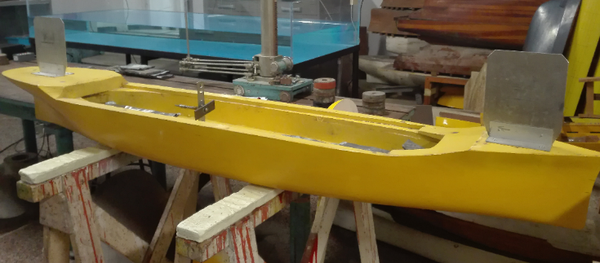
Figure 1. Model of hull

The bottom of the hull is punched realizing two 4x4 square matrix (16 holes) and one 2x4) rectangular matrix (8 holes) positioned as shown in Fig.2: each hole has diameter of 4 mm, reduced to 2 mm by insertion of little pneumatic hoses.

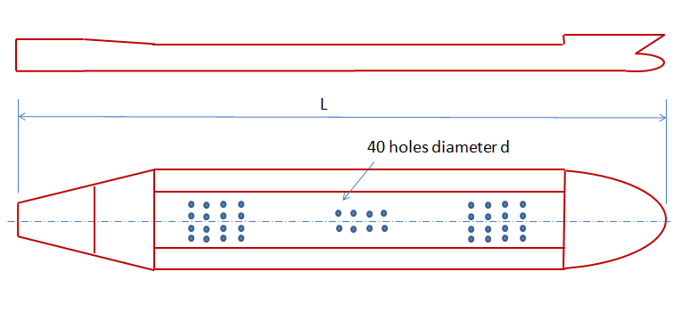
Figure 2. Holes matrix positions (out of scale).

Air distribution circuit
An original and customized pneumatic distribution circuit is designed and realized. It is designed to allow a flexible distribution of air in different areas of the hull: four collectors having each 10 fittings (Fig. 3) manage the pneumatic supply to the holes: the layout of one of them is sketched in Fig. 4, allowing the possibility to select the zone for the injection of the air in flexible way.

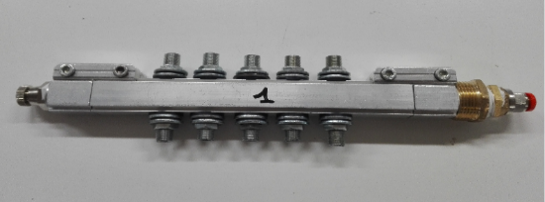
Figure 3. Collectors.

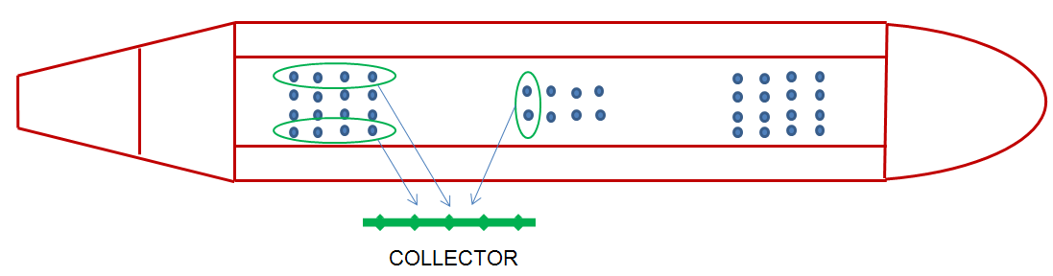Figure 4. Detail of the circuit layout.

Each collector is independent from the others. Each collector is equipped with flow regulator and on each distribution line is assembled a one-way direction valve. An overall view of the hull equipped with the pneumatic system is shown in Fig.5. The unit is arranged in advance to install flow rate proportional valves: this configuration, at the moment under development, will allow a flexible modulation of the air injection during the navigation.
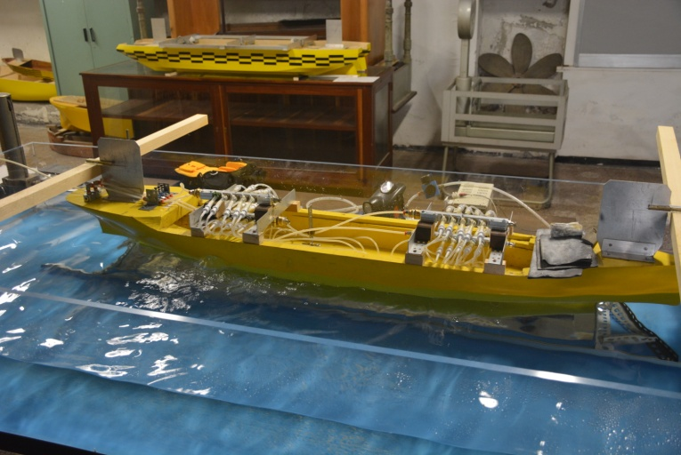
Figure 5. Hull equipped with pneumatic circuit

Test at the towing tank
A systematic campaign of tests is developed at the towing tank of DITEN Dept. (University of Genoa): this test facility has dimensions of 60 x 2.5x 3 and models con reach a maximum speed of 3 m/s. The model is carried out by a dynamometric carriage with capability of measurement of ship trim and resistance (Fig. 6).
Seven different operating conditions at three different levels of speed are implemented: the goal is to estimate the changes in local frictional drag at different levels of flow rate and pressure of injected air in different areas of the bottom.
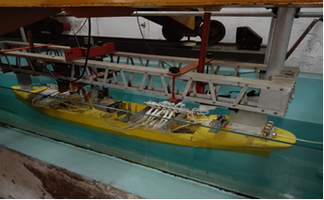
Figure 6. Hull assembled at the dynamometric carriage.
In particular a pressure regulator allows feed the circuit from the compressor at 0.7 bar, 0.5 bar and 1.5 bar: for these three levels of pressure the test was made feeding all the holes after the test made with the original hull and with the hull equipped but without the injection of the air.
All the tests are made respectively at 0.66 m/s, 0.83 m/s and 1.01 m/s.
After preliminary tests the air pressure is selected to 0.7 bar, and in this condition tests with the injection of air only in the holes of the bow and only in the holes of the stern are implemented.
For each operating condition the results are analysed and the average value of the resistance at different speeds is calculated to estimate the total resistance law.
During the experiments the draft and the wetted surface are practically the same.
The tests developed correspond to different Reynolds number (10.4x10⁵ ; 13.1x10⁵ ; 15.9x10⁵ for the different speeds). These values are not very high and so the corresponding conditions are of laminar flow. Some experiments with a higher speed are carried out; trying to achieve the turbulence but the limits related to the dimensions of the towing tank caused the creation of a lot of bubbles and waves during the hull motion, with consequent water entrance in the model compromising the correct execution of the tests.

Results
The resistance law at the different speed is measured for each operating condition:
- original hull
- hull modified without injection of air
- hull modified with air injection at 0.7 bar in all the holes
- hull modified with air injection at 1.5 bar in all the holes
- hull modified with air injection at 0.5 bar in all the holes
- hull modified with air injection at 0.7 bar in holes at the bow
- hull modified with air injection at 0.7 bar in holes at the stern
Numerical results and comparison are collected in Tab.1 and Fig. 7.
The units of the resistance are grams, in according to the measurement scale of the load cell on the dynamometric carriage.
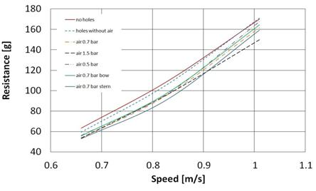
Figure 7. Resistance law
Table 1. Resistance values
Speed [m/s] Resistance [g]
______________________________________________

1 2 3 4 5 6 7
______________________________________________

0.66 63.26 59.43 53.47 53.76 56.29 55.77 53.02
0.83 109.46 106.45 96.25 96.5 97.25 98.11 91.7
1.01 170.14 170.93 161.75 149.78 167.58 164.33 159.13
______________________________________________

The corresponding gains are evaluated under the following working conditions:
- hull modified with air injection at 0.7 bar in all the holes
- hull modified with air injection at 1.5 bar in all the holes
- hull modified with air injection at 0.5 bar in all the holes
- hull modified with air injection at 0.7 bar in holes at the bow
- hull modified with air injection at 0.7 bar in holes at the stern
and are compared to the condition of the hull modified with the matrix of holes but without air injection.
The corresponding results are collected in Tab. 2.
Table 2. Resistance gain
Speed [m/s] Resistance gain [%]
______________________________________________
1 2 3 4 5
______________________________________________

0.66 9.57 9.54 5.28 6.16 10.79
0.83 9.58 9.35 8.64 7.83 13.85
1.01 5.38 12.37 1.96 3.86 6.90
______________________________________________

As the studies about air lubrication say, the air-bubbling technique has influence on the frictional drag; in the present approach any calculation by numerical model to show this influence is developed. The authors have decided to consider the total resistance because it is the value that detectable with measurement instruments embedded on the towing tank.
About the experimental uncertainty it is to note that one of the uncertainty is the measurement is related to the tolerance and to the admissible error of the load cell assembled on the towing tank. Another uncertainty is given by the hypothesis, accepted estimating the transposition of the experimental results at full scale, to consider constant the percentage gain of the total resistance achieved by the introduction of bubbles for the model and for the real hull. This choice is justified as possibility to try to make some estimation for the transposition at full scale without any numerical calculation. This aspect is considered as next step to the present study.

Transposition at Full Scale
A possible transposition of the results obtained to value the effective efficiency of this solution in terms of gain in fuel consumption e gas emissions is estimated. Unfortunately, this transposition is influenced by the towing tank dimensions and by the maximum speed compatible with the generation of acceptable fronts of lateral reflected waves. Consequently is very difficult to discuss observed trends when considering the air-bubbling application at full scale, in terms of resistance.
In particular, the resistance gain achieved with the injection of air at 0.7 bar in all the holes in comparison with the condition of hull modified but without are injection is analyzed. Supposing the hydrostatic pressure and estimating the pressure drops inside the pneumatic circuit at full scale the air injection pressure is estimated around 4 bar.
In this case the resistance gain is 9.58%: the same gain is assumed for the real ship corresponding at the model used.
The resistance of the ship in the two operative conditions is evaluated and consequently the power of the engines with the corresponding fuel consumption that allows to estimate the gain in terms of fuel cost.
Then the cost of the compressed air is estimated and compared with the previous one gain.
Finally a net profit is estimated in 6.5% of the total costs, aligned with the economical results available in technical literature and satisfactory in long terms of time. It is important to note that these estimations are deduced by experiments on model in calm water. The towing tank used for experiments is not equipped with wave making facility: consequently the profit estimation cited above is certainly different in presence of waves.

Conclusions
With reference to the test on the model interesting different performances are detected varying the zone of the air injection, in particular, from stern to bow. The pneumatic unit is designed to allow a flexible distribution of air in different areas of the hull and to organize flexible tests usually not implemented in standard test facilities.
In general the injection of compressed air shows a positive influence in terms of gain of friction resistance; in particular the best condition is given by a medium level of pressure for a medium level of speed with the injection of the air in only zone of the hull’s stern with a gain that is more than the 13% (value comparable with the results available in literature).
Actually the realized test benches can be considered as pilot test facilities able to arrange new systematic unconventional experiments oriented to optimize the gain related to air bubbling technology. In particular, experiments involving proportional flow-rate control valves could be significant to test the effect of the modulation of air flow-rate in different zones of the hull.

Acknowledgments
The authors thank Professor Carlo Podenzana to make available the model of hull and Dr. Alberto Ferrari and Mr. Sergio Talocchi for the support given during the tests at towing tank.

References
- Mizokami S.,Kawakita C., Kodan Y., Takano S., Higasa S., Shigenaga R., "Experimental study of air lubrication method and verification of effects on actual Hull by means of sea trials", Mitsubishi Heavy Industries Technical Review Vol.47 n°3, September 2010.
- Gokcay S., Insel M., Odabasi A.Y., “Revisiting artificial air cavity concept for high speed craft”, Istanbul Technical University, August 2003.
- Jang J., Ho Choi S., Ahn S., Kim B., Seo J., "Experimental investigation of frictional resistance reduction with air layer on the hull bottom of a ship", Marine Research Institute, Samsung Heavy Industries,Korea,2014.
- Stern F. et al. “Recent progress in CFD for naval architecture and ocean engineering”, Journal of Hydrodynamics, Ser. B. Vol.17, Issue 1, Feb. 2015, pp. 1-23.
- Dogrul A, Alikan Y. and Celik F., “A numerical investigation of air lubrication effect on ship resistance”, Intl. Conf. on Ship Drag Reduction (SMOOTH-Ships), Istanbul, Turkey, 20-21 May 2010.
- Blaine W. Andersen, “The Analysis and Design of Pneumatic Systems”, Robert E. Krieger Publishing Company, Malabar, Florida, 1976.
- Choi J.K., Hsiao C.T., Chahine G.L., “Design Trade-off for High Performance Ship Hull with Air Plenums”, 2nd International Symposium on Seawater Drag Reduction, Busan, May 2005.
- Kawabuchi M., Kawakita C., Mizokami S., Higasa S., Kodan Y., Takano S., “CFD Prediction of Bubbly Flow around an Energy-saving Ship with Mitsubishi Air Lubrication System”, Mitsubishi Heavy Industries Technical Review Vol. 48 No. 1, March 2011.
- Zverkhovskyi O., van Terwisga T., Gunsing M., Westerweel J., Delfos R., “Experimental Study on Drag Reduction by Air Cavities on a Ship Model”, 30th Symposium on Naval Hydrodynamics, Tasmania, November 2014.
- Kumagai I., Nakamura N., Murai Y., Tasaka Y., Takeda Y., Takahashi Y., “A New Power-saving Device for Air Bubble Generation: Hydrofoil Air Pump for Ship drag Reduction” International Conference on Ship Drag Reduction, Istanbul, May 2010.
- Lyu X., Tang H., Sun J., Wu X., Chen X., “Simulation of microbubble resistance reduction on a suboff model”, Brodogradnja/Shipbuilding, Volume 65, Number 2, 2014.

Via Montallegro 1, 16100 Genoa (Italy); E-mail: enrico.ravina@unige.it

