Towards A New Toll Calculation Method For Transiting The Suez Canal - Bulk Carriers
Maged ABDEL NABY^{a,} and Mayar ALI ^{b}
ª Department of Naval Architecture and Marine Engineering, Alexandria University
^{b} Alexandria Shipyard
Abstract. The Suez Canal is an artificial sea-level waterway connecting the Mediterranean Sea and the Red Sea through Egypt. Tolls paid by the vessels passing through the Canal represent an important source of income for the Egyptian Economy. The current philosophy of SC tolls is based on calculating the tolls as a percent of the vessels' Suez Canal Net Tonnage. The current research recommends making use of the recent international regulations enforced, particularly the Energy Efficiency Design Index (EEDI), and the timely published international indices for the charter rates and bunker prices for calculating the SC tolls on a case by case basis to respond to the market fluctuations, maximize SC income, and increase potential customers. Bulk Carriers are taken as a case study to compare between the enforced tolls philosophy and the savings calculated using the suggested method, and to study the relevant importance and sensitivity of the parameters used in the calculations in order to reach a base for developing a new toll policy.
Keywords. Suez Canal, EEDI, Bunker, Baltic Index, Time Charter

Introduction
The current philosophy of Suez Canal (SC) tolls is based on considering in general the earning capacity of the transiting vessel according to her type, calculating the ships' savings through the SC route compared to other alternative routes, and sharing part of the saving achieved by transiting vessel. However, the toll basis is decided at the beginning of each year as a percentage of the Suez Canal Net (SCNT) based on the vessels' loading condition, and consequently cannot respond to the real savings of the vessels on different routes or to the fluctuating market conditions, in regards to the bunker prices and charter rates.
The current research makes use of the current boost in the information technology and the timely published international scales and indices in addition to the mandatory enforced Energy Efficiency Design Index (EEDI) for calculating the ship's savings due to passing via SC to suggest a new toll calculation method, which guarantees prompt response to the ever-changing maritime transport sector.
The method focuses on calculating the transit tolls on a case by case basis for each vessel, and expected to guarantee that the tolls paid do not exceed the savings nor are under estimated. Furthermore, it will consider the interests of both Suez Canal Authority (SCA) and the ship owners, and guarantees a balanced win - win situation.
The characteristics of each vessel; including speed and fuel consumption, in addition to the time charter rates, are incorporated with the reduction in distance when using SC, to calculate the total savings.
Bulk Carriers are taken as a case study to calculate the savings and compare them to the tolls enforced by the SCA. The study includes historical and recent data for the savings and the tolls already collected. The savings are compared to the SC tolls to evaluate if the tolls are over or under estimated, demonstrate if there is a necessity for a new toll method, and determine the governing parameters and their relevant references.

The Suez Canal
SC is considered to be the shortest link between the East and the West due to its unique geographic location. The recent developments which were finalized in August, 2015 yielded a reduction in the transit time to reach 11 hours instead of 18 hours, and the waiting time is reduced from 11 hours to 3 hours. The current condition of SC accommodates 61.2 % of the World Tanker fleet, 92.7 % of the Bulk Carrier fleet, and 100 % of the Container and other ships [1].
During 2017, 17,550 vessels passed via SC with a total deadweight of about 1 billion tons. In 2016, 16,833 vessels passed via the canal with a total deadweight of about 0.97 billion tons [1]. It is also worth saying that the World's seaborne trade total volume reached 10.3 billion tons in 2016 [2], which means that about 10% of the World's trade passes via SC. In 2017, SC revenues reached 5.4 billion USD compared to 5 billion USD in 2016 [3].
The above mentioned facts manifests the importance of SC to both, the seaborne trade and the Egyptian Economy. Tolls paid by the vessels transiting the SC represent an important source of income for the Egyptian government.
A quick calculator for the tolls is provided on the SC website which calculates the tolls based on SCNT, Suez Canal Gross Tonnage (SCGT), the type and dimensions of the vessel, and loading condition. The tolls are calculated in Special Drawing Rights (SDR) basket [1]. The currency value of the SDR is determined by the International Monetary Fund (IMF) through summing the values in USD, based on market exchange rates, of a basket of currencies (USD, Euro, the Chinese Renminbi, Japanese Yen and British Pound) [4]. The toll basis is decided at the beginning of each year and can be changed or extended to successive years.
However, the method in which SC tolls are actually calculated can not reflect the SCA philosophy of sharing part of the vessel's savings. The tolls are mainly based on the SCNT; which means the same vessel will pay the same tolls disregarding her trip and the savings earned by the vessel. Moreover, the current SC tolls is the same since 2014, despite of the fluctuations in the maritime market concerning the charter rates and the bunker prices.
SCA adopts flexible policies to rebate a percentage of the tolls to certain vessels on particular routes in attempt to maximize SC clients and avoid that the vessels use alternative routes; via Cape or Panama Canal, when the tolls exceed the vessels' savings.
Several reports discussed that some container lines during the fourth quarter of 2015 and the first three quarters of 2016, preferred using the route via Cape, especially in their ballast trip, due to the reduced voyage expenses [5], which was mainly dictated by the low bunker prices and charter rates. In response, the SCA in February, 2016 granted Container Ships coming from the port of Norfolk and its northern ports, heading to the port Kelang and its eastern ports, a rebate of 45% of the SC normal tolls. Also, VLCC (of more than 250,000 DWT) coming from Arabian Gulf, heading to American Gulf or the Caribbean zone on their round trip to transit the SC, are to pay a lump sum of USD 230,000 on the return ballast trip [1]. Furthermore, other rebates were granted to Bulk Carriers, such as laden Dry Bulk vessels coming from ports at East & South Australia heading to ports at North West Europe were granted a 75% rebate of normal SC transit tolls starting from February, 2017. Also in April, 2017 SCA has decided that Dry Bulk vessels; coming from Republic of South Africa ports and heading to Mediterranean Sea should be granted rebates.
These rebates are still in effect until now, although the bunker prices had increased to about 400 USD/ton instead of 150 USD/ton at the beginning of 2016 [6]. Accordingly, it is a must for the SCA to adopt a more flexible policy which quickly responds to the market changes in order to maximize the number of vessels passing via SC, increase the collected tolls, and guarantee smooth operation.

Bulk Carriers
In 2016, about 30% of the World's seaborne trade was carried by Bulk Carriers [2]. In 2017, the number of Bulk Carriers passing via SC reached 3,288 out of the 17,550 vessels which passed via the Canal. Considering the net tons, about 11% of the cargo passing via SC was carried by Bulk Carriers which outlines the importance of this type of vessels to the income of SC [1].

Classification of Bulk Carriers
For the purpose of current research, the Baltic Exchange classification of Bulk Carriers is mainly adopted. Bulk Carriers are categorized according to their size as per Table 1, the speed and fuel consumption for different types are also outlined [7].
Table 1. Types and characteristics of Bulk Carriers as per Baltic Exchange [7]
Type | Dead weight in tons | Speed in Knots (laden/ballast) | Fuel consumption in tons (380 cst)  (laden/ballast)
Capesize B | 180,000 | 14/14.5 | 62
Panamax B | 74,000 | 14 | 32/28
Supramax B | 52,454 | 14/14.5 | 30
Handysize B | 28,000 | 14 | 22
In addition to the above mentioned data, register books and online resources were addressed to acquire the data of sample Bulk Carriers of almost the same dead weight and dimensions as those of the standard Baltic vessels. These vessels data will be also used for the calculations throughout this work. The characteristics of the acquired vessels are summarized in Table 2. The average sea speed is considered as per the third IMO Greenhouse Gas Study 2014 [8]. There is a pronounced difference in speed between the Baltic vessel and the IMO evaluation of the speed. This can be attributed to slow steaming.

Table 2. Types and characteristics of sample Bulk Carriers.
Type | SCNT | SCGT | Main Engine  MCR (KW) | Average sea  speed in knots
Capesize S | 88,564 | 94,634 | 18,600 | 11.7
Panamax S | 38,761 | 43,006 | 10,000 | 11.9
Supramax S | 30,961 | 34,183 | 9,480 | 11.8
Handysize S | 15,971 | 17,636 | 6,150 | 11.4

Evaluation of Vessel savings
Vessel's savings when passing through the SC is due to the reduction in the distance and the time at sea. These reductions consequently minimize the operating costs and maximize the profit, as the number of trips conducted annually can be increased [9].
The operating costs can be generally categorized as routine and voyage related costs. The routine costs occur on a daily basis and are not affected by the specific voyage of the vessel, and these generally include capital costs, crew wages, victualling, insurance, spares, and periodic maintenance costs. Costs specific to a voyage includes bunkers, port/canal dues, stevedoring, and load/discharge costs [7,9].
In order to simplify the savings calculation procedure and suggest a realistic, reliable and fast method for the calculation, the first group of costs and the vessel's daily profit are named the time savings and corresponds to the time charter (TC) or time charter equivalent (TCE) of the vessel when multiplied by the time saved, both the TC and TCE have reliable daily published indices [7]. Out of the second category of the costs, we are mainly concerned with the bunker cost as the other costs are not affected by passing via SC. By summing up these two parts we can evaluate the total vessel daily savings at sea.
TC grants the charterer the use of the ship and the owner retains responsibility for the vessel. The time charterer pays for the bunker, port charges, agency fees, canal dues, pilotage, and cargo insurance, and the owner pays the routine costs of the vessel [7,9]. TCE is used by companies to compare period to period changes in the shipping industry, despite of the change in the mix of charter types (time, bareboat, etc.) under which the vessels operate. A standard method to compute TCE is to divide the voyage revenues excluding the voyage costs by the round voyage duration (laden/ballast legs) [7]. Consequently TC or TCE includes the routine expenses and the profit.
TC for one year rates during the period from January 2016 to December 2017, for the four ship sizes mentioned above, were acquired through resources available online from ship brokers [10], and will be used for calculating the time savings of the sample vessels. TCE was provided by the Baltic Exchange via personal contacts for the same period and it will be used for calculating the time savings of the standard Baltic vessels.
TC and TCE values are demonstrated in Figure 1. The TCE shows sharp changes while the one year TC has more smooth trend. The two indices have almost the same behavior except for the Capesize vessels. The Capesize TCE shows very sharp changes and is plotted in light yellow to avoid interference with the other values.
For the calculation of the bunker cost, the price and consumption need to be identified. Accordingly, the BW380 is used for the evaluation of the fuel price, which is an index issued by Bunkerworld and recognized by the Baltic Exchange as a trusted source for marine fuel prices. The BW380 Index is a daily average USD value index of 380 cst bunker fuel from 20 key bunkering ports, which were selected by size with reference to their geographical importance [6]. The bunker price as per the Bunkerworld for the period from January, 2016 to December, 2017 is shown in Figure 2.
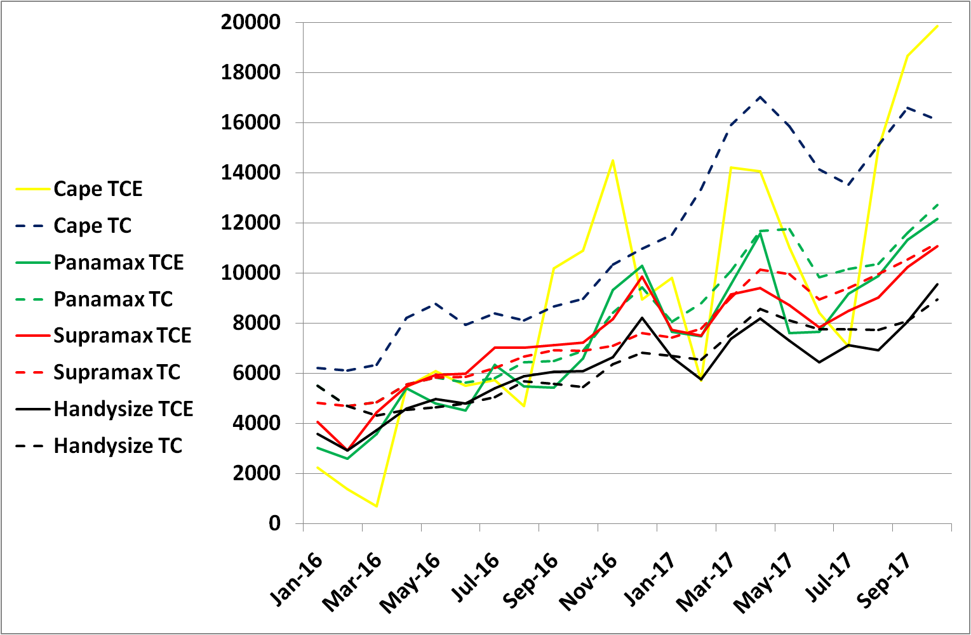
USD
Figure 1. TCE and TC in USD for different vessel sizes [7, 9].
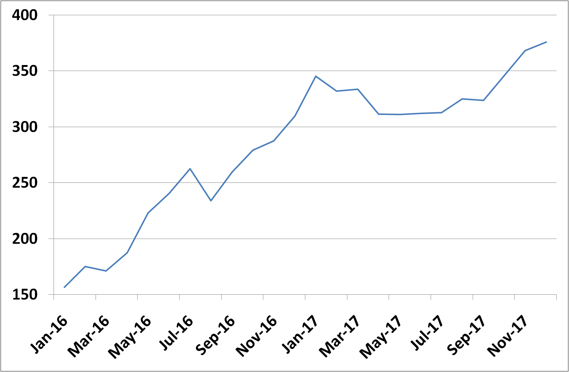
USD
Figure 2. Bunker (380 cst) prices from January 2016 to December 2017 [6].
The voyage bunker consumption for the standard Baltic ships is adopted as per the Baltic recommendations concerning the daily sea consumption and speed including the weather allowance [7]. For the other sample vessels, EEDI guidelines are used for the calculations based on the data and characteristics of the vessel [11], and the specific fuel consumption is adopted as per main engine manufacturer of each vessel.
The energy efficiency requirements were adopted as amendments to MARPOL Annex VI, in 2011. The regulations make the EEDI mandatory for new ships, and the Ship Energy Efficiency Management Plan (SEEMP) is a requirement for all ships. Ships of 5,000 gross tonnage and above will have to collect consumption data for each type of fuel oil they use, as well as other additional specified data for transport work.

Calculation of Voyage Savings and SC Tolls
The voyage savings are calculated for two representative routes, namely Jeddah - Piraeus and Tokyo - Rotterdam with a distance reduction of 9,891 NM and 3,315 NM respectively, when passing via SC instead of Cape. The routes are selected to reflect two distinctive trips where a ship saves about 88% of the distance in the former and 23% in the latter.
On each route, the savings are calculated from January, 2016 until December, 2017 for the various ship sizes. The data of the Baltic vessels incorporating the Baltic TCE and standard Baltic vessel characteristics are used to evaluate the savings. For the sample vessels, the one year TC is used together with the vessel characteristics and EEDI guidelines to calculate the savings.
Time saved is calculated by dividing the saved distance by the relevant vessel speed as per tables 1 and 2 after correction for the weather conditions, then deducting the time required for waiting and transiting via SC. The speed for the Baltic vessels is reduced by a constant value of 7% to compensate for the weather conditions correction [7]. For the sample vessels, the reduction for each vessel speed is calculated as per EEDI guidelines [11], where the speed reduction is a function of the vessel deadweight, and ranges from 19% for the Capesize vessels to 27% for Handysize vessels.
Time savings in USD is calculated by multiplying the time saved in days for each of the Baltic and sample vessels by the TCE [7] and TC [10] respectively. The fuel savings in USD are calculated by multiplying the daily fuel consumption by the time saved (in days) and the cost of bunker as per the Bunkerworld price [6]. The daily fuel consumption for the Baltic vessels is considered as per Table 1. For the sample vessels, the daily fuel consumption is calculated by multiplying the main engine power, as per Table 2 after the corrections recommended by EEDI, and specific fuel consumption as per the main engine maker for each vessel. The auxiliaries' fuel consumption is calculated as per EEDI guidelines.
SC tolls are calculated for the vessels in SDR for the same period using the quick calculator on the SCA website, and the tolls remained constant in SDR throughout the period [1]. This is converted to USD using the IMF historical data for the USD - SDR exchange rates [4].
The savings and SC tolls were plotted and compared, which showed major discrepancies between the savings for the Baltic, and sample vessels on the two routes for the different vessel sizes, particularly Capesize vessels. Extra calculations were made using the sample vessels characteristics and calculation philosophy but using the Baltic TCE. These calculations went in good agreement with the sample vessels results using one year TC.
This shows that the results are sensitive to the vessel speed more than its sensitivity to considering TC or TCE values. As explained earlier, there is a difference in speed between the Baltic vessel and the IMO evaluation which is emphasized by the speed reduction due to weather conditions.
Figures 3 and 4 represent the savings and SC tolls for the different vessels. Baltic vessels, sample vessels, and sample vessels with TCE are denoted by B, S, and S* respectively.
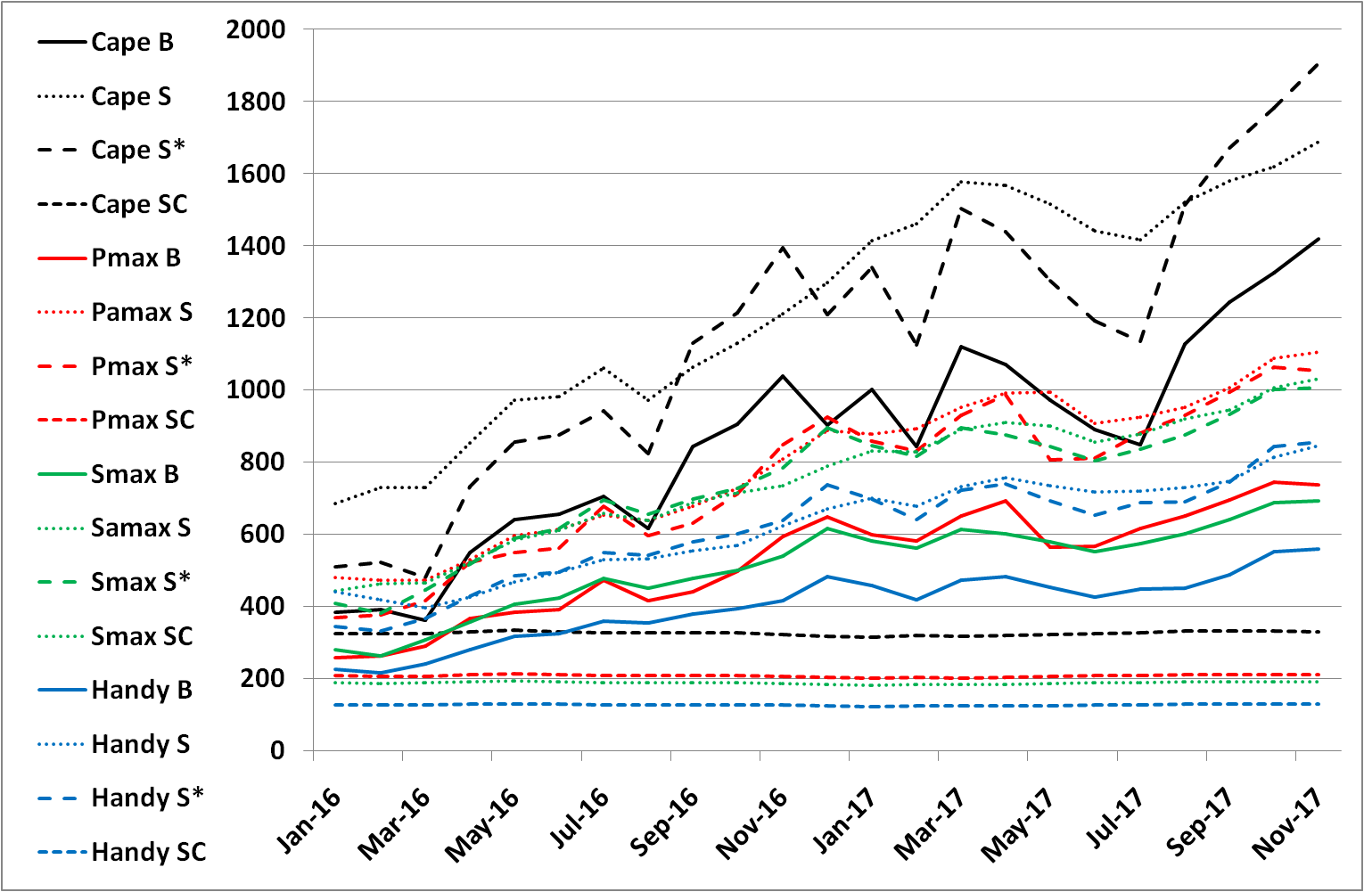
In 1000 USD
Figure 3. Voyage savings and SC tolls in thousand USD for different vessels from Jeddah to Piraeus.
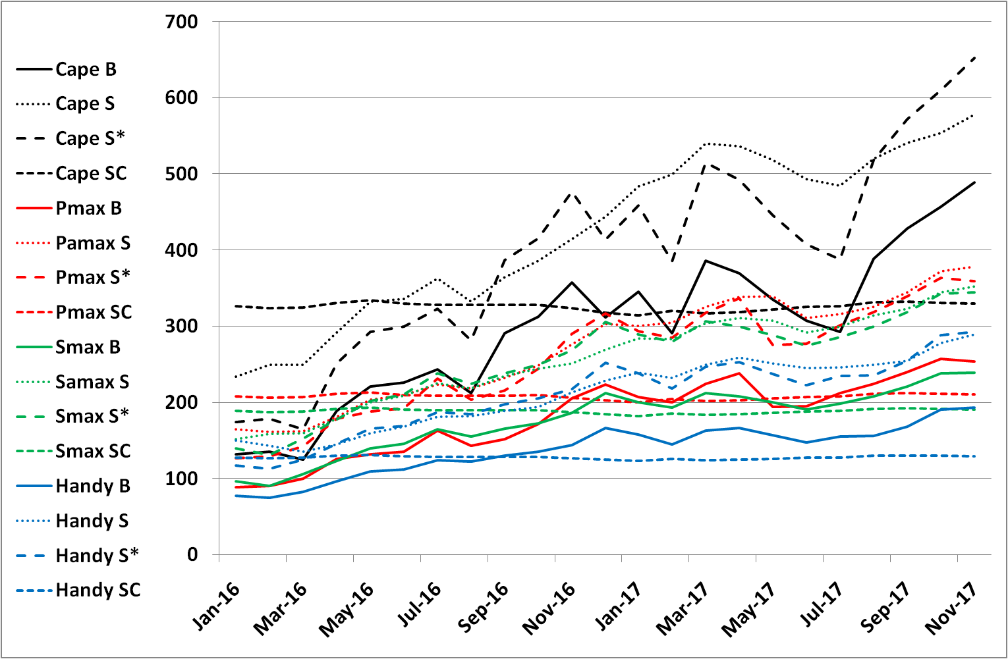
In 1000 USD
Figure 4. Voyage savings and SC tolls in thousand USD for different vessels from Tokyo to Rotterdam.
For Capesize vessel some deviations are present even when using the TCE with the sample vessel characteristics. For the route Jeddah to Piraeus, SC tolls are always less than the total savings of the Baltic vessel, sample vessel, and sample vessel applying TCE. SC tolls to the total savings, in percentage, varied along the period considered, for the Baltic vessel from 89% to 21%, for the sample vessel it varied from 23% to 18%, and from 28.5% to 16% for the sample vessel with TCE. On the other hand, the route Tokyo to Rotterdam, SC tolls to the total savings, in percentage, varied for the first vessel from 259% to 61%, for the second vessel it varied from 139% to 55%, and from 197% to 46% for the third one. This means that in certain periods the SC tolls exceeded the vessels' savings. These periods extend from January 2016 for all the vessels until November, June, and September for the three vessels respectively, which coincides with the reports mentioning that some vessels skipped passage from SC to the Cape during the first three quarters of 2016, due to the reduced bunker prices.
The same pattern holds for Panamax and Supramax vessels as in the case of Capesize vessels. The savings for the sample vessel and the sample vessel with TCE are almost the same. On Tokyo to Rotterdam route, SC tolls in the beginning of 2016 were always greater than the savings. The length of this period varied between the different vessels. SC tolls were by far much less than the savings by the end of 2017.
Handysize vessels show the same pattern with identical savings for the sample vessel and the sample vessel with TCE. For the Handy size vessels, on Tokyo to Rotterdam route, SC tolls were greater than the savings in the beginning of 2016 for the Baltic vessel only. For the other two vessels, in the beginning of 2016, the SC tolls is almost the same as the savings, which is attributed to the fact that the charter rates for the Handysize in this period were high, almost the same as Panamax and Supramax, while the SC tolls is much less than that for the Panamax and Supramax as it is dependent on the SCNT.

Conclusion
As different sources for the charter rates, vessel speed and fuel consumption were considered, the variation in the same vessel total saving on the same route and same date was mainly sensitive to the speed, speed reduction due to weather conditions, and the daily fuel consumption, while switching between the TC or TCE (the variation in the charter rates between different references) was not the deciding parameter. Meanwhile, SC tolls remained constant while the vessels' savings are doubled and sometimes tripled along the period. The tolls calculated when compared to the savings demonstrate over estimation in certain periods and under estimation in others.
Therefore, the current tolls policy fails to mimic the shipping market quick variation for the same vessel on different routes or even on the same route in different dates. This dictates the necessity of adopting a more flexible method for the SC tolls estimation as a percentage of each vessel saving, or by allowing rebates, on case by case basis, if the tolls exceed the savings. The second suggestion allows SCA to raise the tolls without losing its potential customers taking into consideration that the rebate policy is already an acceptable idea and adopted by SCA, but without elaborated explanation and reference to well derived and available indices. The main parameters involved in the suggested new method is the speed, fuel consumption, charter rates, and bunker prices.
With the introduction of the EEDI as a mandatory requirement by IMO, the speed and fuel consumption of each vessel will be properly measured and monitored, and an internationally accepted allowance for the speed reduction due to weather conditions is derived. This provides an independent and trustful reference for the vessels speed and fuel consumption. Relating SC tolls to the EEDI will even contribute to IMO efforts to make shipping a greener industry and will further encourage ship owners to adopt energy efficient technologies.
Bunker prices are daily published and circulated for different ports, which makes this parameter easy to obtain and undisputable, and adopting the Bunkerworld indices is an acceptable method.
Charter rates are available from different brokers and research institutes. As different approaches and data sources are used for deriving the time charter rates, this parameter seems to be the most difficult to evaluate, but still, as mentioned earlier, the variation between TC and TCE is not the main driving parameter. TCEs from the Baltic Exchange are widely accepted in the maritime field, or the time charter rates from different sources can be collaborated to reach an average weighed time charter rate for each vessel type and size.
Still there are other topics which need to be further investigated. Slow steaming and its effect on reducing the fuel consumed during the voyage is an important issue. Also, alternative routes other than the Cape must also be compared, these include Panama Canal and the North Pole route. The impact of increasing SC tolls on encouraging other modes of transportation, as rail and road, on some routes should not be overlooked.

References
- Suez Canal Authority, https://www.suezcanal.gov.eg/English/Pages/default.aspx.
- United Nations Conference on Trade and Development, Review of Maritime Transport, United Nations Publications, New York and Geneva, 2017.
- State Information Service, http://www.sis.gov.eg/Story/123091?lang=en-us.
- International Monetary Fund, Special Drawing Right, http://www.imf.org/en/About/Factsheets/Sheets/2016/08/01/14/51/Special-Drawing-Right-SDR.
- SeaIntel Maritime Analysis, SeaIntel Sunday Spotlight, www.SeaIntel.com issue 273 (2016).
- Bunkerworld, Fuel Prices, http://www.bunkerworld.com/prices/index/.
- The Baltic Exchange, Guide to Market Benchmarks, Baltic Exchange Information services Ltd, 2016.
- International Maritime Organization, Third IMO Greenhouse Gas Study, 2014.
- Thomas Lamb, editor, Ship Design and Construction, The Society of Naval Architects and Marine Engineers, USA, 2003.
- Athenian Shipbrokers S.A, Monthly Report, www.atheniansa.gr, December 2017.
- International Maritime Organization, MARPOL Consolidated Edition, 2017.

Maged Abdel Naby, Naval Architecture and Marine Engineering Department, Faculty of Engineering, Alexandria University, Lotfy El-Sied St. off Gamal Abd El-Naser, 11432 Alexandria, Egypt; E-mail: maged_abdelnaby@yahoo.com.

