Fluid dynamics optimization of a shaft-less rim-driven propeller
Amedeo MIGALI ^{a,}, Daniele BRUNO ^{a,2}, Daniele MALGIERI ^{a,3}, Luca PARUSSINI ^{a,4}, Marco DE SANTIS ^{a,5}
ª MICAD s.r.l.
Abstract. The shaft-less rim-driven propeller (RDP) can provide many advantages over traditional ship propulsion plants, including enhanced onboard comfort and propulsion efficiency, locations arrangement flexible installation, light weight and compact size. For this reason, during last years it become an attractive ship propulsion device in the marine industry. Within the project P. E. R. Na. “Propulsore elettrico reversibile per la Nautica” financed by the FvG region with Uni-TS, Uni-UD and MW.FEP as partners, a hydrodynamic optimization (DoE) was developed with the aim of determining the feasibility of this type of thrusters for propulsion of sailing boats. The electric motor will have the possibility of generating electricity by extracting energy from the boat's motion when it sails. In this preliminary study, only the propulsion phase was investigated. A completely parametric model of the rotor (blades and rim) has been created with Grasshopper inside the Rhinoceros 3D environment, a selection of variables has been included in the multi-objectives optimization process carried out through ModeFrontier (ESTECO) by measuring the parameters chosen by performing CFD simulations with the Star-CCM+ solver (SIEMENS).
Keywords. Optimization, propeller, CFD, DoE.

Introduction
Project P.E.R.Na. financed under the 2014-2020 POR-FESR call for proposals of the Friuli Venezia Giulia Region (Act No 3028/2017). The aim of the project is to construct, with a multidisciplinary approach, a prototype of an electric shaft-less rim-driven propeller (RDP) for sailing boats as alternative to the classic endothermic propulsion at comparable power and range. Shaft-less rim thruster and propeller has become an attractive ship propulsion device in marine industry in recent years, especially regards electrical engines, for several reasons [1]: reduced vibration and noise, enhanced onboard comfort, flexible installation locations arrangement, light weight and compact size.
Project partners are: University of Trieste, which deals with mechanical and electrical design, University of Udine, which together with the company MWFEP S.p.A. have designed and manufactured the control electronic units.
MICAD S.r.l. has conducted research and then fluid dynamic design of the propeller and its interaction with the hull. The study, entirely virtualized, was conducted using modern Design of Experiment techniques and was divided into three macro areas: parametric geometric model (Rhinoceros 3D and Grasshopper), numerical analysis of the fluid dynamic field (STAR-CCM+) and optimization (Mode Frontier).
Special attention has been paid to define the geometric model in order to experience a cost-effective procedure using widely used software such as Grasshopper. Then, prototype of the propeller blades and the mockup of the assembly was made using additive manufacturing technique.

Commercial target and operative conditions
The commercial targets of the project are pleasure boats especially sailing boats, where the reduction in size and the increased comfort is particularly appreciated.
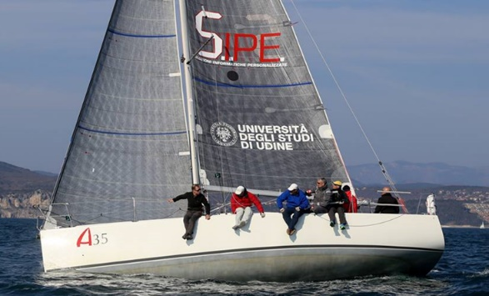
Operative conditions and mission profile was identified taking into account the boat characteristics made available by the University of Udine for the project. On board of the “UniUD Sailing Lab”, at the end of the project, the prototype will be tested in operative conditions.
Figure 1. Sailing Lab - University of Udine
In order to predict the hull resistance, which the propeller thrust is obviously related, a systematic hull series was used. The most reliable method for resistance prediction is the one resulting from studies on the systematic series of Delft Systematic Yacht Hull Series [2]. Once the resistance $R_{T}$ has been estimated, based on the characteristics of the available boat and estimating the wake fraction coefficient $η_{w}$, thrust has been set to a nominal value of 1500 N needed to proceed at a speed of 6 knots.
The optimization cycle has been set based on these values.

Theoretical approach
Starting from the momentum theory and Papmel correlation [3], making hypothesis on: initial diameter referring on commercial propeller available for the test boat and torque available for the preliminary engine, it was possible to estimate target values for $C_{T}$, $K_{T}$ and therefore $K_{Q}$.
Several geometries, changing n. of blades, chord length, inner and outer diameter were manually created in order to verify, by steady CFD simulations, the rated dimensions.
Firstly, only few blades propeller with symmetric profile and elliptical chord distribution were designed, respecting the $P/D$ and $A_{S}/A_{0}$ ratio derived from the assumptions made.
Figure 2. Two initial designs made to investigate on the trade parameters.

The system
The basic structure of the engine includes: an external carter, multi pole stator, fixed bearings, rotor bearings, blades and electronic control unit. Fixed parts of the bearings are mounted inside the carter in order to transfer the propeller’s thrust, coming from the rotor supports, to the boat.
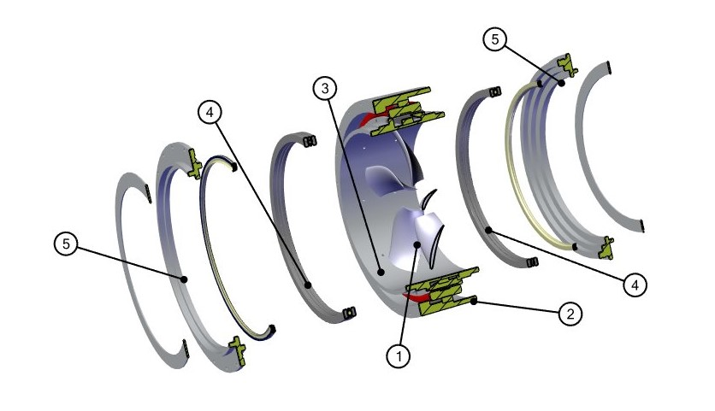
In order to reduce the total resistance, a hydrodynamic cover has been planned to install but since the constraints on the electric machine have not been defined yet, it has not been possible insert the external cover shape in the optimization.
Figure 3. Propeller assembly: (1) Blades (2) Stator (3) Rotor (4) Bearings (5) External Carter

Geometry Parametrization
In order to obtain a collection of propellers with different constitutive parameters, it was developed a full parametric design of the geometry in Rhinoceros 3D. The workflow of parametrization was defined as follows, starting from the airfoil, then constructing the blade and finally the whole propeller.

Profile definition
Blade profile definition was the first step. In this analysis, various manners to define the profile have been evaluated, starting from the NACA 4-digit analytic definition. In the end, the choice has gone for “Bezier-Parsec 3333” parametrization [4] which results to be the most complete way to generate a profile, without increase overly the number of variables.
BP-3333 parametrization consists in defining the profile as sum of thickness distribution and camber curve; totally, only 4 Bezier curves of degree three are required in order to define a profile, two for the thickness and two for the camber, with tangency continuity.
Each curve is defined from 4 control points, of which one is fixed and three variables; the coordinates of the twelve control points are linked from relations retrieved in the reference.

Propeller definition
Once defined the profile, it has been implemented a Visual C++ code in Grasshopper in order to create the single blade. This code is based on the blade geometry classic definition: each profile is nested on a circumference of responding radius, scaled for the responding value of the chord distribution and thickness distribution, rotated along its axis to fit the defined value of the pitch, translated according to the skew angle and rake ratio.
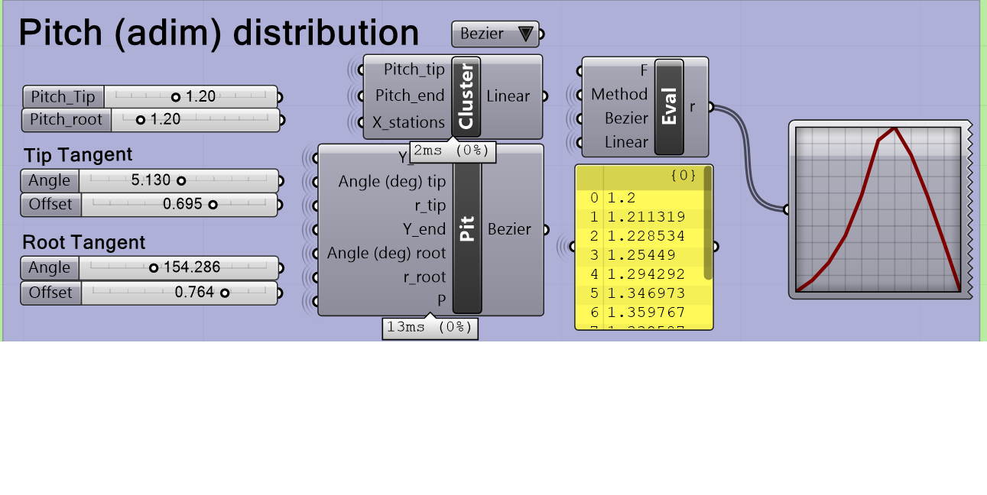
Each Blade variable is distributed along the radius with a function that can be constant, linear or modeled with a Bezier curve. For this reason, the number of variables for each function can be respectively one, two or six.
Figure 4. Example setting of a blade parameter distribution along the radius
In Figure 4 is depicted the Grasshopper module programmed for the parameterization of the Pitch distribution.
Physical parameters considered in the blade construction are Pitch ratio, Rake, Chord distribution and Thickness ratio; all these are set as Bezier distribution except the thickness distribution, supposed as linear.
Last step of the definition of the propeller was to define Diameter, Inner Radius, Number of blades. In Figure 5 is reported a rendering of a geometry generated.

Numerical Model
Figure 5. One of the geometry of the propeller generated.
The mathematical model used for the numerical simulations is described by Reynolds Averaged Navier Stokes Equations (RANSE), solved in their integral form, by means of Finite Volumes methods. The coupling of the Reynolds shear stress tensor is obtained by Two Layer Realizable K-Epsilon using an All y+ Law for the wall modelling. Velocity and pressure are solved in a segregated manner, and then coupled by means of the SIMPLE algorithm.
Commercial code Star-CCM+ has been used for the numerical solutions of the equations.

Mesh Definition
According to our experience and literature reference [5] [6], Fluid Domain dimensions have been set referring to a mean diameter $d=0.40 m$, as shown in Figure 6.
A trimmed mesh, based on hexahedral cells, was chosen as the more appropriate, since the flux exhibits a prevalent (axial) direction. The Base Size of the mesh was validated according the Grid Uncertainty Analyses Verification and Validation Procedure prescribed by ITTC [7], based on Richardson Extrapolation.
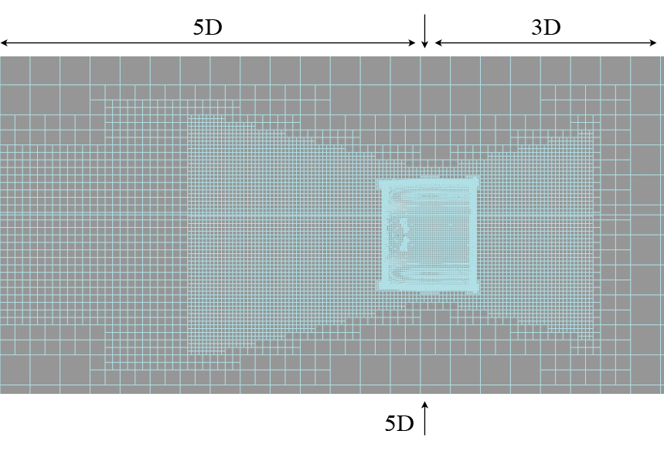
Since no experimental data are available for our propeller architecture, mesh validation was leaded on the VP-1304 Potsdam Propeller Test Case [8].
Figure 6. Mesh of the Fluid Domain.
The mesh was properly thickened in regions were the flux is supposed to be more affected by velocity and pressure gradients; an example of the mesh used for our calculation is shown in Figure 6.

Physic Definition
In order to properly represent the propeller rotation, it has been set a Multiple Reference Frame technique, since it is largely demonstrated to be an adequately accurate method for propeller motion representation, without bring up unsteady methods like mesh-sliding or mesh-morphing that largely increase the computational time.
A large number of simulation have to be leaded in a reasonable time, therefore particular attention is payed on under-relaxation factors for velocity and pressure [9], in order to accelerate convergence without invalidate the results.
Mean objective of the simulation was the calculation of thrust provided and the torque absorbed by the propeller for each geometry and operative point considered, and then the consequential efficiency.

Optimization

Optimization workflow
Once defined the geometry parametrization and properly set the solver Star-CCM+, these two blocks have been integrated in a ModeFrontier algorithm in order to automatize the research of the optimum configuration.
Chosen input parameters are variated through a Python Macro, that assigns the value to the respective Grasshopper input, generating the propeller geometry via Rhinoceros3D. Each geometry has been analyzed directly inside Grasshopper to avoid that wrong geometry could be processed, for example in case of contact between two consecutive blades; then valid geometries have been sent to the working directory in the SabalCore cluster via SSH [10].
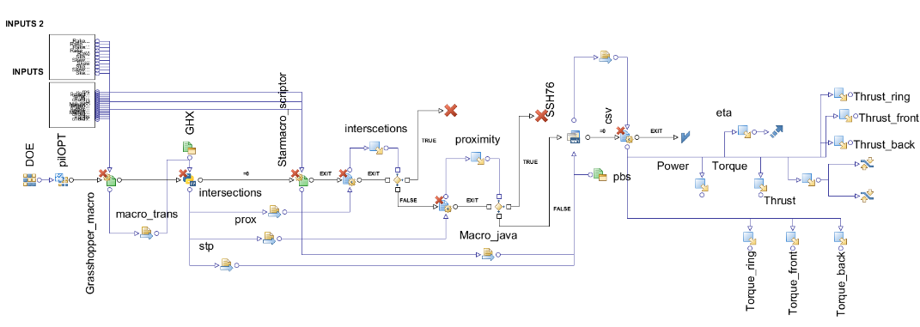
Once received the geometry, a Java Macro provides the instructions to import and repair the geometry, mesh, and finally run Star-CCM+ analyses. Measured parameters (mainly thrust, torque and efficiency) are send to ModeFrontier, and properly treat by the software according to the selected algorithm.
Figure 7. ModeFrontier workflow.

Preliminary Analysis for the evaluation of Operative Point
As a good optimization requires, the choice of an appropriate strategy to pursue pass through the definition of how much time is available, what is the budget invested and how many and which objectives are subjects of the investigation. Therefore, the optimization was conceived on subsequent steps.
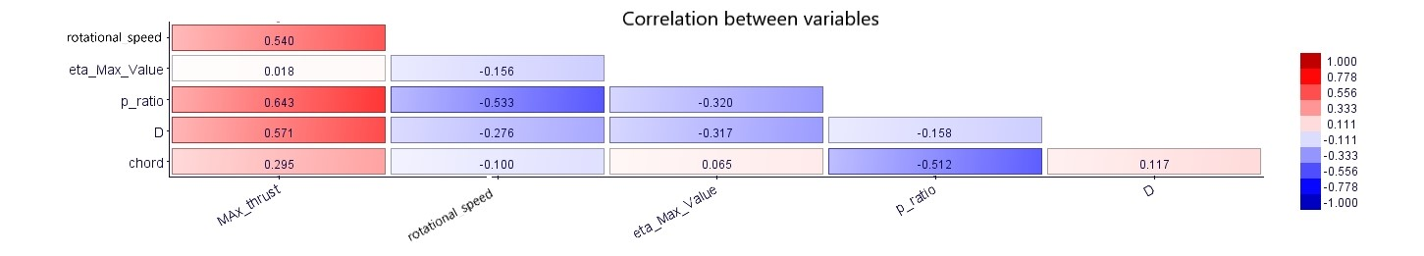
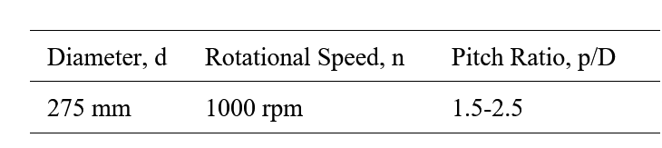
Firstly, with a SIMPLEX optimization algorithm it was analyzed a collection of designs in which number of blades, pitch and chord were variated, fixing all others parameters and using a symmetric NACA-0012 airfoil. This first investigation was focused on retrieve the most suitable diameter and operative point, such as for defined diameter and fixed $V_{∞}$ it is equivalent to define the rotational speed of the propeller; in this analysis the performance characteristic has been retrieved for each propeller evaluated, pointing out the rotational speed that guarantees the highest efficiency and the thrust in compliance with the target.
Figure 8. Results of pre-optimization, main parameters and correlation between variables.

It is important to notice that the previous preliminary analysis led using the Momentum theory and Papmel correlation indicates a diameter of $400 mm$ with $1000 rpm$, while results shown in Figure 8 points out how methods suitable for “traditional” propellers do not agree with RDP.

Optimization of the propeller
Subsequent step has been to variate all the constitutive parameters of the propeller, in order to define the most suitable geometry, retrieving a collection of optimized propellers corresponding to the highest efficiency at the prefixed thrust.
In this phase the airfoil profile has been defined through a 2D analysis around a predicted operative point, estimating flow direction and magnitude near upstream the blade from results of previous evaluation ($V_{∞}$, rpm, pitch angle).
For the high number of variables and the complexity of the problem, the optimization has been performed with the PilOpt algorithm, developed by ESTECO, that analyzed a large number (about 400) of geometries.
Skew | Bezier – 6 variables |  | External Diameter | 250 – 300 mm
Rake | Bezier – 5 variables |  | Inner diameter | 0.2 – 0.4 % of D
Pitch Ratio | Bezier – 6 variables |  | rpm | 1000 rpm
Chord | Bezier – 6 variables |  | Number of blades | 4 - 9
Airfoil | PARSEC-3333 (from 2D analysis)
Table 1. Variables considered in the optimization.
The propeller optimization permitted to increase of about 21% the efficiency of the propeller from the first optimization. Furthermore, the database of results allows us to have a high sensibility on which parameters influence the propeller performances and relative correlation factors. This results a great advantage for further development of RPD with different operative targets.

Conclusion and Outlook
Optimization strategy, has proved cost effective and smart in driving project towards the optimal design comparing hundreds of variants.
The propeller prototype has been realized through additive manufacturing in PLA, each blade was printed and consequently assembled on the engine rotor.
Further studies will be lead on the parametric optimization of the assembly propeller-external carter, adding more variables to the model using the same methodology.
Additional developments will concern the design of a mechanism capable of changing the pitch of the propeller through controlled actuation.

References
[1] | Y. Xinping , L. Xingxin , O. Wu , L. Zhenglin , L. Bao and L. Jiafen , “A review of progress and applications of ship shaft-less rim-driven thrusters,” Ocean Engineering, no. 144, 2017.
[2] | J. Gerritsma, N. Newman and J. Kerwin, “DSYHS Database,” TU Delft, [Online]. Available: http://dsyhs.tudelft.nl/.
[3] | Carlton, Marine Propellers and Propulsion, ELSEVIER, 2010.
[4] | T. Rogalsky, “Acceleration of Differential Evolution for Aerodynamic Design,” 2004.
[5] | L. Jiafen , Y. Xinping , O. Wu , L. Bao e L. Xingxin , «Study on Hydrodynamic Performance of Hubless Rim-Driven Propulsors with Variable Parameters,» in 2017 4th International conference on Transportation Informatin and Safety (ICTIS), Banff - Canada.
[6] | C. Minjian , Y. Canjun , W. Shijun , Z. Yushi and X. Yu , “Hydrodynamic Analysis of A Rim-driven Thruster based on RANS Method,” The Japan Society of Naval Architects and Ocean Engineers, 2015.
[7] | ITTC - International Towing Tank Conference, “Uncertainty Analysis in CFD Verification and Validation Methodology and Procedures,” in Resistance Comitee of 23th ITTC, 2002.
[8] | SVA Potsdam, “PPTC smp’11 Workshop,” Proceedings of the Workshop on Cavitation and Propeller Performance, 2011. [Online]. Available: https://www.sva-potsdam.de/en/pptc-smp11-workshop/.
[9] | Barron and Salehi Neyshabouri, “Effects of under-relaxation factors on turbulent flow simulations,” International journal for numerical methods in fluids, no. 42, p. 923–928, 2003.
[10] | Sabalcore Computing, Inc., “Sabalcore,” 2017. [Online]. Available: www.sabalcore.com.

Amedeo Migali, Managing Director, MICAD s.r.l.; E-mail: a.migali@micad.it. 2 Daniele Bruno, Naval Architect, R&D Engineer, MICAD s.r.l.; E-mail: d.bruno@micad.it. 3 Daniele Malgieri, Aerospace Engineer, MICAD s.r.l.; E-mail: d.malgieri@micad.it. 4 Luca Parussini, Mechanical Engineer, MICAD s.r.l.; E-mail: l.parussini@micad.it. 5 Marco De Santis, Naval Architect, MICAD s.r.l.; E-mail: m.desantis@micad.it.

