System for speed/power trials measurement and analysis in accordance with international recommended procedure

Paolo BECCHI[[1]](#footnote-1), Mirko BASSETTI, Mauro GARBARINO, Giovanni CUSANOa

a*CETENA S.p.A*

**Abstract.** The last international recommended procedures and normatives provide detailed guidelines and formulation for the execution of speed and power sea trials and the analysis of the results. For this reason it starts to be necessary to analyze the data directly onboard as the trials are completed and define the effective contractual speed and power condition of the ship. CETENA recently improved its technical equipment for sea trials measurements, including the custom software “SPEED” aimed to be directly connected with the acquisition one and provide ship performance analysis consistent with both ITTC and ISO normative. In order to guarantee high accuracy in measurement and analysis, each instrument (torquemeter, anemometer, flowmeter, gyro, etc) has been calibrated and certified by accreditated laboratories. The analysis software “SPEED” has been certified by the rules ABS and RINA. The ship speed and power performance analysed by SPEED and thus referred to ideal condition - i.e. with no waves, no wind and prescribed load condition - can be used for verifying the Energy Efficiency Design Index (EEDI) of the ship..

**Keywords.** Propulsion efficiency, sea trials, EEDI

# Introduction

The last international normative such as ISO ([1]-[4]) and ITTC ([5]-0) first require the official sea trial to be analyzed in order to evaluate the ship performances in contractual conditions that usually imply contractual displacement, smooth hull and propeller surfaces, no wind, no waves, no current effect and deep water at 15°C. For this reason the possibility of evaluate the effective ship performances just after the official sea trial speed and power test represents a good opportunity for both the owner and the shipyard. The first can have immediate the results of the test just carried out while the latter can know the ship performance in contractual/ideal condition that represents a good feedback from the point of view of the design.

With over 40 years of experience in sea trials and experimental activities, CETENA has the combination of knowledge, skills and operational experience on board which represent an important background for the development of a new measurement and analysis system aimed to respect the international normative procedure. The system has already be tested on different ships for long term monitoring activities. In the last two years the renewed hardware and software equipment used for sea trial execution has been implemented, tested, certified and currently used for any kind of vessel. The new equipment has been designed in order to reduce weights, costs and installation time. Furthermore, all the components can be quickly replaced and handled if necessary. The software, both the acquisition system and the analysis tool, has been developed optimizing performances for the new hardware components.

# Overview of the system

The whole system (acquisition and analysis) has been developed in LabView 2015, stating the large experience of CETENA in developing onboard hardware and software systems using the National Instruments development framework.

The hardware acquisition unit (**Figure 1**) has been designed and manufactured by CETENA, in order to save weights and dimensions as possible. On the other side, the functionalities related to acquisition, connectivity and installation have been improved respect the previous version.

|  |  |
| --- | --- |
| C:\Qualich\_PRODOTTI\Sysman 2\foto\20170511_145206.jpg | C:\Qualich\_PRODOTTI\Sysman 2\foto\20170511_145240.jpgC:\Qualich\_PRODOTTI\Sysman 2\foto\20170511_145249.jpg |

**Figure 1**: SYSMAN II acquisition unit

# The acquisition system “SYSMAN II”

The acquisition system named “Sysman II” (SYStem MANoevrability) is structured in two main components: the SYSMAN Remote, that is located close to the shaft lines, and the SYSMAN Console (**Figure 2** - **Figure 3**) usually located on the bridge in order to interact directly with the captain for the sea trial execution. The system is able to acquire and store all kinds of signal (analog and digital) required for the analysis of both speed and power performances and maneuverability characteristics. The recorded data are the results of a sampling procedure along 1 second, the sample rate of each signal depends on the type of the signal itself. Together with the data required for the analysis, it is also possible to acquire any kind of analog signal (both current and voltage) that could be useful to know such as fuel consumption, propeller pitch, electric power and so on.

In addition, the system is able to acquire N signals on serial lines (ModBus, NMEA, etc) together with environment conditions obtained by wave radar (if available) and anemometer that are really important for the propulsive performance analysis.

The two parts of the whole system are connected by a serial interface RS-485 2W and using a standard ModBUS RTU protocol with the SYSMAN Console in the role of master.



**Figure 2**: SYSMAN II acquisition console - main console

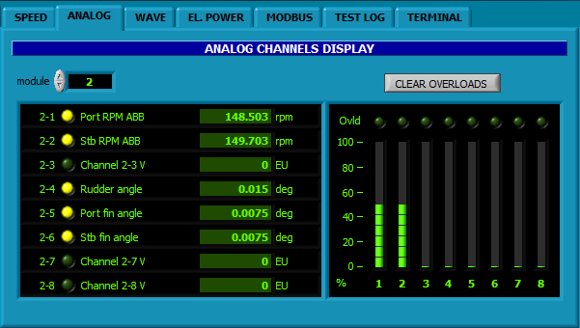

**Figure 3**: SYSMAN II acquisition console - analog inputs

The SYSMAN II system allows the execution of speed&power as well as of other kind of sea trials test, like manoeuvring, turning circle, crash stop, seakeeping tests. The main interface shows many kind of real time data acquired, as ship speed and heading, GPS coordinates, GPS local time, shaft speed and power, current wind as measured by anemometers and, in addition, the history chart of any other signal acquired.

From the point of view of Speed and Power tests, the SYSMAN Console is already customized in order to speed up the interaction with the analysis tool ‘SPEED’ described in the following. Just before a run measurement, the user is required to define the power setting at which the incoming run will be associated during the analysis, the heading condition (forward or return) and the type of test that could be: “speed and power” or “single run”. In the first case the tests are consistent with multiple runs measurement to be analyzed in accordance with ISO 15016 ([1]) or ITTC 2014 ([5], [6]) or ITTC 2017 (0), and in the second one only the ISO 19030 ([2]-[4]) can be applied.

In accordance with the referred procedures, the Speed&Power tests are carried out acquiring a minimum set of parameters for each run, that is: time, propeller shaft torque, propeller shaft speed, ship’s position and heading, ship’s speed over ground, relative wind condition and, if possible, sea state. All the parameter needed are acquired by the same hardware in the same time, in order to guarantee data simultaneity. Each single signal are managed depending on the sensors used, and one measured values data set is provided every second. During the tests, the main console makes it possible to visualize the history of each value as measured (**Figure 4**).

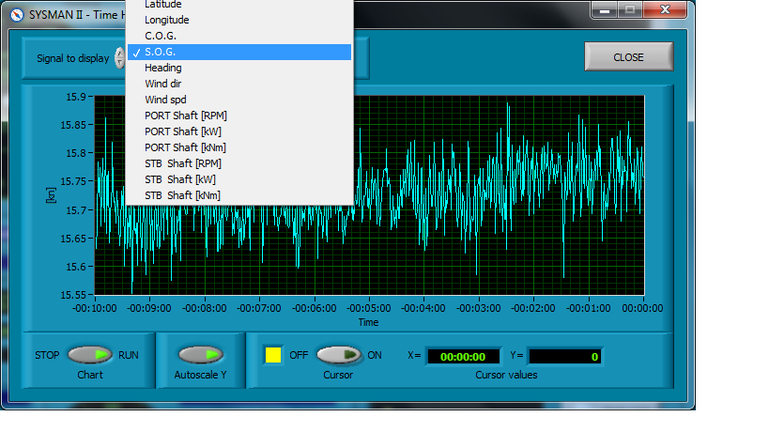

**Figure 4: SYSMAN II - Acquisition console, time history**

# Speed and power trial analysis tool “SPEED”

The analysis of the speed and power trials result is performed using the new own made software “SPEED” v1.0.0 that provides the user the possibility to choose the normative to be used. The recommended procedures currently implemented are:

* ISO 19030 ([2]-[4])
* ISO 15016 ([1])
* ITTC 2014 ([5]-[6]) and
* ITTC 2017 (0).

The software has been implemented keeping into account the following main required skills:

* easiness of the user interface
* easiness and reduced time requirement for the ship configuration
* use of spreadsheet models (Excel) for the configuration file and model test data
* direct interface with the acquisition system
* possibility to choose the normative to be used
* possibility to choose the corrections to be activated
* reduced computation time
* results report in pdf format

These skills help the user, and especially the design team, to check the expected ship performances before the sea trials and speeding up the software configuration passing through spreadsheet models as usually used for any design activity. On the other side, it is also possible for the owner representative onboard to control anytime the configuration used, including the model test data, the correction enabled and the measured run results.

The software has a custom interface with the acquisition system “SYSMAN II” that directly loads all the data acquired and shows the average data for each measured run performed. This skill guarantees no human error due to transcription from the acquired data system and the analysis one.

As prescribed by the international recommended procedures, the configuration data set includes the names of the three persons attending the sea trial representative team (owner, shipyard and sea trial measurement team) that will ask to sign the analysis report just after the execution of the speed and power tests, in order to provide to all the subjects involved in the sea trials an official report with describing the effective contractual ship performances.

The software SPEED has been certified by two rules registers, ABS[[2]](#footnote-2) and RINA[[3]](#footnote-3) in order to guarantee the client both the robustness of the code development and its compliance with the formulations prescribed by the normative. Being designed and developed by CETENA itself, this software is continuously checked, updated/upgraded and implemented depending on clients or CETENA itself requests.

## Brief overview of the main console

In the **Figure 5** the main console of the SPEED software is shown. The interface is characterized by the following main parts:

* the LOGBOOK table showing the main data related to all the measured runs, that is: description, navigation, wind condition, sea state condition, performances
* the SELECTED RUN DATA multi-tab control, that give the possibility to handle data related to each single measured run
* the SPEED & POWER area where the multiple run analysed data are shown both in terms of curve (graph) and detailed results (table)
* the CORRECTION toolbar that makes it possible to enable the correction required and finally the
* the buttons bar for any other action as open and handle configuration data, open and save run logbook file, run computation, print report.

After the execution of the data analysis, it is possible to check the detail of the results opening the ‘detailed results console’ as shown in , where it is possible to highlight the measured runs (first table) related to the power setting results selected in the second table.

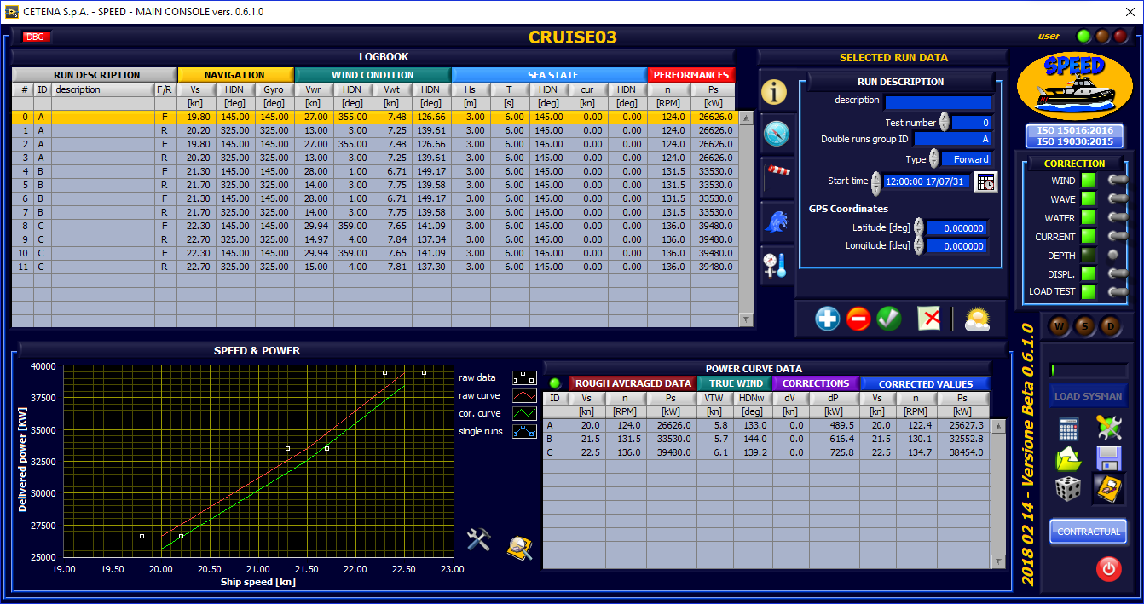

**Figure 5**: SPEED main console

Furthermore a report in pdf format is generated, containing all the configuration data (including model test, ship load conditions, weather conditions) and showing results obtained by the analysis procedure adopted. As prescribed by the current normative the report shows all the data needed to repeat computation and is structured in the following chapters:

* **trial team**, where the prescribed Trial Team responsibilities for sea trial preparation and execution are described. In addition there is a section in which the name of the defined representatives (owner, shipyard and measurement company) are shown and their signature required after the tests for acceptance of the results obtained.
* **ship main dimensions and load condition**, describing all ship conditions configured. Together with load conditions, also the prescribed applicability thresholds are shown for the main weather conditions (wind state, sea state, water depth)
* **correction models**, in which it is possible to check the correction models have been switched on and their configuration.
* **results**, shown in table format, including data as measured, correction applied and final values

The report makes it possible to provide the owner and the shipyard an official document summarizing the test conditions performed and the analysis results, leading to the approval of the Speed and Power tests directly onboard.

## Analysis

As described before, the analysis is carried out consistently with the current international recommended procedures and regulations. CETENA will keep the computations libraries updated with any future modification of these regulation and, in necessary, will improve new regulations if any. **Figure 6** represents the procedure flowchart adopted consistent with the recommended procedures. It can be seen the analysis starts with the definition of arrangement and sorting of the multiple runs, to be carried out at constant power setting. The analysis proceeds with the evaluation of the three main added resistance components due to wind, waves and water density. For the computation of all theses added resistances, it is possible to use experimental data obtained from custom model scale tests, that are: resistance test, self propulsion tests, seakeeping test and wind resistance test. In case of the last two miss, it is possible to adopt different computation approaches, as suggested by the reference normative:

* wind resistance
  + Regression formula by Fujiwara et al.
  + Data set on the wind resistance coefficient
* wave resistance
  + Direct correction method STAWAVE-1
  + Empirical transfer function STAWAVE-2

After that the ship speed is corrected for both current and deep water effect and then the power in ideal condition is computed passing through the correction for propeller load and displacement.



**Figure 6: S&P data analysis flowchart**

The current computations modules have been tested using both direct computations and comparison with analysis performed with other software and with the usual procedure adopted by RINA for this kind of analysis. The differences experienced are small and related to some computation approaches used, as integration or interpolation methods, thus confirming the affordability of results as certified by Classification Societies.

# Conclusions

The possibility to identify the effective ship performances excluding the effects of wind, wave, load condition, deep water and salinity represents an important aspect of the sea trial execution, both from design and manteinance point of view. The official speed and power tests is a key point for the respect of the contractual agreed values and then the delivery of the ship to the owner. The data analysis consistent with the last international normatives and recommended procedures guarantee the owner about the computation of the effective ship performances and provide a good feedback to the shipyard from the design point of view.

Despite other sofware available, the implemented procedure ISO 19030 provides the additional feature regarding the possibility to check performances of a ship in line, and then without the possibility to carry out usual sea trials. The analysis of data in these conditions covers an important rule for the ship performance monitoring, especially across the main maintenance events such as dry-dock, reblading, hull cleaning and so on.

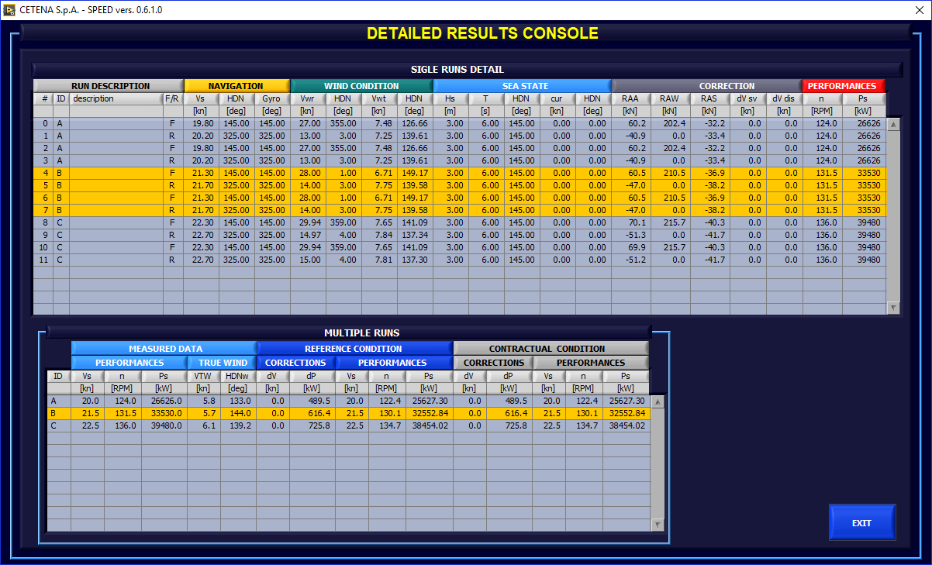

.**Figure 7**: **Detailed** results console

References

1. ISO 15016:2015(E) – *Ship and marine technology – Guidelines for the assessment of speed and power performance by analysis of speed trial data* – Second edition 2015/04/01
2. ISO 19030 - *Ship and marine technology – Measurement of changes in hull and propeller performance – Part 1: General principles* – Edition 2016
3. ISO 19030-2 – *Ship and marine technology – Measurement of changes in hull and propeller performance – Part 2: Default method* – Edition 2016
4. ISO 19030-3 – *Ship and marine technology – Measurement of changes in hull and propeller performance – Part 3: Alternative methods* – Edition 2016
5. ITTC 7.5-04-01-01.1 - *ITTC Recommended Procedures and Guidelines, Speed and Power Trials, Part-1 Preparation and Conduct* (2014)
6. ITTC 7.5-04-01-01.2 - *ITTC Recommended Procedures and Guidelines, Speed and Power Trials, Part-2 Analysis of Speed/Power Trial Data* (2014)

ITTC 7.5-04-01-01.1 – *ITTC Recommended Procedures and Guidelines, Preparation, conduct and analysis of Speed/Power trials (2017)*

1. Paolo Becchi, Operations Monitoring System B. U., CETENA S.p.A., via Ippolito d’Aste 5, 16121 Genova, Italy; E-mail: [paolo.becchi@cetena.it](mailto:paolo.becchi@cetena.it) [↑](#footnote-ref-1)
2. ABS *Certificate of Design Assessment*, 17-GE1695772-PDA (06/12/2017) [↑](#footnote-ref-2)
3. RINA certificate under finalization [↑](#footnote-ref-3)