Heavy-lifting: coupled stability & structural analysis in a load-out operation
Stéphane DARDEL^{a,} Nick DANESEª Jean-Luc MORBELLI ^{b} , Sylvain FLOURET ^{b}
ª Nick Danese Applied Research Sarl, France
^{b} Terra Navtica A/S, Denmark
Abstract. The economic and technical challenges of large-scale load-in/out operations require the assurance provided by specialized and integrated engineering software that provides leading-edge support to preparation and planning and helps ensure enhanced safety and quality control.
This case-study describes the planning of a load-in operation by a Self-Propelled Modular Transporter (SPMT), for which all technical and environmental constraints are integrated in a quasi-dynamic model, developed in a combined GHS™ (hydrostatics & stability) and MAESTRO Marine™ (ship-specialized FE) environment. Model and calculations address and cater to tide, wind, mooring forces (winches, anchors, etc.), ballast, pump capacity, verification at each stage of the loading of draft and trim, stability, hull girder bending moment and deflection, compliance with operational limits and Regulations, etc. The realistic Finite Element structural and the stability models are loaded in synchrony (hydrostatics and SPMT). The integrated GHS and MAESTRO environment allows tracking and managing the combined hydro and mass loading effects in quasi-dynamic mode: the hydrostatically balanced, MAESTRO receives tank loads from GHS, and runs detailed stress analysis and limit state evaluation of the structure, thereby ascertaining the structural integrity and girder deformation patterns of the carrier.
Keywords. Heavy-lifting, stability, structural analysis, structural strength, load-out, GHS, MAESTRO Marine, limit-state, ULSAP, finite-element analysis.

Introduction
The economic and technical challenges of large-scale load-in/out operations require the assurance provided by specialized and integrated engineering software to provide leading-edge support to preparation and planning and helps ensure enhanced safety and quality control.
This paper describes the case study of the load-out of a 1,200t cargo module, loaded onto the Dong Bang Giant 3 heavy-lift carrier vessel. Each step of the load-out process is carefully planned and verified in terms of drafts and trim of the vessel, residuary stability, longitudinal strength, girder deflection and local structural strength, within the integrated and coupled environment offered by state-of the art stability and structural analysis software, GHS and MAESTRO Marine.

Tools
GHS (hydrostatics, stability and longitudinal strength), and MAESTRO Marine (ship-specific first-principles finite-element structural analysis, with limit state analysis and adequacy parameter evaluation), provide an integrated and complementary engineering environment.
The hydrostatic model serves the purpose of planning the ballast sequence as a function of the translation of the SPMT/ cargo assembly along the main deck, taking into account tide changes, windage, mooring forces, and ballast pump capacities.
For each time step of the load-out operation, GHS outputs drafts and trim, reserve of stability, shear force and bending moments and girder deflection along the vessel’s length, as well as other operational limit.
The finite-element structural model is developed in MAESTRO Marine. The software is very “marine” in its philosophy: the model is hydrostatically balanced in a fashion aligned with stability codes, like GHS, thereby taking into account tank fillings, deck loads, still water and wave profiles, etc.

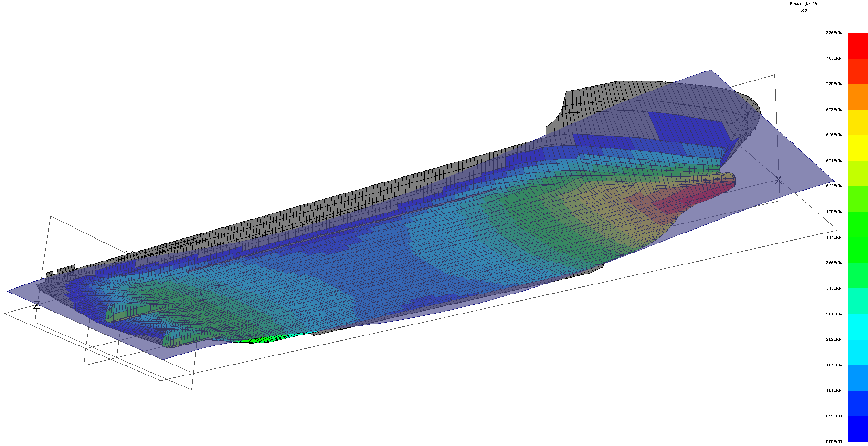
Figure 2.1. MAESTRO model

The Ship
The heavy-lift carrier Dong Bang Giant 3 has a Gross tonnage of 12,183 GRT, and a payload of 14,000t. She was delivered in 2010 and is actively used for heavy-transport activities since.
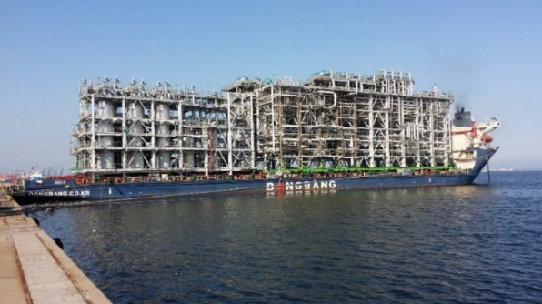
Figure 1. Dong Bang Giant 3

Table 3.1. Dong Bang Giant 3 principal characteristics
Length Overall | 152.20 m
Length between perpendiculars | 139.00 m
Breadth moulded | 38.00 m
Hull depth | 8.00 m
Scantling Draught | 5.10 m
Ballast capacity | 18,400 m³
Fuel capacity | 1,470 m³
Installed Power | 3,360 kW
Service speed | 10.5 knots

The Cargo
The cargo handled was a module for the Wheatstone LNG Plant Project in Australia. Its net weight is 1,200 tonnes, and with overall dimensions L= 67.50m, l=17.00m and h=19.20m.

Rolling Stock
A number of self-propelled modular transporters (SPMTs) were used to lift and displace the cargo. Types used were Scheuerle PEKZ 210.12.4 and PEKZ 140.8.4. Depending on the specification, each axle has a maximum load capacity of 36 to 43 tonnes.

For this load-out, 2 rows of SMTPs were planned, each row with 50 axle lines, making for a total of 400 tyres in contact with the ground and ship’s deck.

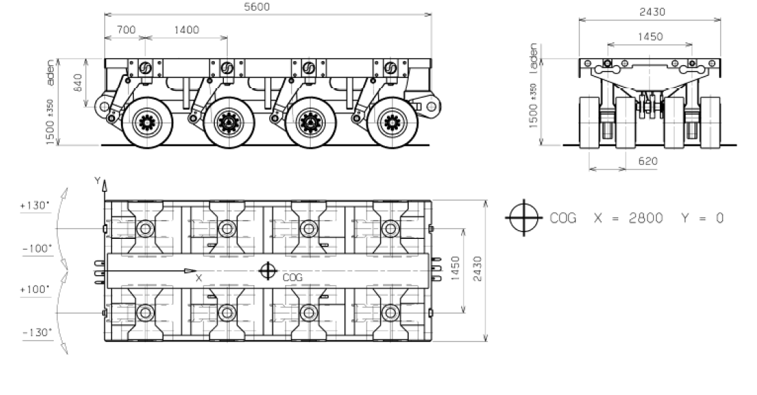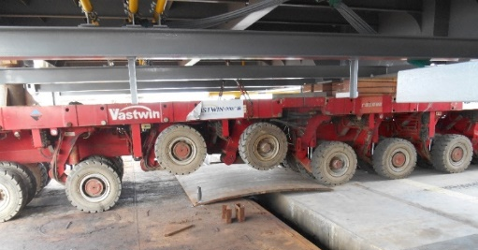
Figure 5.1. Self-propelled Modular Transporter

Digital Model
Two computer models were developed in parallel: hydrostatic & stability and Finite Element.

The hydrostatic and stability model.

The hydrostatic & stability model features a buoyant hull, all tanks and internal compartments (24 ballast tanks, plus fuel, fresh water and ancillary tanks), and superstructure volumes for windage calculations. The model is completed by a lightship longitudinal weight distribution and section modulus data at regular longitudinal intervals allowing the computation of global girder deflection according to regular beam theory.

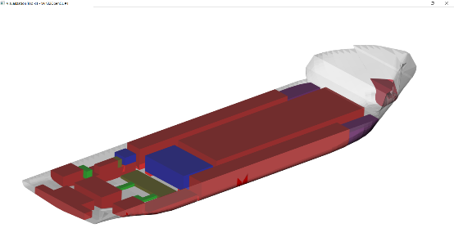
Figure 6.1. GHS hydrostatic model

A custom environment was programmed within the GHS interface to integrate the operational requirements of the load-out sequence: number and respective positions of trailers, number of lines for each trailer, load per line, whether one or several lines are disconnected, etc.

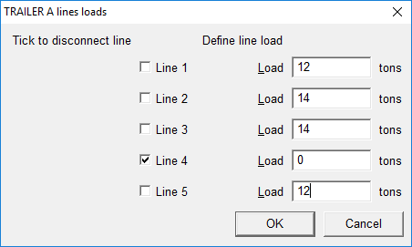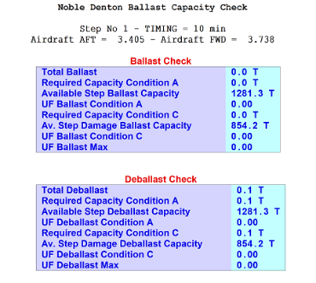
Figure 6.1. Custom dialog box and sample outputs in GHS

This same custom interface provides user dialogs offering controlled, routine and statutory checks for each step of the load-out: drafts, bending moments, tank status, minimum GM required, ballast pumping capacities as per Noble Denton guidelines [1] and values demanded by other required operational limits.

The structural model

The structural FE model is composed of 82,000 nodes and 245,000 elements, and is fully compatible with Nastran to allow additional analysis as the case might demand (forced response vibration, thermal compensation, etc.).

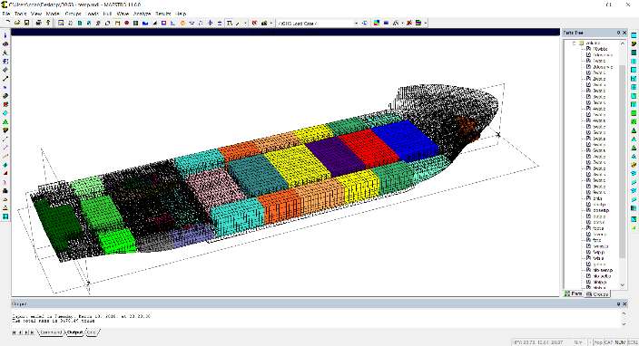
Figure 6.2. MAESTRO structural model
Elements in the structural model are mapped to define exact tank geometry and volumes in conformity with the ones from the hydrostatic model. This allows modelling the same load cases and hydrostatic equilibrium in synchrony, in both software packages.
Furthermore, the MAESTRO model includes a realistic representation of the corrosion state of the shell plating as mapped by Class inspection.

To ensure good agreement in terms of floatation, some sanity checks were performed: draft and trim, residual bending moments, etc. These provided the expected alignment, keeping in mind that the FE model is structurally continuous, while structural inertia is modelled discretely, on a frame basis in the hydrostatic model.

For each time step of the load-out, the following calculation sequence is performed:
- In GHS, verify drafts, trim, stability and longitudinal strength, including check against Class/ Regulation limits
- In GHS, verify pump capacity, as per Noble Denton criteria. This is often the most critical parameter, as pump capacity will dictate the SPMT’s speed
- Automatic transfer of tank loads from GHS to MAESTRO
- In MAESTRO, compute structural response and behaviour

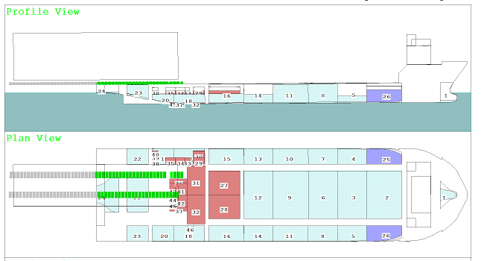
Figure 6.5. “half-way” cargo load-out – GHS

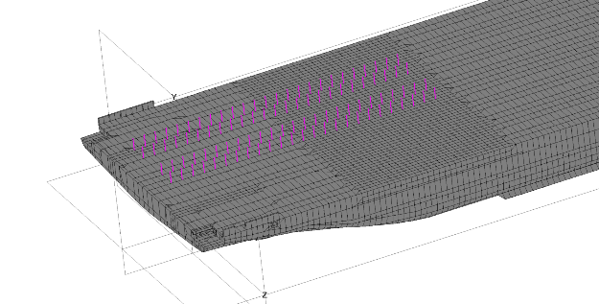
Figure 6.6. “half-way” cargo load-out – MAESTRO

Crucially, the MAESTRO model undergoes two balance solutions:

- a hydrostatic balance to solve for the vertical forces (heave, pitch and roll), and
- an inertia relief balance solution to adjust additional accelerations.

This two-tier approach ensures full spatial balance without the need to employ physical restraints.

Hydrostatic balance: Inertia relief:
$$\left\{\begin{aligned}\sum{{\text{F}}_{\text{h}\text{eave}}\text{=0}} \\ \sum{{\text{M}}_{\text{pitc}\text{h}}\text{=0}} \\ \sum{{\text{M}}_{\text{roll}}\text{=0}}\end{aligned}\right. \left\{\begin{aligned}\sum{{\text{F}}_{\text{surge}}\text{=0}} \\ \sum{{\text{F}}_{\text{sway}}\text{=0}} \\ \sum{{\text{M}}_{\text{yaw}}\text{=0}}\end{aligned}\right.$$
Figure 6.6. the equation of MAESTRO’s two-tier balance solution

Strength Analysis
From the balanced FE model, nodal displacements are computed in a customary fashion: X, Y, shear and Von Mises stresses are recovered from the structural analysis.
In addition to calculating displacements and stresses, MAESTRO also performs a failure evaluation of the principal structural members, so-called Limit State analysis [2].
The Limit State analysis is the automatic verification of the load-bearing capability of a structural assembly as a whole. These assemblies, named “evaluation patches” are evaluated against a set of failure modes, such as collapse in combined buckling, or membrane failure, etc. 14 failure modes are proposed by MAESTRO.
Safety against structural failure of the structural assembly is measured by a parameter called the Adequacy parameter, denoted by g(R), which can be normalized as:

$$\text{g}\left(\text{R}\right)\text{= }\frac{\text{1-γ.R}}{\text{1+γ.R}}$$

where R is the strength ratio (load / limit value), and γ the safety factor
The advantage of using a strength ratio adequacy parameter is that g always lies within the normalized limits of -1 and +1, whereas R ranges from 0 to infinity. Specifically, g(R) → 1 as R → 0 as a result either a very small load or of a very large limit value and at other extreme, g(R) → -1 as R → ∞, as a result of either a very large load or of a very small limit value.
MAESTRO also provides a second type of failure mode evaluation, based on the ALPS/ULSAP approach proposed by J.K Paik et al, of Pusan National University, Korea [3]. Based on the same adequacy parameter paradigm, the ULSAP adds a further set of limit state criteria to MAESTRO’s cross-stiffened panel, combined load components, weld induced annealing, initial imperfections, local denting, etc.
MAESTRO provides several visualization and data filtering tools that highlight the more severely loaded structural members, for example by displaying only the elements exhibiting negative adequacy parameter (hence prone to failure) thereby guiding the structural engineer in identifying critically loaded ares requiring corrective measures bfore the load-in/out operation.

Figure 7.1. Limit State analysis, critically loaded bottom panels

Load-out Operation
The load-out operation itself was performed successfully, in line with the planned procedures and timing. Such operations will typically last several hours, and are categorized in clearly identified steps:
- Ramp installed between quay and ship, cargo on SPMT, still on the quay,
- Loaded SPMT “half-way” between quay and ship. This is the critical step: the operation must now run up to completion, in a timely manner.
- Cargo in place on ship’s deck. The SPMTs are lowered, and the cargo seats on the deck grillage.
- SPMTs rolled from the ship back onto the quay. Note that this step can be accomplished at a later stage, for example after tide change.
The tide, when present, is often perceived as a concern. Yet, it is a formidable, natural “ballast pump” in itself: it is predictable and reliable and will assist beautifully the load-out operation if exploited correctly. Generally, load-outs are performed at rising tide, and load-ins at ebb tide. Tide, grounding points, windage, anchor pulls and all other environmental operational parameters are accounted for by GHS.

Engineering
The preparation of the hydrostatic model represents a few hours of work, allowing very early feasibility checks on payload capacity vs drafts, longitudinal strength, ballast capacity, etc., as well as data for checking compliance with Administration. The GHS environment and model are a significant asset already at the feasibility and bidding stages.
Building the FE structural model took 3-man-weeks, also a very short time within the context of the project and perfectly feasible as part of the initial study. The unprecedented level of quality and assurance thereby gained are invaluable in predicting the structural behaviour of the carrier, identifying potential weak zones and planning any required reinforcing of the structure from very early on in the project. The net savings in time and money can be substantial.
Moreover, creation the hydrostatics & stability and of the FE models is a one-time job: they will be reused in all future operations, save perhaps for small modification.

Future Developments
Specialized engineering software tools subtend a valid digital model and, by simulating real-life conditions, prediction hydrostatic, stability and structural behaviours of the combined carrier-cargo ensemble during load-in/out operation. Predictions are compared to field data: Strain gauges check stress and strain values for crucial structural members, Laser tapes and theodolites measure overall girder deflection
The combined “hydro + structural” model supports sea-going transport and at-sea operations, too. The integrated model opens new areas of engineering analysis and behavioural prediction: combination and interaction of cargo’s and carrier’s strength and overall girder stiffness, assessment of risks to the cargo’s integrity taking into account waves, sea-states, ship speed and duration thereof when sailing in a seaway, extended consequences based on seakeeping analysis: extreme load analysis, fatigue analysis, all ensuing in voyage prediction, planning and critical decision making during the passage.

Conclusion
The use of a synchronized hydros + structural digital model during the feasibility, prediction and operation stages enhances safety and quality control over the entire operation. Specialized GHS + MAESTRO digital models require marginal efforts to compose and remain an accomplished asset for all future jobs.
Use of specialized software completes the predictive and operational monitoring digital-twin set-up, resulting in high ROI.

References
- DNV-GL Noble Denton “Guidelines for Load-outs”, 0013/ND
- Hughes, O.F., "Ship Structural Design," Society of Naval Architects and Marine Engineers, Jersey City, NJ, 1988.
- Paik, Thayamballi, "Ultimate Limit State Design of Steel-Plated Structures," John Wiley & Sons, LTD, England, 2003

Corresponding Author, Nick Danese Applied Research, 150 rue de Goa, 06600 Antibes, France; E-mail: ndar@ndar.com.

