Ship survivability study using high fidelity CFD

Alejandro CALDASª, Constantinos ZEGOS ª, Sotiris SKOUPAS ª, Jane JENKINS ª,
ª Lloyd’s Register
Abstract. Safety is of paramount concern to passenger ship owners and integral to their reputation. For this reason, passenger ship owners are aiming for safety standards well beyond the statutory requirements. The current methods for assessing ship survivability following hull breach and subsequent flooding, adopt a simplified application to define a complex issue leading to uncertainty and over-design. This study uses high fidelity deterministic Computational Fluid Dynamics (CFD) analysis in order to explore the shortfalls of the current design guidance such as SOLAS. A number of flooding scenarios are modelled on a cruise ship at full scale for calm and rough seas.
Keywords. Flooding, SOLAS, survivability, CFD, full scale, alternative methodologies, damage stability.

Introduction
The 2009 amendments to SOLAS and the adoption of the harmonised probabilistic damage stability regulations for dry cargo and passenger ships (SOLAS 2009) [1][2], was a significant step towards a more rational approach for the assessment of ship’s survivability after damage. The safety of cruise vessels was also the subject of several EU funded and Joint Industry projects (i.e. GOALDS 2009-20012, eSAFE 2017-2018) [3][4].
Last year the IMO Marine Safety Committee (MSC) Sub-Committee at its ninety-eighth session, (MSC 98) adopted the amendments to SOLAS Chapter II-1 (Resolution MSC.421(98)) [1] together with the new explanatory notes (Resolution MSC.429(98)) [2], entering in to force on the 1st of January 2020. SOLAS Regulation II-1/4 allows the use of alternative methodologies to calculate a ship’s survivability (Regulation II-1/7-2.2), to assess the intermediate stages of flooding and the determination of the equalisation time as stated in the new explanatory notes. These methodologies pertain to direct calculation using computational fluid dynamics (CFD), time-domain flooding simulations or model testing.
In the described regulatory process, survivability analysis of a damaged ship has moved away from the traditional quasi static, one or two compartment damage case analysis. A more global probabilistic index assessment is favoured with many environmental influences on the ship’s behavior implicitly included in complex generalised formulations. Assessment results for compliance are represented by a single index and no longer provide any indication of specific damage scenarios and ship response.
Owners, particularly in the passenger ship industry, request reviews on the actual survivability and ship motion characteristics over and beyond compliance in order to understand ship performance in implementing highest levels of safety onboard. Time domain tools currently support this need. With computational capacity ever increasing, modern CFD tools are becoming more accessible for analysing the complex physics and dynamics associated with a damaged ship, allowing further insight and understanding of designs.
This paper aims to demonstrate the capability of commercial software to model the complexities of the flooding event of a cruise ship including the multiple physical phenomena driving the process. The exact geometries of the tanks and ship were used, including the air vents, to achieve an accurate representation of the events.
The validation case in the first part of the paper demonstrates the validity of the approach by comparing simulation results against model test measurements. The application case in the second part of the paper considers the flooding of a cruise ship and the influence rough seas have on the outcome.

Methodology
Star-CCM+ was used for all the simulations presented. The model implemented accounted for the hydro and aero-dynamics of the assessed scenarios as well as the floating mechanics of the ship.

Mathematical model
The fluid flow was modelled by means of the Reynolds Averaged Navier-Stokes Equations (RANSE) coupled with a two equation turbulence model (κ-ε) and the energy equation in order to account for the air compressibility.
A 5th order Stokes model was used to model the sea state and the ship mass and moments of inertia were considered in all simulations. Yaw and surge were restricted to keep the direction of the beam seas relative to the ship during the simulations. Both cross flooding and the effect of air vents was accounted for in the simulations.

Numerical models
The solution of the equations was carried out using the Finite Volume method in a segregated manner, using second order schemes and an implicit method for the time discretisation. The ship motions were accounted for using an overlapping mesh technique, whereby the mesh of the moving ship is independent of that of the far-field and can move freely inside it. The meshes were generated by paying particular attention to the sea free surface and the flooding compartments. A summary of the number of cells for the validation case and real application case are shown in Table and Table 2.
Table 1. Barge mesh general characteristics
Barge | Number of cells
Background domain | 1.0M
Hull overset | 0.5M
Compartments | 1.0M

Table 2. Ship mesh general characteristics
Cruise ship | Number of cells: Calm water | Number of cells: In waves
Background domain | 1.8M | 6.2M
Hull overset | 1.1M | 2M
Compartments | 0.5M | 0.5M

Validation case
As a first step towards the use of the computational model proposed in the previous section, a validation was carried for the barge model described in Table 3 and shown in Figure 1. The model included a set of six interconnected compartments (R21-S, R21, R21-P, R11, R12 and R22). The damage opening was on compartment R21-S and there were two air vents in R21-S and R21-P to the atmosphere. A more detailed description of the geometry and experimental conditions can be found in [5].
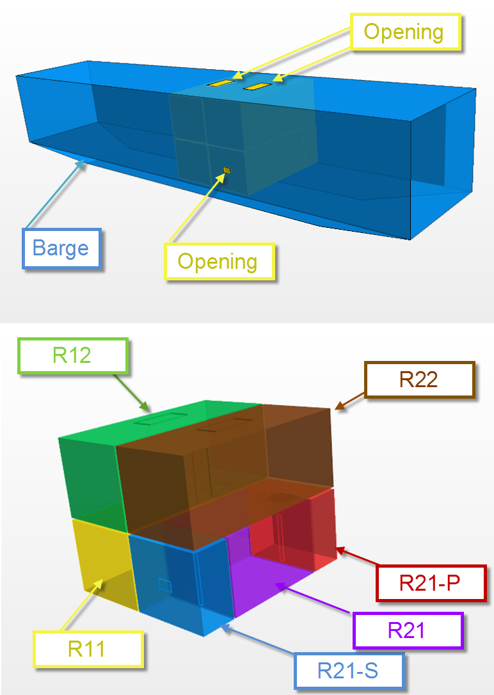
Figure 1. Barge 3D CAD model and compartment arrangement.

Table 3. Barge general characteristics
Length over all | 4.0M
Breadth | 0.8M
Draught | 0.5M

Transversal section plots through the barge including the sea opening are shown in Figure 2. These illustrate the evolution of the flooding of the compartments for the first 20 seconds.
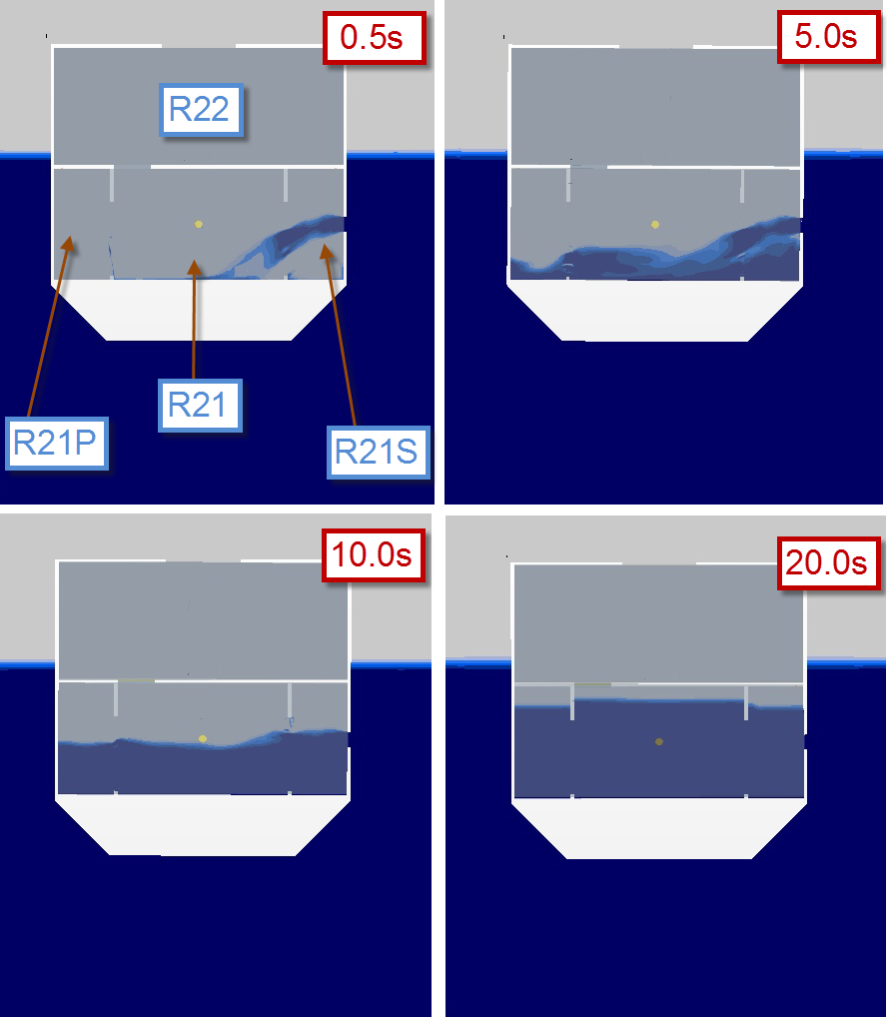
Figure 2. First 20s of the barge flooding

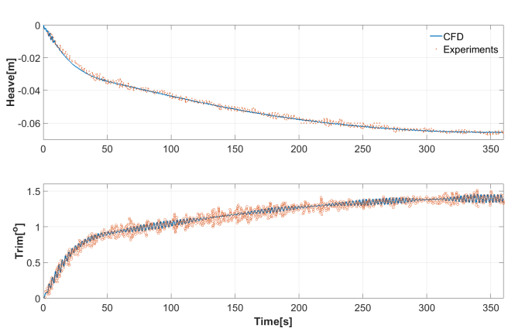
Figure 3. Barge motions-time traces
A comparison of the towing tank tests and the CFD results for the barge heave and trim are shown in Figure 3. For both quantities, the match between CFD and experiments is highly satisfactory, especially when considering the low order of magnitude of the barge motions.
A comparison of the compartment filling rates is also shown in Figure 4. The first compartment to be filled is R21-S, where the sea opening is located, followed by R21 and R21-P.
For the three compartments the agreement between CFD and experiments is satisfactory with minor discrepancies for the total filling time of R21-S and R21-P where the discrepancy is of the order of ~3s. This is attributed to the fact that the pipe losses in the vents located at the top of those compartments were not modelled, leading to a slight overestimation of the flow rate through the vents and hence the faster filling of the compartments.
For both R11 and R22, the water came from R21. In Figure 4, the agreement between the experiments and CFD is outstanding with a minor discrepancy for the filling start time of R22 (3s). The CFD predicts the filling start earlier which is probably related to the overestimation of the flow rate through the vents mentioned earlier.
R12 is filled from the square opening in the top of R11. The filling of this compartment starts at ~191s based on the experimental results. A discrepancy of ~7s can be seen when comparing experimental and CFD. However, the general shape of the filling curve is exactly the same for both cases.
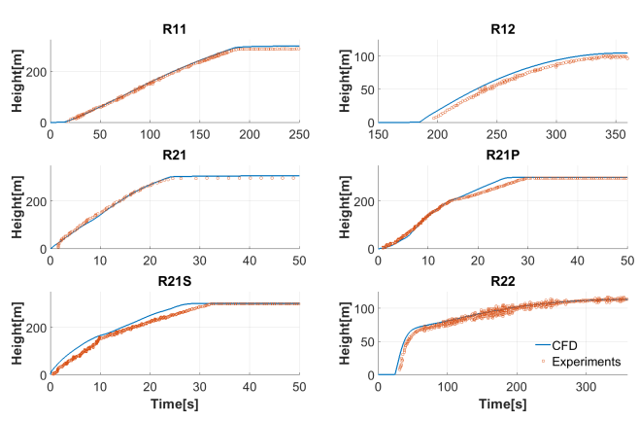
Figure 4. Compartments fill level-time traces

Application case
The flooding of a cruise ship was studied in the application case which was done at full scale. A number of scenarios were simulated both in calm and rough seas. In this paper we present the flooding near the engine room which is the most representative of the results found in the study. Regular waves 4m in height were used for the rough seas case. As the identity of the subject vessel is confidential, particulars are not given and the results are non-dimensionalised.
Bilge keels and the rudders were included in the computer model to achieve an accurate representation of reality. For all cases, the damage was modelled as a rectangular opening on the starboard side of the ship located below the free surface.
During the process of testing, several aspects of the simulations were found to be important to the outcome. One of these was the effect of air compressibility on the flooding process. Air trapped in a compartment during flooding either maintains its volume throughout the process (incompressible) or reduces in volume under the pressure of the incoming water allowing more water into the tank (compressible). The difference between the two cases is clearly shown in the roll and water volume plots shown in Figure 5.
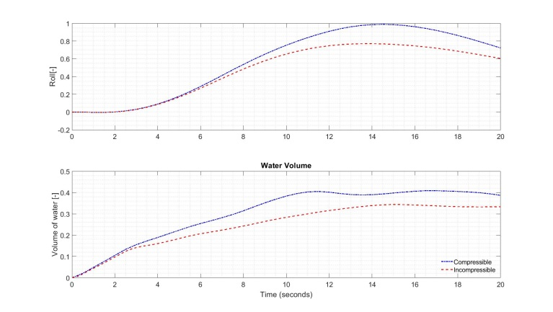
Figure 5. Air compressibility effects on roll and in-flooded water

Another effect assessed was the effect air vents have on the ship behavior during flooding. In Figure 6 a comparison of the roll time-traces for cases with and without vents is presented. As it can be seen an incorrect model of the air vents will lead to very different solutions.
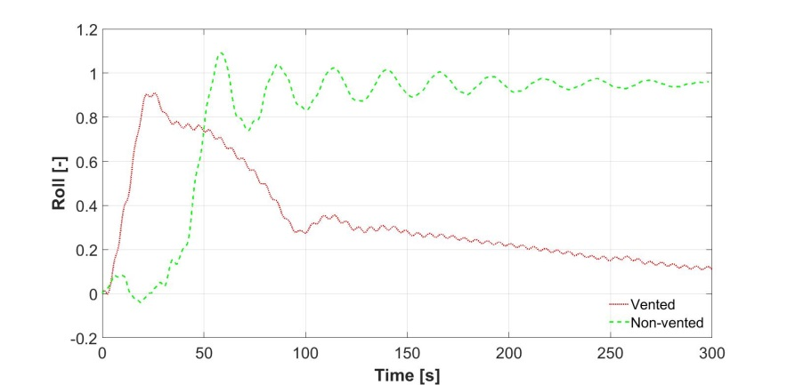
Figure 6. Effect of vents on the roll angle (degrees)

Engine room damage case
The time-traces for the aft-ship damage are presented in Figure 7. As expected, the ship took on more water when flooding in rough seas and the maximum roll angle was higher than in the case of calm seas. The differences caused by the sea state are shown more clearly when comparing the maximum roll angle in calm water and in waves as seen in Figure 8.
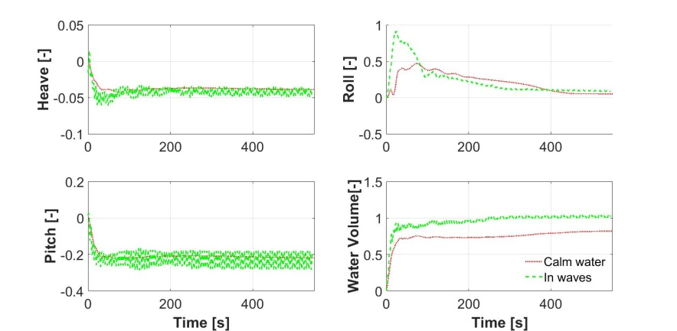
Figure 7. Engine room damage motions time trace

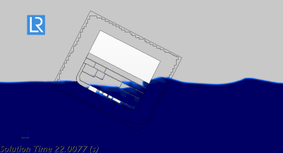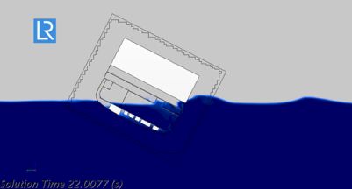
Figure 8. Ship roll during flooding in calm seas above and rough below. Maximum roll to the left and final roll to the right

Conclusions
Based on the work presented above a number of conclusions can be reached. Firstly it has been shown that the level of accuracy demonstrated in the validation stage is highly satisfactory in all aspects of the simulation suggesting CFD is a powerful tool for investigating ship flooding survivability. Secondly, the validation indicated that compressibility is a phenomena that should be accounted for in such studies. Thirdly, when modelling the cruise ship at full scale, the effect of the air vents was shown to be highly influential both on the ship roll motion and final roll angle. Similarly, the sea state was found to influence the final roll angle.
The application of alternative methodologies for determining a ship’s survivability is clearly encouraged by the forthcoming SOLAS, which, as in the current legislation, will be goal based. Today, the marine industry is mature enough to adopt the use of CFD and other methodologies for the assessment of the survival capability in case of a flooding event. Flooding simulations using CFD tools are able to model the real behavior of the damaged vessel and provide the designers with vital information and data to help increase the safety. This is particularly true for complex subdivisions, like in cruise and RoPax ships, which include cross-flooding and down-flooding arrangements, A-Class boundaries, numerous escapes, long evacuation routes, large garage spaces, etc.. For these cases the detailed understanding of the flooding sequence and assessment of the survival capability can be achieved by the use of high fidelity CFD tools which are able to accurately capture the physics that drives the process.
CFD has the potential to provide insight in identifying design improvements and arrangements to further mitigate the effects of flooding. Internal cross flooding provides complexities which can be more accurately simulated and pressures ascertained. During the course of this work the effects of air space entrapment in the event of flooding stood out as a significantly noticeable phenomenon. Legislation provides limited guidance in this respect and is an area worth future investigation with a possibility to enhance guidance on location and arrangement of air pipes to better manage possible flooding sequences following damage.
Currently CFD survivability analysis requires a significant amount of computational time which limits business applications. It can be used in supporting detailed accident review cases and as a validation process. The future lies in either total ship assessment or using CFD to augment existing processes such as the probabilistic assessment for example. More accurate information on time to flood will enable more confidence in prescribing safe evacuation arrangements and procedures for persons on board and enhance criteria for other associated safety systems. There remains significant scope for development of this alternative method into the future and we encourage others to participate in developing this sophisticated area of ship design.

Acknowledgements
The authors acknowledge the support of Lloyd’s Register Passenger Ship Support Centre (PSSC), the Technical Investigation Department as well as eSAFE.

References
- IMO Resolution MSC.421(98), AMENDMENTS TO THE INTERNATIONAL CONVENTION FOR THE SAFETY OF LIFE AT SEA, 1974, AS AMENDED, adopted on 15 June 2017
- IMO Resolution MSC.429(98), REVISED EXPLANATORY NOTES TO THE SOLAS CHAPTER II-1 SUBDIVISION AND DAMAGE STABILITY REGULATIONS, adopted on 9 June 2017
- Skoupas, S., “Investigation of the impact of the amended s-factor formulation on ROPAX ships, 12th International Conference on the Stability of Ships and Ocean Vehicles, Glasgow, 14-19 June 2015
- eSAFE(enhanced Stability After a Flooding Event). Joint industry project on Daage Stability for Cruise Ships. Deliverable eSAFE – D3.2.2. 2017 deliverables
- P. Ruponen, Progressive Flooding of Damaged Passenger Ship, Helsinki University of Technology, Helsinki, 2007.
- Papanikolaou, A., Hamann, R., Lee, B.S., Mains, C., Olufsen, O., Tvedt, E., Vassalos, D. and Zaraphonitis, G., “GOALDS - Goal Based Damage Stability of Passenger Ships” Proc. 2013 Annual Meeting & Expo & Ship Production Symposium - SNAME, Washington D.C., 6-8 November 2013.

Alejandro Caldas, Technical Investigation Department (TID), Lloyd's Register EMEA, Lloyd's Register Global Technology Centre, Southampton Boldrewood Innovation Campus, Burgess Road, Southampton, SO16 7QF, United Kingdom; E-mail: Alejandro.Caldas@lr.org
Constantinos Zegos, Technical Investigation Department (TID), Lloyd's Register EMEA, Lloyd's Register Global Technology Centre, Southampton Boldrewood Innovation Campus, Burgess Road, Southampton, SO16 7QF, United Kingdom; E-mail: Constantinos.Zegos@lr.org
Sotiris Skoupas, Piraeus Technical Support Office (PTSO), Hellenic Lloyd’s S.A., 87 Akti Miaouli, 185 38, Piraeus, Greece; E-mail: Sotiris.Skoupas@lr.org
Jane Jenkins, Passenger Ship Support Centre (PSSC), Lloyd's Register EMEA, Lloyd's Register Global Technology Centre, Southampton Boldrewood Innovation Campus, Burgess Road, Southampton, SO16 7QF, United Kingdom; E-mail: Jane.Jenkins@lr.org

