Modular Platforms for

Early Production / Full Field

Applications

Mirco BUSETTO a,[1] and Marco ZENNARO a ,

Andrea RIMOLDI b and Carmine PALUMBO b

a Fincantieri Oil&Gas

b Eni R&D

**Abstract.** Previous works have shown that the use of floating modular platforms (FMP) can represent a valid approach to the development of human activities at sea, near and off shore, both in civil/residential or industrial applications.

In particular, FMP technology provides a solution that allows the development of offshore fields in sequential stages. This will allows a shortening of the time for the First Oil, reducing the initial investment and starting to produce positive cash flow from the beginning.

During the Early Production phase are furthermore gathered more information on the field that will allow a more accurate and precise planning of the Full Field development by reducing the risks to the oil companies. In addition, modularity of the solution allows a sequential implementation of the system in accordance with the field development, and a potential reuse and relocation of the facilities at the end of the field.

This paper presents the results of a pre-feasibility study jointly developed by Fincantieri and Eni with the scope of evaluating, as alternative to conventional Floating Production Storage and Offloading (FPSO) units, an innovative flexible solution based on several modules connected together to compose an Early Production platform expandable into a Full Field configuration at a later stage.

**Keywords.** Modularity, Floating Production

# Introduction

The oil and gas (O&G) market is dramatically changed compared to only a few years ago [1], requiring for alternative business models and approaches to the exploitation of offshore fields: one of these, is represented by the development of offshore fields in sequential stages. This will allows a shortening of the time for the First Oil, reducing the initial investment and starting to produce positive cash flow from the beginning.

During the Early Production (EP) phase are furthermore gathered more information on the field that will allow a more accurate and precise planning of the Full Field (FF) development by reducing the risks for the oil company.

The above business model requires however an analogous alternative design approach in order to identify innovative floaters capable of modular extension in order to allow a sequential implementation of the configuration in accordance with the field development, and a potential reuse and relocation of the facilities at the end of the field.

This paper present the results of a prefeasibility study jointly developed by Fincantieri and Eni for the application of Floating Modular Platforms (FMP) technology to the exploitation of oil fields according to EP / FF concept.

# Design Principles

The convenience for Oil Companies to split the project into two sequential phases (an early production phases and a full field development stage) in order to speed up the return of investment and dilute over time the Capex costs, poses technical and economic constraints to the conventional FPSO concepts application, mainly related to the design definition of the configuration and to the development schedule.

A solution based on a modular configuration, completely fabricated and assembled on-shore and installed at site fully commissioned, is therefore considered a viable way to face the above problems and to minimize costs and schedule.

According to the above considerations, Fincantieri has developed and patented [2], [3] a innovative concept based on a modular system, named Floating Modular Platforms (FMP), purposely conceived for installation in mild environment (West Africa) and compatible with a delivery in two stages: a small platform as early production plant and an enlarged configuration suited for the full field development.

The concept has been developed for the specific application on the basis of the following main principles:

* to be split in several, of size compatible with construction in conventional marine yards, fitted with their own parts of the process plant;
* to allow the towing of the modules, arranged in sub-assemblies with two or three elements;
* to allow the offshore coupling and permanent connection of the modules;
* to provide operating reliability and performances similar or not lower of the ones of conventional floating systems;
* to allow mooring through conventional systems;
* to allow offloading to shuttle tanker moored to the platform.

The geometrical shape and dimensions of the structures have been defined accounting for the following operating and functional requirements:

* to provide adequate deck area for process plants accommodation;
* to allow floatation and stability performances during towage in a free floating configuration;
* to ensure adequate safety level against potential collision or accidental damages;
* to provide adequate storage capacity for oil and water ballast.

# Platform Description

The platform is composed of several floating modules, with identical hull configuration, accommodating on deck the various process plants. The modules are joined together, partly at the onshore yard, partly at the installation site, with structural bracings and permanent connecting elements, to form a rigid body.

The decks of the modules are also interconnected at the top level with passageways and walkways to form a continuous working platform and with pipe racks to support the interconnecting piping.

## Single module

Each module (overall height 21.5 m) is composed of two main parts:

* a lower hull, having a cylindrical shape with hexagonal base (side 23.0 m, height 19.0 m, operative draft 12.0 m), which represent the floater and accommodate the storage volumes;
* an upper deck, again with an hexagonal base (side 28.9 m, height 2.5 m), accommodating the process and utility plant.

The typical geometry of the individual modules is reported in Figure 1.



**Figure 1.** Single module geometry

The hull of each module is subdivided into several compartments, devoted to oil storage (abt 10000 cubic meters capacity), water ballast and technical rooms. The water ballast compartments are located at the bottom and at periphery of the hull, to realize a double bottom/side configuration.

The modules are connected together though a pair of structural links for each interfacing side at deck level and two pairs of crossing bracings at hull level.

The internal volumes of the deck and of the hull will be accessible through internal stairs, whilst watertight compartments will be accessible for extraordinary maintenance only through manholes.

## Overall platform

The platform is designed to operate in two configurations:

* an early production platform (total displacement abt 50000 t), composed with three modules and accommodating a production unit, an electrical power generation and distribution system, a flare, an accommodation module with helideck, an offloading station, a balcony for connection of production risers, a service crane and an utility module (Figure 2);



**Figure 2.** Early Production configuration

* a full field production platform (total displacement abt 150000 t), composed of nine modules and accommodating an extended oil production and power generation plant, low/high pressure (LP/HP) gas compression systems, sea water and produced water/sand treatment system, a tri-ethylene glycol (TEG) system, a second crane and new utility packages (Figure 3).



**Figure 3.** Full Field configuration

# Analyses and Checks

The analyses of the platform have been developed to a level suitable to confirm the feasibility of the concept in respect to the temporary and permanent working conditions (construction, transportation, installation and operations at site) and to prove that the selected configuration may operate under the expected extreme conditions, with performances comparable with the ones of other more conventional floaters.

The performed analyses covered the following aspects:

* Hydrostatic behaviour of single module and of assembled platforms
* Hydrodynamic behaviour of the assembled platforms
* Preliminary identification of mooring system
* Check of structural strength of connection elements

## Hydrostatic analyses

Hydrostatic analyses are aimed to identify the static configuration of the single modules and of temporary sub-assemblies (three modules joined together) during the towing and installation phase and to evaluate the stability performances of the overall platform in free floating condition.

The most critical conditions in terms of hydrostatic stability are represented by the floatation of the single modules before sub-assembling, in particular for the module having the maximum topside weight. Stability diagrams, in term of righting (GZ) and heeling (HA) arms, have been determined for a wind speed of 50 m/s considering a topside exposed area for the whole width of the platform up to a height of 4.0 m above the deck (Figure 4).



**Figure 4.** Intact Stability - Module n°9

The results confirms that the stability requirements, both in intact and damaged conditions are always in compliance with statutory requirements [4] with large safety margins.

## Hydrodynamic analyses

Hydrodynamic analyses were carried out, for the operative constant draft of 12.0 m, with two main purposes:

* To determine the dynamic behaviour (motions) of the platform;
* to determine the maximum expected acceleration of the process plant, as basis of comparison with other floating system and of judgement about system operability.

The following meteo-marine data, typical of West Africa scenarios, have been assumed for the calculations:

Tr (years) Hs (m) Tp (s)

1 2.5 14 - 16 - 18

100 3.2 15 - 18 - 20

A Jonswap spectrum type with peakdeness factor = 5 has been considered.

Wind speed of 36 m/s (1 min gust) and current speed of 0.7 m/s have been considered associated to 100 year storm wave condition.

Diffraction analysis has been performed to derive platform load and motion RAO's, hydrodynamic added mass and potential damping coefficients, wave drift coefficients [5]. Platform motion (sea-keeping) and mooring analysis have been performed with ORCAFLEX software, which analyses floating multi-bodies, connected each other or moored to seabed or fixed points, in time domain. The software allows to derive time series of each parameter of interest and evaluate statistical data (mean value, standard deviation, response period, maximum and minimum observed and calculated value).

The results indicate that the platform, both in its early production and full field configuration, exhibits relatively low motions, with similar behaviour in roll and pitch. As concerns the acceleration at the process topside, they have been computed for the centre of gravity of all the main packages.

Tables 1 and 2 present, for two significant points (center of gravity of the overall platform and of the most peripheral topside package) and two heading for the envelope of extreme sea states, the most probable maximum (MPM) values calculated for the FF platform compared with the ones obtained for two traditional ship shaped FPSO having similar storage capacity in similar operative scenarios.

**Table 1.** Motions and accelerations comparison:  = 0 deg

|  |  |  |  |  |  |  |
| --- | --- | --- | --- | --- | --- | --- |
| **Vessel** | **Point** | **Xp**  **(m)** | **Zp**  **(m)** | **pitch (deg)** | **Axp**  **(m/s2)** | **Azp**  **(m/s2)** |
| FPSO 1 | 5C | 2.12 | 1.84 | 1.90 | 0.21 | 0.20 |
| FPSO 2 | 5C | 2.09 | 1.76 | 2.00 | 0.20 | 0.19 |
| FF platform | 5C | 1.80 | 2.34 | 2.28 | 0.19 | 0.32 |
| FPSO 1 | 2-M01 | 1.71 | 3.66 | 1.90 | 0.17 | 0.67 |
| FPSO 2 | 2-M01 | 1.67 | 3.90 | 2.00 | 0.16 | 0.70 |
| FF platform | 2-M01 | 1.42 | 4.20 | 2.28 | 0.15 | 0.86 |

**Table 2.** Motions and accelerations comparison:  = 90 deg

|  |  |  |  |  |  |  |
| --- | --- | --- | --- | --- | --- | --- |
| **Vessel** | **Point** | **Xp**  **(m)** | **Zp**  **(m)** | **roll**  **(deg)** | **Axp**  **(m/s2)** | **Azp**  **(m/s2)** |
| FPSO 1 | 5C | 2.90 | 3.10 | 11.10 | 0.59 | 0.75 |
| FPSO 2 | 5C | 4.10 | 3.40 | 7.00 | 0.54 | 0.78 |
| FF platform | 5C | 2.00 | 2.70 | 3.31 | 0.27 | 0.52 |
| FPSO 1 | 2-M01 | 4.50 | 3.66 | 11.10 | 1.18 | 0.90 |
| FPSO 2 | 2-M01 | 5.85 | 3.75 | 7.00 | 0.63 | 0.87 |
| FF platform | 2-M01 | 1.62 | 2.80 | 3.31 | 0.28 | 0.60 |

The obtained values are not too different, thus confirming the good behaviour of the proposed concept.

## Mooring system

A preliminary arrangement of the mooring system has been identified, as compromise between the resulting platform motions (mean excursions) and mooring legs tensions.

The design of mooring system, for the selected operative scenario, is strongly affected by the wind loads which depend from the exposed area and from wind speed.

The analyses, developed according to API rules [6], accounted for both intact configuration of the mooring pattern and damaged condition (one leg broken). The selected mooring pattern (deep water condition) is composed of ten lines (chain, wire rope and anchor), set as per Figure 5: six lines are positioned on the windward side, four lines on the opposite side.

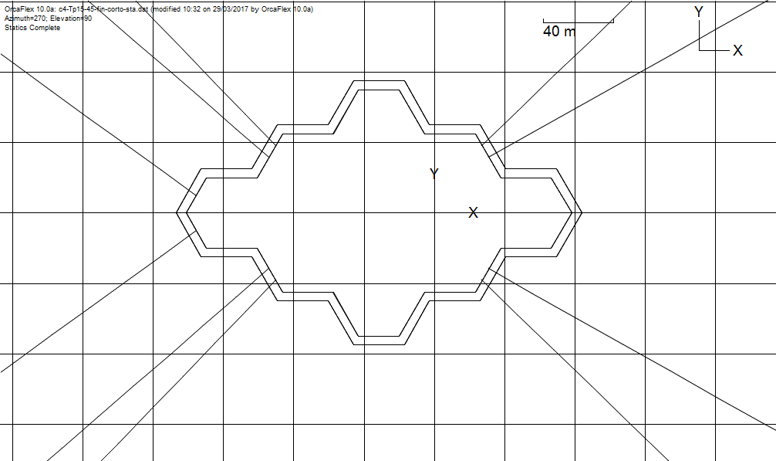

= 90°

= 0°

**Figure 5.** Mooring pattern

The following characteristics of each leg have been selected:

Windward Leeward

Wire rope (spiral 70 mm) 1700 m 1700 m

Chain section (R3 68 mm) 1500 m 500 m

Total length 3200 m 2200 m

Pretension 415 kN 505 kN

Anchor Stevin type 15 t 15 t

After a simplified sensitivity analysis in order to identify the most critical mooring system performances, the results of the final simulations in 3h storm duration have identified MPM values (evaluated with Rayleigh formulation) of mooring line tension below the safety factors (respectively 1.67 and 1.25 for intact and damaged conditions), proving the adequateness of selected configuration.

## Structural checks of connection elements

For structural analysis of connection members among the modules, a “composite” model has been developed, including nine separate modules and related connection members. Each separate module is modelled as a rigid floating body in six degrees of freedom, while connection members between two modules are modelled by means of rigid beams (having mass and axial/bending stiffness) connecting modules at deck level and hull sides (Figure 6).

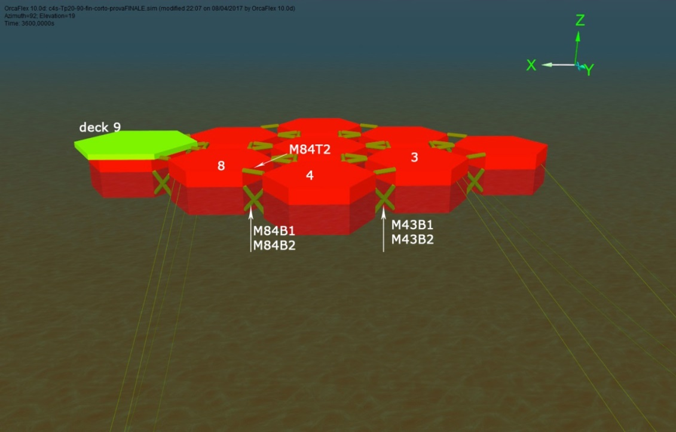  
**Figure 6.** Connections structural model

Connection elements have been checked in 100 years storm extreme meteo condition, for different headings and range of periods: MPM values for axial, shear and bending moment have been calculated and consequent Von Mises stress evaluated.

The maximum loads resulting at the deck and hull level are compatible with tubular bracings having a diameter of 2.0 m with a thickness of 50 mm.

# Installation Procedures

As previously described, the platform is designed to be fully developed in two stages:

* An early production configuration, composed of three modules;
* A full field production configuration, composed of nine modules.

To comply with the above field development scheme, the platform fabrication passes through the following main steps:

* Fabrication of the individual modules, complete with the relevant parts of the process plant;
* Assembly of the first three modules, to form the early production platform;
* Transportation and installation at site and completion of the early production phase;
* Assembly of two series of three modules to form two large sub-units;
* Transportation in the area of the two sub-units;
* Connection of the two sub-units, to form the extended full field platform;
* Installation of the extended platform and joining to the early production plant.

# Conclusions

The project has identified a promising and reliable solution for oil production in milder area and in particular for application in West Africa.

The proposed configuration combines the advantages of a conventional FPSO with the flexibility offered by a modular system, which enhance its profitability operating in a first life stage as early production platform and in a second life as full field development.

The proposed solution provided the following main advantages;

* to be fabricated in a conventional naval yards;
* to allow the full assembly and integration at the construction site;
* to allow transportation by towing;
* to minimize the installation and offshore commissioning schedule and costs;
* to allow the expansion of the plant without removal of the previous one and with minimum production downtimes;
* to allow the use of conventional vessels to assist in the marine operations.

The design activities have investigated the most crucial issues of the concept, ensuring its feasibility and the general compliances with the most recognised standards and rules.

Regarding the economic aspects, the estimated costs are comparable with a typical FPSO: however, it has to be highlighted the proposed FMP concept presents at a major degree of flexibility during the asset development.

Further design activities are foreseen in order apply the innovative concept to other production scenario.

References

1. M. Busetto, L. Ambrosio: *Modular Platforms for Near/Off Shore Applications*, Offshore Mediterranean Conference , Ravenna (Italy), 2017
2. European Patent EP 2 691 289: *Modular Semi-Submersible Structure and Method for Making Such Structure*, 24/12/2014 Bulletin 2014/52
3. Italian Patent 102015000027956: *Modular Semi-Submersible Structure for Floating Offshore Wind Turbine*, 26/06/2015
4. IMO: *MODU CODE Code for the Construction and Equipment of Mobile Offshore Drilling Units*, 2009
5. DNV–RP-C205: *Environmental conditions and environmental loads*, October 2010
6. API-RP-2SK: *Design and Analysis of Stationkeeping Systems for Floating Structures*, October 2005

1. Mirco BUSETTO, Fincantieri Oil&Gas, Passeggio S.Andrea 6/A, 34123 Trieste, Italy; E-mail: mirco.busetto@fincantierioilgas.it.