Impact of hybrid propulsion on the project of small passenger ferries for Italian scenario.
Valerio RUGGIERO^{a,}
ª Dipartimento di Ingegneria, Università di Messina
Abstract. In Italy there is a large fleet of passenger ferries, this fleet always operates in a very special “scenario”: no matters if we talk about internal waters such as the lakes or the Venetian lagoon or the coasts of the islands in Gulf of Naples or the Sicilian ones, all those ferries must deal with port structures, often of historical interest, and environmental situations extremely particular and requiring attention. The ferries operating in those areas have the need to offer great manouvrability, silent running, low emissions or no emissions at all. For all those aspects the hybrid propulsion, combining the use of diesel electric generators and batteries, offers the possibility to adopt efficient systems for manouvrability and propulsion, such as azimuthal or azipodal propellers and battery packs to ensure silent approaching to the mooring facilities, the possibility to stay at night in a port without generators working during the nocturnal stop, using a ship that can operate with almost complete silence and no pollution near the areas of interest .
All those advantages have an impact on the general layout of the project, considering the necessity to respect the limitations in term of stability, with special attention to the damaged stability conditions.
The disposition and the subdivision must be conformed to the navigation requests, not only according to the range calculation performed, but also considering the results of tank tests and the evaluation of the size batteries.
Furthermore the hybrid propulsion, as well known, can be more “space demanding” in terms of installation, due to the need to install not only the diesel engine, but also several components for the management of the propulsion system, and this has an impact on subdivision.
In conclusion the subject of the work is the case study of two projects for ferries, different in size and typology, with hybrid propulsion, examining the fact that the request of maintaining the stability criteria and a emergency propulsion in some situations requires choices of project and obliges the naval architect to a careful disposition of the subdivision. This work aims at underlining those aspects.
Keywords. Ferries, Inland waters, Coastal waters, hybrid propulsion, Ship project, keyword

Introduction
In the last years the environmental protection became more and more important, not only as for the aspect of the chemical pollution, but also as for the noise pollution in some areas of historical scientific interest [1].
All over the world the use of ferries to transport people is an industry moving billions of passengers each ear, and often this movement is located in areas of naturalistic interest such as the Italian lakes or the sea surrounding the Italian islands. As a case in point, as for the most important Italian lakes such as Lago di Garda, Lago Maggiore and Lago di Como, the total of passengers transported each year is about 10.000.000 pax/years.
As described, the main sources of pollution are the CO2 and the NOx or the SOx produced by the traditional propulsion systems, operating with diesel engines. Furthermore there is the noise generated by the engines, noise that is not a minor problem considering the historical structure of the areas where those ships operate. Considering those aspects, in this paper two main scenarios have been considered: the Italian lakes and the ports of the minor Italian islands.
The Italian lakes: Garda, Maggiore and Como are parts of an area with high density of population and constructions: usually the stops of the ferries, used as “water buses” to move people, are very close to private houses, in the middle of ancient historical centers of small towns or villages, such as Arona, Intra, Stresa on Lago Maggiore or Desenzano, Sirmione, Riva on Lago di Garda or Bellagio, Como, Lecco on Lago di Como and so on, just to list the most famous. In all those situations the ferries stop in at a close distance from houses or living areas.
The minor Italian islands, Capri and Ischia, to quote the most famous ones, present the same situations: old historical ports, built often more than 2 centuries ago, surrounded by houses, restaurants, hotels and so on.
In all those scenarios, the interest in reducing the emissions and the noise, at least during the “arrival-embarking-disembarking-departure” moments or during the technical staying of the ferries at the piers, is extremely high.
Today the solution that is becoming more and more utilized is the electrical one [2,3]: the concept of storing energy in batteries and then using it to move the propellers is for sure not new - it was well known at the beginning of XXth century - but we will see the updates and the changes occurred at the present time.
One of the main aspects is for sure the evolution of the batteries: from the traditional Lead-acid batteries the industry moved to the Li-Ion batteries and actually to the Li-Po, with the advantage of a reduction of costs and energy storable: in fact five years ago the traditional Li-Ion batteries price dropped from 500 USD/kWh to 250 USD/kWh nowadays, and it will probably move below 100 USD /kWh by the 2020; at the same time, in the last 10 years the energy density moved from 200 Wh/kg to 270 Wh/kg and this evolution is extremely fast.
In details the proposals for the two ships considered use the last generation of batteries: the LiPo, or Lithium polymer, the LiPo offers 3 times the charge density of the traditional Ni-Cd and Ni-MH, but also improve of about 15-20% the density of charge of the traditional Li-Ion.
This progress has made possible to study an hybrid solution [4,5,6] for ferries operating in the above described scenarios and to develop the project in order to maximize the efficiency of the solutions.
In this paper, the author will examine two studies of ferries where the propulsion system is realized by the combined use of the traditional part with propellers moved by electrical engines, and diesel generators or battery packs as “prime movers” giving the possibility to have the propellers and services operated by batteries for a limited amount of time. This solution is different from what realized in other countries, such as in Norway with the two ferries “MF Ampere” and “Future of Fjords”, with more than 1 MWh of energy stored on board, in Li-Ion batteries (1.04 MWh the batteries of “MF Ampere” and 1.8 MWh the batteries of “Future of Fjords”).
The author will examine the steps considered during the project, in order to provide a method to examine a similar project and in order to give a guide line at the main problems that must be considered in terms of power management [7,8,9], safety and so on.

Preliminary project
The object of the paper is to give two different hypothesis of project of ferries taken as examples, to be used as case studies: one ferry of 32.5 m. that could be employed in one of the major Italian lakes, capable to carry 200 pax and more, and one Ro-Ro ferry, to be potentially operating connecting main ports and the small Italian Islands in the Mediterranean sea,(Livorno – Isola d’Elba, Napoli – Ischia, etc), 80 m long, able to carry 900 pax and 40 cars .
The interesting aspect of those two study-cases is that they get several elements in common, so it is possible to use them to evaluate the problematics, furthermore they must deal with different rules: the Registro Italiano Navale “Rules for the classification of Inland waterway” [10], the Directive 2010/36/UE [11] and the Registro Italiano Navale “Rules for the Classification of Ships” [12].
It is important to underline that the Rules for this kind of ferries became more and more severe in last years, so the standards are higher and the project must deal with many parameters. [13,14] with a consequent change in the geometry of the hull, subdivision, and size of the ship.

General arrangement
The two ships considered have the main dimensions showed in Table 1:

Table 1. Ships main dimensions and data
Main dimensions | Ship 1 – 32.5 m for lakes | Ship 2 – 83 m for Italian islands
L.o.a. | 32.5 m | 83 m
Bmax | 7.15 m | 15.60 m
T (full load)  Speed (operational)  Pax | 1.9 m  12 kn  200 | 3.8 m  14 kn  900

The Figure 1 shows the external view of the Ship N.1, the 32.5m ferry for Lakes. The Figure 2 shows the external view of the Ship N. 2 – 83 m for Italian Islands.

Choice of propulsion
As explained, in consideration of the characteristics, for both typologies of vessels the propulsion/manoeuvrability was chosen trough an azimuthal system, in order to guarantee the maximum capability to operate in closed spaced. This solution also, seemed particularly convenient in addition to the hybrid propulsion because it offered the possibility to guarantee manouevring also during the operational phase with batteries.

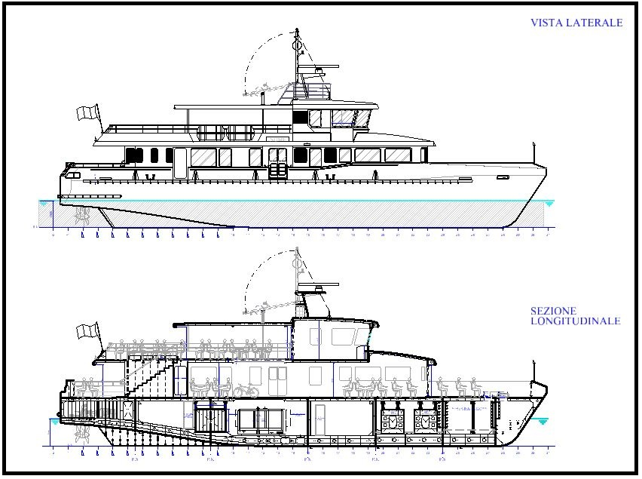
Figure.1 Mn 32.5 m External view.

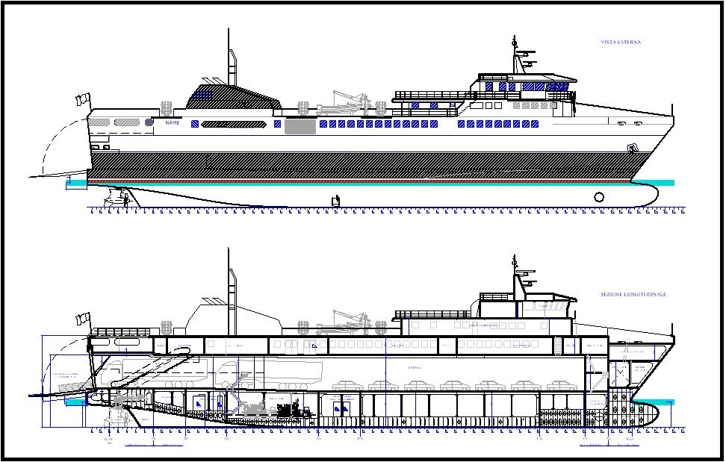
Figure.2 Mn 83 m External view

Evaluation of range an operating time using batteries
The calculation to determine the range obtainable only with batteries is the most particular and interesting aspect of the new propulsion systems, because it needs an appropriate study of the logistic situation and consequentially this leads to technical choices to adapt the propulsion lay out.
A full electric solution, with all the operativity guaranteed by battery packs only, charged during the night, at the present time appears to be difficult to be realized in Italy: it needs mainly an high electrical capacity, in the home port, to charge batteries and this is difficult to get on the lake stops, and also in minor islands. Also the hypothesis to consider a single home port on lakes, and a single port in Italy, such as Napoli or Livorno or Grosseto, must deal with a situation of ashore logistic still to be defined.
Obviously it is possible to use the onboard generators to charge the battery packs during the night, but this solution will cause the night operation of diesel engines in ports, with evident pollution and noise. In addition, the cost per kW of energy produced on board in these conditions will be higher than the cost of energy produced ashore in large quantity.
This evaluation had as consequence the choice of an hybrid propulsion, with large part of the operativity ensured by traditional diesel generators to operate the propellers through electric motors and a use of batteries to solve special problems.

Ship N.1 Inland waters.
In this case, as described, the main problem to solve is to guarantee a silent approach to the pier, the stop for embarking/disembarking passengers, and then the departure.
Considering a commercial speed of 12 knots, the solution is to adopt this profile: 5 min of navigation with batteries, starting at 0.2 nm from pier at reduced speed, 15 mins of stop at the pier, 5 min of navigation to reach a distance of 0.2 nm from the pier.
The calculation scheme to be adopted in this situation is:
- 5 mins approach, Power absorbed (ship plants + propulsion) = 138 kW, that means 11.5 kWh request to battery pack
- 15 mins embarking/disembarking, Power absorbed (from Electrical consumptions, Air conditioning on, in summer day) = 70 kW, that means 17.5 kWh request to battery pack
- 5 mins depart, Power absorbed (ship plants + propulsion) = 138 kW, that means 11.5 kWh request to battery pack
All this creates a request of 11.5 + 17.5 + 11.5 = 40.5 kWh.
In consideration of a navigation time between the 2 stops of 25 mins, with 15 mins at cruising, operating by the Diesel generators, it is required an AC/DC converter of at least 160 kW to rechange, in 15 mins, the batteries with the 40 kWh used.
At this point, it is possible to estimate the components and the weight of the system and the batteries, considering an average usage of batteries at 80% of their nominal capacity, and considering also the need to guarantee the 10 years life of battery packs, avoiding the complete cycle charge-discharge.
It is important to consider the following graph, in Fig. 3, showing the behavior of battery during charging, as parameter to avoid a too short life of batteries:
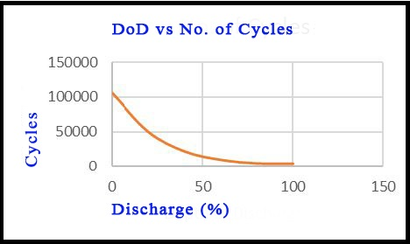
Figure.3 – Average cycles vs percentage of discharge
The average weight of the components for battery propulsion is:
Batteries = ab. 1000 kg
Converter AC/DC = ab. 550 kg
Transformer /liquid cooled) = ab. 900 kg
Switchboards: ab. 200 kg.
For a total of 2650 kg.
It is important to consider an assumed lightship of 175 t., so it is relevant to consider that the “hybrid/battery” solution causes an increasing of Lightship displacement of 1.5%, but also a potential loss of payload (passengers) of 35. On a global passenger numbers of 200 (maintained) this parameter cannot be underestimated.

Ship N.2 Islands vessel
In this case a similar approach is adopted: the ship voyage profile is based on 8 hours navigation each day, at 14 kn, among various ports, with a 90’ longest trip, and average stop of 30’ for disembarkment/embarkment. So the study focuses on assuming a support, trough the batteries at the night stop in island ports, to avoid the use of electrical generators.
In this case the assumed consumption for ships services is 50 kW, for 8 hours, from 22:00 to 6:00 it is figured to allow crew to stay on board, without noise or pollution. This leaded to a 50x8 = 400 kWh provided by batteries.
The choice then is to install at least 1 MWh in batteries, to use just 40% of total capacity.
With an installed power for propulsion of 2 x 1400 kW, and a bow thruster of 300 kW, this amount could make also possible, in future, to operate for limited time only with batteries, similarly to what studied for the other vessel.
In this situation the calculation scheme is the following one:
10 mins approach, Power absorbed (ship plants + propulsion) = 500 kW, that means 84 kWh request to battery pack
15 mins embarking/disembarking, Power absorbed (from Electrical consumptions, Air conditioning on, in summer day) = 100 kW, that means 25 kWh request to battery pack
10 mins depart, Power absorbed (ship plants + propulsion) = 500 kW, that means 84 kWh request to battery pack
All that creates a request of 268 kWh.
In consideration of a navigation time between the two stops of at least 1 hour, at cruising, operating by the Diesel generators, it is required an AC/DC converter of at least 300 kW to rechange in 1 hour the batteries with the 268 kWh used.
An usage of 268 kWh corresponds to a discharge at 73%
The average weight of the components is:
Batteries = ab. 11000 kg
Converter AC/DC = ab. 1400 kg
Transformer /liquid cooled = ab. 1000 kg
Switchboards: ab. 300 kg.
For a total of 13700 kg.
In this case the influence on total displacement (2000 t) of the ship is less, and the weight of batteries doesn’t create a significant reduction in payload.
Conceptually both the system adopted are similar: there are differences in size of components, but the concept is to utilize Asyncronous engines to move the propellers, and a system with AFE units to manage the power. The main data of the systems can be resumed in the following Table 2:
Table 2. Main data of electrical systems
Characteristics | Ship 1 – 32.5 m for lakes | Ship 2 – 83 m for Italian islands
Power of electrical engines . | 2x250 kW | 2x1500 kW
Type of engines  Voltage of system | 660 V/50 Hz  Asyncronous | 690 V/50Hz  Asyncronous
Type of batteries  Battery system | Lithium polimer  Modular packaging | Lithium polimer  Modular packaging

The batteries are air cooled with an heat exchanger air/water, and are subdivided in modules, for an easy maintenance and capability to operate.
The systems drive the EP (engines for propulsion) trough conversion from CC to AC, and AFE to manage the system, the position of AFE is studied on order to avoid that a damage to their compartment can immobilize the ship.

Subdivision: Lay out of propulsion system
The weight of batteries has been examined, showing the different influences on the final payload, but much more interesting is the problem that needs to be solved regarding the subdivision.
In fact, the target considered is to maintain a certain degree of operativity also in case of damage, but the hybrid propulsion takes, as a consequence, the installation of several elements: there are not only the diesel engine and the propellers, but all the system of converters and transformers and switchboards, a system that cannot go underwater and needs appropriate solutions
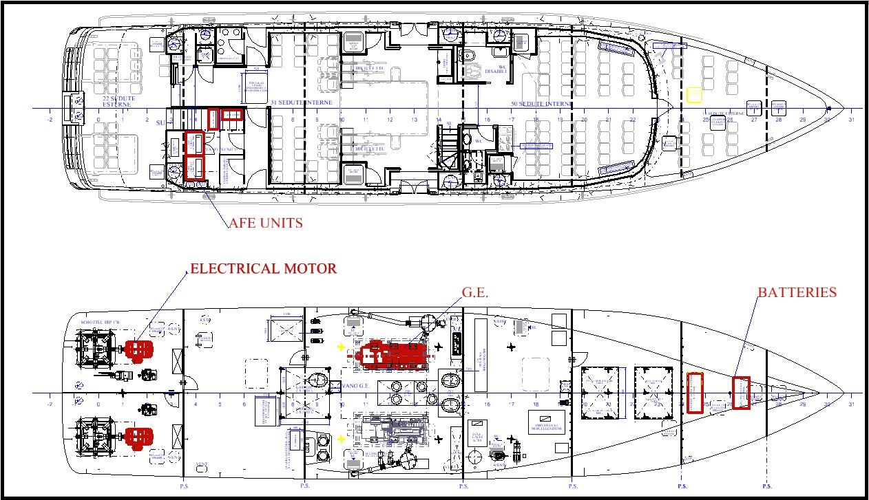
Figure.4 – Arrangement of propulsion system Mn 32.5 m

Ship N.1
In the 32 m “Lake ferries” the following arrangement, in Figure 4, shows how it has been possible to divide all the components in order to respect the criteria of the Inland water class, to have, always propulsion, for emergency:
The arrangement shows the following aspects:
- Longitudinal bulkhead to divide each azimuthal propeller; in case of damage of one compartment, the 2nd unit is working.
- In case of flooding of the GG.EE. room, emergency propulsion is operated by batteries; considering the short distance from ashore, the ship can navigate 20-30 mins at 2 knots and be in proximity of a shore and be safe in a short period of time.
- All the AFE units and switchboard for power management are located above the main deck, in a position not relevant in case of damage.
- In case of damage in the battery compartment, the propulsion is ensured by the GG.EE.
This drawing can also be useful to understand how much the hybrid propulsion can be space- demanding compared with the traditional one. In fact the components of the system require 3 compartments below the main deck, plus one above for the control units.

Ship N.2
In the 83 m, due to the different sizes of the ships, the accommodation of the various components, showed in Fig.5, is less problematic: in fact all the volumes below the Ro-Ro deck can be used for the elements of the propulsion system, maintaining an independence of various components, to guarantee a certain degree of propulsion also in case of damage.

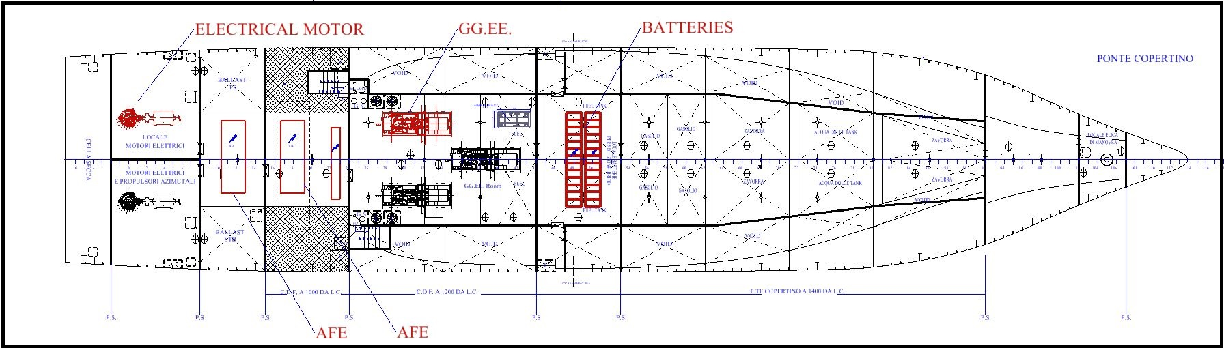
Figure. 5 – Arrangement of propulsion system Mn 83 m
Also in this case, a longitudinal bulkhead in the electrical engine compartment, separating the two Azimutal propellers, could guarantee a “take home” function, at slow speed.
It is also easy to understand how a reasonable amount of power for emergency and propulsion in emergency could be obtained moving one of the EE.GG. in a separate compartment, to have always at least 33% of the installed power available.
Both the case studies show that the diesel electrical propulsion, with batteries, can offer the advantage of a system capable to give emergency propulsion with one compartment flooded.

Management of the electrical propulsion
This aspect could, at first sight, seem secondary for a Naval Architect, the first assumption is that the manufacturer of the electrical systems will consider the management, but in the two studied cases this aspect required a complete and deep involvement of a Naval architect. In fact, in a traditional ship, with mechanical propulsion, it is relatively simple to manage the power flowing from the diesel engine to the propellers; but in a hybrid solution like this, where a part of the run of the ship is powered by the batteries and a part from the engines, it’s necessary to know deeply the different situations that can occur during the manoeuvring and foresee a series of situations. This paragraph doesn’t describe the hardware used by the manufacturer of the electrical parts, but the different situations examined, with the request adopted. The potential situations are similar for the two ships examined, so they will be treated together.
The main examined features are:
‘Possibility that during the manoeuvring there is an emergency’: in this case the power provided by the battery pack cannot be enough to guarantee a crash stop. To face this situation the management of system must keep the generators in condition of “quick start”, in order to feed the electrical motors with enough power to provide full maonoevrability.
‘Possibility that, at the time when the diesel generators are stopped, and the ship is supposed to operate in “battery propulsion” the batteries don’t have enough charge to guarantee the operation in safe manner’. To face this situation the management system needs to avoid the switching from engines to batteries if the batteries are below 80% of charge.
‘Optimization of battery life and maintaining the charge’: one of the main consumers of the electrical power on board is the Air conditioning, during the passengers embarkment/disembarkment time, with all doors open, an optional feature of the system can be the automatic shut off of air conditioning system, to reduce the power absorbed. The same feature must be adopted in case of emergency, as the above described systems, in order to have more power available for propellers.

Firefighting and systems
This aspect also is common to the two ships examined, so it can be treated similarly.
It is important to consider all the cooling of the electrical units, this aspect impacts on two conditions: passive firefighting protection, with all the compartments for Switchboards and batteries protected with A-60 insulation, and ventilation/cooling.
The aspect of passive fire protection, as described, has as a consequence, the adoption of insulation on bulkheads, lower side of decks, structures, the problem of ventilation/extraction, with the adoption of ducts for each compartment containing switchboards and batteries, with all the consequent gates and fans, is more important.
The last modification can be required by the cooling: if the switchboards and the battery packs are liquid cooled it is necessary to provide a circuit, with sea chests and consequent pumps, filters and valves.
Considering the two ships examined, all the above described solutions cause an increase in the weight of each tipology of fittings: insulations, piping, systems, all have an increase in weight of about the 30% of the total. (30% more insulation, 30% more ducts, 30% more systems).

Conclusions
From the study of the two situations showed, and considering the data regarding the nowadays progress in development of Li-Ion batteries in terms of capacity an costs, considering also the actual situation in terms of ashore logistic and energy distribution in Italy, it is possible to conclude that the solution of hybrid propulsion, combining both systems, the traditional diesel electric and the batteries, can offer significative advantages not only in terms of navigation with “Zero emissions” or “No noise” in several areas of interest, but can also, if properly studied, give the advantage of having an improvement in safety, and also with the capability for the ship to operate in condition of emergency propulsion, with one compartment flooded. This emergency condition is particularly appropriate considering the use of ships in inland waters or coastal waters, where the distance from a safe harbour is relatively short.
References
- Bucci, V., Marino, A., Businaro, A. 2015, “The new hybrid small passenger vessel for the Venice lagoon Vittorio Bucci, Alberto Marinò, Andrea Businaro in NAV 2015, Proceedings of 18th Conference on Ships and Shipping research – 24/26 giugno 2015, Lecco, pp. 1107-1115, ISBN 978 88 940 55719
- Bordianu, A., Samoilescu, 2019. "Electric and Hybrid Propulsion in the Naval Industry", 11th symposium ATEE 2019.
- Georgescu, I., Godjevac, M., Visser, K., 2019. "A new perspective on the complexity of on-board primary power systems", Journal of Ship Production and Design, 35(1), pp. 19-30.
- Capasso, C., Notti, E., Veneri, O., 2019. "Design of Hybrid propulsion architecture for midsize boats", Energy Proceedia, 158, pp. 2954-2959.
- Litwin, W., Lesnjewski, W., Piatek, D., Niklos,K., 2019. "Experimental research on the energy efficiency of a parallel hybrid drive for an inland ship", Energies, 12(9), pp.1675
- Nasso, C., la Monaca, U., Bertagna, S., Braidotti, L., Mauro, F., Trincas, G., Marinò, A., Bucci, V., 2019, "Integrated design of an eco-friendly wooden passenger craft for inland navigation", International Shipbuilding Progress, 66(1), pp. 35-55.
- Mauro, F., la Monaca, U., Nasso, C., Bucci, V., 2018. "An hybrid-electric solution for station-keeping and propulsion of a small constant research vessel", Proceedings of SPEEDAM 2018.
- Balsamo, F., Capasso, C., Venevi, O., 2018. "Performance evaluation of an all-electric waterbus supplied by hybrid energy", Proceedings of SPEEDAM 2018.
- Bucci, V., Mauro, F., Marinò, A., Bosich, D., Vicenzutti, A., Sulligoi, G., 2017. "Integrated design of a hybrid-electric power system for coastal navigation multipurpose craft", Proceeding of EVER 2017.
- “Rules for the classification of Inland waterway ship and for conformity to directive 2006/87/EC” from Registro Italiano Navale,
- Directive 2010/36/UE for Passengers ships
- “Rules for the Classification of Ships” 2019 from Registro Italiano Navale.
- Ruggiero, V., 2015, “2004-2014 Ten years of changing in the project of passenger ferries on Italian lakes, due to the 2006/87/CE and consequent rules, in NAV 2015, Proceedings of 18th Conference on Ships and Shipping research – 24/26 giugno 2015, Lecco, pp. 1080-1089, ISBN 978 88 940 55719.
- Bucci, V., Mauro, F., Marinò, A., Bosich, D., Sulligoi, G., 2016. “An innovative hybrid-electric small passenger craft for the sustainable mobility in the Venice Lagoon”, Proceedings of SPEEDAM 2016.

Valerio RUGGIERO, Dipartimento di Ingegneria, Università di Messina, C.da di Dio, Sant’agata (ME), Italy; vruggiero@unime.it.

