Integration of nautical charts and satellite images in Marine GIS of the Gulf of Naples
Emanuele ALCARASª, Claudio PARENTE ^{a,} and Andrea VALLARIO ª,
ªDepartment of Sciences and Technologies, University of Naples “Parthenope”
Abstract. In the last decades Marine Geographic Information Systems (MGISs) have had an increasing diffusion because of their ability to store, manage and analyze a great amount of heterogeneous data concerning sea and ocean environments. To build a MGIS, nautical charts are fundamental: they provide useful information such as shoreline configuration, seafloor morphology, water depths, anchorages, and other features that are suitable not only for navigation, but for marine science applications, i.e. aquatic biology and ecology. Satellite images contribute to bring more information in MGIS concerning many aspects of the sea and ocean environment, so remotely sensed data in high quality, large quantity and multitemporal acquisition can be introduced in the database. For their correct usage, satellite images require pre-elaboration to overlay them to nautical charts: usually they are supplied in different cartographic projection as well as in different geodetic datum that nautical charts, so re-projection and datum transformation are necessary and not banal. This paper aims to describe the approach adopted in MGIS of the Gulf of Naples to harmonize heterogeneous data concerning nautical charts and satellite images, so to able its use for Marine Spatial Planning (MSP). Both large and medium scale maps are considered as well as remotely sensed images with high and medium resolution. The experiments demonstrate that adequate positional accuracy can be achieved for all layers compatibly with the scale of the representation.
Keywords. Marine GIS, Nautical Charts, satellite images, ENC, MSP.

Introduction
Marine Geographic Information System (MGIS) can be considered as the perfect computer tool suitable to acquire, process, analyze and interpret data in support to marine and coastal studies and applications [1]. Many resources are available in literature for describing the advantages of using GIS for marine applications: MGIS technology permits to better understand the marine environment and to increase ability for measuring changes in oceans [2]. For this reason, it is a powerful tool for Marine Spatial Planning (MSP), a process that aims at minimizing the conflicts among different sea uses as well as their negative effects by allocating space and applying zoning for different activities [3]. The most used cartographic bases for MGIS are nautical charts that provide shape and position of shoreline, configuration of seafloor, water depths, locations of hazards for navigation, positions and characteristics of aids to navigation, anchorages, and other features. They are fundamental tools for safe navigation: using them, the mariner is able to plan voyages and navigate ships securely and economically [4]. However, information of nautical charts is useful also for other scopes that navigation. We need only think, for example, of seafloor bathymetry that is essential dataset for understanding several marine and ocean characteristics such as circulation, tides, fishing resources, environmental changes, etc. [5].
Usually nautical charts are supplied in Mercator cartographic representation that can be considered as derived mathematically from direct cylindrical projection [6], [7]. The digital products are available in two forms: raster and vector. The first group includes raster nautical chart (RNC) that is the scanned reproduction of a paper chart issued by, or under authority of, national hydrographic offices [8]. The second group includes the electronic navigational chart (ENC) that is an official database created by a national hydrographic office for use with an Electronic Chart Display and Information System (ECDIS) [8]. An electronic chart must follow the standards definite in the International Hydrographic Organization (IHO) Publication S-57. ENCs are the only nautical charts to be used within ECDIS to meet the International Maritime Organization (IMO) performance standard for ECDIS [10]. The recent production of nautical charts by the Italian Hydrographic Office (Istituto Idrografico della Marina, IIM) is referred to WGS84 while the previous one to ED50. For consequence, using both historical and current nautical maps in MGIS requires datum transformation.
By remotely sensing the Earth from space, satellites provide much more information than would be possible to achieve exclusively from the surface. Data collected by satellites concern many aspects of the waters that cover the earth globe, from bathymetry to ocean and sea surface temperature, from coral reefs to ice [11]. Satellite images are usually referred to WGS84 and the cartographic representation is UTM (Universal Transverse of Mercator). The contextual use of both nautical charts and remotely sensed images is impossible without appropriate operations of re-projection and datum transformation, the only ones that permit to obtain the correct overlay of all layers.
This paper aims to describe methodological aspects concerning the integration of different data in MGIS, in order to enhance its capability to handle topics of MSP. Experiments are carried out to build a MGIS of the Gulf of Naples harmonizing data heterogeneous for type (nautical charts and satellite images), datum (WGS84 and European Datum 1950), projection (Mercator and UTM). Firstly, the main characteristics of MGIS useful to support MSP are remarked (Section 2). Following this, possibilities to expand spatial database integrating nautical charts (raster and vector) as well as satellite images at medium and high resolution, are analyzed (Section 3). Finally, we summarize the paper’s findings and generalize their importance, also in consideration of the potential applications and extensions for future studies.

MGIS for marine spatial planning
Marine planners use spatial data for evaluation of planning options: they need analytical approaches, methods, applications and practical software tools to assess the relationships between ecosystem components and human uses [12]. Their purpose is to realize MSP to manage the demands on marine areas, both spatially and temporally, where several different users may compete for resources or space, to ensure that development is as sustainable as possible [13]. MPS aims to organize the use of the sea and ocean space, with attention to the interactions among human uses (e.g., fisheries, aquaculture, shipping, tourism, renewable energy production) and between users and the marine environment [14].
Because of their characteristics, a MGIS can provide technical support to MSP. Given that most of the information concerning to the marine environment has a spatial component, a GIS provides tools to collect, aggregate and analyze the disparate data generated by public and private sources [15]. Particularly, a MGIS permits: to delineate features, to assess management performance and to combine several types of spatial data [3]. About the first aspect, MGIS can be an efficient tool to identify, locate and visualize the state of biological, geophysical, socio-economical and governance features in a marine area in the form of maps. About the second aspect, MGIS enables to assess the impacts that management has on natural and human components, impacts that become indicators for planning process. About the third aspect, different data in different form (i.e. maps, tables, images, etc.) can be gathered, organized, managed, visualized and analyzed in MGIS, so their usage and integration facilitate the process to relate all human activities in a marine area to the sensitivity of the habitats and species of that area.
Mapping is an important component of MSP: different types of spatial data are required to map the state compared in different areas or the change of state over time, helping to inform management scenarios, and guide policy development [16]. Key sources and tools utilizable to collect data for MGIS are present in literature, e.g. [17]. Digital nautical databases are useful for MSP; some data elements have high priority for many applications, e.g. shoreline position, bathymetry, aids to navigation, bottom types, managed areas (special areas) [15]. Remotely sensed images, both aerial and satellite, can be used to monitor marine environment instead of field surveys that are difficult due to the considerable amount of time and resources necessary to collect in-situ data. They are useful to map biophysical ecosystem features, e.g. Landsat for coral reef ecosystems [18], aerial photos for benthic habitat [19], etc.
In the next section, experiments to integrate different data, such as nautical charts and remotely sensed images, in a MGIS to potentiate it as tool for MPS are described.

Experiments and results

Study area
The Gulf of Naples (Figure 1) is located along the south-western coast of Italy (province of Naples, Campania region). It is delimited on the north by the cities of Naples and Pozzuoli, on the east by Vesuvius Volcan, and on the south by the Sorrento Peninsula that separates the Gulf of Naples from the Gulf of Salerno. Capri, Ischia and Procida are three important tourist attractive isles located in the Gulf of Naples.
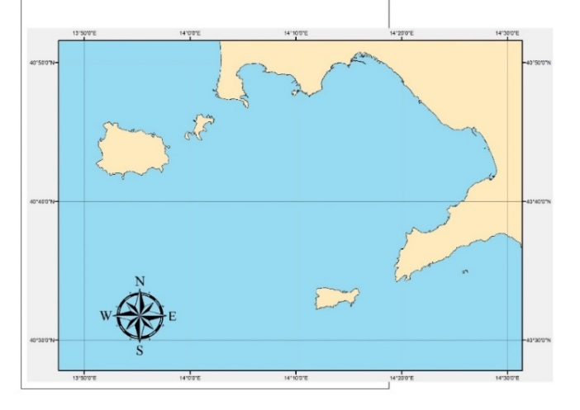
Figure 1. The study area: the Gulf of Naples.

Dataset
To deal with the problem of harmonizing heterogeneous data, two nautical charts and two satellite imageries are considered:
- Scanned Nautical chart, Mercator representation, referred to ED50, in scale 1:60.000;
- bathymetric isolines and sea depths extracted by Electronic Navigational Chart (ENC), referred to WGS84;
- Landsat 8 satellite imagery, resolution 30 m for multispectral bands, 15 m for panchromatic band, georeferenced in UTM-WGS84, Zone 33T;
- IKONOS satellite imagery, resolution 4 m for multispectral bands, 1 m for panchromatic band, georeferenced in UTM-WGS84, Zone 33T.

Scanned Nautical Chart
This map (Figure 2) is obtained by the scan of the nautical chart in paper form produced by the Italian Hydrographic Office (Istituto Idrografico della Marina, IIM), in scale 1:60.000. It covers to whole gulf of Naples with its extension comprised between 13°47.83’ E and 14°11.27’ E of longitude and 40°38.40’ N and 40°50.55’ N of latitude. Referred to ED50, it is designed in Mercator cartographic representation using the parallel at 40° 45’ as standard to reduce deformations in the represented area. The map equations are:

$$\text{x=a}\left(\text{λ}\text{-}{\text{λ}}_{\text{0}}\right)\text{ ∙}\frac{\text{cos}{\text{φ}}_{\text{1}}}{\left(\text{1}-{\text{e}}^{\text{2}} {\text{sin}}^{\text{2}}{\text{φ}}_{\text{1}}\right)}$$  $$\text{y=a}\text{ln}\left[\text{tan}{\text{(}\frac{\text{π}}{\text{4}}}\text{+}\frac{\text{φ}}{\text{2}}\text{)}{\text{ ∙}\left(\frac{\text{1}-\text{e}\text{sin}{\text{φ}}}{\text{1+e}\text{sin}{\text{φ}}}\right)}^{\frac{\text{e}}{\text{2}}}\right]\frac{\text{cos}{\text{φ}}_{\text{1}}}{\sqrt{\left(\text{1}-{\text{e}}^{\text{2 }}{\text{sin}}^{\text{2}}{\text{φ}}_{\text{1}}\right)}}$$ | (1)

where:
ln is the neperian logarithm;
a is the equatorial radius;
e is the eccentricity of the ellipsoid;
φ₁ is the latitude of the standard parallel.
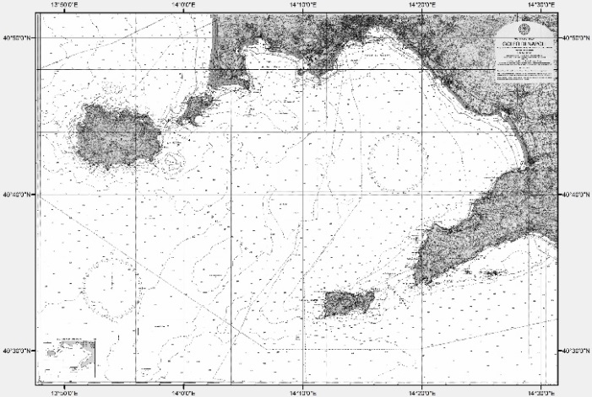
Figure 2. The scanned nautical chart of the Gulf of Naples (nominal scale: 1:60.000).
Firstly, the map is georeferenced in this research using the software free and open source Quantum GIS (QGIS). In QGIS projection library are available approximately 7,000 known Coordinate Reference Systems (CRSs) that define both datum and map projection. The standard CRSs accessible in QGIS are based on those defined by the European Petroleum Search Group (EPSG) and the Institut Geographique National de France (IGNF). Commonly, these standard projections are identified through use of an authority-code combination, where the authority is an organization name such as «EPSG» or «IGNF», and the code is a unique number associated with a specific CRS [20]. However, in QGIS the Mercator projection with the standard parallel located at 40° 45’ and referred to ED50 is not available, so it is specially defined for this work and named Local Mercator (LM)-ED50. To georeferenced the raster map, affine transformation is applied using 24 Ground Control Points (GCPs) and 15 Check Points (CPs) to evaluate the positional accuracy of the resulting georeferred map. Both GCPs and CPs are detected as the intersections between meridians and parallels. Their ellipsoidal coordinates referred to ED50 are transformed in plane ones using the equations (1). The first-order or affine transformation permits to shift, scale and rotate the raster map by means of the following equations:

$\text{x= }{\text{a}}_{\text{0}}\text{+}{\text{a}}_{\text{1}}\text{X+}{\text{a}}_{\text{2}}\text{Y}$ y$\text{= }{\text{b}}_{\text{0}}\text{+}{\text{b}}_{\text{1}}\text{X+}{\text{b}}_{\text{2}}\text{Y}$ | (2)

The application of the equations (2) requires at least 3 GCPs, whose also output coordinates are known, to calculate the six coefficients of the polynomials (a₀, a₁, a₂, b₀, b₁ and b₂). The use of 24 GCPs rather than 3, allows limiting the differences (residuals) between the expected map coordinates and the resulted ones. Statistical values of those residuals (minimum, maximum, mean, standard deviation, RMSE) are reported in table 1. RMSE is diagnostic of the quality of the georeferencing results [21]. Taking into account the graphical error related to the scale of the map that can be assumed equal to 12 m, we conclude that the residual values resulting for both GCPs and CPs, are acceptable and the georeferencing process is good.
Table 1. Residuals (in meters) obtained for GCPs and CPs in the georeferencing process of nautical chart based on Polynomial Functions - 1st order.
 | Min (m) | Max (m) | Mean (m) | St. Dev. (m) | RMSE (m)
GCPs | 1.592 | 17.456 | 6.914 | 4.002 | 7.988
CPs | 1.922 | 14.221 | 7.552 | 3.883 | 8.492
Because the nautical chart is referred to ED50, datum transformation is necessary to report the raster layer to WGS84. Also in this case, a new CRS is defined concerning the local adaptation of Mercator projection with the WGS84 datum (named LM-WGS84). However, datum transformation parameters to pass from WGS84 ellipsoidal coordinates to ED50 ellipsoidal coordinates are reported on the map in paper format: Δλ = 0.5’, Δφ = 0.6’. In our case, the inverse passage is required and concerns plane coordinates, so the calculated datum transformations for our scope are: Δx = -70.380 m Δy = -111.053 m. Obviously, the calculation of datum transformation parameters is carried out through the linearization of the parallel arc and the meridian arc, both realized in correspondence of the central point of the study area.

Electronic Navigational Chart
Bathymetric isolines and sea depths are extracted from the Electronic Navigational Chart (ENC) IT400129 mapping Ischia and Procida Channels, in scale 1:22.000. Data are referred to WGS84 ellipsoidal coordinates. Because there is not a default map projection in the ENC, the considered depth layers are automatically visualized in QGIS as equirectangular projection that maps parallels to equally spaced horizontal straight lines, and meridians to equally spaced vertical straight lines. For consequence, those layers are to be converted in Mercator representation (no datum transformation is necessary in this case). Unlike raster nautical chart, the depth data derived from ENC are vector files. Nevertheless, the reprojection can be carried out in QGIS using the same CRS LM-WGS84introduced in this work and previously described .

Landsat 8 satellite imagery
Two sensor are onboard of the Landsat 8 satellite: the Operational Land Imager (OLI) and the Thermal Infrared Sensor (TIRS) [22]. In table 2 are reported the OLI nine spectral bands in the visible and short wave infrared spectral regions, and the TIRS two long-wave infrared channels, with the respective image resolutions.
The original data used in this study are downloaded from U.S. Geological Survey (USGS) official web site [23] and are georeferenced in UTM-WGS84, Zone 33T. Typically, satellite images cannot be directly used because of their significant geometric distortions: overlay with maps and other GIS layers is possible only after they are transformed and adapted to the selected cartographic projection [24]. In this case, Landsat 8 OLI images are already corrected, but georeferred in different projection (UTM) than that used in MGIS (Mercator). To insert Landsat images in
Table 2. Landsat 8 OLI and TIRS bands
Band name | Wavelengths (µm) | Resolution(m)
Coastal aerosol | 0.433–0.453 | 30
Blue | 0.450–0.515 | 30
Green | 0.525–0.600 | 30
Red | 0.630–0.680 | 30
NIR | 0.845–0.885 | 30
SWIR 1 | 1.560–1.660 | 30
SWIR 2 | 2.100–2.300 | 30
Panchromatic | 0.500–0.680 | 15
Cirrus | 1.360–1.390 | 30
TIRS 1 | 10.6–11.2 | 100
TIRS 2 | 11.5–12.5 | 100
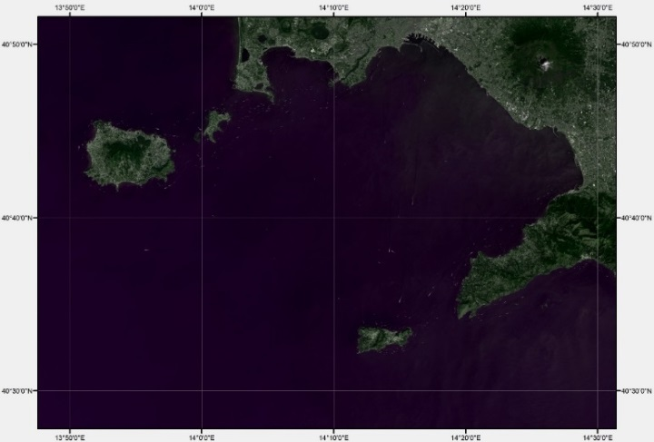
Figure 3. RGB true color composition using Landsat 8 OLI image (Bands 4,3,2) ).
MGIS and overlap them to other layers, reprojection is necessary. Also, in this case, the purpose is achieved using the CRS named LM-WGS84 introduced in this work.
The true color composition (generated by Band 2 on blue channel, Band 3 on Green channel and Band 4 on red channel) is shown in Figure 3.
Of course, all Landsat OLI images are reprojected to have them usable for any kind of GIS application, e.g. NDVI (Normalized Difference Vegetion Index) construction [25], segmentation and features extraction [26], etc.

IKONOS satellite imagery
Launched on 24 September 1999 and deactivated on 31 March 2015, IKONOS satellite carried a two-sensor payload: a panchromatic sensor with 13,500 pixels cross-track, and four multispectral sensors (blue, green, red, and near-infrared) each with 3,375 pixels along-track. Its nadir image swath was 11.3 km (7 mi) [27]. In table 3, spectral bands and resolution of IKONOS images are reported.
Table 3. IKONOS bands
Band name | Wavelengths (µm) | Resolution (m)
Blue | 0.445–0.516 | 4
Green | 0.506–0.595 | 4
Red | 0.632–0.698 | 4
NIR | 0.757–0.853 | 4
Panchromatic | 0.450–0.900 | 1

The dataset is supplied by the vendors with a low level of correction, so it resulted already projected in UTM-WGS84, but the variability of the elevation had not been taken into account. In other words, the dataset is not already ortho-rectified in the photogrammetric sense, so its geo-location is affected by errors.
One of the possible approaches to geometrically correct the dataset is based on the use of 3D Rational Polynomial Functions (RPFs) [28]. The relationship between image coordinates (x’, y’) and 3D object coordinates (X, Y, Z) is defined by [29]:

$${\text{x}}^{\text{'}}\text{=}\frac{{\text{P}}_{\text{1}}^{\text{n}}\text{(X,Y,Z)}}{{\text{P}}_{\text{2}}^{\text{n}}\text{(X,Y,Z)}} {\text{y}}^{\text{'}}\text{=}\frac{{\text{P}}_{\text{3}}^{\text{n}}\text{(X,Y,Z)}}{{\text{P}}_{\text{4}}^{\text{n}}\text{(X,Y,Z)}}$$ | (3)

$${\text{P}}_{\text{1}}^{\text{n}}{\text{,P}}_{\text{2}}^{\text{n}}{\text{,P}}_{\text{3}}^{\text{n}}{\text{,P}}_{\text{4}}^{\text{n}}$$

are usually cubic polynomials.
Each of the above mentioned polynomials includes 20 coefficients and can be expressed as:

$${\text{P}}_{\text{l}}^{\text{n}}\text{=}\sum_{\text{i}\text{=0}}^{{\text{m}}_{\text{1}}}{\sum_{\text{j=0}}^{{\text{m}}_{\text{2}}}{{\sum_{\text{k=0}}^{{\text{m}}_{\text{3}}}{{{\text{a}}_{\text{l}}^{}}_{\text{ijk}}}}_{\text{i,j}}}}{\text{X}}^{\text{i}}{\text{Y}}^{\text{j}}{\text{Z}}^{\text{jk}}$$ | (4)

where

where:

$\text{n} \text{=} \text{3}$ | (5) | $\text{l} \text{=} \text{1,2,3,4}$ | (6)
${\text{0} \text{≤} \text{m}}_{\text{1}} \text{≤} \text{3}$ | (7) | $\text{0 ≤ }{\text{m}}_{\text{2}}\text{ ≤ 3}$ | (8)
$\text{0} \text{≤}{ \text{m}}_{\text{3}} \text{≤} \text{3}$ | (9) | ${\text{m}}_{\text{1}} {\text{+ m}}_{\text{2}}\text{ + }{\text{m}}_{\text{3}}\text{ ≤ 3}$ | (10)

Equations (3) are known in literature as Upward RFM as they allow the image coordinates to be obtained starting from the 3D coordinates of ground points.
Each polynomial includes 20 coefficients, of which the first terms in the polynomials ${\text{P}}_{\text{2}}^{\text{n}}{\text{,P}}_{\text{4}}^{\text{n}}$ are assumed equal to 1. For consequence, 78 coefficients are present in equations (3) and their values can be calculated using at least 39 GCPs. On the other side, their values are usually calculated by the data provider taking into account the position of the satellite at the time of image acquisition, and included in RPCs (Rational Polynomial Coefficients) file [30]. Accuracy of the resulting ortho-images can be increased if also GCPs are used along with RPCs.
In this study IKONOS data set concerning Ischia Island is used. The software OrthoEngine – PCI geomatics [31] permits to correct those images applying the RPF with RPC file, and using 32 GCPs and 15 CPs. Plane UTM-WGS84 coordinates of GCPs and CPs are derived from orthophotos of Campania Region with 0.20 m resolution (nominal scale: 1:5,000), while elevations are obtained by DEM of the area with cell size equal to 20 m. Table 4 shows statistic values (minimum, maximum, mean, standard deviation, RMS) of errors in GCPs and CPs obtained for panchromatic image.
Table 4. Residuals (in meters) obtained for GCPs and CPs by using RPF
 | Min (m) | Max (m) | Mean (m) | St. Dev. (m) | RMSE (m)
GCPs | 0.210 | 2.679 | 1.654 | 0.624 | 1.767
CPs | 0.752 | 3.264 | 1.966 | 0.730 | 2.098

The residuals confirm a good orthorectification process of the IKONOS dataset that can be used in MGIS at scale 1:10.000.
To overlap this imagery to the other layers in MGIS, the re-projection is necessary. It is carried out in the same way as for the other raster and vector files using the CRS named LM-WGS84. The resulting true color composition (Based on Band 1 on blue channel, Band 2 on Green channel and Band 3 on red channel) is shown in Figure 4: in this case, it is draped on DEM of the area, so to obtain a 3D photorealistic model.

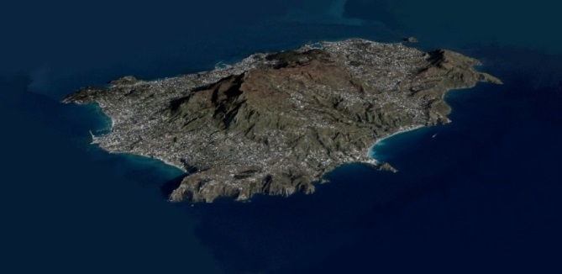
Figure 4. RGB true color composition of IKONOS images (Bands 3,2,1) draped on DEM of the island

Conclusions
MGISs are powerful tools to support MSP because their ability to collect, integrate, manage and analyze different data for multiple purposes, such as the identification of relationships between marine resources and human communities, the assessment of the human impacts on natural environment, the determination of future scenarios. To overlap heterogeneous layers, e.g. maps and remotely sensed images, two aspects require particular attention: datum transformation and cartographic re-projection.
This work demonstrates that managing with care those aspects permits to achieve results matching the accuracy required by the reference scale. The experiments carried out remark the opportunity to integrate GIS basic tools with specific utilities able to meet contingent needs, e.g. the Mercator projection with local adaptation based on the standard parallel located at a specific latitude different from 0°.
The future developments of our research will be focused on the possibility to integrate raw data from bathymetry survey in order to build detailed 3D model of seafloor.

Acknowledgments

This work synthesizes results of experiments performed within the project developed at University of Naples “Parthenope” and coordinated by Prof. Stefano Pierini.

References
- A. Weintrit, The Electronic Chart Display and Information System (ECDIS): an operational handbook, 1st ed. CRC Press, 2009.
- D. J. Wright, Arc marine: GIS for a blue planet, 1st ed. ESRI Press, 1–3, 2007.
- M. Snickars, and T. Pitkänen, GIS tools for marine spatial planning and management, BALANCE Interim Report, 28 (2007).
- NOAA (National Oceanic & Atmospheric Administration), What is a nautical chart? https://oceanservice.noaa.gov/facts/nautical_chart.html
- L. A. Levin, B. J. Bett, A. R. Gates, P.Heimbach, B. M. Howe, F. Janssen, ... & D. Bailey, Global Observing Needs in the Deep Ocean, Frontiers in Marine Science, 6 (2019), 241.
- F. Guastaferro, P. Maglione, C. Parente, Rectification of spot 5 satellite imagery for marine geographic information systems, Advanced Research in Scientific Areas Virtual International Conference (2012), 3–7.
- C. Meneghini, & C. Parente, Use of Mercator cartographic representation for Landsat 8 imageries. Geodesy and Cartography, 43(2) (2017), 50-55.
- Wärtsilä, Raster navigational chart (RNC), Wärtsilä Encyclopedia of Marine Technology, https://www.wartsila.com/encyclopedia/term/raster-navigational-chart-(rnc)
- F. P. Vista IV, B. Long, & K. T. Chong, Design and Development of Information System Template Prototype for Maritime Transportation, International Journal of Software Engineering and Its Applications, 7(6) (2013), 29-40.
- A. Weintrit, Six in one or one in six variants. Electronic navigational charts for open sea, coastal, off-shore, harbour, sea-river and inland navigation, Marine Navigation and Safety of Sea Transportation, (2009), 419-430.
- NOAA (National Oceanic & Atmospheric Administration), How are satellites used to observe the ocean? https://oceanservice.noaa.gov/facts/satellites-ocean.html
- V. Stelzenmüller, J. Lee, A. South, J. Foden, and S. I. Rogers. Practical tools to support marine spatial planning: a review and some prototype tools, Marine Policy 38 (2013): 214-227.
- R. Edwards, & A. Evans, The challenges of marine spatial planning in the Arctic: Results from the ACCESS programme, Ambio, 46(3) (2017), 486-496.
- C. F. Santos, C. N. Ehler, T. Agardy, F. Andrade, M. K. Orbach, and L. B. Crowder, Marine spatial planning, World Seas: An Environmental Evaluation, 571-592, Academic Press, 2019.
- C. A Friel, Nautical Information as a Component of a Marine Geographic Information System. Chapter, 5 (1994), 37-43.
- R. J. Shucksmith, & C. Kelly, Data collection and mapping–Principles, processes and application in marine spatial planning. Marine Policy, 50 (2014), 27-33.
- K. A. Stamoulis, & J. M. Delevaux, Data requirements and tools to operationalize marine spatial planning in the United States, Ocean & Coastal Management, 116 (2015), 214-223.
- V. Smith, R. Rogers, L. Reed, Automated mapping and inventory of Great Barrier Reef zonation with Landsat, OCEANS, 7 (1975), 775-780.
- L. M. Wedding, B.A Gibson, E. J. Walsh, & T. A. Battista, Integrating remote sensing products and GIS tools to support marine spatial management in West Hawai'I, Journal of Conservation Planning, 7 (2011), 60-73.
- QGIS, Working with projections – QGIS user manual.
- C. L. Wengert, Project 1 - Lesson 3: Georeferencing Raster Images,
http://www.personal.psu.edu/clw300/484_Project_1.html
- U. S. Geological Survey, Landsat 8 OLI (Operational Land Imager) and TIRS (Thermal Infrared Sensor) 15- to 30- meter multispectral data from Landsat 8, https://www.usgs.gov/centers/eros/science/usgs-eros-archive-landsat-archives-landsat-8-oli-operational-land-imager-and?qt-science_center_objects=0#qt-science_center_objects
- U. S. Geological Survey. “Earthexplorer”, (2015), http://earthexplorer.usgs.gov
- O. R. Belfiore, & C. Parente, Comparison of different methods to rectify IKONOS imagery without use of sensor viewing geometry, Am. J. Remote Sens, 2 (2014), 15-19.
https://doi.org/10.11648/j.ajrs.20140203.11
- P. D’Allestro & C. Parente, GIS application for NDVI calculation using Landsat 8 OLI images, International Journal of Applied Engineering Research, 10(21) (2015), 42099-42102.
- M. Aguilar, A. Vallario, F. Aguilar, A. Lorca, & C. Parente, Object-based greenhouse horticultural crop identification from multi-temporal satellite imagery: A case study in Almeria, Spain, Remote Sensing, 7 (6) (2015), 7378-7401.
- IKONOS Satellite Sensor, Satellite Imaging Corporation.
- I. Dowman, & J. T. Dolloff, An evaluation of rational functions for photogrammetric restitution, International archives of photogrammetry and remote sensing, 33 (2000), 254-266.
- T. Toutin, Review Article: Geometric processing of remote sensing images: models, algorithms and methods, Int. J. Remote Sens, 25 (10) (2004), 1893-1924.
- O. Belfiore, & C. Parente, Comparison of different algorithms to orthorectify WorldView-2 satellite imagery. Algorithms, 9 (4) (2016), 67.
- OrthoEngine – Version 2013, PCI Geomatics Enterprises, Inc., 50 West Wilmot Street, Richmond Hill, Ontario L4B 1M5, CANADA.

Claudio Parente, Department of Sciences and Technologies, University of Naples “Parthenope”, Centro direzionale di Napoli, Naples, Italy; E-mail: claudio.parente@uniparthenope.it.

