A collection of boat models from the Museo Nazionale Preistorico Etnografico “Luigi Pigorini”: a case study
Claudio PENSAª, Massimo MARTORELLIª, Chiara ZAZZARO^{b,}, Luigi OMBRATOª, Vincenzo SORRRENTINOª
ª Università degli Studi di Napoli Federico II
^{b} Università degli Studi di Napoli “L’Orientale”
Abstract. A collection of boat model kept in the former Colonial Museum in Rome, now housed in the Museo Preistorico Etnografico “Luigi Pigorini” is a rare testimony, in Italy, of traditional boats in use in the early 20th century in the Mediterranean and in the western Indian Ocean. The project — a collaboration among the Museo Nazionale Preistorico Etnografico “Luigi Pigorini”, the Università di Napoli “L’Orientale” and the Università di Napoli “Federico II” — aimed at: providing a digital record of the models, which are currently not on exhibit, an accurate description to improve and update the current museum inventory, to understand more about the history of the collection, and to study the models and the boats they represent. Some model boats were photographed to produce a digital 3D model, in order to obtain line drawings and to conduct hydrostatic analysis. This study has allowed to identify the different types of boats represented by the models and to make an assessment of their historical and ethnographic value.
Keywords. boat models, 3D photogrammetry, Mediterranean, western Indian Ocean, maritime ethnography
- Introduction
The Museo Preistorico Etnografico L. Pigorini currently owns in its storerooms, a collection of boat models from the former Museo Africano (or Museo Coloniale), whose information on the manufacturing, provenance and origin are not detailed. The current catalogue includes three lists of inventory numbers compiled in 1938, 1964 and 1987, probably corresponding to different organisation of the museum. According to this list, most of the models come generically from “Eritrea and Somalia” and “Africa Orientale Italiana” (East Africa), but five of them clearly represent also boats from the Eastern Mediterranean and Sicily. The collection, recently restored, is a unique testimony in Italy of traditional boats used in the western Indian Ocean, and it is a rare example of this type of boat models in the world.
Unfortunately, a part the inventory numbers and the general region of provenance, so far, nothing else is known on this collection, in the museum catalogue or elsewhere. The models were supposedly a representation of boat types that were seen in the Italian colonies. The group of traditional Arab boat models, for example, could represent or recall a small fleet of local vessels employed by the Regia Marina Italiana (Royal Italian Navy) in Eritrea from 1902 to 1914 (Po and Ferrando 1929).
Some of the models are carved in a single wooden block, but the majority is made of assembled wooden listels or the centre vein of a palm tree leaf, particularly for the planking. Most of the models seem to be accurate in the manufacturing, only few of them do not seem to keep the original proportions (numbers: 2969, 2978, 2985, 2982), but unfortunately the scale of all of them is unknown. All the models seem to be made by local artisans, with a high knowledge of local boats, in certain cases, the rigging is very accurate and the equipment is well detailed.
The models described as coming from the “Eritrea and Somalia” regions are likely representations of zaima types of Arab boats, only one model can be interpreted as ‘obri type of boat and two models can be interpreted as abūbūz type of boat (see Agius 2019 and Agius, Cooper and Zazzaro 2010).
- Methodology
Aim of the project was to provide a digital record of the models and to study the boats they represent in order to update the current inventory with accurate descriptions, the correct identification of the boats, their geographical origin and a short description.
Some models have been selected for the purpose of a three-dimensional restitution, useful both for study purposes and to obtain construction plans and line drawings from the photogrammetry - through the technique of the Reverse Engineering - for any exhibition purposes and hydrostatic analysis (Martorelli, Pensa & Speranza 2006). The photogrammetry was processed using Geomagic software, while the CAD restitution was executed using Rhinoceros. The hull surfaces have been analysed with the Autohydro software.

  - The case study: boat models 2968 and 2970
The models 2968 and 2970 of zaima type of vessels (Figure 1) were surveyed and analysed. The result of the photogrammetry revealed that the models are significantly asymmetrical, consequently the level of subjectivity of the reconstruction of the hull surface is increased. The 3D model was employed to extrapolate bi-dimensional line drawings of the two vessels (Figure 2).
For the identification of the reduction scale of model 2968, reference was made to the height of the boat awning assuming that this is 2.0 m high from the quarterdeck. On the basis of this working hypothesis, the model was created on a 1: 15 scale (Figure 3). Nevertheless, due to the early stage of the study, it is reasonable to assume an accuracy of about five percent.
On the basis of the hull forms and colouring of the model 2968, a plausible draught range has been identified: 1.80 m ± 10%. The main dimensions and the hull coefficients analysed with the Autohydro software are shown in Figure 4.
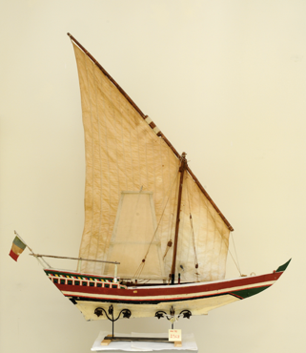 | 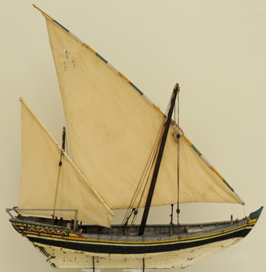

Figure 1. Models of two zaima type of vessels (No 2968 and No 2970).
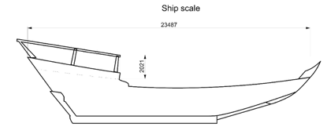

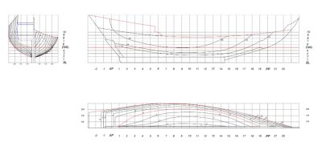 | 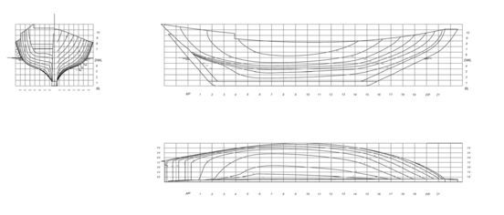

Figure 2. Line drawings of boat models No 2968 and No 2970.

Figure 3. Evaluation of the scale for the boat model No 2968.

Figure 4. Main dimensions and coefficients of the model No 2968.

3. Conclusions

The project revealed the efficacy of the use of 3D methodology and reverse engineering on boat models to understand the characteristics of original boats. This approach will be subsequently applied also to the other boat models of the collection.
The digital models, the photographic and graphic documentation in general, can be used for museum exhibit and for study, for the creation of a database ready to be analysed and for the reconstruction of models in real size.
The team will conduct further bibliographic and archival research aimed at reconstructing the history of the collection narrating the different types of boats, manufacture of the models and their historical value, and identifying iconographic comparisons also for the correct arrangement of the sailing apparatus and equipment.

References
- D. A. Agius, The Life of the Red Sea Dhow. A Cultural History of Seaborne Exploration in the Islamic World, I.B. Tauris, London, New York, 2019.
- D. A. Agius, J. P. Cooper and C. Zazzaro, The dhow’s last redoubt? Vestiges of wooden boatbuilding traditions in Yemen. Proceedings of the Seminar for Arabian Studies 40 (2010), 71-84.
- M. Martorelli, C. Pensa, & D. Speranza, Ricostruzione di carene navali mediante l’impiego di tecniche CAD/RE. Il Progettista Industriale 26.3 (2006), 96–101.
- O. Po and L. Ferrando, L’Opera della R. Marina in Eritrea e in Somalia (dall’occupazione al 1928). Ministero della Marina. Ufficio del Capo di Stato Maggiore della Marina. Ufficio Storico, 511-543, Roma: Istituto Poligrafico dello Stato, 1929.

Chiara Zazzaro, Dipartimento Asia Africa Mediterraneo, Università degli Studi di Napoli “L’Orientale”, piazza S. Domenico Maggiore 12, Italy; E-mail: czazzaro@unior.it.
In this paper we will refer to the boats models by using the numbers of the 1987 inventory.

