Houseboating in ancient times: thalamegos, lusoriae, cubiculae and the Nemi ships as ancestors of nowadays floating houses trend
Martina CALLEGARO, PhD^{a,}
ª Università degli Studi di Genova, DAD - Dipartimento di Architettura e Design, Scuola Politecnica
Abstract. Houseboating is mainly known as a popular recreational activity, that takes place all around the world, involving groups of people of all ages, aboard houseboats of all varieties and sizes. Houseboating is a relatively recent, but this practice seems to have a very ancient history. In fact, it can find its roots in India as well as in China or in the European continent, but the history of this practise has often been told indistinguishably with the origins of pleasure boating. It is hard to define which could have been the very first houseboat or floating home in history, since they have in common almost all the features that will distinguish it from working and military boats. This fact plus a diffused imprecise definition of ‘houseboat’, in the past as nowadays, makes it difficult to reconstruct the true beginning of houseboating, without mixing it with the birth of pleasure yachting. Even if houseboats and pleasure boats are often used as synonymous, these kinds of crafts have in common only the purpose of being both dedicated to a spend some leisure time on board. However if yachts main aim is to sail, with navigation as the main activity to do on board, houseboats primarily feature is to be used as a home, not necessarily moving around but simply floating. Knowing this difference, houseboats may be even older than pleasure boats, with the Thalamegos and the Nemi ships as its most famous ancestors. The aim of this work is to define the difference between houseboats, floating houses and pleasure boats, while tracing their forerunners in the Ancient History of the Western World. The most famous Hellenistic floating palace, the Talamegos, the Roman lusoriae and cubiculatae and the Nemi Ships have been analysed in this work in order to point out similarity and differences between houseboating and pleasure boating, showing links and features with the crafts of today.
Keywords. Houseboats, Thalamegos, Nemi ships, Lusoriae, Cubiculae

Introduction
Houseboating is mainly known as a popular recreational activity, that takes place all around the world, involving groups of people of all ages, aboard houseboats of all varieties and sizes. It is appealing due to the possibility it gives to explore the local landscape while remaining in proximity to any other activity offered on the land and to retain the potential to move the living quarters for a change of view.
Nowadays, houseboating is establishing itself as an alternative to the traditional dwelling narrative that gives a home to thousands o people who decided to live afloat. In fact, it is a relatively recent sustainable housing trend that, since the last few decades, is taking part into an urban regeneration phenomenon redesigning the waterfront of several European cities.
Before the spread of houseboating as the popular activity of nowadays, people used to live on board riverboats since the birth of inland navigation. The history and the type of cargo boats equipped with a living space for a crew -and later on for the boatman’s family-, is double-crossed with the history of the inland waterways system of each country. The boatmen and their families may be considered as the modern ancestors of the now called “boat dwellers”, using their working boats as their permanent homes.
Houseboating can find its roots in India as well as in China or in the European continent, but the history of this practice has often been told indistinguishably with the origins of boating. It is hard to define which could have been the very first houseboat or floating home in history, since almost all the features that will distinguish it from working and military boats could be shared with pleasure boating. This fact plus a diffused imprecise definition of “houseboat” makes it difficult to reconstruct the true history of houseboating, without simply telling the birth of pleasure yachting in general. For this reason it is necessary to clarify the meaning of the terms “houseboat”, “floating house” and “pleasure yacht”.

Houseboat Definition
There are several definitions of ‘houseboat’ according to different dictionaries in different parts of the world.
The first definition that appears when typing on Google in Europe is: «a boat which is or can be moored for use as a dwelling» from the Oxford Dictionary. This explanation says enough to understand the difference existing in comparison to other kinds of boats and goes straight to the point: the main purpose of a houseboat is to be used as a house even if this means to compromise its nautical nature.
Some other dictionaries add some details to this first description. The Cambridge Dictionary, for instance, says: «a boat that people use as their home, often kept in one place on a river or canal». Differently to many others, this definition includes a specific area where houseboats are mainly located, the inland waterways.
However, despite the authority of both dictionaries, it must be said that this kind of boats can actually be found on the coasts too. Many other dictionaries offer very similar definitions always pointing out the fact that the main aim of this craft is to be primarily used as a residence. The Merriam-Webster Dictionary gives a double –and more detailed description: «a boat fitted for use as a dwelling» and «especially: a pleasure craft with a broad beam, a usually shallow draft, and a large superstructure resembling a house». This second part of the explanation is actually referred to some specific kind of boats like, for instance, the French or the Dutch barges, nowadays refitted in order to be used as houseboats, thanks to their big internal volumes that offers space for comfortable interiors. However, these were mainly working boats and not pleasure craft. This is because the nature of pleasure craft is slightly in contrast with the aim of houseboats. The nautical aspects of a yacht are what make it appealing and whoever can accept to compromise certain features of the living quarters in favour of better navigation performances. This won’t happen for houseboats where the aerodynamic shape of the hull is sacrificed in order to have more comfortable interiors. Hence, if houseboats may be considered as an extreme version of pleasure crafts, the other way around won’t be true.
In the common language houseboats and floating homes are often used as synonymous but technically they’ are not the same thing. Indeed, a houseboat is supposed to be a boat even if primarily functioning as a home. ‘Floating home’, instead, refers to all the floating structures that host an accommodation on top, with or without the capability of moving on the water. While many people use the terms interchangeably, it must be noticed that houseboats may be considered as part of the floating homes’ family but not the other way around.
Floating homes are more closely related to traditional real estate because most of them remain static and are moored to a fixed location in order to be tethered to land to provide utilities to benefit of all the comfort of a house build on the ground.

Houseboating in Ancient History

Thalamegos
The most famous example of houseboat of the ancient world is the Thalamegos, commissioned by the Hellenistic king Ptolemy IV Philopator for himself and his wife, Arsinoe III, in 200 b.C.
Thalamegos in ancient Greek (θαλαμηγός) means “cabin carrier” from the Greek ‘Thalamos’, room/cabin, and ‘Ago’, carry/lead/haul. According to Casson (1986, pp. 341): «The Thalamegoi, […], were the dahabiyehs of the ancient world, the Nile yachts, such as those that ferried government officials up and down the river.»
The Philopator’s Thalamegos is not very well documented, but Callixenus of Rhodes provided a very detailed description of it in his Peri Alexandreias: «[The Thalamegos had the] length of half a stadium, and a width by the widest part of thirty cubits. Its height, including the structure of the pavilion, reached almost forty cubits. […] Its form resembled neither warships nor merchant ships, but had been altered to suit the depths of the river. Thus, the lower part was shallow and wide, and instead was high in height. The upper parts, and especially that of the bow, stretched considerably, and its curvature was well traced. It had a double bow and a double stern, and it rose to the top, because in the river the waves often rise very high.»
Translated in meters, the overall sizes were about 90 metres in length, with a beam of about 13 metres and a height of 17 metres. This thalamegos was a huge twin-hulled catamaran made up of two galleys joined together and it was designed exclusively to navigate the river Nile.
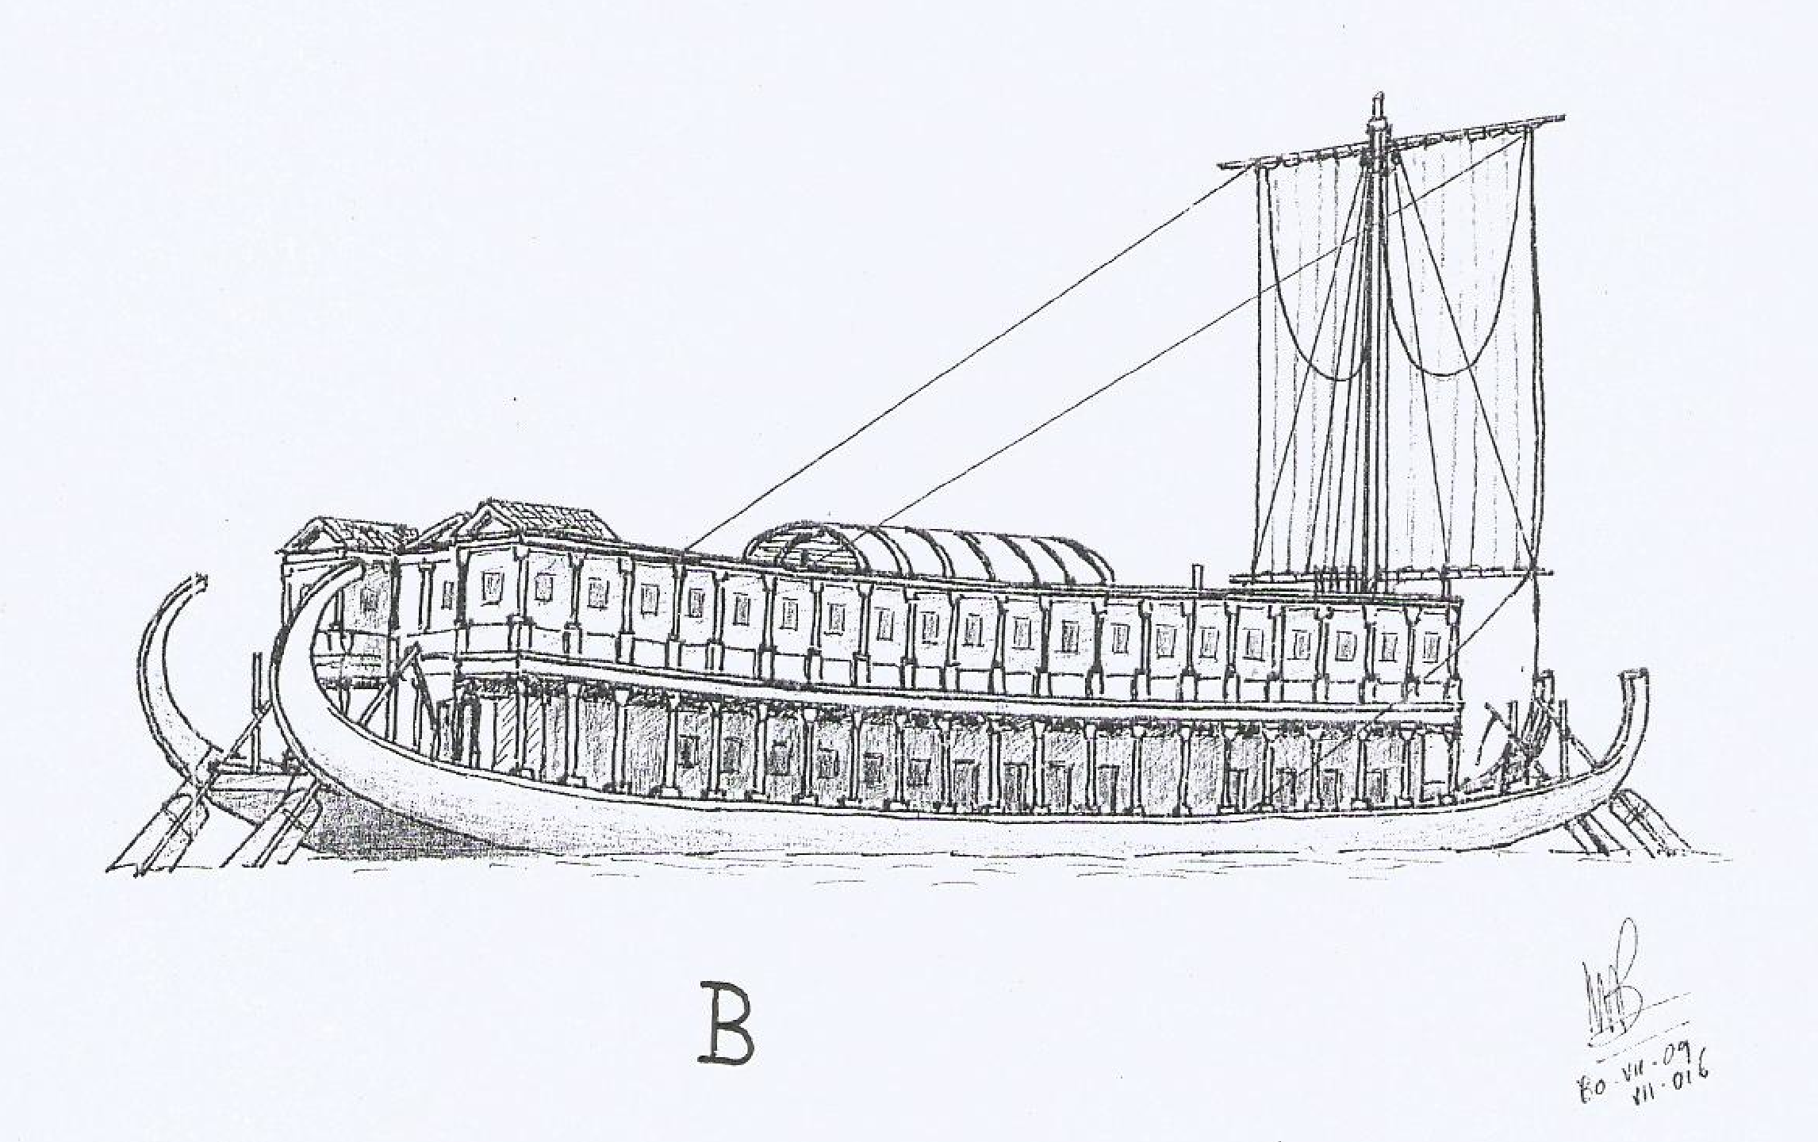
Figura 1. Thalamegos (M. Bonino).
The interiors were distributed over two decks. In his description, Callixenus, says: «In its intermediate cavity were built the banquet halls, the bedrooms and everything else that is needed for daily life.» This highlights the fact that this boat, designed for pleasure cruises, was not sacrificing its interiors in the name of performance, offering to its owners and their guests all the amenities and luxuries of that time accompanied by the pleasure of slow navigation. The materials used for its construction and decoration were the best and most expensive of their kind: ivory, gold, Scythian cedar, thousandth cypress, Indian marble, Paros marble, and so on. According to Callixenus: «Near the bow one came upon a chamber devoted to Dionysos; it contained thirteen couches and was surrounded by a row of columns. It had a cornice which was gilded as far as the surrounding architrave; the ceiling was decorated in accordance with the spirit of the god. In this room, on the right-hand side, a recess was built, which was entirely covered with real gold and precious stones so that it looked like a stone wall. Enshrined in it were portrait statues of the royal family made of Parian marble.»
This kind of barge is often described as a “palace barge” or “floating palace”, and both images contribute to the idea of its extraordinary grandness. The lack of documentation and the confused translations from a language to another in between centuries, contributed to the common belief that “thalamegos” was the name of the vessel designed for Ptolemy IV Philopator, while it is nowadays clear that it was a model of barges in use at that time. «While Philopator’s extravagant creation was singularly spectacular, it was not, of course, the only thalamegos in service; Appian (Praef. 10) reports that Ptolemy II Philadelphus possessed eight hundred, gilded both prow and stern (but fit, at the same time, for military service). Cabin-cruisers were customarily used for government business and religious ceremonial. Strabo reports that a short distance out of Eleusis near Alexandria a canal led to Schedia where was found an anchorage for the thalamegoi used by the hegemones (that is, government officials) travelling to Upper Egypt (17.1.15 [= 799–800c]). And, of course, there were the pleasure-craft. Strabo also reports (loc. cit.) that fun-seekers held feasts on thalamegoi in the shade of the tall bean fields in the delta marshes. These vessels were also used in more mundane ways; for example, in the carriage of freight. (Thus, any definition of thalamegoi which allows only luxury yachts and pleasure craft is unnecessarily, and even misleadingly, restricted.).» (Hillard, 2002).
As explained in recent research, it is clear that the Philopator’s thalamegos cannot be the one in use almost two centuries later, when the last Hellenistic sovereign of Egypt, Cleopatra VII (51-30 b.C.) and Caesar are assumed to have cruised along the Nile on board a sumptuous vessel, accompanied by an impressive military and civil cortege. «In some scholarship it has passed into (implicit) orthodoxy that the boat (or a close double for which it served as the model) was the Ptolemaic ‘state-barge’ still in use in 47 B.C. when Caesar and Cleopatra are said to have navigated the Nile. Non-contemporary accounts, written more than a century and a half after the event, offer the only testimony for that putative voyage. Suetonius (Iul. 52.1) reports that the two traversed Egypt in a navis thalamegus […]; and Appian reports that Caesar ‘ascended the Nile with four hundred ships, exploring the country in the company of Cleopatra and generally enjoying himself with her’ (BCiv. 2.90; Loeb trans.). […] The earliest interpreters of Suetonius Iul. 52.1 do not seem to have spotted there the potential later recognized. Both Philippo Beroaldo (1493) and Marc Antonio Sabellicus (1506) were reading nave thalamoque, rather than nave thalamego. Thus neither realized that he was dealing with a particular ship-classification. […] This, I imagine, represents the crucial stage in the interpretation of Suetonius’ evidence, though the association with Philopator’s boat was clearly not intended to carry the weight it subsequently did. Torrentius added, by way of providing a parallel Latin usage, the observation that Seneca (Ben. 7.20.3) called such a vessel a navis cubiculata and offered as another parallel the elder Pliny’s reference (NH 7.110) to a vittata navis despatched by Dionysius to convey Plato to Sicily. The Senecan reference was doubtless intended by Torrentius to convey the image of a leisure craft (Seneca’s meaning is clear); that of Pliny, no doubt, the image of ceremonial display. Isaac Casaubon, publishing his notes on Suetonius seventeen years later, does not seem, despite a strong interest in Athenaeus (Casaubon published his notes on Suetonius in 1595; his edition of Athenaeus followed two years later, his full-fledged ‘Animadversiones’ in 1600), to have found the Philopator parallel worthy of rehearsal. He noted, on the other hand, that ‘the Egyptian kings’ had eight hundred such vessels (an observation drawn, as noted above, from App. Praef.10, referring in fact to Ptolemy Philadelphus), and provided cross-references, among them the Senecan passage, which suggest that he envisaged thalamegoi as often-luxurious leisure-craft. By the time the first English translation appeared in 1606, Cleopatra’s vessel was thus understood in terms of type as a ‘barge or galley called Thalamegos’, the intention to convey a classification rather than the name of an individual ship being made clear in the accompanying note repeating the information that ‘the Egyptian kings’ had eight undred. An understanding of Cleopatra’s river-boat simply as one of many devoted to leisure seems to have prevailed in the seventeenth century. When Samuel Pitiscus published his commentary, no special significance was seen in Athenaeus’ evidence. The latter’s citation, as one of two parallel passages, was relegated to a single line suggesting the consultation of ‘Athen. V & Max.Tyr. dissert. 31’. His readers were informed that a navis thalamegus was the Greek term for a ship on which (or in which) there was a thalamus. Pitiscus also offered a reference to Strabo, who had noted an anchorage for thalamegoi just out of Alexandria (on which see above), and the opinion, shared with predecessors, that Seneca designated such ships cubiculatae. In the early nineteenth century, Torrentius’ thoughts on the matter were given new currency in the commentary of Baumgarten-Crusius: ‘there was moreover a certain large “thalamegus” which, according to Athenaeus, Ptolemy Philopator ordered built, such that one would think within its thalamum that one was within the palace itself [followed by Athenaeus’ dimensions]’. The association between Philopator’s thalamegos and the ship on which Cleopatra and Caesar travelled was thus established (though it was one, as seen above, which competed with other parallels). » (Hillard, 2002).

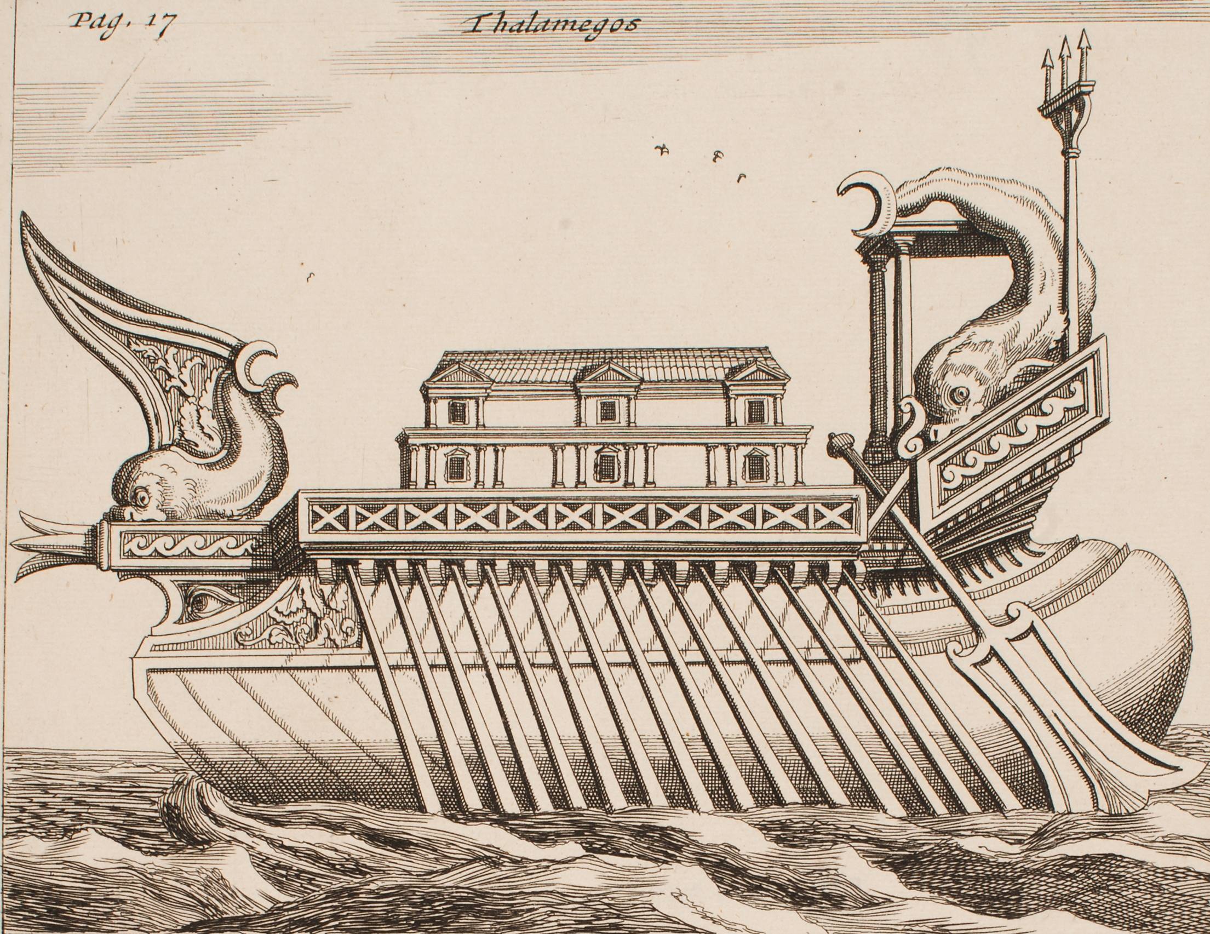
Figura 2. Thalamegos, N. Witsen (1761), sketch on paper, Sjöhistoriska museet digital collection.
Despite the fact that the Thalamegos is often described as the first pleasure boat of history (or more appropriate, it could be considered the superyacht ancestor), it reminds more a “floating palace”, hence, it would be more correct to define it as the first “houseboat” of Ancient History.

Lusoria and cubiculatae
The popularity of pleasure boats on rivers has to deal with the importance of inland navigation all around the known world at that time. « Propertius’ testimony of them [pleasure boats] on the Tiber demonstrates the use of the river by the Roman elite for pleasure sailing, perhaps in the vicinity of Rome itself. » (Tuck, 2013, pp. 239)
In Latin, there were several specific typologies of boats, each one with its one name. The Romans named their houseboats “lusoria” and “cubiculatae”, that is the same term used by Seneca to describe Cleopatra’s thalamegos as seen before. According to several historians “lusoria” and “cubiculatae” can be considered as the Roman version of the Hellenistic thalamegos. « Other Latin terms specifically connected with rivercraft are linter, stlattam, and lusoria. […] Lusoria, on the other hand, is rather more specific. Meaning literally “pleasure boat”, it was originally used of river houseboats, such as the thalamegoi of the Nile, then of working craft. […] The liburna and lusoria, the former known elsewhere only as a naval craft, from the third A.D. on turn up on the Nile as ordinary cargo boats. » (Casson, 1986)
It must be noticed that ‘pleasure boats’ and ‘houseboats’ have often been used as synonymous while describing these vessels, even if they are not the same. In fact, as explained before, houseboats can be seen as a particular niche of the family of pleasure boats but not all the pleasure boats are houseboats-like.
Moreover, from the quotations here reported the reader can assume that those who were defined as ‘houseboats’ by these historians were necessarily riverboats even if this information is not corresponding to its main definition. This fact has been wrongly assumed by many, complicating the attempt to define the forerunners of modern houseboats.
In a note referred to the use of lusoria, Casson cites Seneca, showing the existing difference between the lusoria and the cubiculatae. This document, also clarifies that lusoria could also navigate in open waters, meaning two opposite things. On one hand, this means that this pleasure boats must have been primarily designed to navigate in every circumstances, more than the luxurious thalamegos, built to impress the guests of the Hellenistic royals as a symbol of their power and magnificence. On the other hand, it is not clear if these boats can still be considered houseboats or if they are only pleasure boats, with more ‘nautical interiors’. « Cf. Seneca, de ben. 7.20.3: triremes et aeratas non mitterem, lusorias et cubiculatas et alia ludibria regum in mari lascivientium mittam “I would not send triremes and bronze-shod craft; I should send pleasure boats [lusoriae] and houseboats [cubiculatae, i.e., boats with cubicula ‘bed chambers’] and the other playthings that kings use for desporting themselves on the sea.” As working craft, see note 62 below. The lusoriae apparently were not limited without exception to rivers. IGRR III 48I (mid-3rd A.D.) mentions an official honored by the people of Termessus because, among other things, “He generously exercised imperial authority on the boat [lusorion] during the 9th of November, on which day there was brought a sacred statue of [the Emperor Valerian] […]. The official must have arrived by way of the port of Attalia. » (Ivi)
Contrary to what happened after the Great War in Europe, where working boats were converted into houseboats in response to the emergence of the housing crisis left by the war, in the Ancient world it was the other way around: when these floating palaces were not needed anymore, the same barges were finding a second life as cargo ships mainly used for inland navigation. This is documented by several historians, who described this common secondary use of lusoria and thalamegos all around the Rivers under the Roman Empire. « Lusoria originally referred to river houseboats used for pleasure but was subsequently used of working vessels. By the fourth century, the lusoria referred to the light galleys used by the Roman navy on the Rhine and the Danube. It is worth noting Tacitus’s description of the huge 1,000- ship fleet that Germanicus constructed in A.D.16, which contained a variety of specially designed ships, including some with two rudders so that the steersman could reverse direction and bring them ashore on either bank of a river. […] Many Greek terms were in use for small craft, which generally appeared on the Nile but were probably used on other navigable streams [too]. » (Campbell, 2012)
Other scholars consider the lusoria, only as a military boat used to patrol the river, thank its shape that made this kind of boat faster than others and easier to maneuver.
The lack of information about lusoria is shown by the fact that the experts agree with its definition of ‘pleasure boat’, but not all are sure about their initial or secondary use as houseboats. In fact, some historians aren’t assuming that this kind of boats was certainly, houseboats only because they were mainly cruising on rivers, and this is enlightened by the use of a “perhaps”, like in the following case: « While the overwhelming majority of these vessels were working boats, the lusoria was specifically a pleasure boat, perhaps of the houseboat type. » (Tuck, 2013, pp. 239)
According to the previous descriptions and the lack of visual documentation, it is more credible that even if both types of boats were pleasure boats, the cubiculatae, is closer to the concept of the Hellenistic thalamegoi than the lusoria. In fact, both of them are more corresponding to the modern definition of houseboats, giving more prominence to their interiors and so to the presence of amenities that normally belonged only to houses on the land. This is highlighted by their own names, which contain the word “room”, that help to understand their main purpose.

Nemi Ships
Without any doubt, instead, it can be said that the Nemi ships are the forerunner of modern ‘floating homes’. In fact, this couple of barges represent the most ancient and recorded case of a raft, usually anchored in a fixed spot, with a superstructure built a real house on top.
Nemi is the name of a small volcanic lake, located between the city of Nemi and Genzano di Roma, just about 30 km south of Rome. The lake was a popular place for entertainment and holidays of the ancient Romans. The Lake Nemi Ships were built around 37/40 a.C., for the Roman imperator Caligula. These two huge barges were the result of advanced engineering and they were built as luxury accommodation, designed to host official ceremonies as well as the holidays of Caligula and his guests.
After his death in 41 a.C., the Senate of Rome destroyed everything that was connected to Caligula, including the ships of Nemi that had sunk on the bottom of the lake, in order to erase his memory. Since then, the history of the ships became a legend and only at the beginning of the XX century their wrecks were returned to light.
The Lake Nemi Ships were unique for the fact that their hulls were recovered intact, since they had been underwater for 1900 years, conserved in the still water under layers of mud, demonstrating that Romans were capable of incredible technologically advanced floating construction.
According to different hypothesis one ship, the bigger, was an actual floating palace, while the other was a sort of floating temple dedicated to ceremonies for the Egyptian Isis cult or the cult of Diana Nemorensis.
The larger ship was decorated with gold leaf, rich marble, mosaic floors, 4 meters high columns and it had incredible amenities such as luxurious furniture, baths, hot and cold water pipes. The Imperator was surely influenced by the tastes of the Hellenistic rulers and the construction of these boats was surely an attempt to show the supremacy of Rome. From the description made by Casson (1991), it is notable that the ships were just a little shorter but wider than the Thalamegos of Ptolemy IV. « The superstructures were gone but the hulls were in very good shape-and mighty hulls they were too, one measuring some 224 feet (68 meters) in length and 79 feet (24 meters) in beam, and the other just a shade smaller, 213 (65 meters) by 68 (21 meters). Enough miscellaneous items-bronze decorations, mosaic tesserae, chunks of marble veneering-were recovered to show that the barges were as elegant as they were large, veritable Boating palaces. The hulls, it turned out, were put together by incredibly careful joinery: every plank all along its length was pinned to the ones above and below by a line of mortise and tenon joints set less than four inches apart, and every joint was transfixed by a dowel. » (Casson, 1991)
Both were flat bottomed and therefore rated as barges intended for inland water use only. This choice was leaving the maximum volume possible to the superstructure, renouncing to fast navigation in favour of a better comfort of the living areas. (Exactly the kind of feature that differ pleasure boats from houseboats.) They were steered through 11.3 meters long rudder blades, in order to compensate the huge proportions of the hulls. The bigger barge was almost certainly powered by oars, as structural supports for the rowing positions protrude along the sides of the hull. In order to make the barge more manoeuvrable, the bigger one was equipped with four rudders (two on the bow and two on the stern).
The smaller barge was equipped with only two rudders and it seems to have been towed only when needed, by the other or by smaller boats, since it had no visible means of propulsion. However, there was evidence that it carried a square sail set from a single mast, which probably was a useful aid while towed. In both cases, compared to other barges of the same period, the cruise velocity of both barges must have been very slow, but considering the huge dimensions and the kind of superstructure, it is obvious that moving around the lake wasn’t a priority.

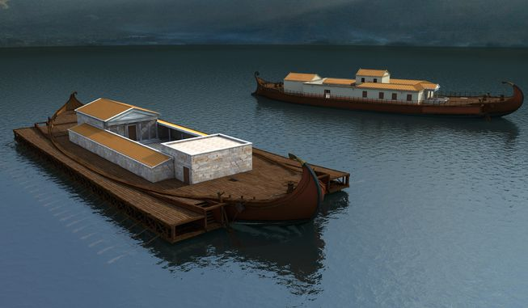
Figura 3. Nemi ships, Digital reconstruction (My, 2013)
According to Marco Bonino, who wrote a lot about these ships, there was a lack of coordination between the structure of the hull and that of the superstructure, which suggests that naval architects designed the hulls, while civil architects then designed the superstructure to use the space available after the hulls were completed.
According to Suetonius Caligula loved to spend time aboard sumptuous ships: « He [Caligula] had Liburnian ships built with ten orders of oars with the sterns covered with gems, polychrome sails, with thermal baths, porches, large triclinia and even with a large varieties of vines and fruit trees. And on these he used to sail while lying down all day long along the banks of Campania between dances and music. »
The liburnia was a military vessel largely used all the Roman wars on water. The boats described by Suetonius may have been liburnia converted into “houseboats” or, has highlighted talking about the Nemi ships, it was probably normal to built hulls that were then equipped differently according to their final function, even by different teams of experts. This will explain why the lusoria, often described as a fast patrol vessel in the II century was also in use as “pleasure boat”, maybe equipped as a houseboat, at the beginning of the I century and then converted for different purposes. If superstructures and hulls were designed as separated entities, as it seems, these boats can be considered forerunners of the concept of “transformable” or multifunction boats designed today. The logic behind this design approach reminds the one in use by Dutch houseboat’s builders specialised in ‘arks’, where hulls of ex-working boats are often used as empty shells for new houseboats. This kind of arks is friendly called ‘schark’ (ship + ark) as explained in the houseboat museum of Amsterdam.

Conclusions
All the civilisations had a strong relationship with water and living on the seacoast or riverbanks was very common among most of the ancient populations. Navigation is one of the most ancient practices of humankind, developed immediately after hunting and fishing. That is why, every civilisation had its own nautical traditions, building fleets of diverse models of boats, according to their needs, mainly related to explore, fish and, conquer.
Canal building finds its routes in ancient history: Assyrians, Sumerians, and Egyptians are known for their elaborate canal systems. However, the most remarkable works are from the Romans, worldwide known for their extensive systems of river regulation and canals in Italy, France, Germany, the Netherlands, and Great Britain. It’s not a coincidence if these countries (with the exception of Italy) are the one where nowadays inland navigation and houseboating are developed the most around Europe.
After the fall of the Roman Empire, inland navigation infrastructures seemed to have had a temporary rest period in the whole of Europe. Only around the 12th century, canal and river navigation revived for the transportation of building materials in response to a European spate of building projects, such as castles, monasteries and churches, opening the ‘Canal Era’ that brought to the Industrial Revolution.
Houseboating on inland waterways has been forgotten for centuries starting to come back on fashion at the end of XIX century when French painters used houseboat studios to go deeper in the pace of nature. However, the real kick-start of houseboating as an activity dedicated to a modern version of the Roman “otium” arrived between the ‘60s and the ‘70s with the hippy movement which re-established working boats as floating dwelling all around Europe, bringing back to life this “Roman” tradition. Nowadays in Europe, there are thousands of houseboats and even more houseboaters but the origins of this popular activity never go further than the Industrial Revolution, when the first families moved on board as not paid crew, helping boatmen on working boats. Seen the common feature with today houseboats, it is clear that there are even older ancestors and that they deserve to be reminded, giving dignity to the history of houseboats as a significant niche in the pleasure yachting world.
References
- Casson, L., Ships and seamanship in the ancient world. Princeton, NJ: Princeton Univ. Pr.,1986
- Casson, L., The Ancient mariners. 2nd ed. Princeton (N.J.): Princeton University Press, 1991, p.174.
- CORRADI M., Lineamenti di Storia della costruzione navale. Morrisville, North Carolina: Lulu Press Inc., 2 voll. 2011, Vol. 1 L’arte di fabbricar navilii, p. 688. ISBN: 978-1-4478-3882-1
- Merzagora, M., La navigazione in Egitto nell’età greco-romana. Aegyptus, 10(2/4), 1929, pp. 105-148. Retrieved from http://www.jstor.org/stable/41214029
- Morozzo, M. and Tiboni, F. (2018). Atti del 2° Convegno nazionale. Cultura navale e marittima transire mare (22-23 settembre 2016). Firenze: goWare, pp.238-244.
- Topper K. Dionysos, Sympotic Ships, and Empire: Banqueting aboard the Thalamegos of Ptolemy IV | Society for Classical Studies [https://classicalstudies.org/annual-meeting/147/abstract/dionysos-sympotic-ships-and-empire-banqueting-aboard-thalamegos-ptolemy]
- Tuck, S. L., “The Tiber and river transport”, in Erdkamp, P. (ed.) The Cambridge Companion to Ancient Rome. Cambridge: Cambridge University Press (Cambridge Companions to the Ancient World), 2013, pp. 229–245. doi: 10.1017/CCO9781139025973.017.
- Versluys, M. J., “Identity,” in Visual Style and Constructing Identity in the Hellenistic World: Nemrud Dağ and Commagene under Antiochos I. Cambridge: Cambridge University Press (Greek Culture in the Roman World), 2017, pp. 108–184. doi: 10.1017/9781316494035.004
- My, M., Le Navi di Nemi Il mistero sommero del lago. 1st ed. [ebook] MyMax s.r.l., 2013 Available at: https://itunes.apple.com/it/book/le-navi-di-nemi/id668449557?mt=11 [Accessed 1 Jul. 2013].
- RAI, (2010). Passaggio a nord est. [TV programme] Available at: http://www.rai.it/dl/RaiTV/programmi/media/ContentItem-888003c4-e1ee-4a5d-a0d4-70652f99239f.html [Accessed 19 May 2017]
- https://dictionary.cambridge.org/dictionary/english/houseboat
- https://en.oxforddictionaries.com/definition/houseboat
- https://digitaltmuseum.se/021025911039/kopparstick

Corresponding Autor: Martina Callegaro, Università degli Studi di Genova, DAD - Dipartimento di Architettura e Design, Scuola Politecnica, Stradone S. Agostino, 37, 16123, Genova, Italia;. email: callegaromartina@gmail.com
The plural of the word ’ahabiyeh’ , an alternative form of dahabieh: a traditional Egyptian sailing boat.
Callixenus of Rhodes was a Hellenistic author from Rhodes. He was a contemporary of Ptolemy IV Philopator. He wrote two works, both of which are lost. One of them, Peri Alexandreias, contained a detailed description of Philopator’s thalamegos, which arrived at us thank the Athenaeus’ Deipnosophistae (5.204d–206c). Athenaeus of Naucratis was a Greek rhetorician and grammarian, flourishing about the end of the 2nd and beginning of the 3rd century AD.
The note 62, quoted by Casson states: “A liburna is listed in a papyrus of the 3rd a.D. (P. Ryl. 223) as carrying miscellaneous cargo. In papyri of the 5th and 6th A.D, a ship called a libernos (Stud. Pal. vIII 1094, P. Oxy. 2042, Sammelb. 5953) or libernion (P. Oxy. 203252, 54) is attested as a cargo carrier. For the lusoria (or lusorion), see P. Ory. 1048.2, 7 (4th/5th A.D.), possibly P. Oxy. 1905.21 (4th/5th a.D.), P. Rend. Harris 150 (5th A.D.), Sammelb. 9563 (4th A.D.).”
‘Nemi’ takes its name from the Nemus Dianae, the sacred forest dedicated to the goddess Diana. Moreover, the lake was called “Speculum Dianae” that means Diana’s mirror and on its shore there was also a Roman temple dedicated to her.
The ownership is demonstrated by the fact that a lead pipe found on one of the wrecks read: ‘Property of Gaius Caesar Augustus Germanicus’, that was Caligula’s full name. The dating of their construction is reinforced by the dates found on a number of tiles taken directly from the wrecks.
After some failed attempts made since the fifteenth century. It was only in the 1920s that the wrecks of the two ships were fully recovered. Unfortunately, both hulls were lost in an arson fire in 1944. Today, they are remembered in their now quite empty museum in Nemi, with two 1:5 scale models and a few of the original relics.
The goddess Isis was considered the protector of sailors (My, 2003)
Similar pairs of steering boards are frequently documented in early II century depictions of ships.
Gaius Suetonius Tranquillus, commonly known as Suetonius (69 –122 AD), was a Roman historian who wrote during the early Imperial era of the Roman Empire. His most important surviving work is entitled De Vita Caesarum, that includes the biography of Caligula.

