Mechanical Behaviour of Strip-Planked Wood for Boatbuilding
Pasqualino CORIGLIANO ^{a,}, Vincenzo CRUPIª, Eugenio GUGLIELMINOª and Alberto MARINÒ^{b}
ª Department of Engineering, University of Messina, Contrada di Dio - 98166 - Sant'Agata, Messina, Italy
^{b} Department of Engineering and Architecture, University of Trieste, Piazzale Europa 1 - 34127, Trieste, Italy
Abstract. The strip-planking technique, which is based on the use of glued-laminated wood, is characterized by many interesting features for wood boatbuilding. The main advantages offered are an easier construction process along with a better exploitation of the mechanical properties of the materials. In order to investigate the response of a particular glued-laminated wooden panel (made by Douglas fir longitudinal strip planks combined with thinner Mahogany veneers at ± 45°), which is quite common for boat construction, a series of experimental tests has been carried out. In the analyzed laminated structure, the Douglas fir strips are the inner layer and give the shape of the hull, whereas the outer Mahogany veneers, in addition to contributing to the overall strength of the structure, give water-tightness to the hull. The results of the tests performed on different specimens are presented in the paper. Specifically, in accordance with the guidelines of the UNI EN standards, bending tests on glued-laminated wooden panels have been carried out. Moreover, tensile and compression tests on specimens made only by Douglas fir strips at 0° or by Mahogany veneers at ± 45° have also been performed. The aim of this study is to find a reliable approach for the structural boat design, using laminated-wood panels with different layers, and strip-planking technique.
Keywords. Boatbuilding, Laminated wood, Composite materials, Mechanical properties, Strip-planking.

Introduction
Nowadays there is a growing interest on wood products and technologies with the increasing progress of the quality and precision in woodworking machines. Moreover, the current ‘green growth’ awareness can be seen as the main reason for the rediscovery of the wood material, which represents an important natural, ecologically sustainable, flexible in usage and easy-to-process material.
Wood is certainly the most ancient material used for the construction of boats and recently it is reconsidered as a very attractive material for marine applications thanks also to the growing interest for green materials and to the development of the wood technology and the progress of woodworking machines in the last years. Moreover, wooden boats at the end of life can be easily recycled. This is one of the advantages with respect to fiber reinforced polymers (FRP), which are generally used for the construction of small vessels. As reported in [1], the large amount of FRP, used for the construction of vessels, represents a big problem for the environment and the health when the vessels are at the end of their life and have to be disposed.
The traditional construction techniques, which have remained practically unchanged for centuries, notoriously require great skill and experience of master carpenters and certainly entail high production costs.
The literature presents new technical solutions [2,3] and new materials [4,5] in the design of woodworking machines for improving their precision and speed. Woodworking industry is increasingly characterized by processing complex spatial forms with high accuracy and high speeds. The use of parallel robot platforms with six degrees of freedom represents an attractive solution as proposed in [6].
The knowledge of quality and mechanical properties of wooden laminates is of outmost importance [7–13]. Mechanical properties of Iroko wood [14] and Iroko laminate [15], used in boatbuilding, were already investigated by the authors, while evaluations of the mechanical properties of Douglas fir and Japanese cedar lumber are reported in [16,17], and the impact responses of wood-based sandwich structures were investigated in [18,19].
Among all the technologies applied for the construction of wooden vessels, the strip-planking technique represents one of the most advantageous methods [1,20]. It represents the fastest and easiest way to build a strong, rigid, lightweight wooden structure. Substantially, the hull planking is achieved through the stratification of laminated wood panels on strip planks, which reproduce the hull forms.
The construction technique (Fig. 1) involves the preparation of a series (rather closed) of transversal frames, reproducing the hull forms (Fig. 1.a). These frames, along with the longitudinal stringers, serve as a support for the long strip planks of wood running in the fore-aft direction (Fig. 1.b). The strip planks are the base for the stratification of laminated wood veneers (Fig. 1.c and Fig. 1.d). The aforementioned longitudinal strip planks, relatively thick, have a rectangular cross section with semicircular mouldings (of a concave and convex shape) on the long edges, which favor an effective bonding and at the same time allow to better follow the hull curvature. The strips are then bonded together by means of epoxy adhesive or nails and staples, which can be subsequently extracted. Furthermore, usually, the strips are not enough long to run from stern to bow, they are usually linked by scarf-joints. In a scarf-joint the ends are cut on a long bevel (slope about 1:7), overlapped and glued together. On the external surface of this first layer, after a suitable preparation, wider and thinner layers of wood veneers are glued with an orientation of the grain of ± 45° in order to obtain the desired thickness of the hull planking.
Following the technique described above, which appears particularly advantageous also for one-off projects, cold-molded hulls are produced without having to resort to the highly qualified manpower required in traditional wooden constructions. Eventually, the external surface of the hull can be covered with resin-coated skin in order to obtain an impermeable surface, suitable for subsequent painting.
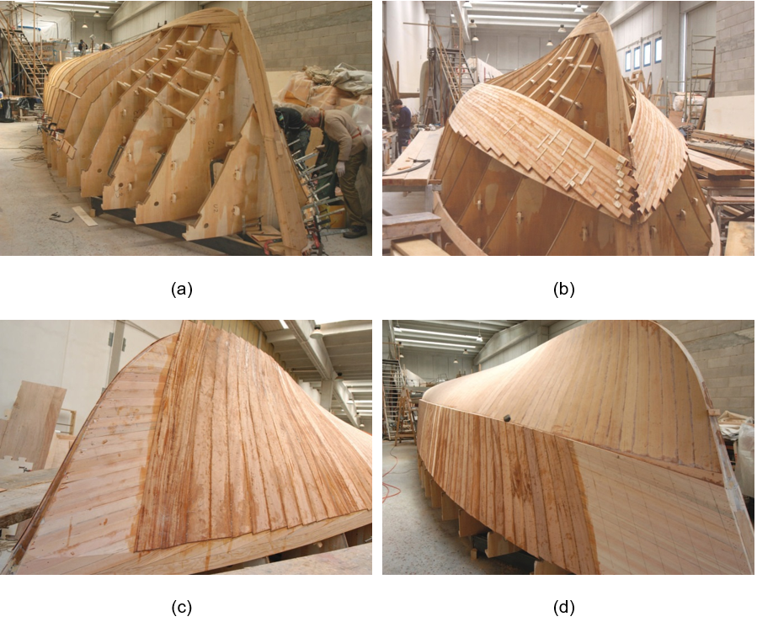
The aim of this study is to investigate the response of a particular glued-laminated wooden panel (made by Douglas fir longitudinal strip planks combined with thinner Mahogany veneers oriented at ± 45°), which is quite common for boat construction, in order to find a reliable approach for the structural design when laminated-wood panels with different layers are used within the strip-planking technique.

Figure 1. Phases of the construction of a laminated wood hull.

Experimental tests
The basic materials used in the construction of the specimens were Douglas fir (Pseudotsuga menziesii) and African mahogany (Khaya anthotheca). A transparent two-component epoxy adhesive (ICA-ADEPOX) was used as glue. In order to provide a complete analysis of both the whole laminate and the single layers, experimental tensile and compression tests were carried out on specimens made of the constituent materials, while three-point bending tests were carried out on the whole laminate. The construction of the specimens and the tests were performed according to the UNI EN 408 standard [21].

Tensile and compression tests
Tensile and compression tests were carried out both on specimens of Douglas fir with 0° fiber orientations and on specimens of angle-veneers in Mahogany crossed at ± 45°. A total of 36 specimens were prepared (nine for each type of test and material).
The tensile test specimens (Fig. 2) had the same nominal dimensions for the two types of material: length between the grips of 280 mm, width 30 mm and thickness 14 mm. Douglas fir 0° specimens consisted of a single strip, while those in Mahogany ± 45° were laminated gluing four layers (each 30 mm wide and 3.5 mm thick) by means of the same epoxy adhesive mentioned above.
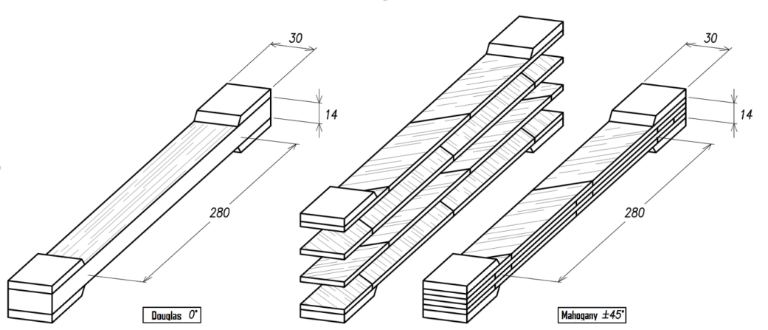

Figure 2. Test specimens for tensile tests (units in mm).

As for the Douglas fir 0° compression tests, specimens 170 mm long, 30 mm wide and 28 mm thick (made by gluing two strips) were prepared, while the Mahogany ± 45° specimens were 145 mm long, 30 mm wide and 21 mm thick (obtained by gluing six layers each 3.5 mm thick and 30 mm wide), as shown in Fig. 3.
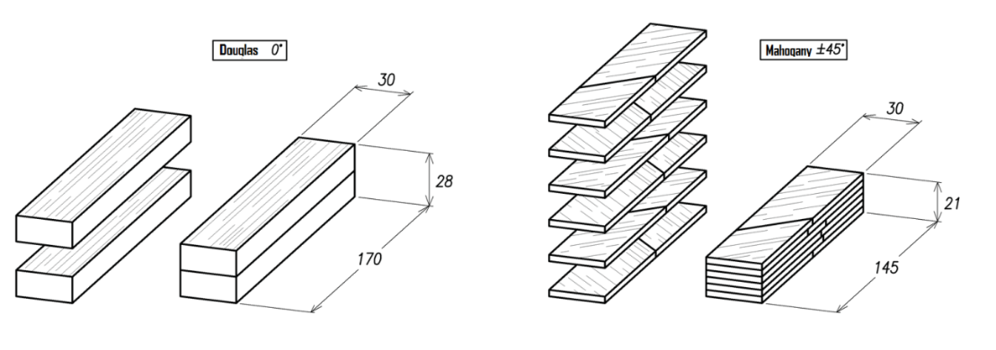

Figure 3. Compression test specimens (units in mm).

The stress-strain curves, obtained by tensile and compression tests on four different specimens, are shown in Fig. 4.

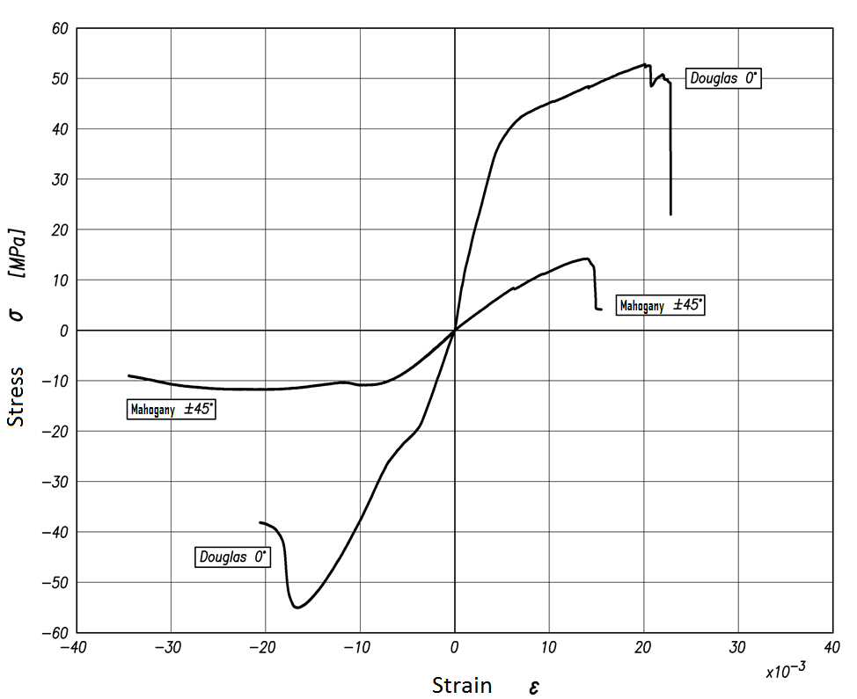
Figure 4. Compression and tensile stress-strain curves.

Mean values of the modulus of elasticity were obtained from tensile tests, which for Douglas fir results equal to E_{t, Douglas 0°} = 8664 MPa with a standard deviation of 1385 MPa, while for the Mahogany ± 45° is E_{t, Mahogany} ± 45° = 1304 MPa with a standard deviation of 148 MPa.
From the compression tests, the following mean values of the modulus of elasticity were obtained: E_{c, Douglas 0°} = 5470 MPa with standard deviation of 410 MPa, E_{c, Mahogany ± 45°} = 1559 MPa with a standard deviation of 134 MPa.
The results showed that there is a significant difference between the tensile and compressive elasticity moduli. In particular, it was observed that the Douglas fir 0° is less stiff under compression loading (approximately 37%), while the Mahogany ± 45° appears to be less stiff under tensile loading (approximately 16%). Beyond any consideration of absolute values (obviously linked to the characteristics of the woodwork on which the tests were made, and to the methods of preparation of the specimens), it is worth noting that these differences are not generally considered and are not contemplated in the construction standards. Neglecting the aforementioned differences may lead to a not correct evaluation of the structural capability.
With regard to the absolute values obtained experimentally for the moduli of elasticity at normal stress, it should be noted that these are lower than those reported in the literature (see for instance [22]). This may be due to both the reasons mentioned above and, especially for the Mahogany ± 45° specimens, to the influence of adhesive interlayers. These relatively low values inevitably lead to lower structural capability calculation than the real one.

Three-point bending tests
Three-point bending tests were performed on laminated wood specimens, with different support span lengths (l = 420-180-135-115 mm), composed of a Douglas fir layer with 0° fibers orientation and a nominal thickness of 14 mm, and two crossed layers at ± 45°of Mahogany, each of nominal thickness of 3.5 mm. The specimens used for the bending tests are shown in Fig. 5. In addition to the above, the specimens had a length of 500 mm, a width b = 80 mm and a nominal thickness h = 21 mm (net of adhesive interlayers). In particular, the single Douglas fir strip (glued along the rounded-moulded edges) was 47 mm wide, while the width of the single Mahogany veneer was 105 mm.

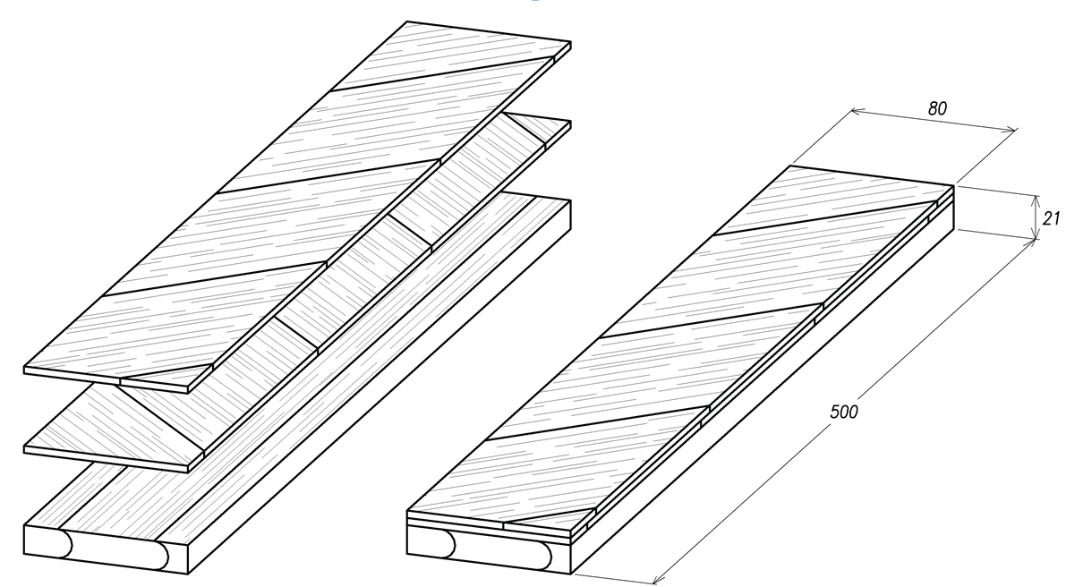
Fig. 5. Specimen for bending tests (units in mm).

The aim of the tests was to evaluate the values of the bending modulus E_{m} and the shear modulus G relative to the lamellar panel. Both these values have been obtained through the so-called “variable support span method”, which is based on the results derived from systematic three-points bending tests.
During the three-point bending tests, the panel is supported by two supports and loaded at its centre (Fig. 6) on the Mahogany side, which is subjected to compressive stresses, in consideration of the fact that this face represents the external surface of the hull.

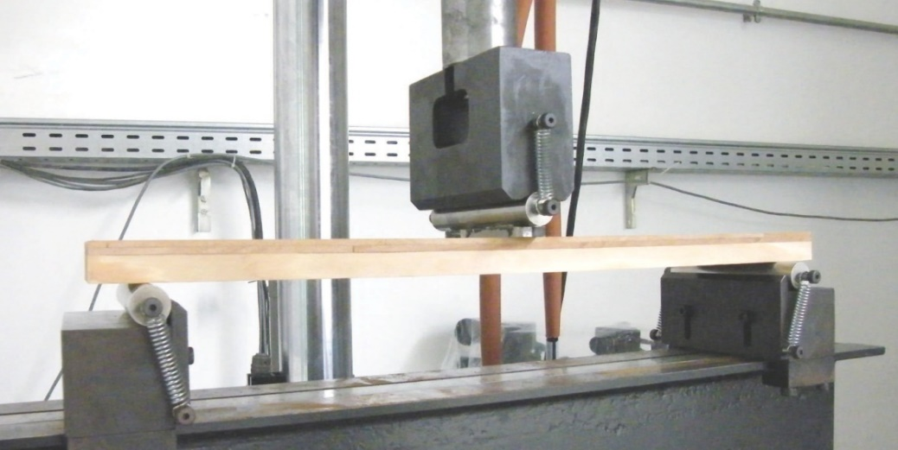
Fig. 6. Three-point bending test.

During the tests, the values of the applied load F and of the corresponding deflection w were measured. Fig. 7 shows the load-deflection curve obtained from the three-point bending test at the support span length l = 420 mm.

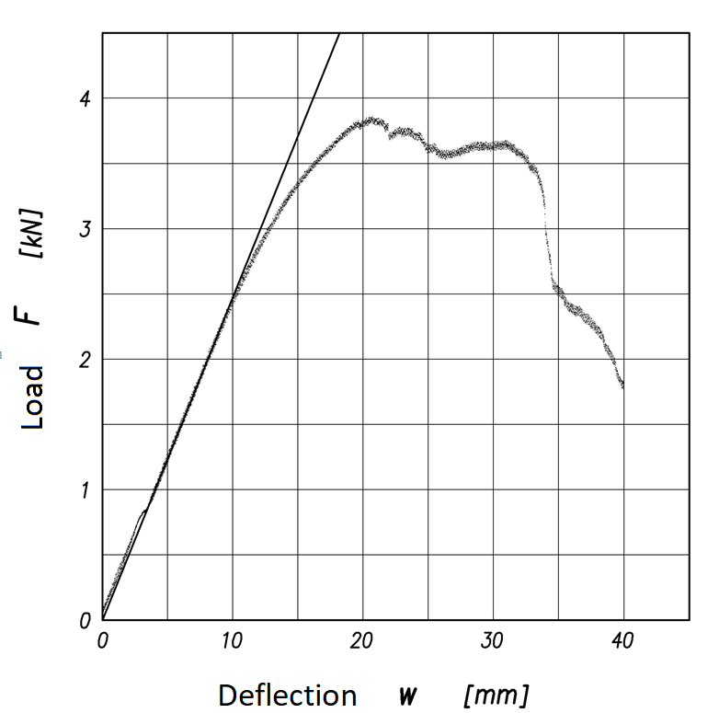
Fig. 7. Load-deflection curve obtained from three-point bending test (l = 420 mm).

The specimen is subjected to bending and shear loadings. The measured deflection $w$ is therefore the result of the contribution of both loadings:

The specimen is subjected to bending and shear loadings. The measured deflection $w$ is therefore the result of the contribution of both loadings:

$w=w_{b}+w_{s}=\frac{1}{48}\frac{{F l}^{3}}{E_{m} I}+\frac{1}{4}\frac{Fl}{GA/α}$$w=w_{b}+w_{s}=\frac{1}{48}\frac{{F l}^{3}}{E_{m} I}+\frac{1}{4}\frac{Fl}{GA/α}$$w=w_{b}+w_{s}=\frac{1}{48}\frac{{F l}^{3}}{E_{m} I}+\frac{1}{4}\frac{Fl}{GA/α}$ (1)

where I is the moment of inertia of the specimen cross section considering the beam as if it were homogeneous ($I={{bh}^{3}}/{12}$), while A is the total area of the cross section ($A=bh$); furthermore, $α$ is the shear factor ($α=1.2$ for rectangular sections).
It is possible to express the total deflection w as if it were produced only by the bending moment, modifying the bending stiffness appropriately. For this purpose, the apparent modulus of elasticity in bending E_{m, app} is introduced, so that:

$w=w_{b}+w_{s}=\frac{1}{48}\frac{{F l}^{3}}{E_{m,app} I}$ (2)

The following relationship can is obtained combining equations (1) and (2):

$\frac{1}{48}\frac{{F l}^{3}}{E_{m,app}I}=\frac{1}{48}\frac{{F l}^{3}}{E_{m}I}+\frac{1}{4}\frac{Fl}{GA/α}$ (3)

Equation (3) highlights that the value of the apparent modulus E_{m, app} is not unique for a given material, but depends on the support span of the beam. Such a dependence allows the determination of the values of the shear modulus G and the bending modulus E_{m}, referred to the whole layered material considered as homogeneous, by means of the variable support span method,
The aforementioned apparent modulus of elasticity in bending E_{m, app} is obtained from the load-deflection F-w curve with reference to the data in which a predominant linear behaviour is evidenced. On the basis of the indications provided by the UNI EN 408 standard, a regression line must be obtained with the data relating to the interval between 10% and 40% of the maximum applied load F_{max}. More precisely, the data in this interval must be considered such as to provide a regression line with a coefficient of determination R² greater than 0.99.
The variable support span method considers, for each specimen, a series of three-point bending tests, with the same cross section at the panel centre, at different support span lengths, with applied load values always below the yield load of the material. The bending tests were carried out at different support spans in order to bring out the different contributions that bending moment and shear give to the total deflection, which depends on the panel slenderness ($h/l$). Equation (3), taking into account the expressions for both the moment of inertia $I$ and the area $A$, allows to write:

$\frac{1/E_{m,app}}{{\left(h/l\right)}^{2}}=\frac{1/E_{m}}{{\left(h/l\right)}^{2}}+\frac{α}{G}$ (4)

$\frac{1}{E_{m,app}}=\frac{1}{E_{m}}+\frac{α}{G}{\left(\frac{h}{l}\right)}^{2}$ (5)

By assuming a quadratic scale for the abscissas, the previous expression becomes a straight line in which the independent variable is ${(h/l)}^{2}$ and the dependent variable is $1/{E_{m,app}}$, having $α/G$as angular coefficient and $1/{E_{m}}$ as intercept with the ordinate axis.
It is possible to note how a regression line, drawn on the basis of the experimental data acquired for different slenderness values ($h/l$), permits to easily obtain the values of $G$ and $E_{m}$ of the composite material constituting the panel. It should be added that the standard requires that the bending tests are carried out for the same specimen on at least four different support span lengths so as to have values of ${(h/l)}^{2}$ approximately equidistant in a domain ranging from 0.0025 to 0.0350 [21].
The experiments were carried out on nine specimens applying four different support span lengths $l$= 420-180-135-115 mm. Fig. 8 shows the experimental results obtained, together with the regression lines drawn for each specimen.

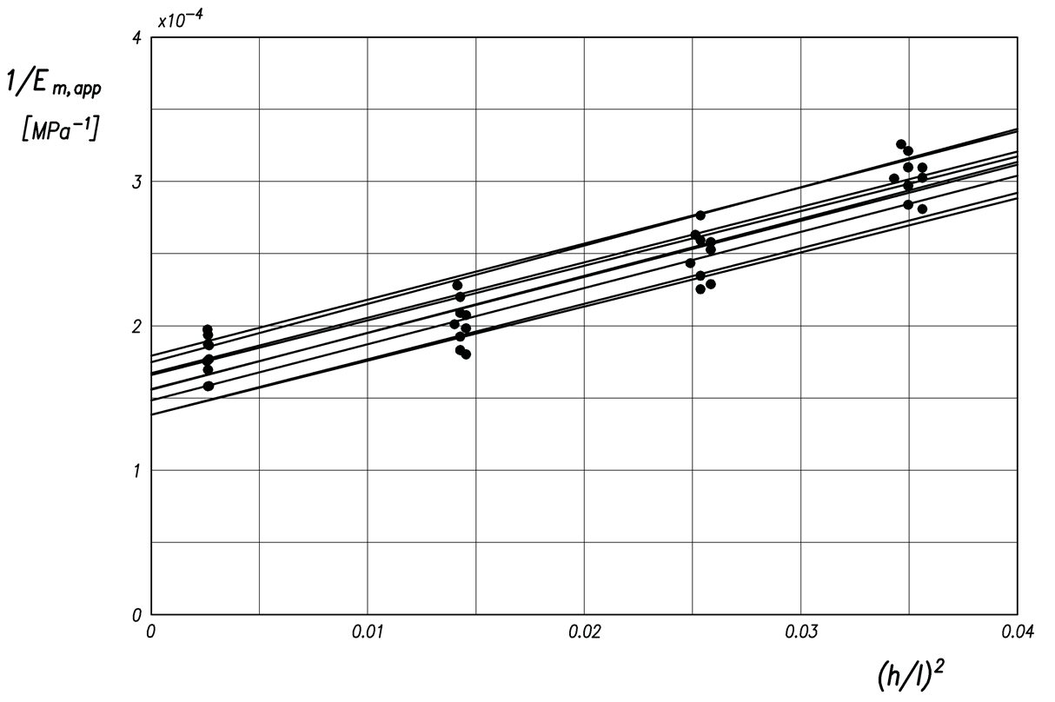
Fig. 8. Variable support span method results on laminated wood specimens.

From the regression line relative to each specimen, the corresponding shear modulus $G$ (from the slope) and the modulus of elasticity in bending $E_{m}$ (from the intercept) are obtained. From the analysis of the results, an average $G$ value of 310 MPa (with a standard deviation of 6.75 MPa) and an average value of $E_{m}$ of 6361 MPa (with standard deviation of 604 MPa) were obtained for the investigated laminated wood panels.
The obtained $G$ value confirms that the shear deflections are significant even in the presence of relatively slender structures. In this regard, it is useful to plot the ${w_{b}}/w$ and ${w_{s}}/w$ ratios as a function of the slenderness ratio$h/l$. Analytically, taking into account the relationships (1) and (2), the ${w_{b}}/w$ and ${w_{s}}/w$ ratios can be written:

$\frac{w_{b}}{w}=\frac{E_{m,app}}{E_{m}}$ (6)

$\frac{w_{s}}{w}=α\frac{E_{m,app}}{G}{\left(\frac{h}{l}\right)}^{2}$ (7)

On the basis of relationship (5):

$\frac{w_{b}}{w}=\left[1+α\frac{E_{m}}{G}{\left(\frac{h}{l}\right)}^{2}\right]$ (8)

$\frac{w_{s}}{w}=\left[1-\frac{w_{b}}{w}\right]$ (9)

Fig. 9 shows the curve obtained from the previous equations, considering the average values of $G$ and $E_{m}$ obtained by means of all the experimental tests performed. The points, evaluated by means of equation (6) for each of the specimens tested on four support spans, are also shown in Fig. 9.

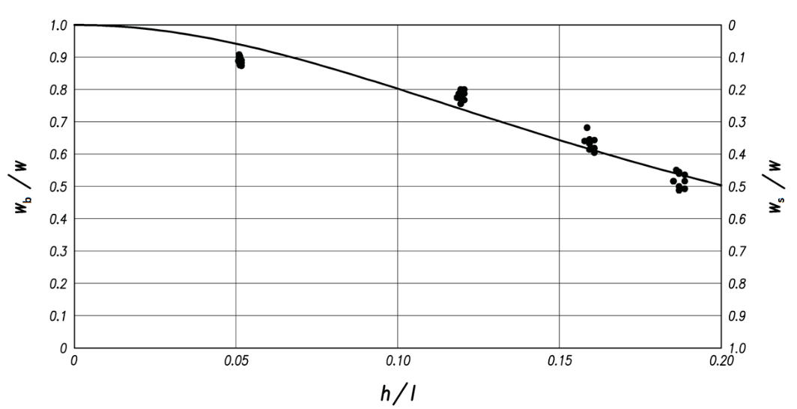
Fig. 9. Bending and shear deflections for the laminated wood specimens.

Conclusion
Among all the technologies applied for the construction of wooden vessels, the strip-planking technique represents one of the most advantageous ones. With reference to this technology, experimental tests (bending, tensile and compression tests) were carried out. Specifically, three-point bending tests were carried out on the whole laminate, while only tensile and compression tests were carried out on specimens made of the component materials.
The results of the tensile and compressive tests of the component materials clearly showed a non-symmetrical behaviour, which appears to be generally neglected in the construction regulations. Therefore, it is easy to state that further experimental investigations are necessary in order to collect a sufficient database on the different behaviour of wood materials with respect to tensile and compressive stresses, so as to allow reliable direct assessments of structural capacity of lamellar systems.
The shear modulus $G$ and the bending modulus $E_{m}$ were determined, through the variable support span method, with reference to a lamellar panel consisting of a Douglas fir strip-planking with fiber 0° oriented 14 mm thick, and two Mahogany veneers crossed at ± 45°, each 3.5 mm thick. In such a lamellar panel, the Douglas fir strip planking provides the main contribution to the strength of the panel, whereas the crossed Mahogany veneers ensure an efficient water tightness of the hull.

Acknowledgements
The authors appreciated the active collaboration of the Cantiere Alto Adriatico of Monfalcone (Italy), which made available its experience and its technology.

References
[1] C. Nasso, U. la Monaca, S. Bertagna, L. Braidotti, F. Mauro, G. Trinca, A. Marinò, and V. Bucci, Integrated design of an eco-friendly wooden passenger craft for inland navigation, International Shipbuilding Progress 66 (2019) 35–55. doi: 10.3233/ISP-180254.
[2] G. Lucisano, M. Stefanovic, and C. Fragassa, Advanced design solutions for high-precision woodworking machines, Int. J. Qual. Res. (2016). doi:10.18421/IJQR10.01-07.
[3] D. Croccolo, M. De Agostinis, and S. Fini, Design of a cutting head for a crosscutting machine, Proc. Inst. Mech. Eng. Part C J. Mech. Eng. Sci. 231 (2017). doi:10.1177/0954406216661367.
[4] M. Fotouhi, H. Saghafi, T. Brugo, G. Minak, C. Fragassa, A. Zucchelli, and M. Ahmadi, Effect of PVDF nanofibers on the fracture behavior of composite laminates for high-speed woodworking machines, Proc. Inst. Mech. Eng. Part C J. Mech. Eng. Sci. (2017). doi:10.1177/0954406216650711.
[5] C. Fragassa, Material selection in machine design: The change of cast iron for improving the high-quality Iin woodworking, Proc. Inst. Mech. Eng. Part C J. Mech. Eng. Sci. (2017). doi:10.1177/0954406216639996.
[6] D. Pršić, N. Nedić, and V. Stojanović, A nature inspired optimal control of pneumatic-driven parallel robot platform, Proc. Inst. Mech. Eng. Part C J. Mech. Eng. Sci. 231 (2017) 59–71. doi:10.1177/0954406216662367.
[7] C.S. Verma, N.K. Sharma, V.M. Chariar, S. Maheshwari, and M.K. Hada, Comparative study of mechanical properties of bamboo laminae and their laminates with woods and wood based composites, Compos. Part B Eng. (2014). doi:10.1016/j.compositesb.2013.12.061.
[8] P.-Y. Kuo, S.-Y. Wang, J.-H. Chen, H.-C. Hsueh, and M.-J. Tsai, Effects of material compositions on the mechanical properties of wood–plastic composites manufactured by injection molding, Mater. Des. 30 (2009) 3489–3496. doi:10.1016/J.MATDES.2009.03.012.
[9] A. Oloyede, and P. Groombridge, Influence of microwave heating on the mechanical properties of wood, J. Mater. Process. Technol. (2000). doi:10.1016/S0924-0136(99)00454-9.
[10] S.Y. Lee, I.A. Kang, G.H. Doh, H.G. Yoon, B.D. Park, and Q. Wu, Thermal and mechanical properties of wood flour/talc-filled polylactic acid composites: Effect of filler content and coupling treatment, J. Thermoplast. Compos. Mater. 21 (2008) 209–223. doi:10.1177/0892705708089473.
[11] H. Bouafif, A. Koubaa, P. Perré, and A. Cloutier, Effects of fiber characteristics on the physical and mechanical properties of wood plastic composites, Compos. Part A Appl. Sci. Manuf. 40 (2009) 1975–1981. doi:10.1016/j.compositesa.2009.06.003.
[12] M.S. Islam, S. Hamdan, M.R. Rahman, I. Jusoh, and A.S. Ahmed, The effect of crosslinker on mechanical and morphological properties of tropical wood material composites, Mater. Des. 32 (2011) 2221–2227. doi:10.1016/j.matdes.2010.11.026.
[13] R. Lopez-Anido, A.P. Michael, and T.C. Sandford, Experimental characterization of FRP composite-wood pile structural response by bending tests, Mar. Struct. 16 (2003) 257–274. doi:10.1016/S0951-8339(03)00021-2.
[14] V. Bucci, P. Corigliano, V. Crupi, G. Epasto, E. Guglielmino, and A. Marinò, Experimental investigation on Iroko wood used in shipbuilding, Proc. Inst. Mech. Eng. Part C J. Mech. Eng. Sci. 231 (2017). doi:10.1177/0954406216674495.
[15] P. Corigliano, V. Crupi, G. Epasto, E. Guglielmino, N. Maugeri, and A. Marinò, Experimental and theoretical analyses of Iroko wood laminates, Compos. Part B Eng. 112 (2017). doi:10.1016/j.compositesb.2016.12.049.
[16] T.H. Yang, S.Y. Wang, C.J. Lin, and M.J. Tsai, Evaluation of the mechanical properties of Douglas-fir and Japanese cedar lumber and its structural glulam by nondestructive techniques, Constr. Build. Mater. 22 (2008) 487–493. doi:10.1016/j.conbuildmat.2006.11.012.
[17] J. WINANDY, and J. MORRELL, Relationship between incipient decay, strength, and chemical composition of Douglas-fir heartwood, Wood Fiber Sci. 25 (1993) 278–288.
[18] J. Susainathan, F. Eyma, E. De Luycker, A. Cantarel, and B. Castanie, Experimental investigation of impact behavior of wood-based sandwich structures, Compos. Part A Appl. Sci. Manuf. 109 (2018) 10–19. doi:10.1016/j.compositesa.2018.02.029.
[19] T.K. Demircioğlu, F. Balıkoğlu, O. İnal, N. Arslan, Ay, and A. Ataş, Experimental investigation on low-velocity impact response of wood skinned sandwich composites with different core configurations, Mater. Today Commun. 17 (2018) 31–39. doi:10.1016/j.mtcomm.2018.08.003.
[20] I. Nicolson, Cold-Molded and Strip-Planked Wood Boatbuilding, Sheridan House, Incorporated, 1991. https://books.google.it/books?id=HtfPPQAACAAJ.
[21] Standard UNI EN 408: “Wooden structures - Solid wood and glued laminated wood - Determination of some physical and mechanical properties,” (2002).
[22] Germanischer Lloyd: “Rules for Classification and Construction, I-Ship Technology”, Part 3-Pleasure Craft, Section 5 - Cold-Molded Wood Construction ", (2002).

Corresponding Author, a Department of Engineering, University of Messina, Contrada di Dio - 98166 - Sant'Agata, Messina, Italy; E-mail: pcorigliano@unime.it.

