Available vs Accessible data and information: the strategic role of adaptive communication the Ship Design and Ship Building processes.
Nick DANESE ª,, Paolo PAGLIUCA^{b}
ª Nick Danese Applied Research, Antibes, France
^{b} Studio Tecnico Navale, Naples, Italy
Abstract. Efficient Data & Information sharing is key to and backbone of the collaborative effort to successful completion of projects on time and on budget. Current software tools generate growing amounts of data, and some generate information in more-or-less structured ways, too. However, a heterogeneous, collaborative approach is not supported much by the software industry which remains rather insular in its strategy, thereby forcing format conversions, data repetition and time-line fractures during the life-time design-to-delivery process. This causes data & information to remain, at best, accessible. A new "availability" paradigm that looks at the current environment from a different perspective is proposed for adoption and application to commence remedying the situation. Accessibility is, by definition, a search-based, existence dependent, uncertain and error-prone condition, while availability is, by definition, a data and information supply strategy that follows specific requirements expressed by each stakeholder. Contrary to general perception, proactive exploitation of data and information in the ship and yacht industries is very rarely undertaken and, even then, much less efficiently than possible today, the causes spanning from incompatible formats to culture. Although the first out-of-the-box, fully enabled PLM environment for ship design and ship building is now available as a commercial software product, the requirement for upstream preparation work remains in itself a techno-cultural obstacle. On the other hand, it is nowadays possible to connect many common-place software tools into a managed, adaptive communication environment thereby effectively making data and information available to all stakeholders at the time and in the format required by each. The research presented in this paper discusses the structure and functioning of the collaborative, shared environment immediately achievable with software tools already in common use. The already-in-use-software element is a fundamental facilitator in adjusting current practices to a more PLM-cognizant strategy and also greatly mitigates the cultural obstacles that hamper the much-needed evolution towards an AGILE and LEAN based PLM approach in our industry. The strategic role of adaptive communications is discussed in the context of requirements, constraints and the changes thereof experienced during the design-to-delivery process, disruptions which is of even greater impact when caused by unforeseen events.
Keywords. Adaptive, Agile, BPA, CAD, Collaborative, Communication, IIIoT&S, LEAN, PLM, Multi-Author, NDAR, Platform, Shared, SSI, TCO, Unique

Introduction
The business model of ship design and ship building has shifted diametrically in the very recent past, from all-capable companies to specialized service and goods providers [2,3,5,7,8,9]. The total cost of ownership (TCO) of a multi-purpose business entity evolved to a point where uncertain market conditions and lack of continuity in the order book made it unsustainable. Subcontracting now spans the labour-to-specialists spectrum and has grown to a point where many of the one-stop-shop shipyards of the XX century are now effectively project managers, subcontracting or interacting with third parties from early design phases throughout production and all the way to delivery. In parallel, though, it must be recognised that many jobs which could be termed “ordinary” just twenty years ago have changed radically and are now the domain of dedicated, single-discipline specialists. Pervasiveness of electronics in the form of advanced software has sealed this transformation [1 2 4 5].
Specialisation and IT are behind the birth first, and the vulgarising after that of many modern aspects of ship design and ship building. The two feed each other and a symbiotic relationship ensued already from the early days. [2] The multiplying of specialisations in a relatively disconnected environment brought the multi-authoring nature of the process to prominence. The commercial opportunity to serve specialist requirements engendered a plethora of software tools, thereby resurrecting a multi-application / multi-platform IT environment of times past. [1,2,5]
The importance of effective communications and of evolutive strategies to support them were recognised early on, but both remain to this day an elusive target, if at all pursued. [2] However, a little evolution in culture can turn the puzzle into a mosaic of which many tiles are already in use in just about every office in the world. LEAN and AGILE data management strategies are valid beacons which readily make use of available tools to build author-agnostic data sets, that is to combine data and information in bespoke Unique Data Models. [1,2,4,5,7,8,9,10]

A short history of electronic data generation.
The growing chasm that separates "culture" and IT is discussed by the author in this and other works. [1,3,4,5,7] Amongst other sources, it finds roots in the very high rate of acceleration of technological evolution. In fact, many milestones in the world of IT were reached and passed over a very short time span in very recent years [Wikipedia]:
- the colour TV set was patented in 1897, prototyped in 1928, and colour broadcasting started in 1951
- T-Square and SketchPad, the first CAD programs, saw the light in 1961
- ARPANET became operational in the early 1960s
- the mouse was invented in 1961 and unsuccessfully commercialized in 1964 (20 years before eventually Apple shipped it with the first MacIntosh)
- PLM was invented in 1965 at American Motor Corporation
- man landed on the moon in 1969, with no protection from the yet-unknown extremely radioactive solar storms and using computers less powerful than a modern kitchen appliance’s
- email was first used in 1972
- Motorola first produced a cell phone in 1973
- the first computer graphical interface was seen on the Xerox Alto in 1973
- the MITS Altair 8800, the first PC, was introduced in 1975
- GSM was born in 1975
- derived from a 1977 commercial software, AutoCAD was first released in 1982, already a 3D program and already supporting plug-ins
- ARPANET adopted TCP/IP to become the internet as we know it in 1983
- Motorola commercialized the cell phone in 1983
- the World Wide Web was invented in 1990
- Amazon was founded in 1994
- Yahoo was created in 1995
- Rhino3D was released a free beta in 1997 and reached the 100000 user mark within 10 months, plug-ins appeared in 2000
- Google was created in 1998
- Facebook was launched in 2004
- etc.
In our time of taken-for-granted smart phones and digital personal assistants just about everyone tends to forget that the technological breakthroughs that define every-day life as we know it today took place so recently. Yet, it has been available to all long enough that one may argue that it should have entered our professional thought process, not just the personal portion of our lives. In our industry more than others, communications remain very human-reliant, with immediate consequences and severely hampering the growth of a badly needed collaborative model in the commercial ship design and ship building processes that encompass design bureaus, engineering offices, shipyards, supply chain, etc. [5,7,8,9,10]

Multiple Authors and Multiple Platforms.
The Naval Architecture design spiral is still present in textbooks, yet this model has effectively ceased a long time ago to be commercially valid in a market where time has become the scarcest of all resources. Current reality resembles more the many-to-many relationship model first programmed neural networks in the mid-1990s. Some one-to-one linearity between local process remains but even that is constantly rebuffed by disruptions arising from external factors. Therefore, as a discretized view of a non-linear reality that requires far more multi-directional, simultaneous communications the design spiral has become a simplified reference. The same can be said for the production process, indeed somewhat more linear than the design process, [2,5,8,9,10] but nonetheless not much evolved since days past from an overall, industrial perspective.
On the other hand, the elements composing the design spiral and the production process remain, overall, rather unchanged. Figure 1 lists a few of the software tools commonly found in the current design and production eco-system, extending from classical Naval Architecture to Virtual & Augmented Reality to the Industrial Internet of Things.
A timeless reality, the fragmentation of the design and production processes into several time and scope limited segments is per-se a significant communications
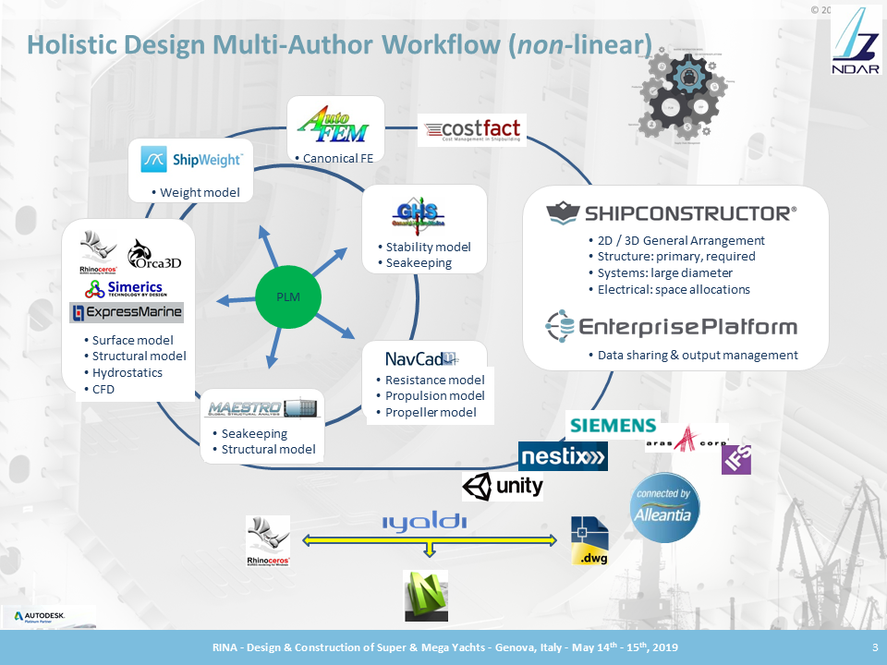
Figure 1. Schematic representation of the eco-system requiring an adaptive communication loop.
problem, compounded by the fact that the numerous different software tools in use rest on proprietary data structures, many of which are metadata-poor. The environment has become one of multiple authors, individually and separately generating all sorts of interlaced data using multiple software programs, data formats and based on multiple platforms. [1,2,4]
In order for the overall system to function, such multiplicity of stakeholders, platforms, tools and data formats require a strong, adaptive and effective communication strategy.

Accessible vs Available.
In order to be of use, data, information and goods have to be put at the disposal of the consumer thereof in a timely fashion. Then, where the data is, which format it is stored in, when was it stored, how was it generated, who provided it, etc. become fundamental parameters that define the usefulness of the data in question for the prescribed purpose. [1,2,3,4,5,7]
Unique Models (essentially data sets) compound the power and effectiveness of making data, information and goods available. A Unique Model is composed of data being made available to a given recipient and specifically so in its contents, formatting, timing, etc. The Google vs Facebook paradigm clearly explains the difference between accessible and available:
A successful Google search requires that the target is present on the internet, that the question allows the Artificial Intelligence algorithms to converge (try “image of man with mammoth”), and that (if it exists) it is displayed in the first one or two pages of results.
Facebook is a “defined” subscription service: the consumer specifies exactly what is to be sent - pictures, posts, etc. posted by specific people - and these are delivered directly to the asker’s desktop as soon as they are posted.

LEAN and AGILE.
LEAN and AGILE are well known business strategies, easy to apply and yet just as widely ignored. Rooted in the 1950s and fundamentally based on common sense and good practice, the two are fully complementary in that LEAN was spawned by the post-WWII transformation of mass-production in the reborn but not yet computerized automotive industrial landscape while AGILE’s roots are found in the early research on iterative & incremental development methods aimed at uninterrupted adding of value to the product soon applied to early software writing. [2,5]
Exploration of the current ship design and ship building aspects most susceptible to be impacted by LEAN and AGILE principles underlines the fundamental role of adaptive communications in the evolution of the overall industry’s process towards greater efficiency.

LEAN
The LEAN business strategy was defined at Toyota in the early 1950s, but only very recently has it surfaced in discussions about improving our industry. [3] LEAN’s “mission statement” is very simply to maximize customer value while minimizing waste, the two approaches to be applied along the overall process, whatever that process might be. There are five LEAN principles and eight LEAN waste sources, respectively:
- value, value stream, flow, pull and perfection
- defects, overproduction, waiting, non-utilized talent, transportation, inventory, motion and extra processing
The current ship building industry can immediately benefit from LEAN in several ways [1,2]:
- better planning and adaptation thereof to evolving situations
- more focused use of specific resources for full sue thereof
- increase quality with improved techniques and coordination
- decrease cost by decreasing waste
- etc.

AGILE
The Wikipedia definition of AGILE is very clear and exact:

"an approach to software development under which requirements and solutions evolve through the collaborative effort of self-organizing and cross-functional teams and their customer(s)/end user(s). It advocates adaptive planning, evolutionary development, early delivery and continual improvement, and it encourages rapid and flexible response to change."
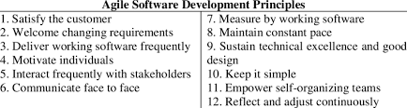
Figure 2. The 12 principles of AGILE.
The direct applicability of the AGILE paradigm to the shipbuilding industry is, to say the least, striking. AGILE is based on four values:
- individuals and interactions [carry more value] over processes and tools
- working software [product] over comprehensive documentation [explanations]
- customer collaboration over contract negotiation
- responding to change over following a plan
and on twelve principles (see Figure 2). The current ship building industry can immediately benefit from LEAN in several ways [1,2]:
- draw more from individuals’ skills and resources
- involve more stakeholders, direct and indirect, in a feedback process
- adapt planning and workflow proactively to changes in the overall process, as opposed to just suffering the consequences
- set more waypoints and more frequent milestone
- assess progress and process ROI very frequently
- consider the design and building processes as an orchestrated flow of concurrent processes as opposed to a linear sequence of discrete events
- etc.
In order for LEAN and AGILE to be effective to its utmost, the real-life distributed information system is to be recognised, accepted and supported. Figure 3 shows an agnostic schema of the distributed information process.

Stakeholders, Consumers, Authors, Unique Models and Unique Data-Sets.
The classical notion that only people are stakeholders and that they only consume data is and has always been fundamentally incorrect. However, the very existence of the many-to-many concurrent relationships linking people, platforms, software tools, processes and machines only became prominent and recognized in the recent past when it was forced to the forefront by the increasingly demanding time and cost constraints imposed on industry.
In fact, all components of any scenario and process are stakeholders - people, platforms, software tools, processes, machines, etc. - and each consumes and consequently produces data and information, perhaps the only truly linear cause-and- effect sequence in the many-to-many ecosystem. Here is where adaptive
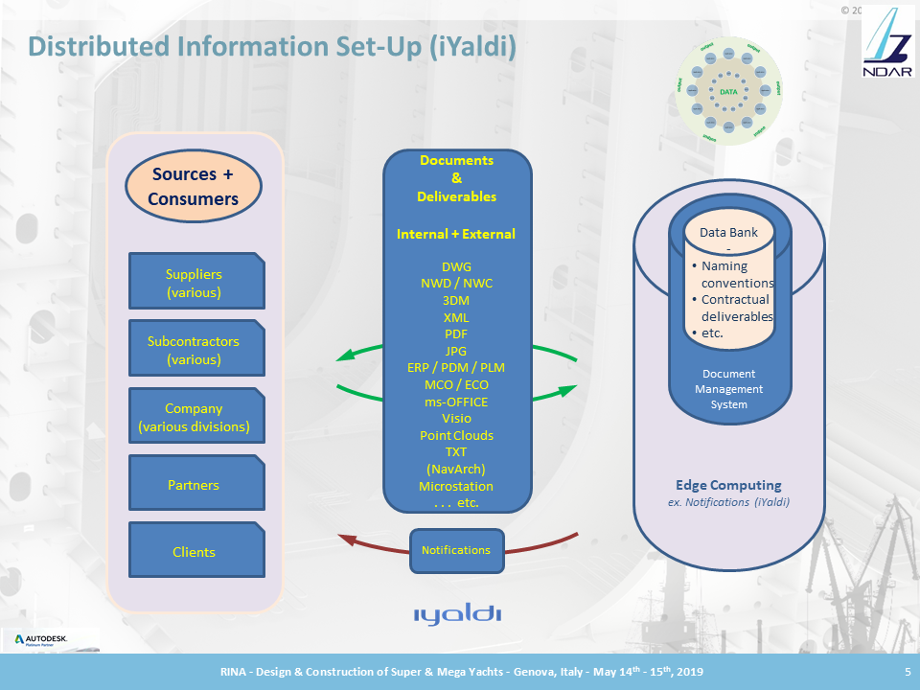
Figure 3. Some of the Fundamental Components of the Adaptive Communications Eco-System, foundation to the LEAN and AGILE paradigms.
communications, intrinsic in the LEAN and AGILE paradigms, become paramount and a genetic keystone of any successful effort, first and foremost by reinjecting data and information produced by the consumption thereof into the communication stream via the feedback loop that is key to managing change.
Therefore, the underlying, common denominator DNA strand in the very concept of adaptive communications is that all - people, platforms, software tools, processes, machines, etc. - are stakeholders, consumers and authors. While “stakeholders” is a more commonly used and also an accurate definition to the role of all, it is not common to identify software, processes and machines as such. Therefore, in line with the goal of the research discussed here all will be referred to as authors. [1,4]

The only thing that never changes is that everything changes.
“Change is the unrecognized birthplace of every initiative” goes a proverb, but most feel that change is at best a nuisance, if not a problem. It can be argued that the unwanted effects of change are generally due to poor planning and inadequate preparation. Both can be remedied by improved communications and LEAN strategies.
Clearer and more granular goal definition, more waypoints and closer milestones make progress monitoring and evaluation possible and effective and allow planning changes in a timely fashion. [2]

Change management
Change is a double-edged sword but it has a handle, too, allowing the wielder to make a most effective use of it. LEAN and AGILE teach the positive-ROI use of both the edges of the “change” blade to produce a better product, on time and on or under budget.
Overall project integrity and robustness are to be ensured in the multi-author reality, which requires both a Work In Progress (WIP) and a “Release” deliverable document set and workflow (Fig. 4).
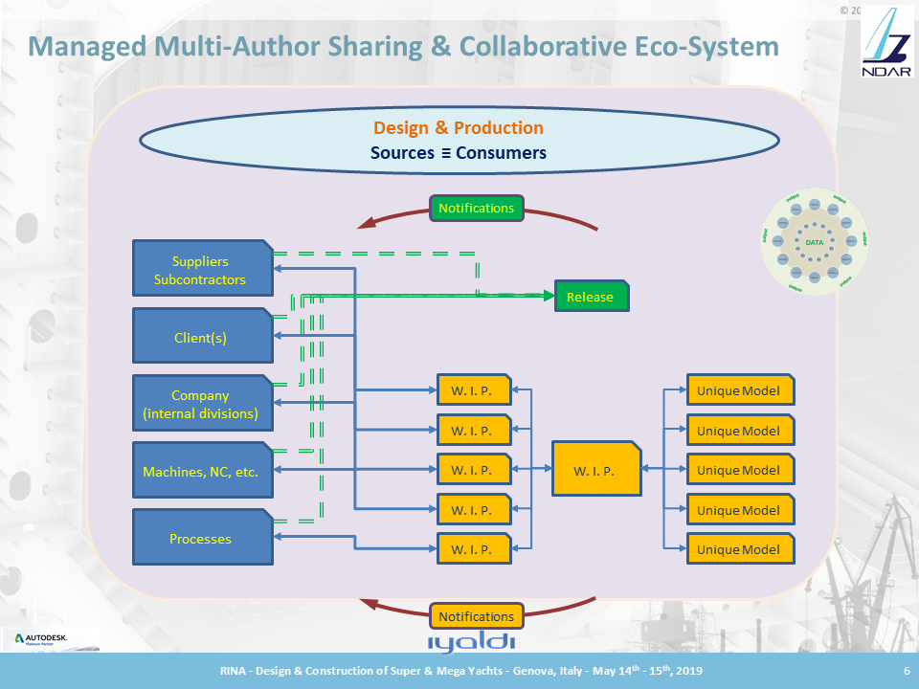
Figure 4. WIP and Release file flow schema (summarized) supported by iYaldi’s iSuite.
Change is to be exploited, as described above, not suffered. One edge of change is disruption, which may initially result in momentary under-performance, but the other edge is the opportunity to devise and implement a stronger, higher ROI solution. [2,4] Needless to say, the better a process has been planned and appropriate resources allocated, the easier it will be to make the best of change.
Because all must be involved and all must contribute to ensure the best outcome, adaptive communications are key to identify change, its causes and to determine and implement the remedies and the new course of action. [1,2,4]

The Seminal Tiles of the Mosaic.
In harmony with the many-to-many nature of all processes, the mosaic of effective communications and of the strategies that supports them spawns from several seminal tiles, some of which are:
- People
- Technology
- Software platforms and tools
- File Management
- Asynchronous information and data sahring
- Unique data sets
- Culture, Cost and ROI
Importantly, adaptive communications are agnostic and ubiquitous by definition, wholly applicable to any industry, initiative, process, etc. [1,2,4]

People
People wish for change and resist it equally, the reasons of the apparent contradiction being the desire for improvement and the fear of losing what are considered acquired gains.
Adaptive communications contribute to accepting and even seeking change and evolution by making progress and newly obtained benefit evident. This concept introduces an interesting component to the underlying PLM process, that is the need to support the binary purpose-perception facet of human nature that determines the quality and extent of people’s participation and buy-in. The Unique Models discussed in this paper are therefore to be composed not only of the individuals’ requests (mostly subjective perception) but also of data and information selected from a broader spectrum (to serve the objective purpose).

Technology
Currently available communication technology is not exploited much, when at all exploitable, in our industry. [1,2,4] There are subjective and objective reasons for this. but the combination of many commonly used software tools constitutes already today a valid tool set to base an adaptive communications effort on [1].
This consideration extends beyond software to machines and industrial processes.

Software Platforms and Tools
Introduction of adaptive communications by least-effort and least-cost implementation being the goals and industry standard(s) being a (de-facto) main requirement, platforms and tools considered in the present, on-going research effort were shortlisted to:
- McNeel
- Autodesk
- File “management"
Crucially, the McNeel and Autodesk platforms offer values unique to the goal pursued by the work in object [1,7]:
- very widely used across the industry, world-wide, including the supply chain
- (de-facto) standard data file formats, respectively 3DM and DWG
- read / write each other’s native formats as well as many others’
- offer unique and complementary CAD environments and capabilities with some useful redundancy and overlap
- count numerous specialist plug-ins, extensions and compatible analysis software tools covering the spectrum of requirements of the industry
- cover the design and production spectrum
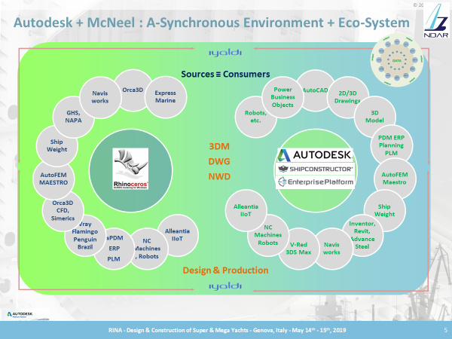
Figure 5. The Autodesk + McNeel A-Synchronous Environment and Eco-System
- offer direct machine and NC interfaces
- offer direct connectivity to ERP, PLM, PDM, etc. platforms, software and environment
- etc.

File Management
File “management” is a sine-qua-non component in that purpose-specific data is to be made available to each author as per LEAN and AGILE principles. A full-fledged, relational database centric PLM remains out of reach for most and high end document management systems remain uncommon. On other hand, the ability to make bespoke data sets available in a managed fashion is provided by (at least) two software systems:
- SSI’s EnterprisePlatform (Fig. 6)
- iYaldi’s Suite (Fig.4, 6)
In addition, the iYaldi system also notifies designated parties of file appearance, absence, change and deletion.

Asynchronous Data & Information Sharing
The traditional approach to data and information sharing is synchronous, that is one asks and, hopefully, an answer is returned [1]. There are major drawbacks to this strategy:
- an answer can be returned only if the right source is asked
- the source been asked must have the answer
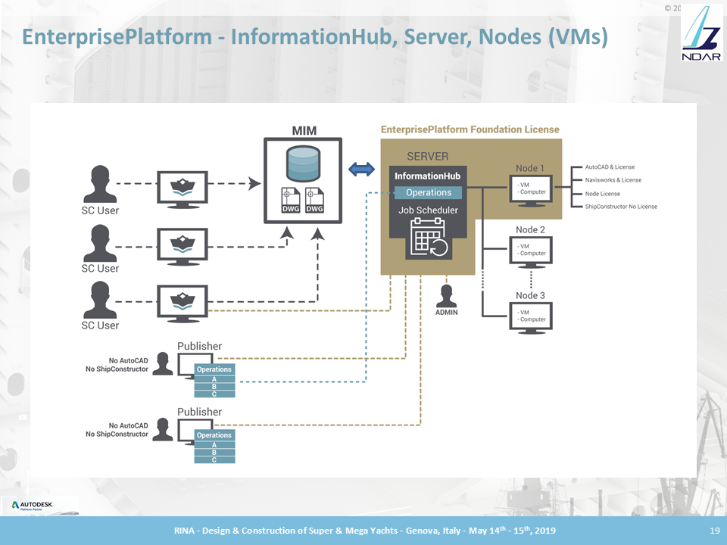
Figure 6. SSI’s EnterprisePlatform’s asynchronous data flow schema (summarized).
- at best, data and information are accessible only to the one asking. Any other author that could/would benefit from the same data and information or change to it is left ignorant
- the environment and eco-system surrounding the data and information does not contribute to the quality and contents thereof and mostly remain ignorant of communications
- feedback is dependent on arbitrary and subjective human action and is not necessarily shared appropriately or in a timely fashion
- etc.
The asynchronous data flow model is diametrically opposite, in that data is made available to all in raw, processed and/or combined form as prescribed the instant it exists, and the designated authors are immediately notified. The advantages of this approach are evident:
- all designated authors are informed of all relevant data events automatically and directly
- absence of response and/or feedback is visible and traceable
- etc.

Unique Data Sets
Unique data sets are required by each author to perform various tasks and fulfil various roles:
- carry out own work
- be informed of anything that influences their work and/or that is influenced by their work
- provide feedback
- etc.

Culture, Cost and ROI
Interestingly, and contrary to perception, although in different ways all cultures are a “natural” obstacle to adaptive communications in that they somehow tend to clash with LEAN and AGILE principles. [1,2] The two diametrically opposite examples are:
- an inflexible and hence overly linear approach with crippling limitations in dealing with change
- an excessively “flexible”, intentionally limited preparation strategy also very vulnerable to change and to unexpected situations and events
However, in too many cases, the deep misunderstanding of the difference between cost and investment is arguably the first show-stopping obstacle. Worse yet, one efficient and effective way to identify the highest Return on Investment evolutionary options is to carry out a Business Process Assessment, itself an investment quickly shunned by fear of change. Other cultural misconceptions also cause:
- inability or unwillingness to quantify the value of waste
- inability to determine the true, total cost of ownership of error
- repetition of error
- resistance to investment
- reduced exploration of new ways and systems
- absence of what-if case studies
- limitations in research & development efforts
- etc.
In essence, the root cause is arguably identifiable in the fear of change.

Adaptive Communications.
The eco-system at hand is therefore a multi-everything scenario (Fig. 7). And, in summary, the entailing required approach to adaptive communications is in itself a cultural shift that relies on:
- the definition of each author’s data and information requirements for purpose and catering to perception: content, format and time frame
- the identification of which author(s) generates which data
- an adaptive approach to combining data from multiple authors into unique data sets and making these available to the appropriate author
- willingness to dynamically adapt the process in order to accommodate change
- a feedback loop making the data produced by consumption available to all concerned
- definition of ROI-checking waypoints and milestones
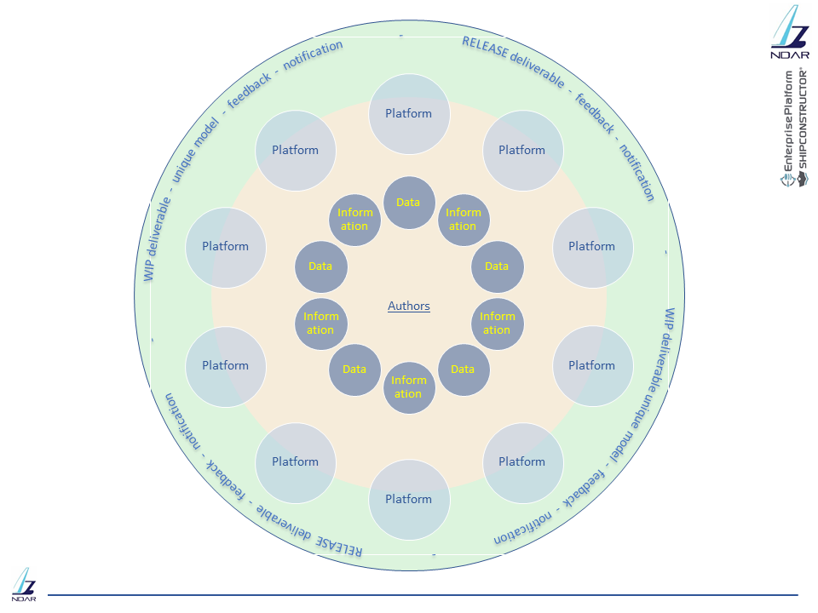
Figure 7. The Multi-Everything Eco-System
Some simple example of work-scenarios requiring adaptive communications are:
- Concept phase: changes in GA or mission profile repercussions on weight, CG, propulsion, structural specificities, cost, etc.
- Design phase: layout of systems requiring additional volume impacts GA, structural arrangement, performance required of other systems, weight, CG and cost
- Production phase: QA does not identify defects early enough or the delivery of a main component is delayed by an unforeseen event (strike, logistics failure, etc.) causing major rework of planning and redistribution of resources in an effort to maintain schedule and budget
Change management: the handling of any of the above example

A simple Road Map.
To start implementing adaptive communication is straight forward, some first easy steps are:
- map the enterprise at the macroscopic level: organigrams, roles, responsibilities, decision making chain and authority, processes, flows, etc.
- identify authors: which data is produced, when, based on which input, and for which purpose
- objective forensics: why are things done the way they are
- identify objective and subjective constraints
- pursue optimization of the status-quo with as little change as possible
- introduce the smallest change that will generate the highest ROI in the shortest time
- plan for medium-long term evolution
- repeat the above
- etc.

Immediate benefits of adaptive communications.
Adaptive communications yield immediate benefits:
- less waste
- fewer errors
- shorter process time
- continuous improvement
- greater efficiency, satisfaction and increased buy-in

IIIoT&S:Intelligent, Industrial, Internet of Things & Services.
Internet of Things is as common an expression as it is misconstrued. IoT is far more pervasive, flexible and capable than exposed by “domotic” applications such as controlling a washing machine from a smart phone. The Industrial Internet of Things (IIoT) is a further step towards integrating processes in the design and production worlds.
Adaptive communications are supported extremely well and efficiently by IIoT in that everything and anything that uses electricity can be monitored and the data edge-computed for immediate exploitation by all authors. More specifically, ERP and PLM processes at any level of complexity benefit immediately by process monitoring from simple welding performance to environmental control.
It is straight forward to see how the overall human-machine relationship can be documented and reviewed for improvement as a whole, one excellent example being the direct operation of the Wolf 9-axis welding robot directly from the ShipConstructor rich-model environment. [2,10] The ability to drive the robot directly from the CAD model – no programming required – allows people to dedicate more time to setting up work for the robot rather than spending thousands of hours welding with un-guaranteed results. Each resource is assigned to what it does best, for grater throughput and financial gain.

Conclusions
Introduction of adaptive communications by least-effort and in least-cost implementation fashion are perfectly achievable today with little change to the present software toolbox, if any. Following LEAN and AGILE principles and using already common-place and off-the-shelf software tools contribute to support a cultural paradigm shift to be carried out gradually, with quasi-zero financial or other investment and yielding immediate returns.
Every company that uses software has at least some building blocks well suited to initiate the evolutive process towards adaptive communications. Rhino3D, Autodesk and iYaldi products constitute a distributed, collaborative, multi-author and multi-platform design-to-production ecosystem that lends itself very well to achieving highest ROI from adaptive communications.
People are identified as the missing link between intention, commercial requirements and constraints, and success. Their reluctance to change constitutes a major obstacle, compounded by a misconception of investment.
The proposed asynchronous approach to the ubiquitously productive adaptive communications paradigm and least-effort, least-cost implementations rests on an itself adaptive, gradual, high Return on Investment, strategy that makes Unique Models / Data Sets available - as opposed to just accessible - to all authors in a timely fashion.
References
- Danese, N, Out-Of-The-Box Integrated, Collaborative, Multi-Authoring, Managed Environment for the Design and Construction of Large Yachts, Proceedings, RINA Design and Construction of Super and Mega Yachts, Genova, 2019
- MORAIS, D., Waveform Blog, 2012-2019
- Various authors, COMPIT, International Conference on Computer and IT Applications in the Maritime Industries, TUHH Technologie, 2012-2019
- Danese, N, Out-of-The-Box Dynamic Distributed Information Sharing Technology in the Marine Industry _ A Case Study, Proceedings, SORTA 2018, Split, 2018
- DANESE, N., MORAIS, D., The Synchronised Shipyard, Proceedings, ICCAS 2016, Bremen, 2016
- MORAIS, D., WALDIE, M., DANESE, N., Ship Design, Engineering and Construction in 2030 and Beyond, Proceedings, HYPER 2016, Cortona, 2016
- MORAIS, D., WALDIE, M., DANESE, N., Open-Architecture Applications: The Key to Best of Breed Solutions, Proceedings, COMPIT, 15th International Conference on Computer and IT Applications in the Maritime Industries, TUHH Technologie, Lecce, 2016
- MORAIS, D., WALDIE, M., LARKINS, D., Innovative Methods for Leveraging a 3D Model, Proceedings, ICCAS 2016, International Conference on Computer Applications in Shipbuilding, Bremen, 2016
- LARKINS., D., WALDIE, M., MORAIS, D., Utilizing a Single 3D Product Model Throughout the Design Process, Proceedings, COMPIT, 14th International Conference on Computer and IT Applications in the Maritime Industries, TUHH Technologie, Berlin, 2015
- MORAIS, D., WALDIE, M., LARKINS, D., Completely Rethinking Weld Management; Leveraging 3D Models and Visualisation, Proceedings, COMPIT, 14th International Conference on Computer and IT Applications in the Maritime Industries, TUHH Technologie, Ulrichshusen, 2015

Corresponding Author: Nick Danese, Nick Danese Applied Research, Antibes, France E-mail: ndar@ndar.com

