The Failed Project of the “Heavy” MAS

Simone MANCINIa,d,[1],Claudio PENSA b, Luigi VITIELLOb,Rasul NIAZMAND BILANDIc,d, Maria DE CARLINId

a Università degli Studi “Giustino Fortunato”

b Università degli Studi di Napoli “Federico II”

cPersian Gulf University, Busher, Iran

dEurisco Consulting Srls

**Abstract.** This paper is focused on the history of a specific MAS (Motoscafo Armato Silurante) project among the many that were developed. The MAS was a class of fast torpedo armed vessel used by the Regia Marina during World War I up to World War II. During the two World Wars the general design of the MAS, however, was changed. From 1932 to 1937 the Baglietto shipyard developed, among the many projects, two different prototypes: the MAS-431 and the Motor Torpedo & Gun Boat “Stefano Turr”. The first project was a small and very fast ship that represents the evolution of the MAS of the first World War, summarizing the best of the experiences gathered up to that moment. The “Stefano Turr” project was a large boat of over 50 tons of displacement that, besides dimensions notably superior to those of the MAS-431, has a stepped hull similar to the MAS-431. Unfortunately, the “Stefano Turr” project not gave satisfactory results in terms of performance. This paper tries to investigate the reasons for the lack of success of the hull performance using modern tools as the Computational Fluid Dynamics (CFD) approach.

**Keywords.** MAS, CFD Simulation, Fast Patrol Boat, Stepped Hull, Royal Italian Navy Ship.

# Introduction

Motoscafo Armato Silurante, commonly abbreviated as MAS, was a class of fast torpedo armed vessel used by the Regia Marina (Royal Italian Navy) during the First and the Second World War. However, originally the name "MAS" was referred to “Motobarca Armata SVAN”, where SVAN stood for Società Veneziana Automobili Navali [1]. MAS was essentially motorboats with displacements of 20 – 30 tonnes (depending on the class), a 10-man crew, and armament composed by two torpedoes, machine guns and occasionally a light gun.

## MAS in the First World War

MAS was widely employed by Regia Marina during World War I in 1915–1918. All the models (Figure 1) used were directly derived from civilian motorboats, provided with petrol engines which were compact and reliable (characteristics which were not common at the time). They were used not only in the AS (Anti-Submarine) patrol role but also for attacks against major units of the Austro-Hungarian Navy.

A significant success came in December 1917, when MAS boat managed to sink the pre-dreadnought battleship SMS Wien in Trieste harbor. Furthermore, the greatest success of Italian MAS was the sinking of the Austro-Hungarian battleship SMS Szent István off Pula on 10 June 1918 by the MAS commanded by Luigi Rizzo. MAS boats later engaged in the Second Battle of Durazzo in October 1918.

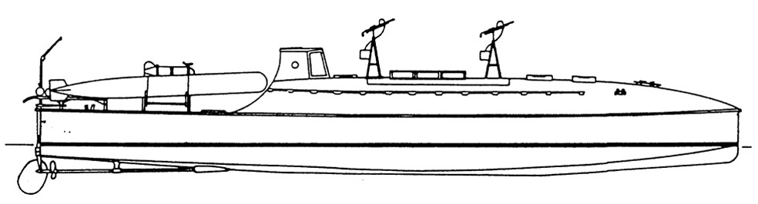

**Figure 1.** Side view of first-class of MAS. (source: www.anb-online.it)

## MAS between the two World Wars

During the twenty-one years between the two World Wars, the research and the development around the MAS continued thanks to the support of Baglietto Shipyard and the Isotta Fraschini engines. Hence, the MAS at the beginning of World War II was able to reach a maximum speed of 45 kn, has two 450 mm torpedoes and one machine gun for anti-aircraft fire. However, the new MAS class continued maintaining the same dimensions and displacement, and, substantially, the same hull shape derived from the MAS 431 that was the link between the old and the new MAS class [2]. In 1940, when Italy went to war, there were 48 MAS 500 (the new MAS class – Figure 2) units available and all the older units were transferred in secondary theatres, such as the Italian East Africa.

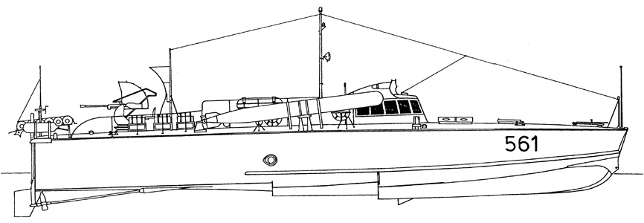

**Figure 2.** Side view of MAS 500 class. (source: www.anb-online.it)

## MAS in the Second World War

In the Second World War, notable war actions performed by MAS include the torpedoing of the Royal Navy C-class cruiser Capetown by MAS 213 of the 21st MAS Squadron working within the Red Sea Flotilla off Massawa, Eritrea; and the failed attack on the harbour of Malta in January 1941, which caused the loss of two MAS. Five MAS were scuttled in Massawa in the first week of April 1941 as a part of the Italian plan for the wrecking of Massawa harbor in the face of the British advance. MAS 204, 206, 210, 213, and 216 were sunk in the harbor; four of the boats were in need of mechanical repairs and could not be evacuated. On 24 July 1941, MAS 532 torpedoed and crippled the transport Sydney Star, which managed to limp to Malta assisted by the destroyer HMAS Nestor. MAS 554, 554 and 557 also sank three allied freighters on 13 August 1942, in the course of Operation Pedestal, for a total tonnage of 28,500 tons. On 29 August 1942, a smaller type of MAS boat, the MTSM, torpedoed and disabled for the rest of the war the British destroyer Eridge off El Daba, Egypt.

A flotilla of MAS was employed as Black Sea reinforcement to German allied forces, in particular in their intended attack on Sevastopol in June 1942. The MAS performed well in the Black Sea area. They sank the 5,000-ton steamer Abkhazia and disabled the 10,000-ton transport Fabritius. MAS boats destroyed troop barges and damaged Soviet warships. Italian sources claim that on the early hours of 3 August 1942, three MAS boats torpedoed and disabled the Soviet cruiser Molotov south-west of Kerch. Another flotilla of four MAS, the XII Squadriglia MAS, was deployed to the Lake Ladoga in April 1942 to support the siege of Leningrad. They claim the sinking of a Soviet gunboat of the Bira class, a 1,300-ton cargo ship, and several barges [3].

However, the MAS in the Second World War was not so effective as in World War I [4]. In fact, the obsolescence of MAS became apparent during the conflict, and they were increasingly replaced by MS (Moto Siluranti) derived from the E-boats built in Germany.

Despite the initial idea that the increasing speed would have been a crucial point for the effectiveness of the MAS in the new conflict, MAS was never effective as in the First World War. MAS was a fast unit with a very flat keel bottom (and *i.e.* a small deadrise angle) and small displacement, so with a poor seakeeping attitude. This characteristic being suitable for closed seas, such as the Adriatic Sea (and also the Red Sea or the Black Sea) but not for the open sea. Their poor seakeeping (and therefore the guaranteed sustainable speed in the rough sea), their limited autonomy, their torpedoes, and their insufficient anti-aircraft weapons determined the overcame of the MAS. So, the E-boats with their displacement (around 79 tons) and dimensions (Length: 32.76 m, Beam: 5.06 m, Draught: 1.47 m, and 3960 CV of installed power) were more effective then MAS [5].

However, a project of a “heavy” MAS configuration was delivered from Baglietto Shipyard in 1936 [2], but this project failed and only one boat (called “Stefano Turr”) was built without success and this boat was never accepted by the Royal Italian Navy because this ship didn’t reach the contractual speed of 34 kn.

In the next paragraphs, the main features, the towing tank tests, and the hull modifications of the “Stefano Turr” boat will expose. Finally, a CFD analysis of the original configuration will show in order to try to investigate the reason why this project failed.

# “Stefano Turr” Hull Details

In the towing tank tests of the “Stefano Turr” performed in the Guidonia-Monte Celio Towing Tank, four different models were considered [5].

The first hull is the original body (Figure 3, top panel). The second, third and fourth hulls have been named Mod. A, Mod. B, and Mod. B&C.

Mod. A: wedge was added. About the wedge application, see some paper in references as [7] and [8]. The wedge dimensions are described by *a* and *b* parameters. For Mod. A, *a* and *b* have been set in 600 mm and 100 mm, respectively. Other parameters are the same as the original hull.

Mod. B: the wedge was improved and both parameters, a and b, have been set in 1600 mm and 80 mm, respectively. Like the Mod. A body, the other parameters are the same as the original model.

Finally, for Mod. B&C, the step position has been changed (parameter *c*). The other parameters are like Mod. B (see Figure 1, below panel).

The body profile and principal characteristics of these four models are illustrated in Figure 3 and Table 1, respectively.

|  |
| --- |
|  |
|  |

**Figure 3**. Side view of the hull body profile of the four models tested, original model (up panel) and Mod A, Mod B, and Mod B&C (down panel)

**Table 1.** Main characteristics of the “Stefano Turr” original hull

|  |  |  |
| --- | --- | --- |
| **Parameter** | **Unit** | **Value** |
| *LOA* | m | 33.0 |
| *BWL* | m | 5.66 |
| T | m | 0.90 |
|  | t | 50 |
| Longitudinal Centre of Gravity (LCG) (from transom) | m | 14.5 |
| Longitudinal position of the step | m | 19.5 |
| Height of the step | m | 0.23 |

# Results and Discussions

## Towing Tank Test Results Analysis

The marine applications of the stepped hull for high-speed vehicles derive directly from the seaplane hulls that are, even today, characterized by one or two steps. The aeronautical derivation of the step is recognizable by the quite forward positions of the steps and by the rising buttocks of the aft part of the hull.

Both these characteristics are effective if applied on the seaplane hull, where high dynamic trims are needed to increase the lift during the take-off and landing phase.

Differently, in marine applications, these step shapes imply trim angles higher than the optimum values. This is caused by the need to move astern the center of dynamic pressure (in order to balance weight and lift).

To avoid this drawback, on the “Stefano Turr” original hull model were applied two different wedges (Mod. A and B) that effectively reduced the trim and, in a wide speed range, the Effective Horse Power (EHP) (Figure 4 and 5). Nevertheless, despite the improved performances, the engine power required was higher than the engine power available. In fact, the motorization of the “Stefano Turr” was based on 4 FIAT V1616 with 16 cylinders for a total amount of 3040 CV [2] and for weight and dimensions reasons this type of engine cannot be changed. Then, considering an OPC (Overall Performance Coefficient) equal to 0.55 an evaluation of PB curves for the four different hull configurations tested is shown in Figure 6.

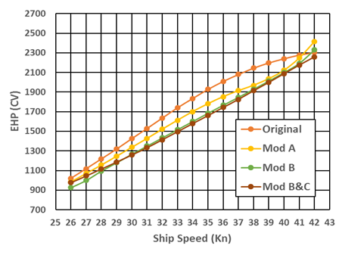

**Figure 4.** Towing Tank results of the four hulls tested – effective power required

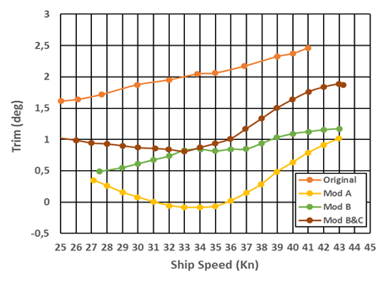

**Figure 5.** Towing Tank results of the four hulls tested – dynamic trim angles

Installed Power



**Figure 6.** Brake Power (PB) of all hull tested with OPC=0.55.

## CFD Results Analysis

The CFD simulations were performed for original hull case at speeds of 30, 35 and 40 kn and for Mod. A hull only at 35 kn. The simulations were performed in full scale using the Overset mesh approach, and for more details see similar papers as [9] and [10].

In this section, the behavior of “Stefano Turr” hull in calm water has been investigated using numerical methods and compared with experimental results (Figures 7 and 8). Figures 7 and 8 show the trend of the EHP and the dynamic trim angle and are similar to that of experimental results, in particular for the original hull case. By analyzing and comparing the numerical method with experimental, it can be observed that for original hull the comparison errors at 30, 35, and 40 kn are:

* for EHP, -7,3%, -6,5%, and 4,5% respectively,
* for the dynamic trim angle, -2,2%, -6,3%, and -2,3% respectively.

These comparison error values are substantially in line with the comparison error between experimental and numerical approach for planing hull exposed in [10]. However, the comparison error, for the Mod. A hull, increases and the overestimation is around 11% for the EHP and around 80% for the dynamic trim angle.



**Figure 7.** Effective Horse Power (EHP) comparison between experimental and CFD results for original hull and Mod. A hull



**Figure 8.** Dynamic trim angles comparison between experimental and CFD results for original hull and Mod. A hull

Following the experimental side view of wetted surface and wave profile of “Stefano Turr”, derived from the original Towing Tank report [6], has been compared with the CFD results. For both experimental and numerical methods, ventilation length of step increases by speed increasing (see Figures 9-11). Furthermore, the shape of the stern is able to decrease the trim angle. For this purpose, Mod. A hull had a wedge in the stern. So the Mod. A hull reduced the trim (Figure 8), but the flow separation behind the step was not developed properly, as shown in Figure 12.

|  |
| --- |
|  |
|  |

**Figure 9.** Comparison between experimental (up) and CFD (down) side view of wetted surface and wave profile on the hull for 30 kn – original hull.

|  |
| --- |
|  |
|  |

**Figure 10.** Comparison between experimental (up) and CFD (down) side view of wetted surface and wave profile on the hull for 35 kn – original hull.

|  |
| --- |
|  |
|  |

**Figure 11.** Comparison between experimental (up) and CFD (down) side view of wetted surface and wave profile on the hull for 40 kn – original hull.

|  |
| --- |
|  |
|  |

**Figure 12.** Comparison between experimental (up) and CFD (down) side view of wetted surface and wave profile on the hull for 35 kn – Mod. A hull.

The CFD analysis of the original hull model substantially confirmes the trim values measured with the experimental tests and highlights the need to decrease these values. At the same time, the simulation performed for the Mod. A hull shows:

* the increase of the dynamic pressures on the bow,
* the strong increase of the wetted surface,
* the insufficient ventilation of the area behind the step.

As the experimental tests have shown, despite the over mentioned drawbacks, the performances of the models with wedges where improved but, observing the CFD results, it seems evident that the application of the modern knowledge would allow significant reductions of the resistance. In particular, following the actual approach [11], the hull would be designed with:

* the step located astern (around the LCG),
* a step taller,
* descendent buttocks in the astern zone,
* a very small wetted bottom near the transom,
* two indents on the step (one for each side) to facilitate the incoming airflow behind the step and on the hull bottom.

With this modern design approach and these devices, it is presumable that about 15-20% of resistance reduction would be achievable, so the performance required would be reached.

However, about the comparison between the numerical and experimental tests, it must be remembered that, in that time, the model-ship correlations followed the pre-ITTC criteria. This issue could imply significant differences in the evaluation of the wetted surfaces and the frictional resistance (mainly due to the friction-line formula followed). Moreover, there is no way in the experimental report to understand how the towing force was applied and, consequently, it is not possible to evaluate its influence on the trim angle and the resistance. The different approach in the model-ship correlation and in the experimental procedure, have an extreme influence in the planing craft performance evaluation. Therefore, the numerical-experimental comparison should be taken into account with caution.

# Conclusions

In this paper, a brief overview of the MAS history has been presented and a detailed analysis of the failed project of the “heavy” MAS “Stefano Turr” has been exposed. The towing tank results of the original hull and her modified versions have been exposed and compared with CFD simulations. The CFD approach was adopted in order to try to investigate the reasons for the failure of this project. It is not so easy to understand exactly these reasons in particular for the lack of knowledge about the procedures followed in the towing tank test.

However, using the CFD approach, some issues were recognized. These issues can be mainly related to some mistakes derived from the “aeronautical” idea of the stepped hull.

Nowadays the knowledge of the physics of the stepped hulls clarified that the two main improvements achievable are the reduction of the wetted surface (as in the past) and the small change of the dynamic trim angle for a wide speed range, so the stepped hull allows a fine optimization of the dynamic trim angle.

These goals can be reached working with these two factors: the step position (the step has to be positioned around a small percentage of LWL forward the Center of Gravity position), the wetted surface (the wetted bottom of the stern part of the hull has to be small and able to force the forward-part of the hull in the optimum trim, typically in the range of 3-4 deg).

In the case of a single step, these dynamic conditions, (=3–4 deg) are frequently obtained shaping the astern part with descending buttocks.

Finally, another important feature, necessary to ensure good performances, is the effective ventilation of the area behind the steps. This is a crucial point to avoid strong negative-dynamic-pressures which would involve an apparent increase in the weight and a consequent higher resistance.

References

1. <https://www.historynet.com/naval-weaponry-italys-mas-torpedo-boats.htm>
2. <http://www.bagliettonavy.com/barche-militari-storiche/>
3. <https://comandosupremo.com/black-sea/>
4. <http://www.regiamarina.net/detail_text_with_list.asp?nid=77&lid=1>
5. E. Bagnasco, *M.A.S. e mezzi d’assalto di superficie italiani*, Ufficio Storico della Marina Militare, Roma, 1996.
6. *Carena “b85” Mototorpediniera “Stefano Turr e modif.” Potenze Effettive e Profili dell’Onda Dedotti dalle Esperienze di Rimorchio col Modello*, Vasca Esperienze di Architettura Navale, Guidonia-Monte Celio, Italia, 1936.
7. F. De Luca, S. Mancini, A. Manfredini, C. Pensa, R. Scognamiglio, *Interceptor Device for a High-Speed Displacing Craft (Comparison Between CFD Simulation and Experimental Data),*.18th International Conference on Ships and Shipping Research (NAV 2015), Lecco, Italy, 2015.
8. G. Karafiath, D Cusanelli, L. C. Wen, *Stern Wedges and Stern Flaps for Improved Powering - U.S. Navy Experience*, Trans. of The Society of Naval Architects and Marine Engineers (SNAME), 1999.
9. A. De Marco, S. Mancini, L. Vitiello, R. Scognamiglio, S. Miranda, *Experimental and Numerical Hydrodynamic Analysis of a Stepped Planing Hull*. Applied Ocean Research, 64, 2017.
10. F. De Luca, S. Mancini, C. Pensa, S. Miranda, *An Extended Verification and Validation Study of CFD Simulations for Planing Hulls*. Journal of Ship Research, 60(2):101-118, 2016.
11. D. Savitsky, M. Morabito, *Surface Wave Contours Associated with the Forebody Wake of Stepped Planing Hulls*, Marine Technology, Vol 47, n° 1, January 2010.

1. Corresponding Author: Simone Mancini, Università degli Studi “Giustino Fortunato”, Via Raffaele Delcogliano 12, Benevento, Italy; E-mail: s.mancini@unifortunato.eu