A Linear Model Analysis of the Unsteady Force Response of a Planing Hull through Forced Vertical Plane Motion Simulations

Nicholas HUSSERa and Stefano BRIZZOLARA a

a Virginia Tech, Kevin T. Crofton Department of Aerospace and Ocean Engineering

**Abstract.** The prediction of planing hull motions and accelerations in a seaway is of paramount importance to the design of high-speed craft to ensure comfort and, in extreme cases, the survivability of passengers and crew. The traditional approaches to predicting the motions and accelerations of a displacement vessel generally are not applicable, because the non-linear effects are more significant on planing hulls than displacement ships. No standard practice for predicting motions or accelerations of planing hulls currently exists, nor does a nonlinear model of the hydrodynamic forces that can be derived by simulation. In this study, captive and virtual planar motion mechanism (VPMM) simulations, using an Unsteady RANSE finite volume solver with volume of fluid approach, are performed on the Generic Prismatic Planing Hull (GPPH) to calculate the linearized added mass, damping, and restoring coefficients in heave and pitch. The linearized added mass and damping coefficients are compared to a simplified theory developed by Faltinsen [6], which combines the method of Savitsky [12] and 2D+t strip theory. The non-linearities in all coefficients will be investigated with respect to both motion amplitude and frequency. Nonlinear contributions to the force response are discussed through comparison of the force response predicted by the linear model and force response measured during simulation. Components of the planing hull dynamics that contribute to nonlinearities in the force response are isolated and discussed.

**Keywords.** Planing Hull, RANSE CFD, Forced Motions, Unsteady, Linear

# Introduction

The effective vertical plane motion prediction of high-speed planing hulls has remained a challenge for designers since the development of the hull form. Even today, the most common practice for evaluating the performance of planing hulls in waves is model testing, which can be very costly, especially for high performance designs that require several iterations before converging on the final hull form. Additionally, an effective model test program on a planing craft requires a level of design maturity such that if poor seakeeping performance is discovered during testing, significant re-work in the design spiral can be required to correct the performance deficit. Reynolds’ Averaged Navier-Stokes Equations (RANSE) CFD simulations in waves can be performed as an alternative to model testing, but these simulations can quickly become too computationally expensive to be cost effective especially when investigating a broad range of speeds, wave periods, and wave heights. Traditional low to medium fidelity motion prediction methods used on displacement hulls are generally performed within the framework of a linear response assumption, which is generally not applicable to the prediction of planing hull motions where more significant nonlinear effects are present.

The following paper uses forced motion simulations to derive the linear added mass and damping coefficients on a planing hull in the vertical plane and evaluate the modes in which the nonlinearities are most significant. After the modes of the nonlinear contributions have been isolated, the goal is develop a CFD-based methodology to derive a nonlinear model of the hydrodynamic forces on a planing hull in motion which can be used to solve the motion response in a variety of sea states.

# Literature Review

The analysis of vertical plane motions of a planing hull generally aims to predict one of two quantities: motion in waves or dynamic instability onset (porpoising). Many methods have been proposed in the past to predict vertical plane motions and dynamic instabilities of planing hulls including direct experimentation [7], linear analysis [5], non-linear analysis [2], and RANSE CFD simulation [4,12].

Troesch [1] experimentally investigated the speed, frequency, and amplitude dependence of the added mass and damping of a prismatic planing hull through a systematic series of captive and forced vertical planar motion (VPM) experiments. Captive experiments were performed at a range of fixed heave and pitch values, and the lift force and trimming moment (TM) were measured at each condition to establish the restoring forces as a function of running attitude. The results of the fixed simulations showed significant nonlinearities in the restoring coefficient, with greater nonlinear effects in heave displacement than trim. VPM experiments were then performed in either forced heave or forced pitch (while the unforced mode was held fixed) and the measured force and moment histories were used to estimate the linear added mass and damping coefficients. The VPM tests showed that both the linear added mass and damping in both modes were frequency dependent, though the added mass showed greater frequency dependence than the damping. Also, the added mass and damping in pitch motions (both the lift and moment response) were amplitude dependent.

This study utilizes a similar procedure of Troesch [1] through a numerical investigation of VPM simulations on a planing hull. The geometry evaluated in this work contains a variable deadrise bow and chine flats to better represent modern high-speed planing hull geometries than a prismatic model.

# Reference Hull Geometry

The hull form evaluated in this work is GPPH, for which extensive experimental testing and numerical simulations have been performed. GPPH has a prismatic section from the transom to around station 5 (see body plan in Figure 1) with increasing variable deadrise forward of station 5 consistent with modern planing hull geometry, though slightly simplified. The inclusion of the prismatic section aft reduces the effect of geometric variables on the performance of the model while the variable deadrise sections forward allows the study of the hydrodynamic effects of bow entry, particularly in waves, that is not present in fully prismatic investigations like Savitsky’s [12].

The GPPH hull form has undergone extensive experimental and numerical investigation at multiple scales [4] [9] [10] [11]. Several investigations based on different computational fluid dynamics solvers have been performed on GPPH in both calm water and waves [3], [4], [9], [11] and found good agreement between the numerical and experimental results. Unfortunately, no forced motion experiments have been performed on GPPH to date, so there is no way to directly validate the results of the forced heave and pitch simulations in this study. However, the availability of numerical studies in the literature that confirm RANSE CFD codes are capable of predicting the steady state and dynamic response of GPPH in waves provide additional confidence that RANSE CFD codes are capable of predicting the relevant hydrodynamics being studied. The particulars of the selected model and load condition are shown in Figure 1. Only one speed is evaluated in the current investigation (V=8.996m/s), which corresponds to the highest speed tested in regular waves [4].

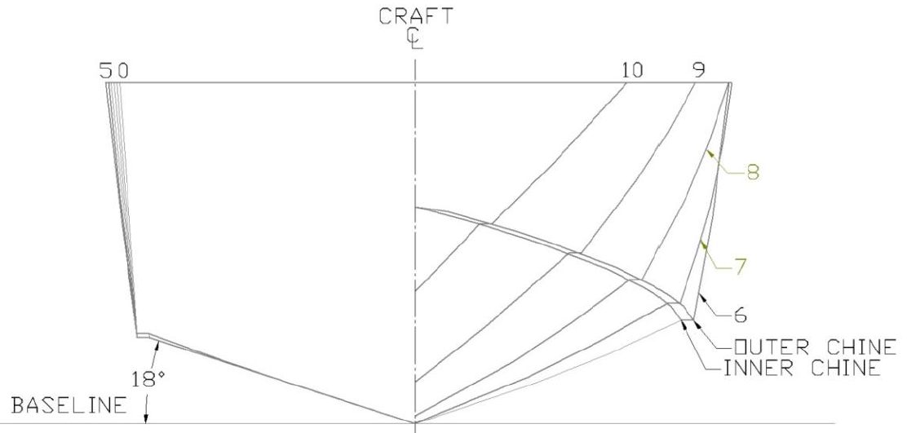 

**Figure 1.** GPPH Body Plan and Particulars

# Analysis Procedure

The motions of planing hulls in waves have been shown in the literature to be nonlinear [7], but a generalized expression of the nonlinearities has only been expressed through applications of 2D+T strip theory [8]. A CFD-based motion prediction model requires a different expression of the nonlinearities of the motion response than has previously been presented in the literature. For this reason, a mathematical analysis of a linear model is performed to identify the modes of the nonlinear effects in planing hull motions. The surge degree of freedom has been neglected for this study.

The coupled linear heave and pitch equations of motions, commonly used for the prediction of displacement hull motions, are shown in Equations 1 and 2.

${(A}_{33}+m)\ddot{η_{3}}\left(t\right)+B_{33}\dot{η_{3}}\left(t\right)+C_{33}η_{3}\left(t\right)+A_{35}\ddot{η_{5}}\left(t\right)+B_{35}\dot{η_{5}}(t)+C_{35}η_{5}(t)=F_{3ext}\left(t\right)$ (1)

${(A}_{55}+I_{55})\ddot{η_{5}}\left(t\right)+B_{55}\dot{η_{5}}\left(t\right)+C_{55}η_{5}\left(t\right)+A_{53}\ddot{η_{3}}\left(t\right)+B_{53}\dot{η_{3}}(t)+C_{53}η_{3}(t)=F_{5ext}(t)$ (2)

In Equations 1 and 2, the subscript 3 corresponds to the heave direction, the subscript 5 corresponds to pitch, *Amn* is the added mass coefficient in the *mth* direction by motion in the *nth* direction, *Bmn* is the damping coefficient in the *mth* direction by motion in the *nth* direction, *Cmn* is the restoring coefficient in the *mth* direction by motion in the *nth* direction, *ηn* is the displacement from steady state equilibrium in the nth direction, and $\dot{η_{n}}$ and $\ddot{η_{n}}$ are the velocity and accelerations respectively. Faltinsen [6] presents a method, to estimate the hydrodynamic coefficients in Eq. 1 and 2. That method is applied to the hull in question, and the results are used for comparison throughout this work.

An alternative to Faltinsen’s method [6] is to calculate the hydrodynamic coefficients using vertical planar motion (VPM) tests. In a VPM test, either a prescribed heave motion is forced while pitch is held constant at the steady state value or pitch is forced while heave is held constant at the steady state value. The following mathematics will only describe a forced heave simulation, but the analysis procedure for a forced pitch simulation is identical. For a linear analysis of the hydrodynamic coefficients, the forced motion is performed in calm water and is sinusoidal with a fixed amplitude and frequency. The velocity and acceleration are then easily obtained by differentiation. The position and acceleration are both functions of $sin⁡(ωt)$ for this motion, so fixed simulations are performed to determine the restoring coefficient independently of the added mass. The model used to calculate the added mass and damping is given in Equations 3 and 4.

$A_{33}\ddot{η_{3}}\left(t\right)+B_{33}\dot{η_{3}}\left(t\right)={-F}_{3}\left(t\right)-C_{33}\left(η_{3}\right)η_{3}\left(t\right)+F_{3}(0)=-\tilde{F_{3}}(t)$ (3)

$A_{53}\ddot{η_{3}}\left(t\right)+B_{53}\dot{η_{3}}\left(t\right)={-F}_{5}\left(t\right)-C_{53}\left(η_{3}\right)η_{3}\left(t\right)+F_{5}(0)=-\tilde{F_{5}}(t)$ (4)

$\tilde{F_{m}}$ is defined as the measured force or moment in the *mth* direction with the restoring force or moment removed. The values of the added mass and damping coefficients can be solved using a variety of methods. Least square regression is used in this work.

# Simulation Description

## Fluid Dynamic Model

All simulations in this investigation were performed using STAR-CCM+ Version 2019.2.1 which solves the Reynolds Averaged Navier-Stokes equations. The average Reynolds stress terms are calculated through the inclusion of the SST k-ω turbulence model developed by Menter [13], which combines the k-ω turbulence model near the wall in the boundary layer with the k-ε turbulence model in the far field and is a commonly used turbulence model for marine flow applications. The free surface is modeled using a 2-phase 2nd order HRIC volume of fluid model, which assumes that within each cell where mixing occurs the two phases can be modeled using the same physics and have the same temperature, velocity and pressure.

Motion of the hull (either free in pitch and heave or forced) is accomplished using an overset mesh scheme. Only a small portion of the domain around the hull (overset region) is allowed to move while the far field of the domain (background) is fixed at all time steps of the simulation. The overset mesh reduces the computational expense of dynamic simulations because only a small portion of the mesh is moved, compared to a scheme which requires modification of the entire mesh at each time step.

## Fluid Domain and Mesh

The same simulation domain was used for all simulations presented in this work. The domain size is 24m (10.7Lp) long, 10m (4.5Lp) tall, and 12m (5.3Lp) wide (Figure 2). Only half of the hull was simulated and the symmetry plane boundary condition was implemented along centerline, which is a zero-flux condition and requires the normal component of velocity and normal gradient of all other variables to be zero.

A mesh convergence study, using free to heave and trim simulations, was performed on mesh sizes ranging from 2.9-23.5 million cells to determine the mesh density required to reliability replicate the calm water experimental results. The results of the mesh convergence study are omitted for brevity. The mesh selected for this investigation contains 11.7 million cells and is shown in Figure 2.

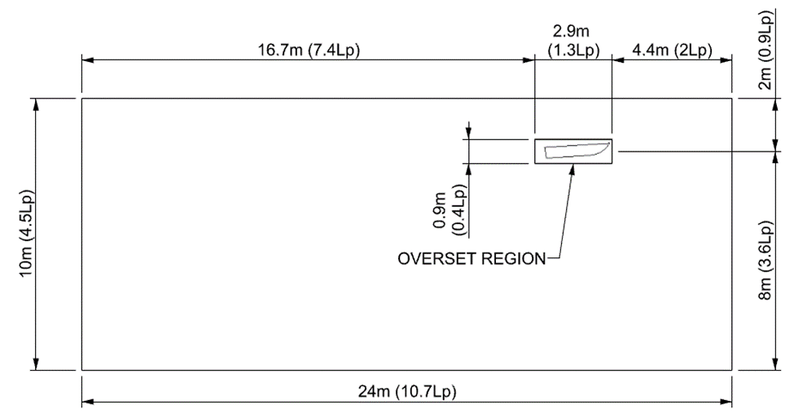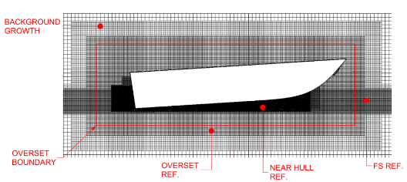

**Figure 2.** Domain Section and Mesh at Symmetry Plane

# Results

## Fixed Simulations­

The following section reports the results of the series of fixed simulations, and compares the CFD results to those predicted by the Savitsky Method [12] and Faltinsen’s linearized theory [6]. The results of the simulations are given in Figure 3. The results are presented in terms of dimensional lift and trimming moment rather than the restoring coefficients because conceptually the dimensional values allow for easier discussion of the trends.

**Figure 3.** Results of Fixed Simulations Compared to Savitsky’s and Faltinsen’s Method.

Figure 3 shows that at the largest heave displacements from equilibrium, the results of the fixed simulations deviate from that predicted by Faltinsen’s linear theory. As the heave displacement changes (top row, non-dimensionalized by chine beam) both the results of the simulations and the Savitsky Method show increasing nonlinearity (although with differing trends) that are not captured by Faltinsen’s linear theory. Therefore, it is reasonable to conclude that nonlinear contributions from the restoring force related to heave displacement will play a role in the force response during forced motions and the motion solution in waves. In general, the trends in restoring force from the fixed heave simulations agree better with Savitsky at positive displacements (coming out of the water) than negative heave displacements. This is believed to be due to the increased submersion of the non-prismatic hull sections as the hull is fixed deeper in the water.

The fixed pitch simulations (bottom row of Figure 3) show fewer non-linearities than the fixed heave simulations and could be approximated well by a linear regression. The Savitsky method agrees that there are fewer nonlinearities with respect to changes in fixed pitch than there are with fixed heave. The rate of change of the trimming moment with respect to pitch has reasonable agreement between all three methods while the rate of change in lift is larger from the simulations than Savitsky or Faltinsen.

All further analysis in this work is carried out using the results of the fixed simulations when analyzing the forced motion simulations. The other methods of predicting the restoring coefficient are only presented here for comparison and to justify the need for a nonlinear force response model in heave to account for hydrodynamic effects associated with the non-prismatic portion of the hull geometry.

## Forced Simulations

Following the completion of the fixed simulations, the analysis procedure described in Section 4 was implemented on the forced heave and pitch simulations to evaluate the best fit linear added mass and damping coefficients, while considering nonlinearities in the restoring coefficient. Snapshots of the Hull VOF and pressure distribution at four instants of a forced heave and forced pitch simulation are shown in Figure 4 to illustrate the hydrodynamics associated with the motions. In all following figures $ζ_{n}$ is the motion amplitude in the *nth* direction. Most notably, at instant “A” of the forced heave simulation, which corresponds to the time of the maximum upward velocity, a significant portion of the chine aft of the spray root is unwetted, indicating that there is a complex relationship between the wetted area of the hull and the dynamics of the motion. Other important notes from the images in Figure 4 are the large variation in wetted surface area (and therefore submerged hull geometry) during the forced heave simulation, large variation in the pressure distribution during both motions, and small variation in wetted surface area during the forced pitch simulation compared to the forced heave simulation. The relatively small change in wetted surface area during the forced pitch simulation suggests that a linear model is more likely to be applicable to model the force responses in pitch than in heave because less geometric variation throughout the motion is present.

Prior to discussion of the linear added mass and damping coefficients themselves, the results of the regression analysis and the force response measured during the simulations are compared in Figure 5 for two forced heave and forced pitch simulations respectively. In this analysis, the added mass and damping coefficient is determined for each simulation individually, so the resulting model for each regression signal uses different coefficients and is the “best fit” for that amplitude and frequency. Figure 5 shows that the linear model of added mass and damping in heave reproduce the low amplitude, low frequency simulation results (bottom row) reasonably, although the peaks in Lift and TM are underpredicted. However, at the higher amplitude and frequency (top row) the linearized model fails to capture nonlinearities in the force response in heave and the regression signal does not adequately recreate the force response in either lift or TM. Contrary to the results in forced heave, Figure 5 shows that a linear model of the force response reasonably recreates the lift and TM response of the forced pitch simulations for both amplitudes and frequencies presented.

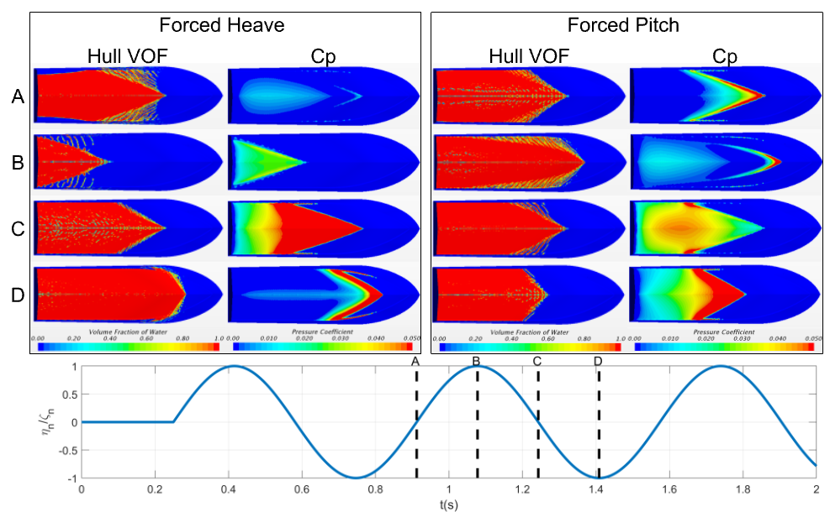

**Figure 4.** Instantaneous Hull VOF and Pressure Coefficient snapshots from force heave ($\frac{ζ_{3}}{B}=0.08$, $ω=9.49 rad/s$) and forced pitch ($ζ_{5}=2.5deg$, $ω=9.49 rad/s$) simulations at the times indicated in the bottom graph.

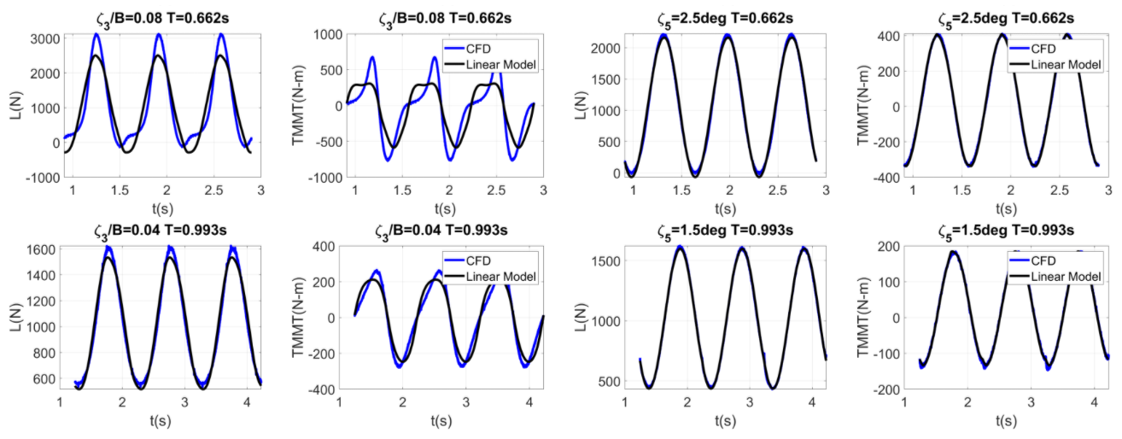

**Figure 5.** Comparison of measured lift and trimming moment from forced heave and pitch simulations to the force response recreated by regression of linear added mass and damping coefficients at two amplitudes and frequencies.

Figures 6 and 7 show the linear added mass and damping coefficients as a function of amplitude and frequency for the forced heave and forced pitch simulations respectively. These values are also compared to the values predicted using Faltinsen’s [6] linearized theory. After removing the restoring coefficients, both the lift and TM signals were nonsymmetrical about zero. Therefore, to allow the best possible fit of a linear model, an offset term was included in the regression such that the signal would be represented as well as possible. The value of the offset provides an indication of the nonlinearity in the force response, with a higher magnitude offset indicating a greater degree of nonlinearity. The value of the offset from regression is also presented in Figures 6 and 7. A non-zero offset value is not desired because it represents a discrepancy between the steady-state equilibrium and equilibrium of the dynamic model. In both Lift and TM, the required offsets are smaller for forced pitch (Figure 7), than forced heave (Figure 6), which is consistent with the observation that the force response in pitch contains fewer nonlinear contributions than the force response in heave.

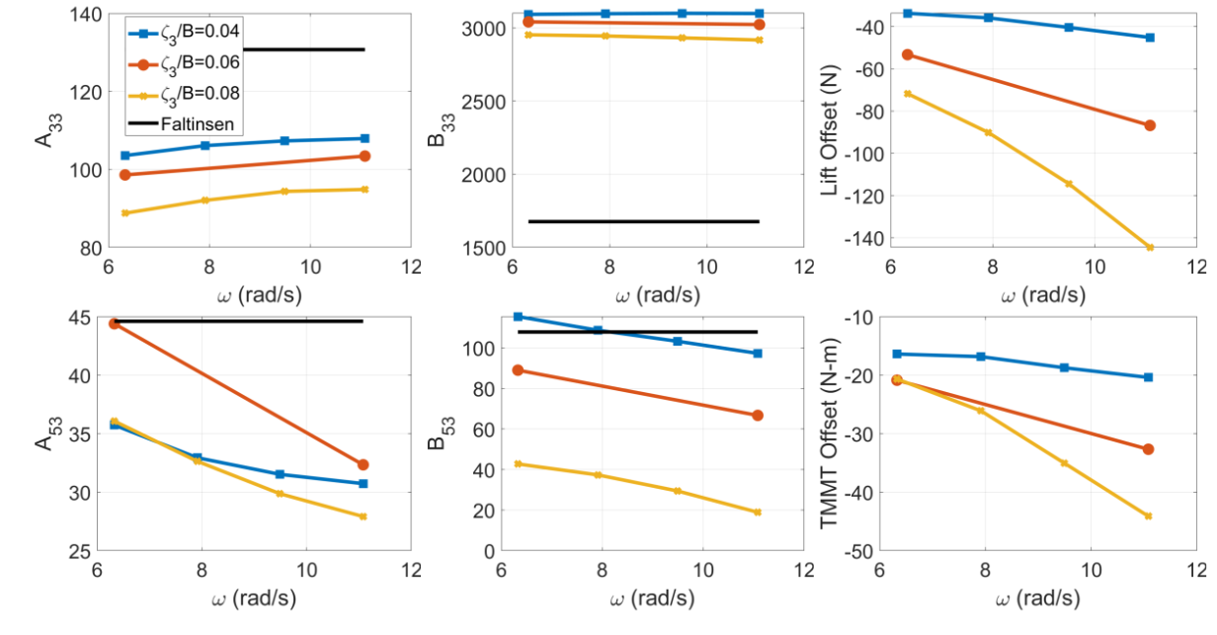

**Figure 6.** Linear coefficients and offsets from individual regression of sinusoidal forced heave simulations showing frequency and amplitude dependence of coefficients. Top Row: Lift, Bottom Row: Trimming Moment, Left Column: Added Mass, Middle Column: Damping, Right Column: Offset

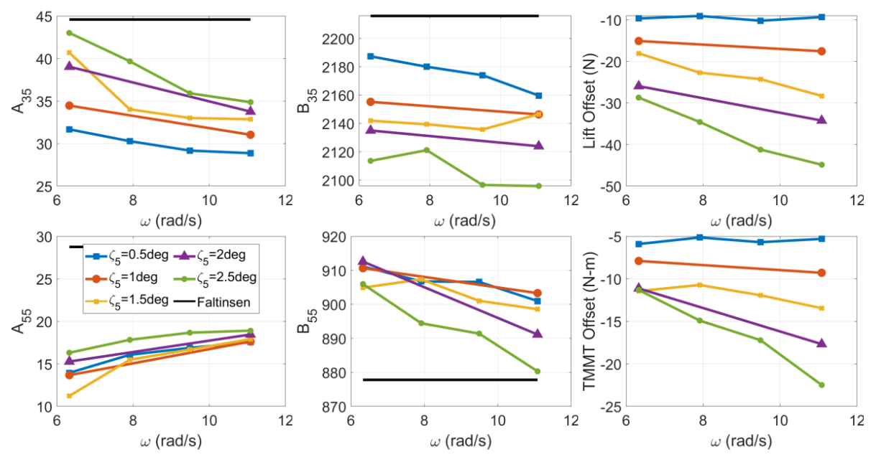

**Figure 7.** Linear coefficients and offsets from individual regression of sinusoidal forced pitch simulations showing frequency and amplitude dependence of coefficients. Top Row: Lift, Bottom Row: Trimming Moment, Left Column: Added Mass, Middle Column: Damping, Right Column: Offset

## Nonlinearities

Two significant sources of nonlinearity in the force response of a planing hull are observed from the single frequency forced motion simulations. First is nonlinearity in the individual force response during a single simulation. This nonlinearity is present with much greater significance in the forced heave simulations than in the forced pitch simulations. The source of this nonlinearity is believed to be associated with the large variations in submerged hull geometry, particularly because the nonlinearities in the lift and TM signals increase as the motion amplitude increases (Figure 5). In fact, these nonlinearities are so significant that the force response during a single forced heave simulation cannot be modeled adequately by a linear model, and the inclusion of nonlinear terms is necessary to accurately recreate the signal. However, at the range of pitch amplitudes evaluated, this type of nonlinear signal does not appear in the forced pitch motion, indicating that a less complex model of the pitch response than the heave response may be viable.

The second form of nonlinearity present in the forced motion results is the frequency and amplitude dependence of the hydrodynamic coefficients. This is seen in all the coefficients associated with both heave and pitch (Figures 6 and 7), though with varying degrees. It is desired to eliminate the frequency and amplitude dependence of the hydrodynamic coefficients through application of a robust nonlinear model when solving motions in the time domain.

Although the nonlinearities in the restoring coefficients in heave and pitch have been directly accounted for by simulation, further nonlinear dynamics are clearly present within the problem. Also, performing both fixed and forced simulations to assess the nonlinearities in the problem quickly increases the required computational load to perform this analysis, so there is a desire to investigate methods to reduce the total number of simulations required to derive an appropriate nonlinear model for the force response of a planing hull. This effort will be addressed in a future publication.

# Conclusions and Future Work

The principal conclusion of this work is that a traditional linear seakeeping model is not adequate to fully model the lift and trimming moment response of a planing hull in vertical plane motion. The large volume of data collected through simulation demonstrate the nonlinear effects and lead to this conclusion. The lift and trimming moment response in heave show nonlinearities in the response to a single frequency sinusoidal motion as well as dependencies on the frequency and amplitude of the motions. In pitch, there are fewer nonlinearities in the individual response of a single frequency sinusoidal motion, and the response appears to be recreated well by a linear model. However, the lift and trimming moment response in pitch also show nonlinearities with respect to the frequency and amplitude of the motion. Nonlinear effects extend into the restoring forces for heave while appearing less significant in pitch. The linear hydrodynamic coefficients evaluated show deviation from that predicted by the linear theory of Faltinsen [6], but without thorough experimental validation it is difficult to conclude the cause of these deviations.

At this time, the validity of decoupling the heave and pitch motion responses in the model has not been investigated, but it is already clear that to accurately model the motion response of a planing hull in waves, a nonlinear model of the force response is required. The authors intend to investigate the application of nonlinear system identification (commonly used by the aerospace field) to identify a nonlinear model which can accurately predict the force response on a planing hull in the time domain. Following the development of such a model, the authors intend to develop a routine to solve for the motion of the reference hull in regular waves and validate against the experimental results [4].

Acknowledgements

This work was supported by the Office of Naval Research under grant number N00014-20-1-2252 administered by Dr. Robert Brizzolara.

References

1. A.W. Troesch, On the hydrodynamics of vertically oscillating planing hulls, J. Ship Research. 36, Vol. 4 (1992) 317-331
2. A.W. Troesch, J.M. Falzarano, Modern nonlinear dynamical analysis of vertical plane motion of planing hulls, J. Ship Research. 37, Vol. 3 (1993) 189-199
3. C. Judge, M. Mousaviraad, F. Stern, E. Lee, A. Fullerton, J. Geiser, C. Schleicher, C. Merrill, C. Weil, J. Morin, M. Jiang, C. Ikeda, Experiments and CFD of a high-speed deep-V planing hull – Part I: Calm water, Appl. Ocean Res. 96 (2020) https://doi.org/10.1016/j.apor.2020.102060
4. C. Judge, M. Mousaviraad, F. Stern, E. Lee, A. Fullerton, J. Geiser, C. Schleicher, C. Merrill, C. Weil, J. Morin, M. Jiang, C. Ikeda, Experiments and CFD of a high-speed deep-V planing hull - part II: slamming in waves, Appl. Ocean Res. 97 (2020) https://doi.org/10.1016/j.apor.2020.102059
5. M. Martin, Theoretical prediction of motions of high speed planing boats in waves, David W. Taylor Ship Research and Development Center, Report 76-0069 (1976)
6. O.M. Faltinsen, Hydrodynamics of High-Speed Marine Vehicles, Cambridge University Press, New York (2005)
7. G. Fridsma, A Systematic Study of the Rough-Water Performance of Planing Boats, Davidson Laboratory, Report 1275 (1969)
8. H. Allaka, M. Groper, Validation and verification of a planing craft motion prediction model based on experiments conducted on full-size crafts operating in real sea. J. Mar. Sci. Technol. (2020) https://doi.org/10.1007/s00773-020-00709-6
9. T.C. Fu, K.A. Brucker, S.M. Mousaviraad, C.M. Ikeda, E.J. Lee, T.T. O’Shea, Z. Wang, F. Stern, C.Q. Judge, An Assessment of Computational Fluid Dynamics Predictions of the hydrodynamics of high-speed planing craft in calm water and waves, 30th Symposium on Naval Hydrodynamics (2014)
10. C.Q. Judge, C.M. Ikeda, An experimental study of planing hull wave slam events, 30th Symposium on Naval Hydrodynamics (2014)
11. J. Li, L. Bonfiglio, S. Brizzolara, Verification and Validation Study of OpenFOAM on the Generic prismatic Planing Hull Form. VIII International Conference on Computational Methods in Marine Engineering, MARINE’19. R. Bensow and J. Ringsberg (Eds), 428-440 (2019)
12. D. Savitsky, Hydrodynamic design of planing hulls, Mar. Technol. 1 (1964) 71-95
13. F.R. Menter, Two-equation eddy-viscosity turbulence modeling for engineering applications, AIAA Journal 32, Vol. 8 (1994) 1598-1605